Supplemental Material

- Items of the puppet-interview

Table A

Items of the puppet-interview – English translation
Scale | Item
HSC | 1 | I like to help to fold the laundry.
 | 2 | I like to help to set the table at home.
 | 3 | I like to help with the dishes.
SSC | 1 | I like to share my crayons.
 | 2 | I make sure everyone gets the same amount.
 | 3 | I like letting other children play with my toys.
CSC | 1 | I like to comfort a child even if they have been mean to me once before.
 | 2 | I stop playing my favorite game to comfort a crying child.
 | 3 | I comfort a child even when they had started a fight.
VSC | 1 | I like looking at books.
 | 2 | I like it when someone reads me a story.
 | 3 | I like listening to stories.
PSC | 1 | I like to play with the ball
 | 2 | I would like to be strong.
 | 3 | I can jump really far.
 | 4 | I can run really fast.
Note. Table only displays items from the positive end of the scale.
HSC= Helping self-concept; SSC= Sharing self-concept; CSC= Comforting self-concept; VSC= Verbal self-concept; PSC= Physical self-concept

- Coding scheme: Helping task

Code | Category | Behavior
99 | Not evaluable | - Cannot be evaluated because the child is crying, for example, or the helping task is aborted
0 | No reaction | - Child does not pay attention to the pencils on the floor  - Child does not comment on the pencils  - Child looks around the room  - Child playing with something else
1 | Low help | - When the experimenter leaves the room, the child informs her that the pencils have fallen and/or points to the pencils on the floor and looks at experimenter  - Child informs experimenter while she is still out of the room, but does not help pick it up (runs after her)  - The child goes to the pencils, sits down next to them, but does not pick them up.  - Child picks up pencils after experimenter came back after 30 seconds/helps experimenter to pick up or  - Child does not pick up the pencils himself, but helps by pointing to missing pencils and thus helps to find the pencils
2 | Moderate help | - 11 seconds to about 30 seconds after the pencils fall down, the child runs to the pencils, and collects them  (This score is given regardless of whether the child has finished picking up all the pencils when experimenter comes back.)  - Child informs experimenter while she is still outside and then helps to pick it up
3 | Strong help | - Immediately (0 seconds) or 10 seconds after the pencils fall down, the child runs to the pencils and picks them up  (This score is given regardless of whether the child has finished picking up all the pencils when experimenter comes back.)

C. Parallel mediation with PSC as the outcome variable (significant paths shaded in black)

Figure C.1

Parallel Mediation Model of the Relation Between Maternal EA and Children's PSC, with Helping, Sharing and Comforting Behavior as Mediator Variables

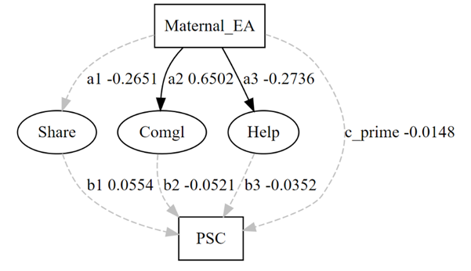
Note: This figure illustrates the parallel mediation model depicting the relations between maternal EA (emotional availability) at T1, children's prosocial behavior at T2 (helping (=Help), sharing (=Share), comforting (=Comgl)), and physical self-concept at T3 (PSC)- The coefficients for each path are displayed.

D. Parallel mediation with VSC as the outcome variable (significant paths shaded in black)

Figure D.1

Parallel Mediation Model of the Relation Between Maternal EA and Children's VSC, with Helping, Sharing and Comforting Behavior as Mediator Variables

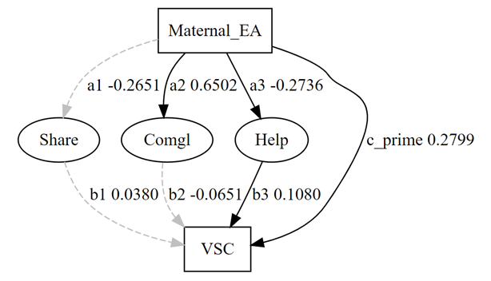
Note: This figure illustrates the parallel mediation model depicting the relations between maternal EA (emotional availability) at T1, children's prosocial behavior at T2 (helping (=Help), sharing (=Share), comforting(=Comgl)), and verbal self-concept at T3 (VSC)- The coefficients for each path are displayed.

