**Supplementary material: Developmental cascades from maternal depressive symptoms in childhood to adolescents’ friendship quality: A 13-year longitudinal study**

*Laura Bechtiger, Annekatrin Steinhoff, Jessica Dollar, Susan Keane, Susan Calkins, Lilly Shanahan*

**RIGHT Track sample attrition**

The current study utilized data from three cohorts of children who are part of an ongoing longitudinal study of social and emotional development. The goal for recruitment was to obtain a sample of children who were at risk for developing future externalizing behavior problems, and who were representative of the surrounding community (i.e., a mid-sized city in North Carolina) in terms of race and socioeconomic status (SES). All cohorts were recruited through child daycare centers, the County Health Department, and the local Women, Infants, and Children program. Potential participants for Cohorts 1 and 2 were recruited at 2 years of age (Cohort 1: 1994–1996 and Cohort 2: 2000–2001) and screened using the Child Behavior Checklist (CBCL 2–3; Achenbach, 1992) completed by the mother, in order to over-sample for externalizing behavior problems. Children were identified as being at risk of future externalizing behaviors if they received an externalizing *T*-score of 60 or above. Efforts were made to obtain approximately equal numbers of males and females. This recruitment effort resulted in a total of 307 children.

Cohort 3 was initially recruited when infants were 6 months of age (in 1998) for their level of frustration, based on laboratory observation and parent report, and were followed through the toddler period (see Calkins et al., 2002, for more information). Children from Cohort 3, whose mothers completed the CBCL at 2 years of age (*n* = 140), were then included in the larger study. Of the entire sample (*N* = 447), 37% of the children were identified as being at risk for future externalizing problems. There were no significant demographic differences among cohorts with regard to gender, χ2 (2, *N* = 447) = 0.63, *p* = .73, race, χ2 (2, *N* = 447) = 1.13, *p* = .57, or 2-year SES, *F*(2, 444) = .53, *p* = .59.

Of the 447 originally selected participants, six were dropped because they did not participate in any data collection at 2 years of age. An additional 12 families participated at recruitment, did not participate at 2 years, but participated in later years. At 4 years of age, 399 families participated. Families lost to attrition included those who could not be located, moved out of the area, declined participation, or did not respond to phone and letter requests to participate. There were no significant differences between families who did and did not participate at 4 years of age in terms of gender, χ2 (1, *N* = 447) = 3.27, *p* = .07, race, χ2 (1, *N* = 447) = 0.65, *p* = .42, 2-year SES, *t*(432) = −0.92, *p* = .36, 2-year externalizing *T*-score, *t*(445) = 0.45, *p* = .65, or maternal depressive symptoms at age 2, *t*(24) = −0.39, *p* = .70. At age 5, 365 families participated, including four that did not participate in the 4-year assessment. Again, there were no significant differences between families who did and did not participate in terms of gender, χ2 (1, *N* = 447) = 0.76, *p* = .38, race, χ2 (1, *N* = 447) = 0.14, *p* = .71, 2-year SES, *t*(432) = −1.99, *p* = .05, 2-year externalizing *T*-score, *t*(445) = 1.39, *p* = .17, or maternal depressive symptoms at age 2, *t*(66) = −0.65, *p* = .52. At 7 years of age, 350 families participated, including 19 that did not participate in the 5-year assessment. Again, there were no significant differences between families who did and did not participate in terms of gender, χ2 (1, *N* = 447) = 2.12, *p* = .15, race, χ2 (3, *N* = 447) = 1.47, *p* = .69, 2-year externalizing *T*-score, *t*(445) = 1.30, *p* = .19, or maternal depressive symptoms at age 2, *t*(92) = −0.35, *p* = .73. Families with lower 2-year SES, *t*(432) = −2.61, *p* < .01, were less likely to participate in the 7-year assessment. At age 10, 357 families participated, including 31 families that did not participate in the 7-year assessment. No significant differences were noted between families who did and did not participate in the 10-year assessment in terms of child gender, χ2 (1, *N* = 447) = 3.31, *p* = .07; race, χ2 (3, *N* = 447) = 5.78, *p* = .12; 2-year SES, *t*(432) = 0.02, *p* = .98; 2-year externalizing *T*-score, *t*(445) = −0.11, *p* = .91, or maternal depressive symptoms, *t*(102) = −1.75, *p* = .08. At age 15, 327 families participated, including 27 families that did not participate in the 10-year assessment. There were no significant differences between families who did and did not participate in the 15-year assessment in terms of race, χ2 (3, *N* = 447) = 3.96, *p* = .27; 2-year SES *t*(432) = −0.56, *p* = .58; 2-year externalizing *T*-score *t*(445) = 0.24, *p* = .81; or maternal depressive symptoms at age 2, *t*(152) = −1.10, *p* = .27. Boys were less likely to participate in the 15-year assessment, χ2 (1, *N* = 447) = 9.31, *p* = .002.

**Reference:**

Calkins, S. D., Dedmon, S. E., Gill, K. L., Lomax, L. E., & Johnson, L. M. (2002). Frustration in Infancy: Implications for Emotion Regulation, Physiological Processes, and Temperament. *Infancy*, *3*(2), 175–197. https://doi.org/10.1207/S15327078IN0302_4

1. **Correlations by sex**

Correlations for males and females are presented separately in Table e1. In males, maternal depressive symptoms were correlated with lower child social skills at ages 7 and 10, and with higher levels of child depressive symptoms at age 7. In females, maternal depressive symptoms were correlated with lower child social skills at age 7. Maternal depressive symptoms were not significantly correlated with adolescent friendship quality in females and at *p*<.10 in males, although this association is significant in the overall sample; this is likely due to the lower sample size (and, subsequently, lower statistical power) when splitting the overall sample into two.

**TABLE e1** Correlations by sex (males in blue under the diagonal and females in red above the diagonal)

|  |  |  |  |  |  |  |  |  |  |  |  |  |  |  |
| --- | --- | --- | --- | --- | --- | --- | --- | --- | --- | --- | --- | --- | --- | --- |
| **Variable** | **1** | **2** | **3** | **4** | **5** | **6** | **7** | **8** | **9** | **10** | **11** | **12** | **13** | **14** |
| 1) Maternal depr. sympt.(ages 2–5) | -- | 0.14 | 0.17 | **–.28**\* | **–.19**\* | .04 | –.10 | .07 | .22+ | –.08 | **–.19**\* | –.03 | .15+ | **.39**\*\* |
| 2) Negative parenting (age 7) | 0.16 | -- | **.55\*\*\*** | -.17 | -.12 | .01 | -.02 | .15 | -.06 | **-.19\*** | **-.26\*\*** | **.39\*\*\*** | **.44\*\*\*** | .07 |
| 3) Negative parenting (age 10) | 0.07 | **.30\*\*** | -- | -.03 | -.05 | .06 | -.05 | .16 | .02 | -.14 | **-.19\*** | **.18\*** | **.25\*\*** | .08 |
| 4) Social skills (age 7) | **–.30**\*\* | **-.28\*\*** | -.10 | -- | **.55**\*\*\* | .03 | .16+ | –.15 | **–.31**\*\*\* | **.21**\* | **.23**\*\* | **–.19**\* | **–.26**\*\* | **–.27**\*\* |
| 5) Social skills (age 10) | **–.21**\* | -.15 | .02 | **.54**\*\*\* | -- | .06 | .13 | –.17 | **–.26**\*\* | **.28**\*\* | **.18**\* | **–.23**\*\* | **–.32**\*\*\* | **–.21**\* |
| 6) Friendship quality (age 7) | .05 | .14 | .26* | .12 | .15 | -- | **.27**\*\* | –.12 | –.02 | .04 | .02 | .13 | .07 | –.08 |
| 7) Friendship quality (age 10) | –.19 | -.05 | -.13 | **.37**\*\*\* | **.19**\* | .15 | -- | –.04 | **–.18**\* | **.34**\*\*\* | –.00 | –.05 | –.09 | –.14+ |
| 8) Child depr. sympt. (age 7) | **.36**\* | .00 | -.02 | –.08 | –.11 | **–.29**\* | .04 | -- | **.32**\*\* | –.05 | –.19+ | **.27**\*\* | .07 | .09 |
| 9) Child depr. sympt. (age 10) | .14 | **.20\*** | -.05 | **–.28**\*\* | **–.27**\*\* | –.12 | **–.23**\* | **.48**\*\* | -- | –.05 | –.10 | .10 | .05 | .15+ |
| 10) Friendship quality (age 15) | –.22+ | -.13 | -.02 | **.25**\* | –.03 | .22+ | **.31**\*\* | .07 | –.09 | -- | .13 | **–.26**\*\* | –.07 | –.04 |
| 11) SES | **–.22**\* | **-.30\*\*\*** | -.13 | .07 | .07 | .01 | .12 | –.13 | **–.30**\*\* | –.07 | -- | **–.17**\* | **–.34**\*\*\* | –.11 |
| 12) Race/ethnicity | .10 | **.35\*\*\*** | **.26\*\*** | **–.23**\*\* | –.09 | .11 | –.05 | .13 | .02 | .08 | **–.25**\*\*\* | -- | **.42**\*\*\* | –.02 |
| 13) Single motherhood (age 2) | .13 | **.30\*\*\*** | **.26\*\*** | **–.31**\*\* | .00 | .12 | –.02 | .03 | **.19**\* | .18+ | **–.36**\*\*\* | **.34**\*\*\* | -- | **.14**\* |
| 14) Externalizing (age 2) | **.49**\*\*\* | **.23\*\*** | -.04 | **–.29**\*\* | **–.27**\*\* | .03 | –.02 | **.27**\* | **.31**\*\* | .01 | **–.25**\*\*\* | -.00 | .10 | -- |

***Note.*** *nmales =* 58-212*; nfemales =* 89-222*.* For the correlations with the latent maternal depressive symptoms factor, the correlation with each variable for males and females was estimated in one multigroup model, and factor loadings for the maternal depressive symptoms factor were constrained to be equal in both groups. The robust maximum likelihood estimator and full information maximum likelihood for missing data was used.

\**p* < 0.05; \*\**p* < 0.01; \*\*\**p* < 0.001

1. **All coefficients of unconditional path model**

**TABLE e2** Unstandardized coefficients and their bias-corrected bootstrap confidence intervals and standardized estimates of unadjusted path model.

|  |  |  |  |  |
| --- | --- | --- | --- | --- |
|  | **Adjusted model** | | |  |
|  |  | **95% CI** | |  |
|  | **Estimate** | **Lower bound** | **Upper bound** | **Standardized Estimate** |
| **Latent factor loadings** |  |  |  |  |
| *Maternal depressive symptoms* |  |  |  |  |
| Age 2 | **1.00** | -- | -- | -- |
| Age 4 | **1.51** | 1.12 | 2.07 | 0.83 |
| Age 5 | **1.68** | 1.27 | 2.26 | 0.89 |
| **Regressions** |  |  |  |  |
| *Negative parenting behavior age 7* |  |  |  |  |
| Maternal depressive symptoms | 0.25 | -0.01 | 0.49 | 0.15 |
| *Social skills age 7* |  |  |  |  |
| Maternal depressive symptoms | **-0.31** | -0.46 | -0.14 | -0.28 |
| *Child depressive symptoms age 7* |  |  |  |  |
| Maternal depressive symptoms | **0.17** | 0.02 | 0.34 | 0.22 |
| *Friendship quality age 7* |  |  |  |  |
| Maternal depressive symptoms | 0.04 | -0.28 | 0.26 | 0.02 |
| *Negative parenting behavior age 10* |  |  |  |  |
| Negative parenting behavior age 7 | **0.41** | 0.27 | 0.56 | 0.45 |
| Social skills age 7 | 0.00 | -0.20 | 0.17 | 0.00 |
| Child depressive symptoms age 7 | 0.11 | -0.30 | 0.38 | 0.05 |
| Friendship quality age 7 | **0.12** | 0.00 | 0.23 | 0.14 |
| *Social skills age 10* |  |  |  |  |
| Negative parenting behavior age 7 | -0.03 | -0.09 | 0.05 | -0.04 |
| Social skills age 7 | **0.56** | 0.44 | 0.67 | 0.55 |
| Child depressive symptoms age 7 | -0.16 | -0.40 | 0.02 | -0.11 |
| Friendship quality age 7 | 0.03 | -0.07 | 0.10 | 0.04 |
| *Child depressive symptoms age 10* |  |  |  |  |
| Child depressive symptoms age 7 | **0.39** | 0.23 | 0.56 | 0.38 |
| Negative parenting behavior age 7 | -0.03 | -0.08 | 0.03 | -0.07 |
| Social skills age 7 | **-0.19** | -0.29 | -0.08 | -0.26 |
| Friendship quality age 7 | 0.05 | -0.01 | 0.12 | 0.12 |
| *Friendship quality age 10* |  |  |  |  |
| Friendship quality age 7 | **0.20** | 0.09 | 0.31 | 0.25 |
| Negative parenting behavior age 7 | 0.01 | -0.12 | 0.12 | 0.01 |
| Social skills age 7 | **0.40** | 0.18 | 0.59 | 0.27 |
| Child depressive symptoms age 7 | 0.05 | -0.24 | 0.36 | 0.02 |
| *Friendship quality age 15* |  |  |  |  |
| Maternal depressive symptoms | -0.15 | -0.41 | 0.09 | -0.08 |
| Friendship quality age 10 | **0.40** | 0.25 | 0.58 | 0.33 |
| Negative parenting behavior age 10 | -0.07 | -0.26 | 0.08 | -0.06 |
| Social skills age 10 | **0.33** | 0.12 | 0.58 | 0.19 |
| Child depressive symptoms age 10 | 0.28 | -0.01 | 0.60 | 0.12 |
| **Covariances** |  |  |  |  |
| Social skills age 7 and |  |  |  |  |
| Negative parenting behavior age 7 | **-0.03** | -0.06 | -0.01 | -0.18 |
| Child depressive symptoms age 7 | -0.01 | -0.02 | 0.00 | -0.11 |
| Friendship quality age 7 | **0.03** | 0.00 | 0.05 | 0.15 |
| Child depressive symptoms age 7 and |  |  |  |  |
| Negative parenting behavior age 7 | 0.01 | -0.01 | 0.04 | 0.11 |
| Friendship quality age 7 | **-0.03** | -0.06 | -0.01 | -0.24 |
| Friendship quality age 7 and |  |  |  |  |
| Negative parenting behavior age 7 | 0.02 | -0.02 | 0.07 | 0.07 |
| Social skills age 10 and |  |  |  |  |
| Negative parenting behavior age 10 | 0.01 | -0.00 | 0.04 | 0.12 |
| Child depressive symptoms age 10 | -0.01 | -0.02 | 0.00 | -0.11 |
| Friendship quality age 10 | 0.01 | -0.01 | 0.03 | 0.08 |
| Child depressive symptoms age 10 and |  |  |  |  |
| Negative parenting behavior age 10 | -0.01 | -0.02 | 0.01 | -0.06 |
| Friendship quality age 10 | -0.02 | -0.03 | 0.00 | -0.15 |
| Friendship quality age 10 and |  |  |  |  |
| Negative parenting behavior age 10 | -0.02 | -0.06 | 0.00 | -0.12 |

*Note.* Standardized coefficients of the unadjusted model (χ2 (*df*) = 28.71 (26), *p* =.324; CFI = .995; RMSEA = 0.016; SRMR = 0.031).Significant coefficients are bolded.

1. **Sensitivity analysis with Cohorts 2 and 3 only**

Because child-reported child depressive symptoms at age 7 were available for only two cohorts (2 and 3), we conducted a sensitivity analysis with only those two cohorts (*n* = 246). The model corresponds to the final model described in the main manuscript. Model fit was good, χ2 = 77.61 (72), *p* = .305; CFI = .987; RMSEA = .018; SRMR = .050. The standardized coefficients of the model can be seen in Figure e1. Overall, the sensitivity analysis confirmed the findings from the final model reported in the main manuscript. The indirect effect from maternal depressive symptoms to adolescent friendship quality through social skills at age 7 to friendship quality at age 10 remained significant (*b* = –0.02, 95% CI

[–0.11, –0.00]), as was the indirect effect from maternal depressive symptoms to children’s depressive symptoms at age 10 through social skills at age 7 (*b* = 0.04, 95% CI [0.00, 0.14]). The confidence intervals were larger than those in the main analyses, which is likely due to the smaller sample size.

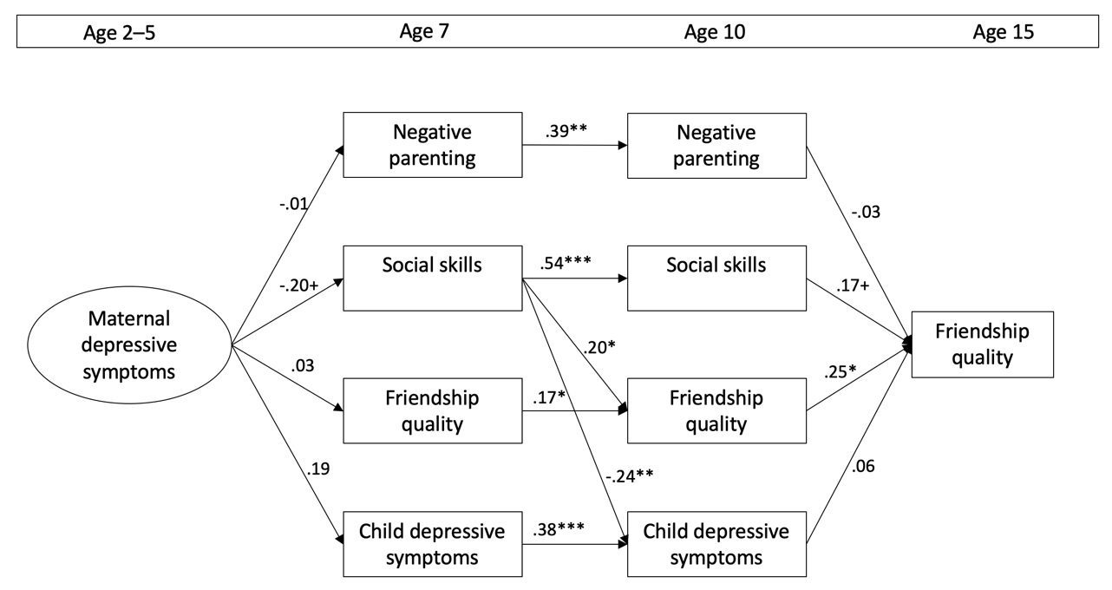

**FIGURE e1.** Standardized coefficients from the sensitivity analysis that included participants from Cohorts 2 and 3 only.

For ease of reading, only cross paths with p<.10 from constructs assessed at age 7 to constructs assessed at age 10 are presented in the figure. Covariances between residuals of constructs assessed at the same point in time and a direct path from maternal depressive symptoms to friendship quality at age 15 are also included in the model, but are not shown in the figure for ease of reading. + p<.10; \**p* < 0.05; \*\**p* < 0.01; \*\*\**p* < 0.001

1. **Sensitivity analysis with the short version of the Friendship Quality Questionnaire (FQQ) throughout**

At age 7, only a short version of the FQQ was available. Therefore, we conducted a sensitivity analysis with the short version of the FQQ throughout. The model corresponds to the final model described in the main manuscript. Model fit was good, χ2 = 78.22 (72), *p* = .288; CFI = .992; RMSEA = .015; SRMR = .039. The standardized coefficients of the model can be seen in Figure e2. Overall, the sensitivity analysis confirmed the findings from the final model reported in the main manuscript. The indirect effect of maternal depressive symptoms on adolescent friendship quality through social skills at age 7 to friendship quality at age 10 remained significant (*b* = –.02, 95% CI [–.06, –.00]), as was the indirect effect of maternal depressive symptoms on children’s depressive symptoms at age 10 through social skills at age 7 (*b* = 0.04, 95% CI [0.01, 0.11).

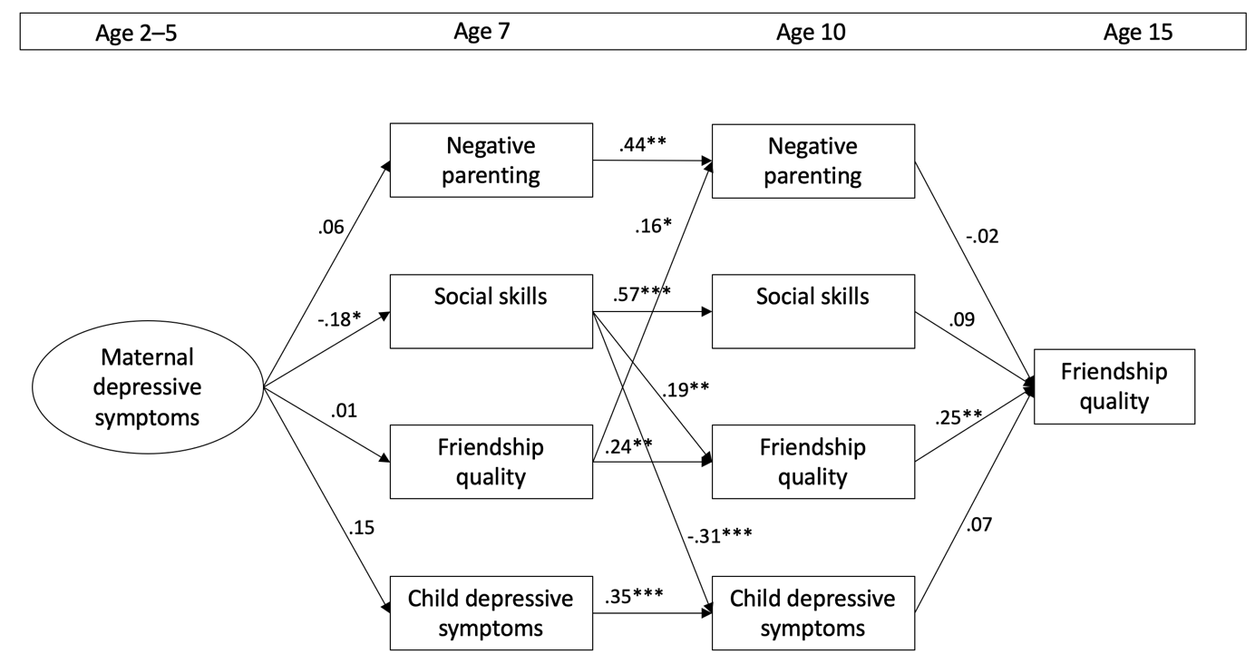

**FIGURE e2.** Standardized coefficients of the sensitivity analysis with the short version of the FQQ throughout.For ease of reading, only significant cross paths from constructs assessed at age 7 to constructs assessed at age 10 are presented in the figure. Covariances between residuals of constructs assessed at the same point in time and a direct path from maternal depressive symptoms to friendship quality at age 15 are also included in the model, but are not shown in the figure for ease of reading. \**p* < 0.05; \*\**p* < 0.01; \*\*\**p* < 0.001

1. **Sensitivity analysis accounting for the continuity of maternal depressive symptoms across middle childhood**

To examine whether maternal depressive symptoms after early childhood could account for the long-term indirect associations with adolescent friendship quality in the main model, we included maternal depressive symptoms in middle childhood (at ages 7 and 10) in the model as a fourth potential mediator instead of negative parenting behavior. Maternal depressive symptoms at ages 7 and 10 were included in the final model described in the manuscript (including only covariates retained in the final model). Model fit was acceptable with χ2 = 125.783(64), *p* < .001; CFI = .934; RMSEA = .049; SRMR = .044. The model coefficients are presented in Table e3. Overall, the results confirm the results of the main analysis. We still see significant indirect effects from maternal depressive symptoms in early childhood to adolescent friendship quality through social skills at age 7 and friendship quality at age 10 (*b* = –.02, 95% CI [–.06, –.00]) and from maternal depressive symptoms to children’s depressive symptoms at age 10 through social skills at age 7 (*b* = 0.04, 95% CI [0.01, 0.09). Maternal depressive symptoms at age 7 was only significantly predictive of higher levels of child depressive symptoms at age 10, but not of children’s social skills or friendship quality. Maternal depressive symptoms at age 10 were not significantly associated with adolescent friendship quality.

Table e3. Unstandardized coefficients and their bias-corrected bootstrap confidence intervals and standardized estimates of the sensitivity analyses including the continuity of maternal depressive symptoms across time.

|  |  |  |  |  |
| --- | --- | --- | --- | --- |
|  |  | **95% CI** | |  |
|  | **Estimate** | **Lower bound** | **Upper bound** | **Standardized Estimate** |
| **Latent factor loadings** |  |  |  |  |
| *Maternal depressive symptoms ages 2-5* |  |  |  |  |
| Age 2 | 1.00 |  |  |  |
| Age 4 | 1.60 | 1.18 | 2.28 | 0.86 |
| Age 5 | 1.70 | 1.32 | 2.24 | 0.88 |
| **Regressions** |  |  |  |  |
| *Social skills age 7* |  |  |  |  |
| Maternal depressive symptoms ages 2-5 | **-0.20** | -0.40 | -0.03 | -0.18 |
| Sex (male=1) | **-0.11** | -0.19 | -0.03 | -0.16 |
| Race (non-White=1) | -0.09 | -0.18 | 0.01 | -0.12 |
| Single motherhood | **-0.13** | -0.24 | -0.02 | -0.15 |
| Externalizing symptoms | **-0.01** | -0.01 | -0.00 | -0.19 |
| *Child depressive symptoms age 7* |  |  |  |  |
| Maternal depressive symptoms ages 2-5 | 0.12 | -0.02 | 0.32 | 0.15 |
| Race (non-White=1) | **0.12** | 0.05 | 0.19 | 0.23 |
| Externalizing symptoms | **0.00** | 0.00 | 0.01 | 0.16 |
| *Friendship quality age 7* |  |  |  |  |
| Maternal depressive symptoms ages 2-5 | 0.09 | -0.16 | 0.32 | 0.05 |
| Sex (male=1) | **-0.26** | -0.41 | -0.10 | -0.21 |
| *Maternal depressive symptoms age 7* |  |  |  |  |
| Maternal depressive symptoms ages 2-5 | **1.24** | 0.86 | 1.73 | 0.76 |
| *Social skills age 10* |  |  |  |  |
| Maternal depressive symptoms age 7 | 0.03 | -0.07 | 0.11 | 0.04 |
| Social skills age 7 | **0.59** | 0.46 | 0.70 | 0.58 |
| Child depressive symptoms age 7 | -0.15 | -0.38 | 0.05 | -0.11 |
| Friendship quality age 7 | 0.01 | -0.08 | 0.09 | 0.02 |
| *Child depressive symptoms age 10* |  |  |  |  |
| Maternal depressive symptoms age 7 | **0.08** | 0.01 | 0.17 | 0.15 |
| Child depressive symptoms age 7 | **0.32** | 0.15 | 0.49 | 0.30 |
| Social skills age 7 | **-0.18** | -0.29 | -0.09 | -0.24 |
| Friendship quality age 7 | 0.04 | -0.02 | 0.11 | 0.09 |
| *Friendship quality age 10* |  |  |  |  |
| Maternal depressive symptoms age 7 | -0.11 | -0.24 | 0.03 | -0.11 |
| Friendship quality age 7 | **0.19** | 0.07 | 0.30 | 0.22 |
| Social skills age 7 | **0.28** | 0.07 | 0.48 | 0.19 |
| Child depressive symptoms age 7 | 0.15 | -0.17 | 0.43 | 0.07 |
| Sex (male=1) | **-0.21** | -0.32 | -0.10 | -0.21 |
| *Maternal depressive symptoms age 10* |  |  |  |  |
| Maternal depressive symptoms age 7 | **0.46** | 0.33 | 0.59 | 0.44 |
| Social skills age 7 | **-0.09** | -0.25 | 0.07 | -0.06 |
| Child depressive symptoms age 7 | 0.07 | -0.24 | 0.35 | 0.03 |
| Friendship quality age 7 | -0.03 | -0.16 | 0.09 | -0.03 |
| *Friendship quality age 15* |  |  |  |  |
| Maternal depressive symptoms age 2-5 | -0.14 | -0.47 | 0.20 | -0.07 |
| Maternal depressive symptoms age 10 | -0.05 | -0.28 | 0.14 | -0.04 |
| Friendship quality age 10 | **0.31** | 0.13 | 0.50 | 0.26 |
| Social skills age 10 | 0.18 | -0.07 | 0.42 | 0.11 |
| Child depressive symptoms age 10 | 0.16 | -0.15 | 0.50 | 0.07 |
| Sex (male=1) | **-0.32** | -0.48 | -0.17 | -0.28 |
| *Maternal depressive symptoms age 2-5* |  |  |  |  |
| Externalizing symptoms | **0.01** | 0.01 | 0.02 | 0.43 |
| **Covariances** |  |  |  |  |
| Social skills age 7 and |  |  |  |  |
| Maternal depressive symptoms age 7 | -0.01 | -0.03 | 0.01 | -0.10 |
| Child depressive symptoms age 7 | -0.00 | -0.01 | 0.01 | -0.06 |
| Friendship quality age 7 | **0.03** | 0.00 | 0.05 | 0.14 |
| Child depressive symptoms age 7 and |  |  |  |  |
| Maternal depressive symptoms age 7 | 0.01 | -0.01 | 0.02 | 0.08 |
| Friendship quality age 7 | **-0.04** | -0.06 | -0.01 | -0.27 |
| Friendship quality age 7 |  |  |  |  |
| Maternal depressive symptoms age 7 | -0.01 | -0.03 | 0.02 | -0.03 |
| Social skills age 10 and |  |  |  |  |
| Maternal depressive symptoms age 10 | -0.00 | -0.03 | 0.02 | -0.02 |
| Child depressive symptoms age 10 | -0.01 | -0.02 | 0.00 | -0.09 |
| Friendship quality age 10 | 0.01 | -0.01 | 0.03 | 0.06 |
| Child depressive symptoms age 10 and |  |  |  |  |
| Maternal depressive symptoms age 10 | 0.01 | -0.02 | 0.04 | 0.05 |
| Friendship quality age 10 | **-0.02** | -0.04 | -.00 | -0.18 |
| Friendship quality age 10 |  |  |  |  |
| Maternal depressive symptoms age 10 | -0.01 | -0.06 | 0.02 | -0.07 |

*Note.* Significant coefficients are bolded. Control variables vary for the different endogeneous variables differ because covariates were omitted from the final model when p >.10. No additional covariates were included in this model than the ones included in the final model.