Supplemental materials for:
ATR HARMONY PREFERENCES IN GHANAIAN INFANTS

This document provides (i) a description of how infants’ exposure to each of their languages was computed from the parental questionnaire and the diary logbook (Supplement 1), (ii) output of statistical model comparison on the inclusion and exclusion of exposure to an ATR harmony language as a predictor (supplement 2, Tables S2a-S2c), (iii) output of the statistical model showing that the inclusion of by-item random intercept (see Table 6 in the main paper) provides the same results of the fixed effects as the model without it (supplement 3, Table S3), (iv) a table with the mean and standard deviation for individual trials (Supplement 4, Table S4) and a figure showing the decrease of looking time (LTs) over the course of the trials in the experiment (Supplement S4, Figure S1), (v) results of the exploratory analyses on trial types (supplement S5, Tables S5a-S5b) and (vi) the results of the models showing that the inclusion of a quadratic predictor for trial number does not explain additional variance (supplement S6, Tables S6a-S6b).

Supplement S1
A description of how infants’ exposure to each of their languages was computed from the parental language questionnaire and the diary logbook.
The parental questionnaire captured speech directed to infants and overheard speech input. For direct speech input, caregivers reported the amount of time that they or other people (e.g., relatives, older siblings of the infant, grandparents) spend with the infant in terms of hours or minutes per day. They were also asked to indicate Akan, Ewe, Ga, Ghanaian English, and other languages they speak and how often they use this when speaking to their infant (on a 5-point scale with the labels always, regularly, sometimes, rarely, and never).
In order to capture infants’ overheard speech input, caregivers also reported the amount of time infants spend in a range of contexts where they are likely exposed to overheard speech (e.g., in the home, social environment, and media). These were reported in hours or minutes per day (e.g., television) or week (specifically from social and religious gatherings). Caregivers were then asked to indicate for Akan, Ewe, Ga, Ghanaian English, and other languages how often their infants overhear speech input in these contexts using the same scale as in the direct input.
To quantify caregivers’ responses from the response scale, we assigned numeric values to the frequency-of-use scale, where always = 4, regularly = 3, sometimes = 2, rarely = 1, and never = 0. In addition, all time reported in hours was converted into minutes, and all time estimates reported per week (e.g., overhead speech) were converted into an estimate per day.
The frequency-of-use values and the minutes-per-day exposure estimates for each language were entered into Excel for calculations. Estimated percentage exposure to each language was computed separately for direct speech and overheard speech for each infant.
The frequency-of-use scores assigned to the languages were interpreted as abstract units of time on an interval scale to estimate the percentage of exposure to different languages. Therefore, the proportion of time an infant hears a given language from a caregiver was calculated as the frequency-of-use score assigned to this language divided by the sum of all frequency-of-use scores for this caregiver. The total time the infant hears this language from the caregiver is this proportion multiplied by the total time spent with the infant. Consider, for example, an infant that hears Akan (sometimes = 2), Ewe (regularly = 3), and Ghana English (rarely = 1) but no Ga (never = 0) from a caregiver that spends 8 hours (= 480 minutes) per day with the infant. This infant hears Akan a third of the time spent with this caregiver (i.e., 2/6, where 2 is the assigned frequency-of-use score for Akan, and 6 is the sum of all this caregiver’s frequency-of-use scores). Thus, the infant hears Akan from this caregiver for 160 minutes a day (i.e., 1/3 * 480 minutes, where 1/3 is the proportion of time that the infant hears Akan from this caregiver and 480 is the total time spent with this caregiver). This process was repeated for each person who spends time with the infant and the languages they speak. The total exposure time to a given language in speech directed to the child is the sum of time of exposure to this language across all the caregivers.
Similar calculations were made with overheard speech. Consider, for example, an infant that hears Akan (rarely = 1), Ewe (sometimes = 2), Ga (sometimes = 2), and Ghanaian English (rarely = 1) from exposure to television for a total of 5 hours (= 300 minutes) per day. This infant hears Akan a sixth of the time spent watching television (i.e., 1/6, where 1 is the assigned numeric score for Akan, and 6 is the sum of numeric scores assigned to all languages). Therefore, this infant hears Akan from television for 50 minutes a day (i.e., 1/6 * 300 minutes, where 1/6 is the proportion of time that the infant hears Akan on television and 300 is the total exposure time to television). This process was repeated for each overheard speech context and language. The total exposure time to a given language in overheard speech is the sum of time of exposure to that language across all overheard-speech contexts. Finally, each infant’s overall percentage of exposure to a harmony language was the sum of exposure to ATR and non-ATR harmony languages divided by the total time of exposure to harmonic and non-harmonic languages multiplied by 100. This overall percentage of exposure was calculated across direct and overheard speech.
For the logbook, we computed exposure to the different languages by first counting the number of times the infant heard each language indicated in the logbook and the total number of entries (all languages combined). Then, for each language, we calculated the percentage of times the infant heard it. This was done by dividing the number of entries for a given language by the sum of entries for all languages multiplied by 100. That is, (a / b) *100, where “a” is the number of entries for each language, and “b” is the sum of entries across all languages.
Here is a sample calculation for an infant that hears Akan (12 times), Ewe (4 times), Ga (3 times), and Ghanaian English (7 times) for the entire day, as reported in the logbook. Percentage exposure to Akan = (12/26) *100 = 46.15%, where 12 is the number of entries for Akan, and 26 is the sum of entries across all languages. All calculations were done in Excel.

Supplement S2
To check whether the inclusion of questionnaire and logbook measures as separate predictors for exposure in our final explain additional variance, we ran two models, one without exposure predictor (Table S2a) and another with questionnaire and logbook estimatest as separate predictors (Table S2b) and then compared the two models using the anova function in R (Table S2c).

Table S2a
Output of the Statistical Model that Does not Include Exposure to (an) ATR harmony Language(s) Obtained from the Questionnaire and Logbook as Predictors.
Formula: LT_sec ~ (harmony) * (ageC + trialnumberC) + (1 | id) + (1 | item)
Fixed effects | β | SE | t |  | p |  | 95% CI
(Intercept) | 8.23089 | 0.37892 | 21.722 | < .001 |  | 7.49, 8.97
Harmony | -0.34682 | 0.13053 | -2.657 | .008 |  | -0.60, -0.09
Age | -0.07096 | 0.11055 | -0.642 | .525 |  | -0.29, 0.15
Trial number | -0.37869 | 0.03795 | -9.979 | < .001 |  | -0.45, -0.30
harmony*Age | -0.04445 | 0.03805 | -1.168 | .243 |  | -0.12, 0.03
Harmony*Trial number | -0.02765 | -0.02765 | -0.723 | .470 |  | -0.10, 0.05

Table S2b
Output of the Statistical Model that Includes Amount of Exposure to (an) ATR harmony Language(s) Obtained from Questionnaire and Logbook as Separate Predictors
Formula: LT ~ (harmony) * (QuestionnaireC + LogbookC + ageC + trial numberC) + (1 | id) + (1|item).
Fixed effects | β | SE | t | p | 95% CI
(Intercept) | 8.2303 | 0.38903 | 21.156 | < .001 | 7.49, 8.97
Harmony | -0.3472 | 0.13075 | -2.656 | .008 | -0.60, -0.09
Questionnaire | -0.0002 | 0.02613 | -0.008 | .994 | -0.05, 0.05
Logbook | 0.0067 | 0.02812 | 0.240 | .812 | -0.05, 0.06
Age | -0.0736 | 0.1230 | -0.598 | .554 | -0.31, 0.16
Trial number | -0.3788 | 0.0380 | -9.965 | < .001 | -0.45, -0.30
Harmony*Questionnaire | 0.0019 | 0.0088 | 0.217 | .828 | -0.01, 0.02
Harmony*Logbook | 0.0041 | 0.0094 | 0.433 | .665 | -0.01, 0.02
harmony*Age | -0.0432 | 0.0412 | -1.048 | .295 | -0.12, 0.04
Harmony*Trial number | -0.0275 | 0.0383 | -0.718 | .473 | -0.10, 0.05

Table S2c
Output of model comparison between the model without an exposure predictor (md0) and the model with amount of exposure to (an) ATR harmony language(s) obtained from the questionnaire and logbook as separate predictors (md1), showing that including exposure estimates from the questionnaire and the logbook as predictors does not improve the model fit.
Models:
md0: LT_sec ~ (harmony) * (ageC + trialnumberC) + (1 | id) + (1 | item)
md1: LT_sec ~ (harmony) * (QuestionnaireC + LbookC + ageC + trialnumberC) + (1 | id) + (1 | item)
 | Npar | AIC | BIC | LogLik | deviance | Chisq | Df | Pr(>Chisq)
md0 | 9 | 2442.7 | 2480.2 | -1212.3 | 2424.7
md1 | 13 | 2450.1 | 2504.2 | -1212.0 | 2424.1 | 0.6064 | 4 | 0.9624

Supplement S3
Table S3
Results of the Statistical Model Without Random Intercept for Item yet Shows the Same Results as the Final Model which Included a Random Intercept for Item in Table 6 above
Formula: LT ~ (harmony) * (exposure + age + trial number) + (1 | id)
Fixed effects | Estimate β | SE | t-value | p-value | 95% CI
(Intercept) | 8.23044 | 0.38380 | 21.444 | < .001 | 7.49, 8.97
Harmony | -0.34725 | 0.13060 | -2.659 | .008 | -0.60, -0.09
Exposure | 0.08038 | 0.31242 | 0.257 | .798 | -0.52, 0.68
Age | -0.06736 | 0.11279 | -0.597 | .554 | -0.29, 0.15
Trial number | -0.37879 | 0.03797 | -9.977 | < .001 | -0.45, -0.30
Harmony*Exposure | 0.07510 | 0.10660 | 0.705 | .481 | -0.13, 0.28
harmony*Age | -0.04145 | 0.03830 | -1.082 | .28 | -0.12, 0.03
Harmony*Trial number | -0.02753 | 0.03825 | -0.720 | .472 | -0.10, 0.05

Supplement S4
Table S4
The Mean (M) and Standard Deviation (SD) for Individual Trials (T1 to T12) Across Infants and Harmony Type (harmonic and non-harmonic), with T1-T6 on the Left and T7-T12 on the Right.
Trial number | M | SD | Trial number | M | SD
T1 | 9.8 | 4.0 | T7 | 8.1 | 4.2
T2 | 10.5 | 3.1 | T8 | 7.7 | 3.7
T3 | 9.4 | 3.7 | T9 | 6.8 | 3.6
T4 | 9.2 | 3.0 | T10 | 7.1 | 3.8
T5 | 8.9 | 3.5 | T11 | 6.9 | 3.9
T6 | 8.7 | 3.7 | T12 | 5.8 | 3.1

Figure S1
Looking Times to Trials across Infants. Dots Indicate Average LTs for Each Trial (From T1-T12), Showing changes in LTs over the Course of the 12 Trials.
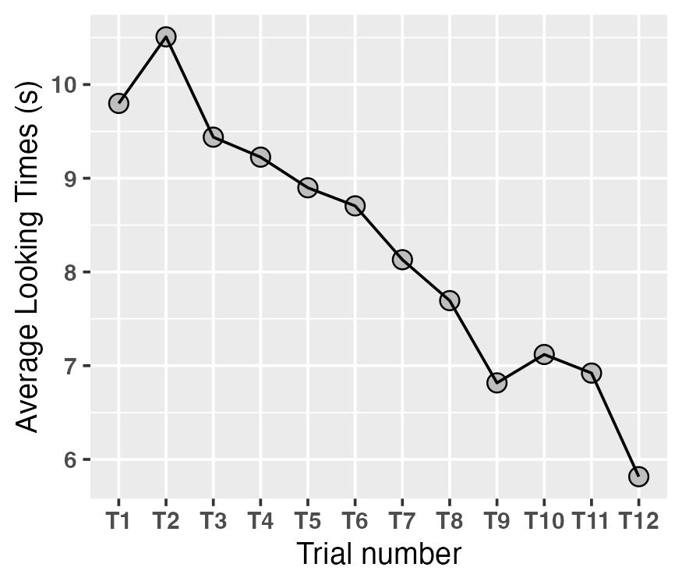

Supplement S5
Two separate mixed-effects models on LTs to the different trial types were conducted in the exploratory analyses presented here. Model 1 was calculated over all data. LT was the dependent variable. Trial type (3-level factor: harmonic [+ATR +ATR], harmonic [-ATR -ATR], and a non-harmony type that pooled [-ATR +ATR] and [+ATR -ATR]) coded using a successive difference orthogonal contrast ([-ATR +ATR, +ATR -ATR] vs. [+ATR +ATR]: 1/3, -2/3; [-ATR -ATR] vs. [-ATR +ATR, +ATR -ATR]: 2/3, -1/3), age (centered), trial number (centered), and exposure (centered) were fixed factors. The model included interactions of trial type with all other predictors. The random structure comprised an intercept for participant and item. The variance of the random by-participant slope was estimated at zero (0); hence, it was not included in the model. As can be seen in the output (Table S5a), LTs were significantly different in the [-ATR +ATR, +ATR -ATR] vs. [+ATR +ATR] contrast but not in the [-ATR -ATR] vs. [-ATR +ATR, +ATR -ATR] contrast.

Table S5a
Output of the Statistical Model Comparing Looking Times to Non-harmonic Trials with [+ATR +ATR] and [-ATR -ATR] Trials. Dependent Variable was LTs to Harmonic and Non-harmonic Trial
Formula: LT ~ (trial type) * (exposureC + ageC + trial numberC) + (1 | id) + (1 | item)
Fixed effects | β | S SE | t | p | 95% CI
(Intercept) | 8.354 | 0.387 | 21.593 | < .0001 | 7.61, 9.10
Non-H_minus_[+ATR +ATR] | -0.926 | 0.321 | -2.880 | .004 | -1.62, -0.30
[-ATR -ATR]_minus_Non-H | 0.486 | 0.321 | 1.514 | .131 | -0.14, 1.11
Age | -0.053 | 0.114 | -0.465 | .645 | -0.27, 0.17
Trial number | -0.364 | 0.039 | -9.243 | <.0001 | -0.44, -0.29
Exposure | 0.053 | 0.315 | 0.168 | .868 | -0.56, 0.66
Non-H_minus_[+ATR +ATR]*Age | -0.049 | 0.094 | -0.525 | .60 | -0.23, 0.13
Non-H_minus_[+ATR +ATR]*Trial number | -0.105 | 0.095 | -1.106 | .269 | 0.29, 0.08
Non-H_minus_[+ATR +ATR]*Exposure | 0.223 | 0.260 | 0.859 | .391 | -0.28, 0.73
[-ATR -ATR]_minus_Non-H*Age | 0.119 | 0.094 | 1.257 | .209 | -0.07, 0.30
[-ATR -ATR]_minus_Non-H*Trial number | 0.021 | 0.091 | 0.228 | .820 | -0.15, 0.2
[-ATR -ATR]_minus_Non-H*Exposure | -0.085 | 0.264 | -0.321 | .748 | -0.60, 0.43

Model 2 specifically looked into the two harmonic trial types [-ATR -ATR] versus [+ATR +ATR] in a data subset that excluded non-harmonic trials. Again, LT was the dependent variable and trial type (this time, a 2-level factor: [-ATR -ATR] vs. [+ATR +ATR]) as fixed factor. All other predictors, their interactions, and random variables were the same as model 1. As can be seen in the output (Table S5b), we do not find a significant difference between the [+ATR +ATR] and [-ATR -ATR]. Hence, we cannot conclude, based on the current findings here, that harmony is driven by either [+ATR +ATR] or [-ATR -ATR], and we can also not conclude that a preference is obviously present for both. Future studies should investigate this further.

Table S5b
Output of the Statistical Model Comparing Looking Times to [+ATR +ATR] and [-ATR -ATR] Trials. Dependent Variable was LTs to [+ATR +ATR] and [-ATR -ATR]
Formula: LT ~ (ATR type) * (exposureC + ageC + trial numberC) + (1 | id) + (1|item).
Fixed effects | β | SE | t | p | 95% CI
(Intercept) | 8.596 | 0.391 | 22.011 | < .0001 | 7.84, 9.35
[-ATR -ATR] - [+ATR +ATR] | -0.214 | 0.192 | -1.113 | .267 | -0.59,0.16
Exposure | 0.001 | 0.318 | 0.004 | .997 | -0.61, 0.62
Age | -0.026 | 0.115 | -0.228 | .821 | -0.25, 0.20
Trial number | -0.344 | 0.054 | -6.342 | < .0001 | -0.45, -0.24
[-ATR -ATR] - [+ATR +ATR]*Exposure | 0.069 | 0.157 | 0.442 | .659 | -0.24, 0.37
[-ATR -ATR] - [+ATR +ATR]*Age | 0.033 | 0.056 | 0.596 | .552 | -0.08, 0.14
ATR type*Trialnumber | -0.043 | 0.054 | -0.790 | .430 | -0.15, 0.06

Supplement S6
To check whether the decrease of LTs over the course of the 12 trials in our experiment was a linear decrease or a non-linearly-decrease, we fit two linear models: first, a model with only trial number as a predictor (Table S6a) and second, a model with both trial number and a quadratic factor as predictors (Table S6b) to see whether the addition of the quadratic factor explains any additional variance in the model.
Table S6a
​​Output of the Statistical Model with Trial Number as the only Predictor, Showing that there is a Linear Decrease in Trial Number
Formula: lm(formula = LT ~ trial number, data = data)
Coefficients:
 | Estimate | Std. Error | t value | Pr(>|t|)
(Intercept) | 11.10069 | 0.39419 | 28.160 | < 2e-16 ***
trialn umber | -0.37960 | 0.04781 | -7.941 | 1.47e-14 ***
Note: Signif. codes: 0 ‘***’ 0.001 ‘**’ 0.01 ‘*’ 0.05 ‘.’ 0.1’’ 1
Residual standard error: 3.598 on 474 degrees of freedom
Multiple R-squared: 0.1174, Adjusted R-squared: 0.1155
F(1, 474) = 63.05, p < .0001

Table S6b
​​Output of the Statistical Model with Trial Number and a Quadratic Factor as Predictors, Showing that the Addition of a Quadratic Factor does not Explain Additional Variance in the Model.
Formula: lm(formula = LT ~ trialnumber + quadratic factor, data=data)
Coefficients:
 | Estimate | SE | t value | Pr(>|t|)
(Intercept) | 10.737445 | 0.797359 | 13.466 | < 2e-16 ***
Trial number | -0.256769 | 0.239147 | -1.074 | 0.284
Quadratic factor | -0.008187 | 0.015618 | -0.524 | 0.600
Note: Signif. codes: 0 ‘***’ 0.001 ‘**’ 0.01 ‘*’ 0.05 ‘.’ 0.1’’ 1
Residual standard error: 3.601 on 473 degrees of freedom
Multiple R-squared: 0.1179, Adjusted R-squared: 0.1142
F(2, 473) = 31.62, p < .0001

