Figure S1.
Developmental Changes in the Different Domains of Parenting Quality
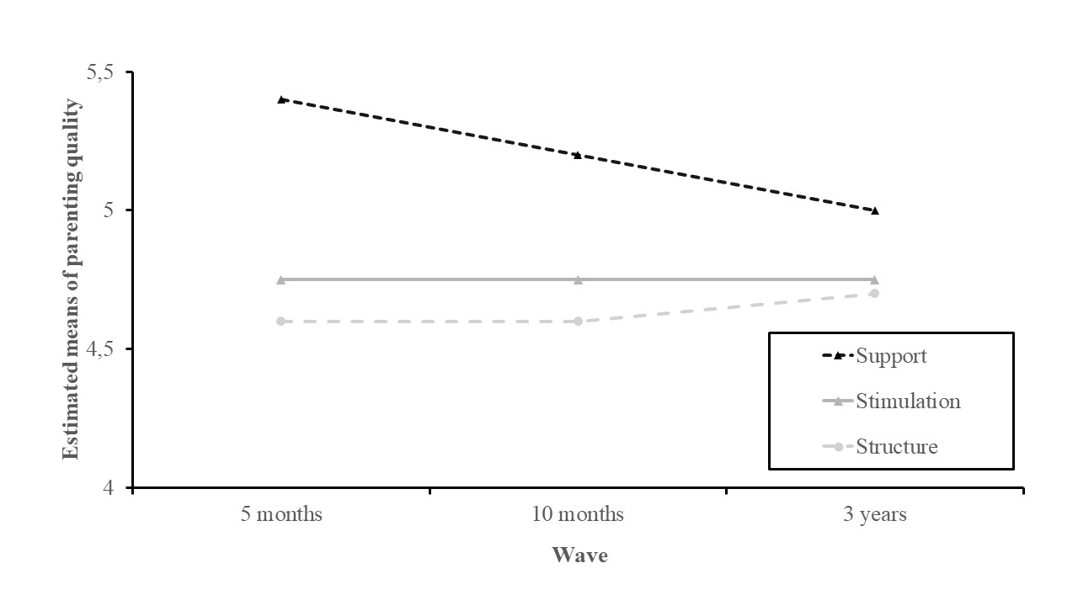

Table S1
Descriptive Statistics and Pearson Correlations for the Different Domains of Parenting Quality
 | Min | Max | M | SD | 1 | 2 | 3 | 4 | 5 | 6 | 7 | 8 | 9 | 10 | 11
1. Cumulative risk T1 | 0 | 5 | 1.11 | 1.10 | -
2. Support T2 | 1 | 7 | 5.35 | 1.15 | -.19* | -
3. Support T3 | 1 | 7 | 5.10 | 1.31 | -.09 | .26** | -
4. Support T4 | 3 | 7 | 5.08 | 1.05 | .05 | .30** | .37** | -
5. Stimulation T2 | 1 | 7 | 4.82 | 1.32 | .04 | .57** | .17* | .33** | -
6. Stimulation T3 | 1 | 7 | 4.82 | 1.31 | -.04 | .16 | .67** | .29** | .18* | -
7. Stimulation T4 | 2 | 7 | 4.81 | 1.25 | -.01 | .29** | .34** | .63** | .19* | .28** | -
8. Structure T2 | 1 | 7 | 4.74 | 1.18 | -.02 | .57** | .22** | .27** | .74** | .23** | .25** | -
9. Structure T3 | 1 | 7 | 4.69 | 1.29 | -.10 | .13 | .60** | .28** | .01 | .64** | .31** | .07 | -
10. Structure T4 | 1 | 7 | 4.87 | 1.28 | -.02 | .22** | .21* | .47** | .09 | .19** | .73** | .10 | .22* | -
11. Self-regulation T2 | 3.88 | 7.00 | 5.43 | 0.55 | -.07 | .09 | .01 | .09 | .07 | -.02 | .03 | .02 | -.10 | .01 | -
12. Self-regulation T4 | 3.46 | 6.77 | 5.19 | 0.60 | -.18* | -.05 | .07 | .08 | -.05 | .05 | .03 | -.04 | .12 | .06 | .15*
Note. *p < .05. ** p < .01

Table S2.
Model Fit Statistics for the Unconditional Growth Models of the Different Domains of Parenting Quality

 | Lineair growth models |  |  |  |  |  | Unspecified growth models
 | χ2/df | CFI | RMSEA | SRMR | AIC | BIC | χ2/df | CFI | RMSEA | SRMR | AIC | BIC
Support | 1.67 | .961 | .054 | .040 | 1679.880 | 1704.307 | 3.60 | .848 | .106 | .131 | 1683.745 | 1707.902
Stimulation | 0.06 | 1.000 | .000 | .008 | 1809.492 | 1833.649 | 0.10 | 1.000 | .000 | .029 | 1809.584 | 1833.741
Structure | 0.25 | 1.000 | .000 | .017 | 1775.614 | 1799.771 | 1.02 | .992 | .009 | .043 | 1777.151 | 1801.308
Note. For the linear growth models, variances of the observed variables of the specific domains of parenting quality at T4 were fixed to zero, due to a negative residual variance.

Table S3
Unstandardized Estimates of Intercepts and Slopes

Parameters | Estimate | SE | p
Support
Mean intercept | 5.27 | 0.07 | .000
Variance intercept | 0.42 | 0.15 | .006
Mean slope | -0.07 | 0.03 | .028
Variance slope | 0.09 | 0.02 | .000
Stimulation
Mean intercept | 4.81 | 0.08 | .000
Variance intercept | 0.33 | 0.17 | .053
Mean slope | 0.00 | 0.04 | .918
Variance slope | 0.15 | 0.03 | .000
Structure
Mean intercept | 4.71 | 0.07 | .000
Variance intercept | 0.12 | 0.14 | .425
Mean slope | 0.05 | 0.04 | .210
Variance slope | 0.16 | 0.03 | .000

Note. Estimates presented in bold refer to statistically significant estimates.

Table S4
Model Fit Indices for the Hypothesized Models
 | χ2/df | CFI | RMSEA | SRMR
Model of maternal support | 0.96 | 1.000 | .000 | .048
Model of maternal stimulation | 0.60 | 1.000 | .000 | .041
Model of maternal structure | 1.70 | .743 | .055 | .067

Note. CFI = comparative fit index, RMSEA = root mean square error of approximation, SRMR = standardized root mean square residual.

Table S5
Parameter Estimates of the Mediation Model of Support
Model parameters | B | SE | p | β | 95% CI
Direct effects
T1 cumulative risk →T4 self-regulation | -0.07 | 0.04 | .073 | -0.14 | [-0.16, 0.00]
T1 cumulative risk → initial levels support | -0.17 | 0.07 | .021 | -0.28 | [-0.31, -0.02]
T1 cumulative risk → slope support | 0.06 | 0.04 | .088 | 0.23 | [-0.01, 0.13]
T1 cumulative risk → initial levels small-worldness | -0.02 | 0.03 | .390 | -0.07 | [-0.07, 0.03]
T1 cumulative risk → slope small-worldness | 0.05 | 0.06 | .392 | 0.09 | [-0.08, 0.17]
Slope support → T4 self-regulation | 0.14 | 0.25 | .586 | 0.07 | [-0.28, 0.72]
Slope small-worldness → T4 self-regulation | -0.29 | 0.11 | .006 | -0.31 | [-0.55, -0.12]
Intercept support ↔ intercept small-worldness | 0.02 | 0.02 | .182 | 0.10 | [-0.01, 0.05]
Slope support ↔ slope small-worldness | -0.02 | 0.01 | .305 | -0.08 | [-0.04, 0.01]
Intercept support ↔ slope support | -0.01 | 0.05 | .820 | -0.06 | [-0.12, 0.08]
Intercept small-worldness ↔ slope small-worldness | -0.20 | 0.03 | .000 | -0.95 | [-0.28, -0.15]
Indirect effects
Indirect effect through slope support | 0.01 | 0.02 | .671 | 0.02 | [-0.07, 0.02]
Indirect effect through slope small-worldness | -0.02 | 0.02 | .444 | -0.03 | [-0.01, 0.07]

Note. Unstandardized Β and standardized β regression coefficients. CI = confidence interval of unstandardized regression coefficients. Variances of the observed variables of small-worldness at T2 and support at T4 were fixed to zero, due to a negative residual variance. Estimates presented in bold refer to statistically significant estimates.

Table S6
Parameter Estimates of the Mediation Model of Stimulation
Model parameters | B | SE | p | β | 95% CI
Direct effects
T1 cumulative risk →T4 self-regulation | -0.07 | 0.04 | .074 | -0.13 | [-0.16, 0.00]
T1 cumulative risk → initial levels stimulation | 0.01 | 0.08 | .908 | 0.02 | [-0.15, 0.16]
T1 cumulative risk → slope stimulation | -0.02 | 0.04 | .535 | -0.07 | [-0.10, 0.06]
T1 cumulative risk → initial levels small-worldness | -0.02 | 0.03 | .433 | -0.07 | [-0.07, 0.03]
T1 cumulative risk → slope small-worldness | 0.05 | 0.06 | .422 | 0.09 | [-0.08, 0.18]
Slope stimulation → T4 self-regulation | -0.06 | 0.20 | .756 | -0.04 | [-0.46, 0.32]
Slope small-worldness → T4 self-regulation | -0.29 | 0.11 | .007 | -0.31 | [-0.54, -0.11]
Intercept stimulation ↔ intercept small-worldness | -0.00 | 0.02 | .888 | -0.01 | [-0.04, 0.03]
Slope stimulation ↔ slope small-worldness | 0.00 | 0.02 | .842 | 0.02 | [-0.04, 0.04]
Intercept stimulation ↔ slope stimulation | -0.01 | 0.06 | .864 | -0.05 | [-0.14, 0.11]
Intercept small-worldness ↔ slope small-worldness | -0.20 | 0.03 | .000 | -0.94 | [-0.28, -0.15]
Indirect effects
Indirect effect through slope stimulation | 0.00 | 0.01 | .875 | 0.00 | [-0.12, 0.03]
Indirect effect through slope small-worldness | -0.02 | 0.02 | .466 | -0.03 | [-0.02, 0.06]

Note. Unstandardized Β and standardized β regression coefficients. CI = confidence interval of unstandardized regression coefficients. Variances of the observed variables of small-worldness at T2 and stimulation at T4 were fixed to zero, due to a negative residual variance. Estimates presented in bold refer to statistically significant estimates.

Table S7
Parameter Estimates of the Mediation Model of Structure
Model parameters | B | SE | p | β | 95% CI
Direct effects
T1 cumulative risk →T4 self-regulation | -0.07 | 0.04 | .067 | -0.13 | [-0.15, 0.00]
T1 cumulative risk → initial levels structure | -0.06 | 0.07 | .351 | -0.20 | [-0.19, 0.07]
T1 cumulative risk → slope structure | 0.00 | 0.04 | .977 | -0.00 | [-0.07, 0.07]
T1 cumulative risk → initial levels small-worldness | -0.02 | 0.03 | .463 | -0.06 | [-0.07, 0.03]
T1 cumulative risk → slope small-worldness | 0.05 | 0.06 | .453 | 0.08 | [-0.08, 0.17]
Slope structure → T4 self-regulation | -0.13 | 0.17 | .437 | -0.09 | [-0.47, 0.20]
Slope small-worldness → T4 self-regulation | -0.26 | 0.10 | .014 | -0.28 | [-0.50, -0.08]
Intercept structure ↔ intercept small-worldness | 0.00 | 0.02 | .991 | 0.00 | [-0.03, 0.03]
Slope structure ↔ slope small-worldness | 0.01 | 0.02 | .485 | 0.05 | [-0.03, 0.05]
Intercept structure ↔ slope structure | 0.01 | 0.06 | .912 | 0.05 | [-0.11, 0.12]
Intercept small-worldness ↔ slope small-worldness | -0.20 | 0.03 | .000 | -0.94 | [-0.28, -0.15]
Indirect effects
Indirect effect through slope structure | 0.00 | 0.01 | .986 | 0.00 | [-0.03, 0.03]
Indirect effect through slope small-worldness | -0.01 | 0.02 | .502 | -0.02 | [-0.11, 0.03]

Note. Unstandardized Β and standardized β regression coefficients. CI = confidence interval of unstandardized regression coefficients. Variances of the observed variables of small-worldness at T2 and structure at T4 were fixed to zero, due to a negative residual variance. Estimates presented in bold refer to statistically significant estimates.

