Time to Transfer: Long-Term Effects of a Sustained and Spiraled Content Literacy Intervention
in the Elementary Grades

Online Supplementary Materials
Table S1

Moderation Analysis by Student Characteristics on Grade 3 and 4 Domain-General Reading Comprehension and Mathematics

Table S-A.1 presents results from moderation analyses involving interactions between MORE treatment and student demographic characteristics (i.e., baseline MAP reading in Grade 1, Black or Hispanic student, English learner, and low or middle socioeconomic status [SES] neighborhoods) on reading comprehension and mathematics outcomes for Grades 3 (see Table 7 for main-effect results) and 4 (see Table 8 for main-effect results)

 | Grade 3 domain-general reading comprehension |  |  |  | Grade 3 Mathematics
 | Baseline MAP reading | Black or Hispanic | English learners | Low or mid SES (school) | Baseline MAP reading | Black or Hispanic | English learners | Low or mid SES (school)
Main MORE effect | .13 (.07)* | .21 (.07)** | .10 (.04)* | .21 (.11)* | .12 (.053)* | .11 (.05)* | .10 (.04)* | .17 (.07)**
Interaction effect | .02 (.05) | -.13 (.07) | .04 (.06) | -.12 (.11) | .00 (.04) | .01 (.06) | .07 (.04) | -.07 (.08)
N | 2,001 | 2,001 | 2,001 | 2,001 | 1,987 | 1,987 | 1,987 | 1,987

 | Grade 4 domain-general reading comprehension |  |  |  | Grade 4 Mathematics
 | Baseline MAP reading | Black or Hispanic | English learners | Low or mid SES (school) | Baseline MAP reading | Black or Hispanic | English learners | Low or mid SES (school)
Main MORE effect | .10 (.07) | .13 (.06)* | .12 (.04)** | .15 (.09) | .13 (.06)* | .15 (.05)** | .13 (.04) | .23 (.05)***
Interaction effect | -.02 (.06) | -.02 (.06) | -.002 (.06) | -.05 (.10) | -.03 (.06) | .02 (.07) | .14 (.05)** | -.09 (.08)
N | 2,025 | 2,025 | 2,025 | 2,025 | 2,020 | 2,020 | 2,020 | 2,020

Note. Models include controls for demographics, randomization block, and cubic baseline reading and mathematics scores. Standard errors were clustered at school level, the unit of randomization. The results for the domain-general reading comprehension and mathematics in Grades 3 and 4 reveal no evidence of moderation by student characteristics, suggesting that MORE was equally effective across a wide range of subgroups.
†p < .10, *p < .05, **p < .01, ***p < .001.

Table S2

Sensitivity Analysis: Intent-to-Treat (ITT) Intervention Effects on Domain-Specific Vocabulary Knowledge (Scores for Total, Taught, and Untaught Words) from Grades 1 to 3

The impact analyses presented in the main text (Table 6) utilized clustered standard errors at the school level. Below, we replicate the analysis using random effects for schools in multilevel models.

 | Grade 1 |  |  | Grade 2 |  |  | Grade 3
 | Total | Taught | Untaught | Total | Taught | Untaught | Total | Taught | Untaught
ITT Science | .34 (.06)*** | .33 (.06)*** | .23 (.06)*** | .07 (.06) | -.002 (.06) | .15 (.06)* | .14 (.05)** | .12 (.05)** | .15 (.05)**
ITT Social Studies | .63 (.06)*** | .75 (.06)*** | .25 (.05)***
Nª | 2,419 | 2,419 | 2,419 | 2,126 | 2,126 | 2,126 | 1,341 | 1,341 | 1,341

Note. The sample size was attenuated by missing data from students who did not take the vocabulary knowledge during the pandemic 2020-2021 school year. ITT models include controls for demographics, randomization block, and cubic baseline reading and mathematics scores. We include random effects for schools, the unit of randomization. Social studies vocabulary knowledge was assessed only in Grade 1.
ªN reported is for science vocabulary knowledge.
†p < .10, *p < .05, **p < .01, ***p < .001.

Table S3

Sensitivity Analysis: Intent-to-Treat (ITT) and Treatment-on-the-Treated (TOT) Intervention Effects on Grade 3 Domain-Specific Reading Comprehension, Grades 3 and 4 Domain-General Reading Comprehension, and Grades 3 and 4 Mathematics Outcomes

The impact analyses presented in the main text (Tables 7 and 8) utilized clustered standard errors at the school level. Here, we replicate the analysis using random effects for schools for both the ITT and 2SLS models in multilevel models.

 | Grade 3 Domain-specific reading comprehension |  |  |  | Grade 3 Domain-general reading comprehension | Grade 3 Mathematics
Source | Total | Near-transfer passage | Mid-transfer passage | Far-transfer passage | Grade 3 Domain-general reading comprehension | Grade 3 Mathematics
ITT | .13 (.06)* | .11 (.05)* | .11 (.05)* | .14 (.05)** | .10 (.04)* | .10 (.04)*
2SLS | .13 (.10) | .11 (.08) | .10 (.06) | .13 (.10) | .11 (.05)* | .12 (.05)**
N | 1,292 | 1,292 | 1,261 | 1,210 | 2,001 | 1,987

Source | Grade 4 Domain-general reading comprehension | Grade 4 Mathematics
ITT | .11 (.03)** | .15 (.05)**
2SLS | .12 (.04)** | .17 (.06)**
N | 2,025 | 2,020

Note. 2SLS = two-stage least squares. ITT and 2SLS analysis models included covariates for demographics, school randomization block, and baseline MAP reading and mathematics scores.
†p < .10, *p < .05, **p < .01, ***p < .001.

Table S-A.4

Sensitivity Analysis: Intent-to-Treat (ITT) Intervention Effects on a Reduced Sample of Domain-Specific Vocabulary Knowledge (Scores for Total, Taught, and Untaught Words) from Grades 1 to 3

The results below replicate Table 6 but limit the sample to n = 1,341 students who took the domain-specific vocabulary knowledge assessments in Grade 3 to ensure that results were not driven by non-random attrition.

 | Grade 1 |  |  | Grade 2 |  |  | Grade 3
Sources | Total | Taught | Untaught | Total | Taught | Untaught | Total | Taught | Untaught
ITT Science | .36 (.07)*** | .35 (.06)*** | .25 (.07)*** | .15 (.07)* | .09 (.07) | .19 (.06)** | .14 (.05)** | .12 (.05)* | .16 (.06)**
ITT Social Studies | .69 (.06)*** | .80 (.05)*** | .29 (.06)***
Nª | 1,225 | 1,225 | 1,225 | 1,286 | 1,286 | 1,286 | 1,341 | 1,341 | 1,341

Note. The sample size was attenuated by missing data from students who did not take the vocabulary knowledge during the pandemic 2020-2021 school year. ITT models include controls for demographics, randomization block, and cubic baseline reading and mathematics scores. Standard errors were clustered at school level, the unit of randomization. Social studies vocabulary knowledge was assessed only in Grade 1.
ªN reported is for science vocabulary knowledge.
†p < .10, *p < .05, **p < .01, ***p < .001.

Table S5

Sensitivity Analysis: Intent-to-Treat (ITT) Intervention Effects on a Reduced Sample of Domain-Specific Vocabulary Knowledge (Scores for Total, Taught, and Untaught Words) from Grades 1 to 3

The results below replicate Table 6 but limit the sample to n = 1,292 students who took the domain-specific reading comprehension assessments in Grade 3 to ensure that results were not driven by non-random attrition.

 | Grade 1 |  |  | Grade 2 |  |  | Grade 3
Sources | Total | Taught | Untaught | Total | Taught | Untaught | Total | Taught | Untaught
ITT Science | .35 (.07)*** | .35 (.06)*** | .23 (.07)*** | .13 (.07) | .07 (.07) | .18 (.06)** | .12 (.05)* | .09 (.05)* | .14 (.06)**
ITT Social Studies | .68 (.06)*** | .78 (.05)*** | .29 (.06)***
Nª | 1,181 | 1,181 | 1,181 | 1,240 | 1,240 | 1,240 | 1,278 | 1,278 | 1,278

Note. The sample size was attenuated by missing data from students who did not take the vocabulary knowledge during the pandemic 2020-2021 school year. ITT models include controls for demographics, randomization block, and cubic baseline reading and mathematics scores. Standard errors were clustered at school level, the unit of randomization. Social studies vocabulary knowledge was assessed only in Grade 1.
ªN reported is for science vocabulary knowledge.
†p < .10, *p < .05, **p < .01, ***p < .001.

Table S6

Sensitivity Analysis: Intent-to-Treat (ITT) Intervention Effects on a Reduced Sample of Domain-Specific Vocabulary Knowledge (Scores for Total, Taught, and Untaught Words) from Grades 1 to 3

The results below replicate Table S-A.4 but limit the sample to n = 1,341 students who took the domain-specific vocabulary knowledge assessments in Grade 3 to ensure that results were not driven by non-random attrition. Clustered standard errors at the school level were used. Here, we replicate the analysis using random effects for schools for both the ITT and 2SLS models.

 | Grade 1 |  |  | Grade 2 |  |  | Grade 3
Sources | Total | Taught | Untaught | Total | Taught | Untaught | Total | Taught | Untaught
ITT Science | .36 (.07)*** | .35 (.06)*** | .25 (.07)*** | .15 (.07)* | .09 (.07) | .19 (.06)** | .14 (.05)** | .12 (.05)* | .16 (.06)**
ITT Social Studies | .69 (.06)*** | .80 (.05)*** | .29 (.06)***
Nª | 1,225 | 1,225 | 1,225 | 1,286 | 1,286 | 1,286 | 1,341 | 1,341 | 1,341

Note. The sample size was attenuated by missing data from students who did not take the vocabulary knowledge during the pandemic 2020-2021 school year. ITT models include controls for demographics, randomization block, and cubic baseline reading and mathematics scores. Social studies vocabulary knowledge was assessed only in Grade 1.
ªN reported is for science vocabulary knowledge.
†p < .10, *p < .05, **p < .01, ***p < .001.

Table S7

Sensitivity Analysis: Intent-to-Treat (ITT) and Treatment-on-the-Treated (TOT) Intervention Effects on Grade 3 Domain-Specific Reading Comprehension, Grades 3 and 4 Domain-General Reading Comprehension, and Grades 3 and 4 Mathematics Outcomes

The results below replicate Table S5 but limit the sample to the sample of n = 1,292 students who took the domain-specific reading comprehension assessments in Grade 3 to ensure that results were not driven by non-random attrition using random effects for schools for both the ITT and 2SLS models.

 | Grade 3 Domain-specific reading comprehension |  |  |  | Grade 3 Domain-general reading comprehension | Grade 3 Mathematics
Source | Total | Near-transfer passage | Mid-transfer passage | Far-transfer passage | Grade 3 Domain-general reading comprehension | Grade 3 Mathematics
ITT | .14 (.06)* | .11 (.06) | .11 (.06)* | .14 (.06)** | .10 (.06) | .09 (.06)
2SLS | .14 (.07)* | .12 (.06) | .11 (.06) | .14 (.06) | .11 (.06) | .10 (.06)
N | 1,292 | 1,292 | 1,259 | 1,208 | 1,195 | 1,186

Source | Grade 4 Domain-general reading comprehension | Grade 4 Mathematics
ITT | .10 (.05)* | .14 (.06)*
2SLS | .11 (.05)* | .14 (.06)*
N | 1,157 | 1,155

Note. 2SLS = two-stage least squares. ITT and 2SLS analysis models included covariates for demographics, school randomization block, and baseline MAP reading and mathematics scores.
†p < .10, *p < .05, **p < .01, ***p < .001.

Table S8

Sensitivity Analysis: Intent-to-Treat (ITT) Effects on Alternative Standardized Reading and Mathematics Assessments (Measure of Academic Progress, MAP) in Grade 3

 | G3 MAP Reading | G3 MAP Mathematics
ITT | .07 (.034)* | .083 (.032)**
N | 2,065 | 2,082
Note. ITT models included covariates for demographics, school randomization block, and baseline MAP reading and mathematics scores.
†p < .10, *p < .05, **p < .01, ***p < .001.

Figure S1

Results of Logistic Regression on College and Career Ready (CCR) Predicted Probability of Exceeding CCR Standard for G4 Domain-General Reading Comprehension and Mathematics

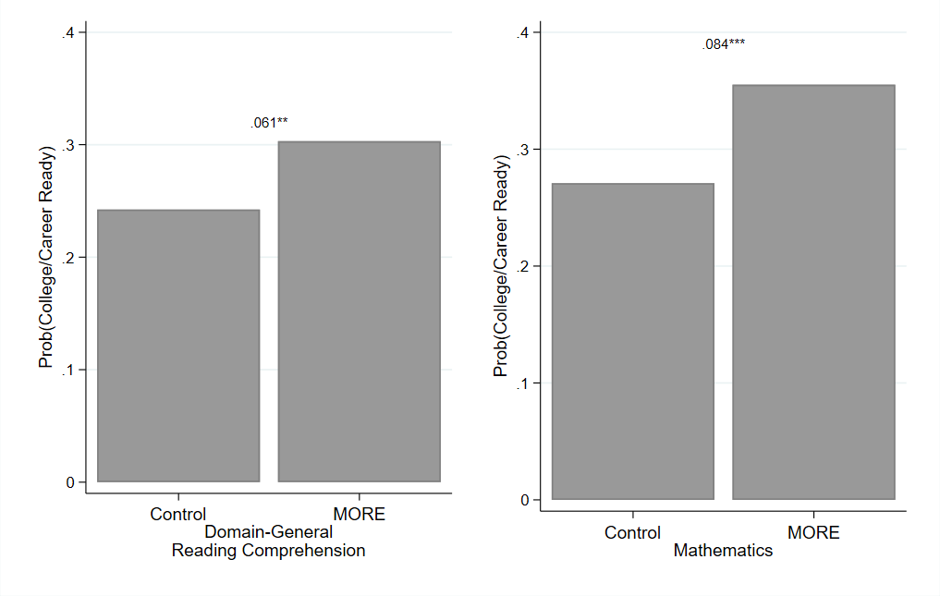
Note. Marginal probability differences derived from a logistic regression model with clustered standard errors at the school level. The marginal probabilities are 24.2% (Control) and 30.3% (Treatment) in Reading, and 27.1% (control) and 35.5% (treatment) in math.

Results of Cost Analysis: Description of Methods for Calculating Program Costs and Cost-Effectiveness

We assess the per pupil annual costs to determine the feasibility of scaling MORE beyond the study site. Using the ingredients method (Lewin & McEwan, 2001), we identified the resources needed to implement MORE for a single year (e.g., personnel, materials, equipment). To date, very few scholars who have conducted RCTs of elementary grade content literacy interventions generate cost analyses, thus making it difficult to determine the scalability and cost-effectiveness of existing programs. Our analysis describes the money and time needed to implement a sustained and spiraled content literacy intervention. Such cost analyses are critical to understanding the feasibility of scaling interventions. To calculate MORE’s cost, the research team compiled all expenses for the project and identified and aggregated the costs into key areas: personnel, materials/equipment, etc. In addition, after the completion of the intervention, the authors also collected compensation data on district personnel to reflect more accurately what the program would cost the district.
We used the E$timator© website developed by Teachers College (Hollands et al., 2015) to calculate our cost per student. E$timator© has several advantages over simply identifying the ingredients and their associated value for the project. First, since our experiment took place over three years, E$timator© calculates the present-day value of future expenses, taking into account the fact that expenses in the future will be less burdensome than in the current years. For example, if we know that we need to incur $1,000 worth of expenses two years from now, we could invest the money in a bank account and earn interest, making it worth more in the second year than the $1,000 we have today. Since interest rates were at historic lows during the period of intervention, we utilized a relatively low discount rate of 1%. We also explored other rates to understand how it would affect the calculations and the changes were relatively small. Second, E$timator© adjusts the costs for inflation using the CPI-U and translates them into 2019 dollars (the first year of our intervention). Third, E$timator© also takes geographical differences in cost into account and ensures that the prices are nationally representative. For example, as personnel in our context were hired in both Massachusetts and other states, the program will adjust the personnel costs to better reflect the national average. Having estimated the cost of the intervention ingredients, we then leverage the number of students that were served during the program to calculate a cost per student. We also break these costs down by personnel, materials/equipment, books, and other types of expense categories.
Several assumptions in our cost estimate should be highlighted. First, our intervention took place during the school day as part of the district’s regular scope and sequence. As such, we have not added the facilities cost to the school. Second, in each year of program implementation, we hired teachers and literacy facilitators (i.e., school coaches) to support implementation. Teachers were required to complete 3 hours of professional development, attend a 1-hour meeting with the grade-level team, and provide 1 hour of general administrative tasks related to the program. Facilitators attended a 3-hour training, attended or led six hours of meetings, and were also allocated about an hour of administrative tasks. In the years after the intervention, we’ve worked with the district to institutionalize compensation for these costs and have used the hourly rate for teachers/facilitators and adjusted them to the national averages. These costs were included as personnel charges in our cost assessment. Third, the research staff prepared for and helped facilitate interaction with district leadership, other central office personnel (e.g., specialists, area superintendents), literacy facilitators, and teachers. The research staff also had the primary responsibility for printing and shipping formative assessments and materials, for example. As such we included the staff time and travel costs associated with these ingredients of the program. Finally, as noted in the main paper, during the 2020-21 school year, we decided to offer MORE to all 3rd grade students in the study schools. For the purposes of these cost estimates, we only include the cost of the treatment group. It is also worth noting that many pieces of the intervention structurally changed during the course of implementation. For example, in the context of COVID-19, all formative assessments were provided online during the 2020-21 school year, where the two prior years the assessments were printed and shipped and returned to the team by mail. Similarly, the iPads that are included in our cost estimates were not needed in the last year of the intervention because our web-based app operated on school computers. These changes would likely have had little effect on the intervention itself but would have resulted in significant cost reductions if introduced at the beginning of the program. As such, we view our cost estimates as conservative and it is likely that if a new district were to implement the intervention, it could be done for much less.
Results of the Costs Analysis
As shown in Table 9, in our trial we spent $411.85 per student (in 2019 dollars) using nationally representative prices. These estimates represent what it would cost to implement MORE as it was in 2018-19 through 2020-21. The cost-effectiveness of MORE is comparable to other literacy interventions that have measured cost (Kim et al., 2016; Jacob et al., 2015; Gray et al., 2022). We believe these costs are an upper estimate of the potential future cost given innovations and changes to the program that happened in the third and final year of the intervention that will continue in future implementation. For example, the largest proportion of the cost is related to Non-Teacher/Coach Personnel. However, much of these costs were reduced in the final year as a significant portion of personnel time in prior years was spent printing, shipping, and organizing lesson materials and formative assessments that are now all online.
Results of Cost Effectiveness Analysis
MORE is relatively low in cost when compared to other interventions with similar effect sizes. We estimate a cost of the intervention of $411.85 per student (in 2019 US dollars) including personnel, books, computer & technology (e.g., iPads), travel (e.g., site visits, and convening for participants), and other miscellaneous expenses. The closest comparison we can find to MORE is Zoology One, an integrated science and literacy program for kindergarten. Program expenses were similar at $480 per student. Given the age of the children, effects were assessed for more constrained skills like passage comprehension and letter naming fluency, ranging from 0.16 to 0.28 standard deviations (Gray et al., 2022) There are at least two other studies related to literacy that also analyzed cost. A cost analysis of Project READS, a summer book program that provided free books and paper activities for elementary school students, found that program expenses were relatively low (between $250-$480 per student) for the observed ITT effects of 0.04 standard deviations (Kim et al., 2016). Similarly, Reading Partners, a program that uses volunteers to provide one-on-one tutoring to struggling readers in elementary school, found effects of 0.10 standard deviations for costs between $480-$1,270 per student (Jacob et al., 2015). Finally, a more general meta-analysis on school spending across grade levels, focus areas, and context found that increasing spending by $1,000 per pupil for four years improved test scores by 0.03 standard deviations (Jackson & Mackevicius, 2023). Thus, MORE is comparatively similar or more cost-effective than other evidence-based, large-scale literacy interventions, which have demonstrated long-term impacts.

Domain-Specific (Science) Reading Comprehension Passages and Psychometric Properties

A. Near Transfer Passage (Underlined Words Appear in the Academic Vocabulary Networks)

- A human is a primate. In primates, the heart sends oxygen in the blood all around the body. The body must have oxygen to function properly. The strong heart muscle contracts to pump blood all around the body. A healthy heart never rests.

- But what happens when a person’s heart gets weaker? People with weak hearts need help. Scientists have to study a medical mystery. Then they might be able to help people.

- First, scientists need to diagnose the reasons that a human heart gets weak. They need to do tests. But sometimes it would be hard on a sick person to have tests done. So, scientists study animals that have body systems like humans. Scientists knew that the macaque monkey’s heart is similar to the human heart. So, they did tests with macaque monkeys. The scientists learned what happens when a monkey has a heart attack. After a heart attack, the monkey’s heart muscle has scar tissue where it was damaged. The scar tissue cannot contract like a strong heart muscle can. Then the monkey’s heart cannot pump enough blood to give the body the oxygen it needs. Without enough oxygen, the monkey’s body cannot function properly.

- Second, scientists wanted to try out new solutions that would keep the heart working. Sometimes the new solutions might fail. So, scientists didn’t want to try the solutions with people right away. They tried a solution with macaque monkeys.

- Scientists developed an idea. Then, they tested an idea. They injected human stem cells from the human heart into the monkey’s heart. After four weeks the human heart cells grew where the monkey’s scar tissue was. After three months, the monkey’s heart got stronger.

- Now scientists are using what they found in this experiment to help humans who have had heart attacks.

Text statistics:
Lexile® Measure: 610L – 800L
Mean Sentence Length: 10.07
Mean Log Word Frequency: 3.50
Word Count: 299

B. Mid Transfer Passage (Underlined Words Appear in the Academic Vocabulary Networks)

- Some birds that are here today are smaller than they were many years ago. Why is this happening? It is a mystery. How do scientists study a mystery?

- First, scientists try to understand the bird’s skeletal and muscular systems. Those systems help birds to fly. One thing scientists know is that birds’ bones are hollow inside. So, they don’t weigh much. Birds’ skeletons weigh less than their feathers. They have also learned that a bird wing works like a human arm. Birds contract their chest muscles to make their wings flap.

- Second, scientists try to diagnose the reasons that the birds’ bodies might have changed over time. Some scientists thought that birds’ skeletal or muscular systems might have changed. So, they studied migratory birds in North America. Migratory birds fly long distances to warmer places for the winter.

- Third, scientists measured the physical characteristics of the birds. They measured the size of the birds’ bones. They found some of the birds’ bones were shorter than they were 40 years ago. For example, the lower leg bone of many birds is smaller.

- Fourth, scientists measured the migratory birds’ wings. They found the birds’ wings are longer than they used to be.

- Many scientists asked, “Why are the birds’ bones smaller than they used be. But their wings are longer?” They thought about the long distance the birds fly in winter. They thought that the birds’ bodies changed to adapt to the long winter flight. They would need a lot of energy for the flight. A smaller body would have smaller muscles and less fat. But smaller bones and longer wings would make flying easier.

- Over time, these characteristics of birds have become more common.

- The scientists came up with some very good ideas about why these skeletal changes might be occurring.

Text statistics:
Lexile® Measure: 610L - 800L
Mean Sentence Length: 10.00
Mean Log Word Frequency: 3.48
Word Count: 299

C. Far Transfer Passage

- In many ways, skyscrapers are like the human body. They have bones that keep it tall and strong and skin to protect the body. They have a command center that is like a brain.

- How do engineers design and build strong and smart skyscrapers? It is very challenging to build a skyscraper because there are many parts that have to work together. If one part is broken, the skyscraper will not work properly.

- First, engineers need a strong and tall frame that supports the floors and walls. This frame is like the bones of a skyscraper. The bones of a skyscraper are made of concrete, steel and other materials. The columns are like the backbone of a human body. The columns go up. The steel columns hold up each floor. There are also steel beams that go across each floor. The steel columns and beams must be strong to resist the force of gravity. The steel columns and beams must work together to form a strong backbone.

- Second, engineers need to design a command center. The command center is a computer that sends signals through wires in a skyscraper. For example, it sends signals to help bring fresh air into rooms, just like your lungs. The command center also controls the heating and air conditioning. It helps the building cool down when it’s too hot and warm up when it’s too cold.

- A skyscraper has many different parts that work together. The bones make the building tall and strong. The skin protects the inside of the building. The skin of a skyscraper can be made of metal, stone, or glass. The brain controls the building temperature.

- The anatomy of a skyscraper is like a human body. All the parts have to work together. That's how a city skyscraper works properly.

Text statistics:
Lexile® Measure: 610L – 800L
Mean Sentence Length: 10.71
Mean Log Word Frequency: 3.61
Word Count: 300

Psychometric Properties of the Grade 3 Content Comprehension and Vocabulary Assessments

- Descriptive Statistics for Item Properties based on a 2PL Model

Test | type | mean | min | max | SD
Content Comp. | Diff | 0.34 | -0.64 | 4.65 | 1.06
Content Comp. | Disc | 1.09 | 0.23 | 1.79 | 0.4
Vocab | Diff | -0.16 | -1.38 | 4.12 | 1.2
Vocab | Disc | 1.36 | 0.4 | 3.22 | 0.63

- 2PL Item Characteristic Curves

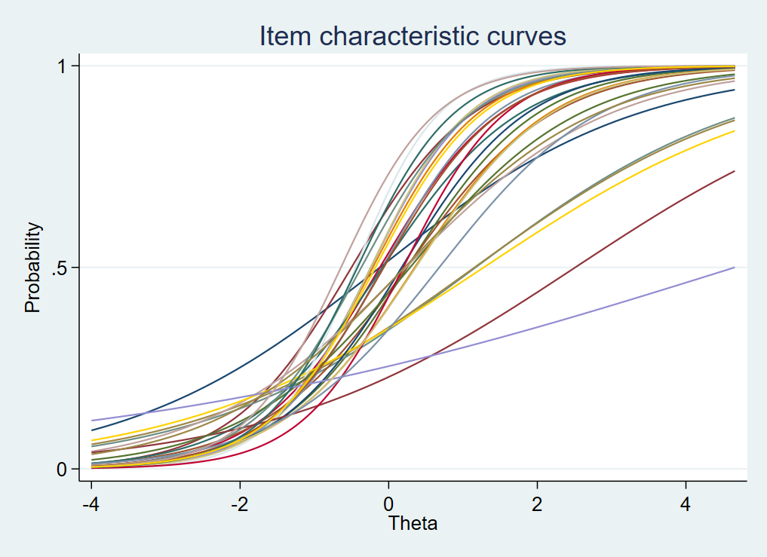

item | Disc. | Diff.
1 | 0.58 | -0.12
2 | 1.23 | -0.5
3 | 1.15 | 0.25
4 | 1.42 | -0.21
5 | 0.55 | 1.16
6 | 1.24 | -0.12
7 | 1.49 | -0.24
8 | 1.53 | -0.24
9 | 1.03 | 0.24
10 | 1.33 | -0.08
11 | 1.09 | -0.08
12 | 0.53 | 1.15
13 | 0.73 | 0.23
14 | 0.49 | 1.27
15 | 1.79 | -0.45
16 | 1.2 | 0.17
17 | 0.49 | 2.49
18 | 0.88 | 0.28
19 | 1.12 | 0.35
20 | 1.36 | -0.37
21 | 1.47 | 0.2
22 | 0.23 | 4.65
23 | 1.11 | 0.36
24 | 1.28 | -0.07
25 | 0.93 | 0.68
26 | 1.55 | -0.42
27 | 0.78 | 0.22
28 | 1.57 | -0.64
29 | 1.4 | -0.18

G3 Vocabulary

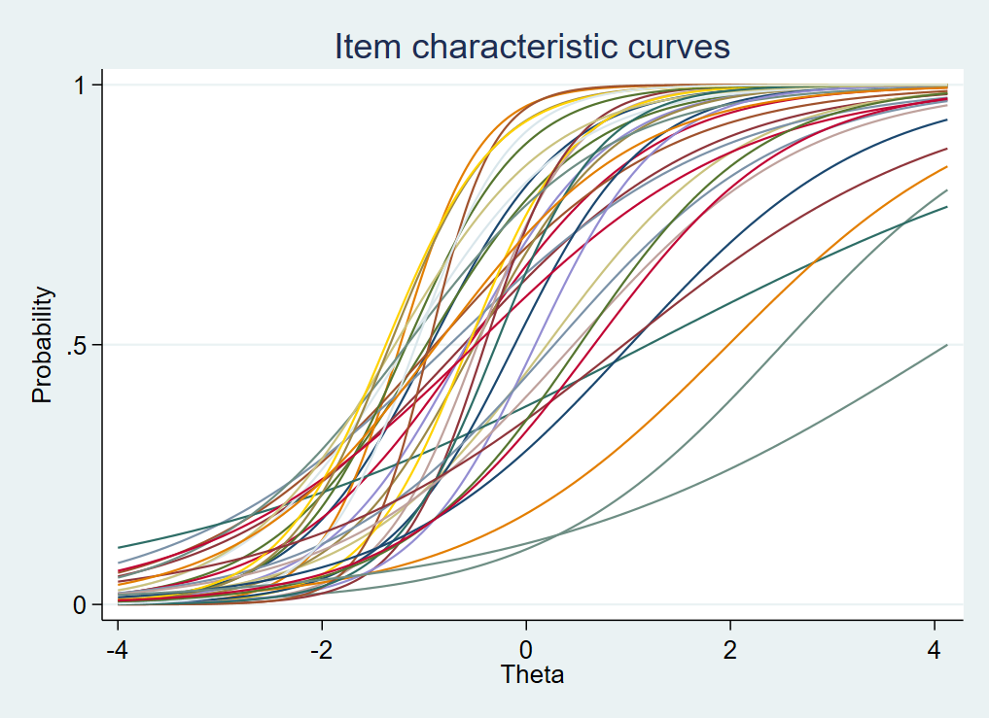

item | Disc. | Int.
1 | 1.53 | -0.93
2 | 0.85 | -0.61
3 | 1.29 | -0.98
4 | 2.56 | -1.23
5 | 0.85 | 2.51
6 | 1.12 | -0.56
7 | 1.44 | -0.59
8 | 1.05 | 0.2
9 | 0.88 | -0.9
10 | 0.75 | -0.76
11 | 0.4 | 1.2
12 | 1.47 | -0.5
13 | 2.08 | -0.48
14 | 1.95 | -0.56
15 | 1.26 | -1.17
16 | 1.57 | -0.11
17 | 2.4 | -0.4
18 | 1.76 | -1.17
19 | 0.78 | 1.99
20 | 1.03 | -1.17
21 | 0.76 | -0.5
22 | 1.65 | 0.08
23 | 1.32 | -1.29
24 | 3.22 | -0.95
25 | 0.89 | 0.27
26 | 1.95 | -0.3
27 | 1.96 | -1.33
28 | 0.87 | 0.46
29 | 1.88 | -1.38
30 | 2.15 | -1.08
31 | 0.85 | 1.02
32 | 0.62 | 0.95
33 | 1.14 | 0.53
34 | 1.04 | -0.88
35 | 0.49 | 4.12
36 | 1.04 | 0.66

- Test Information Functions
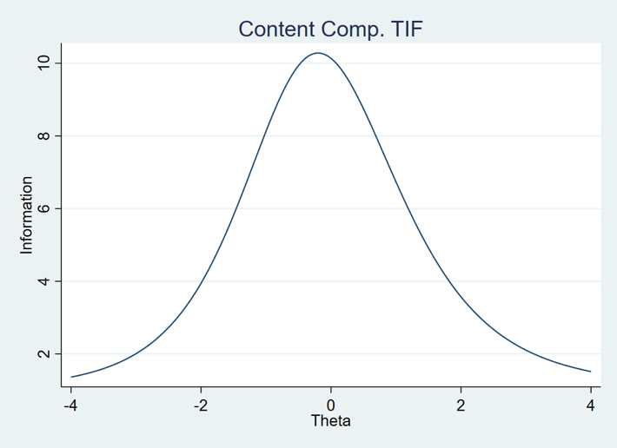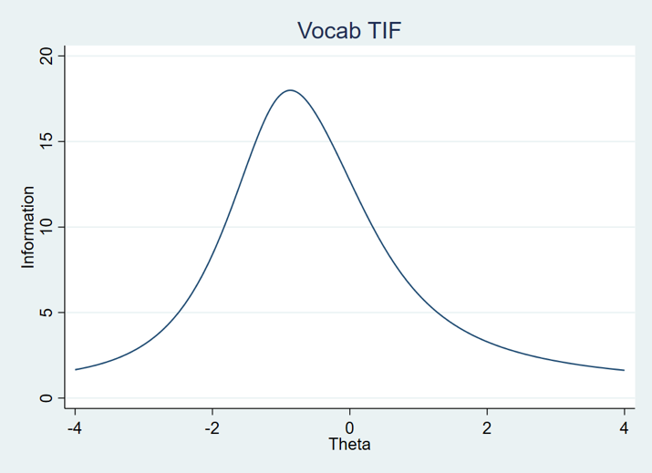
- EFA Scree Plots

Content Comprehension Vocabulary
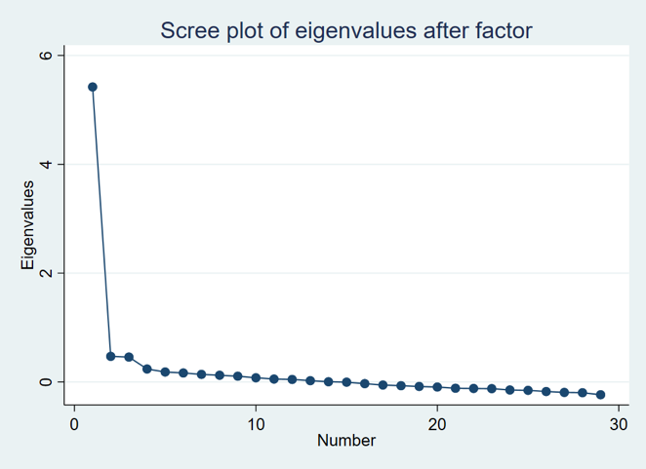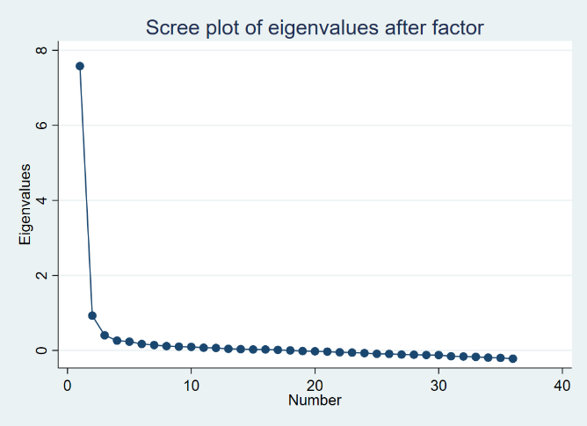

- CFA Fit Statistics
Content Comprehension: RMSEA = 0.03, CFI = 0.922, TLI = 0.916, SRMR = 0.032
Vocabulary: RMSEA = 0.031, CFI = 0.921, TLI = 0.916, SRMR = 0.034
- Correlations between 2PL Theta Estimates and Sum Scores used in the analysis
Content Comprehension: 0.945
Vocab: 0.967

Sample Automated Concept Network for the Word “systems”

The following automated concept map was developed for the word “systems.” As noted in purple, the concept “body systems” appears in the adjacent neighborhood to system, as does “organ,” an untaught word, but one that connects the systems (skeletal, muscular, nervous) that were the focus of the Grade 3 MORE lessons.

