***Excluding mask wearers.*** The same pattern of results was observed when the analyses included only the 71 children who did not wear a mask The most supported omnibus model included all three main effects and interactions of rehearsal type and list length as well as rehearsal type at age (BF10 > 20 million); the most supported model for fixed rehearsal included only list length (BF10 = 11); the most supported model for cumulative rehearsal included only a main effect of age (BF10 = 8); however, this model was favored only 1.1:1 over a model additionally including list length as outlined in the primary analysis.

***Age as a continuous variable.*** The pattern is also replicated when assessed using age as a continuous variable within Bayesian linear models (BayesFactor package in RStudio). All Bayes Factors reported below are relative to a null model containing participant level intercepts.

The same omnibus model -- main effects of age in months, rehearsal type, list length, and interactions of rehearsal type and list length as well as rehearsal type and age in months (BF = 1.6 x 10^17) by a factor of 9 billion to one.

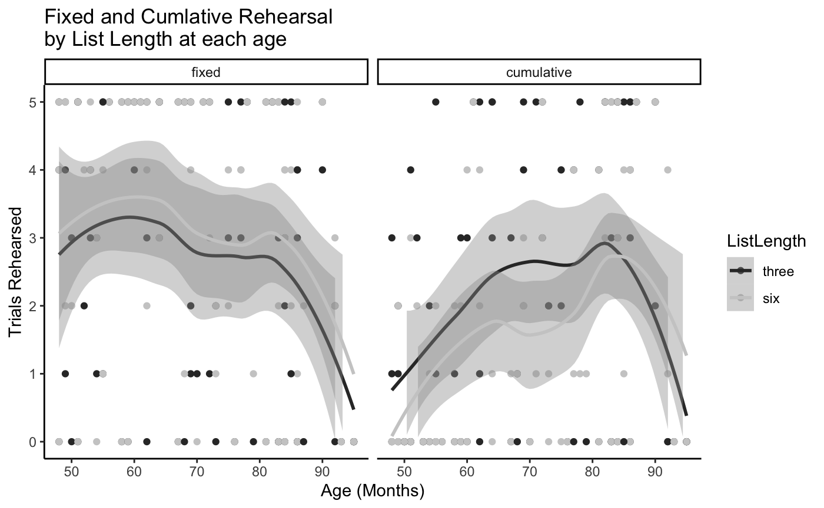

The pattern for fixed rehearsal is less conclusive when age is included as a continuous variable than when age was discrete. The model including main effects of both age in months and List Length (BF=39) is slightly preferred to the model including only List Length (BF=26). However, this effect appears to be driven by the two oldest participants (Figure S1, left) as this slight preference switches to favor the model including only List Length (BF=27) over the model additionally including age in months (BF=19) when those participants are removed.

In contrast, the pattern for cumulative rehearsal holds when age is treated continuously. The model including the main effects of both age in months and List Length (BF=9)is preferred to the model including only List Length (BF=1.6) and removing the two oldest participants only increases support for including both age and list length (BF = 94) over the model with list length alone (BF = 1.6)