Supplementary Materials

S1. Face stimuli
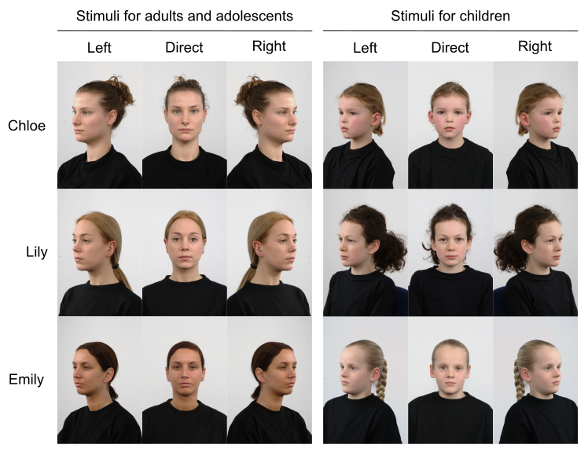
Figure S1-1. Faces used to represent confederates in the social manipulation. Photos reproduced from the Radboud Faces Database (Langner et al., 2010).

S2. Instructions for participants
S2.1. Tetris Task
S2.1.1. General instructions
Welcome to the Tetris Game!
In this game you will see a Tetris slot marked with an arrow and two blocks, like in this picture. You will need to choose which block to fit in the Tetris slot marked with an arrow. But be careful: you can't turn the blocks around, they should fit as they are.
You will play three rounds with other players, and in each round you will score points in a different way. We will tell you more about this at the start of each round.
For now let's practice how to choose a block!
If you want to choose the block on the left hand side, press the left arrow key.
If you want to choose the block on the right hand side, press the down arrow key.
S2.1.2. Cool condition
In this round you will play with Chloe/Emily/Lily.
Both of you will now take turns at playing separate Tetris games. In this round you will score points every time you choose a block: choose the block that you like!
S2.1.3. Hot-positive condition
In this round you will play with Chloe/Emily/Lily.
Both of you will now take turns at playing the Tetris game together. In this round you will score points when you help each other build the Tetris: choose the block that fits in the Tetris slot!
S2.1.4. Hot-negative condition
In this round you will play with Chloe/Emily/Lily.
Both of you will now take turns at playing the Tetris game against each other. In this round you will score points when you block or disrupt the other to build the Tetris, and you will lose points when the other disrupts you: choose the block that does NOT fit in the Tetris slot!
S2.1.5. Questionnaire
Likeability: “How much did you like Chloe/Emily/Lily? (use your mouse to indicate your answer, we won't let her know how you rated her)”
Excitement: “How exciting was the game with Chloe/Emily/Lily? (use your mouse to indicate your answer, we won't let her know how you rated her)”
Interest: “How interesting was the game with Chloe/Emily/Lily? (use your mouse to indicate your answer, we won't let her know how you rated her)”
Response: requires a mouse click on the Likert scale shown below.
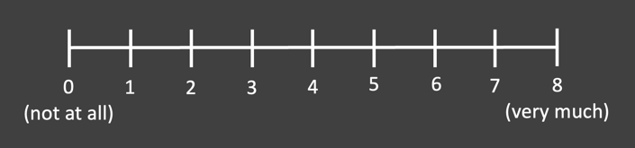
Figure S2-1. Likert scale used in the questionnaire after each Tetris Task round.
S2.2. Stop Signal Task
Welcome to the Faces Game!
In this game, you will see a face of another player. These faces are just an example.
If the face looks towards the left hand side, press the left arrow key.
If the face looks towards the right hand side, press the down arrow key.
Sometimes, the face will change and look at you after looking to the left or right side.
If you see the face changes and looks at you do not press any of the buttons!

S3. Exclusion of participants based on the SSRT exclusion criteria
Table S3-1. Participants excluded in each group based on the SSRT exclusion criteria
Group | SSRT exclusion criteria
Group | Mean SSRT < 0 | Correct go responses < 50% | Both
Children | 0 | 16 | 2
Adolescents | 1 | 5 | 4
Adults | 1 | 15 | 2

S4. Age distribution
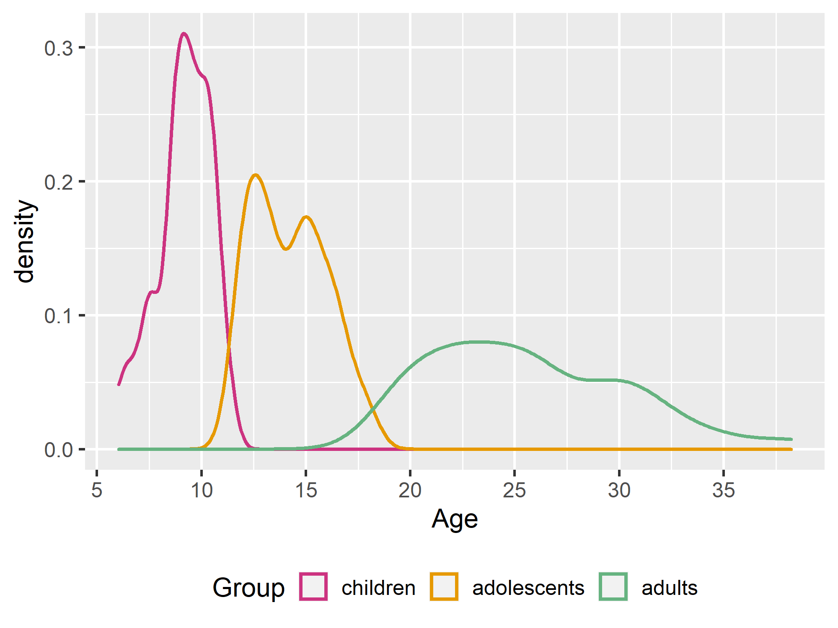
Figure S4-1. Distribution of age.

S5. Correlations between inhibitory control measures and age
We tested whether mu, sigma and tau are associated with age for each age group and condition. There was only a significant negative correlation between tau and age for the adolescent group in the negative condition (r = -.46, p = .043); all other correlations were non-significant (all p > .2). This result thus indicates that as adolescents get older, the degree and variability of occasional extremely slow responses decreases in the hot-negative condition. This finding is particularly interesting, as the main analysis (testing the effects of age group and condition) shows that in the hot-negative condition adults show a greater degree and variability of occasional extremely slow responses compared to adolescents, so we would have expected that over the course of adolescence tau would increase into adulthood levels. Future studies with bigger sample sizes could look into subgroups within adolescence and adulthood for a more fine-grained evaluation of how task performance and intra-individual variability measures change throughout development.
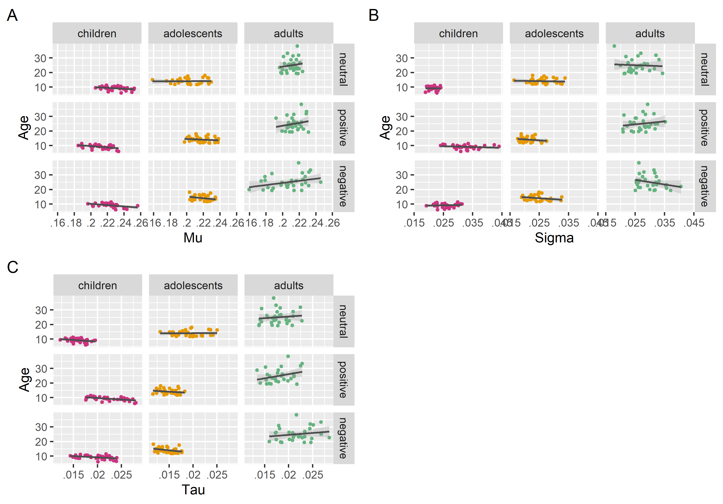
Figure S5-1. Correlation plots between inhibitory control measures and age, for each age group and condition. A) Mu and age. B) Sigma and age. C) Tau and age.

S6. Descriptives for measures
Table S6-1. Descriptives for manipulation checks and Tetris
performance for Tetris Task analysis sample: estimated
marginal mean (standard error).
- Likeability
Group | Condition
Group | Neutral | Positive | Negative
Children | 4.71 (.345) | 5.35 (.345) | 4.73 (.345)
Adolescents | 3.91 (.335) | 4.95 (.335) | 3.07 (.335)
Adults | 5.32 (.335) | 5.79 (.335) | 3.84 (.335)
- Interest
Group | Condition
Group | Neutral | Positive | Negative
Children | 3.93 (.384) | 4.31 (.380) | 3.81 (.384)
Adolescents | 1.93 (.370) | 2.23 (.370) | 1.50 (.370)
Adults | 3.49 (.370) | 3.70 (.370) | 3.45 (.370)
- Excitement
Group | Condition
Group | Neutral | Positive | Negative
Children | 4.26 (.390) | 4.63 (.390) | 4.44 (.390)
Adolescents | 2.37 (.380) | 2.13 (.380) | 1.61 (.380)
Adults | 3.39 (.380) | 3.55 (.380) | 3.32 (.380)
- Tetris performance
Group | Condition
Group | Neutral | Positive | Negative
Children | .856 (.032) | .867 (.032) | .778 (.032)
Adolescents | .853 (.031) | .905 (.031) | .795 (.031)
Adults | .900 (.031) | .937 (.031) | .863 (.031)
- Belief that confederates in Tetris Task were real
Group | (a single rating for all conditions)
Children | 3.24 (.312)
Adolescents | .815 (.304)
Adults | .958 (.304)

Table S6-2. Descriptives for inhibition measures for Stop
Signal Task analysis sample: estimated marginal mean (standard
error)
- Mu
Group | Condition
Group | Neutral | Positive | Negative
Children | .227 (.003) | .206 (.002) | .216 (.003)
Adolescents | .203 (.003) | .219 (.002) | .218 (.003)
Adults | .211 (.003) | .214 (.002) | .203 (.003)
- Sigma
Group | Condition
Group | Neutral | Positive | Negative
Children | .021 (.001) | .031 (.001) | .024 (.001)
Adolescents | .026 (.001) | .022 (.001) | .024 (.001)
Adults | .026 (.001) | .027 (.001) | .030 (.001)
- Tau
Group | Condition
Group | Neutral | Positive | Negative
Children | .015 (.001) | .021 (.000) | .018 (.000)
Adolescents | .019 (.001) | .015 (.000) | .014 (.000)
Adults | .018 (.001) | .018 (.000) | .021 (.000)

Table S6-3. Descriptives for additional inhibition measures for
Stop Signal Task analysis sample: mean (standard error)
- Probability of correct stop response
Group | Condition
Group | Neutral | Positive | Negative
Children | .597 (.007) | .589 (.009) | .597 (.012)
Adolescents | .593 (.011) | .568 (.012) | .577 (.010)
Adults | .587 (.013) | .582 (.011) | .597 (.012)
- Probability of correct go response
Group | Condition
Group | Neutral | Positive | Negative
Children | .757 (.031) | .762 (.028) | .763 (.024)
Adolescents | .814 (.025) | .853 (.019) | .819 (.018)
Adults | .842 (.017) | .827 (.028) | .864 (.022)
- Number of incorrect go trials (out of 60)
Group | Condition
Group | Neutral | Positive | Negative
Children | 18.56 (2.00) | 18.67 (1.72) | 18.72 (1.51)
Adolescents | 13.79 (1.54) | 11.89 (1.09) | 13.03 (.939)
Adults | 10.25 (.997) | 11.00 (1.69) | 9.00 (1.24)

S7. Analysis on mean go reaction time for first and second half of the Stop Signal Task
To test for habituation effects to the facial stimuli, we used the mean reaction time of correct go trials (meanGoRT) as a proxy of how facial stimuli is processed over the course of the Stop Signal Task. We extracted the reaction time of all correct go trials and computed the meanGoRT across the first 40 trials (first half) and across the second 40 trials (second half) of the Stop Signal Task. Using the same statistical analyses procedure as described in the Methods section, we fitted a linear mixed model with meanGoRT as dependent variable, Group (children, adolescents, adults) as between-subject factor, Condition (neutral, positive, negative) and Half (first, second) as within-subject factors, and proportion of correct go responses as covariate. Post-hoc pairwise comparisons using Bonferroni's adjustment were computed. There was a main effect of Group (F(2,59.3) = 4.94, p = .010), where adults were slower than adolescents (t(62.6) = 34.7, p = .01) (Figure S7-1). However, no other main effects or interactions were significant. The proportion of correct go responses was a significant covariate (F(1,344.8) = 88.9, p < .001). These findings show that there is no difference in meanGoRT between first and second half of the task, suggesting that there was no habituation to the socio-affective nature of the facial stimuli during the Stop Signal Task. Future studies with higher number of trials will be needed to test if this is also true for inhibition measures.
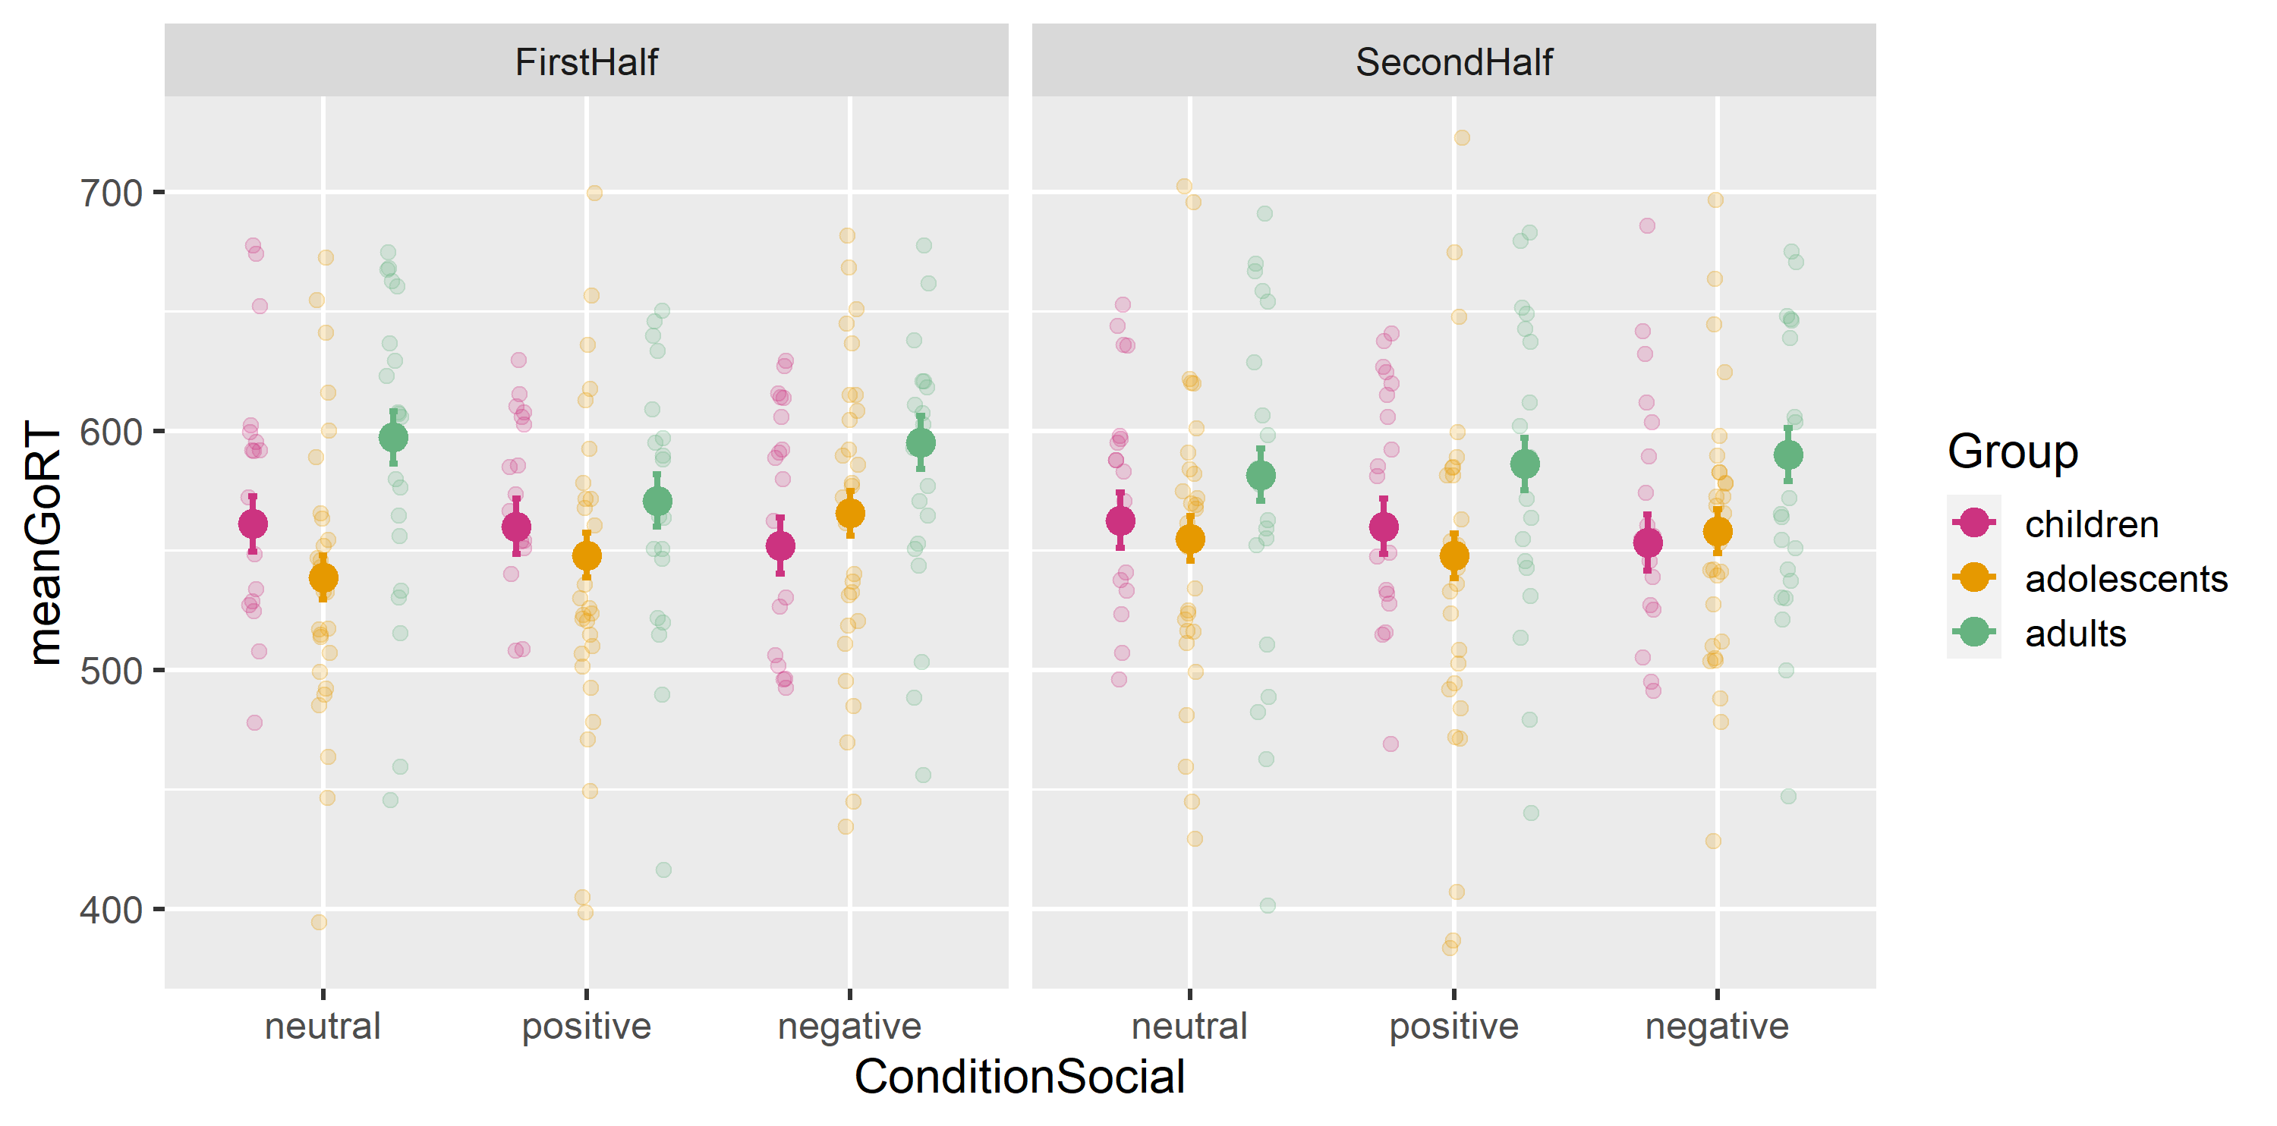
Figure S7-1. Plots for meanGoRT in first half (left panel) and second half (right panel) of the Stop Signal Task: estimated marginal mean (filled circle), SE (error bars), raw datapoints (shaded circles).

S8. Correlation between inhibition success and Go reaction times
To test if participants with higher inhibition success are strategically waiting for the stop signal, extracted measures of inhibition success (i.e. probability of stopping when the stop signal is presented) and mean reaction time in go trials (i.e. mu derived from the ex-Gaussian distribution in Go trials). Using the same statistical analyses procedure as described in the Methods section, we run a Pearson correlation between these measures across all participants. There was a positive correlation between both measures, where participants with greater inhibition success showed higher mu Go RT (i.e. took longer to respond in Go trials) (r = .61, p < .001; Figure S8-1). In the context of the Stop Signal Task, such slowing of go responses can be interpreted as a form of proactive control, where participants learn to strategically slow down go responses in order to increase the probability of correctly Stopping (Verbruggen & Logan, 2008). Importantly, this does not indicate that participants are not performing the Stop Signal Task well, as theoretical and experimental accounts suggest that successful inhibitory control depends upon the implementation of both proactive control strategies (i.e. the preparation of the stopping response, internally generated before any stop signal is presented) and reactive control strategies (i.e. the stopping response, externally generated by the stop signal and typically measured with the SSRT) (Aron, 2011; Braver, 2012).
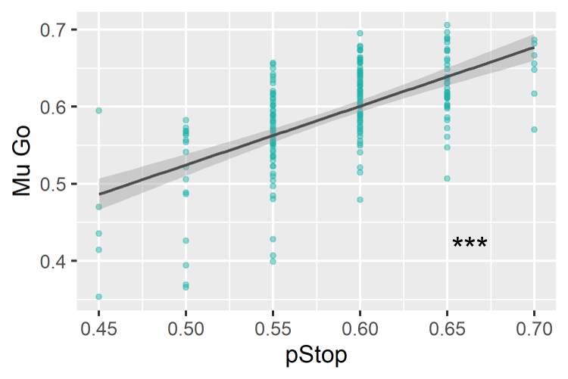
Figure S8-1. Correlation plots between inhibition success (pStop) and mean reaction time in Go trials (Mu Go). Asterisks signify difference at p < 0.05 (*), p < 0.01 (**) and p < 0.001 (***).

