Supplementary material
Children’s knowledge judgement when faced with surprising information
Descriptive data indicated that 5-year-olds responded slightly different than the three other age groups to the Knowledge question. Thus, as a follow-up, we re-ran the main analysis excluding 5-year-olds, finding that a linear regression with children’s average Knowledge score as the dependent variable and Condition as the main predictor revealed a significant main effect, F(1,107) = 5.32, p = .023, R² = .047, β = .218, [0.02, 0.21]. In line with our initial prediction, 4-, 6-, and 7-year-old children are more likely to say that the protagonist has insufficient knowledge when no supporting information is provided (M = 0.24, SE = 0.04), compared to when it is provided (M = 0.13, SE = 0.03). Further post hoc analyses revealed that the response pattern observed among 5-year-olds is primarily driven by their responses to the weight trials (Trials 1 and 4), in which they, contrary to the rest of the children, appear more, and not less, likely to say that the protagonist has insufficient information in the supported condition (M = 0.21, SE = 0.08) compared to no support condition (M = 0.12, SE = 0.07). For trials related to the object’s density or tactile properties (Trials 2 and 3) their responses were in the similar direction as the other age groups, with 5-year-olds being less likely to say that the protagonist has insufficient information in the supported condition (M = 0.14, SE = 0.06) compared to no support condition (M = 0.18, SE = 0.07).
In a set of planned control analyses, we assessed the possible impact of the order of response options (Order: 0 = ‘Knows’ before ‘Does not know’, 1 = ‘Does not know’ before ‘Knows’), child gender (Gender: 0 = Female, 1 = Male), average parental education (Education: 0 = Less than BA degree, 1 = BA degree or higher) and average household income (Income: 0 = Less than population median, 1 = Higher than population median) by introducing these predictors as a preliminary steps in the main model described above. This revealed no main effect of Order, F(1,138) = 0.67, p = .414, R² = .005, β = -.070, [-0.12, 0.05], no effect of Gender, F(1,138) = 0.01, p = .925, R² < .001, β = .008, [-0.08, 0.09], no effect of Education, F(1,135) = 0.01, p = .956, R² < .001, β = .005, [-0.13, 0.14], and no effect of Income, F(1,131) = 1.39, p = .241, R² = .010, β = -.102, [-0.14, 0.04]. Furthermore, in neither of the control analyses did the introduction of these potential predictors affect the original model (data not shown)—Condition remained a non-significant predictor of children’s knowledge assessment.

Children’s decision to select an object in line with an informant’s surprising claim
To investigate children’s object selection across all trials (i.e., including their response to the fourth trial after the Justification question), a linear regression was run with children’s average selection score across all four trials introduced as the dependent variable and Condition introduced as the first predictor. This revealed no significant effect of condition, F(1,134) = 2.00, p = .160, R² = .015, β = .121, [-0.04, 0.22]. There was also no effect of Age, F^{Δ}(1,133) = 2.63, p = .107, R^{2Δ} = .019, β = .138, [-0.12, 0.12], or any Condition BY Age interaction, F^{Δ}(1,132) = 0.57, p = .453, R^{2Δ} = .004, β = -.088, [-0.18, 0.08].
Exploring the potential impact of trial topic, and re-running the main regression model above with children’s Selection score from the two weight trials together indicated no effect of Condition, F(1,129) = 0.65, p = .420, R² = .005, β = .071, [-0.09, 0.22], Age, F^{Δ}(1,128) = 0.02, p = .968, R^{2Δ} < .001, β = -.004, [-0.08, 0.08], or Condition BY Age interaction term, F^{Δ}(1,127) = 0.97, p = .326, R^{2Δ} = .008, β = -.119, [-0.24, 0.08].
In a set of planned control analyses, we assessed the possible impact of Order, Gender, Education, and Income by introducing these predictors as a preliminary steps in the main model described above. This revealed no main effect of Order, F(1,134) = 0.26, p = .871, R² < .001, β = .014, [-0.13, 0.15], Gender, F(1,134) = 0.13, p = .718, R² = .001, β = .031, [-0.12, 0.17], Education, F(1,131) = 3.00, p = .086, R² = .022, β = -.150, [-0.40, 0.03], or Income, F(1,127) = 2.84, p = .094, R² = .022, β = -.148, [-0.26, 0.02]. In neither of the control analyses did the introduction of these potential predictors affect the original model (data not shown)—Age always remained a significant predictor of children’s Selection score.
Analyzing whether children’s responses changed over the course of the experiment, the main model was re-run as a set of generalized linear mixed model regressions using the glmer function of the lme4 package in R, including Trial as a fixed factor and Participant as a random factor (nested). The estimation method was maximum likelihood (the default for the glmer function). As specified in Table 1 below, all models introduced children’s Selection score as the dependent variable and Participant as nested random effects. The fixed effects of Trial, Condition, Age, and the Condition BY Age interaction term were added one by one in each model, with all variables being mean-centered, before model comparisons were run using the anova function in the lme4 package using the likelihood ratio test.
The first model (M1) included the random effects of Participant as well as the fixed effects of Trial. This model was intended to capture the independent effect of Trial while controlling for participant variation and avoiding pseudo replication. As can be seen in Table 2, M1 revealed no significant effect of Trial and the second model (M2) revealed no significant effect of Condition when this was included as a second fixed effect. There was no Trial by Condition interaction (data not shown). Model 3 (M3) included the fixed effect of Age to M2 but indicated no change in children’s choice of object. Finally, model 4 (M4) included the Condition BY Age interaction term to M3 and revealed no significant interaction effect. In sum, there was no effect of Trial on children’s decision to select a given object. Controlling for Trial did however result in the originally observed Age effect becoming not statistically significant. Table 3 shows a comparison of the four models, indicating no significant improvement in model fit.

Table 1. Model formulas for the different model specifications, using Participant as random effects and specifying the distribution as binomial.
Model | Formula
M1 | glmer(Select ~ Trial + (1|Participant))
M2 | glmer(Select ~ Trial + Condition + (1|Participant))
M3 | glmer(Select ~ Trial + Condition + Age + (1|Participant))
M4 | glmer(Select ~ Trial + Condition * Age + (1|Participant))

Table 2. Fixed effect of parameter estimates (β) and with standard errors in parentheses (SE) across the four models. Wald z-test was used to compute z- and p-values.
Model | M1 |  |  | M2 |  |  | M3 |  |  | M4
 | b(SE) | z | p | b(SE) | z | p | b(SE) | z | p | b(SE) | z | p
Intercept | 0.22 (0.21) | 1.09 | .275 | 0.23 (0.20) | 1.14 | .257 | 0.25 (0.21) | 1.19 | .232 | 0.25 (0.20) | 1.23 | .217
Trial | 0.12 (0.12) | 1.02 | .306 | 0.12 (0.12) | 1.01 | .314 | 0.13 (0.13) | 0.99 | .324 | 0.12 (0.12) | 1.02 | .307
Condition |  |  |  | 0.29 (0.20) | 1.44 | .150 | 0.27 (0.21) | 1.32 | .188 | 0.27 (0.20) | 1.32 | .187
Age |  |  |  |  |  |  | 0.34 (0.21) | 1.60 | .109 | 0.33 (0.20) | 1.61 | .108
Condition BY Age |  |  |  |  |  |  |  |  |  | -0.08 (0.20) | -0.42 | .676

Table 3. Model comparison of the four models. Note that the Akaike Information Criterion (AIC) and the Bayesian Information Criterion (BIC) is smallest for models with better fit, while the Log Likelihood (logLik) estimate is increased with increased model fit.
 | Df | AIC | BIC | logLik | Chisq | Chi Df | p
M1 | 453 | 569.28 | 581.65 | -281.64
M2 | 452 | 569.26 | 585.75 | -280.63 | 2.02 | 1 | .155
M3 | 451 | 568.62 | 589.23 | -279.31 | 2.64 | 1 | .104
M4 | 450 | 570.47 | 595.21 | -279.24 | 0.15 | 1 | .699

Children’s reasoning about why an informant’s surprising claim may lend more or less sufficient information for the protagonist to solve their task
In a set of planned control analyses, we assessed the possible impact of Order, Gender, Education, and Income by introducing these predictors as a preliminary steps in the main model with Reasoning (0 = Belief, 1 = Skepticism) as the dependent variable. This revealed no main effect of Order, F(1,67) = 0.31, p = .581, R² = .005, β = .068, [-0.189, 0.31], meaning that there was no difference in children’s responses based on whether they were presented with a claim about small/big rocks or bottles. Children never heard a claim about an object’s density or tactile information as the final claim, so this was not relevant to assess. There also no significant effect of Gender, F(1,67) = 3.38, p = .071, R² = .048, β = .219, [-0.02, 0.46], or Education, F(1,66) = 0.32, p = .571, R² = .005, β = -.070, [-0.49, 0.27].
There was however an effect of Income, F(1,65) = 5.88, p = .018, R² = .083, β = -.288, [-0.52, -0.05], with children from households with higher income being less likely to express skepticism toward the claim (Belief: N = 22, 61.11%; Skepticism: N = 14, 38.89%) than children from households with lower income (Belief: N = 10, 32.25%; Skepticism: N = 21, 67.74%) (see Figure 1). Post hoc chi-square tests of children’s responses within the two income brackets indicated that children from households with lower income were more likely to express skepticism rather than belief when the claim was left unsupported (Belief: N = 5; Skepticism: N = 13), and showed less difference when the claim was supported (Belief: N = 5; Skepticism: N = 8), although this difference in response patterns was not statistically significant, X²(1,31) = 0.39, p = .530. On the other hand, children from households with higher income were more likely to express belief rather than skepticism when then claim was supported (Belief: N = 16; Skepticism: N = 6), but displayed similar levels of belief and disbelief when the claim was left unsupported (Belief: N = 6; Skepticism: N = 8), although again this was not statistically significant, X²(1,36) = 3.21, p = .073.
Controlling for Order, Gender, Education, and Income as a preliminary step in the original model with Reasoning as the dependent variable and Condition, Age, and the Condition BY Age interaction term introduced as independent variables revealed that both Condition and Age remained significant predictors of child reasoning (p = .054 and p = .010, respectively).

Figure 1. Illustration of children’s inclination to express belief in (blue) versus skepticism toward (orange) the informant’s claim when asked the Justification question on the fourth and final trial, relative to parental Income. Numbers inside the bars reflect the number of children providing a given response, proportions are presented on the Y-axis.

Parental questionnaire

Information about the study will be distributed through childcare centers across the country, as well as through social media channels. Parents interested in participating in the study will be asked to click on the link provided on the information sheet, in order to proceed to the consent form in which they are asked to provide contact details (e-mail and phone), and to select a timeslot for which they will be available for participation. One weak prior to their scheduled participation, parents will receive a short online questionnaire on demographic background information. This appendix describes the details of the demographic questionnaire.

Questionnaire on background information:
- Please fill in your contact details (this will only be used to provide you with further information about the study):
  - Phone:
  - E-mail:

- Child birth date

- Child gender
  - Female
  - Male
  - Other

- Is the child enrolled in a childcare center or school?
  - Childcare
  - School
  - Neither
  - Follow-up with open response: And if so, at what level?

- Select the municipality of the child’s home:
  - Agder
  - Innlandet
  - Møre og Romsdal
  - Nordland
  - Oslo
  - Rogaland
  - Vestfold og Telemark
  - Troms of Finnmark
  - Trøndelag
  - Vestland
  - Viken

- Select the main language that the child speaks at home:
  - Norwegian
  - Other
  - Both Norwegian and Other

- Focus on the child’s two main primary caregivers (e.g., mother, father, co-parent), what language(s) does parent no.1 speak at home on a daily basis:
  - Norwegian
  - Other
  - Both Norwegian and Other

- Focus on the child’s two main primary caregivers (e.g., mother, father, co-parent), what language(s) does parent no.2 speak at home on a daily basis:
  - Norwegian
  - Other
  - Both Norwegian and Other

- If relevant, list other languages the child is exposed to on a daily basis (either at home or in childcare/school):
  - Open response

- Focus on the child’s two main primary caregivers (e.g., mother, father, co-parent), what level of education best describes parent no. 1:
  - Primary school
  - Secondary school
  - Higher education/university bachelor level
  - Higher education/university master level or higher

- Focus on the child’s two main primary caregivers (e.g., mother, father, co-parent), what level of education best describes parent no. 2:
  - Primary school
  - High school
  - Higher education/university at bachelor level
  - Higher education/university at master level or higher

- Focus on the child’s two main primary caregivers (e.g., mother, father, co-parent), what level of income best describes parent no. 1 (before taxes):
  - >200.000 NOK
  - 200.001-400.000 NOK
  - 400.001-600.000 NOK
  - 600.001-800.000 NOK
  - >800.000 NOK

- Focus on the child’s two main primary caregivers (e.g., mother, father, co-parent), what level of income best describes parent no. 2 (before taxes):
  - >200.000 NOK
  - 200.001-400.000 NOK
  - 400.001-600.000 NOK
  - 600.001-800.000 NOK
  - >800.000 NOK
Experimental procedure and manuscript

This appendix provides an overview of the testing procedures as well as a detailed protocol for the warm-up task and the main experiment.

Overall procedure
The experimenter initiates the session by providing the parent with brief task instructions. During the warm-up task, parents were asked to sit next to their child and help them understand the questions and locate the correct response buttons, if necessary. For the main experimental task, parents were encouraged to remain present but not involve themselves in the task. If the child were to refer to them for help during the task, parents were told that they could respond by highlighting how the child could respond but not what (e.g., pointing out that there were two buttons the child could choose between, but not indicating which to choose). Prior to initiating the main experiment, the experimenter presents the Warm-up task to familiarize children with the situation. Then, after four trials of the main experiment, the experimenter concludes the session.

Warm-up task
Trial 1
Experimenter introduces the task by saying: “I will now show you some pictures, and then ask you some questions. Sometimes, you will be asked to answer the question by clicking on a button. Other times, you will be asked to say what you think. Does that sound ok?” Experimenter then presents an image of a farm landscape with a range of animals, saying: “Ok, before we begin, let us look at some of the animals at this farm. Wow, there are so many!” The experimenter first asks: “Can you name some of the animals you see?”, upon which the child provides an open response.
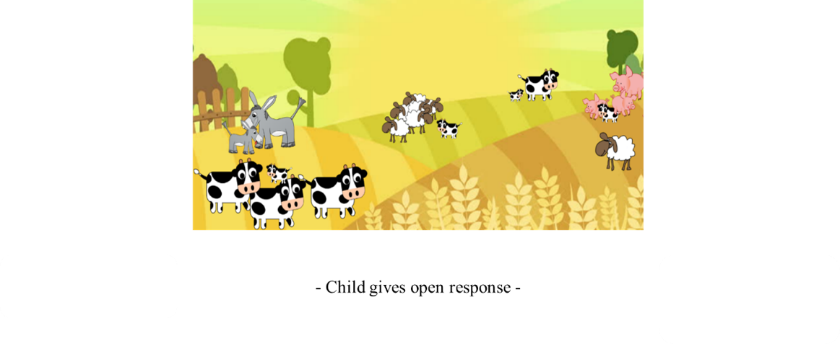
The experimenter then follows by saying: “When you look at this picture, do you see more cows than pigs? If you do, you can click on the ‘Yes’ button, but if not, you can click on the ‘No’ button.” On this trial, the correct answer is ‘Yes'.
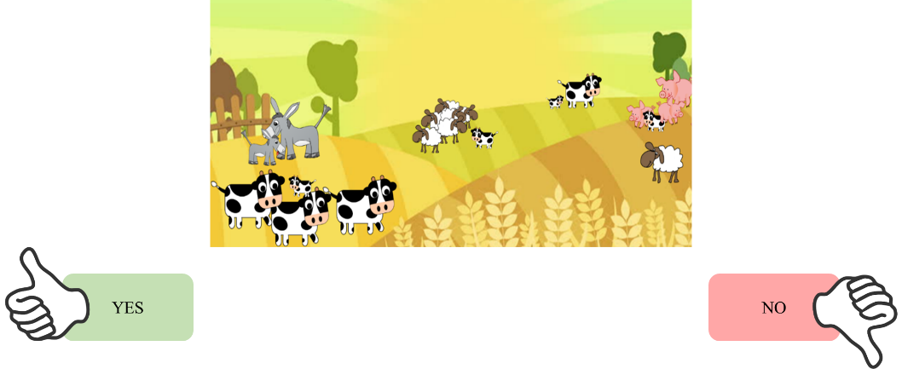

Trial 2
Experimenter presents an image of sheep with a range of colors, saying: “Ok let’s look at another picture. Wow, look at all the colors of these sheep!” The experimenter then asks: “Can you name some of the colors?”, upon which the child provides an open response.
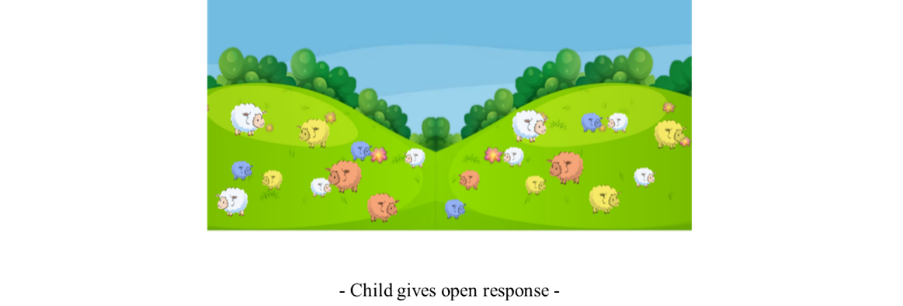
The experimenter then follows by saying: “When you look at this picture, do you see more blue sheep than white sheep?” If you do, you can click on the ‘Yes’ button, but if not, you can click on the ‘No’ button.” On this trial, the correct answer is ‘No’.
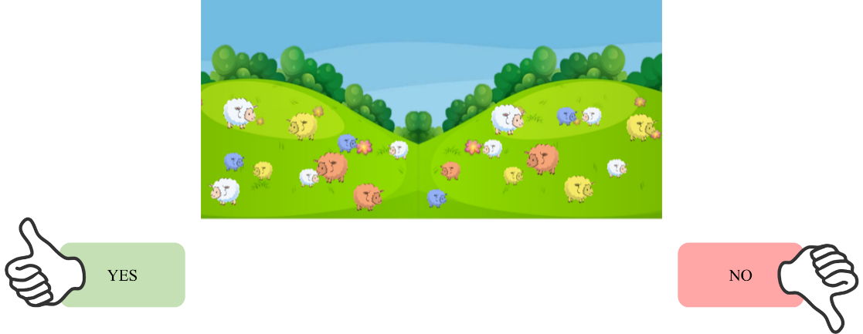
After the warm-up task, the experimenter initiates the main experiment.

Experimental procedure
In the main experiment, each child is assigned to one condition with four trials: a Supporting Information condition or a No Supporting Information condition. The trials are presented in a randomized order within each condition (see Table 1 for an overview of the different trial types). The experimenter introduces the task, by saying: “I will now show you some more pictures, and then ask you some questions. Sometimes you will be asked to answer the question by clicking on a button. Other times you will be asked to say what you think. Does that sound ok?” Once the child responds, the experiment moves on to the next trial, saying: “Ok, let us look at the next picture.” After trial 4, the experimenter concludes the session.

Table 1. Overview of the different trial types.
Trial type | Protagonist task | Adult claim | Supporting information
1. Weight – Rock | Find the heaviest object | “This small rock is much heavier than the big rock.” | “I know, because I just lifted both of them.”
2. Tactile – Shoe | Find the softest object | “This wooden shoe is much softer than the woolen shoe.” | “I know, because I just tried both of them on.”
3. Density – Button | Find the densest object | “This wooden button sinks much faster than the metal button.” | “I know, because I just dropped both of them into the bucket.”
4. Weight – Bottle | Find the heaviest object | “This small bottle is much heavier than the big and the medium bottle.” | “I know, because I just lifted both of them.”
Note. For the claim referring to tactile properties, the term ‘soft’ here refers to the object’s softness (Norwegian: ‘myk’) and not smoothness (Norwegian: ‘glatt’).

Experimental trial manuscript

Trial type 1: Weight - Rock

“This child needs to find the heaviest rock.”


“This adult points to the small rock and says: “This small rock is much heavier than the big rock.” Depending on the condition, the experimenter either provides:
- No Supporting Information: Moves on to next trial image without further information.
- Supporting Information: Continues by saying that the adult says: “I know, because I just lifted both of them.”
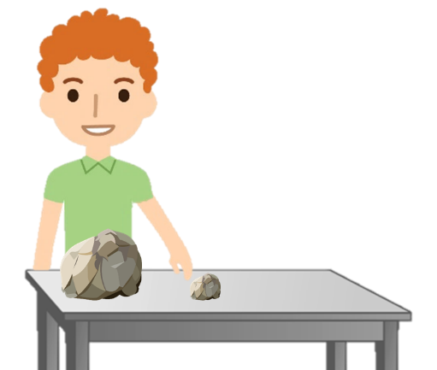

For phases 1-4 - Knowledge question:
“Now the adult had to leave, does the child know which rock to pick to get the heaviest one?”
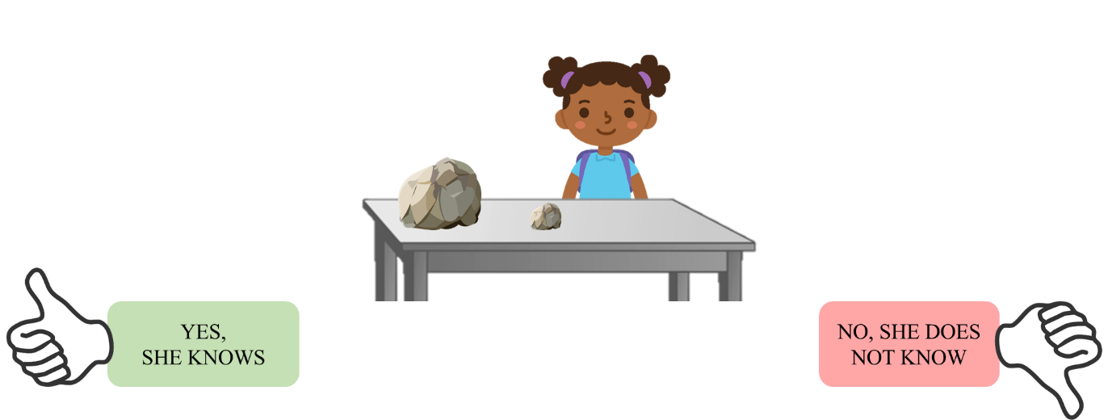

For phases 1-3 – Selection question:
- If child responds to the Knowledge question that the protagonist’s knowledge is sufficient, the experimenter continues by saying: “Which rock do you think the child will pick?”, and after the child provides a response, the experimenter moves on to the next trial by saying: “Ok, let us look at the next picture.”
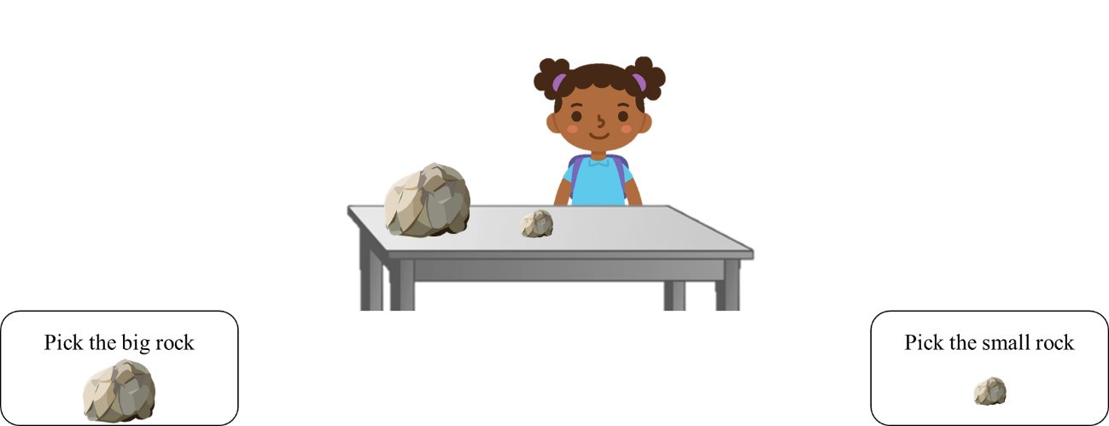

- If child responds to the Knowledge question that the protagonist’s knowledge is insufficient, the experimenter says: “Ok, let us look at the next picture.”

For phase 4 – Justification question:
The experimenter prompts the child to justify their response to the Knowledge question by asking: “Why do you think the child [repeat knowledge judgement]?”, before moving on to the Selection question.
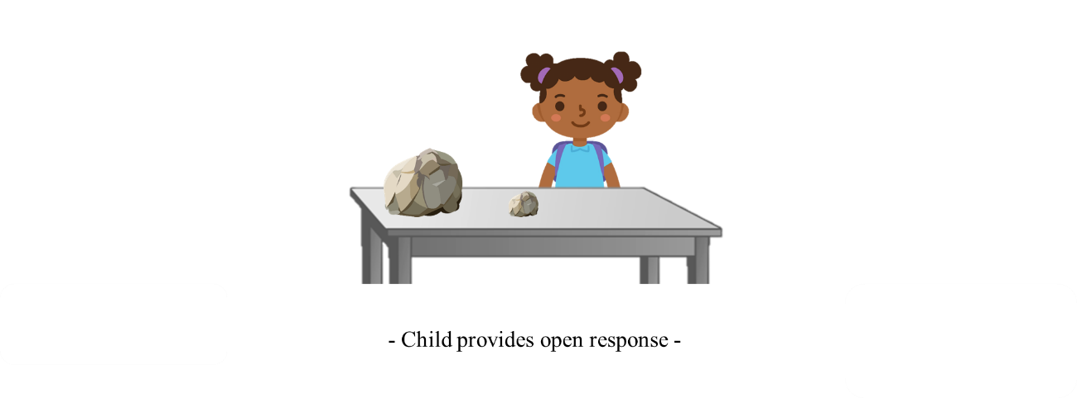

Trial-type 2: Tactile – Shoe

“This child needs to find the softest shoe.”
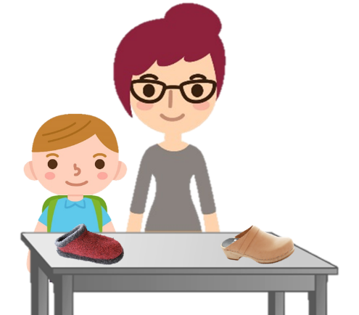

“This adult points to the wooden shoe and says: “This wooden shoe is much softer than the woolen shoe.” Depending on the condition, the experimenter either provides:
- No Supporting Information: Moves on to next trial image without further information.
- Supporting Information: Continues by saying that the adult says: “I know, because I just tried them both on.”
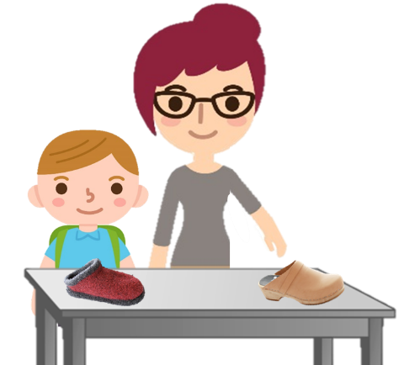

For phases 1-4 – Knowledge question:
“Now the adult had to leave, does the child know which shoe to pick to get the softest one?”
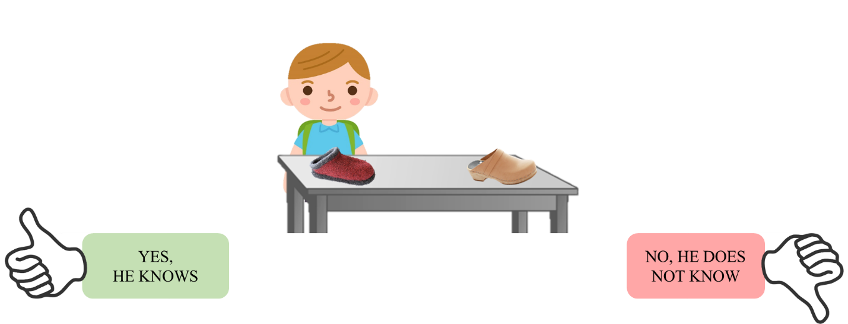

For phases 1-3 – Selection question:
- If child responds to the Knowledge question that the protagonist’s knowledge is sufficient, the experimenter continues by saying: “Which shoe do you think the child will pick?”, and after the child provides a response, the experimenter moves on to the next trial by saying: “Ok, let us look at the next picture.”
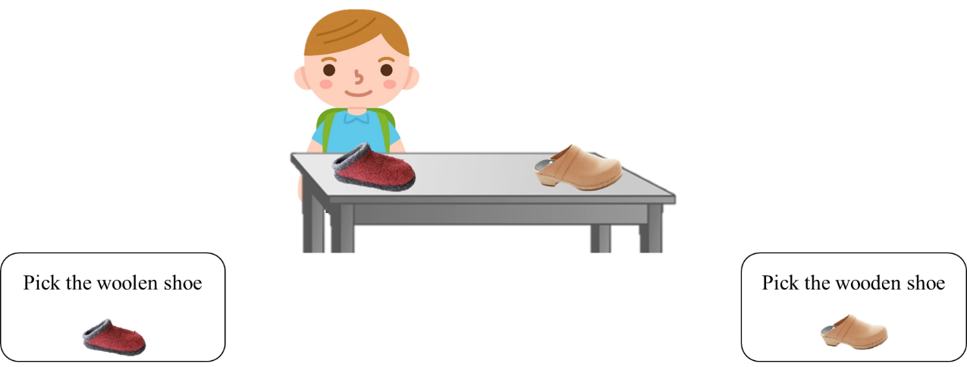
- If child responds to the Knowledge question that the protagonist’s knowledge is insufficient, the experimenter says: “Ok, let us look at the next picture.”

For phase 4 – Justification question:
The experimenter prompts the child to justify their response to the Knowledge question by asking: “Why do you think the child [repeat knowledge judgement]?”, before moving on to the Selection question.
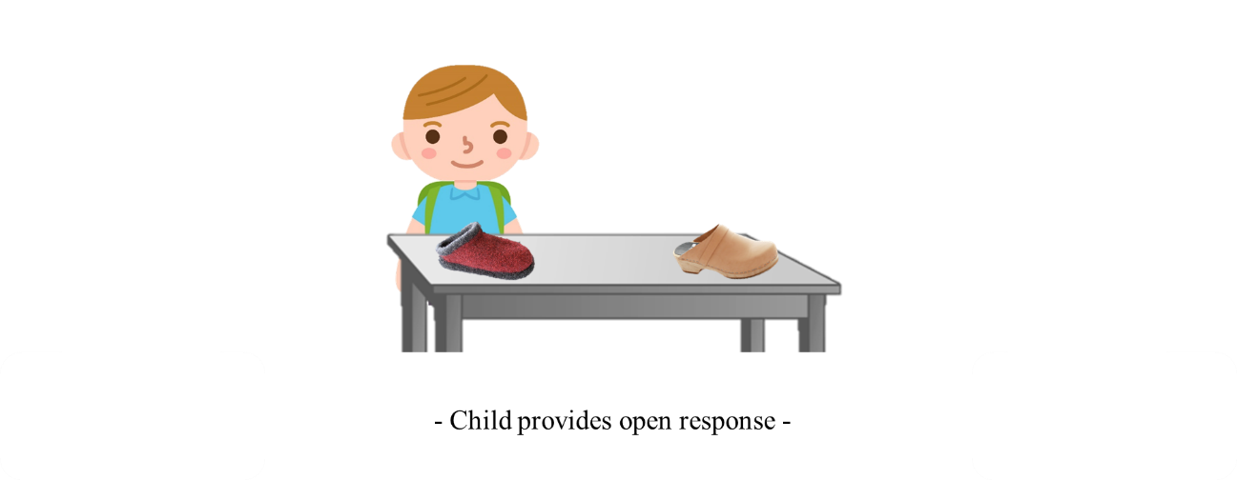
Trial-type 3: Density - Button

“This child needs to find the thing that sinks the fastest.”
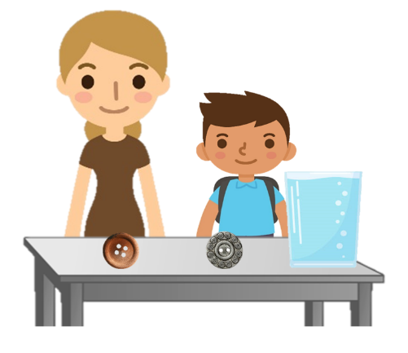
“This adult points to the wooden button and says: “This wooden button sinks much faster than the metal button.” Depending on the condition, the experimenter either provides:
- No Supporting Information: Moves on to next trial image without further information.
- Supporting Information: Continues by saying that the adult says: “I know, because I just dropped them both into the bucket.””

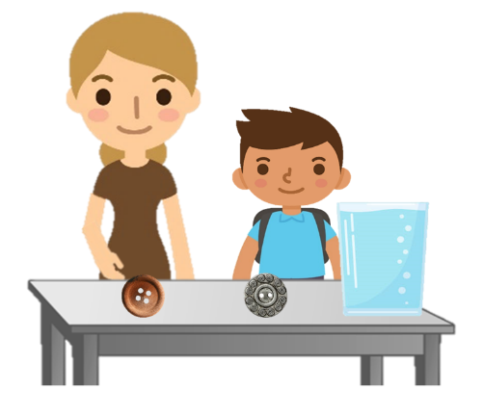
For phases 1-4 - Knowledge question:
“Now the adult had to leave, does the child know which button to pick to get the one that sinks the fastest?”
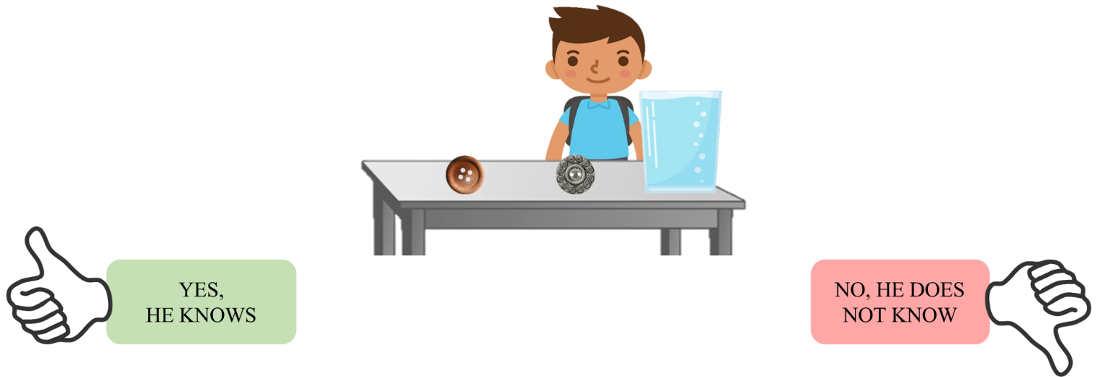

For phases 1-3 – Selection question:
- If child responds to the Knowledge question that the protagonist’s knowledge is sufficient, the experimenter continues by saying: “Which button do you think the child will pick?”, and after the child provides a response, the experimenter moves on to the next trial by saying: “Ok, let us look at the next picture.”
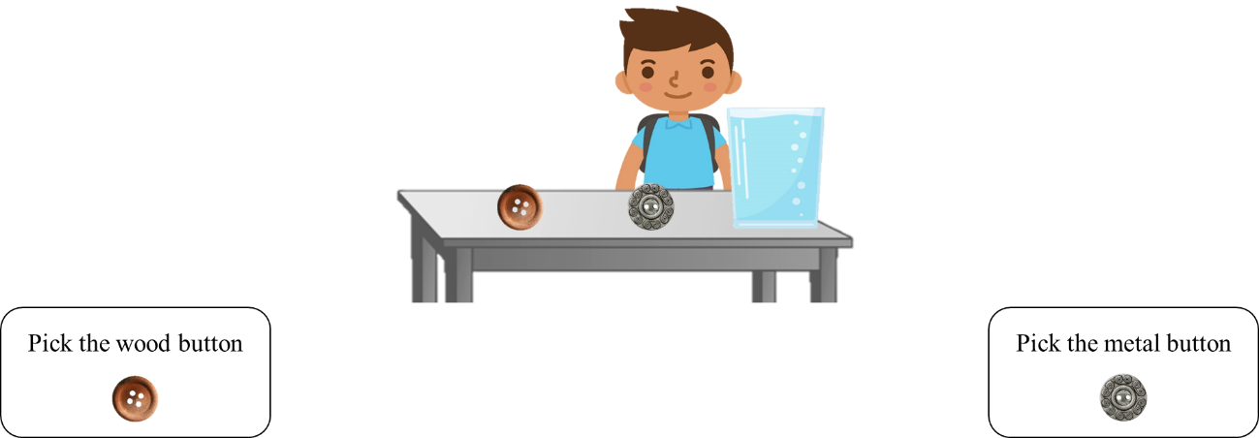

- If child responds to the Knowledge question that the protagonist’s knowledge is insufficient, the experimenter says: “Ok, let us look at the next picture.”

For phase 4 – Justification question:
The experimenter prompts the child to justify their response to the Knowledge question by asking: “Why do you think the child [repeat knowledge judgement]?”, before moving on to the Selection question.
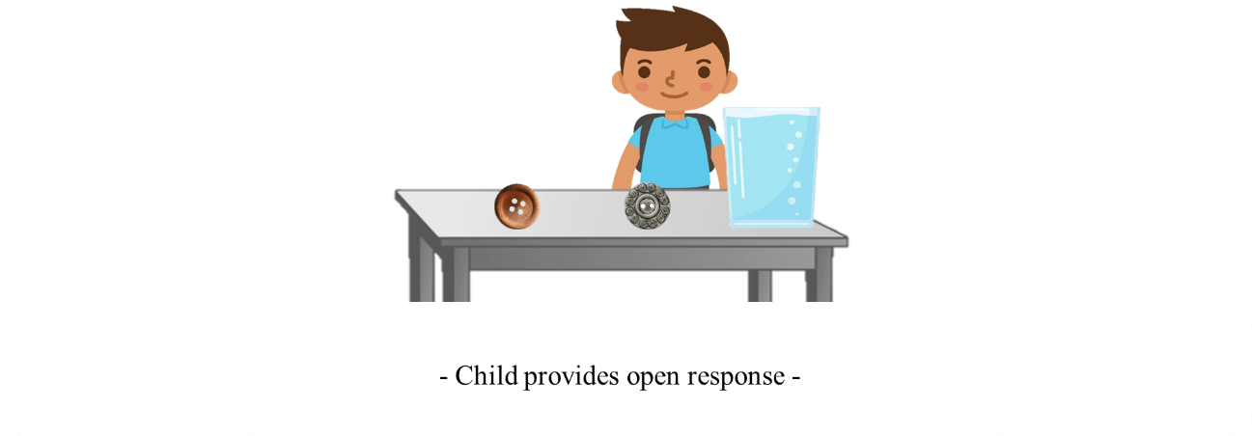

Trial-type 4: Weight - Bottle

“This child needs to find the heaviest bottle.”
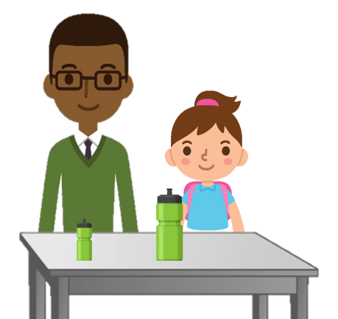

“This adult points to the small bottle and says: “This small bottle is much heavier than the big bottle.” Depending on the condition, the experimenter either provides:
- No Supporting Information: Moves on to next trial image without further information
- Supporting Information: Continues by saying that the adult says: “I know, because I just lifted both of them.”
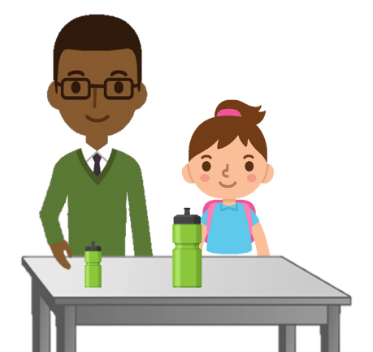

For phases 1-4 – Knowledge question:
“Now the adult had to leave, does the child know which button to pick to get the one that sinks the fastest?”
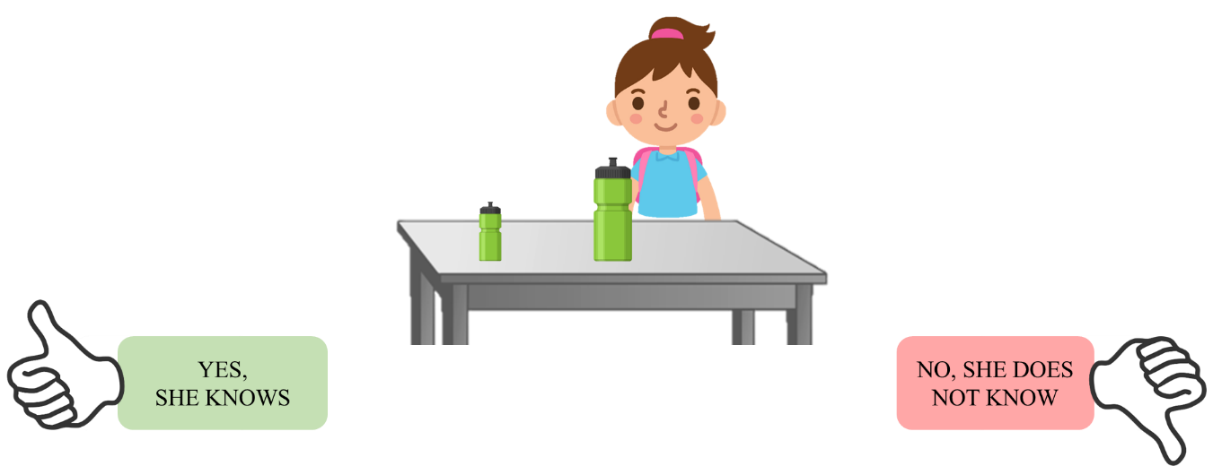

For phase 1-3 – Selection question:
- If child responds to the Knowledge question that the protagonist’s knowledge is sufficient, the experimenter continues by saying: “Which bottle do you think the child will pick?”, and after the child provides a response, the experimenter moves on to the next trial by saying: “Ok, let us look at the next picture.”
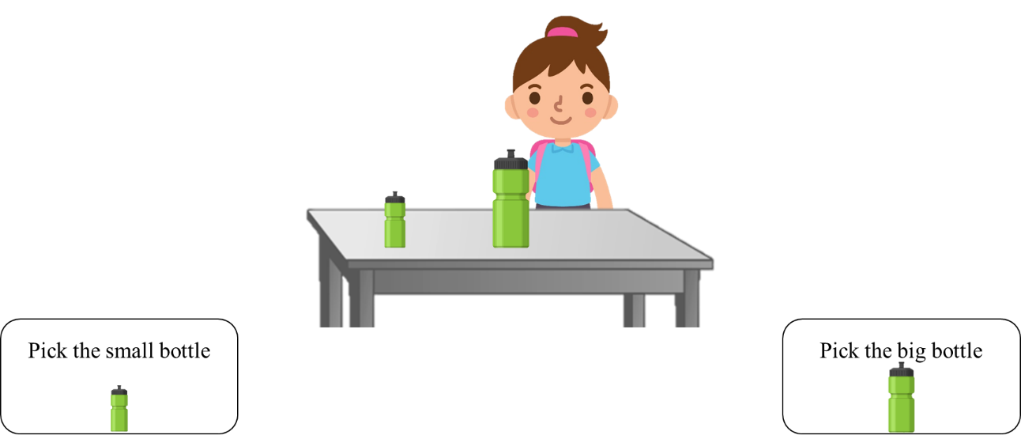
- If child responds to the Knowledge question that the protagonist’s knowledge is insufficient, the experimenter says: “Ok, let us look at the next picture.”

For phase 4 – Justification question:
The experimenter prompts the child to justify their response to the Knowledge question by asking: “Why do you think the child [repeat knowledge judgement]?”, before moving on to the Selection question.
