Table 1
Individual Items from the Home Learning Environment Scale.
- ABCs | On how many days in an average week does anyone at home help <child> learn the ABC or alphabet?
- Songs, Poems, Rhymes | On how many days in an average week does anyone at home help <child> learn songs, poems, or nursery rhymes?
- Reading | On how many days in an average week does anyone at home read to <child>?
- Books | About how many children’s books does <child> have access to in your home now, including any library books?
- Numbers, Counting | On how many days in an average week does anyone at home help <child> learn numbers or counting?
- Board Games | On how many days in an average week does anyone play games [board games, jigsaws, card games etc.) with <child>?
- Art | On how many days in an average week does <child> paint, draw, colour or play with play-doh at home?
Note. Scale reproduced from Murray and Colleagues’ (2013) summary guide to wave 2 of the infant cohort of growing up in Ireland.

Figure 1
Theoretical Model for Pathways from the Formal and Informal HLE and HNE at Three Years Old to Child Outcomes at Five and Nine Years Old.
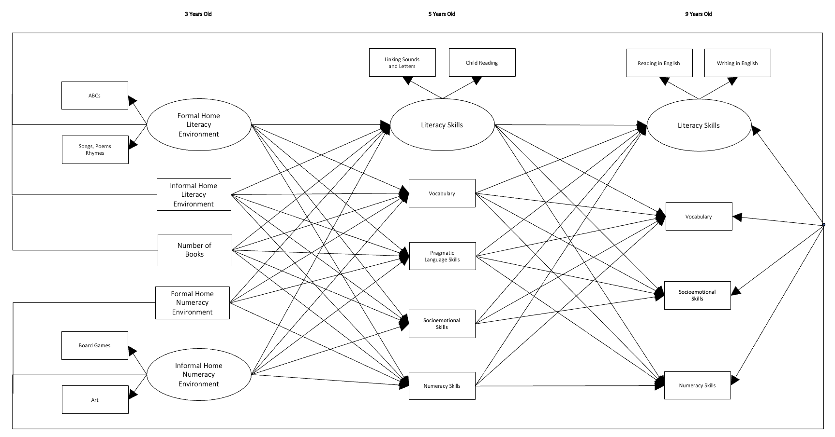
Note. Informal Home Literacy Environment = shared reading; Formal Home Numeracy Environment = teaching child numbers, counting. Number of Books is coded as a dichotomous variable (1 = less than 30 books and 2 = more than 30 books). The model adjusts for covariates.

Table 2
Descriptive Statistics of Study Variables.
 |  | Mean (SD) or n (%) | Min | Max | Variance
Formal HLE
ABCs |  | 3.77 (2.38) | 0 | 7 | 5.68
Songs, poems, rhymes |  | 5.26 (1.99) | 0 | 7 | 3.96
Informal HLE
Reading |  | 5.67 (1.92) | 0 | 7 | 3.70
Number of books
 | Less than 30 | 2920 (41.10%) | - | - | -
 | More than 30 | 4189 (58.90%) | - | - | -
Formal HNE
Numbers |  | 5.19 (1.96) | 0 | 7 | 3.82
Informal HNE
Board games |  | 4.40 (2.19) | 0 | 7 | 4.80
Art |  | 5.02 (1.94) | 0 | 7 | 3.76
Child Baseline Language
Vocabulary at age 3 |  | 76.27 (19.10) | 10 | 170 | 364.84
Academic Competencies at 5 Years
Linking sounds and letters |  | 7.86 (1.78) | 3 | 9 | 3.70
Reading |  | 7.67 (1.63) | 3 | 9 | 2.65
Vocabulary |  | 112.29 (17.19) | 26 | 170 | 295.65
Pragmatic language skills |  | 7.78 (1.92) | 3 | 9 | 3.70
Socioemotional skills |  | 7.94 (2.15) | 0 | 10 | 4.61
Numeracy skills |  | 7.78 (1.36) | 3 | 9 | 1.86
Academic Competencies at 9 Years
Reading in English |  | 3.57 (.48) | 3 | 4 | .24
Writing in English |  | 3.47 (.48) | 3 | 4 | .25
Vocabulary |  | .37(.89) | -2.94 | 2.41 | .80
Socioemotional skills |  | 8.23 (1.97) | 0 | 10 | 3.89
Numeracy skills |  | 3.53 (.50) | 3 | 4 | .25
Note. Linking sounds and letters, reading and numeracy were measured on a 7-point scale ranging from 3 (indicating 3 or less) to 9 with higher scores indicating better child performance within the respective domains; Linking sounds and letters and reading were combined to form a latent variable of literacy.

Table 3
Pearson’s Correlations between Items of the Home Learning Environment Scale, Child Academic Competencies at Five Years and Covariates.
 |  | 1 | 2 | 3 | 4 | 5 | 6 | 7 | 8 | 9 | 10 | 11 | 12 | 13 | 14 | 15 | 16 | 17 | 18 | 19
1 | ABCs | -
2 | Songs, poems, rhymes | .37** | -
3 | Reading | .19** | .27** | -
4 | Number of books | .01 | .11** | .29** | -
5 | Numbers | .49** | .43** | .24** | .08** | -
6 | Board games | .26** | .28** | .27** | .15** | .25** | -
7 | Art | .20** | .26** | .17** | .10** | .24** | .32** | -
8 | Linking sounds and letters | .04** | .05** | .13** | .11** | .03* | .10** | .03** | -
9 | Child reading | .04** | 05** | .13** | .11** | .03** | .11** | .05** | .72** | -
10 | Vocabulary | .06* | .08** | .19** | .18** | .07** | .09** | .01 | .21** | .21** | -
11 | Pragmatic language | .01 | .06** | .17** | .12** | .02 | .11** | .04** | .43** | .47** | .26** | -
12 | Socioemotional | .01 | .05** | .06** | .05** | .01 | .06** | .05** | .20** | .22** | .11** | .41** | -
13 | Numeracy | .03** | .05** | .12** | .09** | .03** | .08** | .02 | .59** | .62* | .15** | .36** | .18** | -
14 | Child Sex | .07** | .13** | .05** | .03* | .04** | .06** | .23** | .09** | .10** | .02** | .09*** | .18** | .04** | -
15 | Baseline language | .06** | .11** | .23** | .20** | .06** | .11** | .09** | .18** | .19** | .50** | .23** | .12** | .15** | .12** | -
16 | First language | .002 | -.05** | -.13** | -.13** | -.03* | -.01 | .04** | -.06** | -.09** | -.40** | -.14** | -.06** | -.04** | .02 | -.30** | -
17 | Family SES | .04** | -.003 | -.20** | -.26** | .01 | -.08** | .02 | -.12** | -.11** | -.19** | -.19** | -.08** | -.11 | .04** | .16** | .14** | -
18 | Parental education | -.02* | .03* | .26** | .28** | .01 | .10** | .02 | .09** | .09** | .13** | .14** | .03* | .09** | -.03* | -.19** | -.003 | -.48** | -
19 | Preschool | .01 | -.01 | -.07** | -.05** | <.001 | -.03 | -.01 | -.08** | -.07** | -.05** | -.05** | -.02 | -.06** | .01 | -.06 | .04** | .14** | -.10** | -
Note. * Correlation is significant at the 0.05 level; ** correlation is significant at the 0.01 level; Items 1-3 and 5-7 represent the frequency with which parents reported engaging in these activities with children per week ranging from ‘0’ to ‘7’ days; Number of books was coded as a dummy variable where 1 = less than 30 books and 2 = more than 30 books; Vocabulary was measured using the Naming Vocabulary scale of the British Abilities Scales (Elliott et al., 1996). Higher scores indicate better vocabularies; Pragmatic language (α = .88) linking sounds and letters (α = .85), child reading (α = .77) and numeracy (α = .76) were measured by teacher report on the Achievement Scales from the UK Cohort Study; Socioemotional skills were obtained from teacher report on the prosocial subscale of the strengths and difficulties questionnaire (SDQ; α =0.81; Goodman, 1997). Higher scores indicate more prosocial behaviour; Child sex was coded as a dummy variable where 0 = male and 1 = female; First language was coded as a dummy variable where 0 = ‘not English’ and 1 = ‘English’; Family SES was a categorical variable ranging from 1 = ‘never worked’ to 5 = ‘professional’; Parent education was a categorical variable ranging from 1 = ‘no qualification’ to 6 = ‘doctorate degree’; Preschool attendance was coded as a dummy variable where 1 = ‘attended’ and 2 = ‘did not attend’.

Table 4
Pearson’s Correlations between Items of the Home Learning Environment Scale, Child Academic Competencies at Nine Years and Covariates.
 |  | 1 | 2 | 3 | 4 | 5 | 6 | 7 | 8 | 9 | 10 | 11 | 12 | 13 | 14 | 15 | 16 | 17 | 18
1 | ABCs | -
2 | Songs, poems, rhymes | .37** | -
3 | Reading | .19** | .27** | -
4 | Number of books | .01 | .11** | .29** | -
5 | Numbers | .49** | .43** | .24** | .08** | -
6 | Board games | .26** | .28** | .27** | .15** | .25** | -
7 | Art | .20** | .26** | .17** | .10** | .24** | .32** | -
8 | Reading in English | .01 | .05** | .17** | .16** | .03* | .08** | .03** | -
9 | Writing in English | -.002 | .03** | .14** | .15** | .02 | .08** | .03** | .72** | -
10 | Vocabulary | .01 | .06** | .21** | .20** | .03** | .09** | 03** | .49** | .45** | -
11 | Socioemotional | .02 | .04** | .04** | .05** | .01 | .04** | .09** | .10** | .13** | .06** | -
12 | Numeracy | -.01 | .002 | .13** | .13** | .01 | .06** | .01 | .58** | .59** | .39** | .10** | -
13 | Child Sex | .07** | .13** | .05** | .03** | .04** | .06** | .23** | .03* | .05** | .02 | .24** | -.07** | -
14 | Baseline language | .06** | .11** | .23** | .20** | .06** | .11** | .09** | .22** | .19** | .32** | .08** | .16** | .12** | -
15 | First language | .002 | -.05** | -.13** | -.13** | -.03* | -.01 | .04** | -.07** | -.05** | -.14** | -.04** | -.001 | .02 | -.30** | -
16 | Family SES | .04** | -.003 | -.20** | -.26** | .01 | -.08** | .02 | -.21** | -.20** | -.24** | -.08** | -.21** | .04** | .16** | .14** | -
17 | Parental education | -.02* | .03* | .26** | .28** | .01 | .10** | .02 | .21** | .21** | .26** | .03* | .22** | -.03* | -.19** | -.003 | -.48** | -
18 | Preschool | .01 | -.01 | -.07** | -.05* | <.01 | -.03 | -.01 | -.04** | -.02 | -.06** | -.02 | -.05** | .01 | -.06** | .04** | .14** | -.10** | -
Note. * Correlation is significant at the 0.05 level; ** correlation is significant at the 0.01 level; Items 1-3 and 5-7 represent the frequency with which parents reported engaging in these activities with children per week ranging from ‘0’ to ‘7’ days; Number of books was coded as a dummy variable where1 = less than 30 books and 2 = more than 30 books; reading and writing in English, and numeracy skills were reported by teachers on a 5-point scale where 1 = ‘well below average’ and 5 = ‘well above average’; Vocabulary was measured using the Drumcondra Primary Reading Test – Revised (DPRT-R), a standardised test administered to school children annually in Ireland (${KR}_{20}$= 93). Higher scores indicate better vocabularies; Socioemotional skills were obtained from teacher report on the prosocial subscale of the strengths and difficulties questionnaire (SDQ; α = .80; Goodman, 1997). Higher scores indicate more prosocial behaviour; Child sex was coded as a dummy variable where 0 = male and 1 = female; First language was coded as a dummy variable where 0 = ‘not English’ and 1 = ‘English’; Family SES was a categorical variable ranging from 1 = ‘never worked’ to 5 = ‘professional’; Parent education was a categorical variable ranging from 1 = ‘no qualification’ to 6 = ‘doctorate degree’; Preschool attendance was coded as a dummy variable where 1 = ‘attended’ and 2 = ‘did not attend’.

