**Supplementary Materials**

Additional supporting information may be found in the online version of this article.

**Figure S1** Centrality Stability for Parenting Network in Total Sample

**Figure S2** Edge-Weight Accuracy for Parenting Network in Total Sample

**Figure S3** Bootstrapped Difference Tests Between Expectedinfluence of 22 Parenting Variables

**Figure S4** Bootstrapped Difference Tests Between Betweenness of 22 Parenting Variables

**Figure S5** Centrality Stability for Parenting Networks in Early, Middle, Late Adolescence

**Figure S6** Edge-Weight Accuracy for Parenting Networks in Early, Middle, And Late Adolescence

**Table S1** Pearson Correlations Between All Parenting Variables in Total Sample

**Table S2** Edge Weights Between All Nodes of Parenting Network in Total Sample

**Figure S1**

*Centrality Stability for Parenting Network in Total Sample*

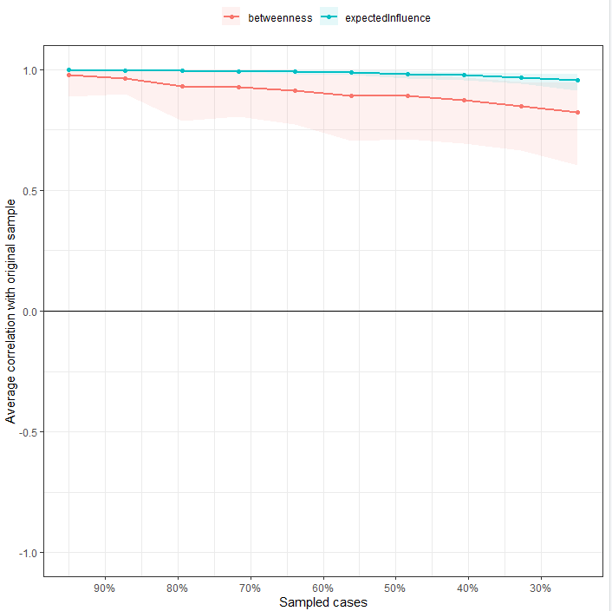

*Note.* Average correlations between centrality indices of networks sampled with persons dropped and the original sample. Lines indicate the means and areas indicate the range from the 2.5th quantile to the 97.5th quantile.

**Figure S2**

*Edge-Weight Accuracy for Parenting Network in Total Sample*

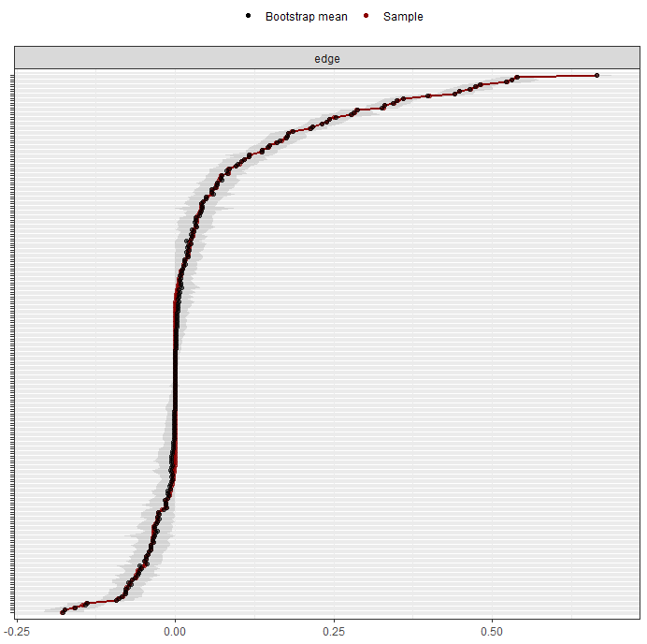

*Note.* Bootstrapped confidence intervals of estimated edge-weights for the estimated network. The red line indicates the sample values and the gray area indicates the bootstrapped confidence intervals. Each horizontal line represents one edge of the network, ordered from the edge with the highest edge-weight to the edge with the lowest edge-weight.

**Figure S3**

*Bootstrapped Difference Tests Between Expectedinfluence of 22 Parenting Variables*

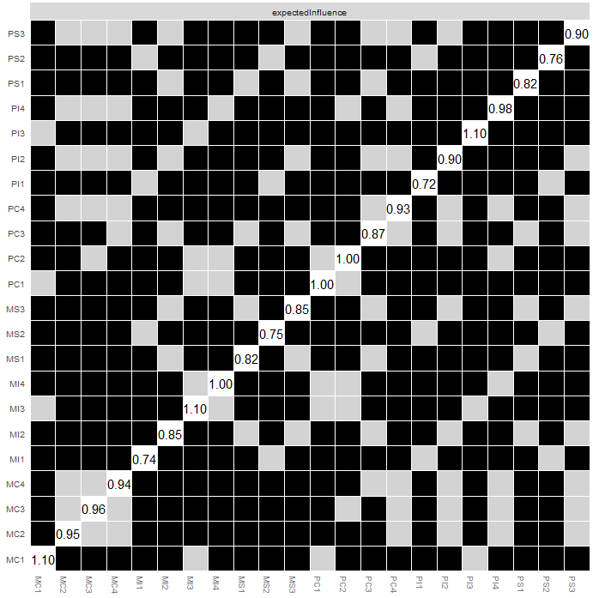

*Note.* Gray boxes indicate nodes that do not differ significantly from one-another and black boxes represent nodes that do differ significantly from one-another.

**Figure S4**

*Bootstrapped Difference Tests Between Betweenness of 22 Parenting Variables*

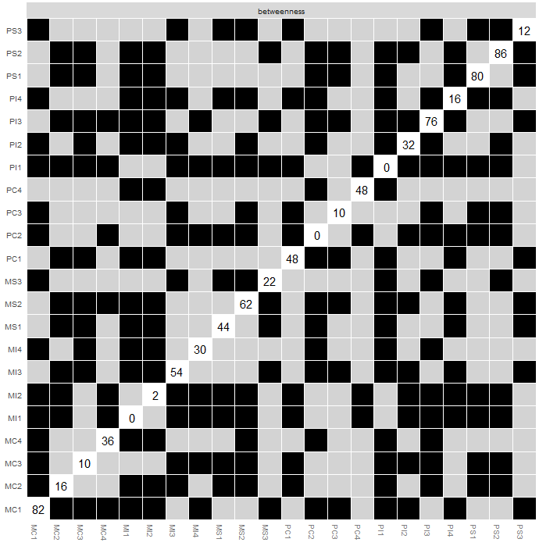

*Note.* Gray boxes indicate nodes that do not differ significantly from one-another and black boxes represent nodes that do differ significantly from one-another.

**Figure S5**

*Centrality Stability for Parenting Networks in Early, Middle, Late Adolescence*

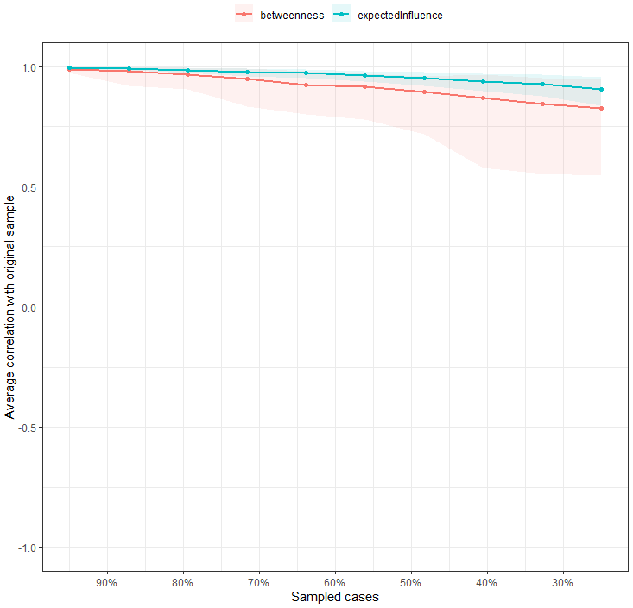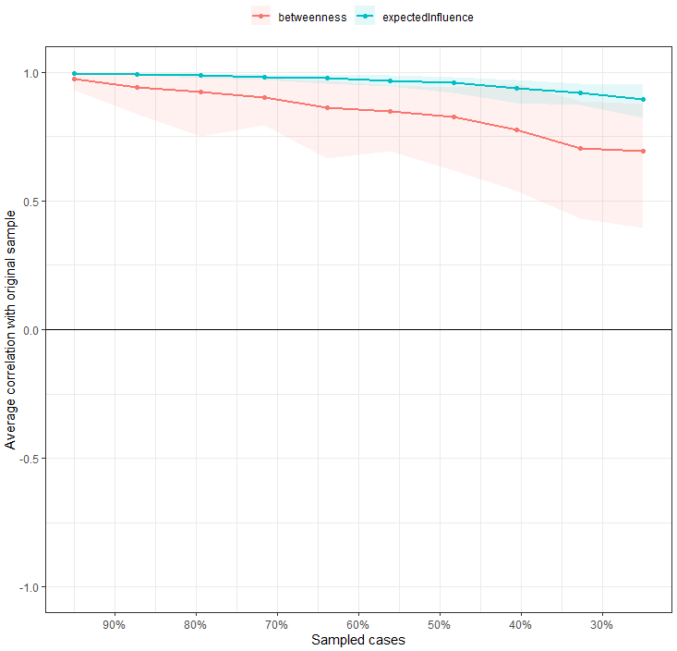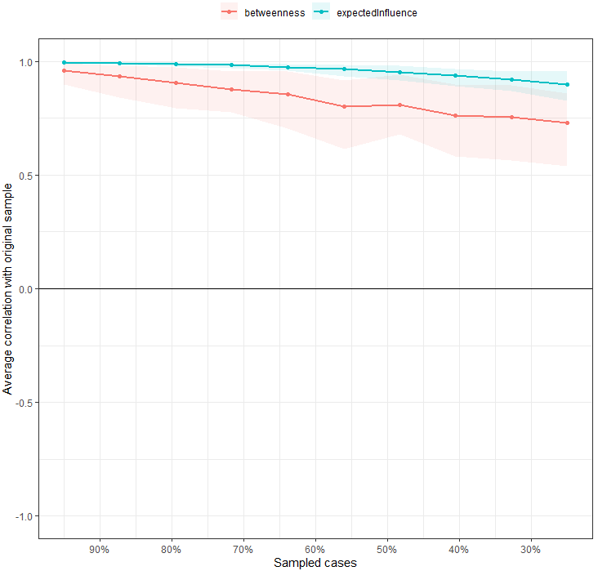

*Note.* Early (left), middle (middle), late (right) adolescence. Average correlations between centrality indices of networks sampled with persons dropped and the original sample. Lines indicate the means and areas indicate the range from the 2.5th quantile to the 97.5th quantile.

**Figure S6**

*Edge-Weight Accuracy for Parenting Networks in Early, Middle, and Late Adolescence*

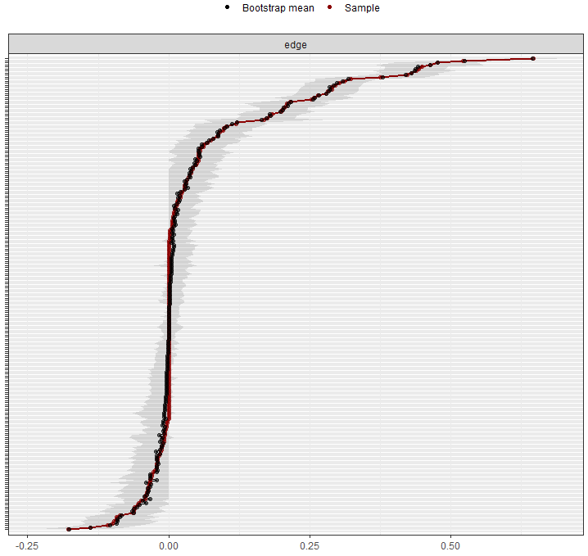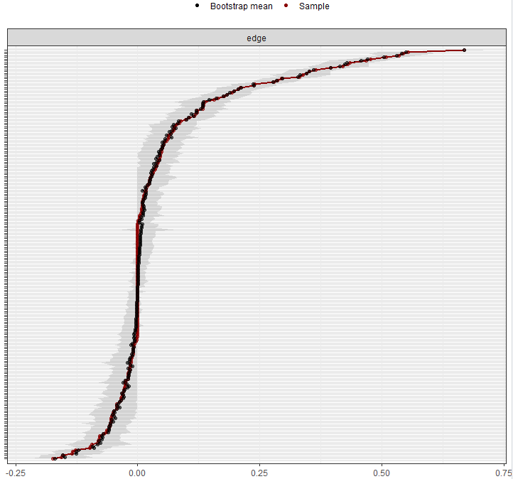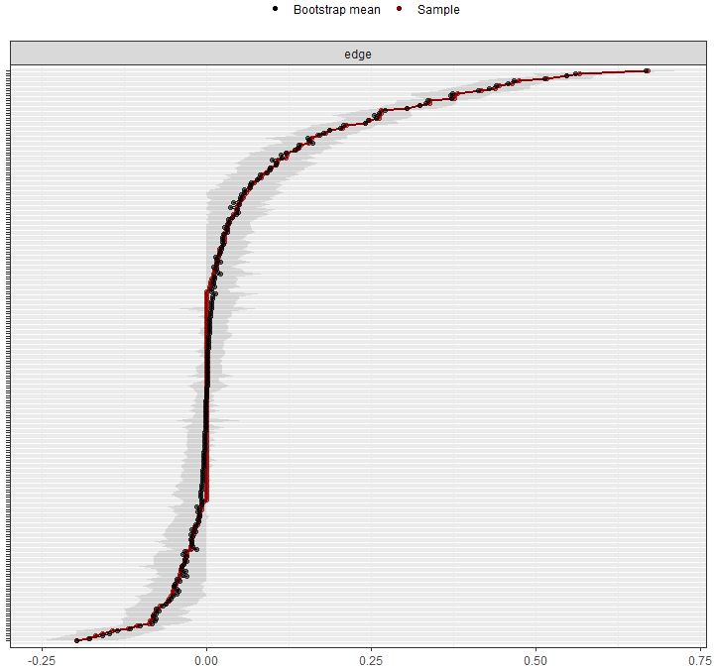

*Note.* Early (left), middle (middle), late (right) adolescence. Bootstrapped confidence intervals of estimated edge-weights for the estimated network. The red line indicates the sample values and the gray area indicates the bootstrapped confidence intervals. Each horizontal line represents one edge of the network, ordered from the edge with the highest edge-weight to the edge with the lowest edge-weight.

**Table S1**

*Pearson Correlations Between All Parenting Variables in Total Sample*

|  |  |  |  |  |  |  |  |  |  |  |  |  |  |  |  |  |  |  |  |  |  |  |
| --- | --- | --- | --- | --- | --- | --- | --- | --- | --- | --- | --- | --- | --- | --- | --- | --- | --- | --- | --- | --- | --- | --- |
|  | MC1 | MC2 | MC3 | MC4 | MI1 | MI2 | MI3 | MI4 | MS1 | MS2 | MS3 | PC1 | PC2 | PC3 | PC4 | PI1 | PI2 | PI3 | PI4 | PS1 | PS2 | PS3 |
| MC1 | ⎯ |  |  |  |  |  |  |  |  |  |  |  |  |  |  |  |  |  |  |  |  |  |
| MC2 | .764*** | ⎯ |  |  |  |  |  |  |  |  |  |  |  |  |  |  |  |  |  |  |  |  |
| MC3 | -.232*** | -.213*** | ⎯ |  |  |  |  |  |  |  |  |  |  |  |  |  |  |  |  |  |  |  |
| MC4 | -.162*** | -.176*** | .788*** | ⎯ |  |  |  |  |  |  |  |  |  |  |  |  |  |  |  |  |  |  |
| MI1 | .543*** | .482*** | -.155*** | -.134*** | ⎯ |  |  |  |  |  |  |  |  |  |  |  |  |  |  |  |  |  |
| MI2 | .593*** | .492*** | -.184*** | -.144*** | .646*** | ⎯ |  |  |  |  |  |  |  |  |  |  |  |  |  |  |  |  |
| MI3 | .729*** | .543*** | -.212*** | -.172*** | .680*** | .754*** | ⎯ |  |  |  |  |  |  |  |  |  |  |  |  |  |  |  |
| MI4 | .565*** | .537*** | -.192*** | -.179*** | .711*** | .671*** | .730*** | ⎯ |  |  |  |  |  |  |  |  |  |  |  |  |  |  |
| MS1 | -.286*** | -.186*** | .474*** | .473*** | -.186*** | -.173*** | -.327*** | -.199*** | ⎯ |  |  |  |  |  |  |  |  |  |  |  |  |  |
| MS2 | .683*** | .528*** | -.298*** | -.272*** | .555*** | .560*** | .742*** | .631*** | -.389*** | ⎯ |  |  |  |  |  |  |  |  |  |  |  |  |
| MS3 | -.139*** | -.047** | .323*** | .319*** | -0.021 | -.064*** | -.159*** | -0.009 | .635*** | -.159*** | ⎯ |  |  |  |  |  |  |  |  |  |  |  |
| PC1 | .869*** | .715*** | -.249*** | -.158*** | .482*** | .556*** | .623*** | .497*** | -.237*** | .584*** | -.131*** | ⎯ |  |  |  |  |  |  |  |  |  |  |
| PC2 | .734*** | .882*** | -.231*** | -.180*** | .501*** | .523*** | .551*** | .564*** | -.184*** | .533*** | -.052*** | .760*** | ⎯ |  |  |  |  |  |  |  |  |  |
| PC3 | -.181*** | -.189*** | .810*** | .674*** | -.094*** | -.129*** | -.146*** | -.142*** | .417*** | -.250*** | .297*** | -.250*** | -.211*** | ⎯ |  |  |  |  |  |  |  |  |
| PC4 | -.117*** | -.156*** | .732*** | .812*** | -.113*** | -.107*** | -.122*** | -.179*** | .410*** | -.233*** | .258*** | -.167*** | -.206*** | .732*** | ⎯ |  |  |  |  |  |  |  |
| PI1 | .538*** | .501*** | -.152*** | -.117*** | .414*** | .442*** | .456*** | .423*** | -.138*** | .412*** | -.061*** | .619*** | .539*** | -.142*** | -.115*** | ⎯ |  |  |  |  |  |  |
| PI2 | .562*** | .523*** | -.187*** | -.129*** | .371*** | .507*** | .481*** | .419*** | -.120*** | .427*** | -.060*** | .640*** | .545*** | -.176*** | -.121*** | .678*** | ⎯ |  |  |  |  |  |
| PI3 | .680*** | .575*** | -.233*** | -.165*** | .440*** | .532*** | .599*** | .479*** | -.203*** | .541*** | -.125*** | .795*** | .617*** | -.225*** | -.167*** | .678*** | .777*** | ⎯ |  |  |  |  |
| PI4 | .559*** | .586*** | -.230*** | -.203*** | .431*** | .453*** | .495*** | .607*** | -.179*** | .512*** | -.044** | .624*** | .620*** | -.209*** | -.211*** | .653*** | .701*** | .734*** | ⎯ |  |  |  |
| PS1 | -.225*** | -.162*** | .421*** | .391*** | -.184*** | -.129*** | -.224*** | -.182*** | .643*** | -.262*** | .447*** | -.269*** | -.198*** | .465*** | .467*** | -.158*** | -.152*** | -.283*** | -.173*** | ⎯ |  |  |
| PS2 | .650*** | .566*** | -.313*** | -.264*** | .425*** | .457*** | .533*** | .477*** | -.274*** | .705*** | -.135*** | .723*** | .608*** | -.332*** | -.288*** | .569*** | .611*** | .760*** | .663*** | -.370*** | ⎯ |  |
| PS3 | -.062*** | -0.001 | .270*** | .255*** | -.074*** | -.046** | -.092*** | -.057*** | .421*** | -.079*** | .584*** | -.081*** | -.029* | .317*** | .322*** | 0.016 | 0.008 | -.104*** | 0.015 | .635*** | -.121*** | ⎯ |

Note. The abbreviation is corresponded to Table 1. \*\*\**p* < .001; \*\**p* < .01; \**p* < .05.

**Table S2**

*Edge Weights Between All Nodes of Parenting Network in Total Sample*

|  |  |  |  |  |  |  |  |  |  |  |  |  |  |  |  |  |  |  |  |  |  |  |
| --- | --- | --- | --- | --- | --- | --- | --- | --- | --- | --- | --- | --- | --- | --- | --- | --- | --- | --- | --- | --- | --- | --- |
|  | MC1 | MC2 | MC3 | MC4 | MI1 | MI2 | MI3 | MI4 | MS1 | MS2 | MS3 | PC1 | PC2 | PC3 | PC4 | PI1 | PI2 | PI3 | PI4 | PS1 | PS2 | PS3 |
| MC1 | ⎯ |  |  |  |  |  |  |  |  |  |  |  |  |  |  |  |  |  |  |  |  |  |
| MC2 | **.251** | ⎯ |  |  |  |  |  |  |  |  |  |  |  |  |  |  |  |  |  |  |  |  |
| MC3 | **-.035** | .000 | ⎯ |  |  |  |  |  |  |  |  |  |  |  |  |  |  |  |  |  |  |  |
| MC4 | .000 | **-.007** | **.401** | ⎯ |  |  |  |  |  |  |  |  |  |  |  |  |  |  |  |  |  |  |
| MI1 | .000 | **.016** | .000 | **-.004** | ⎯ |  |  |  |  |  |  |  |  |  |  |  |  |  |  |  |  |  |
| MI2 | .000 | .000 | **-.028** | **-.001** | **.177** | ⎯ |  |  |  |  |  |  |  |  |  |  |  |  |  |  |  |  |
| MI3 | **.216** | **-.031** | .000 | .000 | **.147** | **.345** | ⎯ |  |  |  |  |  |  |  |  |  |  |  |  |  |  |  |
| MI4 | .000 | **.003** | .000 | .000 | **.331** | **.174** | **.243** | ⎯ |  |  |  |  |  |  |  |  |  |  |  |  |  |  |
| MS1 | **-.038** | .000 | **.057** | **.109** | .000 | **.039** | **-.071** | **.004** | ⎯ |  |  |  |  |  |  |  |  |  |  |  |  |  |
| MS2 | **.160** | .000 | .000 | **-.034** | **.023** | **-.015** | **.329** | **.116** | **-.174** | ⎯ |  |  |  |  |  |  |  |  |  |  |  |  |
| MS3 | **-.004** | **.001** | **.022** | **.049** | **.057** | .000 | **-.048** | **.096** | **.475** | **.011** | ⎯ |  |  |  |  |  |  |  |  |  |  |  |
| PC1 | **.538** | **-.002** | .000 | **.041** | .000 | **.028** | .000 | **-.076** | .000 | **-.090** | **-.004** | ⎯ |  |  |  |  |  |  |  |  |  |  |
| PC2 | .000 | **.665** | .000 | **.004** | **.033** | **.019** | **-.034** | **.084** | **.021** | **-.007** | **.003** | **.184** | ⎯ |  |  |  |  |  |  |  |  |  |
| PC3 | **.033** | .000 | **.523** | **-.035** | **.036** | .000 | **.024** | **.013** | .000 | .000 | .000 | **-.063** | .000 | ⎯ |  |  |  |  |  |  |  |  |
| PC4 | **.071** | .000 | **.040** | **.531** | .000 | .000 | **.028** | **-.036** | **-.015** | .000 | **-.069** | .000 | **-.050** | **.279** | ⎯ |  |  |  |  |  |  |  |
| PI1 | .000 | .000 | **.006** | .000 | **.083** | .000 | .000 | **-.014** | .000 | **-.036** | **-.029** | **.072** | **.021** | **.008** | .000 | ⎯ |  |  |  |  |  |  |
| PI2 | .000 | **.015** | **-.003** | .000 | **-.034** | **.167** | .000 | **-.080** | **.020** | **-.043** | **-.012** | .000 | .000 | .000 | **.001** | **.240** | ⎯ |  |  |  |  |  |
| PI3 | **-.015** | **-.059** | .000 | .000 | .000 | **.001** | **.149** | **-.077** | **.042** | **-.083** | **-.010** | **.287** | .000 | .000 | **.024** | **.104** | **.351** | ⎯ |  |  |  |  |
| PI4 | **-.072** | **.058** | .000 | **-.009** | **-.054** | **-.093** | **-.078** | **.359** | **-.027** | .000 | .000 | .000 | **.064** | .000 | **-.028** | **.178** | **.232** | **.212** | ⎯ |  |  |  |
| PS1 | **.006** | **.008** | **-.002** | **-.062** | **-.039** | **.040** | .000 | .000 | **.441** | **.084** | **-.140** | **-.007** | .000 | **.069** | **.118** | .000 | **.008** | **-.045** | **.032** | ⎯ |  |  |
| PS2 | .000 | .000 | .000 | .000 | .000 | .000 | **-.147** | **-.041** | **.101** | **.466** | .000 | **.136** | **.014** | **-.047** | **-.027** | **.033** | **.006** | **.283** | **.137** | **-.179** | ⎯ |  |
| PS3 | .000 | **.028** | **-.021** | **-.038** | **-.035** | **-.003** | .000 | **-.060** | **-.159** | **.044** | **.448** | .000 | .000 | **.029** | **.066** | **.049** | **.034** | **-.047** | **.065** | **.482** | **.021** | ⎯ |

*Note.* The abbreviation is corresponded to Table 1. **Bold** indicates significant values.