Supplemental Materials
PSID Covariates
One primary adult respondent--typically a male head-of-household--provided child, parent, and household sociodemographic characteristics. Child covariates included child sex (0=male, 1=female); child age at the time of digit span testing measured in years, race (White, Black, Hispanic, Asian or Pacific Islander, American Indian or Alaskan Native, Other); whether the child had ever been diagnosed with a learning disability in 1997 (0=no, 1=yes); reading scores in 1997, 2002, and 2007; and math scores in 1997, 2002, and 2007. Reading scores were measured using the Passage Comprehension (range: 4-43) and Letter-Word (range: 0-57) subscales of the Woodcock-Johnson Psycho-Educational Battery (Woodcock & Johnson, 1989). Math scores were measured using the Applied Problems subscale (range: 0-53) of the Woodcock-Johnson Psycho-Educational Battery (Woodcock & Johnson, 1989). Family covariates included maternal unemployment in 1997 and 2007 (0=no unemployment, 1=received unemployment in the past year), household income in 1997 (range: $0-70,000), and maternal educational attainment measured in years in 1997. If maternal education scores were missing from 1997 but available in 2007, scores from 2007 were used.

PSID missing data analysis
Using the covariates mentioned above, we conducted missing data analyses, where missing data on the digit span variables were dichotomously coded (0=non-missing, 1=missing) and t-tests and chi-square tests were conducted. Analyses showed there were differences in forward digit span missingness based on maternal education (t[7690] = 3.04, p = .0024), child race (𝜒²[5] =19.85, p =.001), child disability status (𝜒²[1] =7.25, p =.007), children’s letter-word scores (t[6353] = -5.21, p < .001), children’s passage comprehension scores (t[6784] = -10.34, p < .001), and children’s applied problems scores (t[6331] = -5.29, p < .001). Analyses showed there were differences in backward digit span missingness based on maternal education (t[7690] = 3.03, p = .003), child race (𝜒²[5] = 20.30, p = .001), child disability status (𝜒²[1] =8.22, p = .004), passage comprehension scores (t[6784] = -10.64, p < .001), and children’s applied problems scores (t[6331] = -2.17, p = .030).

ECLS-K:2011 covariates
Children's race and ethnicity was obtained through parent surveys and coded as White, non-Hispanic; Black, non-Hispanic; Hispanic; Asian; American Indian, Hawaiian, Multiracial, or Other. Household income included salary from all sources, interest, assets, and retirement, and was measured in 18 categories, ranging from $5,000 or less to $200,001 or more. Guardian education level was coded as the highest grade or year of school completed ranging from 1st grade to doctorate or professional degree, and guardian employment status was coded as an ordered categorical variable ranging from 1 (35 or more hours per week) to 4 (not in the labor force). Children’s disability status was reported by parents and indicated whether a child was professionally diagnosed or received therapy for an emotional, psychological, learning, communicative or developmental disorder.

ECLS-K:2011 missing data analysis
Analyses showed there were differences in digit span missingness based on child race (𝜒²[1] = 479.24, p = .001), child disability status (𝜒²[1] = 24.36, p < .001), children’s math scores (t[107992] = 7.22, p < .001), and children’s reading scores (t[108091] = 26.07, p < .001).

Table S1. Biological Sex Subgroup Analyses of Forward Digit Span in the Full PSID-CDS Sample.
Forward Digit Span, Females |  |  |  |  |  | Forward Digit Span, Males
Functional Form |  | Model 1 | Model 2 | Model 3 | Model 4 | Model 1 | Model 2 | Model 3 | Model 4
Linear | b | 0.346 | 1.196 | 2.323 |  | 0.364 | 1.228 | 1.922
 | SE | 0.013 | 0.065 | 0.233 |  | 0.012 | 0.066 | 0.259
 | Lower CI | 0.320 | 1.069 | 1.866 |  | 0.340 | 1.099 | 1.413
 | Upper CI | 0.372 | 1.323 | 2.781 |  | 0.388 | 1.357 | 2.431
 | p-value | <.001 | <.001 | <.001 |  | <.001 | <.001 | <.001
 | AIC | 253569177 |  |  |  | 259024696
 | BIC | 253569204 |  |  |  | 259024722
Quadratic | b |  | -0.038 | -0.149 |  |  | -0.039 | -0.107
 | SE |  | 0.003 | 0.022 |  |  | 0.003 | 0.025
 | Lower CI |  | -0.044 | -0.193 |  |  | -0.044 | -0.156
 | Upper CI |  | -0.032 | -0.105 |  |  | -0.033 | 2.431
 | p-value |  | <.001 | <.001 |  |  | <.001 | <.001
 | AIC |  | 249222204 |  |  |  | 254567694
 | BIC |  | 249222237 |  |  |  | 254567728
Cubic | b |  |  | 0.003 |  |  |  | 0.002
 | SE |  |  | 0.001 |  |  |  | 0.001
 | Lower CI |  |  | 0.002 |  |  |  | 0.001
 | Upper CI |  |  | 0.005 |  |  |  | 0.003
 | p-value |  |  | <.001 |  |  |  | .005
 | AIC |  |  | 248640539 |  |  |  | 254100208
 | BIC |  |  | 248640579 |  |  |  | 254100247
Logarithmic | b |  |  |  | 3.667 |  |  |  | 3.805
 | SE |  |  |  | 0.124 |  |  |  | 0.116
 | Lower CI |  |  |  | 3.421 |  |  |  | 3.577
 | Upper CI |  |  |  | 3.909 |  |  |  | 4.033
 | p-value |  |  |  | <.001 |  |  |  | <.001
 | AIC |  |  |  | 250058694 |  |  |  | 255582623
 | BIC |  |  |  | 250058720 |  |  |  | 255582647
Note: Missing data were handled using multiple imputation, and baseline cross-sectional sampling weights were used. PSID-CDS child age range: 3-19 years. Bolded values indicate best fitting models.
Table S2. Biological Sex Subgroup Analyses of Backward Digit Span in the Full PSID-CDS Sample.
Backward Digit Span, Females |  |  |  |  |  | Backward Digit Span, Males
Functional Form |  | Model 1 | Model 2 | Model 3 | Model 4 | Model 1 | Model 2 | Model 3 | Model 4
Linear | b | 0.401 | 1.161 | 1.860 |  | 0.408 | 1.168 | 1.541
 | SE | 0.011 | 0.047 | 0.174 |  | 0.010 | 0.047 | 0.167
 | Lower CI | 0.380 | 1.069 | 1.518 |  | 0.387 | 1.076 | 1.212
 | Upper CI | 0.423 | 1.253 | 2.202 |  | 0.428 | 1.260 | 1.870
 | p-value | <.001 | <.001 | <.001 |  | <.001 | <.001 | <.001
 | AIC | 233970979 |  |  |  | 238817864
 | BIC | 233971007 |  |  |  | 238817891
Quadratic | b |  | -0.034 | -0.103 |  |  | -0.034 | -0.071
 | SE |  | 0.002 | 0.018 |  |  | 0.002 | 0.017
 | Lower CI |  | -0.038 | -0.137 |  |  | -0.038 | -0.104
 | Upper CI |  | -0.030 | -0.068 |  |  | -0.030 | -0.038
 | p-value |  | <.001 | <.001 |  |  | <.001 | <.001
 | AIC |  | 229040173 |  |  |  | 233896857
 | BIC |  | 229040206 |  |  |  | 233896890
Cubic | b |  |  | 0.002 |  |  |  | 0.001
 | SE |  |  | 0.001 |  |  |  | 0.001
 | Lower CI |  |  | 0.001 |  |  |  | 0.000
 | Upper CI |  |  | 0.003 |  |  |  | 0.002
 | p-value |  |  | <.001 |  |  |  | .035
 | AIC |  |  | 228716715 |  |  |  | 233799591
 | BIC |  |  | 228716754 |  |  |  | 233799629
Logarithmic | b |  |  |  | 4.137 |  |  |  | 4.168
 | SE |  |  |  | 0.089 |  |  |  | 0.088
 | Lower CI |  |  |  | 3.962 |  |  |  | 3.994
 | Upper CI |  |  |  | 4.311 |  |  |  | 4.341
 | p-value |  |  |  | <.001 |  |  |  | <.001
 | AIC |  |  |  | 229641460 |  |  |  | 234718195
 | BIC |  |  |  | 229641487 |  |  |  | 234718221
Note: Missing data were handled using multiple imputation, and baseline cross-sectional sampling weights were used. PSID-CDS child age range: 3-19 years. Bolded values indicate best fitting models.
Table S3. Biological Sex Subgroup Analyses of Backward Digit Span in the Restricted PSID-CDS.
Backward Digit Span, Females |  |  |  |  |  | Backward Digit Span, Males
Functional Form |  | Model 1 | Model 2 | Model 3 | Model 4 | Model 1 | Model 2 | Model 3 | Model 4
Linear | b | 0.605 | 2.600 | 9.957 |  | 0.638 | 2.141 | 1.407
 | SE | 0.032 | 0.410 | 3.491 |  | 0.032 | 0.380 | 3.634
 | Lower CI | 0.543 | 1.796 | 3.115 |  | 0.575 | 1.396 | -5.716
 | Upper CI | 0.668 | 3.404 | 16.800 |  | 0.702 | 2.886 | 8.530
 | p-value | <.001 | <.001 | .004 |  | <.001 | <.001 | .699
 | AIC | 52345650 |  |  |  | 52600975
 | BIC | 52345670 |  |  |  | 52600996
Quadratic | b |  | -0.116 | -1.000 |  |  | -0.087 | 0.001
 | SE |  | 0.024 | 0.419 |  |  | 0.022 | 0.440
 | Lower CI |  | -0.164 | -1.822 |  |  | -0.131 | -0.861
 | Upper CI |  | -0.069 | -0.178 |  |  | -0.044 | 0.863
 | p-value |  | <.001 | .017 |  |  | <.001 | .999
 | AIC |  | 51963865 |  |  |  | 52392606
 | BIC |  | 51963891 |  |  |  | 52392632
Cubic | b |  |  | 0.035 |  |  |  | -0.003
 | SE |  |  | 0.016 |  |  |  | 0.017
 | Lower CI |  |  | 0.002 |  |  |  | -0.037
 | Upper CI |  |  | 0.067 |  |  |  | 0.031
 | p-value |  |  | 0.036 |  |  |  | 0.843
 | AIC |  |  | 51897847 |  |  |  | 52391930
 | BIC |  |  | 51897878 |  |  |  | 52391961
Logarithmic | b |  |  |  | 5.132 |  |  |  | 5.402
 | SE |  |  |  | 0.261 |  |  |  | 0.265
 | Lower CI |  |  |  | 4.621 |  |  |  | 4.882
 | Upper CI |  |  |  | 5.643 |  |  |  | 5.922
 | p-value |  |  |  | <.001 |  |  |  | <.001
 | AIC |  |  |  | 52133165 |  |  |  | 52459309
 | BIC |  |  |  | 52133165 |  |  |  | 52459329
Note: The age range for the PSID-CDS is restricted to ages 6-11 to mirror the ages in the ECLS-K:2011. Missing data were handled using multiple imputation, and baseline cross-sectional sampling weights were used. Bolded values indicate best fitting models.
Table S4. Biological Sex Subgroup Analyses of Numbers Reversed in the ECLS-K:2011.
Backward Digit Span, Females |  |  |  |  |  | Backward Digit Span, Males
Functional Form |  | Model 1 | Model 2 | Model 3 | Model 4 | Model 1 | Model 2 | Model 3 | Model 4
Linear | b | 7.209 | 17.778 | 38.336 |  | 7.399 | 18.287 | 39.143
 | SE | 0.074 | 0.257 | 0.780 |  | 0.073 | 0.270 | 0.733
 | Lower CI | 7.064 | 17.275 | 36.800 |  | 7.256 | 17.757 | 37.702
 | Upper CI | 7.355 | 18.282 | 39.873 |  | 7.541 | 18.817 | 40.584
 | p-value | <.001 | <.001 | <.001 |  | <.001 | <.001 | <.001
 | AIC | 169244550 |  |  |  | 180930462
 | BIC | 169244587 |  |  |  | 180930500
Quadratic | b |  | -1.437 | -8.181 |  |  | -1.481 | -8.322
 | SE |  | 0.035 | 0.244 |  |  | 0.036 | 0.227
 | Lower CI |  | -1.506 | -8.662 |  |  | -1.552 | -8.770
 | Upper CI |  | -1.368 | -7.699 |  |  | -1.409 | -7.875
 | p-value |  | <.001 | <.001 |  |  | <.001 | <.001
 | AIC |  | 168537583 |  |  |  | 180183106
 | BIC |  | 168537628 |  |  |  | 180183152
Cubic | b |  |  | 0.600 |  |  |  | 0.609
 | SE |  |  | 0.021 |  |  |  | 0.020
 | Lower CI |  |  | 0.558 |  |  |  | 0.570
 | Upper CI |  |  | 0.642 |  |  |  | 0.648
 | p-value |  |  | <.001 |  |  |  | <.001
 | AIC |  |  | 168138011 |  |  |  | 179773786
 | BIC |  |  | 168138066 |  |  |  | 179773841
Logarithmic | b |  |  |  | 20.446 |  |  |  | 20.959
 | SE |  |  |  | 0.179 |  |  |  | 0.177
 | Lower CI |  |  |  | 20.095 |  |  |  | 20.612
 | Upper CI |  |  |  | 20.797 |  |  |  | 21.307
 | p-value |  |  |  | <.001 |  |  |  | <.001
 | AIC |  |  |  | 168082820 |  |  |  | 179729539
 | BIC |  |  |  | 168082856 |  |  |  | 179729576
Note: Missing data were handled using multiple imputation, and baseline cross-sectional sampling weights were used.
Table S5. Sample Means for Forward Digit Span in the PSID-CDS.
Age | Mean | SD | Min | Max
3 | 2.76 | 2.19 | 0 | 8
4 | 4.27 | 2.10 | 0 | 9
5 | 5.44 | 2.12 | 0 | 11
6 | 6.61 | 2.29 | 0 | 15
7 | 7.41 | 2.26 | 0 | 15
8 | 7.94 | 2.21 | 2 | 13
9 | 8.68 | 2.40 | 0 | 15
10 | 9.19 | 2.27 | 0 | 15
11 | 9.14 | 2.29 | 2 | 16
12 | 9.47 | 2.45 | 0 | 16
13 | 9.56 | 2.34 | 0 | 16
14 | 9.67 | 2.42 | 4 | 16
15 | 9.97 | 2.30 | 4 | 16
16 | 10.38 | 2.50 | 5 | 16
17 | 10.33 | 2.59 | 4 | 16
18 | 10.37 | 2.59 | 4 | 16
19 | 10.34 | 2.62 | 5 | 16
Note: The PSID-CDS longitudinal weights were used. Means are collapsed across years 1997, 2002, and 2007.

Table S6. Sample Means for Backward Digit Span in the PSID-CDS.
Age | Mean | SD | Min | Max
3 | 0.57 | 0.33 | 0 | 2
4 | 0.19 | 0.63 | 0 | 3
5 | 0.98 | 1.27 | 0 | 4
6 | 1.88 | 1.42 | 0 | 8
7 | 3.07 | 1.44 | 0 | 7
8 | 3.87 | 1.51 | 0 | 10
9 | 4.31 | 1.74 | 0 | 12
10 | 4.79 | 1.92 | 0 | 11
11 | 5.11 | 1.94 | 0 | 12
12 | 5.45 | 2.03 | 0 | 13
13 | 5.72 | 2.14 | 0 | 14
14 | 5.74 | 2.20 | 0 | 13
15 | 6.12 | 2.27 | 0 | 14
16 | 6.40 | 2.39 | 0 | 13
17 | 6.61 | 2.42 | 1 | 14
18 | 6.70 | 2.65 | 2 | 14
19 | 6.50 | 2.23 | 3 | 14
Note: The PSID-CDS longitudinal weights were used. Means are collapsed across years 1997, 2002, and 2007.

.
Table S7. Sample Means for Numbers Reversed in the ECLS-K:2011.
Time | Mean | SD | Min | Max
1 | 434.31 | 30.00 | 393 | 563
2 | 450.93 | 30.12 | 393 | 572
3 | 458.46 | 28.09 | 393 | 596
4 | 470.47 | 24.77 | 393 | 596
5 | 474.84 | 22.93 | 403 | 567
6 | 481.51 | 21.81 | 403 | 567
7 | 490.19 | 21.30 | 403 | 603
8 | 497.42 | 21.05 | 403 | 588
9 | 503.39 | 21.80 | 403 | 588
Note: The ECLS-K:2011 longitudinal weights were used.

Figure S2. Spaghetti plot of Numbers Reversed performance across time in the ECLSK:2011.
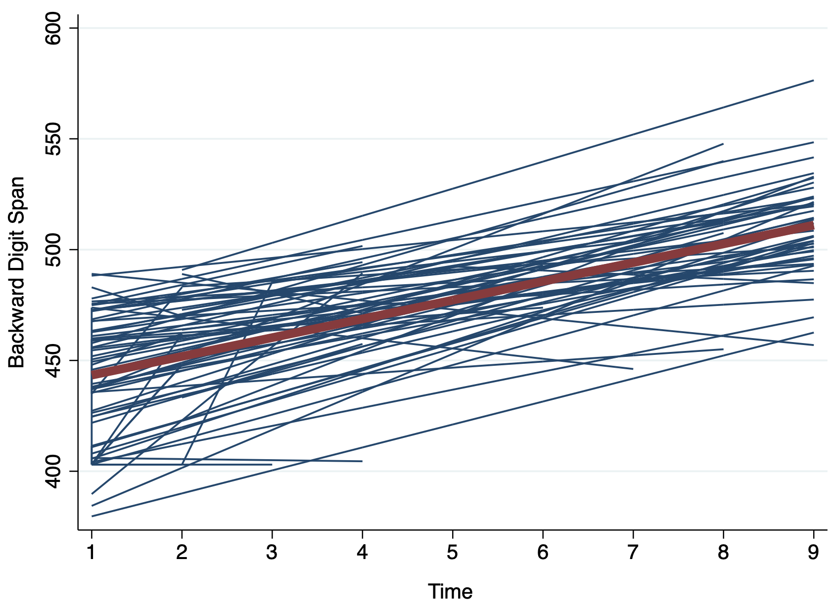
Note: Random subsample of 100 particiapants.

