Supplemental material
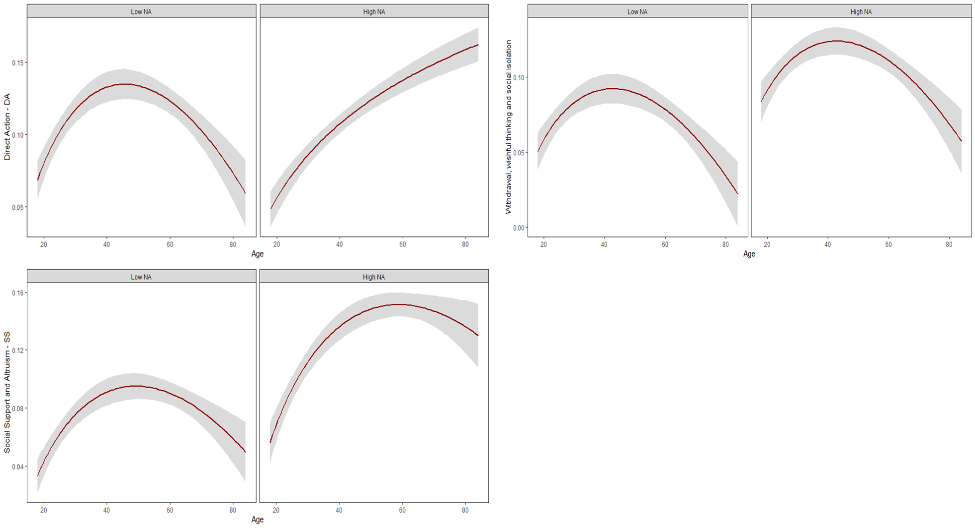
Figure S1. Emotional regulation by Age according to the Intensity of Negative Affects. Data plotting based on 60 measurement points (daily diary) per participant. Colum A showed the modification of situation strategies.
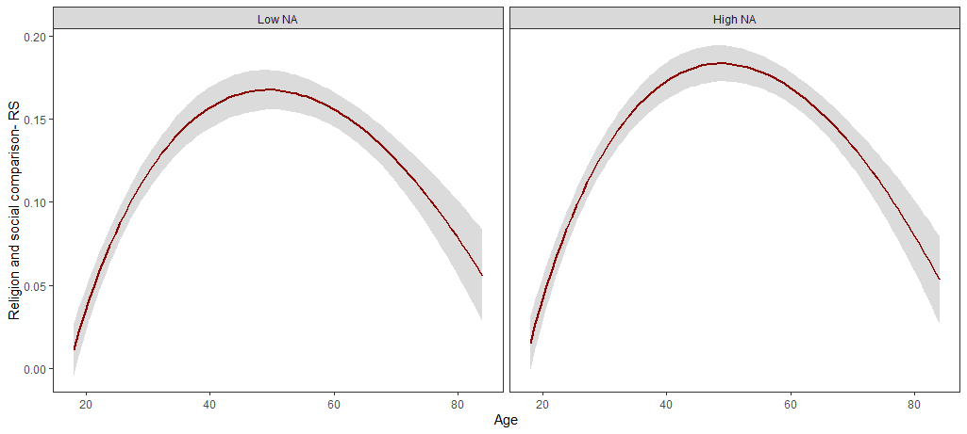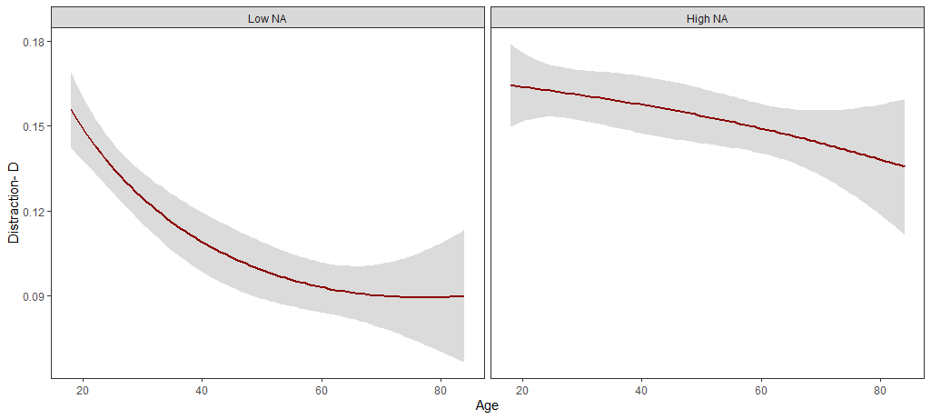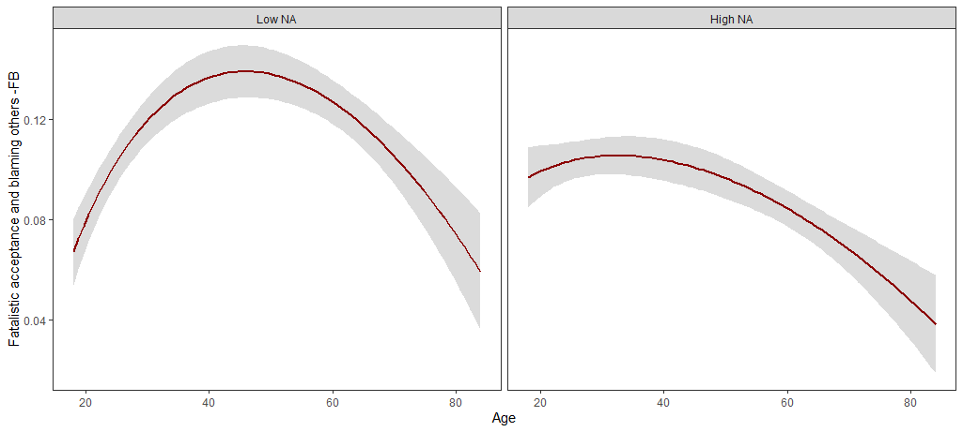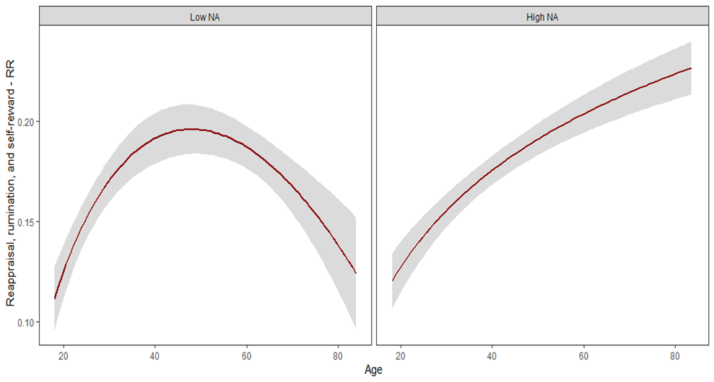

Figure S2. Emotional regulation by Age according to the Intensity of Negative Affects. Data plotting based on 60 measurement points (daily diary) per participant. Colum B includes Attentional deployment and cognitive change
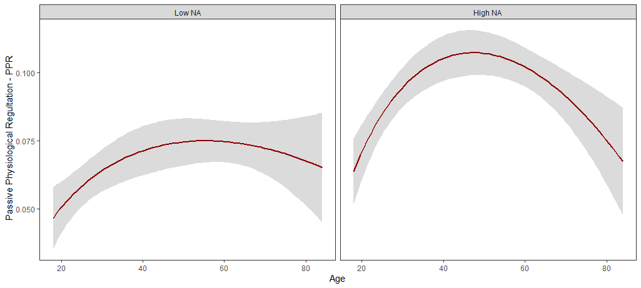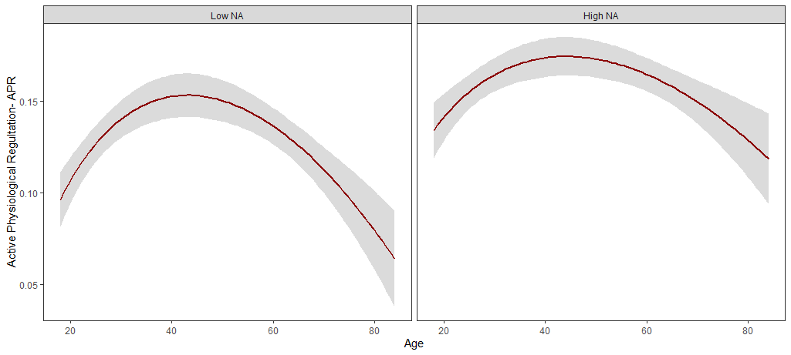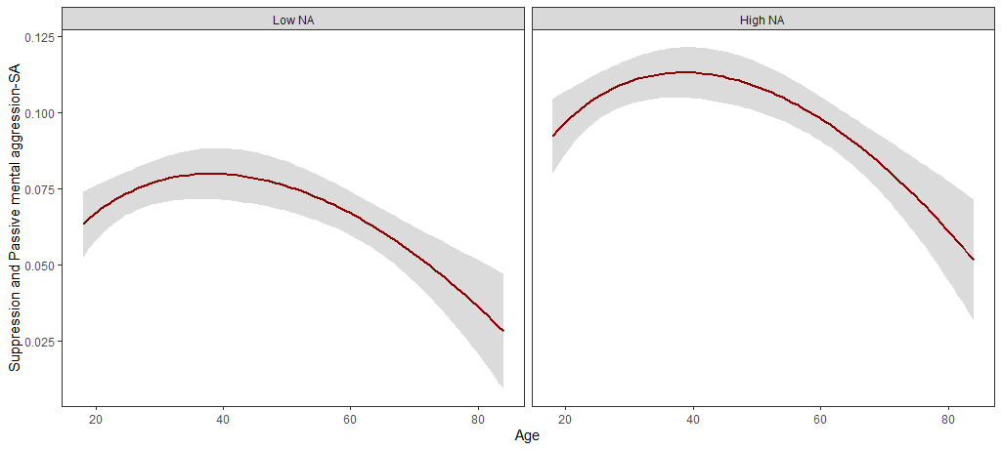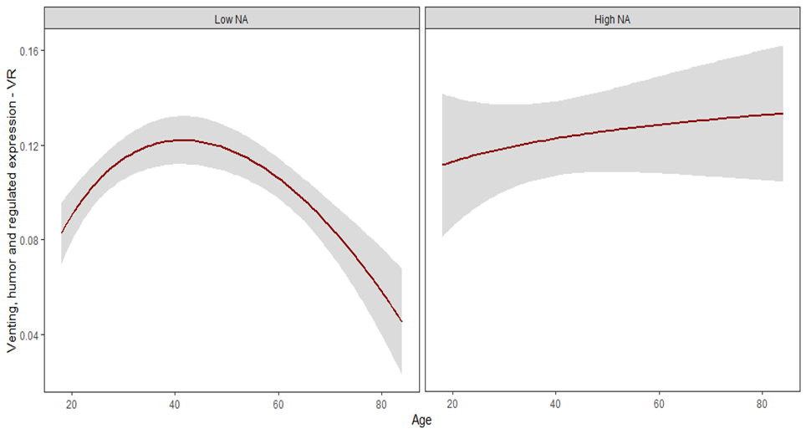

Figure S3. Emotional regulation by Age according to the Intensity of Negative Affects. Data plotting based on 60 measurement points (daily diary) per participant. Response modulation strategies.
Table S1.
Confirmatory factor analysis of the MARS scale: original model
 | S-B χ 2 | df | AIC | CFI | TLI | SRMR | RMSEA | 90% CI RMSEA
¹ Modelo 1. | 768.70 | 55 | 8568.89 | .86 | .81 | .087 | .126 | .103, .149
² Modelo 2 | 1160.22 | 105 | 12250.17 | .86 | .82 | .092 | .125 | .070, .081
³ Modelo 3 | 389.158 | 55 | 68086.93 | .84 | .79 | .100 | .093 | .068, .118
* χ²: p < .0001. ¹ Model 1: modification of situation strategies; ² Model 2: modification of situation strategies; ³ Model 3: response modulation strategies.

