Table S1
Items of the Focal Measurements
Constructs | Items
Self-concept of ability | How much do you agree or disagree with the following statements about your fall 2009 [math/science] course? (Strongly agree, Agree, Disagree, or Strongly disagree)
 | - You are confident that you can do an excellent job on tests in this course
 | - You are certain that you can master the skills being taught in this course
 | - You are confident that you can do an excellent job on assignments in this course
 | - You are certain that you can understand the most difficult material presented in the textbook used in this course
Subjective task value
Utility Value | How much do you agree or disagree with the following statements about the usefulness of your fall 2009 [math/science] course? What students learn in this course (Strongly agree, Agree, Disagree, or Strongly disagree)
 | - is useful for everyday life.
 | - will be useful for college.
 | - will be useful for a future career.
Intrinsic Value | How much do you agree or disagree with the following statements about your fall 2009 [math/science course]? (Strongly agree, Agree, Disagree, or Strongly disagree)
 | - You are enjoying this class very much
 | - You think this class is a waste of your time
 | - You think this class is boring
College Major | What was your major or field of study for your [bachelor's degree/associate's degree/ [first/second/third etc.] certificate/degree or certificate] from [college/trade school attended]?
STEM Major | STEM major included majors as follows:  Agriculture, Agriculture Operations, and Related Sciences  Natural Resources and Conservation  Computer and Information Sciences and Support Services  Engineering  Engineering Technologies/Technicians  Biological and Biomedical Sciences  Mathematics and Statistics  Multi/Interdisciplinary Studies  Military Technologies and Applied Science  Physical Sciences  Science Technologies/Technicians
Gender | What is your sex?  Male  Female
Ethnicity | Are you Hispanic or [Latino/Latina]?  Yes  No
[In addition to learning about your Hispanic background, we would also like to know about your racial background.] Which of the following choices describe your race? You may choose more than one.
(Check all that apply.)
White
Black or African American
Asian
Native Hawaiian or other Pacific Islander
American Indian or Alaska Native
Parents’ highest education | What is the highest level of education [you have/parent #1 has] completed?  Less than high school  High school diploma or GED  Associate’s degree  Bachelor’s degree  Master’s degree  Educational Specialist diploma  Ph.D., M.D., law degree, or other high level professional degree
What is the highest level of education [parent #2] has completed?
Less than high school
High school diploma or GED
Associate’s degree
Bachelor’s degree
Master’s degree
Educational Specialist diploma
Ph.D., M.D., law degree, or other high level professional degree
Family income | Income is a key family characteristic that factors into many research questions including how family finances affect students’ ability to go to college. This information is critically important to the success of this study and will be kept completely confidential.  What was your total household income from all sources prior to taxes and deductions in calendar year 2008? Please include all income such as income from work, investments and alimony.  * We understand that you may not be able to provide an exact number for your family’s income. However, it would be extremely helpful if you would indicate which of the following ranges best estimates your total household income from all sources prior to taxes and deductions in calendar year 2008. Please include all income such as income from work, investments and alimony.  $15,000 or less  $15,001 ‐ $35,000  $35,001 ‐ $55,000  $55,001 ‐ $75,000  $75,001 ‐ $95,000  $95,001 ‐ $115,000  $115,001 ‐ $135,000  $135,001 ‐ $155,000  $155,001 ‐ $175,000  $175,001 ‐ $195,000  $195,001 ‐ $215,000  $215,001 ‐ $235,000  More than $235,000
SOURCE: U.S. Department of Education, National Center for Education Statistics, High School Longitudinal Study of 2009 (HSLS:09).

Table S2
Measurement Invariance Tests across Gender and College Generation Status
Model tested | 𝛘2 | df | p | Δ𝛘2 | Δdf | p | RMSEA | RMSEA 90% CI | CFI | ΔCFI | TLI
Gender
Configural invariance | 252.03 | 84 | .00 | — | — | — | .017 | [.015;.019] | .990 | — | .985
Weak invariance | 266.15 | 96 | .00 | 14.12 | 12 | .29 | .016 | [.014;.018] | .990 | .000 | .987
Strong invariance | 423.31 | 108 | .00 | 157.16 | 12 | .00 | .020 | [.018;.022] | .982 | .008 | .978
College Generation Status
Configural invariance | 230.31 | 84 | .00 | — | — | — | .018 | [.015;.021] | .990 | — | .985
Weak invariance | 233.26 | 96 | .00 | 2.95 | 12 | .99 | .016 | [.013;.019] | .991 | -.001 | .988
Strong invariance | 275.84 | 108 | .00 | 42.58 | 12 | .00 | .017 | [.014;.019] | .989 | .002 | .986
Note. The criteria for passing measurement invariance is ΔCFI<.01 (Cheung & Rensvold, 2002).
SOURCE: U.S. Department of Education, National Center for Education Statistics, High School Longitudinal Study of 2009 (HSLS:09).

Table S3
Comparisons between Participants Who Completed the Last Round of Data Collection and Who Did Not Within the Analysis Sample
 | Participants with college data |  |  |  |  |  | Participants without college data |  |  |  |  | t-test or Chi-square  test | Effect size
Measurements | n | Mean | SD | Min | Max |  | n | Mean | SD | Min | Max | t-test or Chi-square  test | Effect size
Covariates
Female | 8820 | 0.55 | 0.50 | 0.00 | 1.00 |  | 5210 | 0.45 | 0.50 | 0.00 | 1.00 | 130.75*** | .10ª
White | 8820 | 0.59 | 0.49 | 0.00 | 1.00 |  | 5210 | 0.54 | 0.50 | 0.00 | 1.00 | 26.24*** | .04ª
Hispanic | 8820 | 0.13 | 0.34 | 0.00 | 1.00 |  | 5210 | 0.18 | 0.38 | 0.00 | 1.00 | 45.43*** | -.06ª
Black | 8820 | 0.09 | 0.28 | 0.00 | 1.00 |  | 5210 | 0.10 | 0.30 | 0.00 | 1.00 | 5.21* | -.02ª
Asian | 8820 | 0.10 | 0.30 | 0.00 | 1.00 |  | 5210 | 0.07 | 0.25 | 0.00 | 1.00 | 44.55*** | .06ª
Other ethnicities | 8820 | 0.09 | 0.29 | 0.00 | 1.00 |  | 5210 | 0.12 | 0.32 | 0.00 | 1.00 | 20.80*** | -.04ª
First-generation college students | 7540 | 0.28 | 0.45 | 0.00 | 1.00 |  | 3510 | 0.46 | 0.50 | 0.00 | 1.00 | 343.72*** | -.18ª
Parent highest education | 7580 | 3.75 | 1.54 | 1.00 | 7.00 |  | 3520 | 3.11 | 1.36 | 1.00 | 7.00 | 20.90*** | .43
Family income | 7580 | 5.42 | 3.19 | 1.00 | 13.00 |  | 3520 | 4.46 | 3.01 | 1.00 | 13.00 | 14.89*** | .30
Math achievement in 9th grade | 8820 | 55.13 | 9.31 | 24.10 | 82.19 |  | 5210 | 49.65 | 9.43 | 24.47 | 82.19 | 33.52*** | .59
High school English GPA | 8400 | 3.00 | 0.75 | 0.00 | 4.00 |  | 4660 | 2.37 | 0.92 | 0.00 | 4.00 | 42.42*** | .77
9th grade motivational beliefs
Math self-concept of ability | 8810 | 3.03 | 0.64 | 1.00 | 4.00 |  | 5190 | 2.90 | 0.67 | 1.00 | 4.00 | 12.13*** | .21
Math subjective task value | 8820 | 3.03 | 0.55 | 1.00 | 4.00 |  | 5210 | 3.00 | 0.56 | 1.00 | 4.00 | 3.24** | .06
Science self-concept of ability | 8800 | 2.92 | 0.62 | 1.00 | 4.00 |  | 5180 | 2.80 | 0.65 | 1.00 | 4.00 | 11.35*** | .20
Science subjective task value | 8810 | 2.94 | 0.56 | 1.00 | 4.00 |  | 5200 | 2.86 | 0.57 | 1.00 | 4.00 | 8.05*** | .14
STEM outcomes
STEM high school course-taking | 8440 | 8.28 | 2.06 | 0.50 | 15.00 |  | 4700 | 7.03 | 2.72 | 0.00 | 18.00 | 29.58*** | .54
STEM high school GPA | 8410 | 2.85 | 0.76 | 0.00 | 4.00 |  | 4680 | 2.22 | 0.89 | 0.00 | 4.00 | 43.51*** | .78
Note. Effect sizes are Cohen's d for continuous variables: small effect .10, moderate effect .30, large effect .80. Independent sample t-tests were used for continuous variables, and Chi-square tests were used for dichotomous variables. ªindicates effect sizes that are phi coefficients: small effect .10, moderate effect .30, large effect .50. *p < .05. **p < .01. ***p < .001.
The Ns were rounded to the nearest ten according to the IES restricted-use data guidelines.
SOURCE: U.S. Department of Education, National Center for Education Statistics, High School Longitudinal Study of 2009 (HSLS:09).

Table S4
Correlations among Predictor Variables
 | 1 | 2 | 3 | 4 | 5 | 6 | 7 | 8 | 9 | 10 | 11 | 12 | 13 | 14 | 15
1. Female | --
2. White | .00 | --
3. Hispanic | .01 | -.48*** | --
4. Black | -.01 | -.36*** | -.13*** | --
5. Asian | .00 | -.36*** | -.13*** | -.10*** | --
6. Other ethnicities | -.00 | -.39*** | -.14*** | -.11*** | -.11*** | --
7. First-generation college students | .01 | -.12*** | .17*** | .03*** | -.08*** | .04*** | --
8. Parent highest education | -.02 | .11*** | -.19*** | -.04*** | .14*** | -.05*** | -.76*** | --
9. Family income | -.02 | .19*** | -.16*** | -.11*** | .04*** | -.06*** | -.41*** | .56*** | --
10. Math achievement in 9th grade | -.03** | .08*** | -.13*** | -.15*** | .21*** | -.03** | -.27*** | .35*** | .28*** | --
11. High school English GPA | .23*** | .14*** | -.14*** | -.14*** | .13*** | -.05*** | -.25*** | .30*** | .26*** | .48*** | --
12. Math self-concept of ability | -.05*** | .10*** | .03** | .10*** | .04*** | .01 | .05*** | -.06*** | -.06*** | .01 | -.02** | --
13. Math subjective task value | .02 | -.06*** | .01 | .04*** | .06*** | -.01 | .01 | .02** | .00 | .16*** | .12*** | .45*** | --
14. Science self-concept of ability | -.11*** | -.04*** | -.04*** | .04*** | .08*** | .00 | -.08*** | .12*** | .08*** | .31*** | .18*** | .37*** | .47*** | --
15. Science subjective task value | .00 | -.07*** | -.02 | .04*** | .10*** | .01 | -.02 | .03*** | -.01 | .08*** | .08*** | .42*** | .26*** | .21*** | --
Note. *p < .05. **p < .01. ***p < .001.
SOURCE: U.S. Department of Education, National Center for Education Statistics, High School Longitudinal Study of 2009 (HSLS:09).

Table S5
Standardized Estimates from Self-concept of Ability Model
 | 9th Grade |  |  |  |  |  | High School |  |  |  |  |  |  |  |  |  |  | College
 | Math self-concept of ability |  |  | Science self-concept of ability |  |  | STEM course-taking |  |  |  |  | STEM GPA |  |  |  |  |  | STEM major
Predictors | β | SE |  | β | SE |  | β |  | SE |  |  | β |  | SE |  |  |  | β | SE
9th grade motivational beliefs
Math self-concept of ability |  |  |  |  |  |  | .06* |  | .02 |  |  | .11*** |  | .02 |  |  |  | .02 | .02
Science self-concept of ability |  |  |  |  |  |  | .05 |  | .02 |  |  | .00 |  | .02 |  |  |  | .08*** | .02
High school STEM outcomes
STEM course-taking |  |  |  |  |  |  |  |  |  |  |  |  |  |  |  |  |  | .16*** | .02
STEM GPA |  |  |  |  |  |  |  |  |  |  |  |  |  |  |  |  |  | .20*** | .02
Covariates
Female | -.12*** | .02 |  | -.13*** | .02 |  | -.09*** |  | .02 |  |  | -.02* |  | .01 |  |  |  | -.16*** | .02
Hispanic | .03 | .02 |  | .00 | .02 |  | .02 |  | .02 |  |  | -.06*** |  | .01 |  |  |  | .06** | .02
Black | .12*** | .02 |  | .06** | .02 |  | .06* |  | .03 |  |  | -.04*** |  | .01 |  |  |  | .00 | .02
Asian | .00 | .02 |  | -.01 | .03 |  | .01 |  | .02 |  |  | -.01 |  | .01 |  |  |  | .05* | .02
Other ethnicities | .01 | .02 |  | .04* | .02 |  | -.02 |  | .02 |  |  | -.05*** |  | .01 |  |  |  | .02 | .02
Parent highest education | -.01 | .02 |  | .03 | .02 |  | .00 |  | .02 |  |  | .03** |  | .01 |  |  |  | .03 | .02
Family income | -.03 | .02 |  | -.01 | .02 |  | .02 |  | .03 |  |  | -.01 |  | .01 |  |  |  | -.01 | .02
Math achievement in 9th grade | .33*** | .02 |  | .24*** | .02 |  | .07** |  | .02 |  |  | .16*** |  | .01 |  |  |  | .11*** | .02
High school English GPA | ª.05** | .01 |  | ª.07** | .02 |  | .30*** |  | .03 |  |  | .73*** |  | .01 |  |  |  | -.13*** | .03
Note. N = 14,040. The white group was used as the reference group. ªdenoted that coefficients were correlations coefficients instead of beta coefficients.
*p < .05. **p < .01. ***p < .001.
SOURCE: U.S. Department of Education, National Center for Education Statistics, High School Longitudinal Study of 2009 (HSLS:09).

Table S6
Standardized Estimates from Subjective Task Value Model
 | 9th Grade |  |  |  |  |  | High School |  |  |  |  |  |  |  |  |  |  |  |  | College
 | Math subjective task value |  |  | Science subjective task value |  |  | STEM course-taking |  |  |  |  |  | STEM GPA |  |  |  |  |  |  | STEM major
Predictors | β | SE |  | β | SE |  | β |  | SE |  |  |  | β |  | SE |  |  |  |  | β | SE
9th grade motivational beliefs
Math self-concept of ability |  |  |  |  |  |  | .07* |  | .03 |  |  |  | .06*** |  | .01 |  |  |  |  | .01 | .02
Science self-concept of ability |  |  |  |  |  |  | .07 |  | .04 |  |  |  | .01 |  | .01 |  |  |  |  | .09** | .03
High school STEM outcomes
STEM course-taking |  |  |  |  |  |  |  |  |  |  |  |  |  |  |  |  |  |  |  | .16*** | .02
STEM GPA |  |  |  |  |  |  |  |  |  |  |  |  |  |  |  |  |  |  |  | .20*** | .02
Covariates
Female | -.00 | .02 |  | -.02 | .03 |  | -.10*** |  | .02 |  |  |  | -.04*** |  | .01 |  |  |  |  | -.17*** | .02
Hispanic | .06* | .03 |  | .03 | .03 |  | .01 |  | .02 |  |  |  | -.06*** |  | .01 |  |  |  |  | .05** | .02
Black | .10* | .04 |  | .09 | .04 |  | .06* |  | .03 |  |  |  | -.04** |  | .01 |  |  |  |  | .00 | .02
Asian | .03 | .02 |  | .04 | .04 |  | .00 |  | .02 |  |  |  | -.02* |  | .01 |  |  |  |  | .05* | .02
Other ethnicities | -.03 | .03 |  | -.01 | .04 |  | -.02 |  | .02 |  |  |  | -.04*** |  | .01 |  |  |  |  | .02 | .02
Parent highest education | -.06* | .03 |  | -.01 | .02 |  | .00 |  | .02 |  |  |  | .03** |  | .01 |  |  |  |  | .03 | .02
Family income | -.03 | .03 |  | -.01 | .03 |  | .02 |  | .02 |  |  |  | -.01 |  | .01 |  |  |  |  | -.01 | .02
Math achievement in 9th grade | .20*** | .02 |  | .18*** | .02 |  | .07** |  | .02 |  |  |  | .18*** |  | .01 |  |  |  |  | .12*** | .02
High school English GPA | ª.06** | .02 |  | ª.05** | .02 |  | .30*** |  | .03 |  |  |  | .73*** |  | .01 |  |  |  |  | -.12*** | .03
Note. N = 14,040. The white group was used as the reference group. ªdenoted that coefficients were correlations coefficients instead of beta coefficients.
*p < .05. **p < .01. ***p < .001.
SOURCE: U.S. Department of Education, National Center for Education Statistics, High School Longitudinal Study of 2009 (HSLS:09).

Supplemental Material 1:
Subsample Analysis
As noted in the manuscript, we conducted a robustness check analysis using a subsample of participants who remained in the study through the last wave of the data collection. Thus, people who dropped out of the study by college were removed from the analytic sample. We conducted the robustness check analysis to address the potential attrition bias in the last round of data collection which is three years after high school. We re-estimated the six models presented in Figures 2 through 4 which included analyses on the full sample as well as multi-group models to test differences based on gender and college generation. The results across these six models were very similar compared to the results presented in the paper using the full analytical sample. There were three differences in the models worth noting where findings changed in whether they were statistically significant versus not. First, the path from science ability self-concept to STEM course taking for the full sample (Figure 2a) and for the robustness check analyses (Figure S1a) were the same value (β = .05). This path was not statistically significant in the main analyses (Figure 2a), but was statistically significant in the robustness check (Figure S1a). The two other differences emerged in the models testing gender differences. In the main self-concept of ability model, math self-concept of ability significantly predicted students’ STEM GPA for both males and females in Figure 3a. In the robustness check analyses, this relation was only statistically significant for males (Figure S2a). In the task value model, gender differences in the path from math subjective task value to STEM major varied across the two sets of analyses. In the main analyses shown in Figure 3b, the path from math subjective task value to STEM major was not significant for either gender whereas, in the models focusing on participants who reported college data shown in Figure S2b, the path from math subjective task value to STEM major was significant for females, but not significant for males (see Figure S2b). The coefficients for the robustness check models follow in Figures S1 through S3.

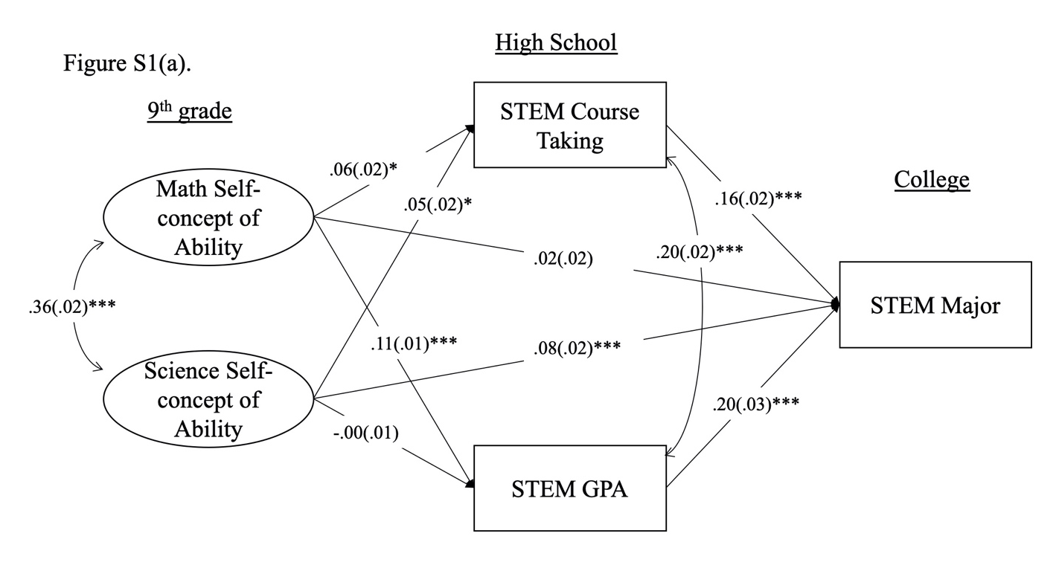

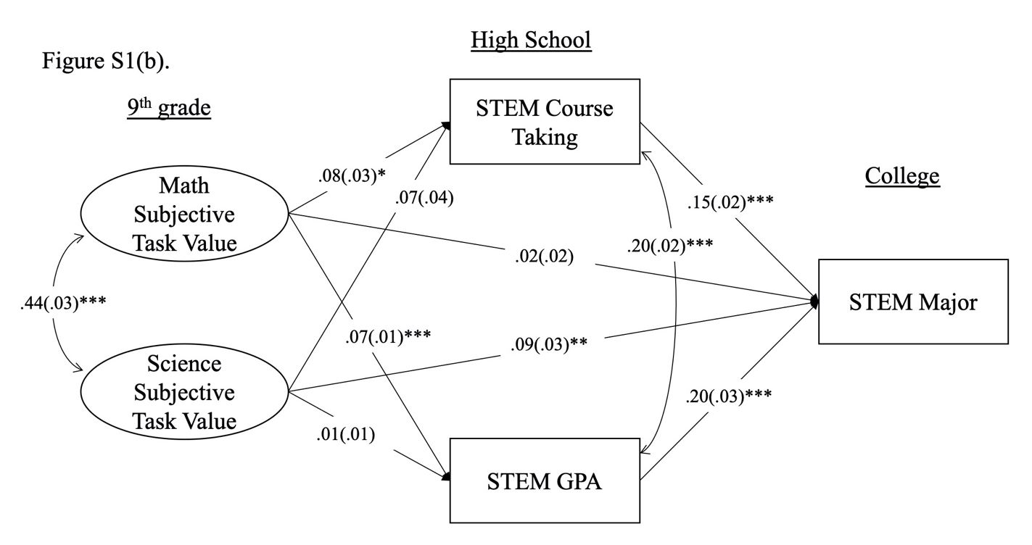
Figure S1. Robustness checks using a subsample of students who remained in the study through the latest phase of data collection. Standardized coefficients (and standard errors) of the predictive paths in the self-concept of ability (a) and subjective task value models (b). Models are fully controlled for parents' highest education, family income, gender, ethnicity, 9th grade math achievement, and high school English GPA. N = 14,040.
*p < .05. **p < .01. ***p < .001.
SOURCE: U.S. Department of Education, National Center for Education Statistics, High School Longitudinal Study of 2009 (HSLS:09).
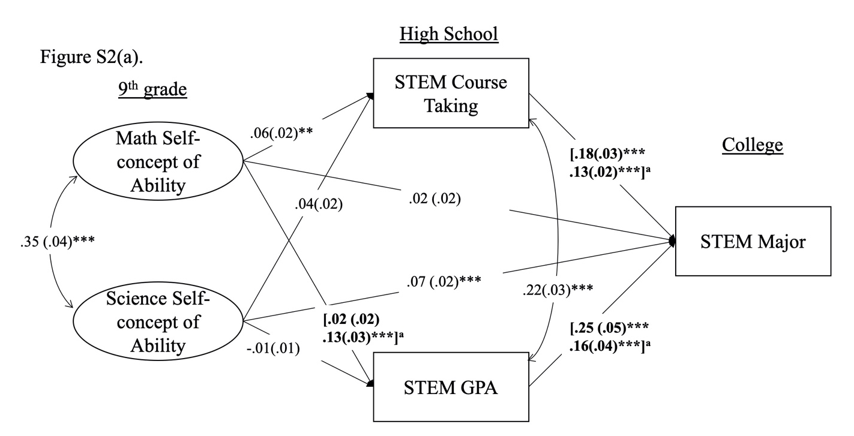
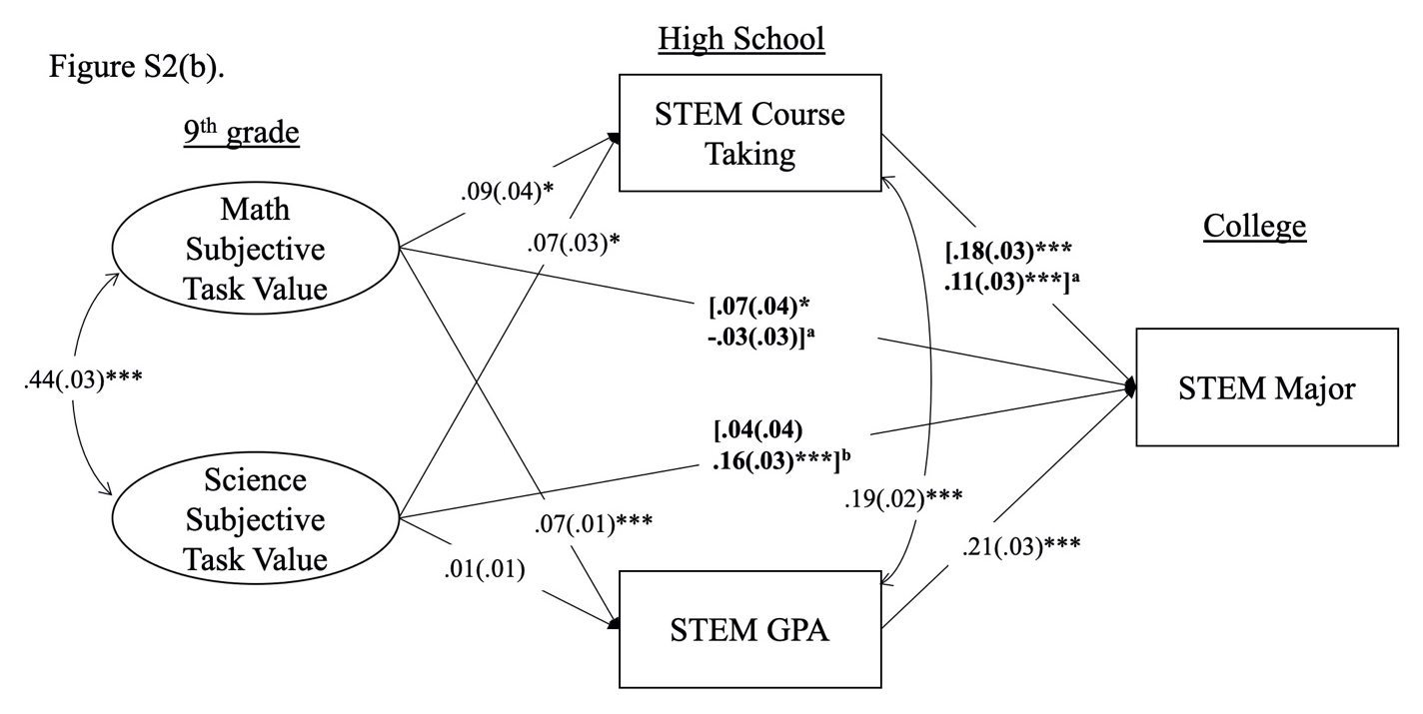
Figure S2. Robustness checks using a subsample of students who remained in the study through the latest phase of data collection. Standardized coefficients (and standard errors) of the predictive paths in the self-concept of ability (a) and subjective task value (b) models for female and male adolescents (female coefficients on top). Paths that are significantly different between gender are bolded. The superscript letter noted the significance of the difference in paths: ªindicates significance at p < .05 level, and ^{b}indicates significance at p < .01 level. Models are fully controlled for parents' highest education, family income, gender, ethnicity, 9th grade math achievement, and high school English GPA. N = 14,040.
*p < .05. **p < .01. ***p < .001.
SOURCE: U.S. Department of Education, National Center for Education Statistics, High School Longitudinal Study of 2009 (HSLS:09).
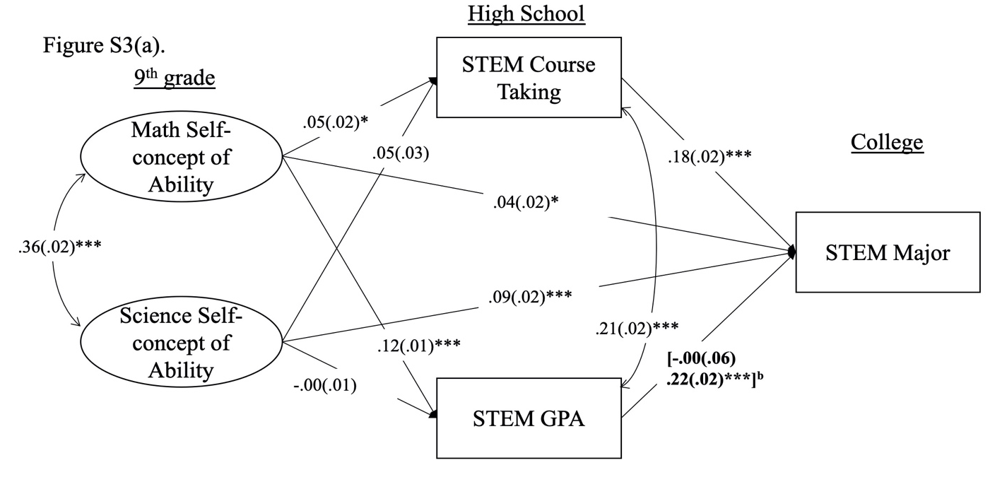
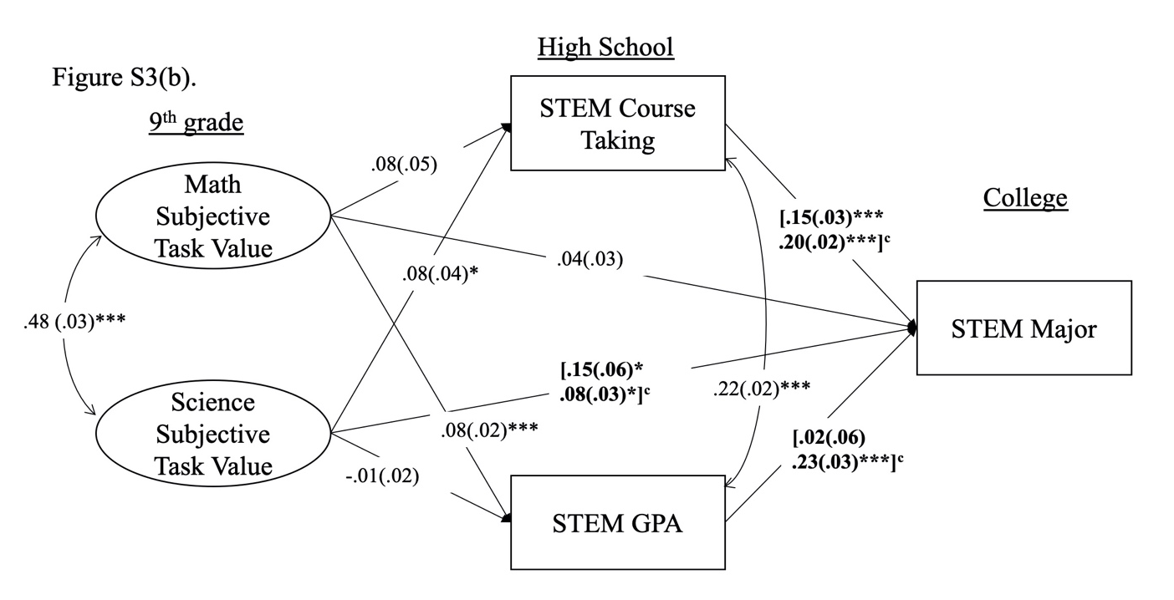
Figure S3. Robustness checks using a subsample of students who remained in the study through the latest phase of data collection. Standardized coefficients (and standard errors) of the predictive paths in the self-concept of ability (a) and subjective task value (b) models for first-generation college students and continuing-generation college students (first-generation college students’ coefficients on top). Paths that are significantly different between the two college generations are bolded. The superscript letter noted the significance of the difference in paths: ªindicates significance at p < .05 level and ^{c}indicates significance at p < .001 level. Models are fully controlled for parents' highest education, family income, gender, ethnicity, 9th grade math achievement, and high school English GPA. n = 11,050.
*p < .05. **p < .01. ***p < .001.
SOURCE: U.S. Department of Education, National Center for Education Statistics, High School Longitudinal Study of 2009 (HSLS:09).

Supplemental Material 2:
Robustness Check for the Definition of First-generation College students
We conducted a robustness check analysis with the multi-group analysis of college generation. We redefined first-generation college students whose parents did not have any college experience or degrees in the robustness check analysis. The robustness check analysis yielded similar results compared to college generation status were defined by parent’s bachelor’s degree (Supplemental Material 2). There was one difference worth noting for the task value model that changed in terms of statistical significance. In the original model (Figure 4b), math subjective task value positively predicted students’ STEM GPA at the same level for first- and continuing-generation college students. In the robustness check, this relation varied across first- and continuing generation college students, Δ χ2 (1) = 22.337, p < .001. Math subjective task value predicted STEM GPA in high school for first-generation college students (β = .12, p < .001), but not for continuing-generation students (β = .04, p = .057) (see Figure S4b).
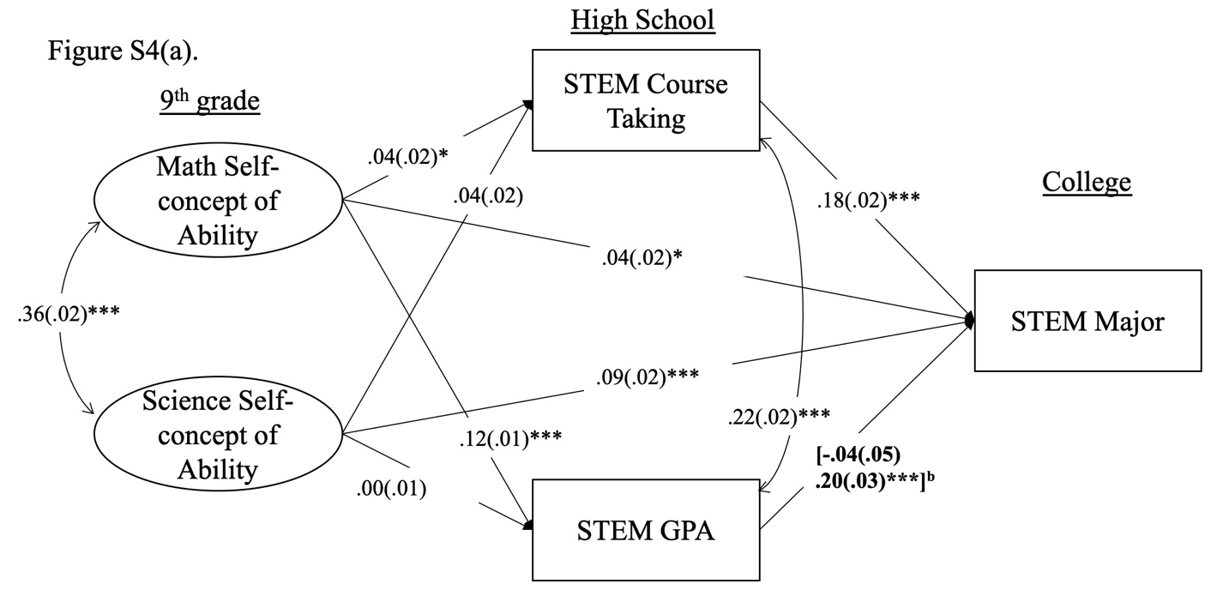
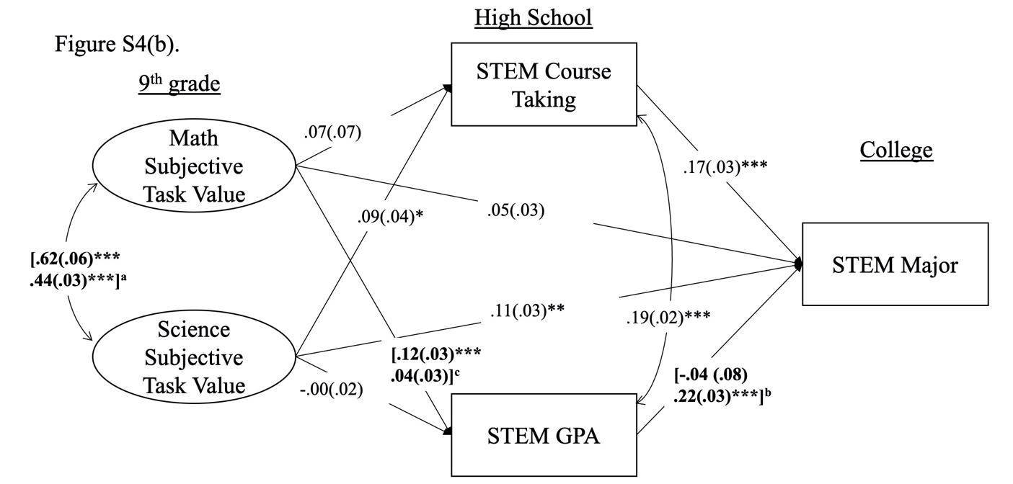
Figure S4. Robustness check of the definition of first-generation college students. Standardized coefficients (and standard errors) of the predictive paths in the self-concept of ability (a) and subjective task value (b) models for first-generation college students and continuing-generation college students (first-generation college students’ coefficients on top) when first-generation college students were defined as either parent have college experience. Paths that are significantly different between the two college generations are bolded. The superscript letter noted the significance of the difference in paths: ^{b}indicates significance at p < .01 level and ^{c}indicates significance at p < .001 level. Models are fully controlled for parents' highest education, family income, gender, ethnicity, 9th grade math achievement, and high school English GPA. n = 11,050.
*p < .05. **p < .01. ***p < .001.
SOURCE: U.S. Department of Education, National Center for Education Statistics, High School Longitudinal Study of 2009 (HSLS:09).

