Supplemental Material for “Prosocial Skills Causally Mediate the Relation between Effective Classroom Management and Academic Competence: An Application of Direction
Dependence Analysis”
Data Visualization and Sensitivity Analyses

In this supplement, we present scatterplots and histograms of covariate-adjusted prosocial behavior (PB), emotional dysregulation (ED), and academic competence (AC) measures and summarize results of sensitivity analyses to evaluate the robustness of DDA results against latent (additional) confounding and measurement error. Figures S1 and S2 show the univariate distributions and the bivariate scatterplots (with LOWESS smoothed line superimposed) for the covariate-adjusted PB, ED, and AC scores.

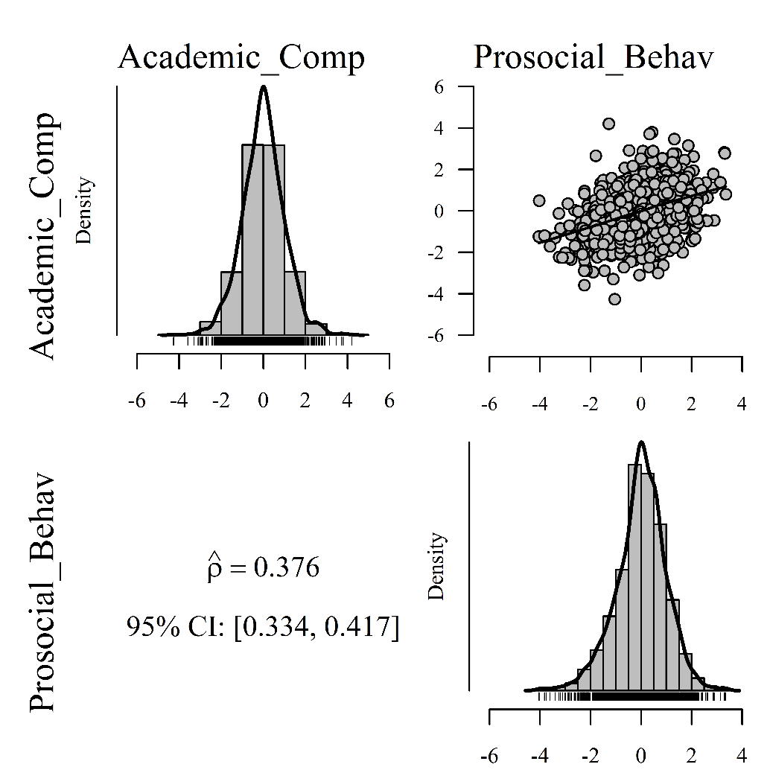
Figure S1: Univariate distributions (main diagonal) and bivariate scatterplot with LOWESS smoothed line superimposed of covariate-adjusted prosocial behavior and academic competence measures.

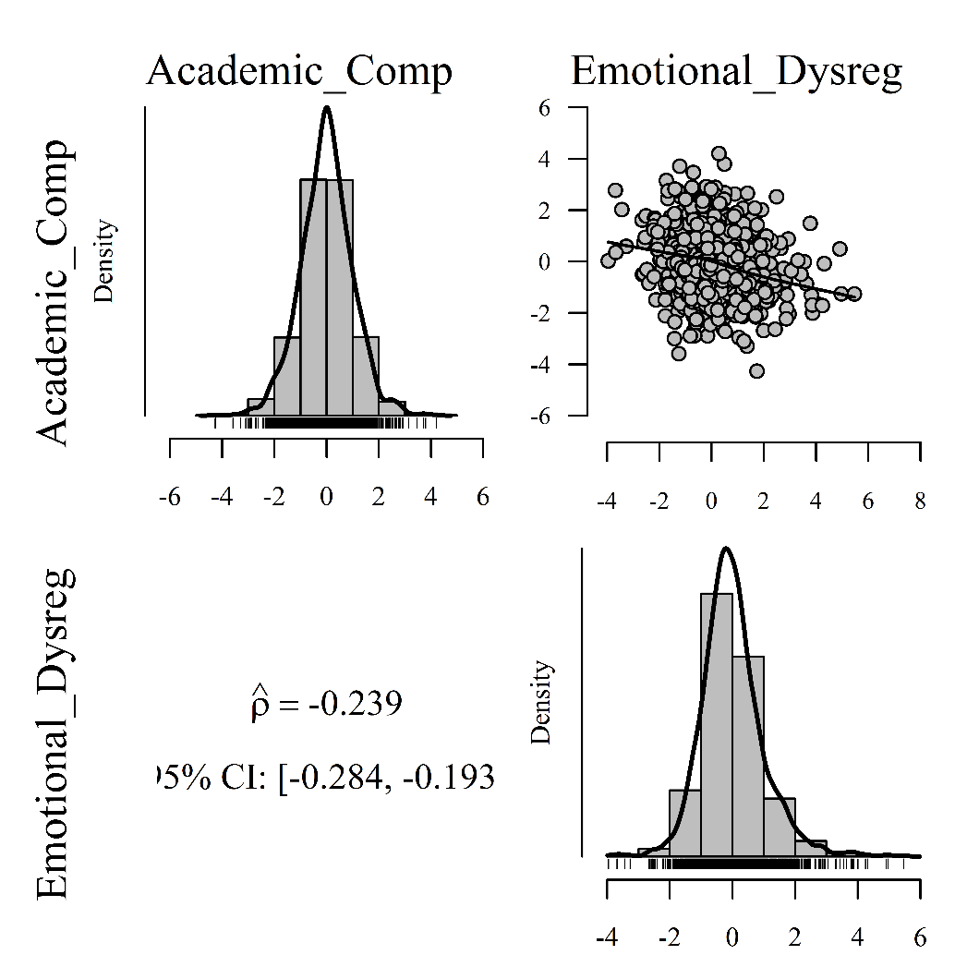
Figure S2: Univariate distributions (main diagonal) and bivariate scatterplot with LOWESS smoothed line superimposed of covariate-adjusted emotional dysregulation and academic competence measures.

Sensitivity Analysis: Latent Confounding and Measurement Error
To evaluate the robustness of DDA model selection against additional (unobserved) confounding, we used a simulation-based sensitivity analysis approach described in Wiedermann and Sebastian (2019). The presence of a confounder (with properties similar to the corresponding tentative predictor) is simulated in both causally competing models. In each model, the percentage of additional confounding (varied from 0 to 100% in increments of 5%) served as the sensitivity parameter. For each confounder scenario, differences in HSIC statistics were computed (200 resamples were used to obtain corresponding 95% percentile bootstrap CIs). Sensitivity results for the two models, PB → AC and AC → PB, are summarized in Figure S3. The left panel gives the HSIC differences for the target model PB → AC, the right panel gives HSIC differences for the alternative model AC → PB. Solid lines refer to the difference in HSIC statistics [Δ(HSIC)] and grey shaded regions reflect the 95% bootstrap CIs. In the left panel, Δ(HSIC) values greater than zero point at the model PB → AC, values smaller than zero point at the alternative model AC → PB. The right panel summarizes sensitivity results for the alternative model AC → PB. Here, Δ(HSIC) values larger than zero suggest the model AC → PB and values smaller than zero point at the model PB → AC. In both analyses, a causal model of the form PB → AC is preferred. Overall, about 20-25% of additional confounding would be needed to render the two competing models indistinguishable.

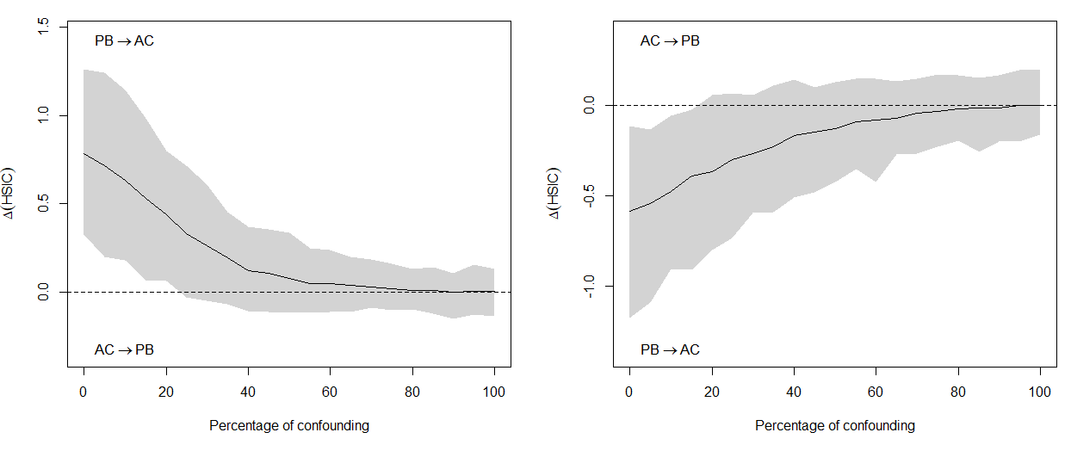
Figure S3: Sensitivity against latent confounding.

Because the presented direction dependence approach does not account for measurement error in composite measures of student behaviors and academic competence, we used a methods of moments approach (MOM; Fuller, 1987) to evaluate distributional properties of observed variables while accounting for measurement error in the tentative predictor (prosocial behavior). In addition, a sensitivity approach (Wiedermann et al., 2018) is used to evaluate the impact of additional measurement error in the tentative outcome (academic competence). Table S1 summarizes DDA estimates together with 95% bootstrap confidence intervals (based on 1000 resamples). In line with previous unadjusted DDA results, prosocial behavior is significantly more skewed than academic competence (Δ(γ) = -0.42; 95% CI = [-0.92; -0.21]) supporting the model PB → AC.

Table S1: Measurement-error-adjusted DDA estimates for PB → AC.
 | Estimate | Mean | Median | 95% CI
Skewness of Prosocial Behavior (PB) | -0.38 | -0.53 | -0.52 | [-0.87; -0.24]
Skewness of Academic Competence (AC) | 0.05 | 0.02 | 0.01 | [-0.17; 0.20]
Differences in Skewnesses (PB - AC) | -0.42 | -0.55 | -0.55 | [-0.92; -0.21]
Note: Mean and Median summarize the location of the bootstrap distribution based on 1000 resamples;
CI = percentile bootstrap confidence interval.

The impact of measurement error in the outcome is summarized in Figure S4. Here, additional measurement error in AC is simulated and the hypothesized reliability is used as a sensitivity parameter. The curved solid line gives the average skewness differences of prosocial behavior and academic competence together with the 95% CI based on 1000 resamples. The dashed vertical lines give the reliability interval for which inferential decisions on the direction of dependence cannot be made. A reliability of academic competence as low as 0.48 would be required to conclude that distributional properties of observed variables no longer support the model PB → AC.
Hypothesized Reliability of Academic Competence (AC)

Figure S4. Sensitivity against measurement error.

References
Fuller, W. A. (1987). Measurement error models. New York, NY: Wiley.
Wiedermann, W., & Merkle, E. C., von Eye, A. (2018). Direction of dependence in measurement error models. British Journal of Mathematical and Statistical Psychology, 71, 117-145. doi: 10.1111/bmsp.12111
Wiedermann, W., & Sebastian, J. (2019b). Sensitivity analysis and extensions of testing the causal direction of dependence: A rejoinder to Thoemmes (2019). Multivariate Behavioral Research, (in press). doi:10.1080/00273171.2019.1659127

