Supplementary Materials

The observational rating system: episodes and scales

We included in our rating system the following LabTAB (Goldsmith, Reilly, Lemery, Longley, & Prescott, 1999) episodes:

- Risk room: The child is left alone to explore a set of novel and ambiguous stimuli, including a large black box with eyes and teeth, a cloth tunnel, a Halloween mask, balance beam, and small staircase (phase 1). After five minutes, the experimenter returns to the room and asked the child to engage in play with each object (phase 2).
- Tower of patience: The child and the experimenter alternate turns in building a tower. During each turn, the experimenter increases delays in placing the block on the tower, making the child wait.
- Stranger approach: The child is briefly left alone in the empty assessment room while the experimenter pretend to go out to look for toys (phase 1). In the experimenter’s absence, a male research assistant (the stranger) enters the room and spoke to the child in a neutral tone (phase 2).
- Exploring new objects: The child enters a room with a set of novel and ambiguous stimuli, including pretend mice in a cage, sticky water-filled gel balls, a mechanical bird, a mechanical spider, and a pretend skull covered under a blanket.
- Pop-up snakes: The experimenter shows the child a pretended can of potato chips, containing instead coiled spring “snakes.” The experimenter then encouraged the child to surprise the child’s parent with the can of snakes.
- Transparent box: The child is asked to select a toy among several toys, taken out of a box by the experimenter (phase 1). Afterwards, the experimenter locks the toy chosen in a transparent box. The child is left in the room with a set of incorrect keys to use to open the box (phase 2).
- Impossibly perfect green circle: The child is instructed to repeatedly draw a circle on a large piece of paper. After each drawing, the experimenter mildly criticizes the circle.

The episodes were coded in accordance with the following newly developed scales:

- Pause to check before exploring a new environment: applied to the Risk-room episode, phase 1. It assess the degree to which the child shows an hesitant behaviour while approaching the environment that coexist with curiosity and interest (based on the assumption that individuals high in SPS pay more attention to stimuli and/or process stimuli more elaborately (Aron, Aron, & Jagiellowicz, 2012)
- Cautious and collaborative attitude towards the experimenter: applied to the Risk-room episode, phase 2. It evaluates the degree of the child’s collaborative and child-to-adult attitude in relation with the experimenter, based on the assumption that children who are more sensitive to the environment, when faced with a relatively new adult figure, because slower in warming up in new environments, may show to a higher extent a more inhibited and cautious behaviour (Aron & Aron, 1997)
- Attending to experimenter’s directions: applied to the Tower of patience episode. It assess the degree to which the child listens at the experimenter’s directions and does not interrupt the experimenter’s play and voice turn; showing a more reactive than proactive behaviour.
- Compliance with the experimenter’s request: applied to the Stranger episode, phase 1. The rationale is the same of scale 2 and 3.
- Fearfulness in response to the stranger’s entrance: applied to the Stranger episode, phase 2; it assesses fearfulness when exposed to new environmental conditions, and specifically to the entrance of a stranger figure. It codes the degree to which the child shows avoidant behaviours and tension in the body to the exposure of a new and potentially threatening social stimuli, as a function of a more in depth process of new environmental stimuli and as captured by negative emotionality in relation to strangers (Aron, 2002)
- Hesitancy paired with curiosity: applied to Exploring New Objects episode. For the rationale see scale 1. However, compared to scale 1, because the environment is more familiar now a slightly less inhibited approach may be expected as well as more startle reactions given the nature of toys
- Positive response/overexcitement: applied to the Pop-up Snake episode, it aims at capturing positive emotional reactivity in response to a positive environmental experience based on the assumption that individuals high in sensitivity are more permeable also to positive stimuli (Lionetti et al., 2018; Nocentini, Menesini, & Pluess, 2018; Slagt, Dubas, van Aken, Ellis, & Dekovic, 2017)
- Attention to toys’ detailed features: applied to the Transparent Box episode, phase 1. It measures the degree to which the child seems to process the details of the toys taken out from the box by the experimenter, based on the assumption that children sensitive to experimental stimuli process details more deeply and may require more time before selecting the preferred toys; they also appreciate more positive environmental features(Pluess et al., 2017) , as it could be a toy for a child
- Careful perseverance when trying to open the box: applied to the Transparent Box, phase 2. It assesses the child’s degree of persistency in opening the box, keeping an adequate and respectful approach (e.g., not shaking the box), as a result of an increased attention for details, as already commented above.
- Preference for (and commitment to drawing) beautiful circles: applied to the Impossibly Perfect Circle episode. It assesses the child’s attitude toward depicting beautiful looking circle. Individual differences may be marked at this age in terms of children’s competencies in drawing, so the coder evaluates the commitment and interest shown toward (even in the presence of distress for the mild critiques of the experimenter) rather than the quality of the circle itself. Its rationale lies in the attention for details and in the preference for beautiful looking stimuli as introduced already above.

z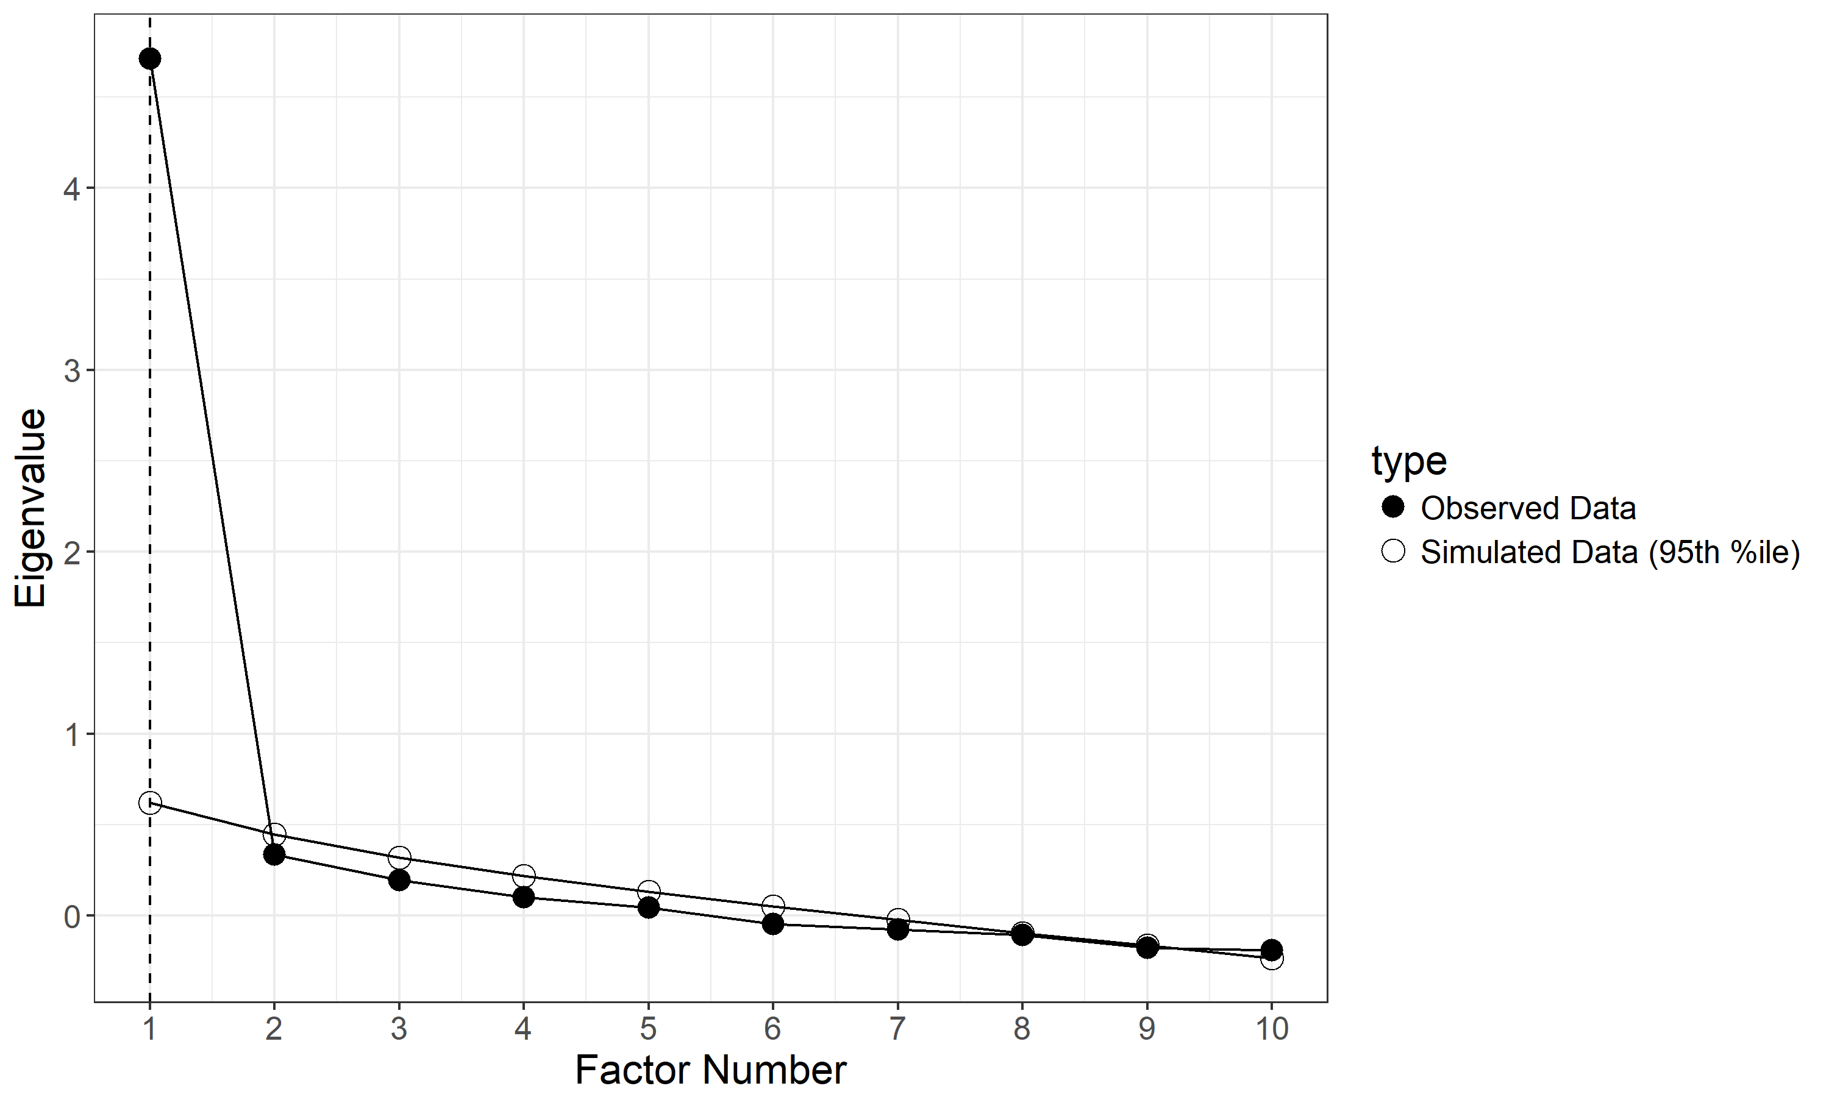
Figure S1: Exploratory Factor Analysis of the HSC rating system in the exploratory sample (N = 161)
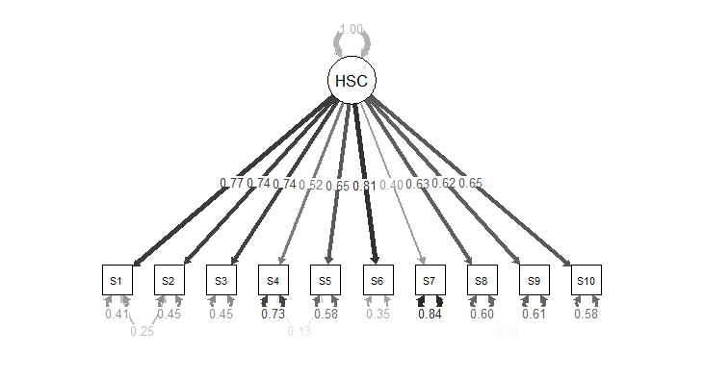
Figure S2: Confirmatory factor analysis of the HSC rating system in the total validation total sample (N = 292)
Items labelled S1 to S10 refer to the following HSC scales: pause to check (S1, risk room), collaborative attitude with the experimenter (S2, risk room episode), attending to experimenter’s directions (S3, tower of patience), compliance with the experimenter’s request (S4, stranger approach), fearfulness in response to stranger’s entrance (S5, stranger’s approach), hesitancy with curiosity (S6, exploring new object), positive overstimulation (S7, pop-up snakes), attention to toys’ features (S8, transparent box), perseverance and carefulness in opening the box (S9, transparent box), preference and commitment to depict the perfect circle (S10, green circle)
Table S1: ICC for the inter-rater agreement on a random selection of 20% of cases
Scale | ICC
Risk Room- Pause to check | .79 [.66 - .87]
Risk Room: Collaborative attitude | .57 [.37- .71]
Tower of patience | .89 [.81 - .93]
Stranger: Compliance | .86 [.71 - .91]
Stranger Fearfulness | .83 [.73 - .90]
Exploring new object | .78 [.64 - .87]
Pop-up Snake | .65 [.47 - .78]
Transparent box: attention | .81 [.68 - .89]
Transparent box: perseverance | .76 [.61 -.85]
Green Circle | .78 [.65 - .86]
HSC mean score | .91 [.85 -.94]

Table S1: Bivariate correlations of study variables
 | 1 | 2 | 3 | 4 | 5 | 6 | 7 | 8 |  | 9 |  | 10
1. HSC | --
2. Sex | .25** | --
3. Permissive parenting | -.02 | .09 | --
4. Authoritative parenting | -.08 | .23* | -.04 | --
5. Authoritarian parenting | .03 | .03 | .33** | -.17* | --
6. Externalizing beh. problems age 3 | -.09 | -.04 | .23** | -.08 | .30** | --
7. Externalizing beh. problems age 6 | -.09 | .04 | .16* | -.15* | .11 | .57** | --
8. Internalizing beh. problems age 3 | .16* | .02 | .21** | -.05 | .22** | .60** | .40** |  | --
9. Internalizing beh. problems age 6 | .10 | .07 | .06 | -.06 | .04 | .37** | .55** |  | .55** |  | --
10. Social competence age 3 | .15* | .22* | -.25** | .17* | -.14* | -.31** | -.20* |  | -.16* |  | -.16* | --
11. Social competence age 6 | .10 | .25* | -.06 | -.22** | -.05 | -.38** | -.39** |  | -.21* |  | -.25* | .30**

Table S2. Estimated parameters from the model comparison approach (Belsky, Pluess, & Widaman, 2013; Widaman et al., 2012). ª Parameter ﬁxed at reported value; SE is not applicable, so is listed as (-).
Externalizing behavioral problems at age three
 |  | Differential Susceptibility |  |  | Diathesis-stress |  | Vantage Sensitivity
Parameters |  | Strong | Weak |  | Strong | Weak | Strong | Weak
B0 |  | 13.93 (0.85) | 13.72 (0.79) |  | 12.52(0.78) | 11.26(1.16) | 14.52(0.84) | 16.79 (2.13)
B1 |  | 0.00(-)ª | - 0.16 (.25) |  | 0.00 (-)ª | 0.31 (0.21) | 0.00 (-)ª | 0.23(0.20)
C |  | 12.79 (1.40) | 12.57 (1.22) |  | 12.57 (-)ª | 12.57(-)ª | 12.57 (-)ª | 12.57 (-)ª
B3 |  | 0.93 (0.27) | 0.93 (0.27) |  | 0.23(0.19) | 0.41(0.23) | 0.27(0.10) | 0.45 (0.19)
Internalizing behavioral problems at age three
B0 | 8.35(0.73) |  | 8.23(1.29) | 8.25(0.64) |  | 8.04(0.96) | 9.03 (0.74) | 11.60(2.10)
B1 | .00(-)ª |  | 0.03(0.21) | 0.00 (-)ª |  | 0.05(0.17) | 0.00 (-)ª | 0.25(0.21)
C | 6.77 (2.19) |  | 6.58(2.83) | 6.58 (-)ª |  | 6.58 (-)ª | 6.58 (-)ª | 6.58 (-)ª
B3 | 0.65(0.23) |  | 0.65(0.23) | 0.59 (1.16) |  | 0.62(0.19) | -0.12(0.09) | 0.07(0.21)
Internalizing behavioral problems at age six
B0 | 2.73(0.53) |  | 3.19(0.60) | 2.60(0.47) |  | 2.86(0.72) | 3.19 (0.55) | 5.28(1.51)
B1 | .00(-)ª |  | -0.15(0.16) | .00(-)ª |  | -0.06(0.13) | .00(-)ª | 0.20(0.13)
C | 7.09 (1.83) |  | 7.90 (1.50) | 7.90 (-)ª |  | 7.90 (-)ª | 7.90 (-)ª | 7.90 (-)ª
B3 | 0.57 (0.19) |  | 0.57 (0.19) | 0.50(0.13) |  | 0.46(0.15) | -0.09(0.07) | 0.08(0.13)
Social competence at age three
B0 | 17.41(0.47) |  | 17.83(0. 95) | 18.06(0.45) |  | 19.19(0.78) | 17.37(0.44) | 17.46(1.01)
B1 | .00(-)ª |  | -0.03(0.07) | .00(-)ª |  | 0.11(0.06) | .00(-)ª | -0.00 (0.05)
C | 45.62 (9.27) |  | 48.66(9.05) | 48.74 (-)ª |  | 48.74 (-)ª | 48.74 (-)ª | 48.74 (-)ª
B3 | 0.14(0.07) |  | 0.14(0.07) | -0.06(0.04) |  | 0.01(0.05) | 0.12(0.03) | 0.12(0.05)
Social competence at age six
B0 | 9.33(0.39) |  | 8.89 (0.98) | 9.74 (0.38) |  | 11.19(0.70) | 9.10 (0.38) | 7.55 (0.88)
B1 | .00(-)ª |  | 0.06 (0.06) | .00(-)ª |  | 0.13(.05) | .00(-)ª | 0.09 (0.05)
C | 56.53 (3.64) |  | 54.05(7.23) | 54.04 (-)ª |  | 54.04 (-)ª | 54.04 (-)ª | 54.04 (-)ª
B3 | 0.18 (0.06) |  | 0.18 (0.06) | 0.02(0.04) |  | 0.10(0.05) | 0.07(0.03) | 0.15 (0.05)

Table S3: Regression parameters for the negative affect follow-up analysis
 | Estimate | Std. Error | p
Externalizing behavioural problems at age 3
Intercept | 1.17 | 5.12
Permissive parenting | 1.00 | 0.44 | .02
Negative affect | 9.92 | 7.70 | .20
HSC | -5.50 | 2.10 | .01
Permissive parenting x Negative affect | -0.74 | 0.63 | 24
Permissive parenting x HSC | 0.41 | 0.19 | .03
Internalizing behavioural problems at age 3
Intercept | .06 | 4.13
Permissive parenting | 0.79 | 0.35 | .03
Negative affect | 7.27 | 6.21 | 0.24
HSC | -3.12 | 1.69 | .07
Permissive parenting x Negative affect | -0.61 | .51 | .23
Permissive parenting x HSC | 0.38 | 0.15 | .01
Social competence at age three
Intercept | 2.10 | 6.53
Authoritative parenting | 0.27 | 0.10 | .01
Negative affect | 15.22 | 10.57 | .15
HSC | -5.23 | 2.29 | .02
Authoritative parenting x Negative affect | -0.25 | 0.16 | .13
Authoritative parenting x HSC | 0.10 | 0.04 | .01
Social competence at age six
Intercept | 3.25 | 5.67
Authoritative parenting | .11 | .09 | .22
Negative affect | -4.98 | 9.07 | .58
HSC | -3.60 | 2.16 | .10
Authoritative parenting x Negative affect | 0.07 | .14 | .63
Authoritative parenting x HSC | .07 | .04 | .08

R script syntax for the model comparison approach (Belsky et al., 2013; Widaman et al., 2012)

#model3a strong differential susceptibly, negative outcome and negative predictor
startlist <- list(B0=1,B3=1,CC=1)
fit3a <- nls(NegOutcome~ Dl*(B0) +
Dh*(B0+B3*(NegEnvironment -CC)),data=dati ,start=startlist)
summary(fit3a)

#model3b weak differential susceptibly, negative outcome and negative predictor
startlist <- list(B0=1,B1=2,B3=1,CC=1)
fit3b <- nls(NegOutcome ~ Dl*(B0+B1*(NegEnvironment -CC)) + Dh*(B0+B3*(NegEnvironment -CC )),data=dati, start=startlist)
summary(fit3b)

#model3c strong diathesis stress, negative outcome and negative predictor
startlist <- list(B0=1,B3=1)
fit3c <- nls(NegOutcome~ Dl*(B0)
+ Dh*(B0+B3*(NegEnvironment -min(PSDQ_Factor3_Permissive_Mother_age3))),
data=dati, start=startlist)
summary(fit3c)

#model3d weak diathesis stress, negative outcome and negative predictor
startlist <- list(B0=1,B1=1,B3=1)
fit3d <- nls(NegOutcome~
+ Dl*(B0+B1*(NegEnvironment -min(NegEnvironment))) +
+ Dh*(B0+B3*(NegEnvironment -min (NegEnvironment))), data=dati,start=startlist)
summary(fit3d)

#model3e strong vantage sensitivity, negative outcome and negative predictor
startlist <- list(B0=1,B3=1)
fit3e <- nls(NegOutcome~ Dl*(B0)
+ Dh*(B0+B3*( NegEnvironment -max(NegEnvironment))),
data=dati,start=startlist)
summary(fit3e)

#model3f weak vantage sensitivity, negative outcome and negative predictor
startlist <- list(B0=1,B1=1,B3=1)
fit3f <- nls(NegOutcome~
+ Dl*(B0+B1*(NegEnvironment –max (NegEnvironment))) +
+ Dh*(B0+B3*(NegEnvironment -max (NegEnvironment))), data =dati, start=startlist)
summary(fit3f)

############

#model3a strong differential susceptibly, positive outcome and positive predictor
startlist <- list(B0=1,B3=1,CC=1)
fit3a <- nls(PosOutcome~ Dl*(B0) +
Dh*(B0+B3*(PosEnvironment -CC)),data=dati,start=startlist)
summary(fit3a)

#model3b weak differential susceptibly, positive outcome and positive predictor
startlist <- list(B0=1,B1=2,B3=1,CC=1)
fit3b <- nls(PosOutcome~ Dl*(B0+B1*(PosEnvironment -CC)) + Dh*(B0+B3*( PosEnvironment -CC )),data=dati,start=startlist)
summary(fit3b)

#model3c strong diathesis stress, positive outcome and positive predictor
startlist <- list(B0=1,B3=1)
fit3c <- nls(PosOutcome~ Dl*(B0)
+ Dh*(B0+B3*(PosEnvironment -max(PosEnvironment))),data=dati, start=startlist)
summary(fit3c)

#model3d weak diathesis stress, positive outcome and positive predictor
startlist <- list(B0=1,B1=1,B3=1)
fit3d <- nls(PosOutcome _age3 ~
+ Dl*(B0+B1*( PosEnvironment -max(PosEnvironment))) +
+ Dh*(B0+B3*( PosEnvironment -max(PosEnvironment))), data =dati,start=startlist)
summary(fit3d)

#model3e strong vantage sensitivity, positive outcome and positive predictor
startlist <- list(B0=1,B3=1)
fit3e <- nls(PosOutcome~ Dl*(B0)
+ Dh*(B0+B3*(PosEnvironment -min(PosEnvironment))),
data=dati,start=startlist)
summary(fit3d)

#model3f weak vantage sensitivity, positive outcome and positive predictor
startlist <- list(B0=1,B1=1,B3=1)
fit3f <- nls(PosOutcome~
+ Dl*(B0+B1*(PosEnvironment -min(PosEnvironment))) +
+ Dh*(B0+B3*(PosEnvironment -min(PosEnvironment))), data =dati,start=startlist)
summary(fit3d)

References
Aron, E. N. (2002). The Highly Sensitive Child. USA: Broadway Book - Thorsons.
Aron, E. N., & Aron, A. (1997). Sensory-processing sensitivity and its relation to introversion and emotionality. Journal of Personality and Social Psychology, 73(2), 345-368.
Aron, E. N., Aron, A., & Jagiellowicz, J. (2012). Sensory processing sensitivity: a review in the light of the evolution of biological responsivity. Personality and Social Psychology Review, 16(3), 262-282. doi:10.1177/1088868311434213
Belsky, J., Pluess, M., & Widaman, K. F. (2013). Confirmatory and competitive evaluation of alternative gene-environment interaction hypotheses. Journal of Child Psychology and Psychiatry and Allied Disciplines, 54(10), 1135-1143. doi:10.1111/jcpp.12075
Goldsmith, H. H., Reilly, J., Lemery, K. S., Longley, S., & Prescott, A. (1999). The Laboratory Temperament Assessment Battery - Preschool version.
Lionetti, F., Aron, A., Aron, E. N., Burns, L. G., Jagiellowicz, J., & Pluess, M. (2018). Dandelions, Tulips and Orchids: evidence for the existence of low-sensitive, medium-sensitive, and high-sensitive individuals Translational Psychiatry, 8(24). doi:doi:10.1038/s41398-017-0090-6
Nocentini, A., Menesini, E., & Pluess, M. (2018). The Personality Trait of Environmental Sensitivity Predicts Children’s Positive Response to School-Based Anti-Bullying Intervention. Clinical Psychological Science. doi:doi:10.1177/2167702618782194
Pluess, M., Assary, E., Lionetti, F., Lester, K. J., Krapohl, E., Aron, E. N., & Aron, A. (2017). Environmental Sensitivity in Children: Development of the Highly Sensitive Child Scale and Identification of Sensitivity Groups. Developmental Psychology. doi:10.1037/dev0000406
Slagt, M., Dubas, J. S., van Aken, M. A., Ellis, B. J., & Dekovic, M. (2017). Sensory Processing Sensitivity as a Marker of Differential Susceptibility to Parenting. Developmental Psychology, Online first publication. doi: http://dx.doi.org/10.1037/dev00004
Widaman, K. F., Helm, J. L., Castro-Schilo, L., Pluess, M., Stallings, M. C., & Belsky, J. (2012). Distinguishing ordinal and disordinal interactions. Psychological Methods, 17(4), 615-622. doi:10.1037/a0030003

