Supplemental Table 1

Correlations of Overall Iowa Gambling Task (IGT) Performance by Assessment Wave

 | Year 0 | Year 2 | Year 4 | Year 6 | Year 8
Year 0 | -
Year 2 | .45 | -
Year 4 | .42 | .50 | -
Year 6 | .30 | .33 | .51 | -
Year 8 | .44 | .33 | .42 | .62 | -
Note. Pairwise deletion was used for missing values. Year 0 represents the baseline of the study. Overall IGT performance = (good-bad) selections across all 100 trials. All correlations are statistically significant at p < .01.

Supplemental Table 2

Correlations of Decision-Making Under Ambiguity by Assessment Wave

 | Year 0 | Year 2 | Year 4 | Year 6 | Year 8
Year 0 | -
Year 2 | .17* | -
Year 4 | .24* | .36** | -
Year 6 | .07 | .14 | .43** | -
Year 8 | .23* | .09 | .48** | .38** | -
Note. Pairwise deletion was used for missing values. Year 0 represents the baseline of the study. Ambiguity metric = (good-bad) selections across the first 40 trials.
* = p < .05, ** = p < .01.
Supplemental Table 3

Correlations of Decision-Making Under Risk by Assessment Wave

 | Year 0 | Year 2 | Year 4 | Year 6 | Year 8
Year 0 | -
Year 2 | .46** | -
Year 4 | .41** | .50** | -
Year 6 | .42** | .40** | .52** | -
Year 8 | .45** | .35** | .32* | .59** | -
Note. Pairwise deletion was used for missing values. Year 0 represents the baseline of the study. Risk metric = (good-bad) selections across the last 60 trials.
* = p < .05. ** = p < .01.

Supplemental Table 4

Comparison of Bayesian Information Criterion (BIC), Weight of Evidence for BIC (bWeight), Akaike Information Criterion (AIC), and Weight of Evidence for AIC (aWeight) for Adjusted Models of Overall Iowa Gambling Task Performance

Model | BIC | bWeight | AIC | aWeight
1. Unadjusted model with age | 6283.8 | < .001 | 6221.4 | < .001
2. Model with age, sex, intelligence, BIS, BAS and overall experience | 6269.7 | .87 | 6171.8 | .35
3. Model with age, sex, intelligence, BIS, BAS, overall experience, and age by overall experience interaction | 6273.6 | .12 | 6171.2 | .46
4. Model with age, sex, intelligence, BIS, BAS, overall experience, and all between subject interaction terms | 6293.2 | < .001 | 6172.9 | .19
Notes. BIS = Behavioral Inhibition System. BAS = Behavioral Activation System. A likelihood ratio test comparing Model 2 and Model 3 was not significant (p = .11). Bolded font indicates best-fitting model for the criterion.

Supplemental Table 5
Comparison of Bayesian Information Criterion (BIC), Weight of Evidence for BIC (bWeight), Akaike Information Criterion (AIC), and Weight of Evidence for AIC (aWeight) for Adjusted Models of Decision-Making Under Ambiguity

Model | BIC | bWeight | AIC | aWeight
1. Unadjusted model with age | 5233.0 | .29 | 5161.7 | < .001
2. Model with age, sex, intelligence, BIS, BAS and overall experience | 5231.4 | .66 | 5124.5 | .59
3. Model with age, sex, intelligence, BIS, BAS, overall experience, and age by overall experience interaction | 5236.7 | .05 | 5125.4 | .39
4. Model with age, sex, intelligence, BIS, BAS, overall experience, and all between subject interaction terms | 5260.3 | < .001 | 5131.2 | .02
Note. BIS = Behavioral Inhibition System. BAS = Behavioral Activation System. Bolded font indicates best-fitting model for the criterion.

Supplemental Table 6

Comparison of Bayesian Information Criterion (BIC), Weight of Evidence for BIC (bWeight), Akaike Information Criterion (AIC), and Weight of Evidence for AIC (aWeight) for Adjusted Models of Decision-Making Under Risk

Model Fit | BIC | bWeight | AIC | aWeight
1. Unadjusted model with age | 5899.4 | .05 | 5832.5 | < .001
2. Model with age, sex, intelligence, BIS, BAS and overall experience | 5893.6 | .94 | 5791.2 | .58
3. Model with age, sex, intelligence, BIS, BAS, overall experience, and age by overall experience interaction | 5903.3 | .007 | 5792.0 | .39
4. Model with age, sex, intelligence, BIS, BAS, overall experience, and all between subject interaction terms | 5926.1 | < .001 | 5796.9 | .03
Note. BIS = Behavioral Inhibition System. BAS = Behavioral Activation System. Bolded font indicates best-fitting model for the criterion.

Supplemental Table 7

Comparison of Bayesian Information Criterion (BIC), Weight of Evidence for BIC (bWeight), Akaike Information Criterion (AIC), and Weight of Evidence for AIC (aWeight) for Adjusted Models of Overall Iowa Gambling Task Performance with Behavioral Inhibition/Behavioral Activation System Subscales (BIS/BAS)

Model Fit | BIC | bWeight | AIC | aWeight
1. Unadjusted model with age | 6283.8 | < .001 | 6221.4 | < .001
2. Model with age, sex, intelligence, BIS/BAS subscales and overall experience | 6237.9 | .87 | 6113.6 | .40
3. Model with age, sex, intelligence, BIS/BAS subscales, overall experience, and age by overall experience interaction | 6241.7 | .13 | 6612.9 | .57
4. Model with age, sex, intelligence, BIS/BAS subscales, overall experience, and all between subject interaction terms | 6278.9 | < .001 | 6119.0 | .03
Note. A likelihood ratio test comparing Model 2 and Model 3 was not significant (p = .10). Bolded font indicates best-fitting model for the criterion.

Supplemental Table 8

Comparison of Best-Fitting Model with Unadjusted Model of Overall Iowa Gambling Task Performance with Behavioral Inhibition/Behavioral Activation System Subscales (BIS/BAS)

Between-Subjects  Effects | Within-Subjects Effects | Unadjusted Model | Final Model
Intercept (SE) |  | 20.13** (1.88) | 24.46** (2.79)
Age (SE) |  | 3.74** (.31) | 3.60** (.31)
Participant Sex (SE) |  | - | -6.60 (3.79)
Intelligence (SE) |  | - | .42* (.18)
Anxiety (SE) |  | - | .71 (.67)
Fear (SE) |  | - | 1.59 (1.44)
Fun-Seeking (SE) |  | - | -.58 (1.21)
Drive (SE) |  | - | -.99 (.69)
RR (SE) |  | - | -1.18 (.66)
Overall Experience (SE) |  | - | 2.99 (1.50)*
 | Intelligence (SE) | - | .46 (.25)
 | Anxiety (SE) | - | .12 (.88)
 | Fear (SE) | - | -.07 (1.47)
 | Fun-Seeking (SE) | - | -.48 (.85)
 | Drive (SE) | - | -1.46 (1.46)
 | RR (SE) | - | 2.72 (1.59)
Variance Components
Intercept |  | 429.80 | 344.10
Residual |  | 718.61 | 705.30
Model Fit
BIC |  | 6284 | 6238
Note. SE = standard error. RR = Reward Responsiveness. BIC = Bayesian Information Criterion. Age, estimated intelligence, overall experience, and BIS/BAS subscales are grand-mean centered. Participant sex is dummy-coded where 0 = male, 1 = female.
* = p < .05. ** = p < .01.

Supplemental Table 9

Comparison of Bayesian Information Criterion (BIC), Weight of Evidence for BIC (bWeight), Akaike Information Criterion (AIC), and Weight of Evidence for AIC (aWeight) for Adjusted Models of Decision-Making Under Ambiguity with Behavioral Inhibition/Behavioral Activation System Subscales (BIS/BAS)

Model Fit | BIC | bWeight | AIC | aWeight
1. Unadjusted model with age | 5233.0 | < .001 | 5161.7 | < .001
2. Model with age, sex, intelligence, BIS/BAS subscales and overall experience | 5221.8 | .91 | 5078.6 | .53
3. Model with age, sex, intelligence, BIS/BAS subscales, overall experience, and age by overall experience interaction | 5216.5 | .09 | 5078.8 | .46
4. Model with age, sex, intelligence, BIS/BAS subscales, overall experience, and all between subject interaction terms | 5255.1 | < .001 | 5086.3 | .01
Note. A likelihood ratio test comparing Model 2 and Model 3 was not significant (p = .19). Bolded font indicates best-fitting model for the criterion.

Supplemental Table 10

Comparison of Best-Fitting Model with Unadjusted Model of Decision-Making Under Ambiguity with Behavioral Inhibition/Behavioral Activation System Subscales (BIS/BAS)

Between-Subjects  Effects | Within-Subjects Effects | Unadjusted Model | Final Model
Intercept (SE) |  | 1.73* (.69) | 1.88 (1.01)
Age (SE) |  | .85** (.13) | .88** (.14)
Participant Sex (SE) |  | - | -.94 (1.32)
Intelligence (SE) |  | - | .03 (.06)
Anxiety (SE) |  | - | .17 (.24)
Fear (SE) |  | - | .87 (.50)
Fun-Seeking (SE) |  | - | .31 (.45)
Drive (SE) |  | - | -.31 (.24)
RR (SE) |  | - | -.31 (.22)
Overall Experience (SE) |  | - | 1.66** (.57)
 | Intelligence (SE) | - | .20 (.12)
 | Anxiety (SE) | - | -.09 (.41)
 | Fear (SE) | - | -.13 (.70)
 | Fun-Seeking (SE) | - | -.34 (.39)
 | Drive (SE) | - | -.10 (.73)
 | RR (SE) | - | .88 (.78)
Variance Components
Intercept |  | 68.89 | 58.82
Age |  | .28 | .26
Residual |  | 125.38 | 125.36
Model Fit
BIC |  | 5233 | 5222
Note. SE = standard error. RR = Reward Responsiveness. BIC = Bayesian Information Criterion. Age, estimated intelligence, overall experience, and BIS/BAS subscales are grand-mean centered. Participant sex is dummy-coded where 0 = male, 1 = female.
* = p < .05. ** = p < .01.

Supplemental Table 11

Comparison of Bayesian Information Criterion (BIC), Weight of Evidence for BIC (bWeight), Akaike Information Criterion (AIC), and Weight of Evidence for AIC (aWeight) for Adjusted Models of Decision-Making Under Risk with Behavioral Inhibition/Behavioral Activation System Subscales (BIS/BAS)

Model Fit | BIC | bWeight | AIC | aWeight
1. Unadjusted model with age | 5899.4 | < .001 | 5832.5 | < .001
2. Model with age, sex, intelligence, BIS/BAS subscales and overall experience | 5864.9 | .99 | 5736.1 | .64
3. Model with age, sex, intelligence, BIS/BAS subscales, overall experience, and age by overall experience interaction | 5874.9 | .006 | 5737.3 | .36
4. Model with age, sex, intelligence, BIS/BAS subscales, overall experience, and all between subject interaction terms | 5915.4 | < .001 | 5746.7 | .003
Note. Bolded font indicates best-fitting model for the criterion.

Supplemental Table 12

Comparison of Best-Fitting Model with Unadjusted Model of Decision-Making Under Risk with Behavioral Inhibition/Behavioral Activation System Subscales (BIS/BAS)

Between-Subjects Effects | Within-Subjects Effects | Unadjusted Model | Final Model
Intercept (SE) |  | 20.38** (1.56) | 24.23** (2.18)
Age (SE) |  | 2.89** (.22) | 2.81** (.22)
Age² (SE) |  | -.08* (.03) | -.08* (.03)
Participant Sex (SE) |  | - | -5.66* (2.84)
Intelligence (SE) |  | - | .33* (.13)
Anxiety (SE) |  | - | .67 (.50)
Fear (SE) |  | - | .15 (1.09)
Fun-Seeking (SE) |  | - | -.59 (.90)
Drive (SE) |  | - | -.41 (.51)
RR (SE) |  | - | -1.04* (.50)
 | Intelligence (SE) | - | .21 (.19)
 | Anxiety (SE) | - | .01 (.65)
 | Fear (SE) | - | .15 (1.09)
 | Fun-Seeking (SE) | - | -.22 (.61)
 | Drive (SE) | - | -1.24 (1.07)
 | RR (SE) | - | 2.17 (1.16)
Variance Components
Intercept |  | 239.80 | 171.97
Residual |  | 390.64 | 405.73
Model Fit
BIC |  | 5899 | 5865
Note. SE = standard error. RR = Reward Responsiveness. BIC = Bayesian Information Criterion. Age, estimated intelligence, overall experience, and BIS/BAS subscales are grand-mean centered. Participant sex is dummy-coded where 0 = male, 1 = female.
* = p < .05. ** = p < .01.

Supplemental Table 13

Comparison of Bayesian Information Criterion (BIC), Weight of Evidence for BIC (bWeight), Akaike Information Criterion (AIC), and Weight of Evidence for AIC (aWeight) for Unadjusted Models of Estimated Intelligence

Model | BIC | bWeight | AIC | aWeight
1. Null model (intercept only) | 4626.4 | .01 | 4568.3 | < .001
2. Linear effect of age and random effect of intercept | 4617.4 | .94 | 4554.8 | .69
3. Linear and quadratic effects of age and random effect of intercept | 4623.4 | .05 | 4556.4 | .31
Note. Bolded font indicates best-fitting model for the criterion.

Supplemental Table 14

Comparison of Bayesian Information Criterion (BIC), Weight of Evidence for BIC (bWeight), Akaike Information Criterion (AIC), and Weight of Evidence for AIC (aWeight) for Unadjusted Models of Behavioral Inhibition System Total Score

Model | BIC | bWeight | AIC | aWeight
1. Null model (intercept only) | 3306.3 | < .001 | 3248.3 | < .001
2. Linear effect of age and random effect of intercept | 3270.5 | .95 | 3208.0 | .67
3. Linear and quadratic effects of age and random effect of intercept | 3276.4 | .05 | 3209.5 | .33
Note. Bolded font indicates best-fitting model for the criterion.

Supplemental Table 15

Comparison of Bayesian Information Criterion (BIC), Weight of Evidence for BIC (bWeight), Akaike Information Criterion (AIC), and Weight of Evidence for AIC (aWeight) for Unadjusted Models of Behavioral Activation System Total Score

Model | BIC | bWeight | AIC | aWeight
1. Null model (intercept only) | 3715.9 | .20 | 3657.9 | < .01
2. Linear effect of age and random effect of intercept | 3716.7 | .14 | 3654.2 | .02
3. Linear and quadratic effects of age and random effect of intercept | 3713.6 | .66 | 3646.6 | .98
Note. Bolded font indicates best-fitting model for the criterion.

Supplemental Table 16

Comparison of Bayesian Information Criterion (BIC), Weight of Evidence for BIC (bWeight), Akaike Information Criterion (AIC) and Weight of Evidence for AIC (aWeight) for Unadjusted Models of Behavioral Inhibition System Anxiety Subscale

Model | BIC | bWeight | AIC | aWeight
1. Null model (intercept only) | 2998.1 | < .001 | 2940.2 | < .001
2. Linear effect of age and random effect of intercept | 2968.7 | .96 | 2906.3 | .73
3. Linear and quadratic effects of age and random effect of intercept | 2975.1 | .04 | 2908.3 | .27
Note. Bolded font indicates best-fitting model for the criterion.

Supplemental Table 17

Comparison of Bayesian Information Criterion (BIC), Weight of Evidence for BIC (bWeight), Akaike Information Criterion (AIC) and Weight of Evidence for AIC (aWeight) for Unadjusted Models of Behavioral Inhibition System Fear Subscale

Model | BIC | bWeight | AIC | aWeight
1. Null model (intercept only) | 2218.2 | .03 | 2160.3 | .001
2. Linear effect of age and random effect of intercept | 2211.6 | .79 | 2149.3 | .32
3. Linear and quadratic effects of age and random effect of intercept | 2214.5 | .18 | 2147.7 | .68
Note. A likelihood ratio test comparing Model 2 and Model 3 was not significant (p = .06). Bolded font indicates best-fitting model for the criterion.

Supplemental Table 18

Comparison of Bayesian Information Criterion (BIC), Weight of Evidence for BIC (bWeight), Akaike Information Criterion (AIC), and Weight of Evidence for AIC (aWeight) for Unadjusted Models of Behavioral Activation System Drive Subscale

Model | BIC | bWeight | AIC | aWeight
1. Null model (intercept only) | 2810.3 | < .01 | 2752.2 | < .001
2. Linear effect of age and random effect of intercept | 2799.7 | .41 | 2737.2 | .07
3. Linear and quadratic effects of age and random effect of intercept | 2798.9 | .59 | 2732.0 | .93
Note. Bolded font indicates best-fitting model for the criterion.

Supplemental Table 19

Comparison of Bayesian Information Criterion (BIC), Weight of Evidence for BIC (bWeight), Akaike Information Criterion (AIC), and Weight of Evidence for AIC (aWeight) for Unadjusted Models of Behavioral Activation System Fun-Seeking Subscale

Model | BIC | bWeight | AIC | aWeight
1. Null model (intercept only) | 2676.5 | .95 | 2618.5 | .41
2. Linear effect of age and random effect of intercept | 2683.0 | .04 | 2620.5 | .15
3. Linear and quadratic effects of age and random effect of intercept | 2685.3 | .01 | 2618.3 | .44
Note. Likelihood ratio tests comparing Model 1 and Model 2 (p = .92) and Model 1 and Model 3 (p = .12) were not significant. Bolded font indicates best-fitting model for the criterion.

Supplemental Table 20

Comparison of Bayesian Information Criterion (BIC), Weight of Evidence for BIC (bWeight), Akaike Information Criterion (AIC), and Weight of Evidence for AIC (aWeight) for Unadjusted Models of Behavioral Activation System Reward Responsiveness Subscale

Model | BIC | bWeight | AIC | aWeight
1. Null model (intercept only) | 2578.4 | .60 | 2520.4 | .04
2. Linear effect of age and random effect of intercept | 2580.1 | .27 | 2517.6 | .18
3. Linear and quadratic effects of age and random effect of intercept | 2581.6 | .13 | 2514.6 | .78
Note. Likelihood ratio tests comparing Model 1 and Model 2 (p = .03), Model 1 and Model 3 (p < .01), and Model 2 and 3 (p = .03) were all significant. Bolded font indicates best-fitting model for the criterion.

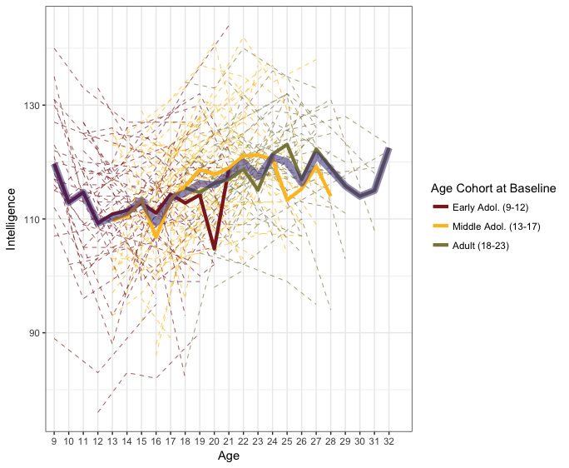

Supplemental Figure 1. Estimated intelligence for all subjects (dashed lines) during the study. The three opaque lines represent the average of a cohort at a given age. The transparent, purple line represents the average intelligence at each age across cohorts. Adol. = adolescent.
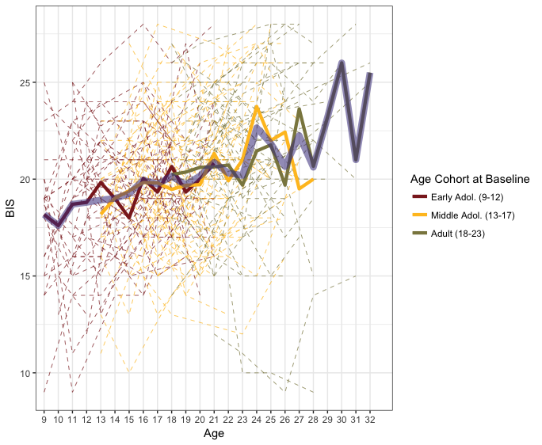
Supplemental Figure 2. Total Behavioral Inhibition System (BIS) scores for all subjects (dashed lines) during the study. The three opaque lines represent the average of a cohort at a given age. The transparent, purple line represents the average BIS score at each age across cohorts. Adol. = adolescent.

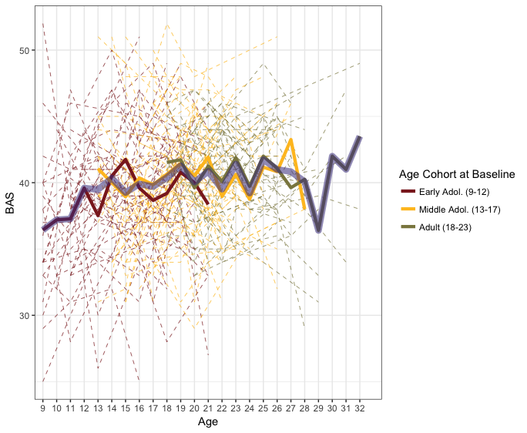
Supplemental Figure 3. Total Behavioral Activation System (BAS) scores for all subjects (dashed lines) during the study. The three opaque lines represent the average of a cohort at a given age. The transparent, purple line represents the average BAS score at each age across cohorts. Adol. = adolescent.
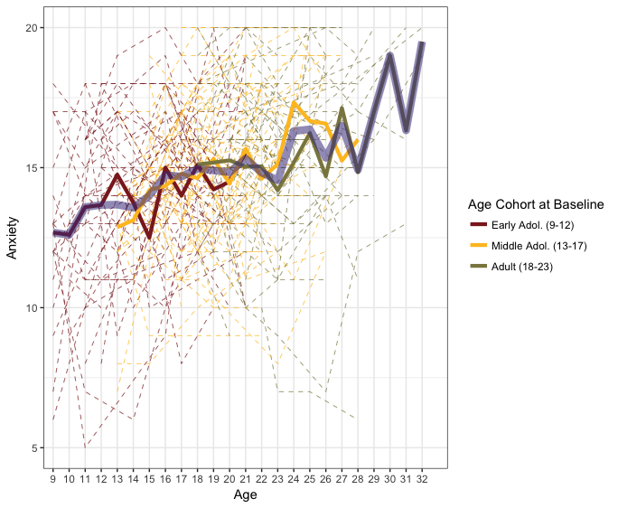
Supplemental Figure 4. Anxiety subscale scores of the Behavioral Inhibition System for all subjects (dashed lines) during the study. The three opaque lines represent the average of a cohort at a given age. The transparent, purple line represents the average Anxiety score at each age across cohorts. Adol. = adolescent.
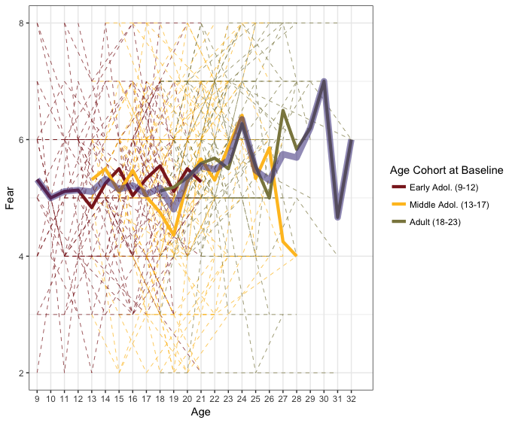
Supplemental Figure 5. Fear subscale scores of the Behavioral Inhibition System for all subjects (dashed lines) during the study. The three opaque lines represent the average of a cohort at a given age. The transparent, purple line represents the average Fear score at each age across cohorts. Adol. = adolescent.

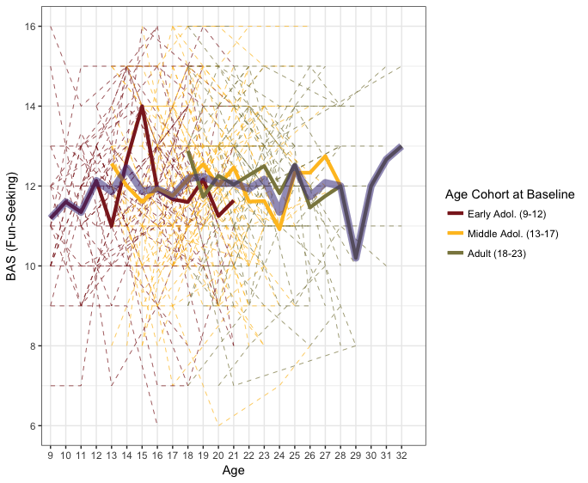
Supplemental Figure 6. Fun-Seeking subscale scores of the Behavioral Activation System for all subjects (dashed lines) during the study. The three opaque lines represent the average of a cohort at a given age. The transparent, purple line represents the average Fun-Seeking score at each age across cohorts. Adol. = adolescent.

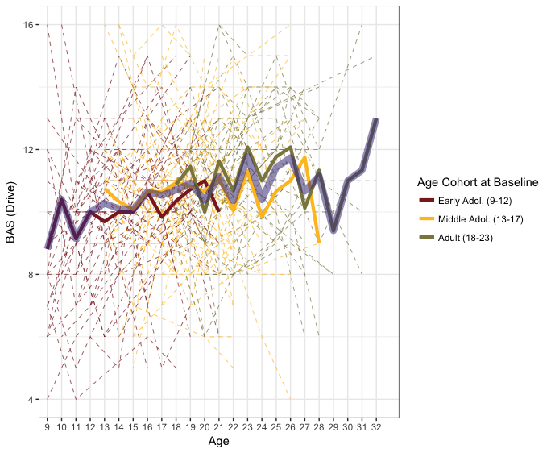
Supplemental Figure 7. Drive subscale scores of the Behavioral Activation System for all subjects (dashed lines) during the study. The three opaque lines represent the average of a cohort at a given age. The transparent, purple line represents the average Drive score at each age across cohorts. Adol. = adolescent.
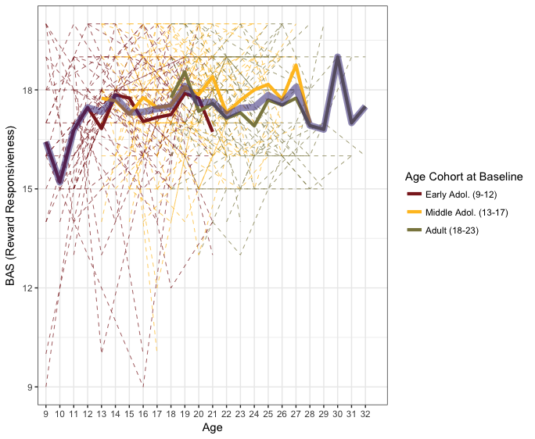
Supplemental Figure 8. Reward Responsiveness (RR) subscale scores of the Behavioral Activation System (BAS) for all subjects (dashed lines) during the study. The three opaque lines represent the average of a cohort at a given age. The transparent, purple line represents the average RR score at each age across cohorts. Adol. = adolescent.

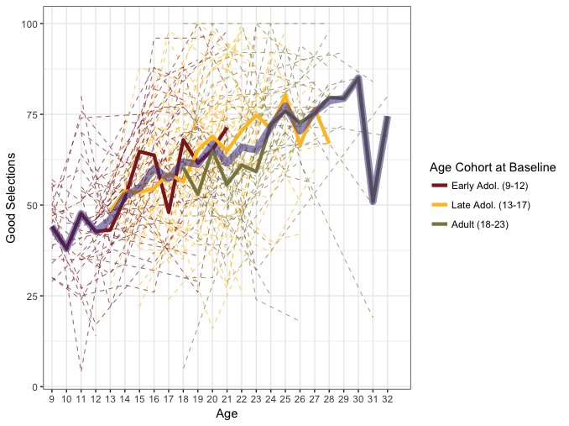
Supplemental Figure 9. Good deck selections on the IGT for all subjects (dashed lines) during the study. The three opaque lines represent the average of a cohort at a given age. The transparent, purple line represents the average number of good deck selections at each age across cohorts. Adol. = adolescent.

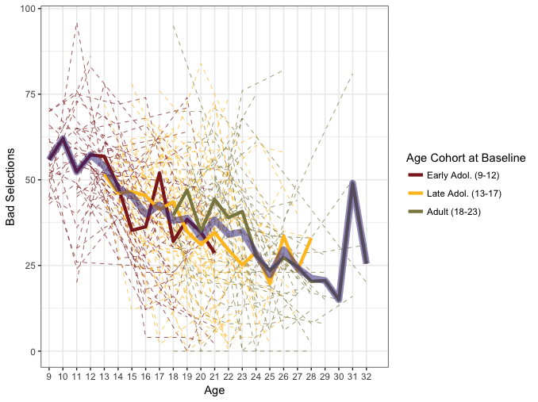
Supplemental Figure 10. Bad deck selections on the IGT for all subjects (dashed lines) during the study. The three opaque lines represent the average of a cohort at a given age. The transparent, purple line represents the average number of bad deck selections at each age across cohorts. Adol. = adolescent.

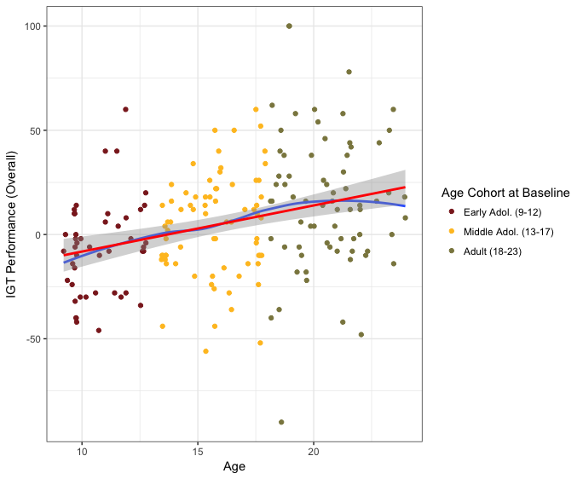
Supplemental Figure 11. Scatterplot of overall Iowa Gambling Task (IGT) performance at baseline (Year 0) of the study for all subjects (colored dots). The red line represents linear fitting and the gray area represents the 95 percent confidence interval of the linear fit. The blue line represents LOESS fitting. Adol. = adolescent.
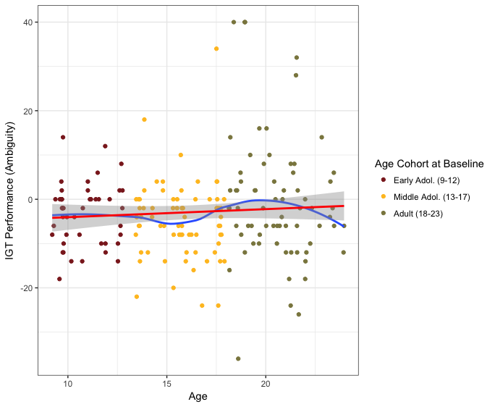
Supplemental Figure 12. Scatterplot of decision-making under ambiguity at baseline (Year 0) of the study for all subjects (colored dots). The red line represents linear fitting and the gray area represents the 95 percent confidence interval of the linear fit. The blue line represents LOESS fitting. IGT = Iowa Gambling Task. Adol. = adolescent.

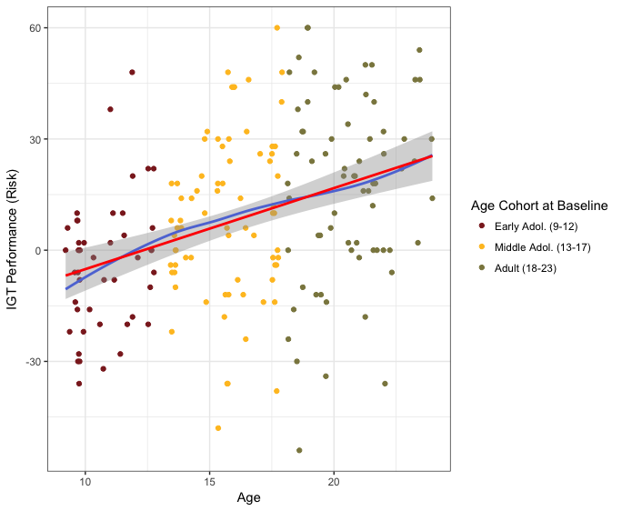

Supplemental Figure 13. Scatterplot of decision-making under risk at baseline (Year 0) of the study for all subjects (colored dots). The red line represents linear fitting and the gray area represents the 95 percent confidence interval of the linear fit. The blue line represents LOESS fitting. IGT = Iowa Gambling Task. Adol. = adolescent.

