Supplemental Materials
Cognitive Performance Across the Life Course of Bolivian Forager-Farmers with Limited Schooling
by M. Gurven et al., 2016, Developmental Psychology
http://dx.doi.org/10.1037/dev0000175

Supplementary Materials

4 Supplementary Figures

1 Supplementary Table

Figure S1. Frequency Distribution of Schooling by Sex (0=female, 1=male).

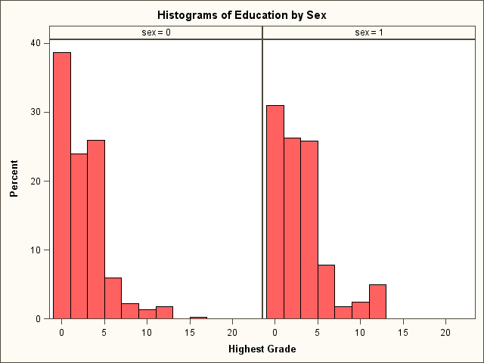
Mean=2.64
STD=3.03
N=461
Mean=2.13
STD=2.54
N=455

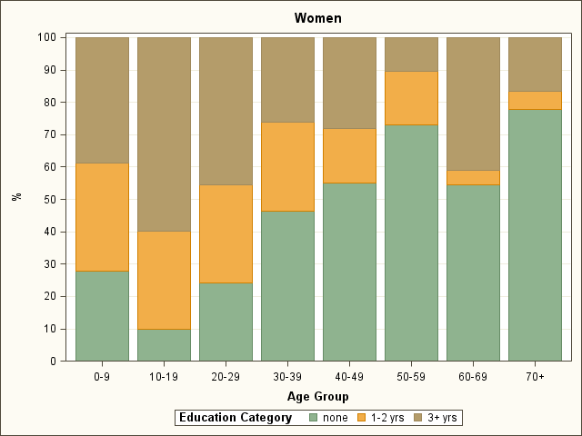
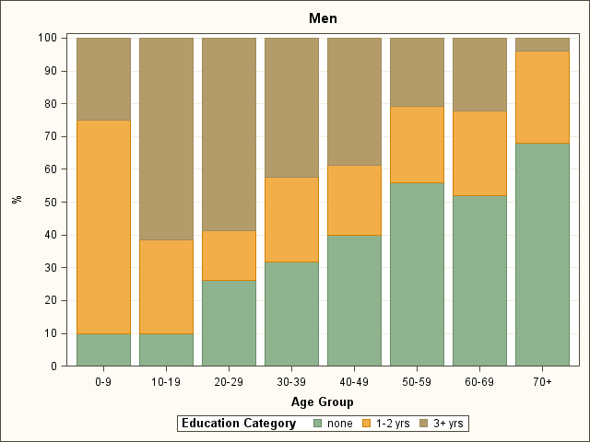
Figure S2. Stacked histograms of Educational Attainment by Age and Sex.
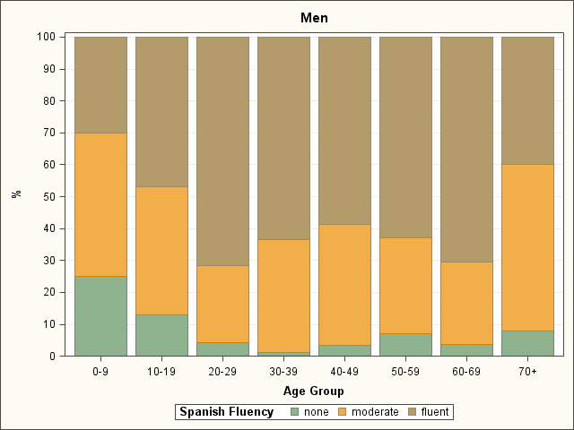
Figure S3. Stacked Histograms of Spanish Fluency by Age and Sex. Spanish fluency is an average measure of Spanish speaking ability and writing ability, each ranked on a five point scale (0 to 4). Categories here defined as none (<0.5), moderate (0.5 to 2.5) and fluent (>2.5).
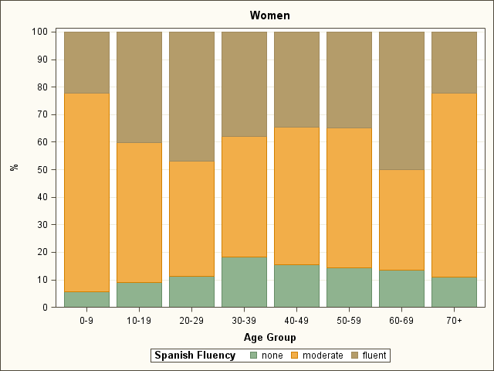

Figure S4. Segmented linear regression predicting peak age of performance for cognitive subtasks, grouped by three levels of educational attainment.

Table S1. Schooling effects as a function of village history and quality of schooling (captured by the variable “Village School Level”). Similar to Table 8 in main text, but results shown here for each cognitive task.

 | Short-Term Recall | Long-Term Recall | Tsimane Digit Forward | Spanish Digit Forward | Spatial Forward | Visual Scan | Animal Fluency | Fish Fluency
Predictor | est. | est. | est. | est. | est. | est. | est. | est.
Intercept | 0.267 | -0.680 | -0.730 | -0.672 | -0.736*** | -0.332 | -1.638 | -1.806
Age | 0.025*** | 0.024*** | 0.024*** | 0.019** | 0.017** | 0.018*** | 0.068*** | 0.067***
Age² | -0.000*** | -0.000*** | -0.000*** | -0.000*** | -0.000*** | -0.001*** | -0.001*** | -0.001***
Sex | 0.287** | 0.030 | 0.336*** | 0.538*** | 0.515*** | 0.296*** | 0.504*** | 0.479***
Grade | 0.122** | 0.132** | 0.051 | 0.094* | 0.256*** | 0.207*** | 0.018 | 0.039
Grade² | -0.008* | -0.012** | 0.003 | -0.001 | -0.012*** | -0.012*** | 0.001 | -0.002
Spanish | -0.295*** | 0.339*** | 0.143† | 0.132 | 0.022 | 0.038 | 0.026 | 0.089
Spanish² | 0.023 | -0.049** | -0.028 | -0.019 | 0.012 | 0.009 | -0.001 | -0.022
Sex*Grade | -0.074 | -0.049 | 0.031 | -0.112* | -0.143** | -0.022 | -0.042 | -0.049
Sex*Grade² | 0.009† | 0.009† | -0.005 | 0.007 | 0.009* | 0.003 | 0.003 | 0.005
Village School Level
(low vs. high) | -0.440* | -0.096 | -0.236* | -0.431*** | -0.590*** | -0.654*** | 0.301† | 0.421**
(moderate vs. high) | -0.184 | 0.161 | 0.091 | -0.006 | -0.148 | -0.148 | 0.13 | 0.199
Grade*Village School Level
(low vs. high) | 0.003 | -0.084† | 0.014 | 0.002 | -0.043 | -0.057 | -0.053 | 0.000
(moderate vs. high) | -0.059† | -0.044 | -0.020 | -0.052 | -0.033 | -0.069* | 0.039 | 0.034

