Supplemental Appendix A
Experimental Instructions
Welcome to our study!
You will be asked to evaluate several lotteries. Please read the instructions CAREFULLY so that you can make the best possible evaluations. If you have questions, please raise your hand and ask the experimenter at ANY TIME.

The General Procedure
You will see a large number of lotteries one after another and will be asked to evaluate each of them. In addition you will be asked to fill out two short questionnaires and, at the conclusion of the study, you will get to play two lotteries for real money.

Understand the lottery
Each lottery is accompanied by both verbal and graphical representations on the left side of the screen. The verbal part describes the rules and the procedure, the probability of winning and the possible prizes.

In the graphical representation you will see a chance wheel with two colors (Green and White) and a Red pointer. The probability of winning and the possible prizes are also shown on the wheel. Imagine spinning the wheel: If the pointer points to the green area when the wheel stops, you win; if the pointer points to the white area, you do not win.

There are different types of lotteries. Depending on the rules of each lottery, you may need to spin one or more wheels. We are interested in your personal valuation of these lotteries. There are no “right” or “wrong” answers. Therefore, it is important that you read carefully the verbal and graphical descriptions for each lottery before you evaluate it.

For example:
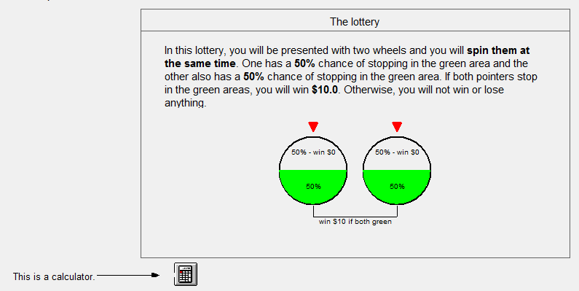

Evaluating the lottery
The evaluation consists of two steps which will be shown on the right side of the screen.
In the first step, you will be asked to make a series of choices between Option A and Option B. The number of choices will vary depending on the lottery you evaluate.
- Option A will always be “Play the lottery”.
- Option B is “Receive an amount of money (in a given range) for sure.” The various ranges in Option B are arranged in ASCENDING order.
- In each row, you must choose between A and B. Option A, “Play the lottery”, is the default.
  - If you prefer the lottery over all the amounts listed, just click CONFIRM to move to the next lottery.
  - If you prefer some of fixed amounts listed under Option B, you need to click the appropriate buttons.
- Since the amounts in the Option B columns are listed in ascending order, we assume that you would also prefer all higher amounts to the lottery. You can, simply, click OK, to change all choices involving higher amounts automatically to favor option B.
- If you want to revise your choices, you need to click RESET first to restore defaults, and then make new choices.
- Click CONFIRM to enter the second step. Once you click CONFIRM, you cannot go back to change your choices.

In the second step, you will be asked to evaluate the lottery more precisely (to the nearest $0.1) by entering an amount in the range you selected in the first step.

Continue with the example: Suppose your final evaluation for the lottery is $2.8. Please practice following the side instructions.

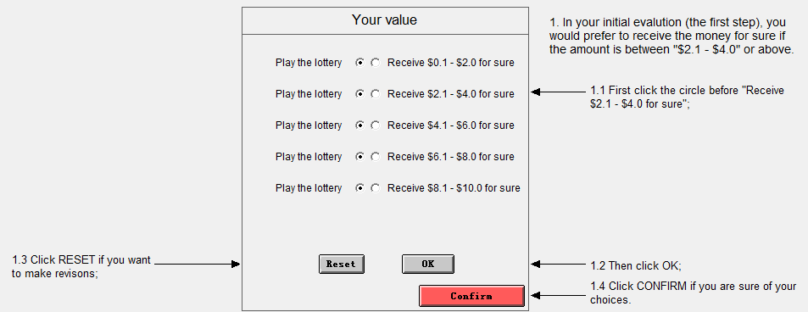

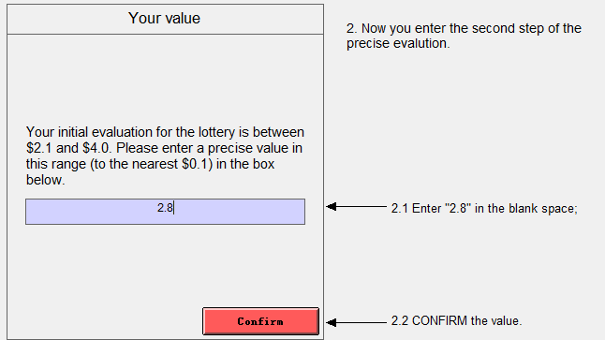

Payments
In addition to your $5 show up fee, you will be paid based on your evaluations. After you finish all the evaluations, we will select 4 lotteries and pair them randomly. In each of these 2pairs of lotteries, you will play the lottery to which you assigned a higher value. You will spin the wheel(s) you see and, if you win, you will get the payoffs specified in the lottery.

You cannot anticipate which lotteries will be selected and how they will be paired randomly. Thus, to maximize your gains, your best strategy is to evaluate each lottery carefully, honestly and as accurately as possible.

Supplemental Appendix B
Contrasts Used in Repeated Measures ANOVA
1. “Compound vs. One-stage” -16 -16 1 1 1 1 1 1 1 1 1 1 1 1 1 1 1 1 1 1 1 1 1 1 1 1 1 1 1 1 1 1 1 1;
2. “Two-stage vs. One-stage” -8 -8 1 1 1 1 1 1 1 1 1 1 1 1 1 1 1 1 0 0 0 0 0 0 0 0 0 0 0 0 0 0 0 0;
3. “Three-stage vs. One-stage” -8 -8 0 0 0 0 0 0 0 0 0 0 0 0 0 0 0 0 1 1 1 1 1 1 1 1 1 1 1 1 1 1 1 1;
4. “All .09($20) vs. All .18($10)” -1 1 -1 -1 -1 -1 -1 -1 -1 -1 1 1 1 1 1 1 1 1 -1 -1 -1 -1 -1 -1 -1 -1 1 1 1 1 1 1 1 1;
5. “Three-stage vs. Two-stage” 0 0 -1 -1 -1 -1 -1 -1 -1 -1 -1 -1 -1 -1 -1 -1 -1 -1 1 1 1 1 1 1 1 1 1 1 1 1 1 1 1 1;
6. “Compound .09($20) vs. Compound .18($10)” 0 0 -1 -1 -1 -1 -1 -1 -1 -1 1 1 1 1 1 1 1 1 -1 -1 -1 -1 -1 -1 -1 -1 1 1 1 1 1 1 1 1;
7. “Sequential vs. Simultaneous” 0 0 -5 -5 -5 3 3 3 3 3 -5 -5 -5 3 3 3 3 3 -5 -5 -5 3 3 3 3 3 -5 -5 -5 3 3 3 3 3;
8. “Unequal vs. equal” 0 0 -3 1 1 -3 1 1 1 1 -3 1 1 -3 1 1 1 1 -3 1 1 -3 1 1 1 1 -3 1 1 -3 1 1 1 1;
9. “Descending vs. Ascending” 0 0 0 0 0 0 -1 -1 1 1 0 0 0 0 -1 -1 1 1 0 0 0 0 -1 -1 1 1 0 0 0 0 -1 -1 1 1;
10. “High diff vs. Low diff” 0 0 0 0 0 0 -1 1 -1 1 0 0 0 0 -1 1 -1 1 0 0 0 0 -1 1 -1 1 0 0 0 0 -1 1 -1 1;
11. “Compound/One * All .09($20)/.18($10)” 16 -16 -1 -1 -1 -1 -1 -1 -1 -1 1 1 1 1 1 1 1 1 -1 -1 -1 -1 -1 -1 -1 -1 1 1 1 1 1 1 1 1;
12. “Two/One-stage * All .09($20)/.18($10)” 8 -8 -1 -1 -1 -1 -1 -1 -1 -1 1 1 1 1 1 1 1 1 0 0 0 0 0 0 0 0 0 0 0 0 0 0 0 0;
13. “Three/One-stage * All .09($20)/.18($10)” 8 -8 0 0 0 0 0 0 0 0 0 0 0 0 0 0 0 0 -1 -1 -1 -1 -1 -1 -1 -1 1 1 1 1 1 1 1 1;
14. “Three/Two-stage * Compound .09($20)/.18($10)” 0 0 1 1 1 1 1 1 1 1 -1 -1 -1 -1 -1 -1 -1 -1 -1 -1 -1 -1 -1 -1 -1 -1 1 1 1 1 1 1 1 1;
15. “Three/Two-stage * Seq/Sim” 0 0 5 5 5 -3 -3 -3 -3 -3 5 5 5 -3 -3 -3 -3 -3 -5 -5 -5 3 3 3 3 3 -5 -5 -5 3 3 3 3 3;
16. “Three/Two-stage * Unequal/Equal” 0 0 3 -1 -1 3 -1 -1 -1 -1 3 -1 -1 3 -1 -1 -1 -1 -3 1 1 -3 1 1 1 1 -3 1 1 -3 1 1 1 1;
17. “Three/Two-stage * Descending/Ascending” 0 0 0 0 0 0 1 1 -1 -1 0 0 0 0 1 1 -1 -1 0 0 0 0 -1 -1 1 1 0 0 0 0 -1 -1 1 1;
18. “Three/Two-stage * Low diff/High diff” 0 0 0 0 0 0 1 -1 1 -1 0 0 0 0 1 -1 1 -1 0 0 0 0 -1 1 -1 1 0 0 0 0 -1 1 -1 1;
19. “Compound .09($20)/.18($10) * Seq/Sim” 0 0 5 5 5 -3 -3 -3 -3 -3 -5 -5 -5 3 3 3 3 3 5 5 5 -3 -3 -3 -3 -3 -5 -5 -5 3 3 3 3 3;
20. “Compound .09($20)/.18($10) * Unequal/Equal” 0 0 3 -1 -1 3 -1 -1 -1 -1 -3 1 1 -3 1 1 1 1 3 -1 -1 3 -1 -1 -1 -1 -3 1 1 -3 1 1 1 1;
21. “Compound .09($20)/.18($10) * Descending/Ascending” 0 0 0 0 0 0 1 1 -1 -1 0 0 0 0 -1 -1 1 1 0 0 0 0 1 1 -1 -1 0 0 0 0 -1 -1 1 1;
22. “Compound .09($20)/.18($10) * High diff/Low diff” 0 0 0 0 0 0 1 -1 1 -1 0 0 0 0 -1 1 -1 1 0 0 0 0 1 -1 1 -1 0 0 0 0 -1 1 -1 1;
23. “Descending/Ascending * High diff/Low diff” 0 0 0 0 0 0 1 -1 -1 1 0 0 0 0 1 -1 -1 1 0 0 0 0 1 -1 -1 1 0 0 0 0 1 -1 -1 1;
24. “Three/Two-stage * Compound .09($20)/.18($10) * Seq/Sim”
0 0 -5 -5 -5 3 3 3 3 3 5 5 5 -3 -3 -3 -3 -3 5 5 5 -3 -3 -3 -3 -3 -5 -5 -5 3 3 3 3 3;
25. “Three/Two-stage * Compound .09($20)/.18($10) * Unequal/Equal”
0 0 -3 1 1 -3 1 1 1 1 3 -1 -1 3 -1 -1 -1 -1 3 -1 -1 3 -1 -1 -1 -1 -3 1 1 -3 1 1 1 1;
26. “Three/Two-stage * Compound .09($20)/.18($10) * Descending/Ascending”
0 0 0 0 0 0 -1 -1 1 1 0 0 0 0 1 1 -1 -1 0 0 0 0 1 1 -1 -1 0 0 0 0 -1 -1 1 1;
27. “Three/Two-stage * Compound .09($20)/.18($10) * High diff/Low diff”
0 0 0 0 0 0 -1 1 -1 1 0 0 0 0 1 -1 1 -1 0 0 0 0 1 -1 1 -1 0 0 0 0 -1 1 -1 1;
28. “Three/Two-stage * Seq/Sim * Unequal/Equal”
0 0 -15 5 5 9 -3 -3 -3 -3 -15 5 5 9 -3 -3 -3 -3 15 -5 -5 -9 3 3 3 3 15 -5 -5 -9 3 3 3 3;
29. “Three/Two-stage * Descending/Ascending * High diff/Low diff”
0 0 0 0 0 0 -1 1 1 -1 0 0 0 0 -1 1 1 -1 0 0 0 0 1 -1 -1 1 0 0 0 0 1 -1 -1 1;
30. “Compound .09($20)/.18($10) * Seq/Sim * Unequal/Equal”
0 0 -15 5 5 9 -3 -3 -3 -3 15 -5 -5 -9 3 3 3 3 -15 5 5 9 -3 -3 -3 -3 15 -5 -5 -9 3 3 3 3;
31. “Compound .09($20)/.18($10) * Descending/Ascending * High diff/Low diff”
0 0 0 0 0 0 -1 1 1 -1 0 0 0 0 1 -1 -1 1 0 0 0 0 -1 1 1 -1 0 0 0 0 1 -1 -1 1;
32. “Three/Two-stage * Compound .09($20)/.18($10) * Seq/Sim * Unequal/Eequal”
0 0 15 -5 -5 -9 3 3 3 3 -15 5 5 9 -3 -3 -3 -3 -15 5 5 9 -3 -3 -3 -3 15 -5 -5 -9 3 3 3 3;
33. “Three/Two-Stage * Compound .09($20)/.18($10) * Descending/Ascending * High diff/Low diff”
0 0 0 0 0 0 1 -1 -1 1 0 0 0 0 -1 1 1 -1 0 0 0 0 -1 1 1 -1 0 0 0 0 1 -1 -1 1;

Supplemental Appendix C
Parameter Estimation using Least Square Method
Equation 8 in the manuscript can be rewritten as: $αln⁡(\frac{CE}{x})= -{(-ln{p)}}^{r}$. Assign $A= ln⁡(\frac{CE}{x})$and $B=-ln⁡(p)$, then we can write the equation as $αA= -B^{r}$. Taking the natural log of both sides, we obtain $lnα+ln⁡(-A)= γ(ln{B})$, and then $ln⁡(-A)=-lnα+γ(ln{B})$.
In the experiment we crossed x and p (see Table 1), so we have 16 observations for CE, x, and p. In the least squares estimation, $-lnα$was considered as the intercept, and $γ$ as the slope. If a participant made judgments on at least two of the lotteries, an optimal and unique pair of α and γ could be estimated for the participant.

Supplemental Appendix D
Robustness of the Parameter Estimates
To validate, and test the robustness of, the parameter estimates of the power utility function and the Prelec’s one-parameter weighing function for the one-stage lotteries, we estimated three other sets of parameters using the exponential utility function and the symmetric neo-additive weighting function (Chateauneuf, Eichberger, & Grant, 2007; Abdellaoui, L’Haridon, & Zank, 2010). The two utility functions crossed with two probability weighing functions generates four sets of parameters, with a single individual parameter for each function. Table D1 describes the four sets: (1) the first set consists of parameters for the power utility function and the Prelec’s one-parameter weighting function (PP), estimated using the least squares method which are used in the manuscript; (2) the second set consists of parameters for the power utility function and the neo-additive weighting function (PN), estimated using the Newton-Raphson method; (3) the third set involves parameters for the exponential utility function and the Prelec’s one-parameter weighting function (EP), estimated using the Newton-Raphson method; (4) the fourth set consists of parameters for the exponential utility function and the neo-additive weighting function (EN), estimated using the Newton-Raphson method.

Table D1
Utility functions, weighting functions, and estimation methods
 |  | Weighting function
 |  | Prelec:  $$w\left(p\right)= e^{-{(-lnp)}^{r}}$$ | Neo-additive:  $$w\left(p\right)=\left(1-2b\right)p+b$$
Utility function | Power:  $$U\left(x\right)= x^{α}$$ | (1) PP: Linear  (least squares) | (2) PN: Nonlinear  (Newton-Raphson)
 | Exponential:  $$U\left(x\right)= \frac{{1-e}^{-ax}}{a}$$ | (3) EP: Nonlinear  (Newton-Raphson) | (4) EN: Nonlinear  (Newton-Raphson)

Sincere α and a, as well as γ and b, have different meanings and are not directly comparable, we compared the predicted CEs from each set of functions to the observed CEs, and between them. Based on the scatter plots and the coefficient of identity shown in Figure D1, the predicted CEs from different set of functions are highly similar, and their performances are also very similar. The correlation between the observed CEs and the predicted CEs using the power utility function and the Prelec’s one-parameter weighting function (CE_PP) is high (.97).

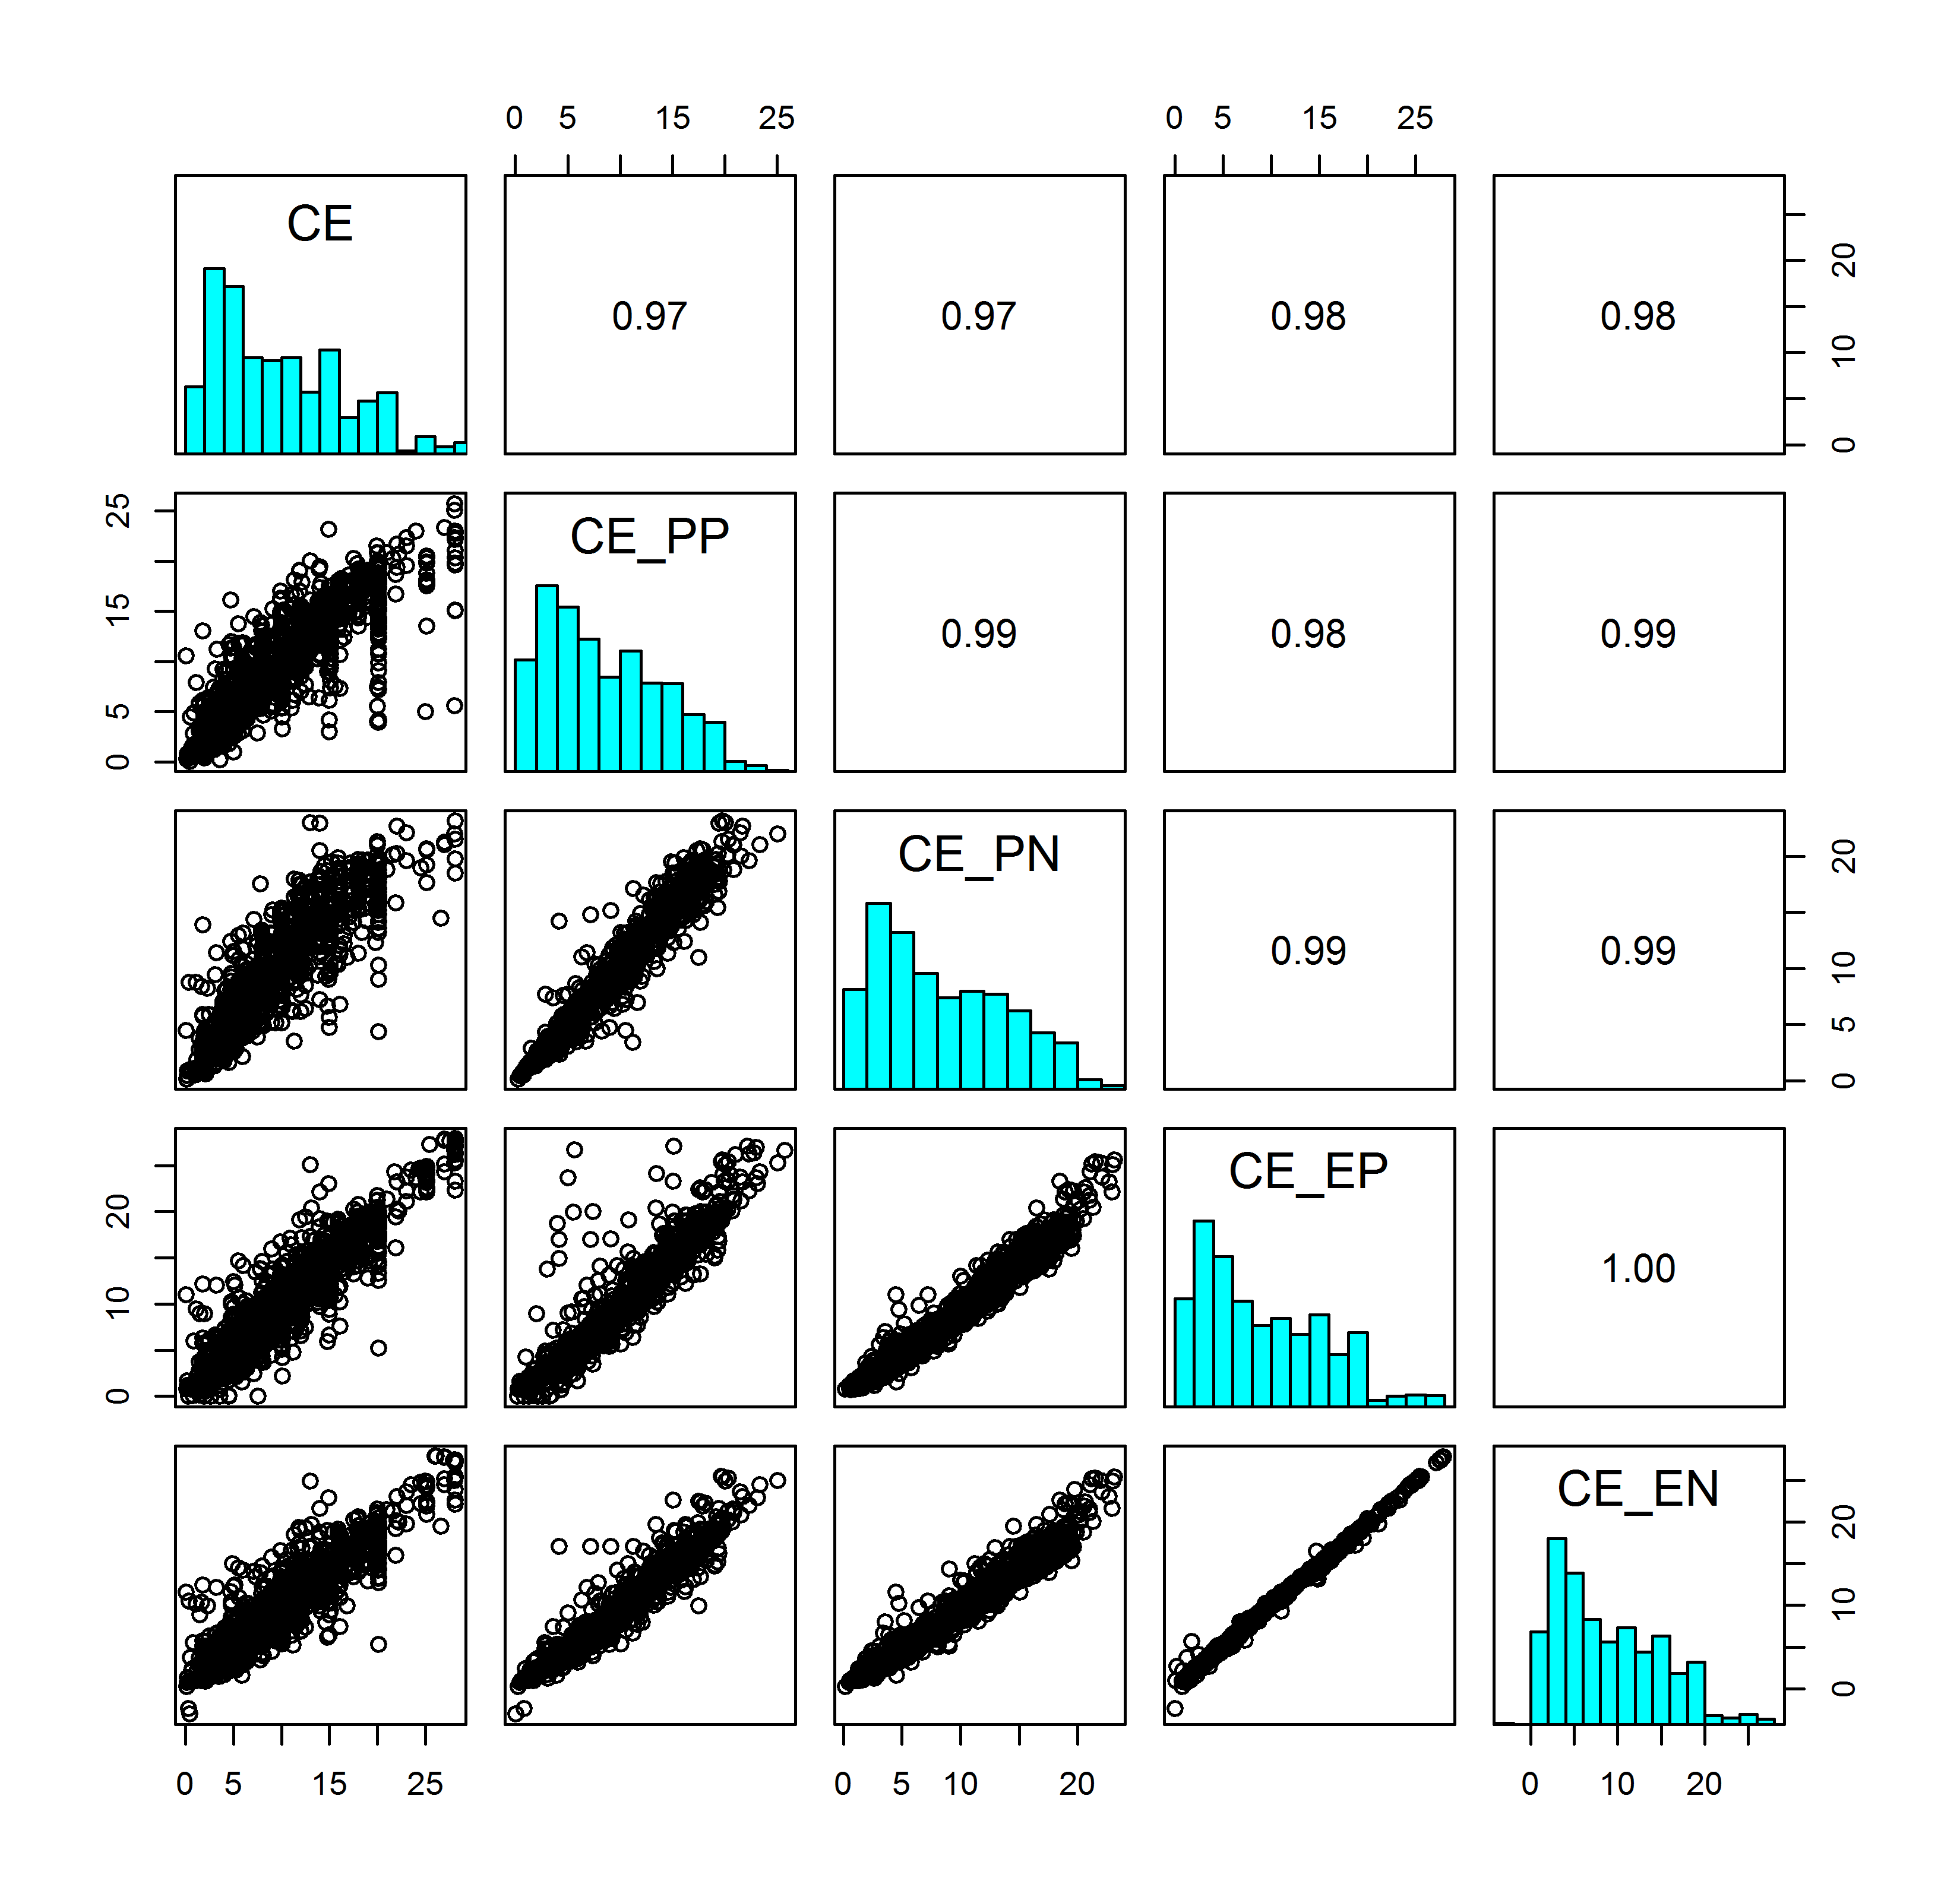
Figure D1. Scatter plots and coefficients of Identity between observed CEs, predicted CEs using the power utility function and the Prelec’s one-parameter weighting function (CE_PP), predicted CEs using the power utility function and the neo-additive weighting function (CE_PN), predicted CEs using the exponential utility function and the Prelec’s one-parameter weighting function (CE_EP), predicted CEs using the exponential utility function and the neo-additive weighting function (CE_EN).

Figure D2 shows the boxplots of RMSEs of the four sets of predicted CEs. The performances of the four models are very similar.

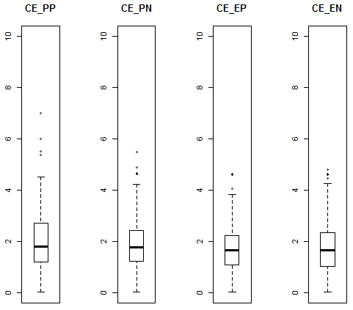
Figure D2. Boxplots of RMSEs of the predicted CEs using the power utility function and the Prelec’s one-parameter weighting function (CE_PP), using the power utility function and the neo-additive weighting function (CE_PN), using the exponential utility function and the Prelec’s one-parameter weighting function (CE_EP), using the exponential utility function and the neo-additive weighting function (CE_EN).

In addition, we examined whether the distribution of risk attitudes were significantly different across the four sets of parameter estimates. Subjects were classified into three categories, risk averse (α < 1; a > 0), risk neutral (α = 1; a = 0), and risk seeking (α > 1; a < 0). The results are shown in Table D2. Then we used Fisher’s exact test to test the null hypothesis that there is no difference in the proportions of risk seekers estimated from one model and from the other model for each pair out of the four sets of models. Table D3 shows the p-value for the test for each pair of models. Using the Sidak adjustment (significant level at .009), no test was significant.

Table D2
Risk attitudes across the four sets of functions
Utility | Weighting | Risk Averse | Risk Neutral | Risk Seeking | Total
Power | Prelec | 17 | 0 | 102 | 119
 | neo-additive | 24 | 0 | 78 | 102
Exponential | Prelec | 22 | 0 | 97 | 119
 | neo-additive | 30 | 0 | 76 | 106

Table D3
P-values of Fisher’s exact tests
 | α_PP | α_PN | a_EP | a_EN
α_PP | -
α_PN | .08 | -
a_EP | .48 | .41 | -
a_EN | .01 | .53 | .08 | -

Supplemental Appendix E
Correlations between the Parameter Estimates and Covariates
We examined numeracy level and decision making style (“intuitive” or “rational”) to study why different subjects are well described by different models, but we did not find significant effects of the two variables. Table E1 shows the correlations between estimates of the utility function parameter α, estimates of the weighting function parameter γ, the rational decision making style, the intuitive decision making style, and the numeracy scores. The correlations between the three covariates and the parameter estimates (either α or γ) are all very low.

Table E1
Correlations between first-stage parameter estimates and covariates
 | α | γ | Rational | Intuitive | Numeracy
α | -
γ | -.22* | -
Rational | .00 | .03 | -
Intuitive | .05 | .03 | -0.18* | -
Numeracy | -.06 | -.05 | 0.20* | -.05 | -
* p < .05

We also plotted the minimum RMSE for each subject across the 10 good performing models (Models M1, M3, M5 in the class “first combine and then weight”, models M7, M9, M10 in the class “first weight and then combine”, and models M14 and M15 in the “anchoring” class) against decision making styles (rational and intuitive) and numeracy. Figure E1 shows no clear pattern.
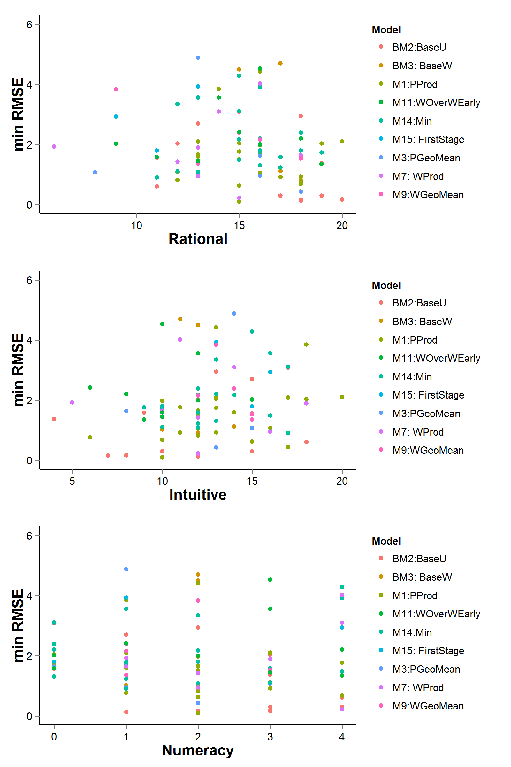
Figure E1. Minimum RMSE for each subject across the 10 good performing models against decision making styles (rational and intuitive) and numeracy.

For these non-linear models using the Newton-Raphson estimation method, the starting values were first determined using the brute force (grid searching) estimation.

