The efficacy of acute-phase psychological therapies for depression in preventing depressive relapse post-treatment: A systematic review and meta-analysis.

Supplementary Material

Contents
Database searches and results 2
Excluded studies 5
Studies for which authors were contacted for inclusion 6
Studies for which relapse denominator was changed 8
Intervention types with only one included study 8
Collaborative Care 8
Structured Exercise 8
Risk of Bias 9
GRADE assessments 10
Forest Plots 11
Control type 11
Follow-Up Time Subgroups 12
Secondary Outcome - Depression Scores 15
T1 – end of treatment 15
T2 – follow-up 16
Sensitivity analyses 19
Funnel Plot and Egger’s Test for primary outcome 19
Funnel Plot: Duval and Tweedie’s Trim and Fill 20
Meta-Regressions 21
PRISMA Checklist 22

Database searches and results

Database: Embase <1974 to 2025 March 12>
Search Strategy:
1 exp major depression/ (87021)
2 depress*.ti,kf. (308175)
3 exp psychosis/ (336909)
4 bipolar disorder/ or bipolar depression/ (76497)
5 1 or 2 (342348)
6 3 or 4 (382544)
7 5 not 6 (302283)
8 exp relapse/ (180163)
9 relaps*.mp. (469841)
10 recurr*.mp. (1358043)
11 8 or 9 or 10 (1639111)
12 clinical trial/ (1083972)
13 Randomized Controlled Trial/ (826901)
14 controlled clinical trial/ (473400)
15 multicenter study/ (394926)
16 Phase 3 clinical trial/ (76193)
17 Phase 4 clinical trial/ (7381)
18 exp RANDOMIZATION/ (99804)
19 Single Blind Procedure/ (55123)
20 Double Blind Procedure/ (220135)
21 Crossover Procedure/ (78411)
22 PLACEBO/ (414096)
23 randomi?ed controlled trial$.tw. (348823)
24 rct.tw. (58122)
25 (random$ adj2 allocat$).tw. (57664)
26 single blind$.tw. (33306)
27 double blind$.tw. (252892)
28 ((treble or triple) adj blind$).tw. (2137)
29 placebo$.tw. (380780)
30 Prospective Study/ (923188)
31 or/12-30 (3068412)
32 Case Study/ (101396)
33 case report.tw. (573417)
34 abstract report/ or letter/ (1332654)
35 Conference proceeding.pt. (0)
36 Conference abstract.pt. (5183084)
37 Editorial.pt. (809165)
38 Letter.pt. (1325478)
39 Note.pt. (989338)
40 or/32-39 (8883888)
41 31 not 40 (2188326)
42 7 and 11 and 41 (3004)

Database: Ovid MEDLINE(R) ALL <1946 to March 12, 2024>
Search Strategy:
1 exp Depressive Disorder/ or exp Depressive Disorder, Major/ or exp Depression/ (266694)
2 depress*.ti,kf. (235389)
3 exp Psychotic Disorders/ or Bipolar Disorder/ or exp Schizophrenia/ (196963)
4 1 or 2 (344062)
5 4 not 3 (317016)
6 exp Recurrence/ (204389)
7 relaps*.mp. (235493)
8 recurr*.mp. (882576)
9 6 or 7 or 8 (1036973)
10 Randomized Controlled Trials as Topic/ (170939)
11 randomized controlled trial/ (615435)
12 Random Allocation/ (107326)
13 Double Blind Method/ (179025)
14 Single Blind Method/ (33607)
15 clinical trial/ (540058)
16 clinical trial, phase i.pt. (26078)
17 clinical trial, phase ii.pt. (41460)
18 clinical trial, phase iii.pt. (22849)
19 clinical trial, phase iv.pt. (2510)
20 controlled clinical trial.pt. (95556)
21 randomized controlled trial.pt. (615435)
22 multicenter study.pt. (348672)
23 clinical trial.pt. (540058)
24 exp Clinical Trials as topic/ (393400)
25 or/10-24 (1612800)
26 (clinical adj trial$).tw. (515214)
27 ((singl$ or doubl$ or treb$ or tripl$) adj (blind$3 or mask$3)).tw. (205823)
28 PLACEBOS/ (35966)
29 placebo$.tw. (257187)
30 randomly allocated.tw. (38832)
31 (allocated adj2 random$).tw. (42762)
32 or/26-31 (830672)
33 25 or 32 (1990011)
34 case report.tw. (428961)
35 letter/ (1258219)
36 historical article/ (370405)
37 or/34-36 (2037355)
38 33 not 37 (1945912)
39 5 and 9 and 38 (2876)

Database: APA PsycInfo <1806 to March Week 1 2025>
Search Strategy:
1 exp Major Depression/ or exp "Depression (Emotion)"/ (195708)
2 depress*.ti,hw. (207177)
3 exp Psychosis/ (132791)
4 Bipolar Disorder/ or Bipolar II Disorder/ or Bipolar I Disorder/ (31970)
5 1 or 2 (207676)
6 3 or 4 (158596)
7 5 not 6 (191133)
8 exp Relapse Prevention/ or exp "Relapse (Disorders)"/ (11477)
9 relaps*.mp. (36398)
10 recurr*.mp. (47268)
11 8 or 9 or 10 (76216)
12 exp Intervention/ or exp Randomized Controlled Trials/ or exp Clinical Trials/ or exp Treatment Outcomes/ or exp Treatment Effectiveness Evaluation/ (331737)
13 clinical trial, phase i.mp. (3)
14 clinical trial, phase ii.mp. (2)
15 clinical trial, phase iii.mp. (0)
16 clinical trial, phase iv.mp. (1)
17 controlled clinical trial.mp. (1920)
18 randomized controlled trial.mp. (26768)
19 multicenter study.mp. (2006)
20 clinical trial.mp. (19939)
21 or/12-20 (357709)
22 (clinical adj trial$).tw. (44833)
23 ((singl$ or doubl$ or treb$ or tripl$) adj (blind$3 or mask$3)).tw. (29935)
24 Placebo/ (6681)
25 placebo$.tw. (45545)
26 randomly allocated.tw. (4613)
27 (allocated adj2 random$).tw. (4878)
28 or/22-27 (95626)
29 21 or 28 (408036)
30 case report.tw. (31018)
31 29 not 30 (402898)
32 7 and 11 and 31 (2570)
Database: Cochrane Central Register of Controlled Trials
Date Run: 12/03/2025 11:07:40
ID Search Hits
#1 MeSH descriptor: [Depression] explode all trees 18256
#2 depress*:ti,kw 72539
#3 MeSH descriptor: [Psychotic Disorders] explode all trees 4069
#4 MeSH descriptor: [Bipolar Disorder] explode all trees 3586
#5 #1 OR #2 72539
#6 #3 OR #4 7324
#7 #5 NOT #6 70540
#8 MeSH descriptor: [Recurrence] explode all trees 16564
#9 relaps*:ti,ab,kw 48612
#10 recurr*:ti,ab,kw 93902
#11 #8 OR #9 OR #10 124193
#12 MeSH descriptor: [Randomized Controlled Trials as Topic] explode all trees 54939
#13 MeSH descriptor: [Randomized Controlled Trial] explode all trees 37
#14 MeSH descriptor: [Random Allocation] explode all trees 26024
#15 MeSH descriptor: [Double-Blind Method] explode all trees 170974
#16 MeSH descriptor: [Single-Blind Method] explode all trees 27387
#17 MeSH descriptor: [Clinical Trial] explode all trees 45
#18 controlled clinical trial:pt 342852
#19 randomized controlled trial:pt 271873
#20 clinical trial:pt 342853
#21 MeSH descriptor: [Clinical Trials as Topic] explode all trees 96046
#22 #12 OR #13 OR #14 OR #15 OR #16 OR #17 OR #18 OR #19 OR #20 OR #21 684496
#23 (clinical adj trial$):ti,ab,kw 447
#24 MeSH descriptor: [Placebos] explode all trees 27204
#25 placebo*:ti,ab,kw 388592
#26 randomly allocated:ti,ab,kw 55867
#27 #23 OR #24 OR #25 OR #26 435676
#28 #22 OR #27 900479
#29 case report:ti,ab,kw 18403
#30 MeSH descriptor: [Letter] explode all trees 0
#31 MeSH descriptor: [Historical Article] explode all trees 1
#32 #29 OR #30 OR #31 18404
#33 #28 NOT #32 892935
#34 #7 AND #11 AND #33 2431

Excluded studies

Below is a list of studies that that might seem to meet the inclusion criteria but were excluded:
Citation | Reason for exclusion
Birmaher, B., Brent, D. A., Kolko, D., Baugher, M., Bridge, J., Holder, D., ... & Ulloa, R. E. (2000). Clinical outcome after short-term psychotherapy for adolescents with major depressive disorder. Archives of general psychiatry, 57(1), 29-36. | Relapse data not provided separately for each treatment arm. Authors were contacted but the data was unavailable
Clarke, G., Debar, L., Lynch, F., Powell, J., Gale, J., O'Connor, E., ... & Hertert, S. (2005). A randomized effectiveness trial of brief cognitive-behavioral therapy for depressed adolescents receiving antidepressant medication. Journal of the American Academy of Child & Adolescent Psychiatry, 44(9), 888-898. | Relapse data not provided separately for each treatment arm. Authors were contacted but the data was unavailable
Dennis, C. L., Grigoriadis, S., Zupancic, J., Kiss, A., & Ravitz, P. (2020). Telephone-based nurse-delivered interpersonal psychotherapy for postpartum depression: nationwide randomised controlled trial. The British Journal of Psychiatry, 216(4), 189-196. | TAU relapse data not reported. Authors contacted but no response received.
DeRubeis, R. J., Zajecka, J., Shelton, R. C., Amsterdam, J. D., Fawcett, J., Xu, C., ... & Hollon, S. D. (2020). Prevention of recurrence after recovery from a major depressive episode with antidepressant medication alone or in combination with cognitive behavioral therapy: phase 2 of a 2-phase randomized clinical trial. JAMA psychiatry, 77(3), 237-245. | Treatment had a continuation phase
Krampen, G. (1999). Long-term evaluation of the effectiveness of additional autogenic training in the psychotherapy of depressive disorders. European Psychologist, 4(1), 11. | Reports relapse out of the total followed up (treatment completers) and not those that remitted. Since the study does not report information on remission, the study was excluded.

Studies for which authors were contacted for inclusion

Response - data obtained for inclusion
- Ammerman, R. T., Putnam, F. W., Altaye, M., Stevens, J., Teeters, A. R., & Van Ginkel, J. B. (2013). A clinical trial of in-home CBT for depressed mothers in home visitation. Behavior therapy, 44(3), 359-372. https://doi.org/10.1016/j.beth.2013.01.002
- Bruijniks, S. J., Hollon, S. D., Lemmens, L. H., Peeters, F. P., Arntz, A., Cuijpers, P., ... & Huibers, M. J. (2024). Long-term outcomes of once weekly v. twice weekly sessions of cognitive behavioral therapy and interpersonal psychotherapy for depression. Psychological medicine, 54(3), 517-526. https://doi.org/10.1017/s0033291723002143
- Hauschildt, M., Arlt, S., Moritz, S., Yassari, A. H., & Jelinek, L. (2022). Efficacy of metacognitive training for depression as add‐on intervention for patients with depression in acute intensive psychiatric inpatient care: A randomized controlled trial. Clinical Psychology & Psychotherapy, 29(5), 1542-1555. https://doi.org/10.1002/cpp.2733
- Richards, D. A., Hill, J. J., Gask, L., Lovell, K., Chew-Graham, C., Bower, P., ... & Barkham, M. (2013). Clinical effectiveness of collaborative care for depression in UK primary care (CADET): cluster randomised controlled trial. Bmj, 347. https://doi.org/10.1136/bmj.f4913
- Salisbury, C., O'Cathain, A., Edwards, L., Thomas, C., Gaunt, D., Hollinghurst, S., ... & Montgomery, A. A. (2016). Effectiveness of an integrated telehealth service for patients with depression: a pragmatic randomised controlled trial of a complex intervention. The Lancet Psychiatry, 3(6), 515-525. https://doi.org/10.1016/s2215-0366(16)00083-3
- Smith, J., Newby, J. M., Burston, N., Murphy, M. J., Michael, S., Mackenzie, A., ... & Andrews, G. (2017). Help from home for depression: A randomised controlled trial comparing internet-delivered cognitive behaviour therapy with bibliotherapy for depression. Internet interventions, 9, 25-37. https://doi.org/10.1016/j.invent.2017.05.001
- Zetsche, U., Neumann, P., Bürkner, P. C., Renneberg, B., Koster, E. H., & Hoorelbeke, K. (2024). Computerized cognitive control training to reduce rumination in major depression: A randomized controlled trial. Behaviour Research and Therapy, 177, 104521. https://doi.org/10.1016/j.brat.2024.104521

Response - data unavailable
- Birmaher, B., Brent, D. A., Kolko, D., Baugher, M., Bridge, J., Holder, D., ... & Ulloa, R. E. (2000). Clinical outcome after short-term psychotherapy for adolescents with major depressive disorder. Archives of general psychiatry, 57(1), 29-36. https://doi.org/10.1001/archpsyc.57.1.29
- Bondesson, E., Jöud, A., Stigmar, K., Ringqvist, Å., Kraepelien, M., Kaldo, V., ... & Schelin, M. E. (2022). Utilization of healthcare and prescription medicines after non-pharmacological interventions for depression-A 3-year register follow-up of an RCT in primary care. Preventive Medicine Reports, 25, 101658. https://doi.org/10.1016/j.pmedr.2021.101658
- Clarke, G., DeBar, L. L., Pearson, J. A., Dickerson, J. F., Lynch, F. L., Gullion, C. M., & Leo, M. C. (2016). Cognitive behavioral therapy in primary care for youth declining antidepressants: a randomized trial. Pediatrics, 137(5). https://doi.org/10.1542/peds.2015-1851
- Clarke, G., Debar, L., Lynch, F., Powell, J., Gale, J., O'Connor, E., ... & Hertert, S. (2005). A randomized effectiveness trial of brief cognitive-behavioral therapy for depressed adolescents receiving antidepressant medication. Journal of the American Academy of Child & Adolescent Psychiatry, 44(9), 888-898. https://doi.org/10.1016/s0890-8567(09)62194-8
- Gallagher-Thompson, D., Hanley-Peterson, P., & Thompson, L. W. (1990). Maintenance of gains versus relapse following brief psychotherapy for depression. Journal of Consulting and Clinical Psychology, 58(3), 371. https://doi.org/10.1037//0022-006x.58.3.371
- Hoffman, B. M., Babyak, M. A., Craighead, W. E., Sherwood, A., Doraiswamy, P. M., Coons, M. J., & Blumenthal, J. A. (2011). Exercise and pharmacotherapy in patients with major depression: one-year follow-up of the SMILE study. Psychosomatic medicine, 73(2), 127-133. https://doi.org/10.1097/psy.0b013e31820433a5
- Hallford, D. J., Austin, D. W., Takano, K., Fuller-Tyszkiewicz, M., & Raes, F. (2021). Computerized Memory Specificity Training (c-MeST) for major depression: A randomised controlled trial. Behaviour Research and Therapy, 136, 103783. https://doi.org/10.1016/j.brat.2020.103783
- Hallgren, M., Kraepelien, M., Lindefors, N., Zeebari, Z., Kaldo, V., & Forsell, Y. (2015). Physical exercise and internet-based cognitive–behavioural therapy in the treatment of depression: randomised controlled trial. The British Journal of Psychiatry, 207(3), 227-234. https://doi.org/10.1192/bjp.bp.114.160101
- A-Tjak, J. G., Morina, N., Topper, M., & Emmelkamp, P. M. (2021). One year follow-up and mediation in cognitive behavioral therapy and acceptance and commitment therapy for adult depression. BMC psychiatry, 21, 1-17. https://doi.org/10.1186/s12888-020-03020-1
- Ostacoli, L., Carletto, S., Cavallo, M., Baldomir-Gago, P., Di Lorenzo, G., Fernandez, I., ... & Hofmann, A. (2018). Comparison of eye movement desensitization reprocessing and cognitive behavioral therapy as adjunctive treatments for recurrent depression: The European Depression EMDR Network (EDEN) randomized controlled trial. Frontiers in psychology, 9, 74. https://doi.org/10.3389/fpsyg.2018.00074
- Renner, W., & Berry, J. W. (2011). The ineffectiveness of group interventions for female Turkish migrants with recurrent depression. Social Behavior and Personality: an international journal, 39(9), 1217-1234. https://doi.org/10.2224/sbp.2011.39.9.1217
- Vostanis, P., Feehan, C., & Grattan, E. (1998). Two-year outcome of children treated for depression. European Child & Adolescent Psychiatry, 7, 12-18. https://doi.org/10.1007/s007870050039
- Wolinsky, F. D., Mahncke, H. W., Weg, M. W. V., Martin, R., Unverzagt, F. W., Ball, K. K., ... & Tennstedt, S. L. (2009). The ACTIVE cognitive training interventions and the onset of and recovery from suspected clinical depression. Journals of Gerontology Series B: Psychological Sciences and Social Sciences, 64(5), 577-585. https://doi.org/10.1093/geronb/gbp061

No response
- Aagaard, J., Foldager, L., Makki, A., Hansen, V., & Müller-Nielsen, K. (2017). The efficacy of psychoeducation on recurrent depression: a randomized trial with a 2-year follow-up. Nordic Journal of Psychiatry, 71(3), 223-229. https://doi.org/10.1080/08039488.2016.1266385
- Areán, P. A., Gum, A., McCulloch, C. E., Bostrom, A., Gallagher-Thompson, D., & Thompson, L. (2005). Treatment of depression in low-income older adults. Psychology and aging, 20(4), 601. https://doi.org/10.1037/0882-7974.20.4.601
- Bosanquet, K., Adamson, J., Atherton, K., Bailey, D., Baxter, C., Beresford-Dent, J., ... & Gilbody, S. (2017). CollAborative care for Screen-Positive EldeRs with major depression (CASPER plus): a multicentred randomised controlled trial of clinical effectiveness and cost-effectiveness. Health Technology Assessment (Winchester, England), 21(67), 1. https://doi.org/10.3310/hta21670
- Cohen, S. (2007). Development of a brief couples therapy for depression: Targeting illness-related attitudes and behaviors, empathy, and support. State University of New York at Stony Brook.
- Dennis, C. L., Grigoriadis, S., Zupancic, J., Kiss, A., & Ravitz, P. (2020). Telephone-based nurse-delivered interpersonal psychotherapy for postpartum depression: nationwide randomised controlled trial. The British Journal of Psychiatry, 216(4), 189-196. https://doi.org/10.1192/bjp.2019.275
- Dimidjian, S., Goodman, S. H., Sherwood, N. E., Simon, G. E., Ludman, E., Gallop, R., ... & Beck, A. (2017). A pragmatic randomized clinical trial of behavioral activation for depressed pregnant women. Journal of consulting and clinical psychology, 85(1), 26. https://doi.org/10.1037/ccp0000151
- Dos Santos, É. N., Molina, M. L., Mondin, T., de Azevedo Cardoso, T., Silva, R., Souza, L., & Jansen, K. (2020). Long-term effectiveness of two models of brief psychotherapy for depression: a three-year follow-up randomized clinical trial. Psychiatry Research, 286, 112804. https://doi.org/10.1016/j.psychres.2020.112804
- Hees, H. L., de Vries, G., Koeter, M. W., & Schene, A. H. (2013). Adjuvant occupational therapy improves long-term depression recovery and return-to-work in good health in sick-listed employees with major depression: results of a randomised controlled trial. Occupational and Environmental Medicine, 70(4), 252-260. https://doi.org/10.1136/oemed-2012-100789
- Hunkeler, E. M., Katon, W., Tang, L., Williams, J. W., Kroenke, K., Lin, E. H., ... & Unützer, J. (2006). Long term outcomes from the IMPACT randomised trial for depressed elderly patients in primary care. Bmj, 332(7536), 259-263. https://doi.org/10.1136/bmj.38683.710255.be
- Mergl, R., Allgaier, A. K., Hautzinger, M., Coyne, J. C., Hegerl, U., & Henkel, V. (2018). One-year follow-up of a randomized controlled trial of sertraline and cognitive behavior group therapy in depressed primary care patients (MIND study). Journal of affective disorders, 230, 15-21. https://doi.org/10.1016/j.jad.2017.12.084
- Rohde, P., Seeley, J. R., Kaufman, N. K., Clarke, G. N., & Stice, E. (2006). Predicting time to recovery among depressed adolescents treated in two psychosocial group interventions. Journal of consulting and clinical psychology, 74(1), 80. https://doi.org/10.1037/0022-006x.74.1.80
- Rosso, G., Martini, B., & Maina, G. (2013). Brief dynamic therapy and depression severity: A single-blind, randomized study. Journal of affective disorders, 147(1-3), 101-106. https://doi.org/10.1016/j.jad.2012.10.017
- Solati, K. (2016). Effectiveness of cognitive-behavior group therapy, psycho-education family, and drug therapy in reducing and preventing recurrence of symptoms in patients with major depressive disorder. Group, 2(40.84), 3-55.
- Town, J. M., Abbass, A., Stride, C., Nunes, A., Bernier, D., & Berrigan, P. (2020). Efficacy and cost-effectiveness of intensive short-term dynamic psychotherapy for treatment resistant depression: 18-Month follow-up of the Halifax depression trial. Journal of Affective Disorders, 273, 194-202. https://doi.org/10.1016/j.jad.2020.04.035
- Xie, J., He, G., Ding, S., Pan, C., Zhang, X., Zhou, J., & Iennaco, J. D. (2019). A randomized study on the effect of modified behavioral activation treatment for depressive symptoms in rural left-behind elderly. Psychotherapy Research, 29(3), 372-382. https://doi.org/10.1080/10503307.2017.1364444

Studies for which relapse denominator was changed
Below is a list of studies for which the denominator for relapse was changed from what was reported. The authors reported relapse out of the total number of participants that were followed up, as opposed to the number that recovered/remitted and were therefore eligible for relapse. Authors were contacted however, when no response or data was obtained, the denominator for relapse was changed to the number that recovered/remitted. These studies were removed in a sensitivity analysis alongside other studies that reported data unclearly.
- Floyd, M., Rohen, N., Shackelford, J. A., Hubbard, K. L., Parnell, M. B., Scogin, F., & Coates, A. (2006). Two-year follow-up of bibliotherapy and individual cognitive therapy for depressed older adults. Behavior Modification, 30(3), 281-294. https://doi.org/10.1177/0145445503261176
- Hauschildt, M., Arlt, S., Moritz, S., Yassari, A. H., & Jelinek, L. (2022). Efficacy of metacognitive training for depression as add‐on intervention for patients with depression in acute intensive psychiatric inpatient care: A randomized controlled trial. Clinical Psychology & Psychotherapy, 29(5), 1542-1555. https://doi.org/10.1002/cpp.2733
- Hautzinger, M., deJongMeyer, R., Treiber, R., Rudolf, G. A. E., & Thien, U. (1996). Efficacy of cognitive behavior therapy, pharmacotherapy, and the combination of both in non-melancholic, unipolar depression. Zeitschrift fur Klinische Psychologie-Forschung und Praxis, 25(2), 130-145.
- Weobong, B., Weiss, H. A., McDaid, D., Singla, D. R., Hollon, S. D., Nadkarni, A., ... & Patel, V. (2017). Sustained effectiveness and cost-effectiveness of the Healthy Activity Programme, a brief psychological treatment for depression delivered by lay counsellors in primary care: 12-month follow-up of a randomised controlled trial. PLoS medicine, 14(9), e1002385. https://doi.org/10.1371/journal.pmed.1002385

Intervention types with only one included study

Collaborative Care
Richards et al. (2013) was the only study included that assessed the efficacy of Collaborative Care. Compared to TAU, the intervention reduced the odds of relapse by 69% (95% CI [0.16-0.62]).

Structured Exercise
One comparison was included in this subgroup and the odds of relapse following exercise treatment is 0.14 compared to ADM (95% CI [0.02, 0.85]).

Risk of Bias

GRADE assessments
Outcome | Risk of Bias | Inconsistency | Indirectness | Imprecision | Publication Bias
Odds of relapse | 33/34 studies had high risk of bias. This was often due to high dropout rate resulting in missing outcome data and the lack of blinding. The high risk of bias limits confidence in the results. | The heterogeneity statistics suggest that the data is not inconsistent across studies (I² = 22.7%). This does vary within the different subgroups and I² goes up to 63.6% for the Behavioural Activation group. However, all other subgroups have I² values <40%. | Relapse is defined differently across studies, reducing the directness of the evidence. Additionally, majority of comparisons include different active controls which makes results less comparable. | Confidence intervals are often wide, largely due to small sample sizes at follow-up. This was either due to drop outs or small ample sizes at randomisation. | A funnel plot was produced and Egger’s Test for asymmetry suggests possible publication bias (p = 0.0474)
Odds of relapse | Very serious limitations, downgrade | No serious limitations, do not downgrade | Serious limitations, downgrade | Serious limitations, downgrade | Serious limitations, downgrade
Depression scores at the end of treatment | The majority of studies have high risk of bias due to lack of blinding and dropout rate | Results of the meta-regression yielded an I² of 21.1% indicating a low degree of heterogeneity. All intervention subgroups have I² values <20%. | Studies used different active controls which makes results hard to compare between subgroups. | The confidence intervals of individual comparisons are often wide due to small sample sizes which reduces the precision of results. The aggregate effect does not have a particularly wide confidence interval. | A funnel plot was produced and Egger’s Test for asymmetry suggests no significant publication bias (p = 0.5133)
Depression scores at the end of treatment | Serious limitations, downgrade | No serious limitations, do not downgrade | Serious limitations, downgrade | Serious limitations, downgrade | No serious limitations, do not downgrade
Depression scores at the end of follow-up | The majority of studies have high risk of bias due to lack of blinding and dropout rate | The I² values for the CBT and IPT subgroups are 40.6% and 80.9% respectively. However, the overall I² is 18.3% which indicates a low degree of heterogeneity. | Studies used different active controls which makes results harder to compare between subgroups. | The confidence intervals are often wide – especially for the IPT and couples therapy subgroups. | A funnel plot was produced and Egger’s Test for asymmetry suggests no significant publication bias (p = 0.8104)
Depression scores at the end of follow-up | Serious limitations, downgrade | No serious limitations, do not downgrade | Serious limitations, downgrade | Serious limitations, downgrade | No serious limitations, do not downgrade

Forest Plots

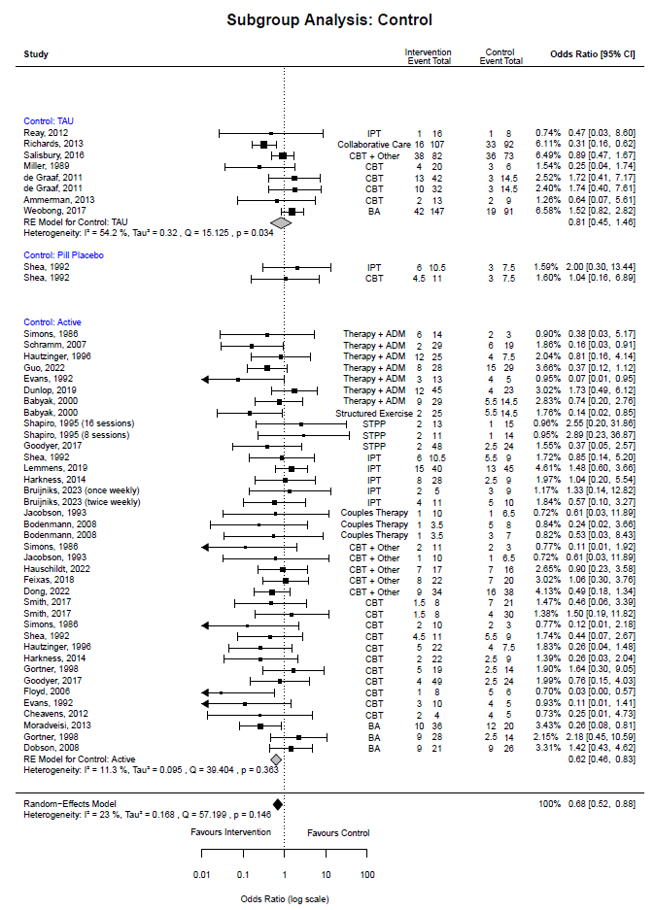
Control type

Follow-Up Time Subgroups
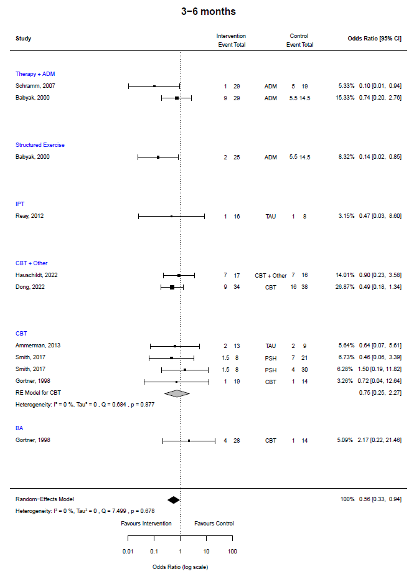
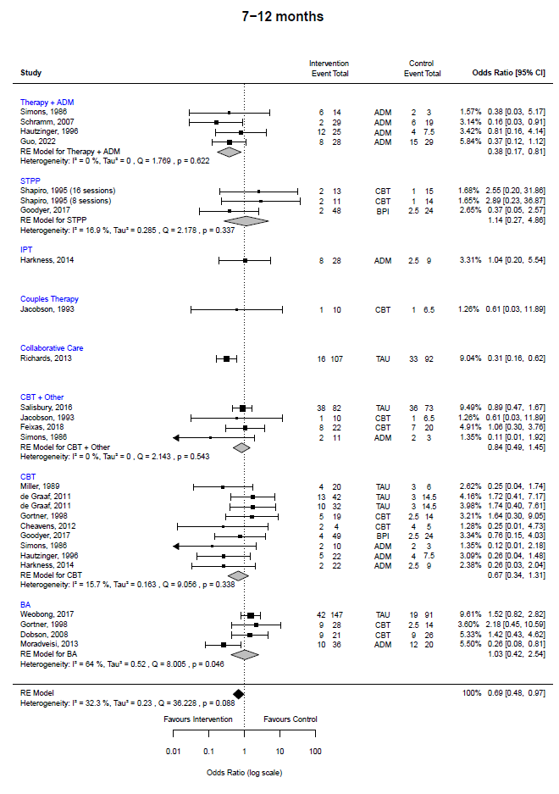
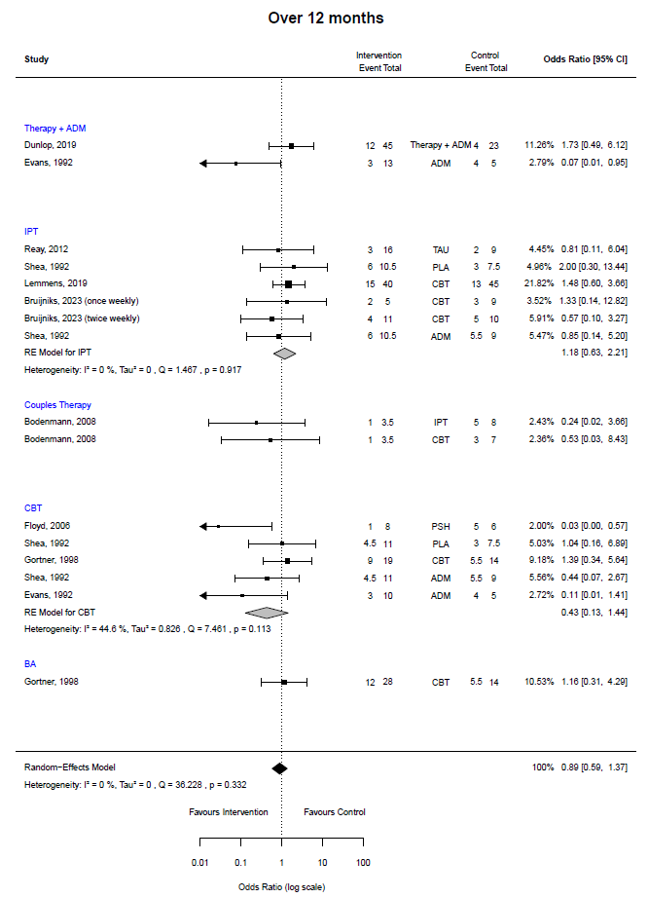

Secondary Outcome - Depression Scores

T1 – end of treatment
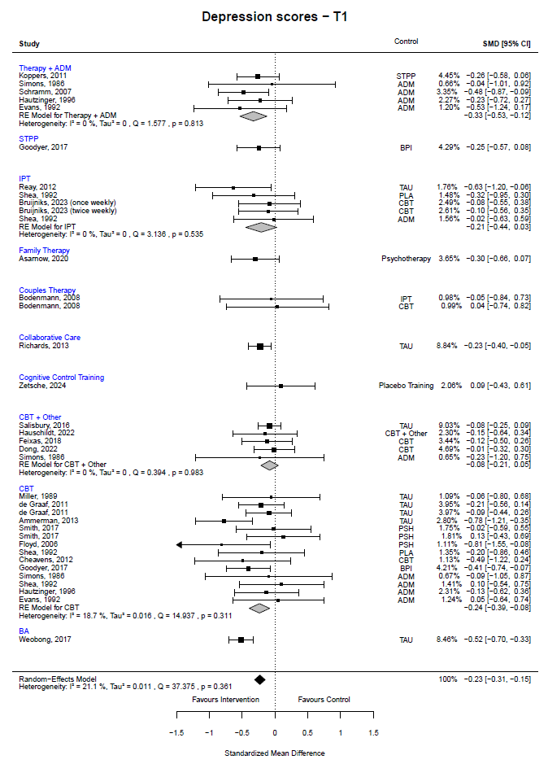

T2 – follow-up
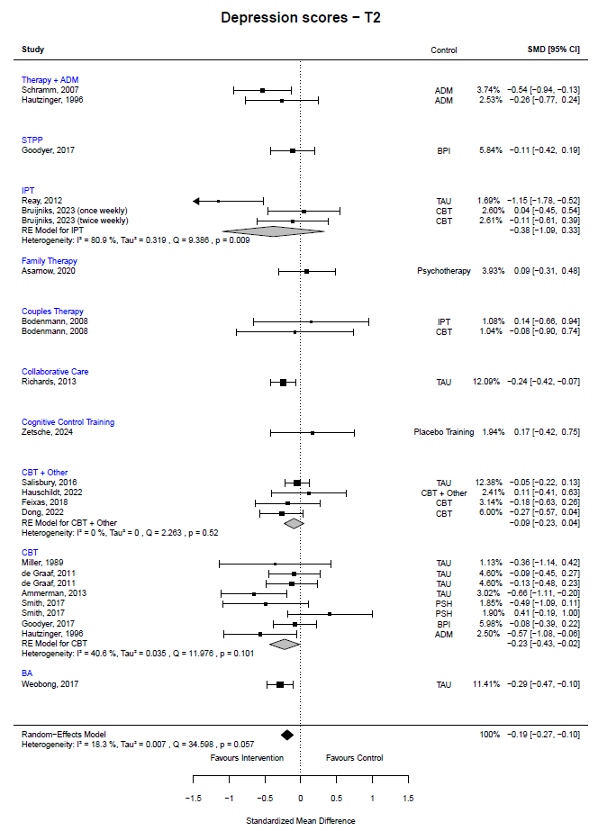

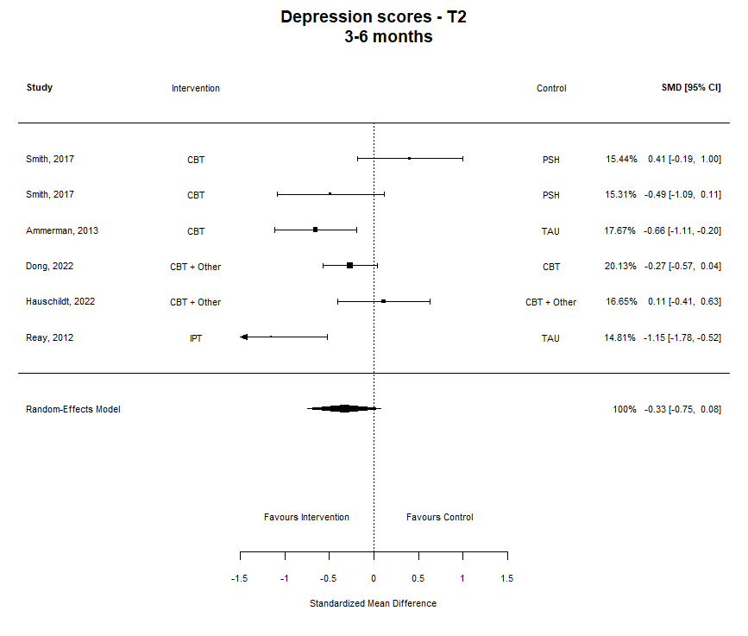
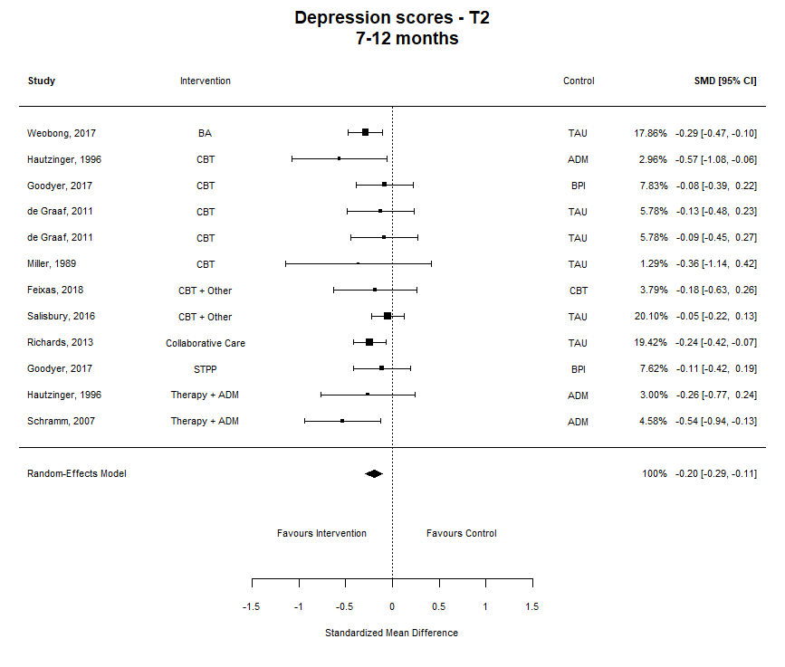
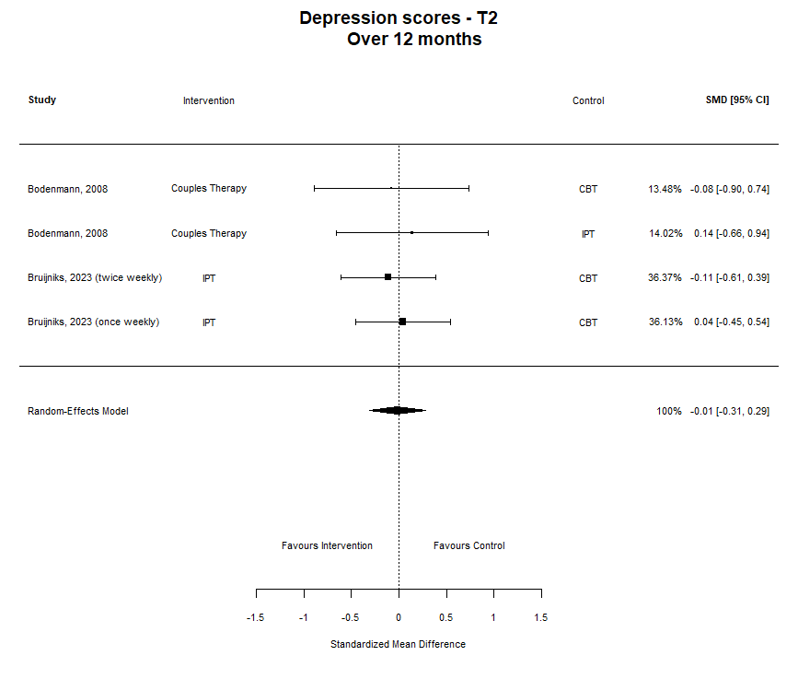

Sensitivity analyses
Relapse outcome meta-analysis | k | OR | 95% CI | I²
Original analysis – all studies, overall aggregate effect | 48 | 0.68 | 0.52, 0.88 | 23%
Assumed drop outs relapsed | 48 | 0.70 | 0.55, 0.90 | 25.6%
Excluding studies with unclear data | 37 | 0.65 | 0.48, 0.87 | 17.5%
Excluding Dunlop – different control to others | 47 | 0.66 | 0.51, 0.86 | 22.6%
Excluding Goodyer – underpowered | 46 | 0.68 | 0.52, 0.89 | 24.6%
Excluding Schramm – included bipolar patients | 47 | 0.70 | 0.54, 0.91 | 21.6%
Original analysis – Therapy + ADM subgroup | 7 | 0.51 | 0.25, 1.03 | 28.2%
Excluding Dunlop – different control to others | 6 | 0.40 | 0.21, 0.76 | 0%
Original analysis – follow-up over 12 months | 16 | 0.89 | 0.59, 1.37 | 0%
Excluding study with unclear data | 15 | 0.90 | 0.58, 1.39 | 0%

Funnel Plot and Egger’s Test for primary outcome
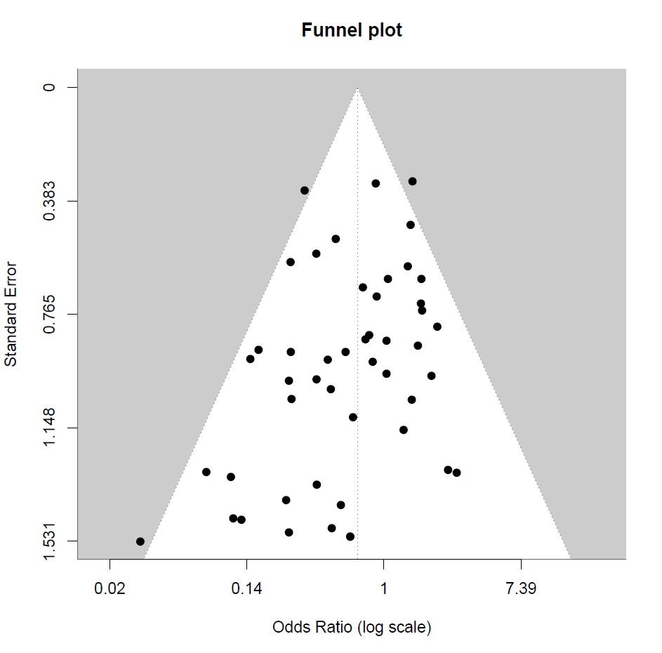

Regression Test for Funnel Plot Asymmetry
Model: | mixed-effects meta-regression model
Predictor: | standard error
Test for Funnel Plot Asymmetry: | z = -1.9826, p = 0.0474
Limit Estimate (as sei -> 0): | b = 0.2153 (CI: -0.4340, 0.8645)

Funnel Plot: Duval and Tweedie’s Trim and Fill

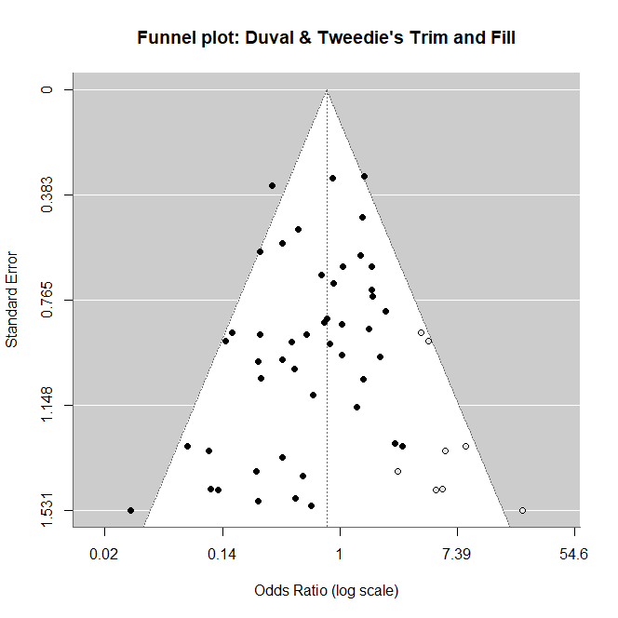

Estimated number of missing studies on the right side: 8 (SE = 4.5763).
Random-Effects Model (k = 56)
tau² | 0.2282 (SE = 0.1615)
I² | 27.04%
H² | 1.37
Q | 79.8691 (p-val = 0.0159)
estimate | 0.80
ci.lb | 0.62
ci.ub | 1.04
Regression Test for Funnel Plot Asymmetry
Model: | mixed-effects meta-regression model
Predictor: | standard error
Test for Funnel Plot Asymmetry: | z = -0.2106, p = 0.8332
Limit Estimate (as sei -> 0): | b = -0.1563 (CI: -0.8368, 0.5242)

Meta-Regressions |  | k | I² | Tau² | QE | QE p-value | QM | QM p-value | Predictor | Log estimate | p-value | Log CI (lower) | Log CI (upper) | Sig.
 | Relapse
Follow-up time |  | 48 | 23.73% | 0.1792 | 56.2152 | 0.1220 | 0.3710 | 0.8307 | Intercept - 3-6 months | -0.566 | 0.0885 | -1.2177 | 0.0853 | .
 |  |  |  |  |  |  |  |  | 7-12 months | 0.1950 | 0.6014 | -0.5368 | 0.9269
 |  |  |  |  |  |  |  |  | > 12 months | 0.2566 | 0.5598 | -0.6058 | 1.1189
Relapse outcome measure |  | 45 | 23.01% | 0.1737 | 48.9115 | 0.1852 | 4.4558 | 0.2163 | Intercept - Continuous e.g. LIFE | 0.1150 | 0.7181 | -0.5096 | 0.7397
 |  |  |  |  |  |  |  |  | Diagnostic e.g. SCID | -0.8759 | 0.0707 | -1.8256 | 0.0739 | .
 |  |  |  |  |  |  |  |  | Clinician rated e.g. HRSD | -0.8198 | 0.0861 | -1.7561 | 0.1165 | .
 |  |  |  |  |  |  |  |  | Self-report e.g. BDI | -0.4151 | 0.2656 | -1.1461 | 0.3158
Subgroup followed up |  | 48 | 23.86% | 0.1797 | 55.9988 | 0.1260 | 0.8590 | 0.6508 | Intercept - All followed up | -0.4226 | 0.0097 | -0.7428 | -0.1024 | **
 |  |  |  |  |  |  |  |  | Treatment completers | -0.1021 | 0.7835 | -0.8307 | 0.6265
 |  |  |  |  |  |  |  |  | Treatment responders | 0.3006 | 0.4152 | -0.4225 | 1.0237
Type of control |  | 48 | 23.70% | 0.1821 | 54.7580 | 0.1511 | 1.9721 | 0.3730 | Intercept - Active | -0.4974 | 0.0020 | -0.8133 | -0.1815 | **
 |  |  |  |  |  |  |  |  | TAU | 0.2921 | 0.3364 | -0.3035 | 0.8876
 |  |  |  |  |  |  |  |  | Pill Placebo | 0.8609 | 0.2607 | -0.6394 | 2.3613
Treatment duration (weeks - categorical) |  | 45 | 24.29% | 0.1784 | 53.9662 | 0.1220 | 1.9570 | 0.1618 | Intercept - ≤ 12 weeks | 0.6651 | 0.0043 | -1.1213 | -0.2090 | **
 |  |  |  |  |  |  |  |  | > 12 weeks | 0.4029 | 0.1618 | -0.1616 | 0.9674
Treatment duration (weeks - continuous) |  | 45 | 24.78% | 0.1833 | 55.4209 | 0.0970 | 0.7461 | 0.3877 | Intercept | -0.6973 | 0.0578 | -1.4177 | 0.0230 | .
 |  |  |  |  |  |  |  |  | Treatment duration | 0.0196 | 0.3877 | -0.0249 | 0.0641
Mean age at randomisation |  | 43 | 25.69% | 0.1840 | 52.6892 | 0.1043 | 0.0010 | 0.9744 | Intercept | -0.3281 | 0.6404 | -1.7048 | 1.0485
 |  |  |  |  |  |  |  |  | Mean age | 0.0005 | 0.9744 | -0.0337 | 0.0326
% Female at randomisation |  | 45 | 22.39% | 0.1552 | 50.9943 | 0.1882 | 2.7978 | 0.0944 | Intercept | 1.2144 | 0.1993 | -0.6398 | 3.0686
 |  |  |  |  |  |  |  |  | % Female | -2.2507 | 0.0944 | -4.8879 | 0.3866 | .
Baseline HRSD-17 |  | 23 | 7.14% | 0.0689 | 22.7437 | 0.3578 | 4.3795 | 0.0368 | Intercept | 2.4488 | 0.0817 | -0.3082 | 5.2057 | .
 |  |  |  |  |  |  |  |  | Baseline HRSD-17 | -0.1498 | 0.0364 | -0.2900 | -0.0095 | *
 | Depression Scores – T1 (end of treatment)
Depression measure |  | 36 | 21.64% | 0.0115 | 36.0838 | 0.3714 | 1.2685 | 0.2600 | Intercept – Clinician rated | -0.2922 | <.0001 | -0.4292 | -0.1552 | ***
 |  |  |  |  |  |  |  |  | Self-report | 0.0975 | 0.2600 | -0.0722 | 0.2673
Subgroup followed up |  | 36 | 23.19% | 0.0123 | 36.8958 | 0.2935 | 0.5277 | 0.7681 | Intercept - All followed up | -0.2139 | <.0001 | -0.3048 | -0.1230 | ***
 |  |  |  |  |  |  |  |  | Treatment completers | -0.0689 | 0.5505 | -0.2949 | 0.1572
 |  |  |  |  |  |  |  |  | Treatment responders | -0.1031 | 0.6439 | -0.5401 | 0.3340
 | Depression Scores – T2 (follow-up)
Depression outcome measure |  | 24 | 18.36% | 0.0074 | 32.7161 | 0.0660 | 1.7184 | 0.1899 | Intercept – Clinician rated | -0.3051 | 0.0020 | -0.4985 | -0.1116 | **
 |  |  |  |  |  |  |  |  | Self-report | 0.1440 | 0.1899 | -0.0713 | 0.3592
Subgroup followed up  Sig. codes: 0 ‘***’ 0.001 ‘**’ 0.01 ‘*’ 0.05 ‘.’ 0.1 ‘ ’ 1 |  | 24 | 16.19% | 0.0063 | 32.7450 | 0.0656 | 1.6106 | 0.2044 | Intercept - All followed up | -0.1729 | <.0001 | -0.2595 | -0.0862 | ***
 |  |  |  |  |  |  |  |  | Treatment completers | -0.2004 | 0.2044 | -0.5099 | 0.1091

PRISMA Checklist

Section and Topic | Item # | Checklist item | Location where item is reported
TITLE
Title | 1 | Identify the report as a systematic review. | Page 1
ABSTRACT
Abstract | 2 | See the PRISMA 2020 for Abstracts checklist. | Page 1
INTRODUCTION
Rationale | 3 | Describe the rationale for the review in the context of existing knowledge. | Page 3
Objectives | 4 | Provide an explicit statement of the objective(s) or question(s) the review addresses. | Page 5
METHODS
Eligibility criteria | 5 | Specify the inclusion and exclusion criteria for the review and how studies were grouped for the syntheses. | Page 5
Information sources | 6 | Specify all databases, registers, websites, organisations, reference lists and other sources searched or consulted to identify studies. Specify the date when each source was last searched or consulted. | Page 6
Search strategy | 7 | Present the full search strategies for all databases, registers and websites, including any filters and limits used. | S, Page 2
Selection process | 8 | Specify the methods used to decide whether a study met the inclusion criteria of the review, including how many reviewers screened each record and each report retrieved, whether they worked independently, and if applicable, details of automation tools used in the process. | Page 8
Data collection process | 9 | Specify the methods used to collect data from reports, including how many reviewers collected data from each report, whether they worked independently, any processes for obtaining or confirming data from study investigators, and if applicable, details of automation tools used in the process. | Page 8
Data items | 10a | List and define all outcomes for which data were sought. Specify whether all results that were compatible with each outcome domain in each study were sought (e.g. for all measures, time points, analyses), and if not, the methods used to decide which results to collect. | Page 7
Data items | 10b | List and define all other variables for which data were sought (e.g. participant and intervention characteristics, funding sources). Describe any assumptions made about any missing or unclear information. | Page 6
Study risk of bias assessment | 11 | Specify the methods used to assess risk of bias in the included studies, including details of the tool(s) used, how many reviewers assessed each study and whether they worked independently, and if applicable, details of automation tools used in the process. | Page 8
Effect measures | 12 | Specify for each outcome the effect measure(s) (e.g. risk ratio, mean difference) used in the synthesis or presentation of results. | Page 9
Synthesis methods | 13a | Describe the processes used to decide which studies were eligible for each synthesis (e.g. tabulating the study intervention characteristics and comparing against the planned groups for each synthesis (item #5)). | Page 6
Synthesis methods | 13b | Describe any methods required to prepare the data for presentation or synthesis, such as handling of missing summary statistics, or data conversions. | Page 9
Synthesis methods | 13c | Describe any methods used to tabulate or visually display results of individual studies and syntheses. | Page 9
Synthesis methods | 13d | Describe any methods used to synthesize results and provide a rationale for the choice(s). If meta-analysis was performed, describe the model(s), method(s) to identify the presence and extent of statistical heterogeneity, and software package(s) used. | Page 9
Synthesis methods | 13e | Describe any methods used to explore possible causes of heterogeneity among study results (e.g. subgroup analysis, meta-regression). | Page 9
Synthesis methods | 13f | Describe any sensitivity analyses conducted to assess robustness of the synthesized results. | Page 10
Reporting bias assessment | 14 | Describe any methods used to assess risk of bias due to missing results in a synthesis (arising from reporting biases). | Page 8
Certainty assessment | 15 | Describe any methods used to assess certainty (or confidence) in the body of evidence for an outcome. | Page 9
RESULTS
Study selection | 16a | Describe the results of the search and selection process, from the number of records identified in the search to the number of studies included in the review, ideally using a flow diagram. | Page 14
Study selection | 16b | Cite studies that might appear to meet the inclusion criteria, but which were excluded, and explain why they were excluded. | S, page 5
Study characteristics | 17 | Cite each included study and present its characteristics. | Page 16
Risk of bias in studies | 18 | Present assessments of risk of bias for each included study. | S, Page 9
Results of individual studies | 19 | For all outcomes, present, for each study: (a) summary statistics for each group (where appropriate) and (b) an effect estimate and its precision (e.g. confidence/credible interval), ideally using structured tables or plots. | Page 28-30  S, Page 11-18
Results of syntheses | 20a | For each synthesis, briefly summarise the characteristics and risk of bias among contributing studies. | Page 15
Results of syntheses | 20b | Present results of all statistical syntheses conducted. If meta-analysis was done, present for each the summary estimate and its precision (e.g. confidence/credible interval) and measures of statistical heterogeneity. If comparing groups, describe the direction of the effect. | Page 28-30
Results of syntheses | 20c | Present results of all investigations of possible causes of heterogeneity among study results. | Page 31  S, Page 21
Results of syntheses | 20d | Present results of all sensitivity analyses conducted to assess the robustness of the synthesized results. | Page 26  S, Page 19
Reporting biases | 21 | Present assessments of risk of bias due to missing results (arising from reporting biases) for each synthesis assessed. | Page 32  S, Page 19
Certainty of evidence | 22 | Present assessments of certainty (or confidence) in the body of evidence for each outcome assessed. | Page 15,  S, Page 10
DISCUSSION
Discussion | 23a | Provide a general interpretation of the results in the context of other evidence. | Page 32
Discussion | 23b | Discuss any limitations of the evidence included in the review. | Page 34
Discussion | 23c | Discuss any limitations of the review processes used. | Page 35
Discussion | 23d | Discuss implications of the results for practice, policy, and future research. | Page 38
OTHER INFORMATION
Registration and protocol | 24a | Provide registration information for the review, including register name and registration number, or state that the review was not registered. | Page 2
Registration and protocol | 24b | Indicate where the review protocol can be accessed, or state that a protocol was not prepared. | Page 2
Registration and protocol | 24c | Describe and explain any amendments to information provided at registration or in the protocol. | Page 11
Support | 25 | Describe sources of financial or non-financial support for the review, and the role of the funders or sponsors in the review. | Cover Letter
Competing interests | 26 | Declare any competing interests of review authors. | Cover Letter
Availability of data, code and other materials | 27 | Report which of the following are publicly available and where they can be found: template data collection forms; data extracted from included studies; data used for all analyses; analytic code; any other materials used in the review. | Page 40

From: Page MJ, McKenzie JE, Bossuyt PM, Boutron I, Hoffmann TC, Mulrow CD, et al. The PRISMA 2020 statement: an updated guideline for reporting systematic reviews. BMJ 2021;372:n71. doi: 10.1136/bmj.n71
For more information, visit: http://www.prisma-statement.org/

