Supplementary Material 1: Forest Plots of Mean Differences and Correlations
Figure 1.
Forest plot of mean TAS scores: standardized mean effect size for differences (SMD) between individuals with depressive disorders and healthy controls. 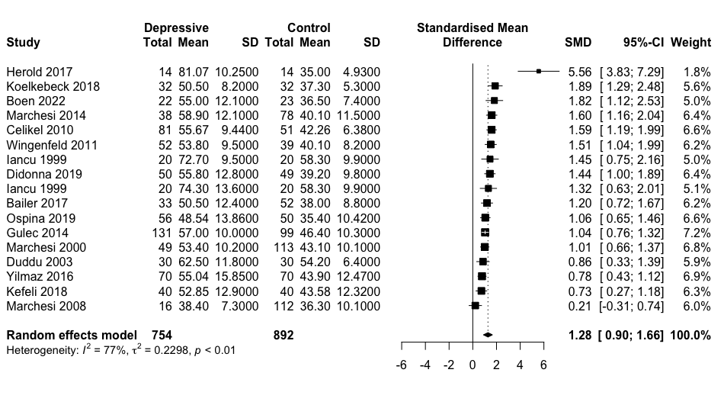
Figure 2.
Forest plot of mean DIF scores: standardized mean effect size for differences (SMD) between individuals with depressive disorders and healthy controls.
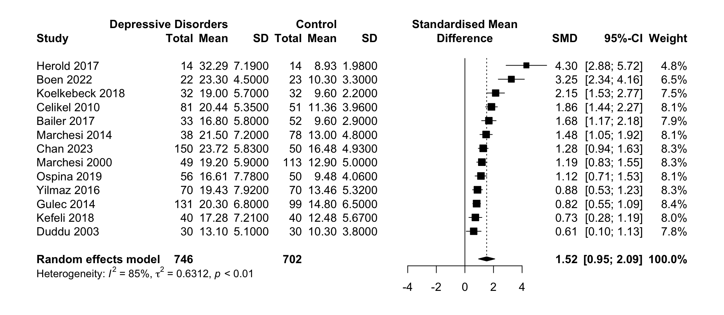

Figure 3.
Forest plot of mean DDF scores: standardized mean effect size for differences (SMD) between individuals with depressive disorders and healthy controls.
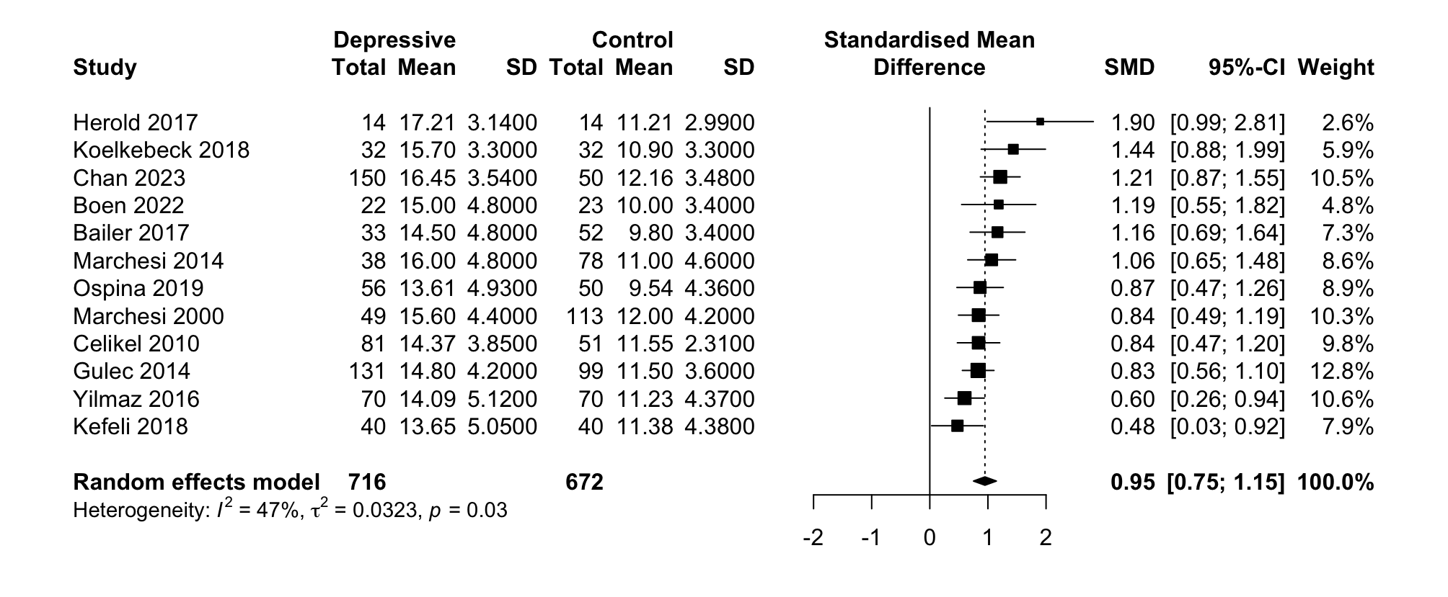

Figure 4.
Forest plot of mean EOT scores: standardized mean effect size for differences (SMD) between individuals with depressive disorders and healthy controls.
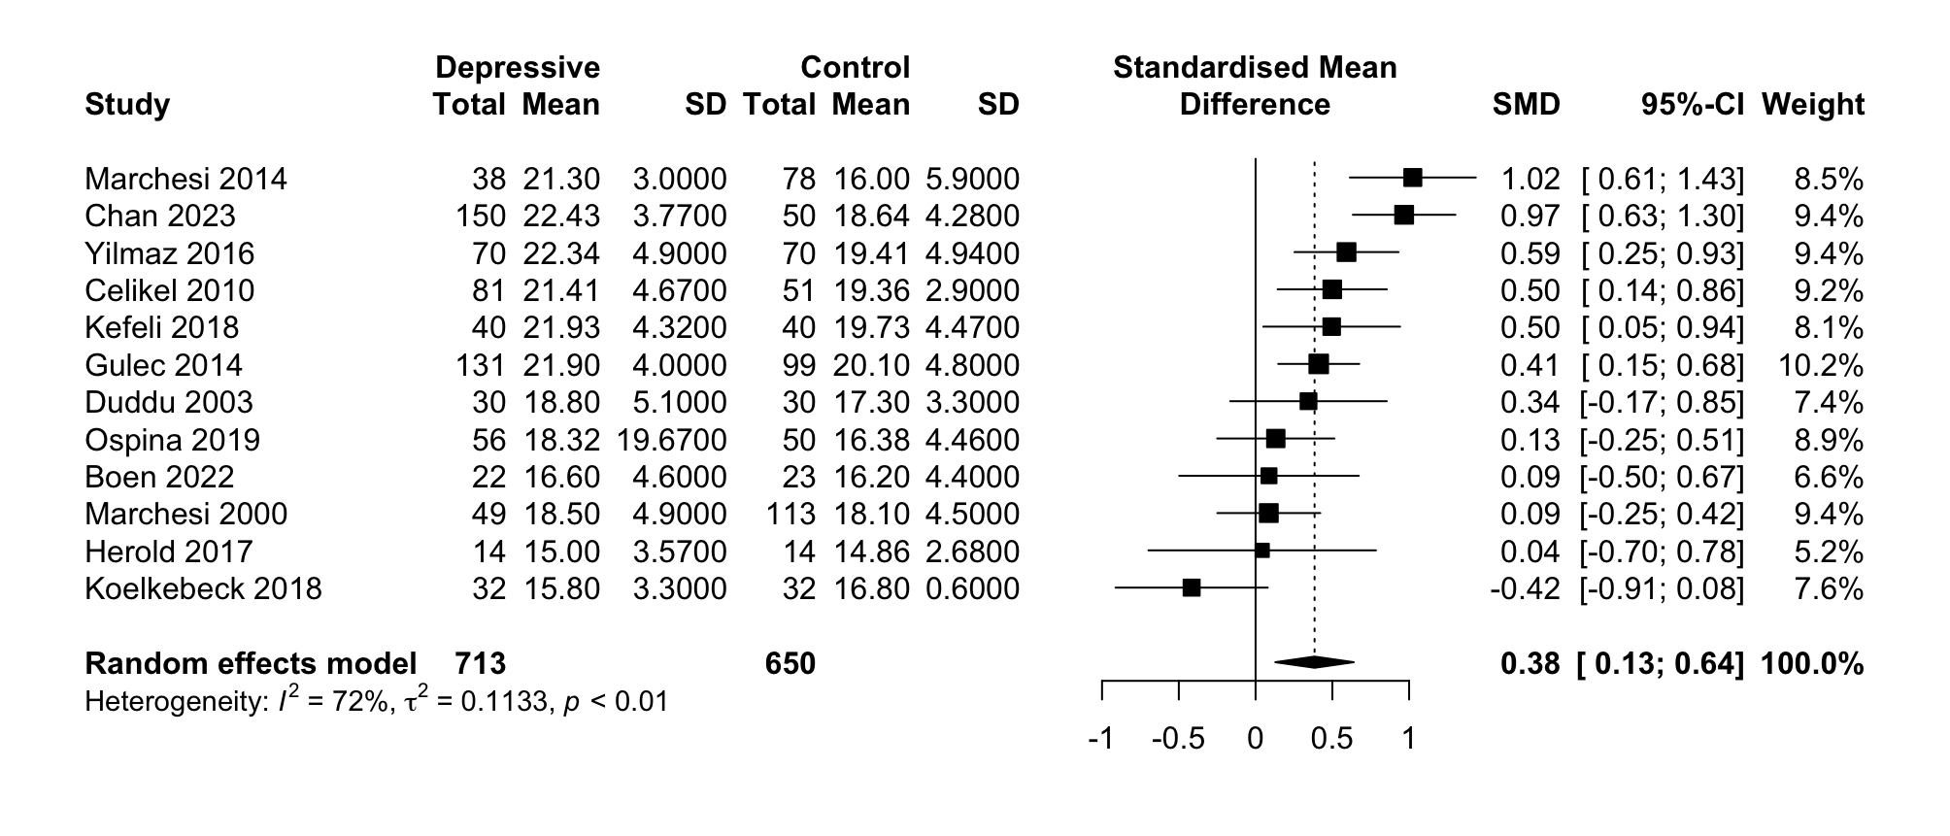

Figure 5.
Forest plot of mean TAS scores: standardized mean effect size for differences (SMD) between individuals with anxiety disorders and healthy controls.
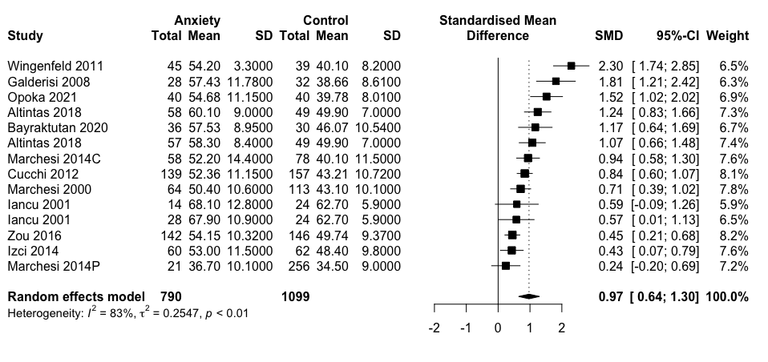
Figure 6.
Forest plot of mean DIF scores: standardized mean effect size for differences (SMD) between individuals with anxiety disorders and healthy controls.
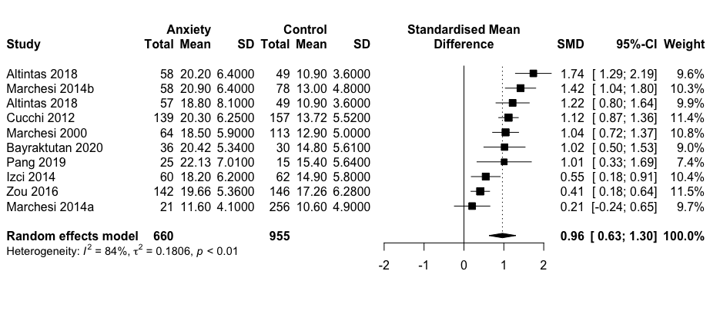

Figure 7.
Forest plot of mean DDF scores: standardized mean effect size for differences (SMD) between individuals with anxiety disorders and healthy controls.
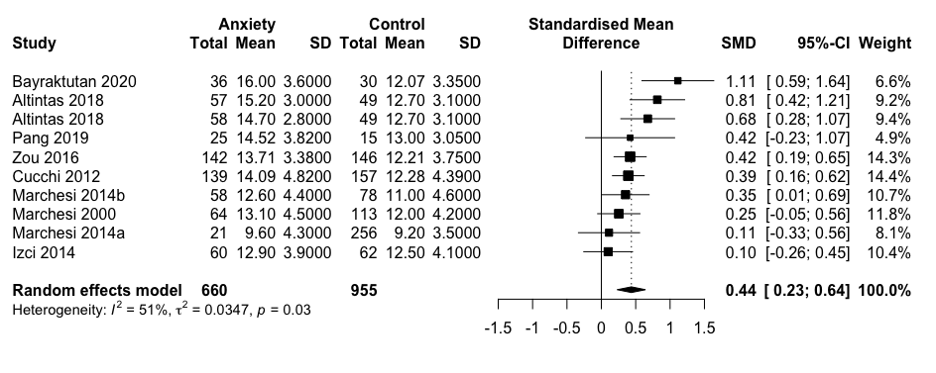

Figure 8.
Forest plot of mean EOT scores: standardized mean effect size for differences (SMD) between individuals with anxiety disorders and healthy controls.
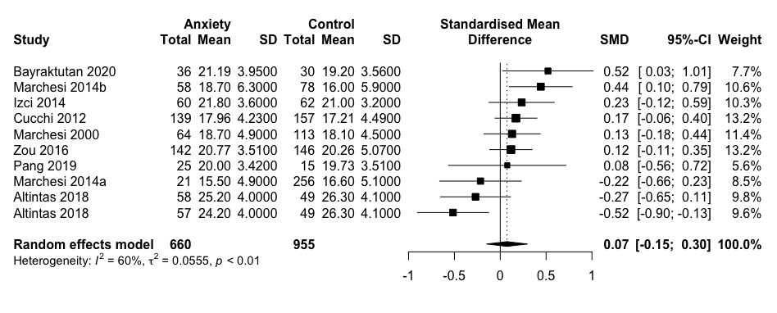

Figure 9.
Forest plot of mean TAS scores: standardized mean effect size for differences (SMD) between individuals with eating disorders and healthy controls.
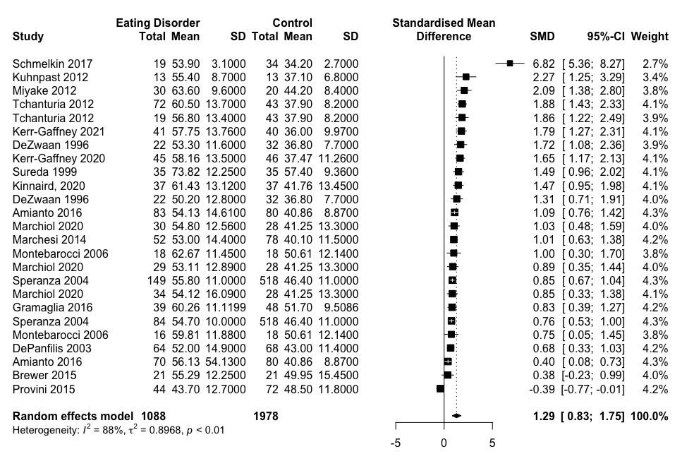

Figure 10.
Forest plot of mean DIF scores: standardized mean effect size for differences (SMD) between individuals with eating disorders and healthy controls.
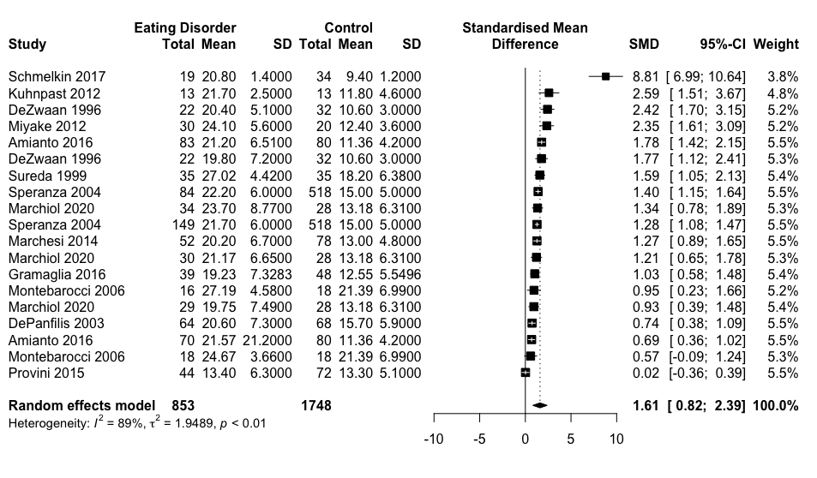Figure 11.
Forest plot of mean DDF scores: standardized mean effect size for differences (SMD) between individuals with eating disorders and healthy controls.
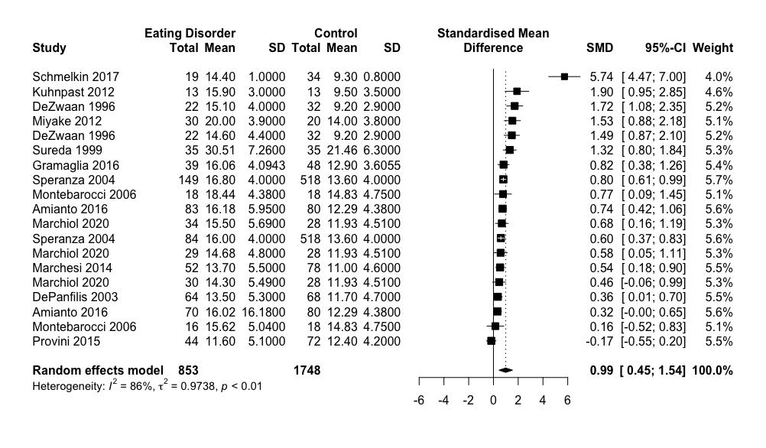
Figure 12.
Forest plot of mean EOT scores: standardized mean effect size for differences (SMD) between individuals with eating disorders and healthy controls.
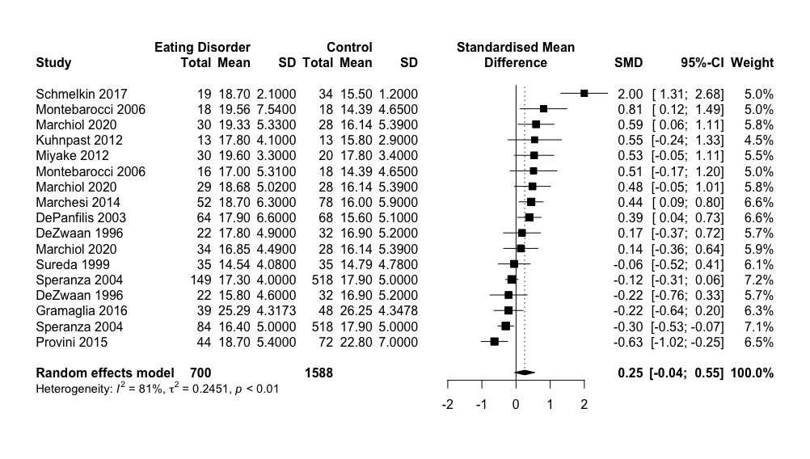

Figure 13.
Forest plot of mean TAS scores: standardized mean effect size for differences (SMD) between individuals with major depressive disorder (MDD) and healthy controls.
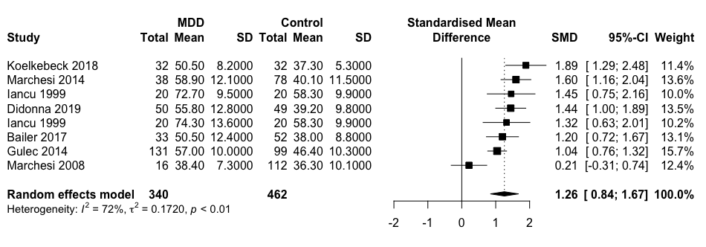

Figure 14.
Forest plot of mean DIF scores: standardized mean effect size for differences (SMD) between individuals with major depressive disorder (MDD) and healthy controls.
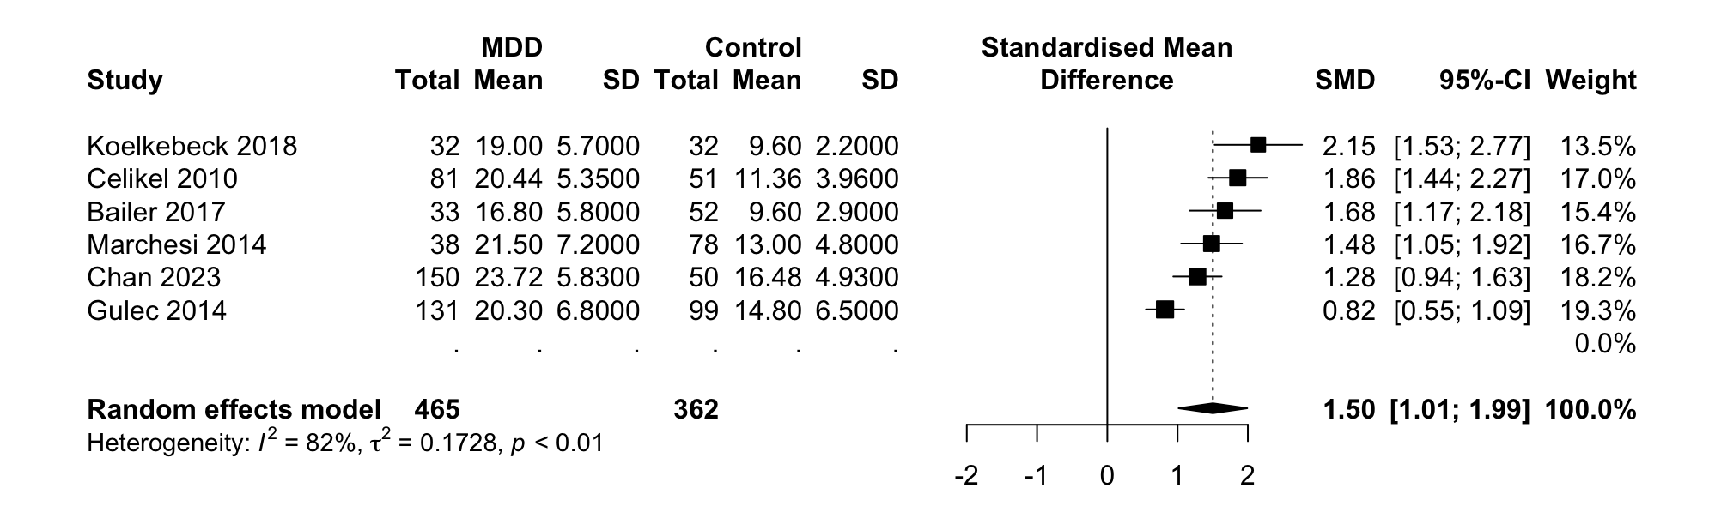
Figure 15.
Forest plot of mean DDF scores: standardized mean effect size for differences (SMD) between individuals with major depressive disorder (MDD) and healthy controls.
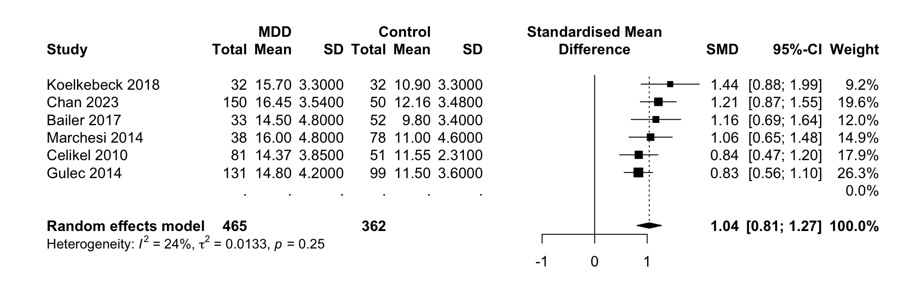
Figure 16.
Forest plot of mean EOT scores: standardized mean effect size for differences (SMD) between individuals with major depressive disorder (MDD) and healthy controls.
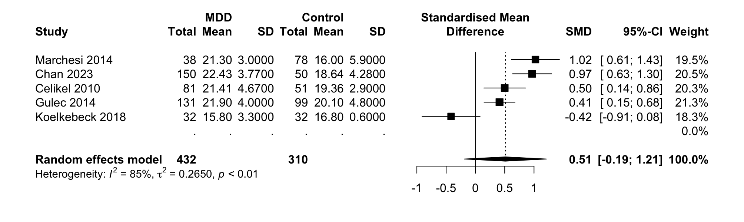
Figure 17.
Forest plot of mean TAS scores: standardized mean effect size for differences (SMD) between individuals with bipolar disorder (BP) and healthy controls.
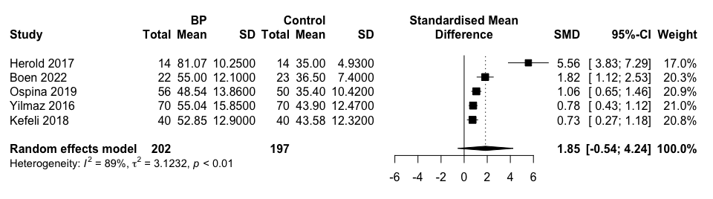
Figure 18.
Forest plot of mean DIF scores: standardized mean effect size for differences (SMD) between individuals with bipolar disorder (BP) and healthy controls.
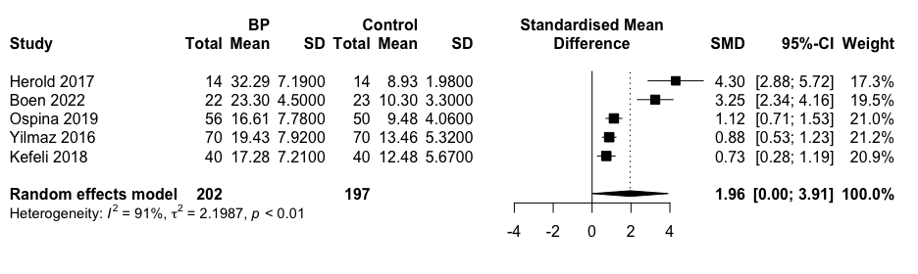
Figure 19.
Forest plot of mean DDF scores: standardized mean effect size for differences (SMD) between individuals with bipolar disorder (BP) and healthy controls.
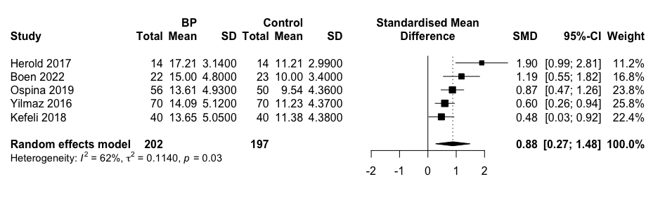
Figure 20.
Forest plot of mean EOT scores: standardized mean effect size for differences (SMD) between individuals with bipolar disorder (BP) and healthy controls.
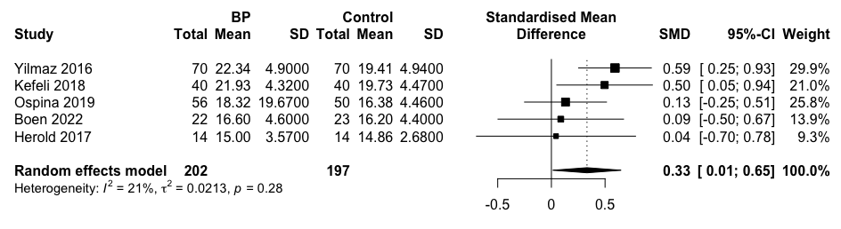
Figure 21.
Forest plot of mean TAS scores: standardized mean effect size for differences (SMD) between individuals with panic disorder (PD) and healthy controls.
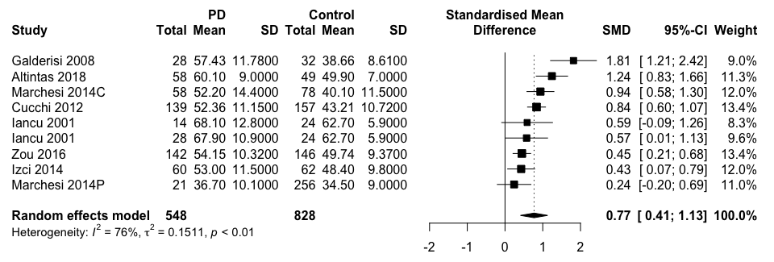
Figure 22.
Forest plot of mean DIF scores: standardized mean effect size for differences (SMD) between individuals with panic disorder (PD) and healthy controls.
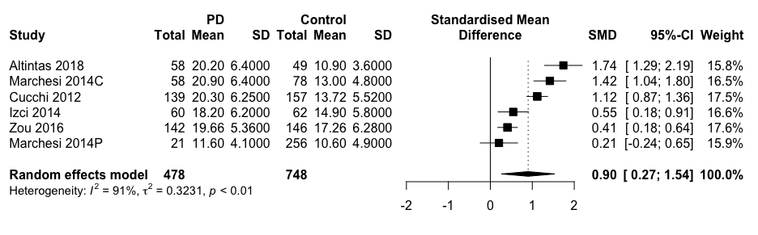
Figure 23.
Forest plot of mean DDF scores: standardized mean effect size for differences (SMD) between individuals with panic disorder (PD) and healthy controls.
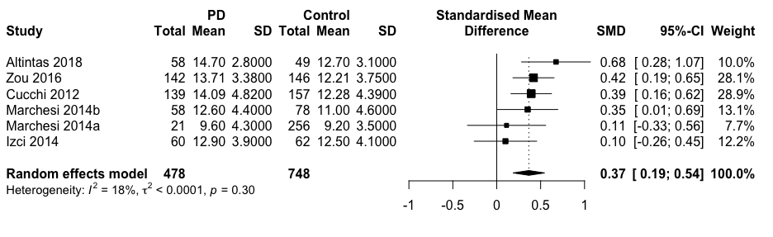

Figure 24.
Forest plot of mean EOT scores: standardized mean effect size for differences (SMD) between individuals with panic disorder (PD) and healthy controls.
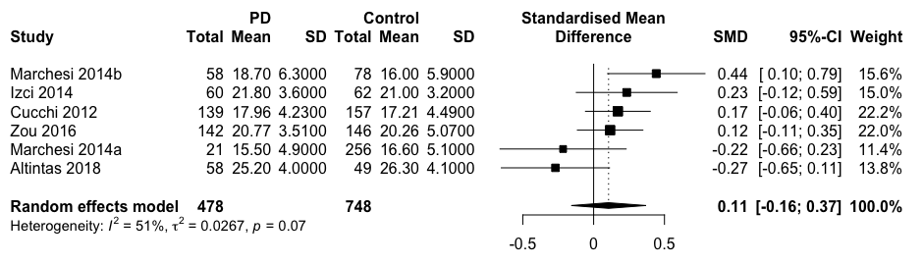

Figure 25.
Forest plot of mean TAS scores: standardized mean effect size for differences (SMD) between individuals with anorexia nervosa (AN) and healthy controls.
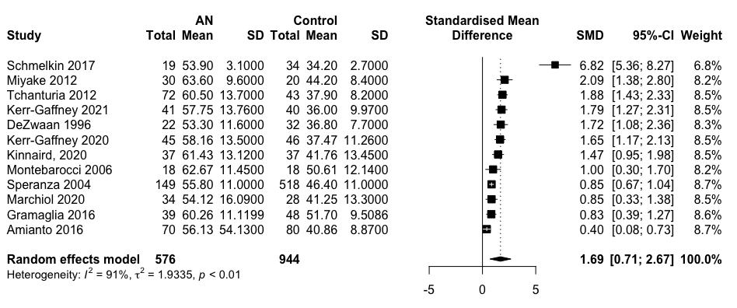

Figure 26.
Forest plot of mean DIF scores: standardized mean effect size for differences (SMD) between individuals with anorexia nervosa (AN) and healthy controls.
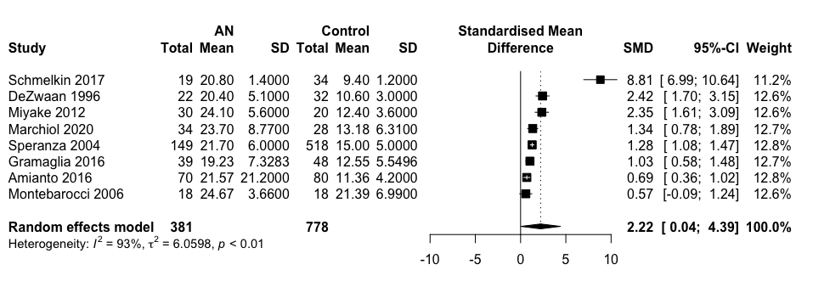

Figure 27.
Forest plot of mean DDF scores: standardized mean effect size for differences (SMD) between individuals with anorexia nervosa (AN) and healthy controls.
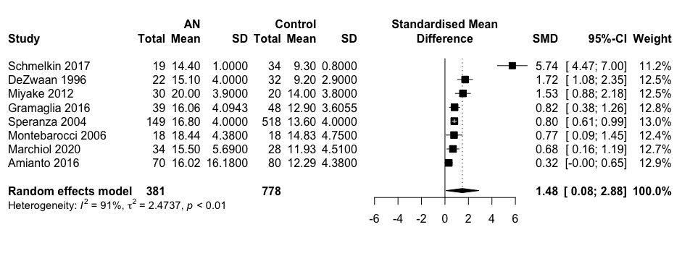

Figure 28.
Forest plot of mean EOT scores: standardized mean effect size for differences (SMD) between individuals with anorexia nervosa (AN) and healthy controls.
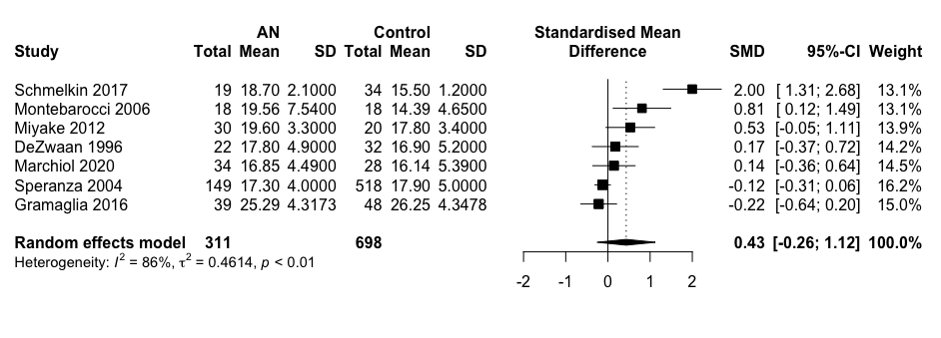

Figure 29.
Forest plot of mean TAS scores: standardized mean effect size for differences (SMD) between individuals with bulimia nervosa (BN) and healthy controls.
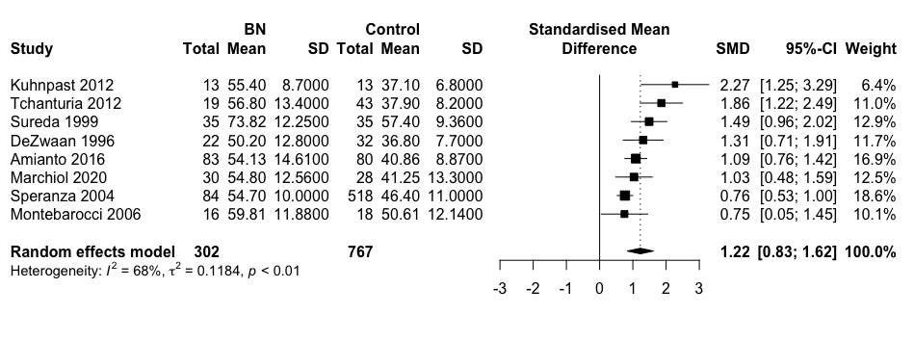

Figure 30.
Forest plot of mean DIF scores: standardized mean effect size for differences (SMD) between individuals with bulimia nervosa (BN) and healthy controls.
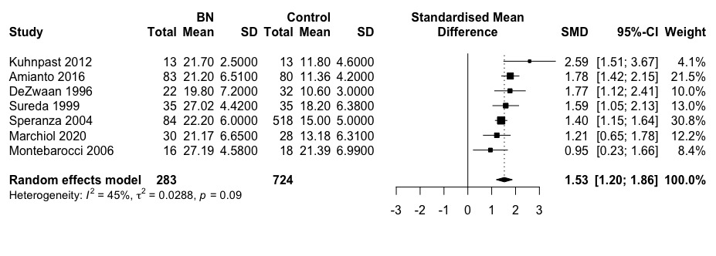

Figure 31.
Forest plot of mean DDF scores: standardized mean effect size for differences (SMD) between individuals with bulimia nervosa (BN) and healthy controls.
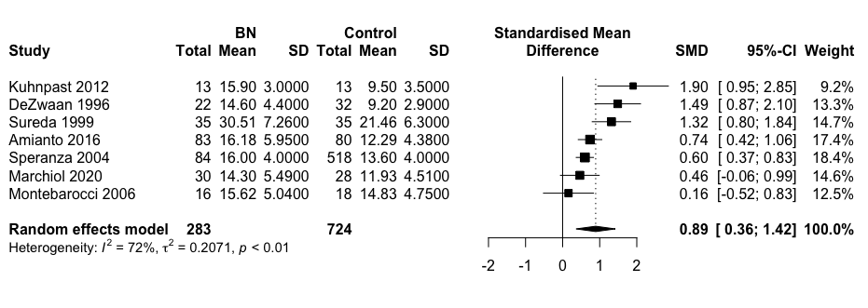

Figure 32.
Forest plot of mean EOT scores: standardized mean effect size for differences (SMD) between individuals with bulimia nervosa (BN) and healthy controls.
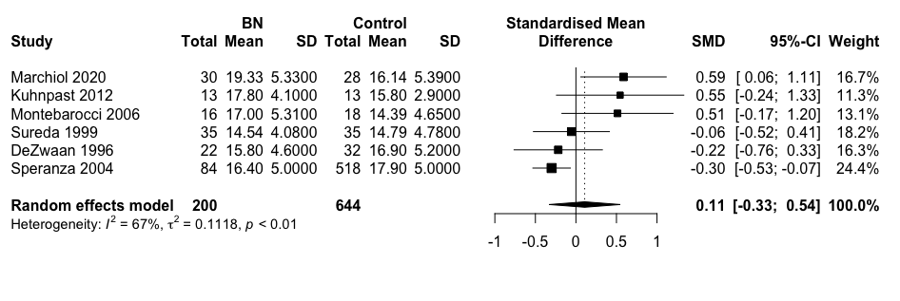

Figure 33.
Forest plot of correlation coefficients: the association between TAS scores and disorder symptom severity in depressive disorders.
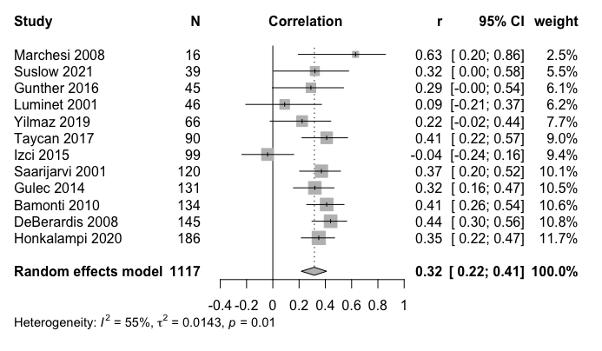
Figure 34.
Forest plot of correlation coefficients: the association between DIF scores and disorder symptom severity in depressive disorders.
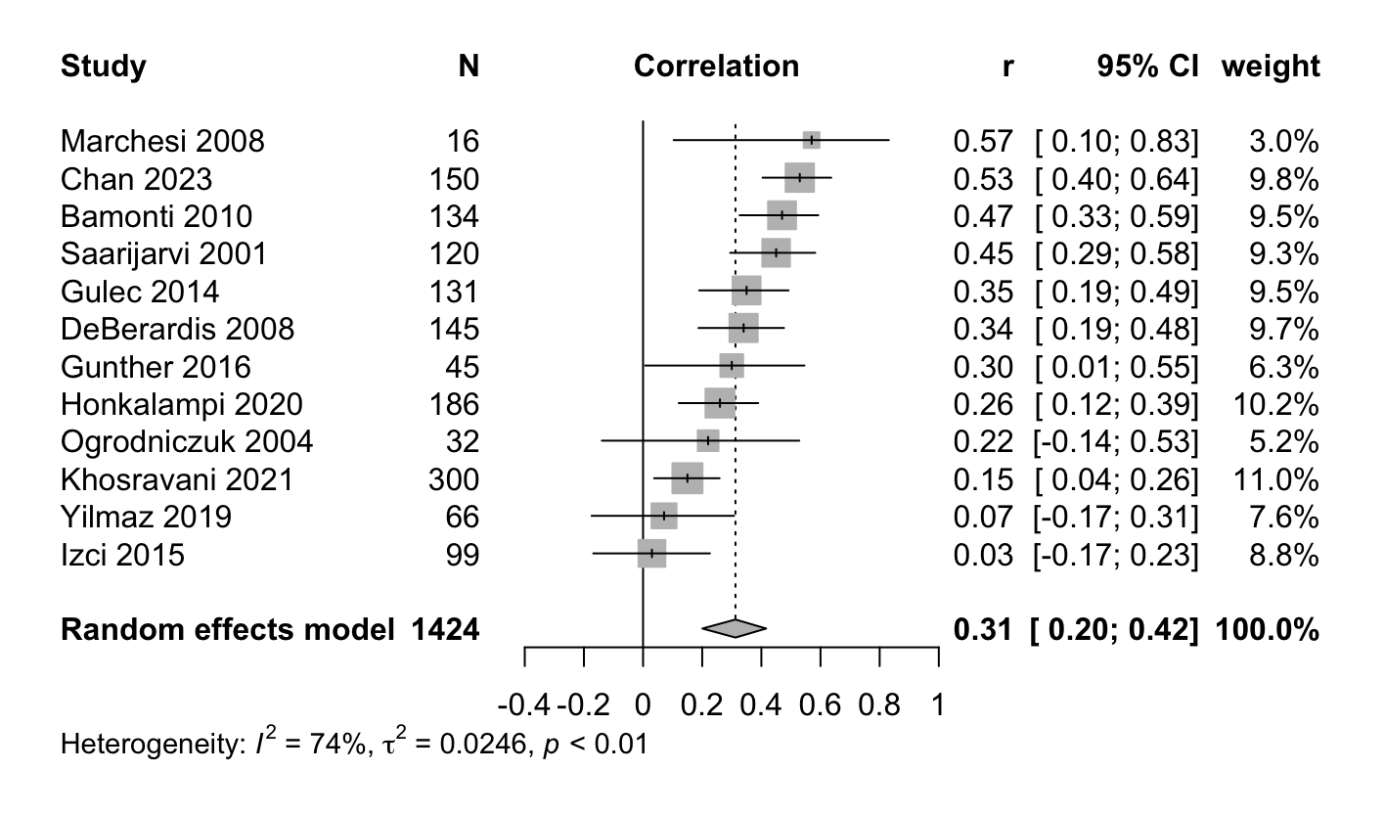
Figure 35.
Forest plot of correlation coefficients: the association between DDF scores and disorder symptom severity in depressive disorders.
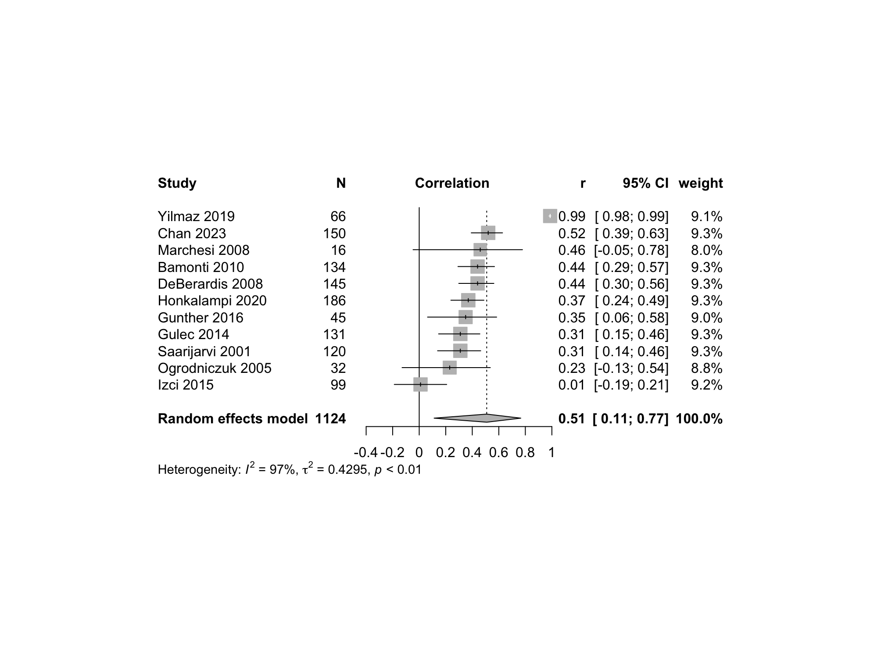
Figure 36.
Forest plot of correlation coefficients: the association between EOT scores and disorder symptom severity in depressive disorders.
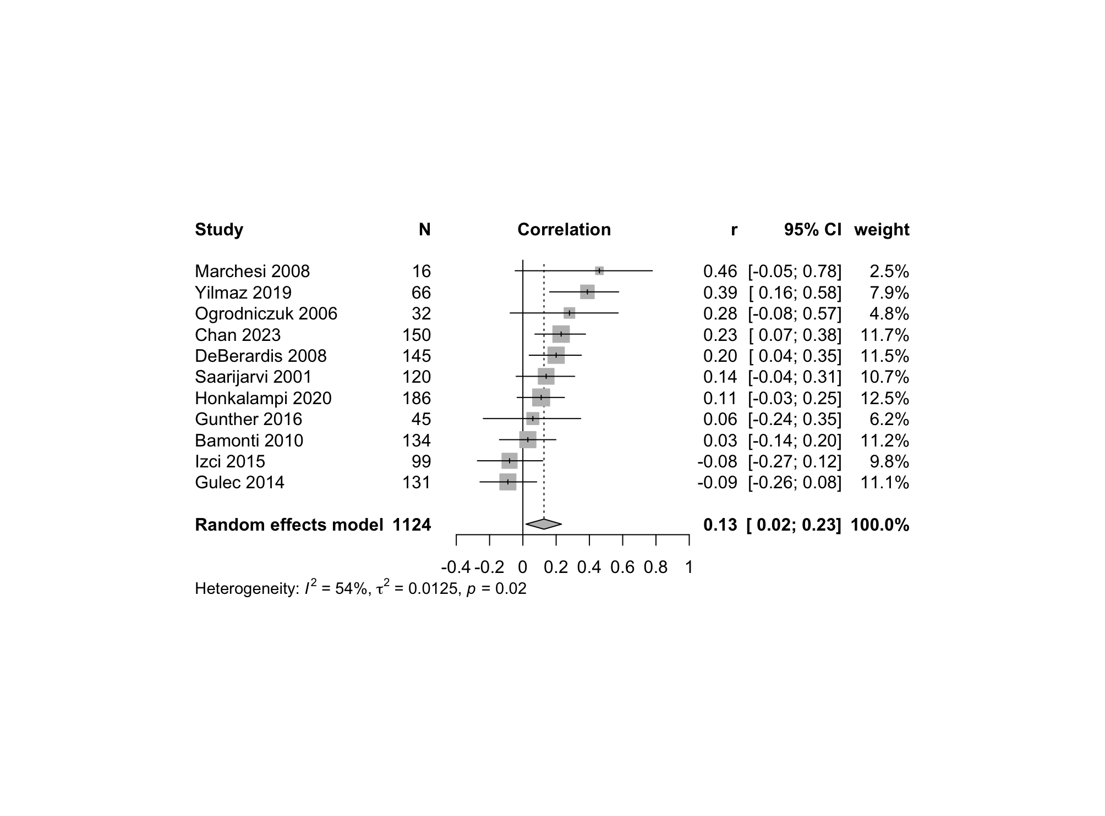

Figure 37.
Forest plot of correlation coefficients: the association between TAS scores and disorder symptom severity in anxiety disorders.
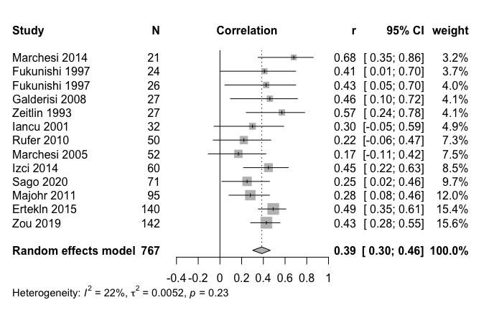
Figure 38.
Forest plot of correlation coefficients: the association between DIF scores and disorder symptom severity in anxiety disorders.
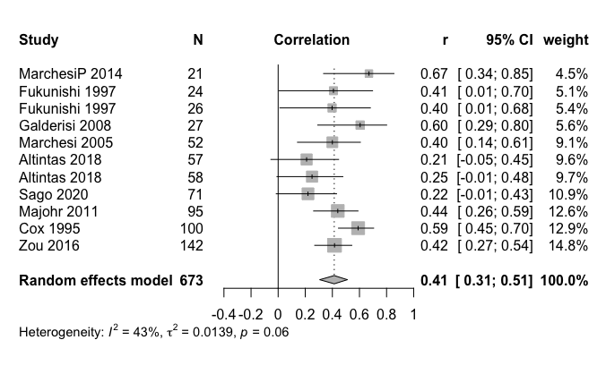
Figure 39.
Forest plot of correlation coefficients: the association between DDF scores and disorder symptom severity in anxiety disorders.
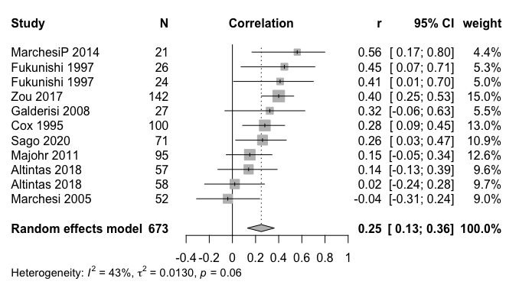
Figure 40.
Forest plot of correlation coefficients: the association between EOT scores and disorder symptom severity in anxiety disorders.
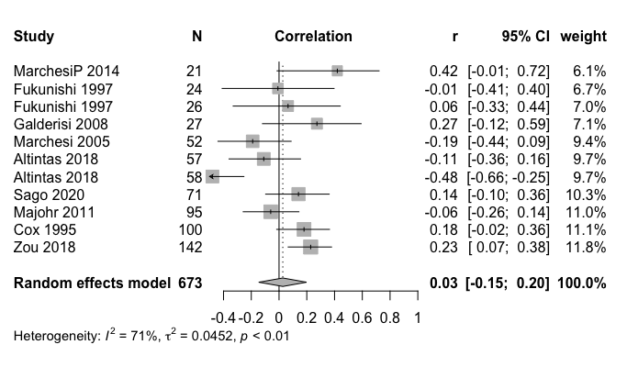
Figure 41.
Forest plot of correlation coefficients: the association between TAS scores and disorder symptom severity in eating disorders.
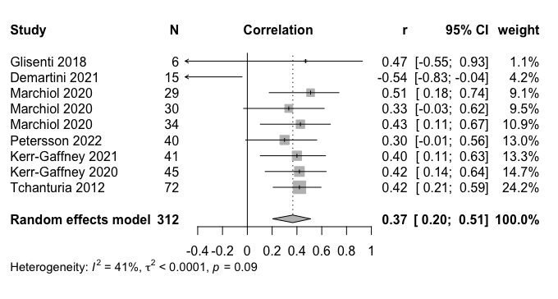
Figure 42.
Forest plot of correlation coefficients: the association between TAS scores and disorder symptom severity among those with major depressive disorder.
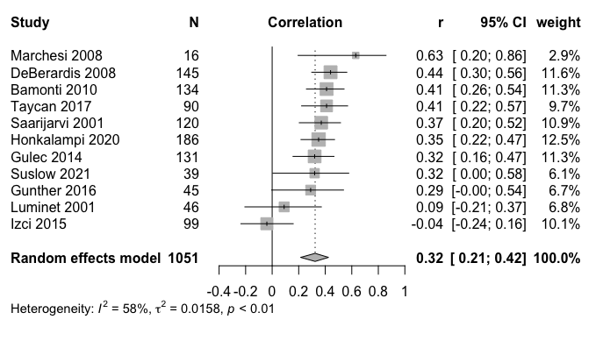
Figure 43.
Forest plot of correlation coefficients: the association between DIF scores and disorder symptom severity among those with major depressive disorder.
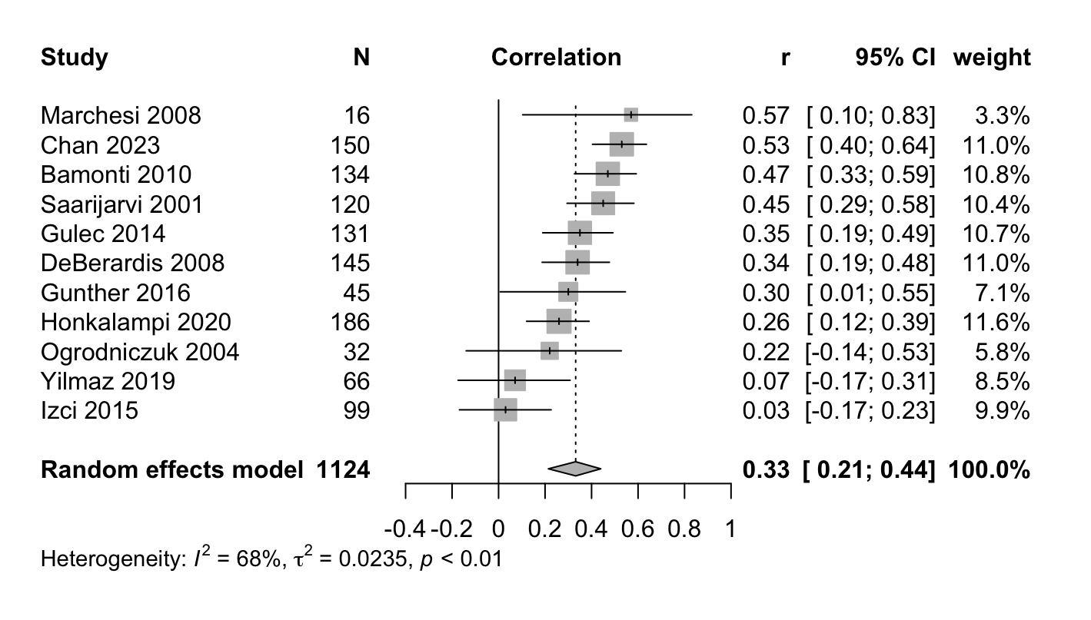

Figure 44.
Forest plot of correlation coefficients: the association between DDF scores and disorder symptom severity among those with major depressive disorder.
Figure 45.
Forest plot of correlation coefficients: the association between EOT scores and disorder symptom severity among those with major depressive disorder.
Figure 46.
Forest plot of correlation coefficients: the association between TAS scores and disorder symptom severity among those with panic disorder.
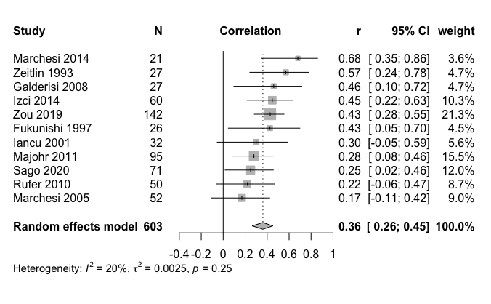
Figure 47.
Forest plot of correlation coefficients: the association between DIF scores and disorder symptom severity among those with panic disorder.
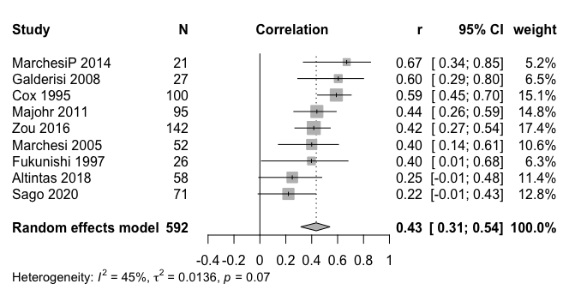
Figure 48.
Forest plot of correlation coefficients: the association between DDF scores and disorder symptom severity among those with panic disorder.
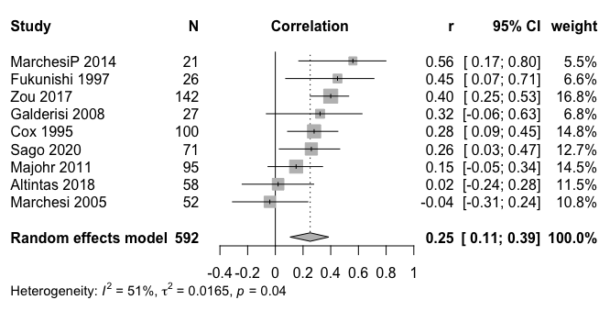

Figure 49.
Forest plot of correlation coefficients: the association between EOT scores and disorder symptoms among those with panic disorder.
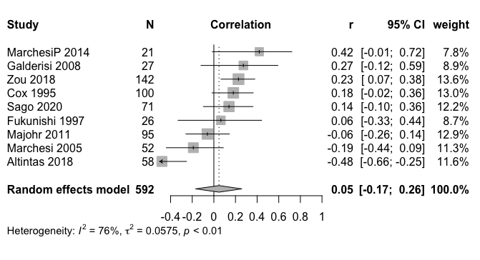

Figure 50.
Forest plot of correlation coefficients: the association between TAS scores and disorder symptom severity among those with anorexia nervosa.
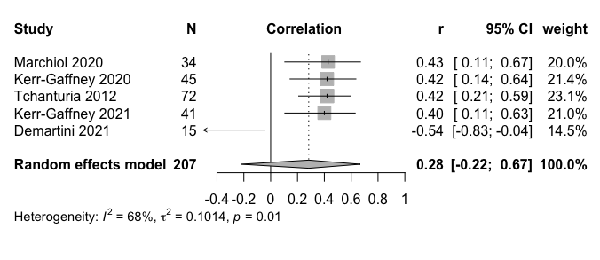

Supplementary Material 2 – Non-Significant Findings from the Meta-regression Analyses
Table 1
Table showing meta-regression results investigating mean age and proportion of females as moderators of correlations between disorder symptoms and alexithymia in depressive and anxiety disorders.
Variables | Scale | Moderators | b Weight | SE | t-value | p-value | 95% CI
Depressive Disorders | TAS | Mean Age | -0.0005 | 0.006 | -0.09 | 0.93 | [-0.01; 0.01]
Depressive Disorders | TAS | Proportion of females | 0.003 | 0.004 | 0.78 | 0.46 | [-0.006; 0.01]
Depressive Disorders | DIF | Mean Age | 0.008 | 0.005 | 1.67 | 0.13 | [-0.003; 0.02]
Depressive Disorders | DIF | Proportion of females | -0.002 | 0.003 | -0.58 | 0.58 | [-0.009; 0.005]
Depressive Disorders | DDF | Mean Age | -0.018 | 0.03 | -0.71 | 0.5 | [-0.08; 0.04]
Depressive Disorders | DDF | Proportion of females | 0.03 | 0.02 | 1.68 | 0.14 | [-0.01; 0.07]
Anxiety Disorders | DDF | Mean Age | 0.02 | 0.01 | 1.2 | 0.25 | [-0.01; 0.05]
Anxiety Disorders | DDF | Proportion of females | 0.005 | 0.005 | 1.03 | 0.34 | [-0.007; 0.02]
Note. TAS=Toronto Alexithymia Scale; DIF = Difficulties Identifying Feelings subscale; DDF = Difficulties Describing Feeling subscale

Table 2
Table showing meta-regression results investigating mean age and proportion of females as moderators of correlations between disorder symptoms and alexithymia in panic disorder and anorexia nervosa specifically.
Variables | Scale | Moderators | b Weight | SE | t-value | p-value | 95% CI
PD | DDF | Mean Age | 0.02 | 0.02 | 0.9 | 0.41 | [-0.03; 0.06]
PD | DDF | Proportion of females | 0.006 | 0.006 | 0.93 | 0.4 | [-0.01; 0.02]
AN | TAS | Mean Age | -0.31 | 0.17 | -1.82 | 0.17 | [-0.86; 0.23]
AN | TAS | Proportion of females | -0.03 | 0.05 | -0.61 | 0.58 | [-0.19; 0.13]

Note: PD = Panic Disorder; AN = Anorexia Nervosa; DDF = Difficulties Describing Feeling subscale; TAS=Toronto Alexithymia Scale

