Figure 3
Forest-Plots of the subgroup-analysis for the outcome domains depression and anxiety
Depression (VI)
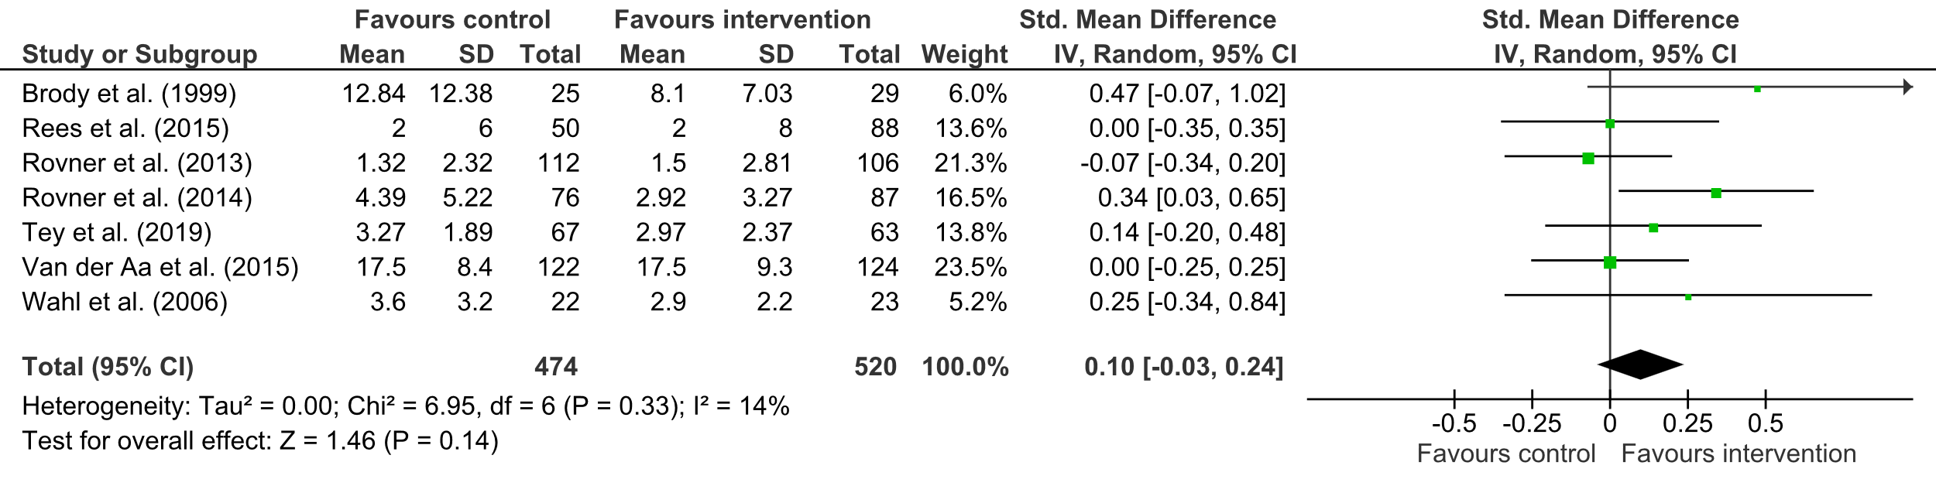
Anxiety (VI)
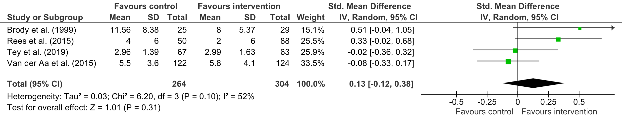

Table 3
All Mental Health Outcomes for Post Measurement Included in the Meta-Analysis (k = 23)
Study | N | Mental health outcomes
Brody et al. (1999) | 54 | Mood
Brody et al. (2002) | 230 | Mood
Garnefski & Kraaij (2012) | 45 | Depression; anxiety
Jansson-Fröjmark et al. (2012) | 32 | insomnia disorder; depression; anxiety
Matsuguma et al. (2019) | 22 | Self-esteemª
Rees et al. (2015) | 138 | Depression; anxiety; stress; self-efficacyª
Rovner et al. (2013) | 218 | Depression
Rovner et al. (2014) | 163 | Depression
Tey et al. (2019) | 130 | Depressionª; anxietyª; stressª; self-efficacyª; generic health-related quality of lifeª; health-related quality of lifeª
Van der Aa et al. (2015) | 246 | Depression; anxiety
Wahl et al. (2006) | 45 | Depression
Notes. ª The direction of the outcome domain was converted by multiplying with -1.

Table 4
Categories of Identified Methods to Improve the Accessibility in Psychological Interventions for Persons with Hearing (VI) or Vision Impairment (VI)
Category | Example | Quantity of studies
C1: Trained personnel or experts (e.g., audiologists, occupational therapists, optometrist, psychologists) | Rovner et al. (2014): “In the former, occupational therapists delivered BA to address depression and functional deficits owing to vision loss.” | HI or VI (N = 16): n = 13; 81% (Brody et al., 2002; Brody et al., 2006; Brody et al., 2005; Brody et al., 1999; Deemer et al., 2017; Jansson-Fröjmark et al., 2012; Rees et al., 2015; Rovner et al., 2013; Rovner et al., 2014; Tey et al., 2019; van der Aa et al., 2015; van der Aa et al., 2017; Wahl et al., 2006)
C2: Independence through remaining eyesight | Brody et al. (2002): “We challenged them to use their remaining eyesight to maintain their independence and involvement in personally meaningful activities.” | VI (N = 14): n = 3; 21% (Brody et al., 2002; Brody et al., 2005; Brody et al., 1999)
C3: Low vision aids and devices | Brody et al. (1999): “Participants randomized to the wait-list condition also attended the intervention, allowing pre-post comparisons on the use of vision aids, activities, and health-related quality of life variables.” | VI (N = 14): n = 5; 36% (Brody et al., 2002; Brody et al., 1999; Deemer et al., 2017; Rees et al., 2015; Rovner et al., 2014)
C4: Modeled interventions by experts and/or patients | Van der Aa et al. (2015): “Patients (n = 8) from low vision rehabilitation organizations were involved in the development and implementation of the stepped care program based on two focus group meetings in the Netherlands and Belgium.” | VI (N = 14): n = 4; 29% (Brody et al., 2006; Brody et al., 2005; van der Aa et al., 2015; van der Aa et al., 2017)
C5: Different methods of recruitment (e.g., oral, mail, e-mail, telephone) | Matsuguma (2019): “Oral informed consent was obtained from all participants.” | VI (N = 14): n = 4; 29% (Deemer et al., 2017; Matsuguma et al., 2019; van der Aa et al., 2015; van der Aa et al., 2017)
C6: In-home interventions | Garnefski & Kraaij (2012): “Respondents who were allocated to the CBS condition received the self-help program at home by regular mail.” | HI or VI (N = 16): n = 6; 38% (Deemer et al., 2017; Garnefski & Kraaij, 2012; Girdler et al., 2010; Rovner et al., 2014; van der Aa et al., 2015; van der Aa et al., 2017)
C7: Face-to-face interviews | Girdler et al. (2010): “Face-to-face structured interviews (including oral administration of questionnaires) were administered in participants’ homes.” | VI (N = 14): n = 6; 43% (Girdler et al., 2010; Matsuguma et al., 2019; Rees et al., 2015; Rovner et al., 2013; van der Aa et al., 2015; van der Aa et al., 2017)
C8: Communication by mail | Jansson-Fröjmark et al. (2012): “At three time points (pre-treatment, post-treatment, and 3-month follow-up), the participants were sent the questionnaires and a weekly sleep diary by mail.” | HI (N = 2): n = 2; 100% (Garnefski & Kraaij, 2012; Jansson-Fröjmark, et al. 2012)
C9: Arranged transport | Rees et al. (2015): “The sessions  were held at urban rehabilitation centers, and transport for participants arranged (when requested) and provided free of cost.” | VI (N = 14): n = 1; 7% (Rees et al., (2015)
C10: Accompaniment of participants | Rees et al. (2015): “Participants were given the option to have a relative, friend or other caregiver accompany them to the program in order to provide support and assistance and to encourage sustainability of learning.” | VI (N = 14): n = 1; 7% (Rees et al., (2015)
C11: Different types of therapy materials (e.g., written, digital, audio, Braille) | Van der Aa et al. (2015): ” Specific attention was also given to the manner in which the program was offered (for example, audio and Braille version of written documents).” | HI or VI (N = 16): n = 6; 38% (Brody et al., 2002; Garnefski & Kraaij, 2012; Jansson-Fröjmark et al., 2012; Tay et al., 2019; van der Aa et al., 2015; van der Aa et al., 2017)
C12: Phone-interviews | Wahl et al. (2006): “All the assessments in the study were performed as telephone interviews by trained research assistants who were not informed about the research status of those they interviewed.” | VI (N = 14): n = 3; 21% (van der Aa et al., 2015; van der Aa et al., 2017; Wahl et al., 2006)
C13: Repetition of content and additional information | Jansson-Fröjmark (2012): “Receipt was attained by (a) asking the patient at the end of each session to describe the treatment components for that session and the therapist supplying additional information if a component was not described in a full manner…” | HI (N = 2): n = 1; 50% (Jansson-Fröjmark et al., 2012)

