**Supplementary Materials**

Table of Contents

**Supplementary Materials 1: Characteristics of Perfectionism and Social Anxiety**

**Supplementary Materials 2: Risk of Bias Ratings**

**Supplementary Materials 3: Results of Publication Bias Test**

**Supplementary Materials 1: Characteristics of Perfectionism and Social Anxiety**

**Table S1**

*Characteristics of perfectionism: dimensions, measures and definitions.*

|  |  |  |
| --- | --- | --- |
| **Perfectionism Dimension** | **Perfectionism Measure** | **Definition** |
| Socially Prescribed Perfectionism | Multidimension Perfectionism Scale (HF) | Perception of unrealistically high standards being imposed on the self. Socially prescribed perfectionism at the dimensional level reflects a generalized sense of other people or society rather the demands of specific people such as parents (Flett & Hewitt, 2022). |
| Self-Oriented Perfectionism | Multidimension Perfectionism Scale (HF) | High personal standards and motivation to attain perfection At extreme levels, this dimension involves settling for only perfection for oneself, and even a small shortfall may be regarded as a failure (Flett & Hewitt, 2022). |
| Other-Oriented Perfectionism | Multidimension Perfectionism Scale (HF) | Exceedingly high standards for other people (Flett & Hewitt, 2022). |
| Concern Over Mistakes | Multidimension Perfectionism Scale (F) | Negative reactions to mistakes, the interpretation of mistakes as equivalent to failure, and the belief that one will lose the respect of others after failure (Frost et al., 2010). |
| Doubts About Actions | Multidimension Perfectionism Scale (F) | The tendency to doubt the quality of one’s actions and competence (Frost et al., 2010). |
| Parental Criticism | Multidimension Perfectionism Scale (F) | The belief that parents are overly critical of one’s attempts to meet them (Frost et al., 2010). |
| Parental Expectation | Multidimension Perfectionism Scale (F) | The perception that parents set extremely high standards (Frost et al., 2010). |
| Personal Standards | Multidimension Perfectionism Scale (F) | The setting of excessively high standards for performance (Frost et al., 2010). |
| Organization | Multidimension Perfectionism Scale (F) | Belief in the importance of neatness and order (Flett & Hewitt, 2002). |
| Perfectionistic Concerns | Multidimension Perfectionism Scale (F)  Multidimension Perfectionism Scale (HF) | The impact of mistakes, failure, and feelings of discrepancy between one’s expectations and perceived performance on feelings of self-worth and identity (Osenk et al., 2020). |
| Perfectionistic Strivings | Multidimension Perfectionism Scale (F)  Multidimension Perfectionism Scale (HF) | Aspects of perfectionism associated with self-oriented striving for perfection and the setting of very high personal performance standards (Gotwals et al., 2012). |
| Clinical Perfectionism | Clinical Perfectionism Questionnaire | The overdependence of self-evaluation on the determined pursuit of personally demanding self-imposed standards in at least one highly salient domain despite adverse consequences (Shafran et al., 2001). |
| Perfectionistic Self-Promotion | Perfectionistic Self-Presentation Scale | Focusing on proclaiming and displaying one’s perfection (Hewitt et al., 2003). |
| Nondisplay of Imperfection | Perfectionistic Self-Presentation Scale | Concentrating on concealing and avoiding behavioral demonstrations of one’s imperfection (Hewitt et al., 2003). |
| Nondisclosure of Imperfection | Perfectionistic Self-Presentation Scale | Centering on evading and avoiding verbal admissions of one’s imperfection (Hewitt et al., 2003). |
| Perfectionistic Cognitions | Perfectionistic Cognitions Inventory | Automatic thoughts that reflect the need to be perfect and awareness of imperfections (Flett & Hewitt, 2002). |
| Adaptive Perfectionism | Almost Perfect Scale | High standards and orderliness; however, most scale users assess only the high standards component because of concerns that orderliness represents conscientiousness and not perfectionism. |
| Maladaptive Perfectionism | Almost Perfect Scale | The perceived discrepancy or difference between the standards one has for oneself and one’s actual performance (Slanely et al, 2001). |

**Table S2**

*Characteristics of social anxiety: dimensions, measures, and definitions.*

| Social Anxiety Dimension | Social Anxiety Measure | Definition |
| --- | --- | --- |
| Fear of Negative Evaluation | Fear of Negative Evaluation Scale (FNE) | Fear of negative evaluation was defined as apprehension about others’ evaluations, distress over their negative evaluations, avoidance of evaluative situations, and the expectation that others would evaluate oneself negatively (Watson & Friend, 1969). |
| Social Avoidance | Social Avoidance and Distress Scale (SAD) | Social avoidance was defined as avoiding being with, talking to, or escaping from others for any reason. Both actual avoidance and the desire for avoidance were included (Watson & Friend, 1969). |
| Social Distress | Social Avoidance and Distress Scale (SAD) | Social distress was defined as the reported experience of a negative emotion, such as being upset, distressed, tense, or anxious, in social interactions, or the reported lack of negative emotion, such as being relaxed, calm, at ease, or comfortable (Watson & Friend, 1969). |
| Fear | Social Phobia Inventory (SPIN) | Fear of people in authority, of parties and social events, of being criticised, of talking to strangers, of doing things when people are watching, and of being embarrassed (Connor et al., 2000). |
| Avoidance | Social Phobia Inventory (SPIN) | Avoidance of talking to strangers, of speaking to people for fear of embarrassment, of going to parties, of being the centre of attention, of making speeches, of being criticised, of speaking to authority (Connor et al., 2000). |
| Physiological discomfort | Social Phobia Inventory (SPIN) | Blushing, sweating, palpitations, or shaking and trembling in front of people (Conner et al., 2000). |
| Social Anxiety | The Social Phobia and Anxiety Inventory (SPAI) | Assesses various dimensions of social anxiety, including fear of negative evaluation, social avoidance and distress, and physiological symptoms related to social situations. |
| Interaction Anxiety | The Social Interaction and Anxiety Scale (SIAS) | Levels of anxiety and discomfort in social interactions and situations. |
| Social Phobia | The Social Phobia Scale (SPS) | Assesses symptoms in relation to social phobia, including fear in social situations, avoidance behaviours, and physical symptoms. |
| Fear | The Liebowitz Social Anxiety Scale (LSAS) | The level of fear or anxiety experience in various social situations. |
| Avoidance | The Liebowitz Social Anxiety Scale (LSAS) | The level of avoidance of various social situations. |
| Self-Consciousness | Self-Consciousness Scale | Levels of self-awareness, self-monitoring, and self-consciousness in social situations. |
| Social Appearance Anxiety | Social Appearance Anxiety Scale | Anxiety and distress specifically related to concerns about their physical appearance in social situations. |

**Supplementary Materials 2: Risk of Bias Ratings**

**Table S1**

*Rater 1 Risk of Bias Assessment*

| Study | 1. Were subjects and setting described in detail? | | 2. Was the participant eligibility and inclusion methods clear, standardized and objective? | | 3. Was the sample used representative of the intended population? | |
| --- | --- | --- | --- | --- | --- | --- |
| Al-Naggar (2013) | Yes |  | Yes | They used random sample technique where they selected respondents based on a random numbering method | No |  |
| Cerea (2018) | Yes |  | No | Were vague about the information they used in a 'background information schedule' to exclude participants | No |  |
| Christian (2021 ) | Yes |  | No |  | No |  |
| Flett (2012) | Yes |  | No |  | No |  |
| Rosser (2003) | Yes |  | Yes |  | No |  |
| Juster (1996) | Yes |  | Yes |  | No |  |
| Kumari (2012) | Yes |  | Yes |  | No |  |
| Levison (2015) 1 | Yes |  | Yes |  | No |  |
| Levison (2015) 2 | Yes |  | Yes |  | No |  |
| Levison (2015) 3 | Yes |  | No | They repeated the same reason for only selecting females (an ED research question) | No |  |
| Lundh (1996) | Yes |  | Yes |  | No |  |
| Maeda (2017) | Yes |  | No |  | No |  |
| March (1997) 1 | Yes |  | Yes |  | Yes |  |
| March (1997) 2 | Yes |  | Yes |  | Yes |  |
| Menatti (2013) | Yes |  | No | They only included females and they cited one paper to justify that there is high prevalence of ED among female undergraduates | No |  |
| Nishikawa (2017) | Yes |  | Yes |  | No |  |
| Levison (2013) 1 | Yes |  | No |  | No |  |
| Levison (2013) 2 | Yes |  | No | They only recruited females because of one paper they cited saying that they are at a higher risk of developing an ED | No |  |
| Saboonchi (1997) | Yes |  | No |  | No |  |
| Unubol (2018) | Yes |  | No | They excluded those who had a chronic or psychiatric disorder but only asked participants to say yes or no to have them | No |  |
| Vassilopoulos (2018) | Yes |  | Yes |  | No |  |
| Wong (2012) | Yes |  | No |  | No |  |
| Wong (2016) | Yes |  | No |  | No |  |
| Kaczkurkin (2021) | Yes |  | Yes |  | No |  |
| Redden (2022) | Yes |  | Yes |  | No |  |
| Saulnier (2022) | Yes |  | Yes |  | No |  |
| Abdollahi (2019) | Yes |  | No |  | No |  |
| Brown (2013) | Yes |  | Yes |  | No |  |
| Casale (2020) | Yes |  | No |  | No |  |
| Cox (2015) | Yes |  | No |  | No |  |
| Gautrea (2015) | Yes |  | No |  | No | Representative of other samples used at the university |
| Goya (2016) | Yes |  | Yes |  | Yes |  |
| Iancu (2014) | Yes |  | No | Their exclusion criteria was not consenting and not knowing enough Hebrew | No |  |
| Jain (2010) | Yes | Although they didn't describe the measures in detail | Yes |  | No |  |
| Laurenti (2008) | Yes |  | No |  | No |  |
| Mohammadian (2018) | Yes |  | No | While they wanted them to be non-clinical, they did not measure and exclude anyone over | Yes | They considered gender, faculty, and major |
| Newby (2017) | Yes |  | No |  | No |  |
| Scott (2014) | Yes |  | No | Used word of mouth and snowballing methods to recruit, although they were from the community | No |  |
| Shaumaker (2009) | Yes |  | No |  | No |  |
| Nepon (2011) | Yes |  | No |  | No |  |
| Kawamoto (2023) | Yes |  | No |  | No |  |
| Manova (2023) | Yes | Although they don't give much in terms of a procedure | Yes | They had to be enrolled into a Canadian institution | No |  |
| Wang (2022) | Yes |  | Yes | They didn't have any reason to exclude anyone | No |  |
| Momene (2022) | Yes |  | No |  | No |  |

**Table S2**

*Rater 2 Risk of Bias Assessment*

| Study | 1. Were subjects and setting described in detail? | | 2. Was the participant eligibility and inclusion methods clear, standardized and objective? | | 3. Was the sample used representative of the intended population? | |
| --- | --- | --- | --- | --- | --- | --- |
| Al-Naggar (2013) | Yes |  | Yes |  | No |  |
| Cerea (2018) | Yes |  | Yes |  | No |  |
| Christian (2021 ) | Yes |  | No | University sample, which explores psychopathology in a nonclinical sample. | No |  |
| Flett (2012) | No | Only age and sex reported | No |  | No |  |
| Rosser (2003) | Yes |  | Yes |  | No |  |
| Juster (1996) | Yes |  | Yes |  | No |  |
| Kumari (2012) | Yes |  | Yes |  | No | Underrepresentation of women in the clinical sample. |
| Levison (2015) 1 | Yes |  | No | Possible convenience sampling university samples used without clear rationale | No |  |
| Levison (2015) 2 | Yes |  | No |  | No |  |
| Levison (2015) 3 | Yes |  | No | Part of an ongoing longitudinal study examining eating disorders. | No |  |
| Lundh (1996) | Yes |  | Yes |  | No |  |
| Maeda (2017) | No | Only age and sex reported | No | Possible convenience sampling university samples used without clear rationale | No |  |
| March (1997) 1 | Yes |  | Yes |  | Yes |  |
| March (1997) 2 | Yes |  | Yes |  | No |  |
| Menatti (2013) | Yes |  | Yes |  | No |  |
| Nishikawa (2017) | Yes |  | Yes |  | No |  |
| Levison (2013) 1 | Yes |  | No |  | No |  |
| Levison (2013) 2 | Yes |  | Yes |  | No |  |
| Saboonchi (1997) | No | Only age and sex reported | No |  | No |  |
| Unubol (2018) | Yes |  | Yes |  | No |  |
| Vassilopoulos (2018) | Yes |  | Yes |  | No |  |
| Wong (2012) | No | Only age and sex reported | No |  | No |  |
| Wong (2016) | No | Only age and sex reported | No | Possible convenience sampling university samples used without clear rationale | No |  |
| Kaczkurkin (2021) | Yes |  | Yes |  | No |  |
| Redden (2022) | Yes |  | No | Possible convenience sampling university samples used without clear rationale | No |  |
| Saulnier (2022) | Yes |  | Yes |  | No |  |
| Abdollahi (2019) | Yes |  | No |  | No |  |
| Brown (2013) | Yes |  | Yes |  | No |  |
| Casale (2020) | Yes |  | No | Possible convenience sampling university samples used without clear rationale. | No |  |
| Cox (2015) | No | Only age and sex reported | Yes |  | No |  |
| Gautrea (2015) | Yes |  | No | They mention a limitation of the population measuring subclinical levels of social anxiety | No |  |
| Goya (2016) | Yes |  | Yes |  | Yes |  |
| Iancu (2014) | Yes |  | No | Possible convenience sampling university samples used without clear rationale | No |  |
| Jain (2010) | Yes |  | Yes |  | No |  |
| Laurenti (2008) | Yes |  | Yes |  | No |  |
| Mohammadian (2018) | No |  | No |  | No |  |
| Newby (2017) | Yes |  | No |  | No |  |
| Scott (2014) | Yes |  | No | Possible convenience sampling university samples used without clear rationale | No |  |
| Shaumaker (2009) | Yes |  | No | No information on how students nervous about making a speech were measured | No |  |
| Nepon (2011) | Yes |  | No |  | No |  |
| Kawamoto (2023) | Yes |  | Yes | They specifically set out to use university students, so method used to recruit seems appropriate. | No |  |
| Manova (2023) | Yes |  | Yes |  | No |  |
| Wang (2022) | Yes |  | No | Possible convenience sampling university samples used without clear rationale | No |  |
| Momene (2022) | Yes |  | No |  | No |  |

**Table S3**

*Final Risk of Bias Assessment*

| Study ID | 1. Were subjects and setting described in detail? | 2. Was the participant eligibility and inclusion methods clear, standardized and objective? | 3. Was the sample used representative of the intended population? | Level of Risk |
| --- | --- | --- | --- | --- |
| Al-Naggar (2013) | Yes | Yes | No | Low |
| Cerea (2018) | Yes | No | No | Medium |
| Christian (2021) | Yes | No | No | Medium |
| Flett (2012) | No | No | No | High |
| Rosser (2003) | Yes | Yes | No | Low |
| Juster (1996) | Yes | Yes | No | Low |
| Kumari (2012) | Yes | Yes | No | Low |
| Levison (2015) Study 1 | Yes | No | No | Medium |
| Levison (2015) Study 2 | Yes | No | No | Medium |
| Levison (2015) Study 3 | Yes | No | No | Medium |
| Lundh (1996) | Yes | Yes | No | Low |
| Maeda (2017) | No | No | No | High |
| March (1997) Study 1 | Yes | Yes | Yes | Low |
| March (1997) Study 2 | Yes | Yes | No | Low |
| Menatti (2013) | Yes | No | No | Medium |
| Nishikawa (2017) | Yes | Yes | No | Low |
| Levison (2013) Study 1 | Yes | No | No | Medium |
| Levison (2013) Study 2 | Yes | No | No | Medium |
| Saboonchi (1997) | No | No | No | High |
| Unubol (2018) | Yes | Yes | No | Low |
| Vassilopoulos (2018) | Yes | Yes | No | Low |
| Wong (2012) | No | No | No | High |
| Wong (2016) | No | No | No | High |
| Kaczkurkin (2021) | Yes | Yes | No | Low |
| Redden (2022) | Yes | No | No | Medium |
| Saulnier (2022) | Yes | Yes | No | Low |
| Abdollahi (2019) | Yes | No | No | Medium |
| Brown (2013) | Yes | Yes | No | Low |
| Casale (2020) | Yes | No | No | Medium |
| Cox (2015) | No | Yes | No | Medium |
| Gautrea (2015) | Yes | No | No | Medium |
| Goya (2016) | Yes | Yes | Yes | Low |
| Iancu (2014) | Yes | No | No | Medium |
| Jain (2010) | Yes | Yes | No | Low |
| Laurenti (2008) | Yes | Yes | No | Low |
| Mohammadian (2018) | No | No | No | High |
| Newby (2017) | Yes | No | No | Medium |
| Scott (2014) | Yes | No | No | Medium |
| Shaumaker (2009) | Yes | No | No | Medium |
| Nepon (2011) | Yes | No | No | Medium |
| Kawamoto (2023) | Yes | Yes | No | Low |
| Manova (2023) | Yes | Yes | No | Low |
| Wang (2022) | Yes | No | No | Medium |
| Momene (2022) | Yes | No | No | Medium |

**Supplementary Materials 3: Results of Publication Bias Test**

**Perfectionistic Concerns and Social Anxiety**

The Egger’s test did not indicate the presence of funnel plot asymmetry. The funnel plot indicated that the effects sizes were spread symmetrically (Figure S1).

**Figure S1**

*Funnel plot of the fisher-z transformed correlation between perfectionistic concerns and social anxiety.*

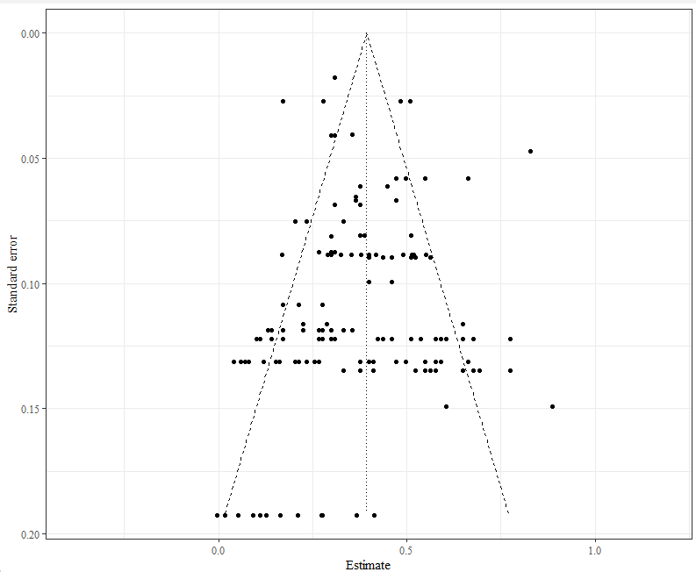

**Perfectionistic Strivings and Social Anxiety**

The Egger’s test did not indicate the presence of funnel plot asymmetry. The funnel plot indicated that the effects sizes were spread symmetrically (Figure S2).

**Figure S2**

*Funnel plot of the fisher-z transformed correlation between perfectionistic strivings and social anxiety.*

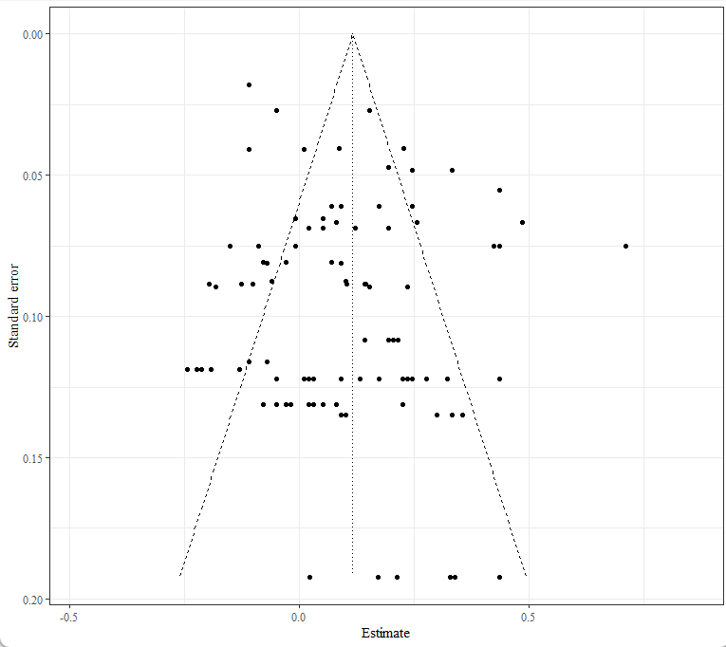

**Self-Presentational Perfectionism and Social Anxiety**

The Egger’s test did not indicate the presence of funnel plot asymmetry. The funnel plot indicated that the effects sizes were spread symmetrically (Figure S3).

**Figure S3**

*Funnel plot of the fisher-z transformed correlation between self-presentational perfectionism and social anxiety.*

