SUPPLEMENTARY MATERIALS

Study 1
Reversed longitudinal mediation models with cognitive flexibility as the outcome variable and emotional distress as the mediators were also conducted. As shown in Fig S1 and Table S1, group negatively predicted general emotional distress at T3 (Fig S1a: B=-2.119, p<0.001) and T5 (Fig S1a: B=-2.225, p<0.001). However, group only negatively predict anxiety (Fig S1b: B=-1.225, p<0.001) and depression (Fig S1c: B=-0.902, p<0.001) at T5, did not negatively predict anxiety (Fig S1b: B=-0.117, p=0.718) and depression (Fig S1c: B=-0.435, p=0.178) at T3. General emotional distress (Fig S1a: B=-0.082, p=0.017), anxiety (Fig S1b: B=-0.163, p=0.011), and depression (Fig S1c: B=-0.129, p=0.036) at T3 and T5 negatively predicted cognitive flexibility at T5 and T7. The mediating effects of emotional distress at T5 (Group-T5K10-T7CFI: a₂b=0.182, 95% CI=[0.031, 0.381]; Group-T5OASIS-T7CFI: a₂b=0.200, 95% CI=[0.045, 0.396]; Group-T5ODSIS-T7CFI: a₂b=0.116, 95% CI=[0.004, 0.255]) between group and cognitive flexibility at T7 were all significant. Additionally, the mediating effect of general emotional distress at T3 (Group-T3K10-T5CFI: a₁b=0.173, 95% CI=[0.028, 0.386]) between group and cognitive flexibility at T5 was significant. However, the mediating effects of anxiety (Group-T3OASIS-T5CFI: a₁b=0.019, 95% CI=[-0.096, 0.148]) and depression (Group-T3ODSIS-T5CFI: a₁b=0.056, 95% CI=[-0.030, 0.179]) at T3 between group and cognitive flexibility at T5 were not significant.
The models demonstrated acceptable model fit (K10: CFI=0.983, TLI=0.969, SRMR=0.059, RMSEA=0.057, χ²(20)=59.643, p<0.001; OASIS: CFI=0.986, TLI=0.975, SRMR=0.038, RMSEA=0.049, χ²(20)=49.127, p<0.001; ODSIS: CFI=0.988, TLI=0.978, SRMR=0.041, RMSEA=0.048, χ²(20)=47.436, p<0.001).

Table S1. Reversed longitudinal mediation models with lagged b paths.

Mediator | Time-specific  outcome | Paths and Effect of treatment | Estimate | SE | p | 95% bootstrap CI | IND%
K10 | T5 CFI | Total effect | 4.020 | 0.696 | <0.001 | [2.667, 5.369] | /
 |  | Indirect effect  Group-T3K10-T5CFI | 0.173 | 0.090 | 0.056 | [0.028, 0.386] | 4.3%
 |  | Direct effect | 3.847 | 0.698 | <0.001 | [2.481, 5.189] | /
 | T7 CFI | Total effect | 4.184 | 0.704 | <0.001 | [2.811, 5.544] | /
 |  | Indirect effect | 0.511 | 0.233 | 0.028 | [0.104, 1.029] | 12.2%
 |  | Group-T5K10-T7CFI | 0.182 | 0.087 | 0.038 | [0.031, 0.381] | 4.3%
 |  | Group-T3K10 -T5K10-T7CFI | 0.164 | 0.086 | 0.057 | [0.026, 0.370] | 3.9%
 |  | Group-T3K10 -T5CFI-T7CFI | 0.165 | 0.084 | 0.049 | [0.027, 0.354] | 3.9%
 |  | Direct effect | 3.673 | 0.701 | <0.001 | [2.327, 5.020] | /
OASIS | T5 CFI | Total effect | 4.019 | 0.699 | <0.001 | [2.636, 5.341] | /
 |  | Indirect effect  Group-T3OASIS -T5CFI | 0.019 | 0.057 | 0.737 | [-0.096, 0.148] | 0.5%
 |  | Direct effect | 3.999 | 0.690 | <0.001 | [2.640, 5.299] | /
 | T7 CFI | Total effect | 4.043 | 0.708 | <0.001 | [2.632, 5.396] | /
 |  | Indirect effect | 0.236 | 0.134 | 0.078 | [0.021, 0.546] | 5.8%
 |  | Group-T5OASIS-T7CFI | 0.200 | 0.090 | 0.026 | [0.045, 0.396] | 4.9%
 |  | Group-T3OASIS -T5OASIS-T7CFI | 0.018 | 0.055 | 0.738 | [-0.094, 0.142] | 0.4%
 |  | Group-T3OASIS-T5CFI-T7CFI | 0.018 | 0.054 | 0.735 | [-0.087, 0.139] | 0.4%
 |  | Direct effect | 3.806 | 0.691 | <0.001 | [2.465, 5.146] | /
ODSIS | T5 CFI | Total effect | 4.040 | 0.690 | <0.001 | [2.690, 5.370] | /
 |  | Indirect effect  Group-T3ODSIS-T5CFI | 0.056 | 0.053 | 0.285 | [-0.030, 0.179] | 1.4%
 |  | Direct effect | 3.983 | 0.683 | <0.001 | [2.647, 5.284] | /
 | T7 CFI | Total effect | 4.044 | 0.705 | <0.001 | [2.691, 5.389] | /
 |  | Indirect effect | 0.222 | 0.131 | 0.089 | [0.005, 0.510] | 5.5%
 |  | Group-T5ODSIS-T7CFI | 0.116 | 0.065 | 0.075 | [0.004, 0.255] | 2.9%
 |  | Group-T3ODSIS-T5ODSIS-T7CFI | 0.052 | 0.049 | 0.292 | [-0.027, 0.170] | 1.3%
 |  | Group-T3ODSIS-T5CFI-T7CFI | 0.054 | 0.050 | 0.279 | [-0.028, 0.171] | 1.3%
 |  | Direct effect | 3.822 | 0.687 | <0.001 | [2.487, 5.120] | /
Note. SE = standard error; T3, week 3; T5, week 5; T7, week 7; CFI, cognitive flexibility level; K10, general emotional distress level. ODSIS, depression level; OASIS, anxiety level. IND% = The percentage of the indirect effect on the total effect.
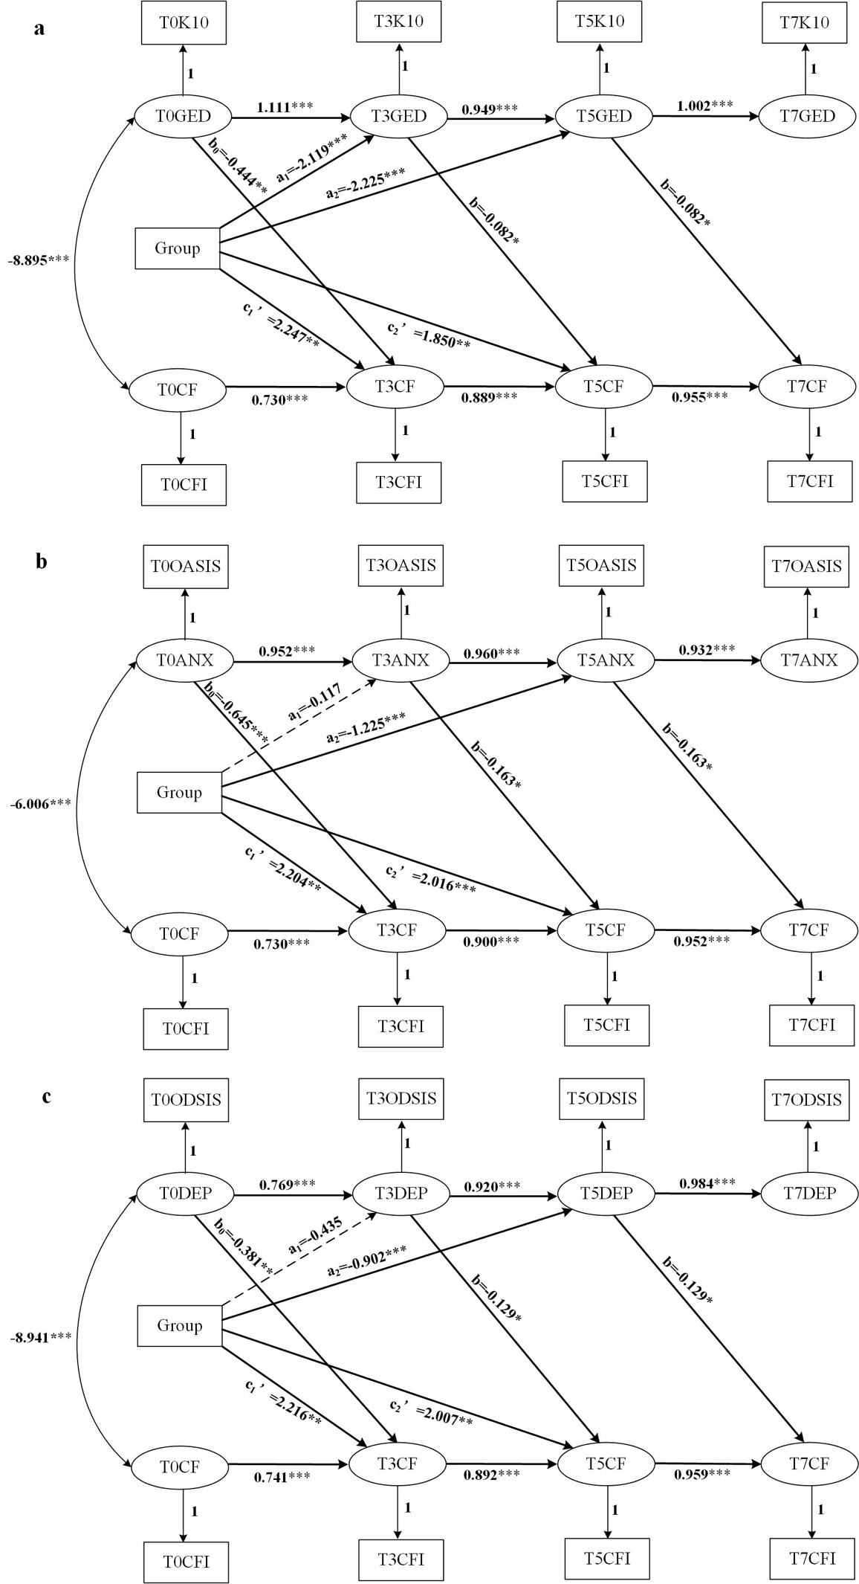
Fig S1. Reversed longitudinal mediation models with lagged b paths.
Note. *p<0.05, **p<0.01, ***p<0.001; T0, baseline; T3, week 3; T5, week 5; T7, week 7; CF, cognitive flexibility level; GED, general emotional distress level; ANX, anxiety level; DEP, depression level; CFI, the score of the Cognitive Flexibility Inventory; K10, the score of the 10-item Kessler Psychological Distress Scale; OASIS, the score of the Overall Anxiety Severity and Impairment Scale; ODSIS, the score of the Overall Depression Severity and Impairment Scale.

Study 2
Table S2. Indirect effects of mediation analyses.
Model | β | SE | 95% bootstrap CI | IND %
group→T3P/A→T7OASIS | -0.010 | 0.022 | [-0.085, 0.015] | 5.4
group→T3P/A→T7ODSIS | -0.010 | 0.018 | [-0.066, 0.010] | 5.0
group→T3P/A→T7K10 | -0.008 | 0.022 | [-0.077, 0.019] | 3.3
group→T3P/NA→T7OASIS | 0.007 | 0.019 | [-0.015, 0.067] | 3.8
group→T3P/NA→T7ODSIS | 0.007 | 0.016 | [-0.012, 0.058] | 3.5
group→T3P/NA→T7K10 | 0.020 | 0.024 | [-0.007, 0.098] | 8.2
group→T3N/A→T7OASIS | 0.001 | 0.014 | [-0.020, 0.041] | 0.5
group→T3N/A→T7ODSIS | 0.000 | 0.014 | [-0.025, 0.036] | 0.0
group→T3N/A→T7K10 | -0.006 | 0.016 | [-0.058, 0.011] | 2.5
group→T3N/NA→T7OASIS | -0.001 | 0.017 | [-0.047, 0.029] | 0.5
group→T3N/NA→T7ODSIS | -0.001 | 0.018 | [-0.057, 0.025] | 0.5
group→T3N/NA→T7K10 | -0.008 | 0.018 | [-0.076, 0.012] | 3.3
group→T5P/A→T7OASIS | 0.000 | 0.014 | [-0.021, 0.039] | 0.0
group→T5P/A→T7ODSIS | -0.006 | 0.018 | [-0.071, 0.011] | 3.0
group→T5P/A→T7K10 | -0.007 | 0.019 | [-0.080, 0.012] | 2.9
group→T5P/NA→T7OASIS | 0.005 | 0.019 | [-0.019, 0.072] | 2.7
group→T5P/NA→T7ODSIS | 0.004 | 0.017 | [-0.018, 0.058] | 2.0
group→T5P/NA→T7K10 | 0.000 | 0.010 | [-0.022, 0.024] | 0
group→T5N/A→T7OASIS | -0.003 | 0.014 | [-0.054, 0.011] | 1.6
group→T5N/A→T7ODSIS | -0.002 | 0.013 | [-0.053, 0.013] | 1.0
group→T5N/A→T7K10 | -0.001 | 0.013 | [-0.039, 0.015] | 0.4
group→T5N/NA→T7OASIS | -0.010 | 0.024 | [-0.098, 0.014] | 5.4
group→T5N/NA→T7ODSIS | -0.004 | 0.022 | [-0.072, 0.028] | 2.0
group→T5N/NA→T7K10 | 0.014 | 0.019 | [-0.010, 0.079] | 5.8
Note. N/NA, negative non-affective switch cost; N/A, negative affective switch cost; P/NA, positive non-affective switch cost; P/A, positive affective switch cost; ODSIS, depression level; OASIS, anxiety level; K10, general emotional distress level; T3, week 3; T5, week 5; T7, week 7. IND%=The percentage of the indirect effect on the total effect.

