Supplemental Table 1.
Descriptive Statistics for Daily Minority Stressors and Threat Appraisal
Level 1 Variable (Within-Person) | n (%) | Range | Mean | SD
Daily threat appraisalª
I perceived a situation, individual, or environment to be unsafe because of my sexual minority identity | 178 (25.9%) | 0 – 6 | 2.98 | 1.31
Daily minority stressors
Someone responded defensively or disagreed with me when I pointed out heterosexist language or thought something was anti-LGBTQ+^{b} | 76 (11.0%) | 0 – 6 | 0.27 | 0.90
I was verbally harassed by someone | 71 (10.4%) | 0 – 6 | 0.25 | 0.84
I was told I was overreacting or being oversensitive regarding sexual minority issues | 66 (9.6%) | 0 – 6 | 0.04 | 0.86
I heard others make fun of, mock, or call sexual minority people names, such as fag or dyke | 64 (9.3%) | 0 – 6 | 0.22 | 0.81
I heard anti-LGBTQ+ talk from family members^{c} | 62 (9.1%) | 0 – 6 | 0.22 | 0.84
Someone laughed at me, made jokes at my expense, or called me a name | 40 (5.9%) | 0 – 6 | 0.15 | 0.67
I was explicitly threatened with harm as a result of my sexual minority identity | 24 (3.5%) | 0 – 6 | 0.06 | 0.37
Note. LGBTQ+ = lesbian, gay bisexual, transgender, or queer.
ªDaily threat appraisal item is also part of the 8-item daily sexual minority stress scale
^{b}Item assessing sexual orientation-based microaggressions was changed from “homophobic” to “anti-LGBTQ+” for inclusivity and to mirror the item assessing heterosexist harassment, rejection, and discrimination.
^{c}Item assessing heterosexist harassment, rejection, and discrimination was changed from “anti-LGBT” to “anti-LGBTQ+” for inclusivity.

Supplemental Table 2.
Variable | ICC | Percent missing | M (SD) | Possible range | Observed range
1. Daily minority stressorsª | 0.533 | .3% | 0.85 (1.61) | 0-8 | 0-8
2. Daily threat appraisalª | 0.381 | .1% | 0.26 (0.44) | 0-1 | 0-1
3. Avoidance coping^{b} | — | 0% | 12.03 (4.19) | 6-24 | 6-23
4. Daily concealmentª | 0.633 | .3% | 2.98 (2.03) | 1-7 | 1-7
5. Number of days completed^{b} | — | 0% | 12.81 (2.08) | 1-14 | 1-14
Note. ICC = intraclass correlation coefficient; M = mean; SD = standard deviation. LGBQ = lesbian, gay bisexual or queer
ªMean levels across days are presented for within-person variables.
^{b}Mean levels across participants are presented for between-person variables.
Univariate Descriptive Statistics for Main Variables
Supplemental Table 3.
 | Model 1a |  | Model 2a |  | Model 3a
Predictor | Daily concealment |  | Daily concealment |  | Daily concealment
 | b | 95% CI | b | 95% CI | b | 95% CI
Level 1 (WP)
Daily minority stressors | — |  | 0.26*** | 0.18, 0.33 | 0.30*** | 0.18, 0.42
Day | -0.02† | -0.04, -0.01 | -0.02 | -0.04, 0.01 | -0.01 | -0.03, 0.01
Level 2 (BP)
Intercept | 2.54*** | 1.93, 3.15 | 2.58*** | 2.05, 3.11 | 2.58*** | 2.04, 3.11
Mean minority stressors | — |  | 0.64*** | 0.41, 0.87 | 0.63*** | 0.40, 0.86
Gender identityª | 0.88* | 0.16, 1.51 | 0.77* | 0.15, 1.39 | 0.74† | 0.10, 1.38
Number of days completed | -0.19** | -0.31, -0.07 | -0.19** | -0.29, -0.08 | -0.20** | -0.30, -0.09
Level 1 | Random effect variances
Residual | — |  | — |  | 1.35*** | 1.22, 1.48
Level 2
Intercept | — |  | — |  | 1.51*** | 1.01, 2.01
Daily minority stressors slopes | — |  | — |  | 0.10* | 0.02, 0.17
Note. CI = confidence interval. Unstandardized coefficients are reported. The boldface coefficients were significantly different from zero at 95% CI.
Model 1 contains covariates entered as fixed effect predictors of same-day variability in daily concealment levels.
Model 2 represents an adjusted random intercept model that modeled within-person daily minority stressors and between-person mean minority stressors as fixed effect predictors of same-day concealment levels.
Model 3 represents an adjusted random slope model in which within-person daily minority stressors was entered as a random (in addition to fixed) effect to test for significant variability in slopes predicting same-day concealment level from within-person daily minority stressors. Daily minority stressor slopes were allowed to vary randomly across participants in Model 3.
ª0 = cisgender, 1 = transgender and/or nonbinary.
† p < .10, * p < .05, ** p < .01, *** p < .001.
Model Statistics for Multilevel Models Predicting Same-Day Concealment from Daily and Mean Minority Stressors

Supplemental Table 4.
 | Model 1a |  | Model 2a |  | Model 3a
Predictor | Daily concealment |  | Daily concealment |  | Daily concealment
 | b | 95% CI | b | 95% CI | b | 95% CI
Level 1 (WP)
Daily threat appraisal | — |  | 0.74*** | 0.51, 0.98 | 0.72*** | 0.40, 1.04
Day | -0.02 | -0.04, -0.01 | -0.02 | -0.04, 0.01 | -0.02 | -0.04, 0.01
Level 2 (BP)
Intercept | 2.54*** | 1.93, 3.15 | 2.60*** | 2.03, 3.17 | 2.58*** | 2.02, 3.14
Mean threat appraisal |  |  | 1.73** | 0.64, 2.83 | 1.90** | 0.74, 3.05
Gender identityª | 0.88* | 0.16, 1.51 | 0.46 | -0.21, 1.13 | 0.51 | -0.16, 1.17
Number of days completed | -0.19** | -0.31, -0.07 | -0.16 | -0.27, -0.05 | -0.15* | -0.26, -0.05
Level 1 | Random effect variances
Residual | — |  | — |  | 1.39*** | 1.26, 1.52
Level 2
Intercept | — |  | — |  | 1.52*** | 0.99, 2.04
Daily threat appraisal slopes | — |  | — |  | 0.73* | 0.14, 1.31
Note. CI = confidence interval. Unstandardized coefficients are reported. The boldface coefficients were significantly different from zero at 95% CI.
Model 1 contains covariates entered as fixed effect predictors of same-day variability in daily concealment levels.
Model 2 represents an adjusted random intercept model that modeled within-person daily threat appraisal levels and between-person mean threat appraisal levels as fixed effect predictors of same-day concealment levels.
Model 3 represents an adjusted random slope model in which within-person daily threat appraisal was entered as a random (as opposed to fixed) effect to test for significant variability in slopes predicting same-day concealment level from within-person daily threat appraisal. Daily threat appraisal slopes were allowed to vary randomly across participants in Model 3.
ª0 = cisgender, 1 = transgender and/or nonbinary.
† p < .10, * p < .05, ** p < .01, *** p < .001.
Model Statistics for Multilevel Models Predicting Same-Day Concealment from Daily and Mean Threat Appraisal

Supplemental Figure 1
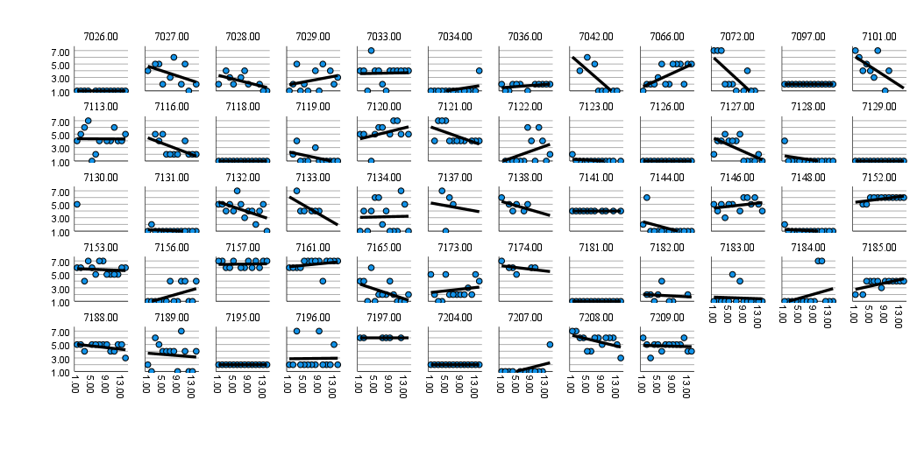
Panel Plots of the 14-day Time Course of Daily Concealment for Each Participant
Time in Days
Daily concealment

