SUPPLEMENTAL ONLINE MATERIAL
Table S1
Effects of Conscientiousness x Strength- vs. Symptom-focused Priming on Therapeutic Evaluation of Patients (Study 1)
Effects | Estimate | SE | 95% CI |  | t | df | p | R²
 |  |  | LL | UL
GSI ª |  |  |  |  |  |  |  | .60 ^{e}
Fixed effects |  |  |  |  |  |  |  | .00 ^{f}
Intercept | 18.32*** | 0.71 | 16.90 | 19.65 | 25.63 | 82.65 | <.001
Priming | -0.32 | 0.64 | -1.56 | 0.89 | -0.50 | 56 | .617
Conscientiousness | -0 | 0.90 | -1.74 | 1.73 | 0 | 82.65 | .997
Conscientiousness x Priming | 0.02 | 0.81 | -1.47 | 1.56 | 0.02 | 56 | .983
Random effects
Intercept variance | 4.15 |  | 2.99 | 5.15
Residual variance | 3.38 |  | 2.73 | 3.92
Resilience ^{b} |  |  |  |  |  |  |  | .64 ^{e}
Fixed effects |  |  |  |  |  |  |  | .11 ^{f}
Intercept | 41.82*** | 1.24 | 39.49 | 44.06 | 33.86 | 82.77 | <.001
Priming | 3.89*** | 1.11 | 1.72 | 6.22 | 3.50 | 56 | <.001
Conscientiousness | 3.92* | 1.56 | 0.80 | 6.88 | 2.51 | 82.77 | .013
Conscientiousness x Priming | -1.35 | 1.41 | -3.95 | 1.50 | -0.96 | 56 | .339
Random effects
Intercept variance | 7.13 |  | 4.81 | 8.63
Residual variance | 5.89 |  | 4.68 | 6.97
GAF ^{c} |  |  |  |  |  |  |  | .65 ^{e}
Fixed effects |  |  |  |  |  |  |  | .05 ^{f}
Intercept | 57.82*** | 1.60 | 54.73 | 60.88 | 36.24 | 79.59 | <.001
Priming | 3.34* | 1.36 | 0.59 | 5.95 | 2.46 | 56 | .017
Conscientiousness | 2.15 | 2.02 | -1.62 | 5.88 | 1.07 | 79.59 | .289
Conscientiousness x Priming | 0.67 | 1.72 | -2.58 | 3.86 | 0.39 | 56 | .697
Random effects
Intercept variance | 9.54 |  | 6.94 | 11.77
Residual variance | 7.18 |  | 5.73 | 8.42
Bond ^{d} |  |  |  |  |  |  |  | .52 ^{e}
Fixed effects |  |  |  |  |  |  |  | .05 ^{f}
Intercept | 2.74*** | 0.10 | 2.52 | 2.94 | 26.10 | 89.61 | <.001
Priming | 0.11 | 0.10 | -0.11 | 2.94 | 1.02 | 56 | .311
Conscientiousness | 0.21 | 0.13 | -0.6 | 0.31 | 1.59 | 89.61 | .116
Conscientiousness x Priming | -0.01 | 0.13 | -0.27 | 0.26 | -0.09 | 56 | .930
Random effects
Intercept variance | 0.55 |  | 0.36 | 0.69
Residual variance | 0.55 |  | 0.44 | 0.65
Note. N_{Therapists} = 56; N_{Datapoints} = 112; Estimates = unstandardized multilevel regression coefficients; SE = standard error; 95% CI = percentile bootstrap 95% confidence interval of estimate (1,000 resamples); LL = lower limit; UL = upper limit. Priming is coded with 0 (symptom-focus) and 1 (strength-focus). Symptom-focus was the reference category. Intercept and residual variance are reported as standard deviation. Conscientiousness was grand mean centered.
*p < .05. ** p < .01. ***p < .001.
ª Random intercept model with Global Severity Index (GSI) as outcome
^{b} Random intercept model with resilience as outcome
^{c} Random intercept model with level of Global Functioning (GAF) as outcome
^{d} Random intercept model with bond as outcome
^{e} Total variance in the outcome variable explained by the model without priming
^{f} Total variance in the outcome variable explained by priming
Table S2
Effects of Conscientiousness x Strength- vs. Symptom-focused Priming on Therapeutic Evaluation of Patients (Study 2)
Effects | Estimate | SE | 95% CI |  | t | df | p
 |  |  | LL | UL
GSI ª
Fixed effects
Intercept | 18.75*** | 0.66 | 17.47 | 20.01 | 28.42 | 96.31 | <.001
Priming | -1.77** | 0.61 | -3 | -0.56 | -2.90 | 64 | .005
Conscientiousness | -1.31 | 0.80 | -2.94 | 0.29 | -1.63 | 96.61 | .106
Conscientiousness x Priming | 2.95*** | 0.74 | 1.54 | 4.40 | 3.99 | 64 | .001
Random effects
Intercept variance | 4 |  | 2.92 | 4.90
Residual variance | 3.45 |  | 2.79 | 4
Resilience ^{b}
Fixed effects
Intercept | 38.44*** | 1.08 | 36.79 | 40.93 | 35.83 | 124.18 | <.001
Priming | 7.05*** | 1.39 | 4.36 | 9.71 | 5.06 | 64 | <.001
Conscientiousness | 0.23 | 1.32 | -2.24 | 2.78 | 0.18 | 124.18 | .861
Conscientiousness x Priming | -2.48 | 1.69 | -5.76 | 0.91 | -1.47 | 64 | .148
Random effects
Intercept variance | 3.63 |  | 0 | 5.72
Residual variance | 7.88 |  | 6.44 | 9.05
GAF ^{c}
Fixed effects
Intercept | 56.94*** | 1.55 | 53.95 | 59.86 | 36.66 | 93.57 | <.001
Priming | 3.61* | 1.38 | 1.02 | 6.28 | 2.62 | 64 | .011
Conscientiousness | -0.84 | 1.89 | -4.40 | 3.01 | -0.44 | 93.57 | .658
Conscientiousness x Priming | -0.61 | 1.67 | -3.81 | 2.85 | -0.36 | 64 | .717
Random effects
Intercept variance | 9.68 |  | 7.16 | 11.78
Residual variance | 7.79 |  | 6.21 | 9.05
Bond ^{d}
Fixed effects
Intercept | 2.68*** | 0.09 | 2.51 | 2.86 | 30.39 | 113.13 | <.001
Priming | 0.21* | 0.10 | 0.01 | 0.42 | 2.12 | 64 | .038
Conscientiousness | 0.09 | 0.12 | -0.13 | 0.30 | 0.82 | 113.13 | .416
Conscientiousness x Priming | 0.04 |  | -0.19 | 0.27 | 0.31 | 64 | .56
Random effects
Intercept variance | 0.43 |  | 0.22 | 0.57
Residual variance | 0.56 |  | 0.46 | 0.65
Note. N_{Therapists} = 64; N_{Datapoints} = 128; Estimates = unstandardized multilevel regression coefficients; SE = standard error; 95% CI = percentile bootstrap 95% confidence interval of estimate (1,000 resamples); LL = lower limit; UL = upper limit. Priming is coded with 0 (symptom-focus) and 1 (strength-focus). Symptom-focus was the reference category. Intercept and residual variance are reported as standard deviation. Conscientiousness was grand mean centered.
*p < .05. ** p < .01. ***p < .001.
ª Random intercept model with Global Severity Index (GSI) as outcome
^{b} Random intercept model with resilience as outcome
^{c} Random intercept model with level of Global Functioning (GAF) as outcome
^{d} Random intercept model with bond as outcome
^{e} Total variance in the outcome variable explained by the model without priming
^{f} Total variance in the outcome variable explained by priming

Figure S1
Example of the procedures (start with patient M or H, followed by H or M)
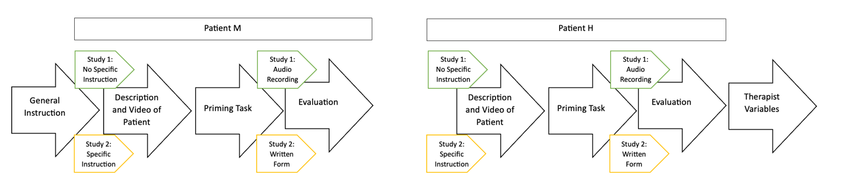

Figure S2
Interaction Effect of Conscientiousness and Priming on the Therapist’s Evaluation of the Patient’s Psychopathology (Study 2)
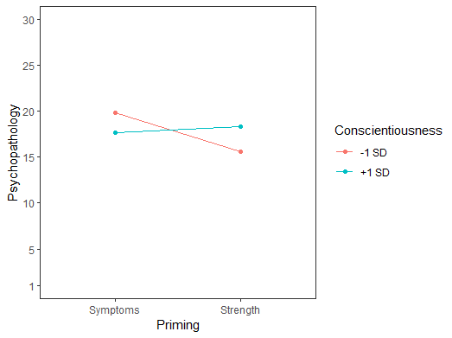
Note. N_{Therapists} = 64; N_{Datapoints} = 128. Graphic depicting the interaction effect between Conscientiousness of the therapist and the priming condition on the therapist’s evaluation of the patient’s pathology. Priming is coded with 0 (symptom-focus) and 1 (strength-focus). Conscientiousness was grand mean centered. Psychopathology was measured by using the SCL-K-9 (Derogatis, 1977).

Blinded

