Supplementary Material
Screenshot of the homepage for CWYC for Spring 2020
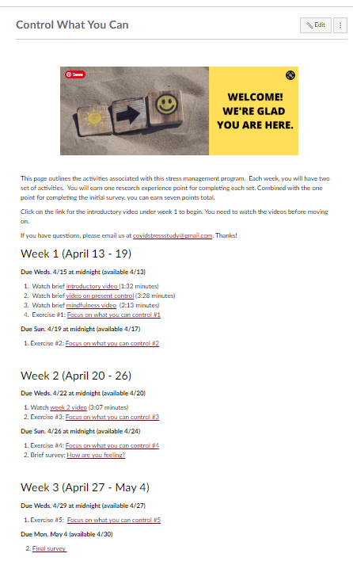
Screenshot of the home page for CDC for Spring 2020
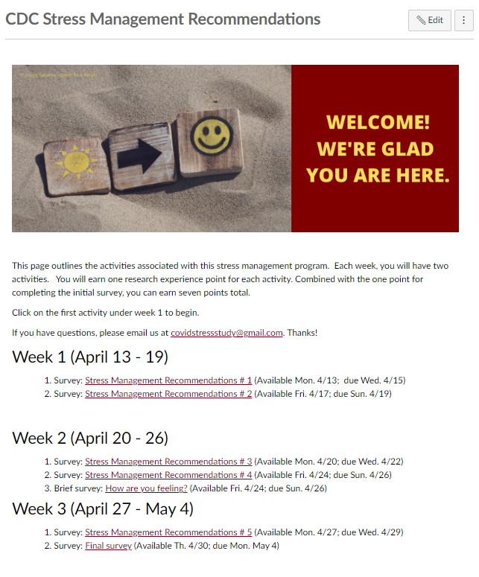

Example exercise (#2) for Control What You Can (CWYC) intervention Spring 2020

Red Light

When completing this exercise, remember the stoplight metaphor.
Red light: Stop and take a few deep cleansing breaths. Practice breathing in for 4 seconds, exhale for 8 seconds.


What is stressing you out?

Think for a minute about what has been causing you most the stress recently.

Yellow Light

Yellow light: Slow down and observe.
What feelings, thoughts, or bodily sensations come up for you when you think about your stressors?

& drop reordering. Press Enter or Space to move this question.
Stressors
Now, describe each stressor here. You can describe one or more than one. After you are done, copy and paste your list into the next two questions.
Outside your control
For each stressor, what aspects of it are outside of your control?

move this question.
Inside your control
Copy your stressor list here again. What aspects of each stressor can you control? Remember that in every situation, there are things that you can control even if it is only your reaction.
This element is a more accessible alternative to drag & drop reordering. Press Enter or Space to move this question.
Green Light

Green light: Choose an effective action and proceed!
An effective action involves focusing on what you can control. Looking at the things you can control, list the specific actions you can take here. If you have several action items, it may be helpful to prioritize them.
drop reordering. Press Enter or Space to move
What actions did you take?
Think about the actions you listed on your last "Focus on what you can control" exercise. You can go back and check if you can't remember! Which of those have you been able to do?
Example: "Last time I said I could be more assertive with my family. In the last day, I've spoken up twice when before I would have stayed silent."

This element is a more accessible alternative to drag & drop reordering. Press Enter or Space to move this question.
What changed as a result of your actions?

What has changed about the stressor as a result of the action you've taken?
Example: "Since I realized that I couldn't stop my boyfriend from being mad and instead focused on doing more things that I enjoy, I've spent less time worrying about what he thinks..."

This element is a more accessible alternative to drag & drop reordering. Press Enter or Space to move this question.
If you catch yourself worrying...
Finally, remember that If you catch yourself worrying about any of the things you CAN control, STOP, acknowledge the thoughts and remind yourself that you have a plan for dealing with them.
If you catch yourself worrying about any of the things you CAN'T control, again, STOP, acknowledge the thoughts and remind yourself that worry won’t change the situation.
Relax and breathe to slow yourself down, anytime you are feeling stressed.

Example survey for CDC intervention
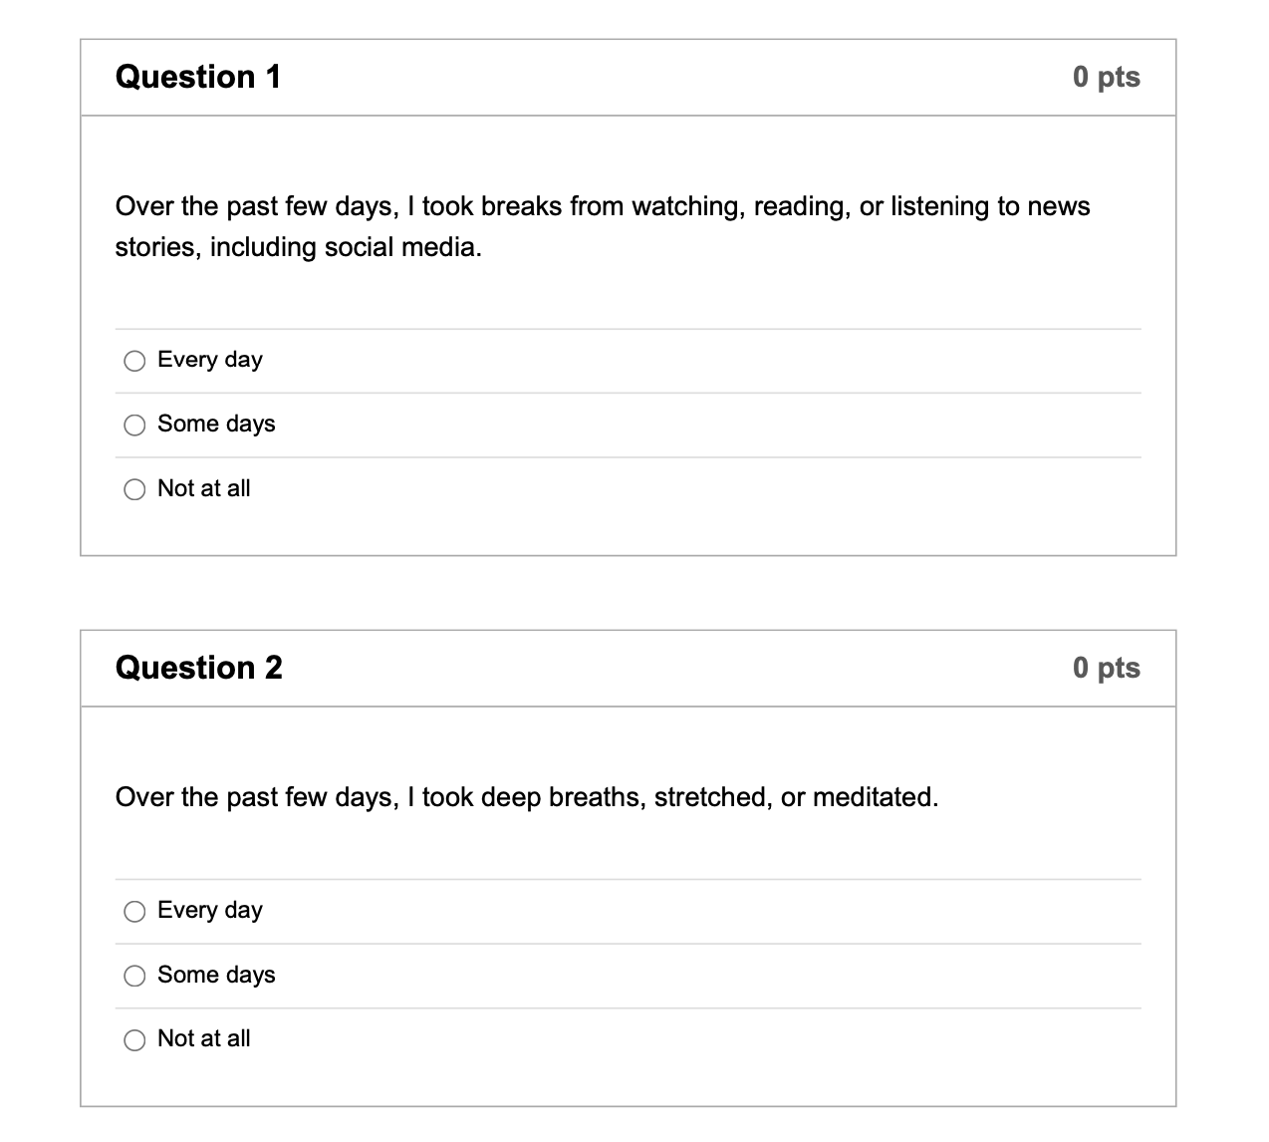

CONSORT Flow Diagram Spring 2020
Analyzed (n = 182)
♦ Excluded from analysis (low quality data; n= 11)
Analyzed (n = 186)
♦ Excluded from analysis (low quality data; n = 7)

Enrollment
Randomized (n = 386)
Assessed for eligibility (n = 386) )

Excluded (n = 0)

Allocated to intervention (n = 193)
♦ Received allocated intervention (n = 191)
♦ Did not receive allocated intervention (did not complete any intervention activities; n = 2)

Allocation
Allocated to intervention (n = 193)
♦ Received allocated intervention (n = 192)
♦ Did not receive allocated intervention (did not complete any intervention activities; n = 1)
CONSORT flow chart for summer 2020

Analysis

Posttest

Completed posttest (n = 152)
♦ Did not complete posttest (n = 41)
Completed posttest (n = 166)
♦ Did not complete posttest (n = 27)

From “CONSORT 2010 Statement: Updated Guidelines for Reporting Parallel Group Randomised Trials,” by K. F. Schulz, D. G. Altman, and D. Moher for the CONSORT Group, 2010, Annals of Internal Medicine 152(11), pp. 726-732 (https://doi.org/10.7326/0003-4819-152-11-201006010-00232). CC BY 2.0.
From “CONSORT 2010 Statement: Updated Guidelines for Reporting Parallel Group Randomised Trials,” by K. F. Schulz, D. G. Altman, and D. Moher for the CONSORT Group, 2010, Annals of Internal Medicine 152(11), pp. 726-732 (https://doi.org/10.7326/0003-4819-152-11-201006010-00232). CC BY 2.0.
CONSORT Flow Diagram Summer 2020
Analyzed (n = 72)
♦ Excluded from analysis (low quality data; n = 3)
Analyzed (n = 75)
♦ Excluded from analysis (low quality data; n = 3)

Completed posttest (n = 53)
♦ Did not complete posttest (n = 25)

Completed posttest (n = 64)
♦ Did not complete posttest (n = 11)

Enrollment
Allocated to waitlist (n = 78)

Randomized (n = 153)
Assessed for eligibility (n = 153)

Excluded (n = 0)

Allocation
Allocated to intervention (n = 75)
♦ Received allocated intervention (n = 72)
♦ Did not receive allocated intervention (did not complete any intervention activities; n = 3)

Posttest

Analysis

From “CONSORT 2010 Statement: Updated Guidelines for Reporting Parallel Group Randomised Trials,” by K. F. Schulz, D. G. Altman, and D. Moher for the CONSORT Group, 2010, Annals of Internal Medicine 152(11), pp. 726-732 (https://doi.org/10.7326/0003-4819-152-11-201006010-00232). CC BY 2.0.
From “CONSORT 2010 Statement: Updated Guidelines for Reporting Parallel Group Randomised Trials,” by K. F. Schulz, D. G. Altman, and D. Moher for the CONSORT Group, 2010, Annals of Internal Medicine 152(11), pp. 726-732 (https://doi.org/10.7326/0003-4819-152-11-201006010-00232). CC BY 2.0.
CONSORT Flow Diagram Fall 2020

Enrollment
Allocated to waitlist (n = 90)

Allocated to CWYC intervention (n = 90)
♦ Received allocated intervention (n = 80)
♦ Did not receive allocated intervention (did not complete any intervention activities; n = 10)
From “CONSORT 2010 Statement: Updated Guidelines for Reporting Parallel Group Randomised Trials,” by K. F. Schulz, D. G. Altman, and D. Moher for the CONSORT Group, 2010, Annals of Internal Medicine 152(11), pp. 726-732 (https://doi.org/10.7326/0003-4819-152-11-201006010-00232). CC BY 2.0.
Analyzed (n = 85)
♦ Excluded from analysis (low quality data; n = 5)
Completed follow-up (n = 64)
♦ Did not complete follow-up (n = 26)
Allocated to CDC intervention (n = 90)
♦ Received allocated intervention (n = 86)
♦ Did not receive allocated intervention (did not complete and intervention activities; n = 4)
Analyzed (n = 87)
♦ Excluded from analysis (low quality data; n = 3)
Completed follow-up (n = 73)
♦ Did not complete follow-up (n = 17)
Analyzed (n = 88)
♦ Excluded from analysis (low quality data; n = 2)
Completed follow-up (n = 77)
♦ Did not complete follow-up (n = 13)

Analysis
Assessed for eligibility (n = 270)
Excluded (n = 0)

Posttest

Allocation
Randomized (n = 270)
Supplemental Table

Means and Standard Deviations for Completer Sample

 | CWYC |  | CDC |  | Waitlist
 | M | SD | M | SD | M | SD
PSS
Pre-Intervention | 2.12 | 0.73 | 2.18 | 0.71 | 2.09 | 0.70
Post-Intervention | 1.88 | 0.69 | 1.94 | 0.68 | 2.08 | 0.75
Follow-Up | 1.89 | 0.61 | 1.82 | 0.68 | 2.16 | 0.68
DASS Anxiety
Pre-Intervention | 0.64 | 0.60 | 0.64 | 0.62 | 0.70 | 0.64
Post-Intervention | 0.64 | 0.59 | 0.57 | 0.55 | 0.71 | 0.64
Follow-Up | 0.53 | 0.52 | 0.52 | 0.57 | 0.70 | 0.59
DASS Depression
Pre-Intervention | 1.0 | 0.74 | 0.97 | 0.72 | 0.85 | 0.68
Post-Intervention | 0.84 | 0.70 | 0.83 | 0.69 | 0.86 | 0.74
Follow-Up | 0.86 | 0.68 | 0.75 | 0.64 | 1.04 | 0.69
DASS Stress
Pre-Intervention | 1.12 | 0.72 | 1.07 | 0.68 | 1.10 | 0.67
Post-Intervention | 1.01 | 0.68 | 0.96 | 0.64 | 1.18 | 0.70
Follow-Up | 0.94 | 0.66 | 0.89 | 0.59 | 1.22 | 0.65
Boredom
Pre-Intervention | 4.51 | 1.34 | 4.58 | 1.31 | 4.14 | 1.30
Post-Intervention | 4.07 | 1.39 | 4.32 | 1.26 | 4.25 | 1.42
Follow-Up | 4.10 | 1.22 | 3.92 | 1.39 | 4.44 | 1.26
Note. PSS = Perceived Stress Scale. DASS = Depression Anxiety Stress Scale. CWYC = Control What You Can intervention condition. CDC = Centers for Disease Control and Prevention intervention condition.

SPSS v. 28 Syntax for Linear Mixed Models
MIXED PSS BY Time merged_condition
/FIXED=Time merged_condition Time*merged_condition | SSTYPE(3)
/METHOD=REML
/PRINT=CPS CORB COVB DESCRIPTIVES G LMATRIX R SOLUTION TESTCOV
/RANDOM=INTERCEPT | SUBJECT(CaseID) COVTYPE(VC)
/EMMEANS=TABLES(Time) COMPARE ADJ(BONFERRONI)
/EMMEANS=TABLES(merged_condition) COMPARE ADJ(BONFERRONI)
/EMMEANS=TABLES(Time*merged_condition).

