The Effects of Goal–Landmark Distance on Overshadowing: a Replication in Humans (Homo sapiens) of Goodyear and Kamil (2004)

Estibaliz Herrera, Joe Austen & Gonzalo P. Urcelay.

Supplementary materials

Supplementary Figure 1

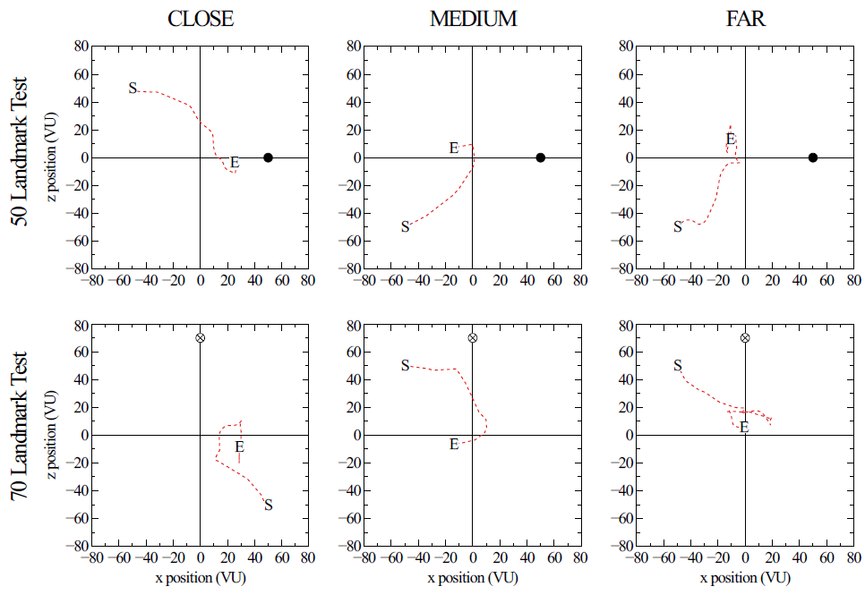

Supplementary Figure 1: The figure shows six representative paths of participants of the three Groups during the test of Experiment 1. The two panels on the left show paths when landmarks 50 (top; the dark dot represents the location of the landmark) and 70 (bottom; the crossed dot represents the location of the landmark) were tested. The Middle panel shows similar representative examples of participants in Group Medium, and the two panels on the right show representative paths from participants in Group Far. S reflects the starting position, and E the location that participants indicated during test.

