Exploring the Associations Between Internalized Racial Oppression, Emotional Eating, and Mental Health Symptoms among Black Young Adult Women
Supplemental Material
Sensitivity Analysis: Internalized Racial Oppression
Given the constraints of variability in the main analysis of the paper, we conducted a sensitivity latent profile analysis (LPA) using the same sample to explore the patterns of variation in both main variables of interest, emotional eating (Ozier et al., 2007) and internalized racial oppression (Campon & Carter, 2015), at the person level. The total score of the emotional eating scale and the four subscales of internalized racial oppression (emotional responses, American standard of beauty, devaluation of own group, and patterns of thinking) were used as indicators. The subscales for internalized racial oppression were chosen instead of the total score to capture possible variation within this scale. Due to the exploratory nature of this analysis and lack of previous empirical work that utilizes person-centered techniques to investigate internalized racial oppression or emotional eating, we estimated seven latent profile analysis models.
We used multiple fit indices to find the optimal number of profiles at each time point, including the log-likelihood (LL), Vuong-Lo-Medell-Rubin Likelihood Ratio Test (VLMR- LRT), adjusted Lo-Mendell-Rubin likelihood ratio test (LMR-LRT), Bootstrapped Likelihood Ratio Test (BLRT), AIC, BIC, and sample size-adjusted BIC (SABIC). Lower values for the AIC, BIC, and sample size-adjusted BIC indicate a better fitting model. A non-significant VLMR-LRT, LMR-LRT, or BLRT for a k-class model indicates that the k-1 model is a better fit to the data compared to the k-class model.
Supplemental Table 1 presents the fit statistics for each latent profile analysis model. The LL, AIC, BIC, and SABIC all increased with each number of profiles while entropy increased until profile four, dropped for profile five, and increased until profile seven. The VLMR LRT, LMR-LRT, and BLRT indicated that the four-profile solution was optimal. Though the four-profile solution was significantly better than the three-profile solution, there was one profile with a small sample size. Taken together, the three-profile solution was determined to have the best fit.
Supplemental Figure 1 presents all estimated means in a bar graph for each profile. Women in the first profile, low internalized oppression-low emotional eating, were characterized by relatively low endorsement on all the internalized oppression subscales (range of estimated means: 1.49 to 1.70) as well as the lowest estimated mean of emotional eating (2.57) compared to the other profiles. Women in the second profile, average internalized oppression-low emotional eating, were characterized by relatively average endorsement for all the internalized oppression subscales (range of estimated means: 2.46 to 3.19) with an estimated mean for emotional eating (2.76) that was slightly higher than the first profile and lower than the third profile. Women in the third profile, high internalized oppression-average emotional eating, were characterized by having the highest endorsement on the internalized oppression subscales (range of mean estimates: 3.33 to 4.87) and emotional eating. Notably, women in the third profile scored, on average, 1-Likert scale point more on the emotional responses and devaluation of own group subscales.
Across profiles, there is clear variability in endorsement of internalized racial oppression; in contrast, the differences in emotional eating are small. Internalized racial oppression is the driving characteristic that distinguishes women in this sample. Nonetheless, there is a trend in the means where women who score higher on internalized racial oppression subscales have higher emotional eating, though not by a high magnitude. This supplemental analysis sheds light on the value of future research using person-centered techniques to investigate associations between internalized racial oppression, emotional eating, and mental health outcomes. It may also be fruitful to utilize the subscales versus the total score for internalized racial oppression.

Supplemental Table S1
Fit Statistics for Latent Profile Models of Internalized Racial Oppression and Emotional Eating
# of Profiles | LL | VLMR LRT | Adj-LMR | BLRT | Entropy | AIC | BIC | SABIC | n1 | n2 | n3 | n4 | n5 | n6 | n7
1 | -3875.8 | - | - | - | - | 7771.6 | 7813.8 | 7782.1 | 504 | - | - | - | - | - | -
2 | -3456.1 | p < .001 | p < .001 | p < .001 | 0.87 | 6944.2 | 7011.7 | 6960.9 | 343 | 161 | - | - | - | - | -
3 | -3229.3 | p = .006 | p = .006 | p < .001 | 0.91 | 6502.5 | 6595.4 | 6525.6 | 229 | 189 | 86 | - | - | - | -
4 | -3095.4 | p = .002 | p = .002 | p < .001 | 0.93 | 6246.8 | 6365.1 | 6276.2 | 213 | 162 | 104 | 25 | - | - | -
5 | -2965.2 | p = .086 | p = .090 | p < .001 | 0.82 | 5998.4 | 6142.0 | 6034.1 | 126 | 138 | 131 | 85 | 24 | - | -
6 | -2860.8 | p = .903 | p = .904 | p < .001 | 0.93 | 5801.6 | 5970.5 | 5843.5 | 133 | 113 | 103 | 80 | 52 | 23 | -
7 | -2756.7 | p = .999 | p = .999 | p < .001 | 0.95 | 5605.3 | 5799.6 | 5653.6 | 103 | 102 | 100 | 70 | 63 | 46 | 20
Note. Bolded row indicates selected model. LL = log-likelihood, VLMR LRT = Vuong-Lo-Medell-Rubin Likelihood Ratio Test. Adj-LMR = Lo-Mendell-Rubin Test. BLRT = Bootstrap Likelihood Ratio Test. AIC = Akaike Information Criterion. BIC = Bayesian Information Criterion. SABIC = Sample-Size-Adjusted BIC.
Supplemental Figure S1
Mean Estimates of Internalized Racial Oppression and Emotional Eating Profiles Observed in the Sample
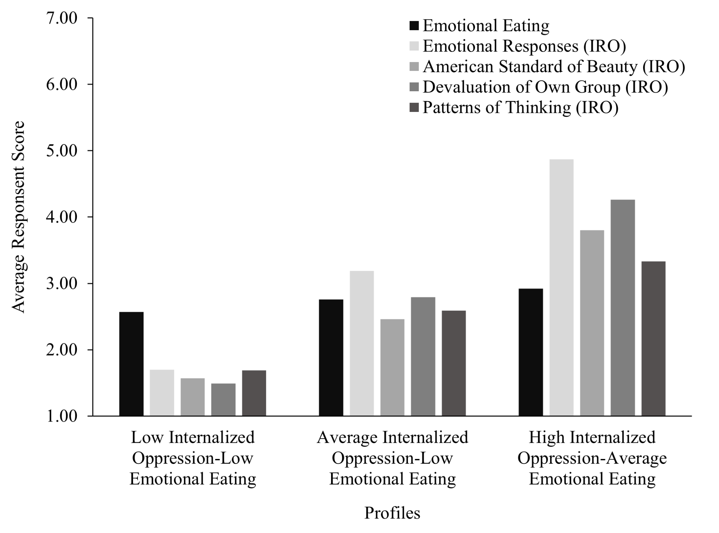
Note. IRO = Internalized racial oppression. Profile names are based on their most notable distinctions from one another based on their mean estimates.

