Supplementary Materials
- Supplementary tables: Full participant demographic information
- Supplementary tables: Descriptive statistics and bivariate correlations
- Supplementary figures: Significant interaction plots (Study 2)
- Supplementary figures: Significant interaction plots (Study 3)

A. Supplementary tables: Full participant demographic information
Table A1
Full Demographic Information (Study 1)
Demographic Variable | N | %
Racial Group
Asian | 100 | 78.7%
South Asian | 23 | 18.1%
Mixed | 4 | 3.1%
Ethnic Background
Bangladeshi | 5 | 3.9%
Burmese | 1 | 0.8%
Chinese | 36 | 28.3%
Filipino | 13 | 10.2%
Hmong | 3 | 2.4%
Indian | 16 | 12.6%
Japanese | 1 | 0.8%
Korean | 14 | 11.0%
Mixed | 13 | 10.2%
Pakistani | 6 | 4.7%
Taiwanese | 3 | 2.4%
Thai | 2 | 1.6%
Vietnamese | 14 | 11.0%
U.S. Born
Born in the U.S. | 86 | 67.7%
Born outside the U.S. | 41 | 32.3%
Sexual Orientation
Heterosexual | 126 | 99.2%
Bisexual | 1 | 0.8%
Relationship Status
Single | 61 | 48.0%
In a relationship | 50 | 39.4%
Married | 15 | 11.8%
Engaged | 1 | 0.8%
Income
Less than $10,000 | 29 | 22.8%
$10,000 - $39,999 | 20 | 17.3%
$40,000 - $69,999 | 39 | 30.7%
$70,000 - $99,999 | 14 | 11.0%
$100,000 - $129,999 | 13 | 10.2%
$130,000 - $159,999 | 1 | 0.8%
Prefer not to say | 11 | 8.7%
Education
High school | 5 | 3.9%
Some college | 18 | 14.2%
College graduate | 85 | 66.9%
Postgraduate | 18 | 14.2%
Do not wish to specify | 1 | 0.8%
Note. N = 127.
Table A2
Full Demographic Information (Study 2)
Demographic Variable | N | %
Gender
Female/woman | 121 | 50.4%
Male/man | 119 | 49.0%
Ethnic Background
Cambodian | 3 | 1.3%
Chinese | 87 | 36.3%
Filipino | 39 | 16.3%
Hmong | 2 | 0.8%
Indian | 3 | 1.3%
Indonesian | 1 | 0.4%
Japanese | 3 | 1.3%
Korean | 25 | 10.4%
Pakistani | 2 | 0.8%
Taiwanese | 9 | 3.8%
Thai | 2 | 0.8%
Vietnamese | 36 | 15.0%
Other | 1 | 0.4%
Mixed ethnicity / multiple identified | 27 | 11.3%
U.S. Born
Born in the U.S. | 205 | 85.4%
Born outside the U.S. | 35 | 14.6%
Sexual Orientation
Heterosexual | 237 | 98.8%
Bisexual | 3 | 1.3%
Relationship Status
Single | 123 | 51.2%
In a relationship | 104 | 43.3%
Married | 12 | 5.0%
Other | 1 | 0.4%
Income
Less than $10,000 | 39 | 16.3%
$10,000 - $19,999 | 17 | 7.1%
$20,000 - $29,999 | 15 | 6.3%
$30,000 - $39,999 | 12 | 5.0%
$40,000 - $49,999 | 15 | 6.3%
$50,000 - $59,999 | 18 | 7.5%
$60,000 - $69,999 | 20 | 8.3%
$70,000 - $79,999 | 13 | 5.4%
$80,000 - $89,999 | 19 | 7.9%
$90,000 - $99,999 | 13 | 5.4%
$100,000 - $149,999 | 29 | 12.1%
More than $150,000 | 14 | 5.8%
Do not wish to specify | 16 | 6.7%

Education Level
Some school | 1 | 0.4%
High school | 13 | 5.4%
Some college | 44 | 18.3%
College graduate | 145 | 60.4%
Postgraduate | 35 | 14.6%
Do not wish to specify | 2 | 0.8%
Note. N = 240.

Table A3
Full Demographic Information (Study 3)
Demographic Variable | N | %
Gender
Male/man | 119 | 49%
Female/woman | 121 | 50.4%
Ethnic Background
African | 17 | 5.0%
African American | 226 | 65.9%
American | 4 | 1.2%
Arab | 1 | 0.3%
Afro-Latino | 1 | 0.3%
Barbados | 1 | 0.3%
Black | 22 | 6.4%
Black American | 10 | 2.9%
Carribean / Afro-Caribbean / Black Caribbean | 4 | 1.2%
Dominican | 1 | 0.3%
Ethiopian | 1 | 0.3%
Ghanaian | 2 | 0.6%
Guinean | 1 | 0.3%
Haitian | 5 | 1.5%
Honduran | 1 | 0.3%
Jamaican | 9 | 2.6%
Kenyan | 1 | 0.3%
Louisiana Creole | 1 | 0.3%
Netherland Antillean | 1 | 0.3%
Nigerian | 7 | 2.0%
Senegalese | 1 | 0.3%
Sudanese | 1 | 0.3%
Togolese | 1 | 0.3%
Mixed ethnicity / multiple identified | 13 | 3.8%
Unspecified | 11 | 3.2%
U.S. Born
Born in the U.S. | 299 | 87.2%
Born outside the U.S. | 44 | 12.8%
Sexuality
Heterosexual | 340 | 99.1%
Bisexual | 2 | 0.6%
Other | 1 | 0.3%
Relationship Status
Single | 191 | 55.7%
In a relationship | 72 | 21.0%
Married | 78 | 22.7%
Other | 2 | 0.6%

Income
Less than $10,000 | 38 | 11.1%
$10,000 - $19,999 | 20 | 5.8%
$20,000 - $29,999 | 30 | 8.7%
$30,000 - $39,999 | 38 | 11.1%
$40,000 - $49,999 | 33 | 9.6%
$50,000 - $59,999 | 52 | 15.2%
$60,000 - $69,999 | 23 | 6.7%
$70,000 - $79,999 | 26 | 7.6%
$80,000 - $89,999 | 10 | 2.9%
$90,000 - $99,999 | 13 | 3.8%
$100,000 - $149,999 | 24 | 7.0%
More than $150,000 | 18 | 5.2%
Do not wish to specify | 18 | 5.2%
Education Level
No schooling | 1 | 0.3%
Some school | 2 | 0.6%
High school | 43 | 12.5%
Some college | 76 | 22.2%
College graduate | 155 | 45.2%
Postgraduate | 64 | 18.7%
Do not wish to specify | 2 | 0.6%
Note. N = 343.

B. Supplementary tables: Descriptive statistics and bivariate correlations
Table B1
Descriptive Statistics and Bivariate Correlations between All Dependent Variables (Study 1)
Variables | M  (SD) | 1 | 2 | 3 | 4 | 5 | 6 | 7 | 8
1. Race-based depersonalization | 4.9  (1.7) | -
2. Stereotyping | 5.0  (1.3) | 0.86***  [0.80, 0.90] | -
3. Exoticization | 5.1  (1.6) | 0.79***  [0.71, 0.86] | 0.77***  [0.67, 0.85] | -
4. Appearance objectification | 4.9  (1.5) | 0.65***  [0.54, 0.75] | 0.64***  [0.53, 0.74] | 0.70***  [0.59, 0.80] | -
5. Individuation | 3.8  (1.5) | -0.68***  [-0.76, -0.58] | -0.69***  [-0.77, -0.59] | -0.62***  [-0.72, -0.50] | -0.57***  [-0.68, -0.43] | -
6. Attraction | 3.3  (1.7) | -0.63***  [-0.73, -0.51] | -0.59***  [-0.69, -0.48] | -0.67***  [-0.75, -0.57] | -0.49***  [-0.63, -0.35] | 0.66***  [0.56, 0.75] | -
7. Ease of connection | 3.4  (1.5) | -0.58***  [-0.69, -0.46] | -0.58***  [-0.69, -0.46] | -0.58***  [-0.68, -0.47] | -0.44***  [-0.58, -0.29] | 0.64***  [0.52, 0.74] | 0.78***  [0.70, 0.84] | -
8. Racism | 4.1  (1.6) | 0.65***  [0.51, 0.75] | 0.65***  [0.51, 0.76] | 0.65***  [0.52, 0.76] | 0.45***  [0.30, 0.59] | -0.55***  [-0.68, -0.39] | -0.54***  [-0.66, -0.41] | -0.47***  [-0.60, -0.32] | -
9. Global evaluations | 4.0  (1.3) | -0.66***  [-0.74, -0.55] | -0.64***  [-0.73, -0.54] | -0.61***  [-0.70, -0.50] | -0.51***  [-0.62, -0.37] | 0.76***  [0.67, 0.83] | 0.69***  [0.59, 0.76] | 0.68***  [0.57, 0.76] | -0.60***  [-0.73, -0.42]
Note. 95% confidence intervals for each correlation coefficient are presented in [brackets].

Table B2
Descriptive Statistics and Bivariate Correlations between All Dependent Variables (Study 2)
Variables | M  (SD) | 1 | 2 | 3 | 4 | 5 | 6 | 7 | 8
1. Race-based depersonalization | 4.4  (1.7) | -
2. Stereotyping | 4.6  (1.3) | 0.84***  [0.00, 0.24] | -
3. Exoticization | 4.6  (1.7) | 0.78***  [0.08, 0.30] | 0.76***  [0.71, 0.84] | -
4. Appearance objectification | 4.6  (1.4) | 0.63***  [0.01, 0.25] | 0.62***  [0.54, 0.72] | 0.69***  [0.52, 0.71] | -
5. Individuation | 4.2  (1.3) | -0.54***  [-0.26, -0.01] | -0.59***  [-0.64, -0.43] | -0.45***  [-0.68, -0.48] | -0.43***  [-0.57, -0.31] | -
6. Attraction | 4.2  (1.7) | -0.49***  [-0.35, -0.1] | -0.47***  [-0.60, -0.37] | -0.42***  [-0.57, -0.35] | -0.38***  [-0.53, -0.29] | 0.66***  [-0.50, -0.25] | -
7. Ease of connection | 3.8  (1.5) | -0.41***  [-0.30, -0.05] | -0.42***  [-0.52, -0.29] | -0.33***  [-0.52, -0.31] | -0.36***  [-0.45, -0.21] | 0.66***  [-0.49, -0.22] | 0.75***  [0.58, 0.74] | -
8. Racism | 3.7  (1.6) | 0.64***  [0.04, 0.28] | 0.61***  [0.55, 0.71] | 0.59***  [0.52, 0.69] | 0.46***  [0.50, 0.68] | -0.51***  [0.35, 0.56] | -0.43***  [-0.62, -0.38] | -0.37***  [-0.55, -0.31] | -
9. Global evaluations | 4.3  (1.2) | -0.56***  [-0.30, -0.04] | -0.59***  [-0.66, -0.44] | -0.47***  [-0.69, -0.47] | -0.44***  [-0.59, -0.33] | 0.77***  [-0.56, -0.30] | 0.73***  [0.70, 0.82] | 0.66***  [0.66, 0.79] | -0.51***  [0.57, 0.74]
Note. 95% confidence intervals for each correlation coefficient are presented in [brackets].

Table B3
Descriptive Statistics and Bivariate Correlations between All Dependent Variables (Study 3)
Variables | M  (SD) | 1 | 2 | 3 | 4 | 5 | 6 | 7 | 8
1. Race-based depersonalization | 4.3  (1.6) | -
2. Stereotyping | 4.1  (1.3) | 0.57***  [0.49, 0.65] | -
3. Exoticization | 3.9  (2.0) | 0.50***  [0.41, 0.58] | 0.51***  [0.42, 0.60] | -
4. Appearance objectification | 4.4  (1.6) | 0.59***  [0.49, 0.67] | 0.63***  [0.55, 0.70] | 0.62***  [0.55, 0.69] | -
5. Individuation | 4.8  (1.4) | -0.27***  [-0.38, -0.14] | -0.46***  [-0.56, -0.35] | -0.27***  [-0.38, -0.15] | -0.27***  [-0.39, -0.14] | -
6. Attraction | 4.4  (1.7) | -0.10  [-0.21, 0.01] | -0.22***  [-0.32, -0.12] | -0.05  [-0.16, 0.06] | -0.08  [-0.19, 0.03] | 0.53***  [0.44, 0.61] | -
7. Ease of connection | 4.3  (1.6) | -0.06  [-0.18, 0.06] | -0.24***  [-0.35, -0.12] | -0.09  [-0.21, 0.02] | -0.12*  [-0.24, 0.00] | 0.56***  [0.47, 0.65] | 0.74***  [0.68, 0.79] | -
8. Racism | 3.0  (1.8) | 0.42***  [0.32, 0.51] | 0.50***  [0.41, 0.58] | 0.48***  [0.39, 0.57] | 0.38***  [0.28, 0.48] | -0.39***  [-0.49, -0.28] | -0.22***  [-0.34, -0.10] | -0.21***  [-0.33, -0.09] | -
9. Global evaluations | 4.8  (1.1) | -0.20***  [-0.31, -0.08] | -0.38***  [-0.48, -0.28] | -0.22***  [-0.32, -0.11] | -0.28***  [-0.39, -0.16] | 0.68***  [0.61, 0.75] | 0.61***  [0.53, 0.68] | 0.63***  [0.55, 0.71] | -0.35***  [-0.47, -0.23]
Note. 95% confidence intervals for each correlation coefficient are presented in [brackets].

C. Supplementary figures: Significant interaction plots (Study 2)
Figure C1
Racial Preference Disclosure × Participant Gender Interaction on Race-Based Depersonalization (Study 2)
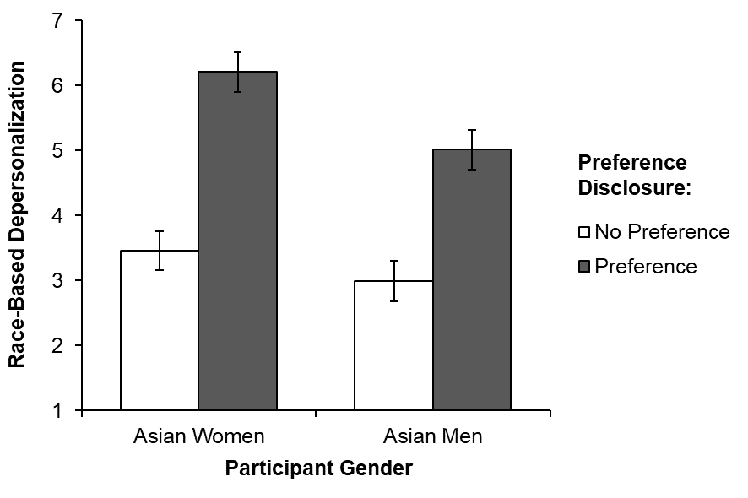
Note. Error bars represent 95% confidence intervals around the mean.

Figure C2
Racial Preference Disclosure × Participant Gender Interaction on Individuation (Study 2)
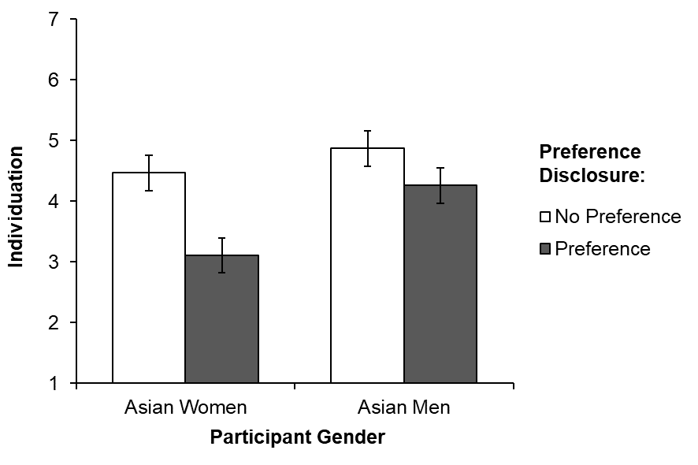
Note. Error bars represent 95% confidence intervals around the mean.

Figure C3
Racial Preference Disclosure × Participant Gender Interaction on Attraction (Study 2)
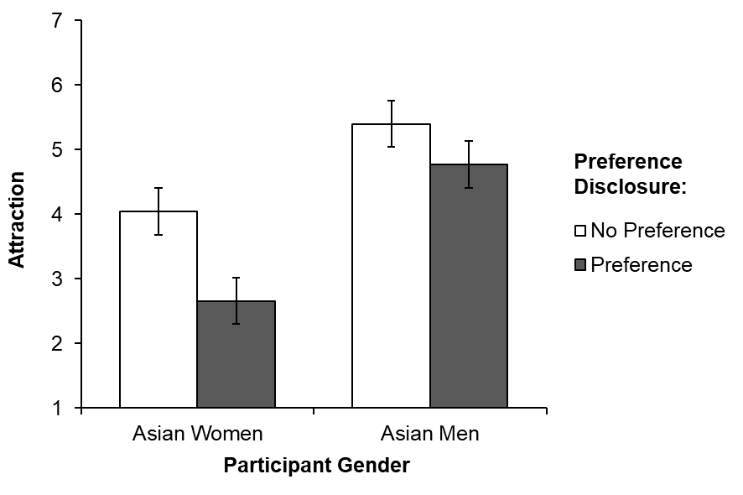
Note. Error bars represent 95% confidence intervals around the mean.

Figure C4
Racial Preference Disclosure × Participant Gender Interaction on Anticipated Ease of Connection (Study 2)
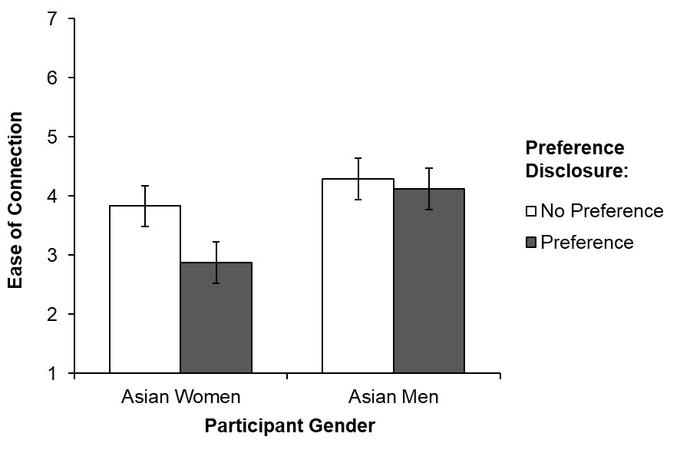
Note. Error bars represent 95% confidence intervals around the mean.

Figure C5
Racial Preference Disclosure × Participant Gender Interaction on Target Racism (Study 2)
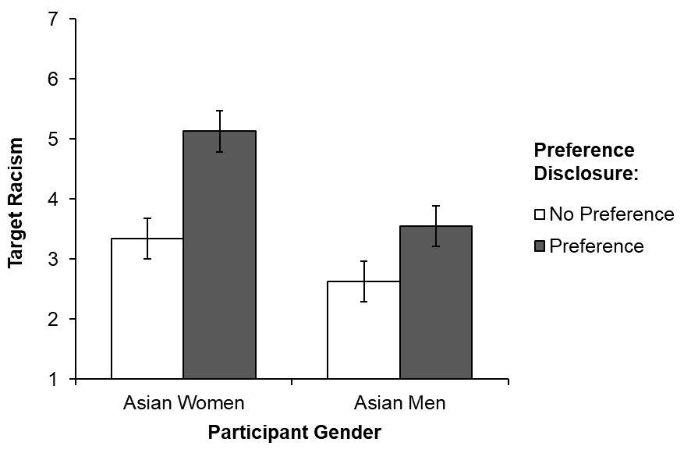
Note. Error bars represent 95% confidence intervals around the mean.

Figure C6
Racial Preference Disclosure × Participant Gender Interaction on General Target Evaluations (Study 2)
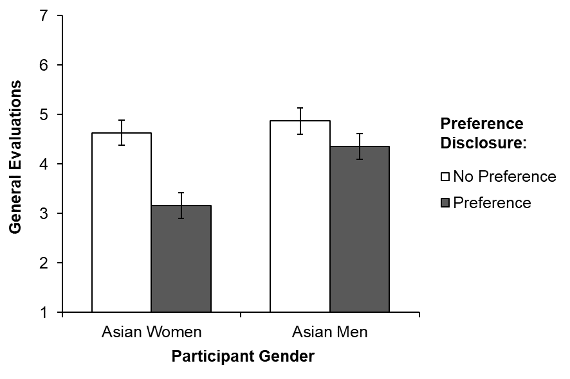
Note. Error bars represent 95% confidence intervals around the mean.

D. Supplementary figures: Significant interaction plots (Study 3)
Figure D1
Racial Preference Disclosure × Target Race Interaction on Race-Based Depersonalization (Study 3)
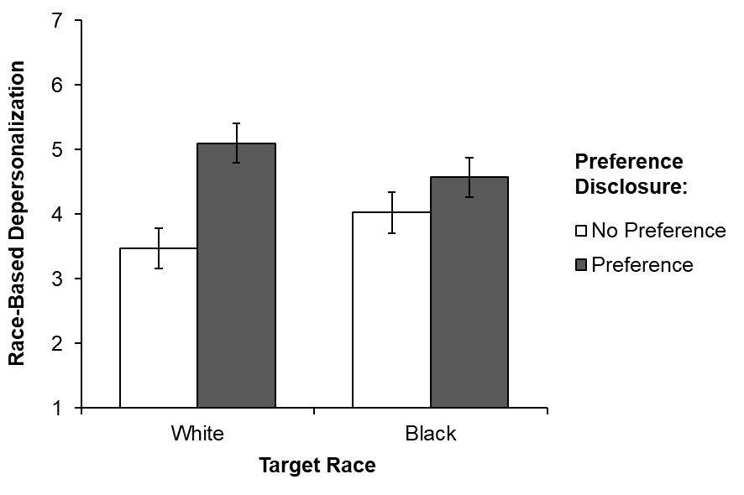
Note. Error bars represent 95% confidence intervals around the mean.

Figure D2
Racial Preference Disclosure × Target Race Interaction on Exoticization (Study 3)
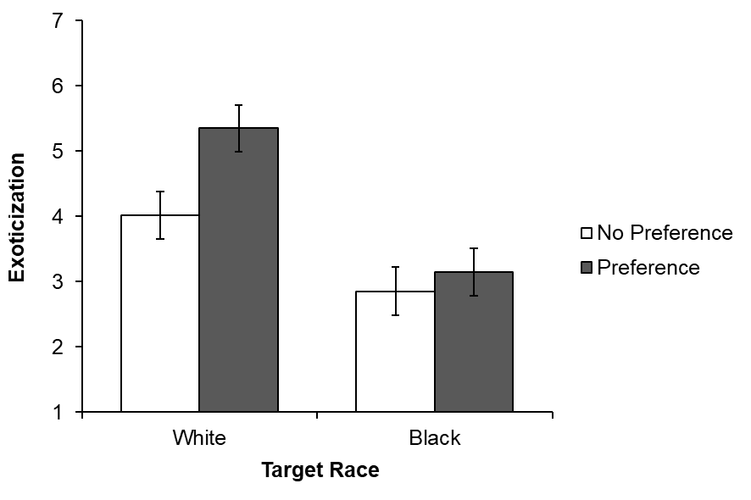
Note. Error bars represent 95% confidence intervals around the mean.

Figure D3
Racial Preference Disclosure × Target Race Interaction on Appearance Objectification (Study 3)
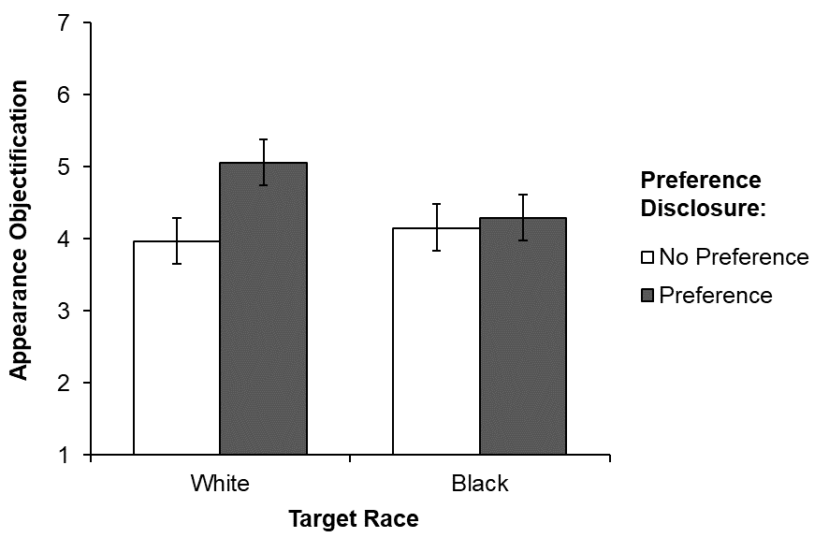
Note. Error bars represent 95% confidence intervals around the mean.

Figure D4
Racial Preference Disclosure × Target Race × Participant Gender Interaction on Stereotyping (Study 3)
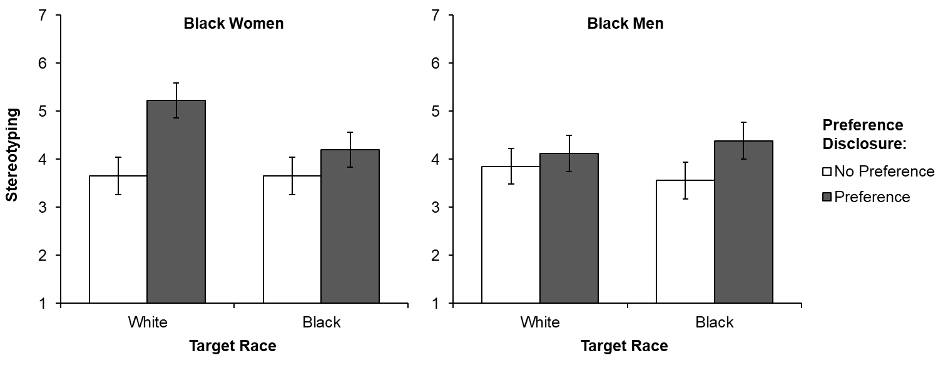
Note. Error bars represent 95% confidence intervals around the mean.

Figure D5
Racial Preference Disclosure × Target Race × Participant Gender Interaction on Individuation (Study 3)
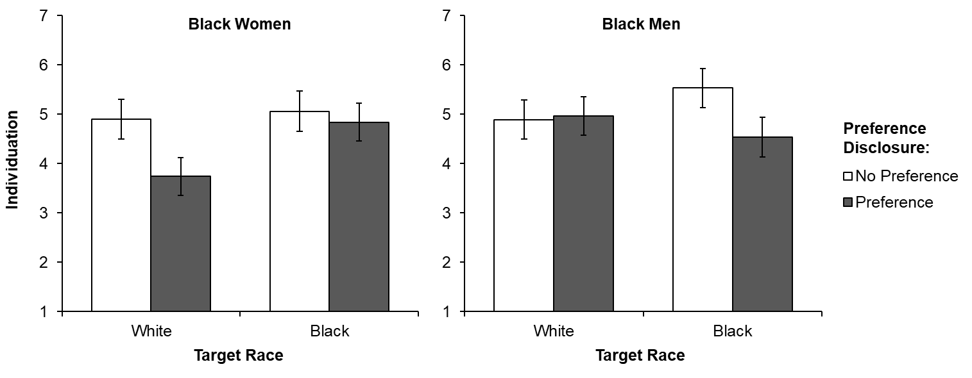
Note. Error bars represent 95% confidence intervals around the mean.

Figure D6
Racial Preference Disclosure × Target Race × Participant Gender Interaction on Target Racism (Study 3)
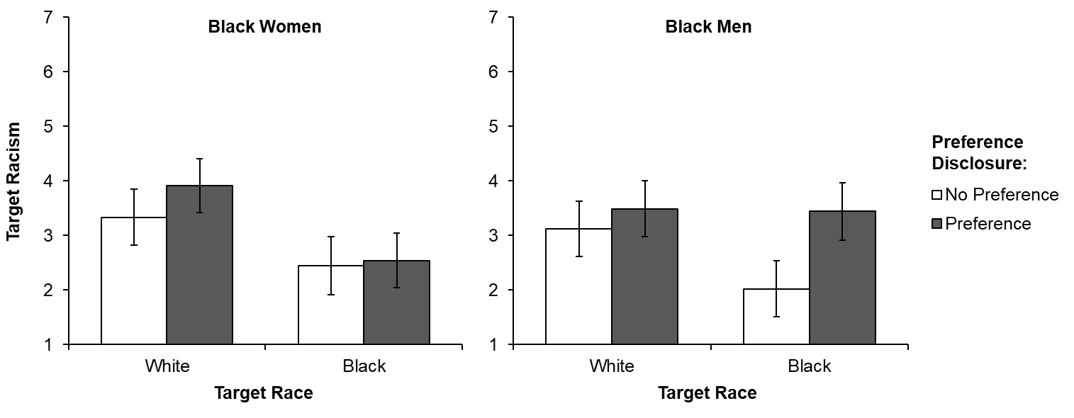
Note. Error bars represent 95% confidence intervals around the mean.

