Appendix A. Supplementary data for “Therapist effects in internet-delivered Cognitive Behaviour Therapy (iCBT) for anxiety and depression”, Feliciano et al.

The following tables and figures provide information which complements the results of the study. The tables below provide the results of the sensitivity analyses conducted. Specifically, the tables present the results of all the main analyses of the data, including missing data. Additionally, the figures included provide visual representations of therapists’ effects across all the outcomes of the study.
Table S1
Multilevel model without Multiple Imputation results predicting anxiety symptoms (GAD-7) over time
 | Fixed coefficient γ₁₀ |  | Estimated Means |  | Change from Baseline
 | Estimate | Std Error | Estimate | Std Error | % [95% CI]
Fixed effects
Intercept γ ₀₀ | 2.392*** | 0.007 |  |  | -
Time 1 | 0^{b} | - | 10.934*** | 0.071 | -
Time 2 | -0.183*** | 0.005 | 9.108*** | 0.067 | 16.7 (14.8,18.6)
Time 3 | -0.299*** | 0.006 | 8.111*** | 0.068 | 25.8 (24.0,27.7)
Time 4 | -0.381*** | 0.007 | 7.473*** | 0.064 | 31.7 (29.9,33.4)
Time 5 | -0.485*** | 0.009 | 6.730*** | 0.067 | 38.4 (36.6,40.2)
Time 6 | -0.548*** | 0.009 | 6.323*** | 0.065 | 42.2 (40.4,43.9)
Time 7 | -0.644*** | 0.009 | 5.740*** | 0.062 | 47.5 (45.8,49.1)
Random effects
Residual variance σ²_{εij} | 0.5642*** | 0.012 | - | - | -
Therapist variance (Intercept) σ²_{µ0j} | 0.000 | 0.000 | - | - | -
Therapist variance (Time) σ²_{µ1j} | 0.000 | 0.000 | - | - | -
Total Therapist variance (VPC) at post treatment | 0.07% | - | - | - | -
Note. ***p<.001, **p<.01, *p<.05
^{b} the coefficient is set to zero because it is redundant.

Table S2
Multilevel model without Multiple Imputation results predicting depression symptoms (PHQ9) over time
 | Fixed coefficient γ₁₀ |  | Estimated Means |  | Change from Baseline
 | Estimate | Std Error | Estimate | Std Error | % [95% CI]
Fixed effects
Intercept γ₀₀ | 2.493*** | 0.007 | - | - | -
Time 1 | 0^{b} | - | 12.10 | 0.083 | -
Time 2 | -0.175*** | 0.004 | 10.16 | 0.078 | 16.1 (14.2,17.8)
Time 3 | -0.297*** | 0.006 | 8.99 | 0.077 | 25.7 (23.8,27.5)
Time 4 | -0.384*** | 0.006 | 8.24 | 0.072 | 31.9 (30.1,33.6)
Time 5 | -0.479*** | 0.008 | 7.50 | 0.075 | 38.1 (36.3,39.8)
Time 6 | -0.544*** | 0.008 | 7.02 | 0.074 | 42.0 (40.2,43.7)
Time 7 | -0.631*** | 0.009 | 6.44 | 0.071 | 46.8 (45.1,48.4)
Random effects
Residual variance σ²_{εij} | 0.657*** | 0.012 | - | - | -
Therapist variance (Intercept) σ²_{µ0j} | 0.001 | 0.000 | - | - | -
Therapist variance (Time) σ²_{µ1j} | 0.000*** | - | - | - | -
Total Therapist variance (VPC) at post treatment | - | - | - | - | -
Note. ***p<.001, **p<.01, *p<.05
^{b} the coefficient is set to zero because it is redundant.

Table S3
Multilevel model without Multiple Imputation results predicting significant clinical change, treatment adherence and satisfaction
 | Anxiety Improvement | Depression Improvement | Treatment Completion | Treatment Satisfaction
Fixed effects
Fixed coefficient (Intercept; SE) β₀ | 0.250 (0.035)* | 0.256 (0.029)*** | 0.401 (0.056)*** | 1.668 (0.052)***
Proportion (%; 95% CI) | 56.2 (54.5,57.9) | 56.4 (54.9,57.8) | 59.9 (57.2,62.5) | 84.1 (82.7,85.4)
Random effects
Therapist variance (Intercept) σ²_{µ0j} | 0.013 (0.009)* | 0.003 (0.007)* | 0.098 (0.031)** | 0.033 (0.027)*
Therapist ICC | 0.3% | 0.1% | 2.3% | 0.4%
Note. Clinical improvement was operationalized as ≥ 50% improvement from baseline to post-treatment. ***p<.001, **p<.01, *p<.05

Figure S1
Therapists’ proportion of clients (with 95% CIs) making clinically significant change in anxiety (GAD-7)
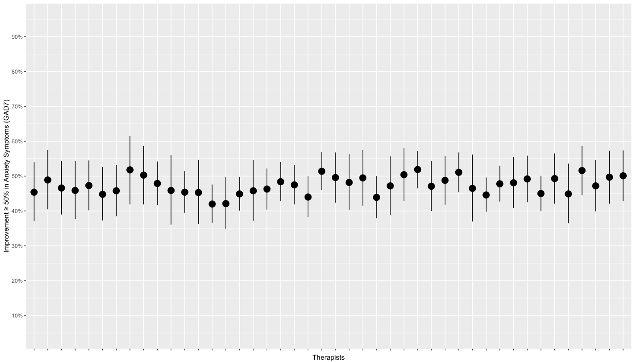

Figure S2
Therapists’ proportion of clients (with 95% CIs) making clinically significant change in depression (PHQ-9)
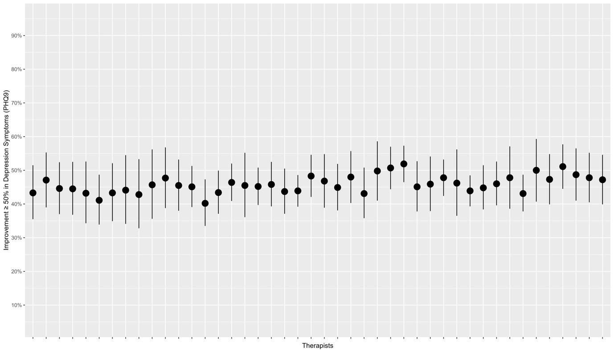

Figure S3
Therapists’ proportion of clients (with 95% CIs) completing treatment
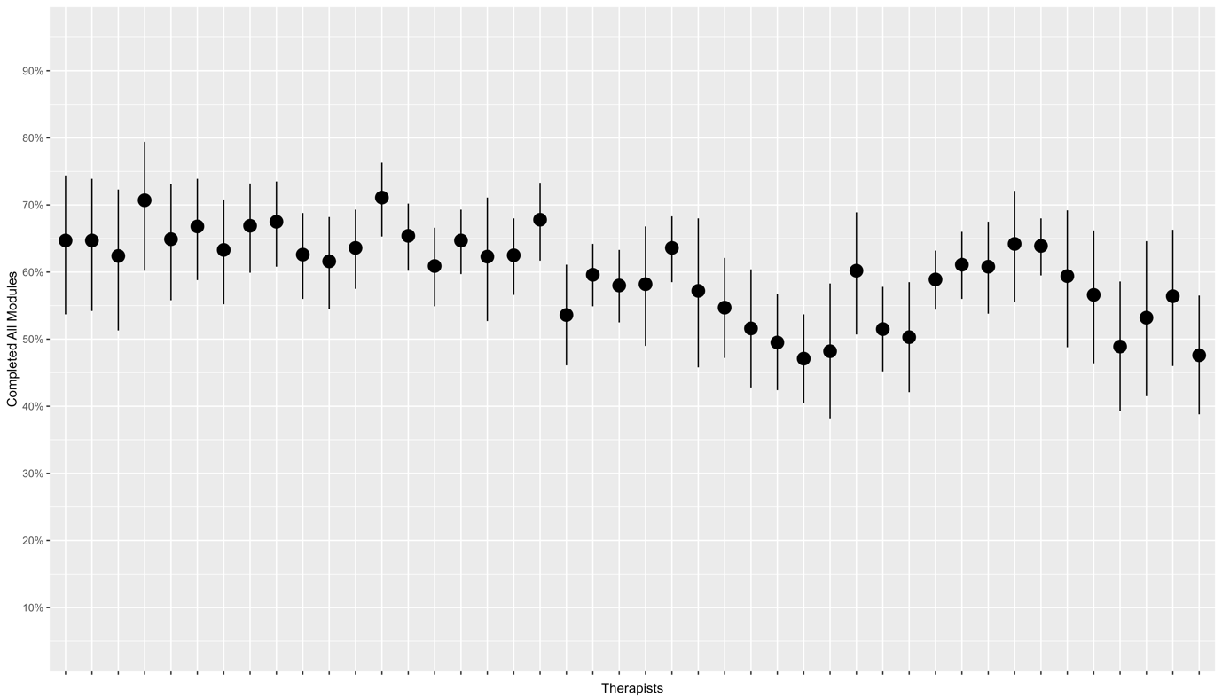

Figure S4
Therapists’ proportion of clients (with 95% CIs) satisfied with treatment
