Supplementary figure 4. Cost-Effectiveness acceptability curve for sensitivity sample 2.
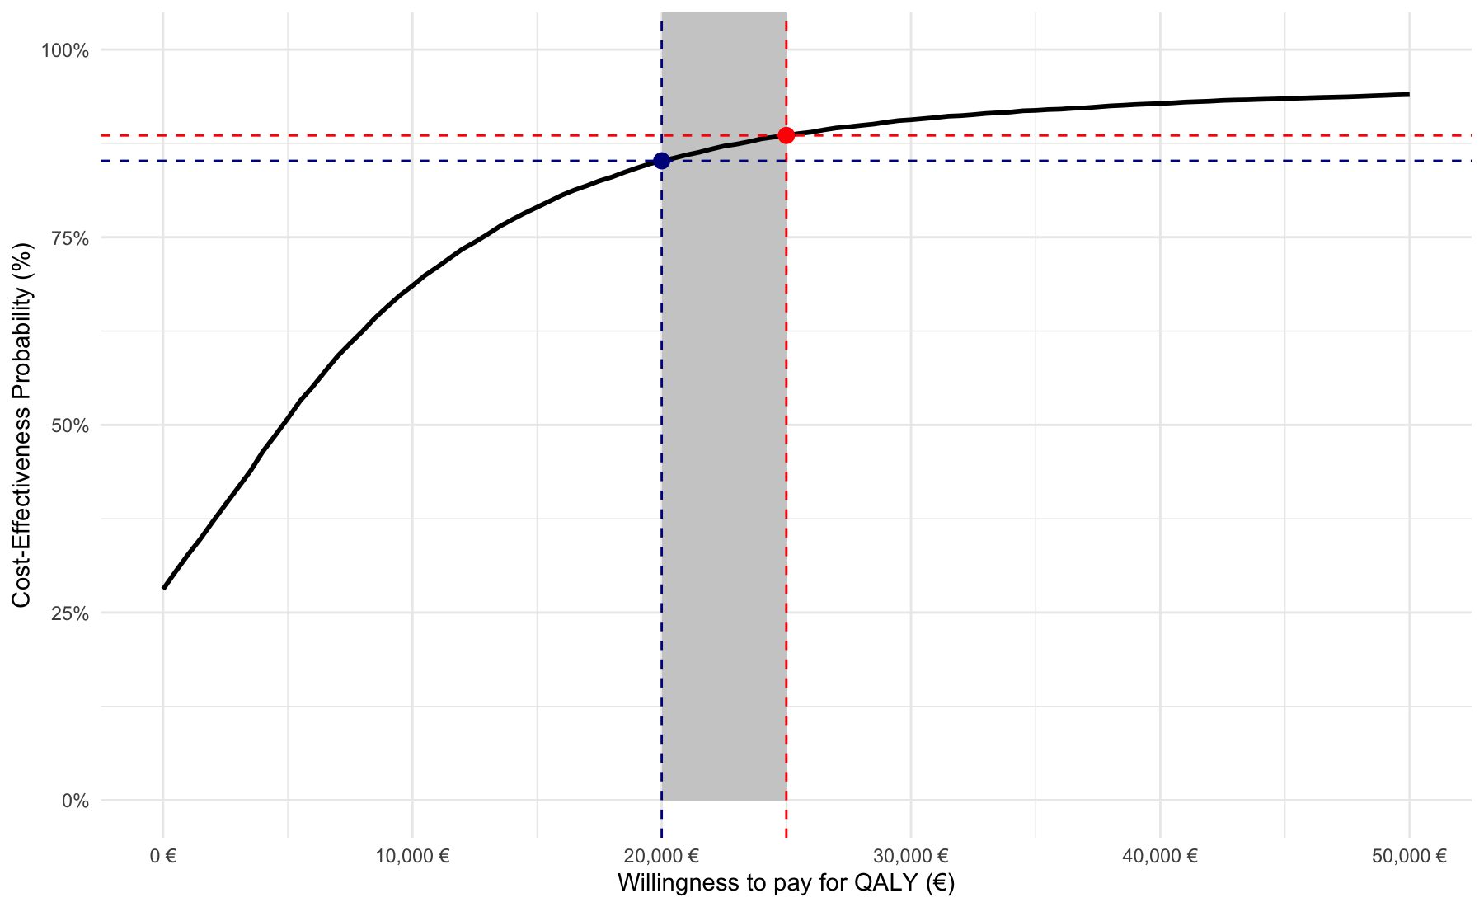

Note: The cost-effectiveness acceptability curve shows the probability (Y-axis) that the TD-GCBT+TAU intervention will be cost-effective within a range of willingness-to-pay thresholds (X-axis). The willingness-to-pay threshold represents the maximum monetary amount (in euros) that the healthcare system is willing to pay to obtain an additional QALY. The blue and red lines delimit the willingness-to-pay range in Spain (20,000-25,000 euros). The curve was generated from 10,000 bootstrap simulations.

