Supplementary figure 1. Cost-Effectiveness plane for TD-GCBT+TAU group in sensitivity sample 1.
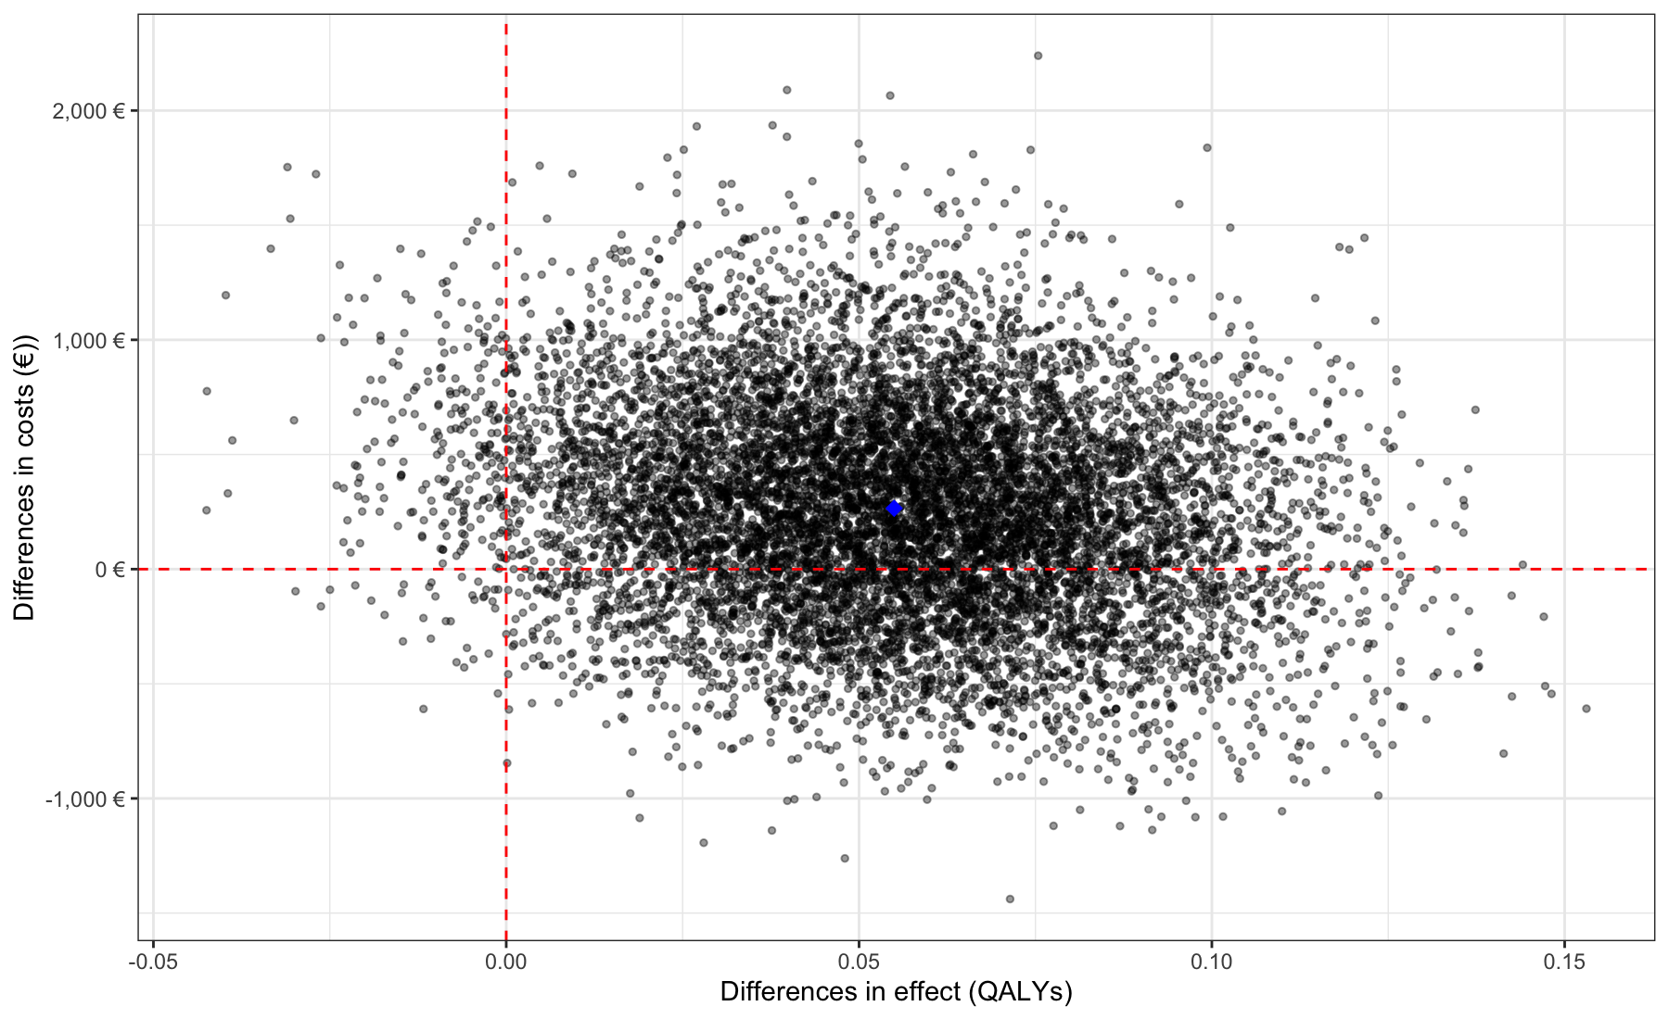

Note: The cost-effectiveness plane represents uncertainty around incremental costs (vertical axis, in euros) and incremental effectiveness (horizontal axis, in quality-adjusted life years, QALYs) of the intervention compared to the control. The results are interpreted in four quadrants: southeast (the intervention is dominant: more effective and less costly), northeast (more effective but more costly), southwest (less effective and less costly), and northwest (the intervention is dominated: less effective and more costly). Each black dot represents the result of one of the 10.000 bootstrap simulations, while the blue dot represents the sample from the original study.

