Supplementary Table 1 (Table S1).
Comparison of OST-C, OST-S, and OST-T2
 | OST-C | OST-S | OST-T2
Number of sessions | 20 (19 with child, 1 parent only) | 19 | 16
Session length | 60 min | 40 min | 35 min
Session format | Individual | Small group (3 to 4 students) | Small group (3 to 4 students)
Cognitive framing to prepare students for change | - Used glitches analogy and growth mindset to address implementation difficulties | - Same as OST-C | - Same as OST-C
In-session skills training and practice with students | - In-session skills practice was individualized to match situations that students encountered (e.g., how teachers told students about assignments) | - Fewer iterations of practice due to shorter session duration  - Group-based in-session practice reflected generic (not individualized) situations students were likely to encounter | - Similar to OST-S, plus practices for Time Management and Planning modified to teach key concepts in fewer sessions
Generalization Supports:
Between-session homework | - Students practice using skills to complete their regular school assignments | - Same as OST-C | - Same as OST-C
Caregiver involvement | - One caregiver-only session - instruction on token economy development and implementation and reinforcement of between-session skills use  - Caregivers joined the beginning and end of each session  - Student explained new skill to caregiver at the end of each session  - Caregivers taught to implement a token economy to reinforce skills practice | - No caregiver sessions  - Caregiver Manual provided, including written training on using prompting and praise to reinforce skill use, as well as a handout describing the skills learned at each session | 2 Caregiver sessions:  - Caregiver Manual provided at first session, similar format as OST-S  - Caregivers taught behaviors students will learn and how to prompt, monitor, and praise use of skills  Student sessions:  - Student role played explaining new skill to caregivers  - Sent home handouts explaining skill for week & Mastermind Sheets for caregivers to record between-session use of skills
Teacher involvement | - 5 teacher consultations, at least the first one in person.  - First session, teachers taught about the intervention and how to prompt and praise use of skills  - Teachers taught about each component of the program in the first four sessions  - Teachers taught how to prompt students to continue to use skills after the program in the last session  - Teacher report of between-session practice via two questions on Daily Assignment Record | - No teacher sessions  - Teacher Manual provided, including written training on using prompting and praise to reinforce skill use, as well as a handout describing the skills learned at each session | 2 Teacher sessions:  - Given Teacher Manual at first session  - Teachers taught behaviors students will learn and how to prompt, monitor, and praise use of skills  Student sessions:  - Gave teachers handouts explaining skill for week & Mastermind Sheets for teachers to record between-session use of skills

Supplementary Table 2 (Table S2).
Outline of OST-T2 Sessions
OST-T2 Activity | Topic
Module 1 – Orientation
Caregiver Meeting 1 | - Introduce caregivers to skills taught  - Train caregivers to prompt and praise between session skills use  - Homework: Prompt and reinforce student’s use of skills
Teacher Meeting 1 | - Same as Caregiver Meeting 1
Activity 1 Orientation¹ | - Introduce the cognitive mindset for change, externalizing OTMP problems as manifestations of mental “glitches” (e.g., “The Go-Ahead-Forget-It Glitch”, “The Go-Ahead-Lose It Glitch”, “The Time Bandit”, “The Go-Ahead-Don’t-Plan Glitch”) that can be controlled by building the skills of the “Mastermind”  - Engage students in talking about OTMP skills challenges they experience
Module 2 - Tracking Assignments
Activity 2 - Tracking Assignments¹ | - Teach effective strategies for keeping track of short-term and long-term assignments
Activity 3 – Tracking Assignments¹ | - Practice effective strategies for keeping track of short-term and long-term assignments
Module 3 – Managing Materials
Activity 4 - Paper Management¹ | - Teach effective strategies for managing papers
Activity 5 - Paper Management¹ | - Practice effective paper management strategies
Activity 6 – Backpacks Organization¹ | - Teach use of a checklist attached to the backpack as a reminder to transport needed items between home and school
Activity 7 – Workspace Preparation¹ | - Teach how to prepare workspace before starting work by getting all needed materials and removing distractions
Activity 8 – Weed It Out Strategy¹ | - Teach how to regularly ‘weed out’ storage areas and workspaces to keep materials organized
Module 4 – Time Management
Caregiver Meeting 2 | - Review progress in Tracking Assignments and Managing Materials  - Problem-solve caregiver support for between-session skills use  - Introduce caregivers to Time Management and Planning Modules and teach them how they can support student learning  - Homework: Reinforce students’ use of skills as they do school assignments and daily tasks
Teacher Meeting 2 | - Same as Caregiver Meeting 2
Activity 9 – Time Detective¹ | - Teach how to estimate task duration and time how long tasks actually take to complete
Activity 10 Time Detective ¹ | - Teach how to estimate task duration for tasks that vary by subject matter and length of assignment
Activity 11 Time Management for Homework¹ | - Teach use of effective time management strategies for homework by estimating how long homework will take and timing how long it actually took
Activity 12 Time Management for Homework¹ | - Practice estimating how long homework will take and then timing it. Identify ways to work accurately and efficiently
Module 5 – Planning
Activity 13 Planning - Breaking it Down¹ | - Teach the first three steps of planning - set your goal, break it down into steps, and put the steps in order
Activity 14 Planning – Managing Materials and Time¹ | - Teach the next two steps of planning, managing materials and managing time, and then practice the first five steps of planning
Activity 15 Planning – Fitting it In¹ | - Teach the next step of planning, fitting their plan into their weekly schedule, and practice the first six steps of planning
Activity 16 Planning – Check It Out and Maintaining Gains¹ | - Teach and practice the last step of planning, checking their work to make sure it is neat and complete  - Review skills learned during program and plan for continued use of skills

Notes: ¹Each of these sessions are student group sessions and include the following:
1) Except for Activity 1, begin with a review of between session skills practice and problem solve implementation challenges.
2) Main focus of the session is on repeated practice of a new skill.
3) Conclusion: Plan to practice the new skill and prior skills between sessions. Role play explaining new skills to caregivers. Use skills when packing up to leave the session.

Supplementary Table 3 (Table S3).
Threshold Analyses: Participants Scoring in the Clearly Normative Range by Timepoint Based on Actual, Unadjusted Data
 | Baseline  N (%) |  | Post (14 weeks)  N (%) |  | 5-month Follow-up (22 weeks) N (%) |  | 12-month Follow-up (55 weeks) N (%)
 | OST-T2 | TAU/WL | OST-T2 | TAU/WL | OST-T2 | TAU/WL | OST-T2 | TAU/WL
COSS-P | 25 (26.32) | 34 (38.64) | 58 (66.67) | 35 (43.21) | 45 (61.64) | 24 (35.29) | 47 (58.75) | 37 (46.84)
COSS-T | 8 (8.42) | 5 (5.88) | 39 (42.39) | 9 (10.84) | 33 (43.42) | 7 (10.00) | 28 (35.90) | 20 (27.78)
HPC | 20 (21.05) | 30 (34.09) | 45 (51.14) | 31 (38.27) | 38 (52.78) | 20 (29.41) | 32 (42.11) | 37 (46.25)
HPQ | 8 (8.42) | 3 (3.57) | 26 (28.26) | 6 (7.23) | 18 (24.00) | 8 (11.59) | 17 (22.37) | 10 (14.08)
ACES | 19 (21.59) | 14 (17.28) | 27 (31.76) | 12 (15.19) | 27 (39.71) | 11 (16.92) | 29 (40.28) | 17 (24.64)
APS | 33 (34.74) | 25 (29.41) | 38 (41.76) | 24 (28.92) | 37 (48.68) | 21 (30.00) | 39 (48.75) | 23 (32.39)

Note: OST-T2 = Organizational Skills Treatment, Tier 2. TAU/WL = Treatment as usual, wait list. COSS-P and COSS-T = Child Organizational Skills Scale Parent and Teacher versions, respectively. HPC = Homework Problem Checklist; HPQ = Homework Performance Questionnaire; ACES = Academic Competence Evaluation Scales; and APS = Academic Proficiency Scale. The thresholds were determined based on the means and standard deviations of each outcome measure in a normative sample by child sex. “Clearly Normative” was defined as participants whose scores were greater than/less than or equal to the normative mean score plus or minus 0.5 standard deviation. The directionality (greater than vs less than, plus vs minus) was determined based on whether higher or lower scores represent more favorable outcomes. The normative means and standard deviation by sex were used, as described above, to determine the thresholds for the COSS-P (Boys = 2.48; Girls = 2.21), COSS-T (Boys = 2.36; Girls = 1.94), HPC (Boys = 1.03; Girls = 0.72), and HPQ (Boys = 3.49; Girls = 3.64). For the academic performance measures, the threshold was based on scale anchors, whereby 3 indicates “at grade level” for ACES and “at the standard expected at this time of year” for APS. The percentages at each assessment point reflect the number of students scoring within the clearly normal range divided by the number of completed assessments at that time point. See Figure 1 for sample sizes for parent- and teacher-report measures at each time point.

Figure S1.
Theory of Change for Organizational Skills Treatment-Tier 2 (OST-T2).
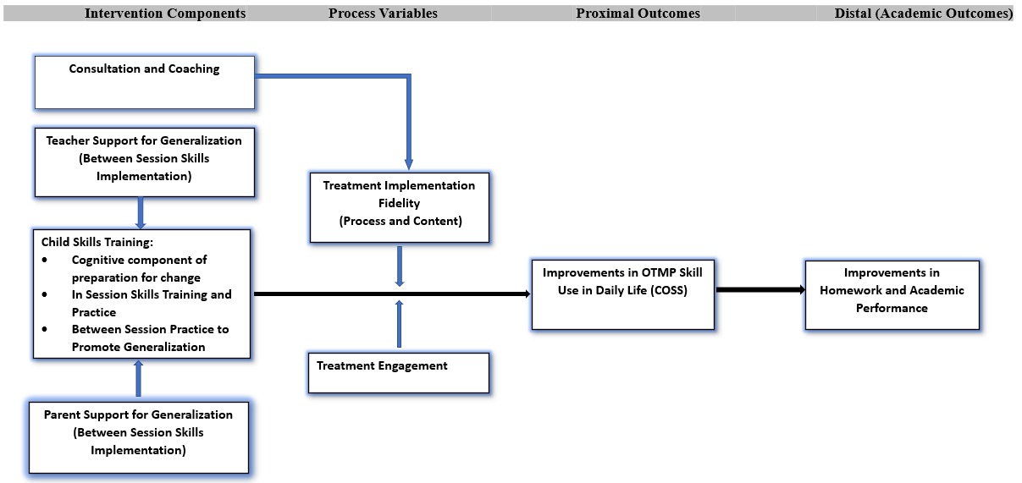
Note: OST-T2 includes (a) cognitive framing with students to promote a sense of self-efficacy, (b) in-session skills training and practice with students, (c) between-session practice using skills to promote generalization, (d) consultation with caregivers and teachers to support practice between sessions, and (e) consultation with school interventionists to promote fidelity and student engagement. OST-T2 is designed to improve OTMP skills, which in turn can lead to improved homework and academic performance. The fidelity with which OST-T2 is implemented and student, caregiver, and teacher engagement in the intervention are expected to influence the results.
Figure S2.
Model-based Adjusted Mean HPC Item Scores at Each Assessment Period
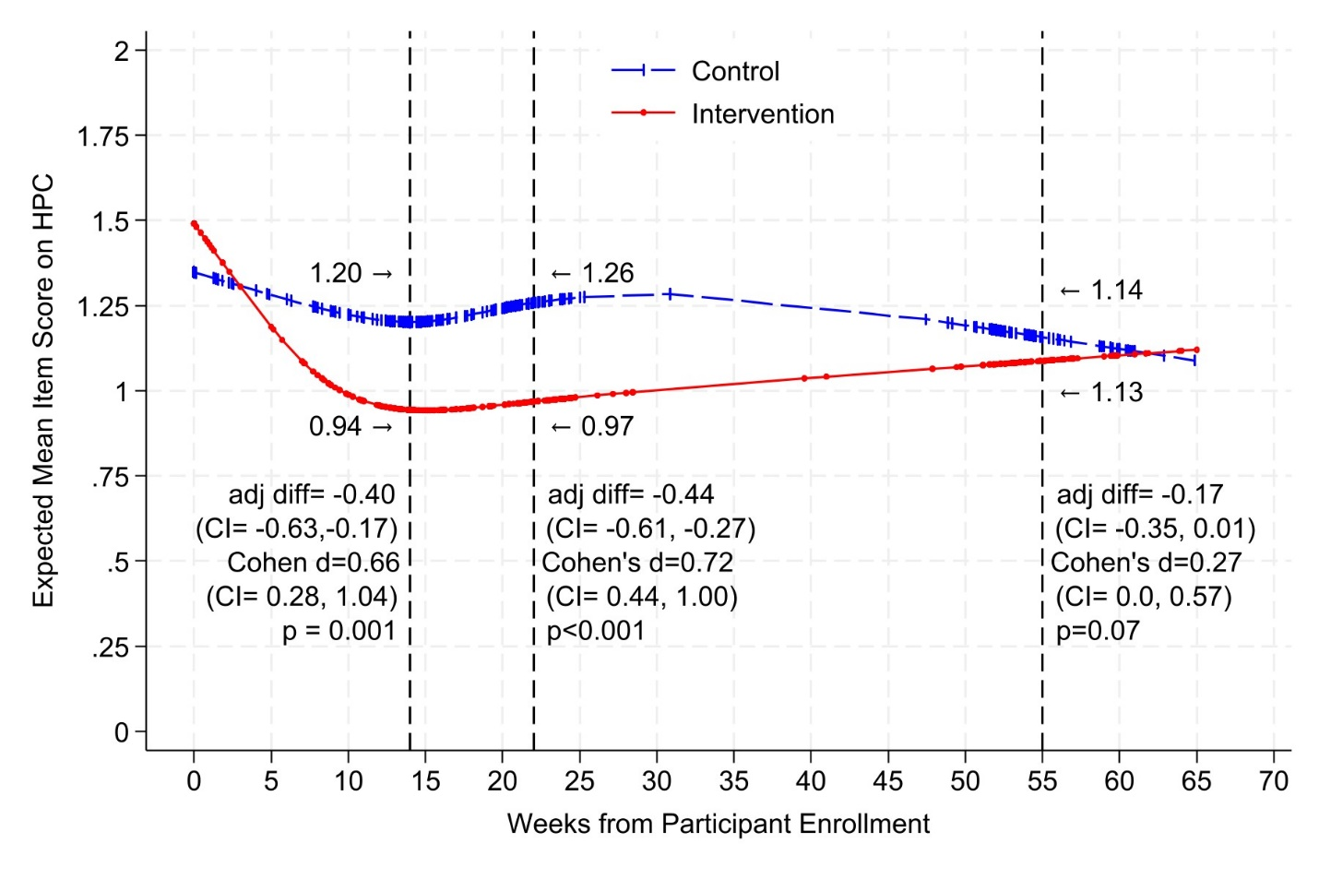
Note. HPC = Homework Problem Checklist. Lower scores reflect lower homework performance difficulty. Measurement completion varied somewhat across children leading to these outcome assessment estimations: 14 weeks from participant enrollment for post-treatment; 22 weeks from enrollment for 5-month follow-up; and 55 weeks from enrollment for 12-month follow up. Markers on curves indicate mixed-effects model-based HPC mean scores at actual individual measurement times and curves join these markers. Figure notations indicate between-group differences of estimated change based on model-adjusted values (adjusted for covariates) from baseline to the designated outcome assessment weeks, the associated confidence intervals, the corresponding Cohen’s d, 95% confidence interval for Cohen’s d, and p values. To account for multiple comparisons, differences in changes from baseline to post-treatment and follow-up were deemed statistically significant if p<.083. Between-group differences in changes over time are adjusted for baseline scores and do not necessarily equal within-group differences at each reported week of estimation.

Figure S3.
Model-based Adjusted Mean HPQ-T Item Scores at Each Assessment Period
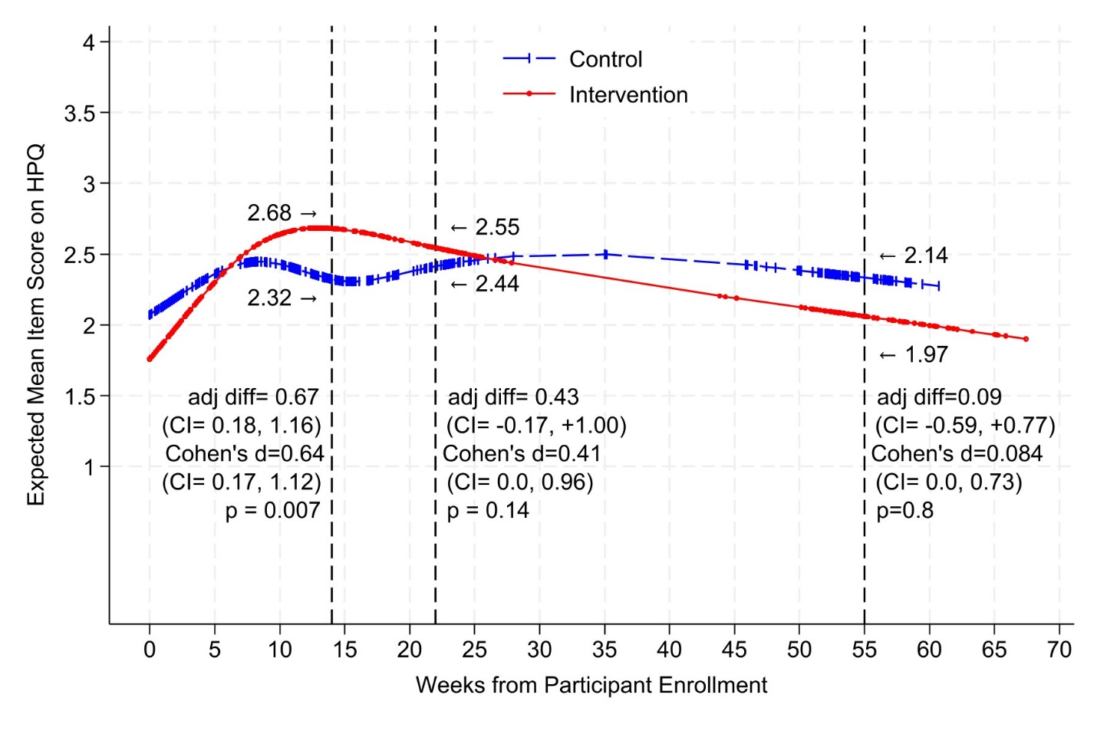
Note. HPQ-T = Homework Performance Questionnaire, Teacher version. Higher scores reflect better homework performance. The rest of the note for Figure S2 applies to Figure S3.

Supplemental Section 1. Sample size justification and power calculations
We examined power assuming 20 schools, inclusion of 3-4 students per grade level across two grade levels (3.5 students per school), and randomization at the school level. The design targets on average 14 students per school. To allow for 15% loss to follow up at the child level, we assumed 120 children per arm. We assumed conservatively a baseline measure and one follow up per child.
As longitudinal measures at the child level increase power and clustering of children within schools decreases power, we assumed modest correlations of outcome measures within child over time: 0.5, 0.6 and 0.7, which correspond to SDs of change of 1.0, 0.8, and 0.6 for a 1 SD cross sectional difference. Correlations of 0.5 lead to no increase in power from the design, and correlations of 0.6 and 0.7 correspond to approximately 10% and 20% increases in power. To account for clustering, we assumed intra-cluster correlations (ICC)=0.01, typical in school-based trials (Office of Behavioral and Social Sciences Research, NIH: http://esourceresearch.org/tabid/384/Default.aspx), as well as ICC=0.038, corresponding to variation of outcome scores across schools of 0.4 SD. The design effects of these assumptions are 1.03 (small) and 1.11 (modest), to be expected with a relatively small number of children per school and correspond to a reduction in the effective sample size of 3-11%.
Calculations were performed using PASS 11 (Hintze, 2011; www.ncss.com) demonstrating 90% power to detect a change in outcomes equivalent to 0.5 or greater in cross-sectional SDs, assuming 12 children per school and model correlation of these scores within child over time (corr=0.7), and assuming an ICC of 0.038 (a relatively large degree of variation across schools). A change equivalent to 0.5 cross-sectional SDs in outcome scores would remain detectable (power>0.85) for a correlation within children over time= 0.7 and the ICC across schools = 0.038. Based on the pilot study of OST-S, we expected effect sizes for outcomes to be in the 0.6 to 0.8 range.
Confidence intervals reported throughout in tables and figures account for actual post-study power. (Goodman, S. N., & Berlin, J. A. (1994). The use of predicted confidence intervals when planning experiments and the misuse of power when interpreting results. Annals of internal medicine, 121(3), 200–206. https://doi.org/10.7326/0003-4819-121-3-199408010-00008)

