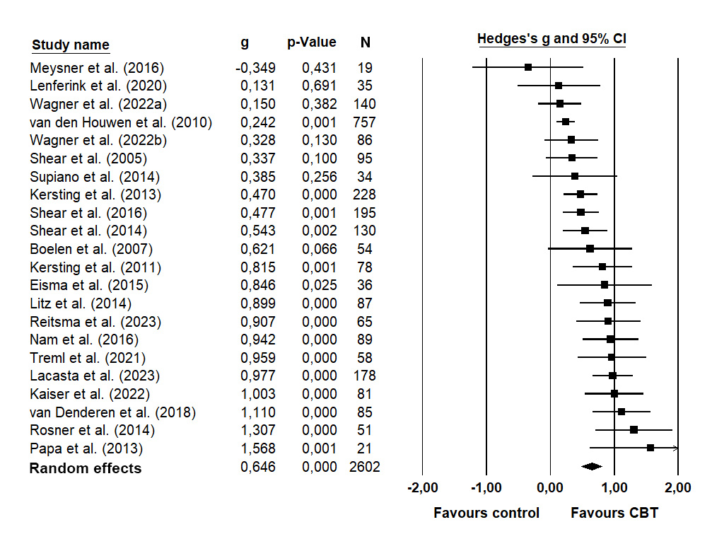
Figure S1. Forest plot for the effect of grief-focused CBTs on PGD symptoms at post-intervention.

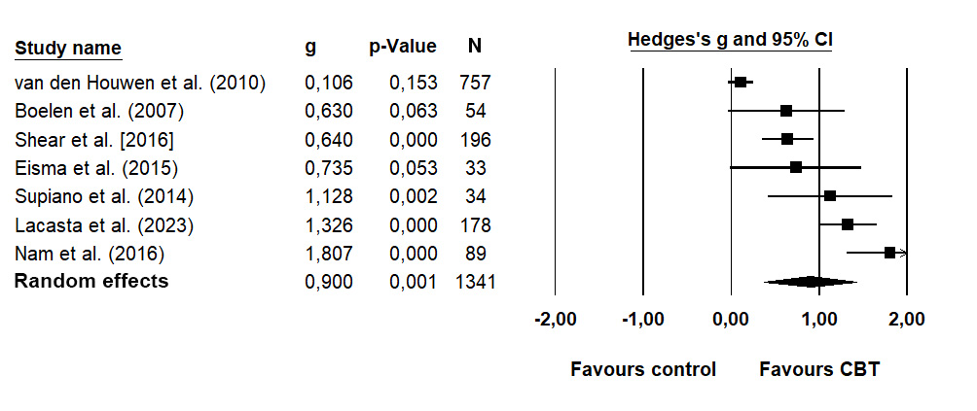

Figure S2. Forest plot for the effect of grief-focused CBTs on PGD symptoms at follow-up.

Table S1. Treatment characteristics.
Author (year) | Treatment provider | Delivery format and modality | Treatment dose | E | CR | BA | Non-CBT components
Boelen et al. (2007) | Psychologist | Individual;  Face-to-face | 12 sessions of 45 minutes (12 weeks) | x | x
Eisma et al. (2015)ª | Self-guided with feedback | Individual;  Digital | 6 sessions  (7 weeks) | x |  | x
Kaiser et al. (2022) | Self-guided with feedback | Individual;  Digital | 10 sessions of 45 minutes (5 weeks) | x | x
Kersting et al. (2011) | Self-guided with feedback | Individual;  Digital | 10 sessions of 45 minutes (5 weeks) | x | x
Kersting et al. (2013) | Self-guided with feedback | Individual;  Digital | 10 sessions of 45 minutes (5 weeks) | x | x
Lacasta and Cruzado (2023) | Psychologist | Group;  Face-to-face | 16 sessions of 120 minutes (16 weeks) | x |  | x
Lenferink et al. (2020) | Psychologist | Individual;  Face-to-face | 8 sessions of 71.25 minutes (12 weeks) |  | x |  | EMDR
Litz et al. (2014) | Self-guided with feedback | Individual;  Digital | 18 sessions of 20 minutes (6 weeks) |  |  | x
Meysner et al. (2016) | Student | Individual;  Face-to-face | 7 sessions of 83.57 minutes (7 weeks) | x | x |  | EMDR;  GT
Nam (2016) | Psychologist | Individual;  Face-to-face | 8 sessions of 120 minutes (8 weeks) | x |  | x | IPT; MI
Papa et al. (2013) | Psychologist | Individual;  Face-to-face | 14 sessions  (12 weeks) |  |  | x
Reitsma et al. (2023) | Self-guided | Individual;  Digital | 8 sessions of 120 minutes (12 weeks) | x | x | x
Rosner et al. (2014) | Psychologist | Individual;  Face-to-face | 24.4 sessions of 53.3 minutes (46 weeks) | x | x
Shear et al. (2005) | Psychologist | Individual;  Face-to-face | 16 sessions  (19 weeks) | x |  | x | IPT; MI
Shear et al. (2014) | Psychologist | Individual;  Face-to-face | 15.1 sessions  (16 weeks) | x |  | x | IPT; MI
Shear et al. (2016) | Psychologist | Individual;  Face-to-face | 16 sessions  (16 weeks) | x |  | x | IPT; MI
Supiano and Luptak (2014) | Psychologist | Group;  Face-to-face | 16 sessions of 120 minutes (16 weeks) | x | x | x | IPT; MI
Treml et al. (2021) | Psychologist | Individual;  Digital | 10 sessions of 45 minutes (5 weeks) | x | x
van Denderen et al. (2018) | Psychologist | Individual;  Face-to-face | 8 sessions of 45 minutes (8 weeks) |  | x |  | EMDR
van der Houwen et al. (2010) | Self-guided | Individual;  Digital | 5 sessions  (7 weeks) | x | x
Wagner, Grafiadeli, et al. (2022) | Psychologist or student therapist | Group;  Digital | 12 sessions of 90 minutes (12 weeks) | x |  | x
Wagner, Hofmann, et al. (2022) | Psychologist | Individual;  Digital | 7.6 sessions of 45 minutes (6 weeks) | x | x | x
Note. The exact (averaged) number of sessions given to the patients in the study is reported. If not reported in the study, the number of sessions according to treatment manual is reported. If the treatment included sessions of different durations, an average was calculated. Eye Movement Desensitization and Reprocessing (EMDR); Gestalt Therapy (GT); Motivational Interviewing (MI); Interpersonal therapy (IPT); a) Either behavioral activation or exposure treatment was given in this study.

Table S2. GRADE evidence profile for Grief-focused CBTs for PGD symptoms at post-intervention.
Quality assessment |  |  |  |  |  |  | Summary of findings
No. of studies  (Design) | Risk of bias | Inconsistency | Indirectness | Imprecision | Publication bias |  | No. of patients in analyses; effect on PGD; 95 % CI | Overall quality
22 RCTs with passive, active, or competing control | No serious limitations ª | Serious inconsistency ^{b} | Serious indirectness ^{c} | No serious imprecision ^{d} | Some indications ^{e} |  | N = 2602  g = 0.65  CI: 0.49-0.81 | Moderate
Notes.
a) Two studies yielded a high risk of bias (n= 172 out of 2602 participants included in the meta-analysis, 6.6%). In 18 studies there were some concerns about the risk of bias mainly due to an unblinded outcome assessor (a common problem in psychotherapeutic research) and no pre-registration of analyses (selected reporting could not be ruled out with certainty, thus some concerns were present in some studies). However, when studies of high risk of bias were excluded, the pooled effect estimate remained statistically significant and medium (see Table 2). For these reasons, we rated no serious limitations of risk of bias in the overall quality of the meta-analytical evidence.
b) Point estimates varied from negative to positive effects (1 study favored the control, 3 studies were close to zero effect, and 18 studies favored CBTs). The only study favoring the control group was compared to a competing intervention (Meysner et al., 2016). Not all confidence intervals of the included studies were overlapping and statistical tests for heterogeneity indicated considerable proportions of heterogeneity. Differences in effect estimates were found in subgroups when looking at the type of control group (active, competing, and passive control), using clinically relevant symptoms of PGD as inclusion criterion as well as the time criterion of ≥ 6 months post-loss, and samples of unnatural versus natural causes of death. However, none of the moderator analyses reached statistically significant when exploring possible causes for heterogeneity.
c) The meta-analytical evidence was based on a broad population of bereaved adults, and thus some concerns are present regarding generalizing the estimate to bereaved individuals with ICD-11 or DSM-5-TR PGD symptoms. Eight out of 22 studies did not include participants based on the presence of clinically relevant symptoms of PGD. However, in six out of these eight studies, the study mean of PGD symptoms at baseline was above cut-offs for clinically relevant PGD symptoms, and five of these eight studies had PGD as the primary outcome. In terms of the indirectness of interventions, eight out of 22 studies included additional non-CBT components. In terms of outcome measures, several different measures of PGD symptoms were used, however, all measures included the same core symptoms of PGD (e.g., intense yearning and preoccupation).
d) Based on the 95% confidence interval, the effect estimate is likely to be between just below medium and large, and the 95% confidence interval did not overlap with no effect.
e) The sample sizes of the included studies ranged from small (n = 19) to large (n = 757). In nine studies, authors noted that their study was or could have been underpowered. While both positive and negative effects of CBTs were observed in small studies, the majority reported positive effects (K = 7; 78%). When inspecting conventional and contour-enhanced funnel plots, there were some indications of small study effects due to possible publication bias. Such asymmetrical effects can, however, also be due to other factors, including true heterogeneity or chance (Page et al., 2020). When adjusting statistically for possible publication bias with the Trim and Fill procedure, only one “missing” study was added and the effect size estimate remained of medium magnitude (g = 0.63 vs. 0.65). When adjusted with the PET-PEESE method, on the other hand, the effect estimate was reduced to g = 0.39, but remained statistically significant. Although the PET-PEESE method has been proposed to outperform the Trim and Fill method, the reliability of this method is limited when 1) large heterogeneity is present, 2) all included studies are small or 3) relatively few studies are included in the meta-analysis (Stanley et al., 2017). In the present meta-analysis, 1) the effect sizes were relatively heterogeneous, 2) about half of the studies were based on small samples (K = 9; 41%), and 3) the number of available studies was limited to 22. Furthermore, when possible outliers were omitted the effect remained stable (g = 0.65 vs. 0.65). While there were some indications of possible publication bias, we do not suspect that this will seriously impact the effect estimate.

Search strategy
P (Population) | Bereaved people | (grief OR griev* OR mourn* OR bereave*)
I (Interventions) | Cognitive behavioral therapies | (intervention OR therapeut* OR therapy OR treat* OR counsel* OR trial*)  AND  ("cognitive behavioral" OR "cognitive behavioural" OR exposure OR "cognitive restructuring" OR "cognitive reappraisal" OR "behavioral activation" OR "behavioural activation" OR "goal work" OR “cognitive behavioural therapy” OR “cognitive behavioral therapy” OR "complicated grief therapy" OR "complicated grief treatment")
C (Comparator group) | Different types of controls (active, passive, no-treatment)
O (Outcome) | Symptoms of PGD (and symptoms of PTSD, depression, anxiety, general well-being) | ("prolonged grief" OR "complicated grief" OR "persistent complex bereavement disorder" OR depress* OR anxiety OR "posttraumatic stress" OR PTSD OR "post-traumatic stress")

PubMed:
grief OR griev* OR mourn* OR bereave*
AND
intervention OR therapeut* OR therapy OR treat* OR counsel* OR trial*

AND
"cognitive behavioral" OR "cognitive behavioural" OR exposure OR "cognitive restructuring" OR "cognitive reappraisal" OR "behavioral activation" OR "behavioural activation" OR "goal work" OR “cognitive behavioural therapy” OR “cognitive behavioral therapy” OR "complicated grief therapy" OR "complicated grief treatment"
AND
"prolonged grief" OR "complicated grief" OR "persistent complex bereavement disorder" OR depress* OR anxiety OR "posttraumatic stress" OR PTSD OR "post-traumatic stress"

MeSH-terms for the most important words to avoid to many irrelevant hits:
grief OR griev* OR mourn* OR bereave* | "Bereavement"[Mesh]  (includes both “grief” and “prolonged grief disorder” as Mesh terms)
AND
intervention OR therapeut* OR therapy OR treat* OR counsel* OR trial*
AND
"cognitive behavioral" OR "cognitive behavioural" OR exposure OR "cognitive restructuring" OR "cognitive reappraisal" OR "behavioral activation" OR "behavioural activation" OR "goal work" OR “cognitive behavioural therapy” OR “cognitive behavioral therapy” OR "complicated grief therapy" OR "complicated grief treatment" | "Cognitive Behavioral Therapy"[Mesh]
AND
"prolonged grief" OR "complicated grief" OR "persistent complex bereavement disorder" OR depress* OR anxiety OR "posttraumatic stress" OR PTSD OR "post-traumatic stress"

Search in PubMed: ((((grief OR griev* OR mourn* OR bereave*) OR ("Bereavement"[Mesh])) AND (intervention OR therapeut* OR therapy OR treat* OR counsel* OR trial*)) AND (("Cognitive Behavioral Therapy"[Mesh]) OR ("cognitive behavioral" OR "cognitive behavioural" OR exposure OR "cognitive restructuring" OR "cognitive reappraisal" OR "behavioral activation" OR "behavioural activation" OR "goal work" OR "cognitive behavioural therapy" OR "cognitive behavioral therapy" OR "complicated grief therapy" OR "complicated grief treatment"))) AND ("prolonged grief" OR "complicated grief" OR "persistent complex bereavement disorder" OR depress* OR anxiety OR "posttraumatic stress" OR PTSD OR "post-traumatic stress")

Embase:
grief OR griev* OR mourn* OR bereave*
AND
intervention OR therapeut* OR therapy OR treat* OR counsel* OR trial*

AND
"cognitive behavioral" OR "cognitive behavioural" OR exposure OR "cognitive restructuring" OR "cognitive reappraisal" OR "behavioral activation" OR "behavioural activation" OR "goal work" OR “cognitive behavioural therapy” OR “cognitive behavioral therapy” OR "complicated grief therapy" OR "complicated grief treatment"
AND
"prolonged grief" OR "complicated grief" OR "persistent complex bereavement disorder" OR depress* OR anxiety OR "posttraumatic stress" OR PTSD OR "post-traumatic stress"

Extra index terms found in the Emtree browser:
grief OR griev* OR mourn* OR bereave* | 'grief'/exp (includes both “prolonged grief disorder” and “complicated grief”)  'bereavement'/exp
AND
intervention OR therapeut* OR therapy OR treat* OR counsel* OR trial*
AND
"cognitive behavioral" OR "cognitive behavioural" OR exposure OR "cognitive restructuring" OR "cognitive reappraisal" OR "behavioral activation" OR "behavioural activation" OR "goal work" OR “cognitive behavioural therapy” OR “cognitive behavioral therapy” OR "complicated grief therapy" OR "complicated grief treatment" | 'cognitive behavioral therapy'/exp  'cognitive reappraisal'/exp  'exposure therapy'/exp
AND
"prolonged grief" OR "complicated grief" OR "persistent complex bereavement disorder" OR depress* OR anxiety OR "posttraumatic stress" OR PTSD OR "post-traumatic stress"

Search in Embase: ('prolonged grief' OR 'complicated grief' OR 'persistent complex bereavement disorder' OR depress* OR anxiety OR 'posttraumatic stress' OR ptsd OR 'post-traumatic stress') AND (intervention OR therapeut* OR therapy OR treat* OR counsel* OR trial*) AND ('grief'/exp OR 'bereavement'/exp OR grief OR griev* OR mourn* OR bereave*) AND ('cognitive behavioral therapy'/exp OR 'cognitive behavioral' OR 'cognitive behavioural' OR exposure OR 'cognitive restructuring' OR 'cognitive reappraisal' OR 'behavioral activation' OR 'behavioural activation' OR 'goal work' OR 'cognitive behavioural therapy' OR 'cognitive behavioral therapy' OR 'complicated grief therapy' OR 'complicated grief treatment' OR 'cognitive reappraisal'/exp OR 'exposure therapy'/exp)

Web of Science:
grief OR griev* OR mourn* OR bereave*
AND
intervention OR therapeut* OR therapy OR treat* OR counsel* OR trial*

AND
"cognitive behavioral" OR "cognitive behavioural" OR exposure OR "cognitive restructuring" OR "cognitive reappraisal" OR "behavioral activation" OR "behavioural activation" OR "goal work" OR “cognitive behavioural therapy” OR “cognitive behavioral therapy” OR "complicated grief therapy" OR "complicated grief treatment"
AND
"prolonged grief" OR "complicated grief" OR "persistent complex bereavement disorder" OR depress* OR anxiety OR "posttraumatic stress" OR PTSD OR "post-traumatic stress"

No extra index terms are available/needed for this database.
Search in Web of Science: ALL=((grief OR griev* OR mourn* OR bereave*) AND (intervention OR therapeut* OR therapy OR treat* OR counsel* OR trial*) AND ("cognitive behavioral" OR "cognitive behavioural" OR exposure OR "cognitive restructuring" OR "cognitive reappraisal" OR "behavioral activation" OR "behavioural activation" OR "goal work" OR "cognitive behavioural therapy" OR "cognitive behavioral therapy" OR "complicated grief therapy" OR "complicated grief treatment") AND ("prolonged grief" OR "complicated grief" OR "persistent complex bereavement disorder" OR depress* OR anxiety OR "posttraumatic stress" OR PTSD OR "post-traumatic stress"))

PsycInfo:
grief OR griev* OR mourn* OR bereave*
AND
intervention OR therapeut* OR therapy OR treat* OR counsel* OR trial*

AND
"cognitive behavioral" OR "cognitive behavioural" OR exposure OR "cognitive restructuring" OR "cognitive reappraisal" OR "behavioral activation" OR "behavioural activation" OR "goal work" OR “cognitive behavioural therapy” OR “cognitive behavioral therapy” OR "complicated grief therapy" OR "complicated grief treatment"
AND
"prolonged grief" OR "complicated grief" OR "persistent complex bereavement disorder" OR depress* OR anxiety OR "posttraumatic stress" OR PTSD OR "post-traumatic stress"

Extra index terms found in Thesaurus:
grief OR griev* OR mourn* OR bereave* | MAINSUBJECT.EXACT.EXPLODE("Bereavement") (includes also “grief”)
AND
intervention OR therapeut* OR therapy OR treat* OR counsel* OR trial*
AND
"cognitive behavioral" OR "cognitive behavioural" OR exposure OR "cognitive restructuring" OR "cognitive reappraisal" OR "behavioral activation" OR "behavioural activation" OR "goal work" OR “cognitive behavioural therapy” OR “cognitive behavioral therapy” OR "complicated grief therapy" OR "complicated grief treatment" | MAINSUBJECT.EXACT("Cognitive Restructuring") OR MAINSUBJECT.EXACT("Cognitive Therapy") OR MAINSUBJECT.EXACT.EXPLODE("Cognitive Behavior Therapy") OR MAINSUBJECT.EXACT.EXPLODE("Exposure Therapy")
AND
"prolonged grief" OR "complicated grief" OR "persistent complex bereavement disorder" OR depress* OR anxiety OR "posttraumatic stress" OR PTSD OR "post-traumatic stress" | MAINSUBJECT.EXACT("Prolonged Grief Disorder")

Search in PsycInfo: (MAINSUBJECT.EXACT.EXPLODE("Bereavement") OR grief OR griev* OR mourn* OR bereave*) AND (intervention OR therapeut* OR therapy OR treat* OR counsel* OR trial*) AND (MAINSUBJECT.EXACT("Cognitive Restructuring") OR MAINSUBJECT.EXACT("Cognitive Therapy") OR MAINSUBJECT.EXACT.EXPLODE("Exposure Therapy") OR MAINSUBJECT.EXACT.EXPLODE("Cognitive Behavior Therapy") OR "cognitive behavioral" OR "cognitive behavioural" OR exposure OR "cognitive restructuring" OR "cognitive reappraisal" OR "behavioral activation" OR "behavioural activation" OR "goal work" OR "cognitive behavioural therapy" OR "cognitive behavioral therapy" OR "complicated grief therapy" OR "complicated grief treatment") AND (MAINSUBJECT.EXACT("Prolonged Grief Disorder") OR "prolonged grief" OR "complicated grief" OR "persistent complex bereavement disorder" OR depress* OR anxiety OR "posttraumatic stress" OR PTSD OR "post-traumatic stress")
Limited to peer-reviewed.

