Supplemental Content for “Session-level Effects of Cognitive Processing Therapy and Prolonged Exposure on Individual Symptoms of PTSD among US Veterans”

Method: Additional Analytic Details

Although some patients were offered opportunity to complete 13th and 14th sessions of treatment, data from these sessions were not included in the NIA due to the likelihood of collider bias and the small sample size (n = 72 and 42, respectively).

In NIA analyses, we used the next chronologically available PCL-5 after a protocol therapy session. For instance, if a patient attended a Session 4 protocol session following Session 3, then the PCL-5 administered at Session 4 (immediately prior to that therapy session) was considered to be the “Post-Session 3” PCL-5. If a patient elected to have a non-protocol stressor session following Session 3, the PCL-5 administered immediately before the stressor session was considered to be the “Post-Session 3” PCL-5. The PCL-5 administered at the session following a non-protocol stressor session was not used in NIA analyses. The proportion of patients using at least one of the two available “stressor sessions” was 15.6% and 13.4% in the CPT and PE groups, respectively.

Results
Supplemental Table 1.

Comparison of residualized change scores between treatment condition among the sample of treatment completers according to PCL-5 data collected at pre-treatment and at each participant’s final therapy session (CPT n = 246, PE n = 201)
PCL-5 Item |  | Effect Size of Between-Treatment Change Score ^{b}
 | d |  |  | [95% CI]
1. Intrusive memories | .23* |  |  | [0.04, 0.42]
2. Nightmares | .12 |  |  | [-0.06, 0.31]
3. Flashbacks | .23* |  |  | [0.04, 0.42]
4. Psychological distress in response to reminders | .29* |  |  | [0.10, 0.48]
5. Physiological reactions to reminders | .23* |  |  | [0.04, 0.41]
6. Avoidance of thoughts and feelings | .27* |  |  | [0.09, 0.46]
7. Avoidance of external reminders | .40* |  |  | [0.21, 0.59]
8. Amnesia | .16 |  |  | [-0.03, 0.35]
9. Distorted negative beliefs | .22* |  |  | [0.03, 0.35]
10. Distorted blame | .10 |  |  | [-.09, 0.28]
11. Persistent negative emotions | .30* |  |  | [0.11, 0.48]
12. Loss of interest | .21* |  |  | [0.03, 0.40]
13. Detachment | .22* |  |  | [0.03, 0.41]
14. Inability to experience positive emotions | .25* |  |  | [0.06, 0.44]
15. Irritable or aggressive behavior | .20* |  |  | [0.01, 0.39]
16. Reckless behavior | .13 |  |  | [-.06, 0.32]
17. Hypervigilance | .29* |  |  | [0.10, 0.47]
18. Exaggerated Startle | .18 |  |  | [-0.01, 0.37]
19. Concentration problems | .17 |  |  | [-0.01, 0.36]
20. Sleep disturbance | .18 |  |  | [-.01, 0.37]

Supplemental Table 2. Summary of significant edges between treatment condition node and PCL-5 item residualized change score nodes following each therapy session in Network Intervention Analysis (NIA) in entire sample and completer samples.
 | Entire Sample |  | Completer Sample
Timepoint | CPT  n = 402 | PE  n = 400 | CPT  n = 246 | PE  n = 201
Baseline | n/a | n/a | n/a | n/a
Session 1 | n/a | Hypervigilance | Avoidance of thoughts/memories | Negative beliefs  Hypervigilance
Session 2 | n/a | n/a | n/a | Avoidance of external reminders  Loss of interest
Session 3 | Intrusive memoriesª Nightmaresª | Flashbacks^{b}  Avoidance of external reminders  Blame  Distress due to reminders  Persistent negative emotions  Detachment  Amnesia  Loss of interest | n/a | n/a
Session 4 | n/a | Intrusions  Startle | Physiological reactions to reminders | Intrusions  Startle
Session 5 | n/a | Avoidance of thoughts and memories | n/a | Avoidance of thoughts and memories  Physiological reactions to reminders
Session 6 | Blame | Negative beliefs  Hypervigilance  Nightmares  Flashbacks  Distress due to reminders  Avoidance of external reminders  Sleep disturbance | Avoid of thoughts/memories  Blame | Distress due to reminders  Startle  Flashbacks  Avoidance of external reminders  Negative beliefs  Negative emotions  Loss of interest
Session 7 | n/a | n/a | n/a | n/a
Session 8 | n/a | Negative beliefs  Loss of interest Detachment | n/a | Negative beliefs  Intrusive memories  amnesia
Session 9 | n/a | Physiological reactions to reminders | Blame | Physiological reactions to reminders
Notes. Edges that were significant in 60% or more of bootstrapped samples during mgm resample procedure are bolded.
Networks for Sessions 10, 11, and 12 were not modeled due to introduction of collider bias into sample (see Method)

Abbreviations: CPT = Cognitive Processing Therapy, PE = Prolonged Exposure Therapy

ª The mean scores on these items after Session 2 and 3 suggest that these symptoms were exacerbated in the PE group rather than improved in the CPT group.
^{b} The mean scores on this item after Session 2 and 3 suggest that these symptoms were exacerbated in the CPT group rather than improved in the PE group

Supplemental Figures: Session by session plots of Network Intervention Analysis Models

Notes regarding network plots. A green line indicates a positive relationship between nodes and a red line indicates a negative relationship between nodes. Treatment node is coded 0 = CPT and 1 = PE. All other nodes are residualized change scores reflecting the change from immediately prior to the session to the next PCL-5 assessment. A green edge between the treatment node and a symptom node reflects greater reduction in symptom in CPT group, and a red edge between treatment and a symptom reflects greater reduction in that symptom in the PE group.

Abbreviations: tx= treatment condition, mem = intrusive memories; drm = distressing dreams; fls = flashbacks; ups = psychological distress in response to trauma cues; phy = physiological reactivity to trauma cues; avm = avoidance of memories/thoughts of trauma; avx = avoidance of external reminders of the trauma; amn = traumatic amnesia; blf = negative beliefs about oneself, others, or the world; blm = blaming self or others for the trauma; neg = persistent negative emotion; anh = diminished interest; det = detachment from others; num = inability to experience positive emotion; irr = irritable/angry behavior; rsk = risky/self-destructive behavior; hyp = hypervigilance; str = exaggerated startled response; cnc = difficulty concentrating; slp = sleep disturbance.

Session 1:

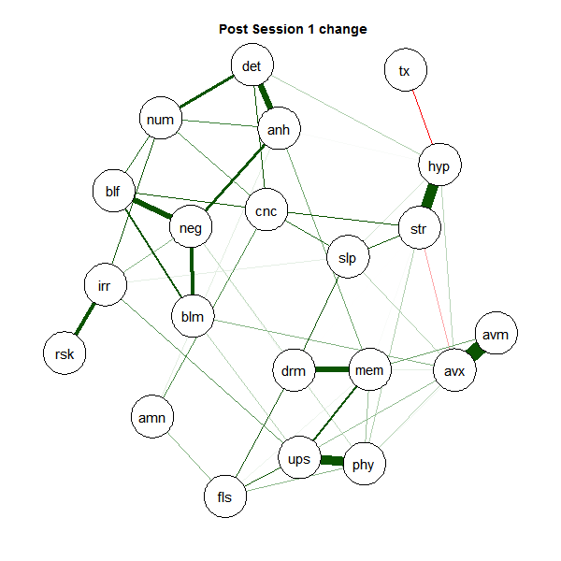

Session 2:

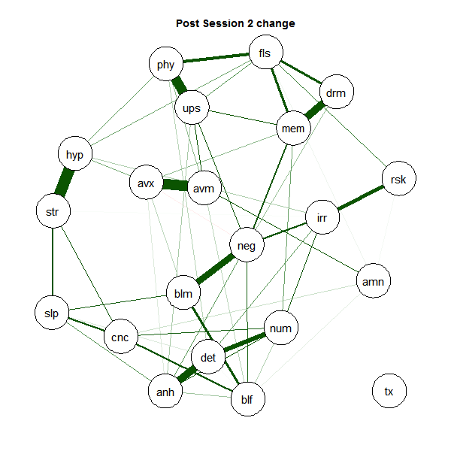

Session 3:
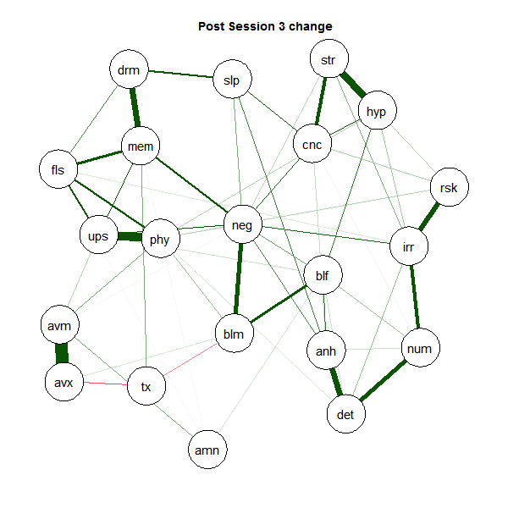

Session 4:
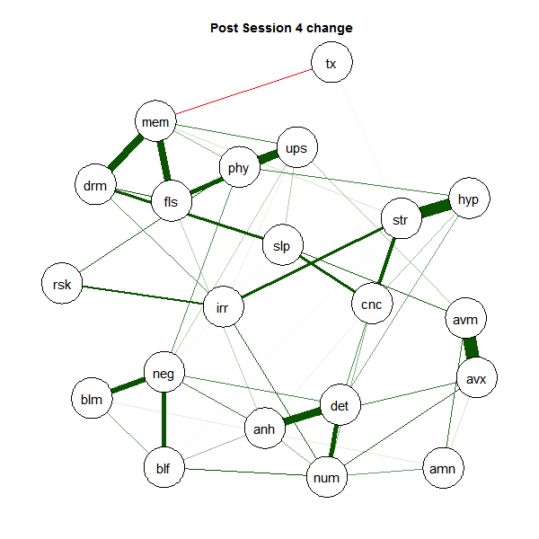

Session 5:
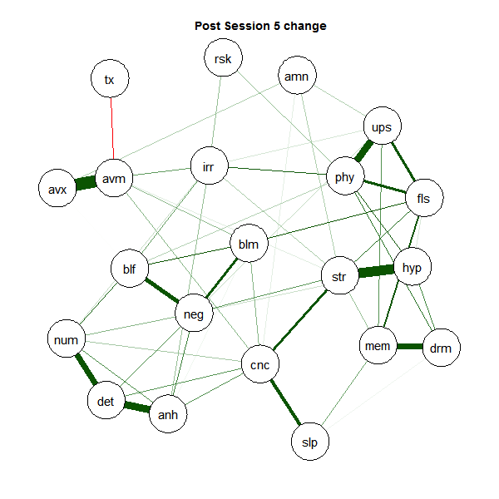

Session 6:
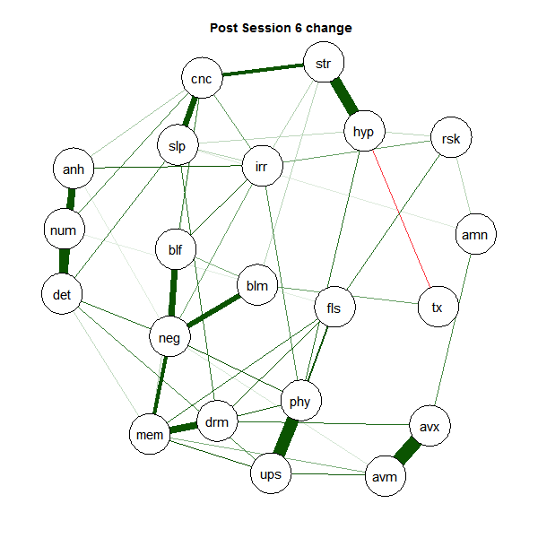

Session 7:
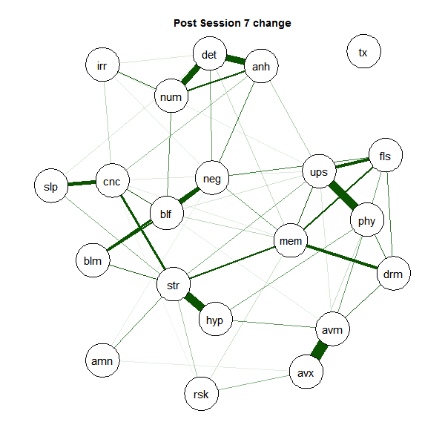

Session 8:
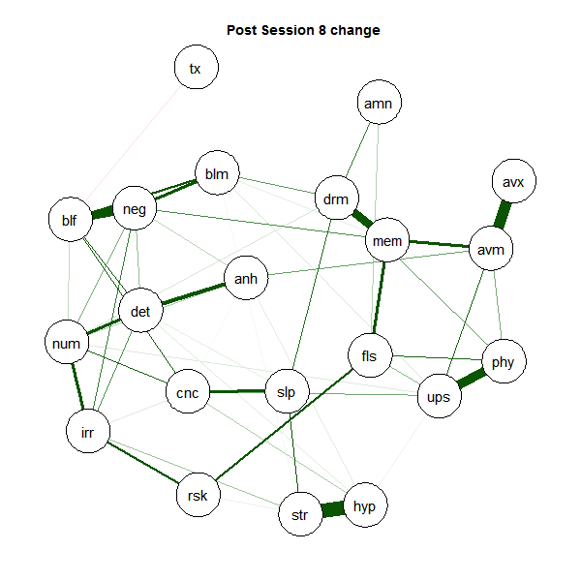
Session 9:
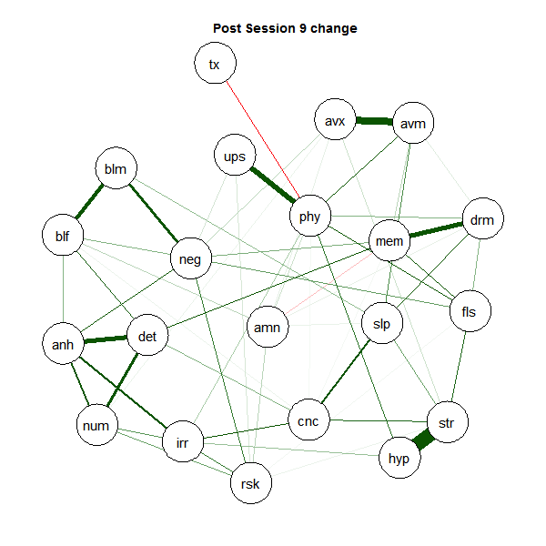

Supplemental Figures:

Plots of the bootstrapped sampling distribution of the edge weights of the network at each timepoint are available at the link below:

https://emmanuel0-my.sharepoint.com/:f:/g/personal/moshiers_emmanuel_edu/EtrHpuZ7-LdBtxC60FKcqkQBJDZk88yrOQsmdgI7Ufc1RQ?e=sPcvgh

Abbreviations: tx= treatment condition, mem = intrusive memories; drm = distressing dreams; fls = flashbacks; ups = psychological distress in response to trauma cues; phy = physiological reactivity to trauma cues; avm = avoidance of memories/thoughts of trauma; avx = avoidance of external reminders of the trauma; amn = traumatic amnesia; blf = negative beliefs about oneself, others, or the world; blm = blaming self or others for the trauma; neg = persistent negative emotion; anh = diminished interest; det = detachment from others; num = inability to experience positive emotion; irr = irritable/angry behavior; rsk = risky/self-destructive behavior; hyp = hypervigilance; str = exaggerated startled response; cnc = difficulty concentrating; slp = sleep disturbance.

