Supplemental Table 1

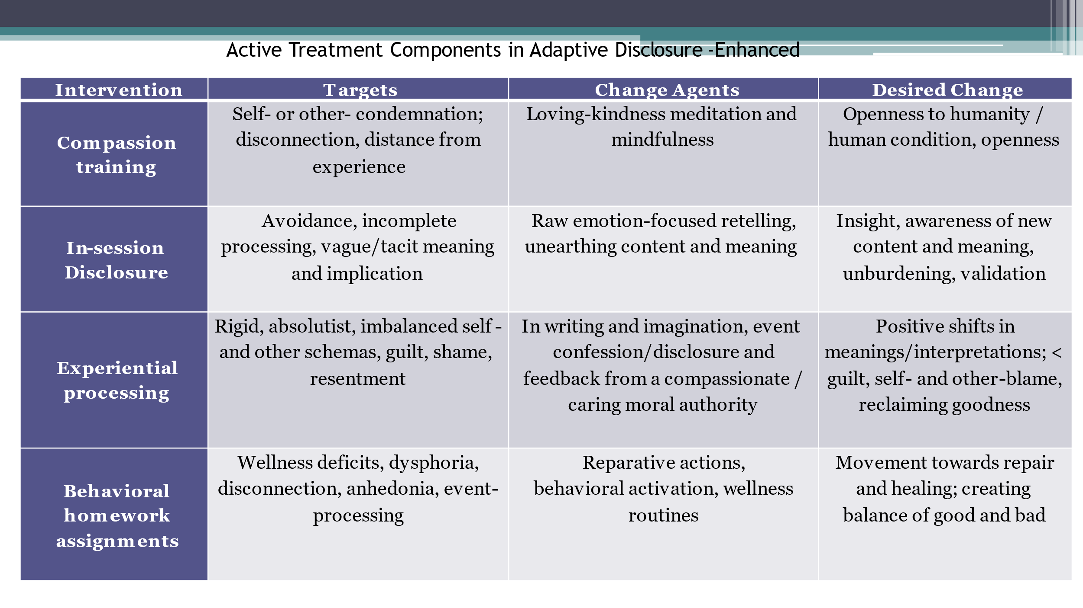
Clinically Significant Change Outcomes
Table 2 depicts the results of the Jacobson and Truax methodology of indexing individual participant clinically significant change for the functioning (SDS, B-IPF) and primary mental and behavioral health (CAPS-5, DAR, CTS-2 Psychological Aggression) measures. At each follow-up, individuals were classified as experiencing probable recovery if they passed the Criterion Cutoff and the RCI criteria; improved if they passed the RCI criterion, but their post-treatment or follow-up score did not pass the Criterion Cutoff; unchanged if they failed to pass the RCI; or deteriorated if they passed the RCI criterion but symptom scores increased. Fisher’s exact tests for difference in proportions were used to compare prevalence of categories between arms at each follow-up.
These clinically significant change outcomes are exploratory; we did not explicitly power the study to confirm a proportion of statistically significant differences clinical change outcomes between treatment arms. Additionally, one of the limitations of the Jacobson and Truax methodology is that classifications require observed data. This limits the results to participants with both baseline and either post-treatment/three-month follow-up/six-month follow-up data, depending on the bi-temporal change trajectory of interest. Consequently, because of lowered observed data in the follow-up intervals, the likelihood of Type II error is arguably substantially high for these results.
The Jacobson and Truax methodology is reliant upon approximately normally distributed scores to derive valid RCI Threshold and Criterion Cutoff score parameters. The CTS-2 Physical Assault Subscale and the Quick Drinking Screen were excessively zero-inflated and right-skewed to obtain reliable J&T parameter estimates; we therefore excluded them from the analysis.

Supplemental Table 2
Jacobson and Truax Individual-level Clinical Significance: Primary Outcomes
 |  |  | % (n)
 |  |  | Pre-to-post-treatment |  | Pre-to-3MFU |  | Pre-to-6MFU
Outcome |  |  | AD-E | PCT | AD-E | PCT | AD-E | PCT
Functioning
 | SDSª
 |  | Probable Recovery | 56.86 (29)* | 35.71 (20) | 37.21 (16) | 28.85 (15) | 48.65 (18) | 31.58 (12)
 |  | Improved | 0 (0)* | 12.50 (7) | 6.98 (3) | 0 (0) | 5.41 (2) | 2.43 (1)
 |  | Unchanged | 43.14 (22) | 48.21 (27) | 53.49 (23) | 71.15 (37) | 45.95 (17) | 60.53 (23)
 |  | Deteriorated | 0 (0) | 3.57 (2) | 2.33 (1) | 0 (0) | 0 (0) | 5.26 (2)
 | B-IPF^{b}
 |  | Probable Recovery | 4.08 (2) | 8.47 (5) | 17.02 (8) | 15.69 (8) | 17.50 (7) | 15.38 (6)
 |  | Improved | 22.45 (11) | 13.56 (8) | 25.53 (12) | 13.73 (7) | 30.00 (12) | 15.38 (6)
 |  | Unchanged | 61.22 (30) | 61.02 (36) | 48.94 (23) | 60.78 (31) | 47.50 (19) | 58.97 (23)
 |  | Deteriorated | 12.24 (6) | 16.95 (10) | 8.51 (4) | 9.80 (5) | 5.00 (2) | 10.26 (4)
Mental and behavioral health
 | CAPS-5^{c}
 |  | Probable Recovery | 15.25 (9)* | 3.03 (2) | 9.26 (5) | 3.85 (2) | 20.93 (9) | 7.50 (3)
 |  | Improved | 30.51 (18) | 25.76 (17) | 25.76 (17) | 23.08 (12) | 34.88 (15) | 25.00 (10)
 |  | Unchanged | 52.54 (31) | 63.64 (40) | 55.56 (30) | 63.46 (33) | 37.21 (16) | 55.00 (22)
 |  | Deteriorated | 1.69 (1) | 10.61 (7) | 3.70 (2) | 12.50 (5) | 6.98 (3) | 12.50 (5)
 | DAR^{d}
 |  | Probable Recovery | 4.08 (2) | 1.69 (1) | 10.87 (5) | 5.77 (3) | 7.50 (3) | 2.56 (1)
 |  | Improved | 18.37 (9) | 18.64 (11) | 15.22 (7) | 13.46 (7) | 27.50 (11) | 12.82 (5)
 |  | Unchanged | 71.43 (35) | 66.10 (39) | 65.22 (30) | 73.08 (38) | 60.00 (24) | 69.23 (27)
 |  | Deteriorated | 6.12 (3) | 13.56 (8) | 8.70 (4) | 7.69 (4) | 5.00 (2) | 15.38 (6)
 |  |  | % (n)
 |  |  | Pre-to-post-treatment |  | Pre-to-3MFU |  | Pre-to-6MFU
Outcome |  |  | AD-E | PCT | AD-E | PCT | AD-E | PCT
 | CTS-2 Psychological^{e}
 |  | Probable Recovery | 20.93 (9)* | 3.39 (2) | 15.79 (6) | 3.39 (2) | 16.00 (8) | 10.26 (4)
 |  | Improved | 18.60 (8) | 15.25 (9) | 18.42 (7) | 15.25 (9) | 8.00 (4) | 12.82 (5)
 |  | Unchanged | 55.81 (24)* | 76.27 (45) | 60.53 (23)* | 76.27 (45) | 72.00 (36) | 66.67 (26)
 |  | Deteriorated | 4.65 (2) | 5.08 (3) | 5.26 (2) | 5.08 (3) | 4.00 (2) | 10.26 (4)
ªThe RCI Threshold score was 7 and the Criterion Cutoff score was 14. External data used in the J&T calculations were sourced from Olfsen et al., 1997. ^{b} The RCI Threshold score was 34 and the Criterion Cutoff score was 20. External data used in the J&T calculations were sourced from Kleiman et al., 2020. ^{c}The CAPS-5 RCI Threshold score was 13 and the Criterion Cutoff score was 8. External data used in the J&T calculations were sourced from Marx et al., 2022. ^{d}The DAR RCI Threshold score was 10 and the Criterion Cutoff score was 6. ^{e}The log-transformed CTS-2 Psychological Aggression RCI Threshold score was 1.47 and the Criterion Cutoff score was 0.02.
* Indicates statistically significant Fisher’s exact test results for difference of proportion between AD-E and PCT at the two-sided 0.05 level of significance.

Observational “Per Protocol” Complete Case Analysis of Covariance (ANCOVA) Bi-Temporal Analyses
Table 3 depicts the results of the bi-temporal, complete case analysis ANCOVA models, which assess the differential in mean symptom change from baseline between the AD-E and PCT treatment arms, while controlling for baseline symptom burden. The analytical samples comprise participants with available data for the components of the bi-temporal change slopes for each time interval (i.e., participants with observed baseline and post-treatment measurements); the n values in Table 3 represent the number of subjects with available data for the respective analysis (e.g. subjects with observed baseline and post-treatment data in the pre-post outcome ANCOVA). Since these models are bi-temporal ANCOVAs, subjects with missing values at either of the respective timepoints in each analysis are excluded, as per complete case analysis. The results thus represent an observational subset of the ITT sample which had sufficient observed data.
Because these participants were in the majority treatment completers, we regarded the complete case analysis sample as per protocol. For example, in the AD-E arm, those participants with available baseline and post-treatment SDS scores attended a mean of 11.94 sessions (SD = 0.31); in the PCT arm the mean was 11.43 (SD = 2.00). Ninety-six percent of AD-E treatment completers had observed baseline and post-treatment SDS measurements, while 88% of PCT treatment completers had observed baseline and post-treatment SDS measurements; this difference was not statistically significant (OR = 1.41, 95% CI [.71, 2.85], Fisher’s p = .33). Finally, the modal number of sessions attended in both complete case cohorts was 12.

Supplemental Table 3
Results of Per-Protocol Analysis of Covariance (ANCOVA) Models Assessing Treatment Effects from Baseline
 |  |  |  | AD-E |  |  |  |  | PCT |  |  |  |  | Comparison
Outcome and time interval |  |  |  | n | B | df | t | d | n | B | df | t | d | B | df | t | d
Functioning
 | SDS
 |  | Post-treatment |  | 51 | −10.82 | 100 | −11.07 | 2.21*** | 56 | −6.52 | 100 | −7.15 | 1.43*** | −4.29 | 100 | −3.20 | 0.64**
 |  | 3 months |  | 43 | −7.58 | 89 | −6.97 | 1.48*** | 52 | −5.04 | 89 | −5.17 | 1.10*** | −2.54 | 89 | −1.74 | 0.37
 |  | 6 months |  | 37 | −9.74 | 69 | −8.12 | 1.96*** | 38 | −5.33 | 69 | −4.56 | 1.10*** | −4.41 | 69 | −2.64 | 0.64**
 | B-IPF
 |  | Post-treatment |  | 49 | −8.12 | 105 | −2.38 | 0.46* | 59 | −4.65 | 105 | −1.50 | 0.24 | −3.47 | 105 | −0.75 | 0.15
 |  | 3 months |  | 47 | −16.81 | 95 | −4.64 | 0.95*** | 51 | −7.48 | 95 | −2.15 | 0.44* | −9.34 | 95 | −1.86 | 0.38*
 |  | 6 months |  | 40 | −19.22 | 76 | −5.08 | 1.17*** | 39 | −7.14 | 76 | −1.87 | 0.43* | −11.98 | 76 | −2.23 | 0.51*
Mental and behavioral health
 | CAPS-5
 |  | Post-treatment |  | 59 | −13.04 | 122 | −8.04 | 1.46*** | 66 | −4.90 | 122 | −3.20, | 0.58** | −8.13 | 122 | −3.64 | 0.66***
 |  | 3 months |  | 54 | −9.96 | 103 | −5.50 | 1.08*** | 52 | −2.83 | 103 | −2.83 | 0.56** | −4.74 | 103 | −1.83 | 0.36*
 |  | 6 months |  | 43 | −12.21 | 81 | −5.82 | 1.29*** | 41 | −5.72 | 81 | −2.67 | 0.58** | −6.49 | 81 | −2.16 | 0.47*
 | DAR
 |  | Post-treatment |  | 49 | −5.65 | 105 | −3.15 | 0.61** | 59 | −2.23 | 105 | −1.37 | 0.27 | −3.42 | 105 | −1.41 | 0.28
 |  | 3 months |  | 46 | −7.34 | 95 | −4.14 | 0.85*** | 52 | −2.20 | 95 | −1.32 | 0.28 | −5.14 | 95 | −2.11 | 0.43*
 |  | 6 months |  | 40 | −8.53 | 76 | −4.46 | 1.02*** | 31 | −0.76 | 76 | −0.40 | 0.09 | −7.76 | 76 | −2.86 | 0.65***
 | CTS-2 Psychologicalª
 |  | Post-treatment |  | 49 | −0.82 | 105 | −5.16 | 1.01*** | 59 | −0.40 | 105 | −2.80 | 0.55*** | −0.41 | 105 | −1.93 | 0.38
 |  | 3 months |  | 43 | −1.12 | 90 | −5.50 | 1.16*** | 50 | −0.67 | 90 | −3.53 | 0.74*** | −0.46 | 90 | −1.63 | 0.34
 |  | 6 months |  | 38 | −0.87 | 74 | −4.13 | 0.96*** | 39 | −0.40 | 74 | −1.91 | 0.44 | −0.47 | 74 | −1.59 | 0.37
 | CTS-2 Physicalª
 |  | Post-treatment |  | 49 | −0.04 | 105 | −0.34 | 0.07 | 59 | 0.04 | 105 | 0.40 | 0.08 | −0.07 | 105 | −0.52 | 0.10
 |  | 3 months |  | 43 | −0.18 | 90 | −1.82 | 0.38 | 50 | −0.01 | 90 | −0.13 | 0.03 | −0.17 | 90 | −1.24 | 0.26
 |  | 6 months |  | 38 | −0.13 | 74 | −1.42 | 0.33 | 39 | 0.01 | 74 | 0.11 | 0.03 | −0.14 | 74 | −1.08 | 0.25
 |  |  |  | AD-E |  |  |  |  | PCT |  |  |  |  | Comparison
Outcome and time interval |  |  |  | n | B | df | t | d | n | B | df | t | d | B | df | t | d
 | QDS
 |  | Post-treatment |  | 48 | −1.34 | 103 | −1.83 | 0.36 | 58 | 0.55 | 103 | 0.83 | 0.16 | −1.89 | 103 | −1.90 | 0.38
 |  | 3 months |  | 45 | −0.34 | 92 | −0.37 | 0.08 | 50 | 1.34 | 92 | 1.54 | 0.32 | −1.68 | 92 | −1.32 | 0.28
 |  | 6 months |  | 38 | −0.91 | 73 | −0.91 | 0.21 | 38 | 1.43 | 73 | 1.43 | 0.33 | −2.34 | 73 | -1.64 | 0.38
Note. n = the number of subjects with both baseline and the respective second timepoint for each of the change-from-baseline analyses. B = mean change in symptom burden from baseline to respective time period between AD-E and PCT. d = Cohen’s d standardized effect size of between-arm differential mean change. SDS = Sheehan Disability Scale; B-IPF = Brief Inventory of Psychosocial Functioning; CAPS-5 = Clinician Administered PTSD Scale for DSM-5; DAR = Dimensions of Anger Reactions; CTS-2 = Conflict Tactics Scale 2: Psychological Aggression and Physical Assault subscales; QDS = Quick Drinking Screen. ªThe CTS-2 subscales were log-transformed to address right-skewness and better approximate normal distribution.
*p < .05. **p < .01. ***p < .001.

Missingness Not at Random (MNAR) Sensitivity Analyses
Linear Mixed Effects Models (LMM) produce Maximum Likelihood estimates that use all available data and are unbiased under Missingness at Random (MAR) assumptions regarding missing data. To investigate whether or not there was evidence of Missingness Not at Random (MNAR)– deviations from the MAR assumptions inherent in LMM – we performed a sensitivity analysis applying the concept of Pattern Mixture Modeling (PMM) to our LMM results (Hedeker & Gibbons, 2006). Our PMM approach entailed incorporating attendance/dropout patterns into the LMM; we compared the PMM results to the primary MAR models to determine whether our primary results were robust to subject missingness trajectory, evidencing the MAR assumption as robust and warranted.
Per Hedeker & Gibbons, we first determined and delineated different missingness patterns within the sample. We derived three summary missingness patterns: (1) participants which attended baseline assessment, at least eight of twelve therapy sessions, and the three-month follow-up assessments (n = 71; AD-E = 35, PCT = 36); (2) participants which attended baseline assessment and at least eight of twelve therapy sessions, but did not complete the follow-ups (n = 129; AD-E = 67. PCT = 62); (3) participants which did not complete at least eight of twelve therapy sessions (n = 45; AD-E = 22, PCT = 23). We incorporated the missingness patterns into our LMM by coding two indicator dummy variables, indicating a subject’s membership to either category 1 or category 2 (with treatment dropouts, category 3, as the reference group). We examined the interactions of the missingness pattern indicators on each parameter of the growth curve of the LMM (time from pre-post, time from post-6MFU, treatment group, and the interactions of treatment by (pre-post) and treatment by (post-6MFU), as well as their standalone main effects. For measures of which there was evidence of MNAR influence – as represented by statistically significant three-way interactions of treatment, time, and missingness pattern -- we used methods by Hedeker & Gibbons to combine the growth curve results for each missingness pattern and obtain a weighted average growth curve across each pattern. We then compared the results to those from the MAR LMM primary results. The same model specifications used in the primary LMM analyses were used for the PMM sensitivity analyses.
MNAR Sensitivity Analyses Results
The CTS-2 Psychological Aggression subscale growth curve treatment differential was statistically significantly moderated by missingness pattern. Specifically, the treatment differential in CTS-2 Psychological Aggression trajectory was moderated by whether or not the subject completed all assessments (including post-treatment follow-ups). There is evidence that the participants in the AD-E treatment arm which completed all assessments saw greater improvement (reduced CTS-2 Psychological Aggression scores) compared to those which did not (follow-up completers predicted mean log of CTS-2 Psychological Aggression: 1.29, 0.24, 0.07, -0.10 at baseline, post-treatment, 3MFU, 6MFU; non-follow-up completers predicted mean log of CTS-2 Psychological Aggression: 1.29, 0.84, 0.93, 1.01 at the respective timepoints). The participants in the PCT treatment arm did not linearly demonstrate a differential between follow-up completers and non-follow-up completers (follow-up completers predicted mean log of CTS-2 Psychological Aggression: 1.29, 0.92, 0.85, 0.77, at baseline, post-treatment, 3MFU, 6MFU; non-follow-up completers predicted mean log of CTS-2 Psychological Aggression: 1.28, 0.68, 0.75, 0.82 at the respective timepoints). The composite, weighted-average MNAR-adjusted treatment differential aligned with the treatment differential results of the primary LMM MAR model; the MNAR differential magnitude was slightly lower than the MAR differential magnitude, but the directionality remained the same (MNAR-adjusted predicted log CTS-2 Psychological Aggression mean differentials [AD-E vs. PCT; baseline to 6MFU]: 0.005, -0.18, -0.20, -0.22; MAR predicted log CTS-2 Psychological Aggression mean differentials [AD-E vs. PCT; baseline to 6MFU]: 0.004, -0.36, -0.44, -0.52). The direction of the treatment effect on CTS-2 Psychological Aggression remained the same between the MAR and MNAR-adjusted models, but the magnitude decreased slightly when adjusting for missingness pattern, indicating that completing all assessments may lead to better outcomes.
The Quick Drinking Screen (QDS) curve treatment differential was also statistically significantly moderated by missingness pattern. Likewise, the treatment differential trajectory was moderated by whether or not the subject completed all assessments (included post-treatment follow-ups). Paradoxically, there is evidence that the participants in the AD-E treatment arm which completed all assessments saw lower improvement (reduced QDS scores) compared to those which did not (follow-up completers predicted mean QDS: 1.29, 0.24, 0.07, -0.10 at baseline, post-treatment, 3MFU, 6MFU; non-follow-up completers predicted mean QDS: 2.19, 0.82, 0.91, 0.99 at the respective timepoints). The participants in the PCT treatment arm saw a strong differential between follow-up completers and non-follow-up completers, in favor of completers (follow-up completers predicted mean QDS: 2.24, 0.66, 0.87, 1.09, at baseline, post-treatment, 3MFU, 6MFU; non-follow-up completers predicted mean QDS: 2.03, 4.90, 5.92, 6.93 at the respective timepoints). The composite, weighted-average MNAR-adjusted treatment differential was greater than the treatment differential results of the primary LMM MAR model, in the same direction: (MNAR-adjusted predicted QDS differentials [AD-E vs. PCT; baseline to 6MFU]: -0.06, -2.01, -2.63, -3.26; MAR predicted QDS mean differentials [AD-E vs. PCT; baseline to 6MFU]: -0.08, -1.18, -1.79, -2.39). However, the primary LMM MAR results for QDS did not demonstrate a statistically significant treatment differential, and results should be interpreted with caution; the QDS in our sample was found to be highly positive-skewed due to the floor effect created by indicating problematic alcohol use as an exclusion criterion in the trial.
Supplemental Figures 1 and 2 contain the predicted treatment differential trajectory curves for CTS-2 Psychological Aggression and QDS, for the MNAR-adjusted and primary MAR models, for visual comparison. They reiterate that the statistically significant moderation of treatment by time differential by missingness pattern does not indicate clinically meaningful differences.
None of the other measures we analyzed demonstrated evidence of statistically significant moderation of missingness trajectory on treatment differential over time. We therefore conclude that the primary MAR model results are unbiased with respect to our selected PMM analyses.

Supplemental Figure 1
Predicted Mean Values of the Log-Transformed CTS-2 Psychological Aggression and the Quick Drinking Screening (QDS) From Linear Mixed Models Assuming Missing-At-Random (MAR) and Missing-Not-At-Random (MNAR)
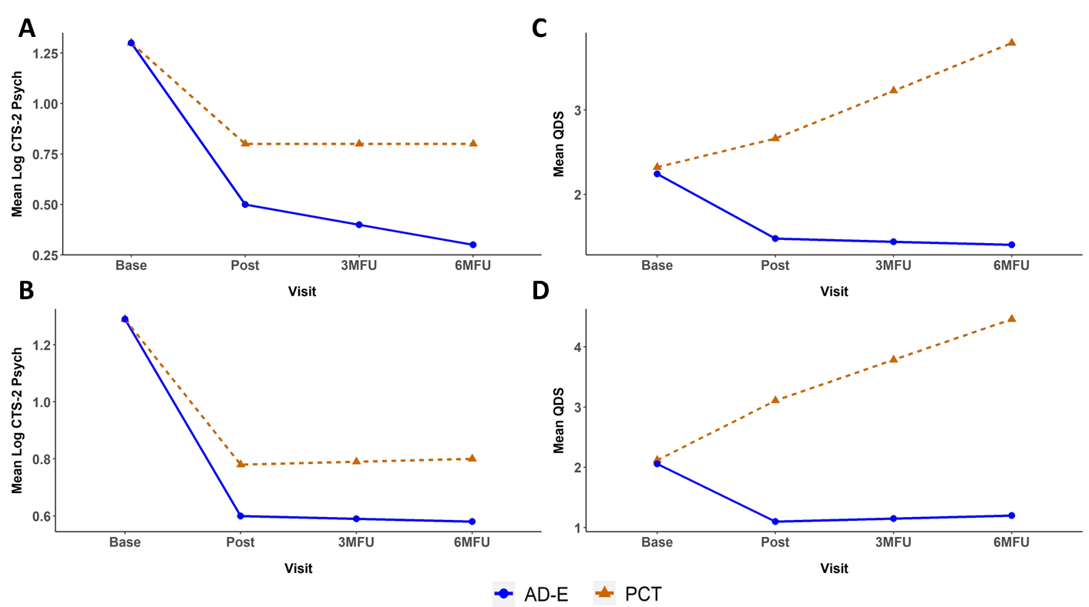
Figures A and B represent the predicted mean values of the log transformed CTS-2 Psychological Aggression Subscale under the Missing-at-Random (MAR) and Missing-Not-at-Random (MNAR) specifications, respectively. Figures C and D represent the predicted mean values of the QDS under the MAR and MNAR specifications, respectively.

REFERENCES
Cameron, I. M., Crawford, J. R., Lawton, K., & Reid, I. C. (2008). Psychometric comparison of PHQ-9 and HADS for measuring depression severity in primary care. British Journal of General Practice, 58(546), 32–36. https://doi.org/10.3399/bjgp08X263794
Hedeker, D., & Gibbons, R. (2006). Longitudinal Data Analysis. John Wiley & Sons.
Kroenke, K., Spitzer, R. L., & Williams, J. B. (2001). The PHQ-9: Validity of a brief depression severity measure. Journal of General Internal Medicine, 16(9), 606–613. https://doi.org/10.1046/j.1525-1497.2001.016009606
MacGregor KL, Funderburk JS, Pigeon W, Maisto SA. Evaluation of the PHQ-9 Item 3 as a screen for sleep disturbance in primary care. J Gen Intern Med. 2012 Mar;27(3):339-44. doi: 10.1007/s11606-011-1884-5.
Marx, B. P., Lee, D. J., Norman, S. B., Bovin, M. J., Sloan, D. M., Weathers, F. W., Keane, T. M., & Schnurr, P. P. (2022). Reliable and clinically significant change in the clinician-administered PTSD Scale for DSM-5 and PTSD Checklist for DSM-5 among male Veterans. Psychological Assessment, 34(2), 197-203. https://doi.org/10.1037/pas0001098

