**ONLINE SUPPLEMENTARY MATERIALS**

**Targeting Maladaptive Anger With Brief Therapist-Supported Internet-Delivered Emotion Regulation Treatments: A Randomized Controlled Trial**

Bjureberg, J., Ojala, O., Berg, A., Edvardsson, E., Kolbeinsson, Ö., Molander, O., Morin, E., Nordgren, L., Palme, K., Särnholm, J., Wedin, L., Rück, C., Gross, J. J., Hesser, H.

Running Head: Internet-Delivered Emotion Regulation Treatment For Anger

**Methods**

**Treatments**

The treatments were based on CBT treatment protocols for anger-related problems (Deffenbacher & McKay, 2000; Eifert et al., 2006; Hesser et al., 2017) and emotional disorders and maladaptive behaviors (Barlow et al., 2018; Bjureberg et al., 2018; Bjureberg et al., 2017; Linehan, 1993; McKay et al., 2007). Specifically, the applied relaxation training was based on Öst (1987). The crisis management strategy “time-out” was modelled after Deffenbacher and McKay (2000). Participants were also briefly introduced to problem-solving and communication skills in Module 4.

**Data Analytic Plan and Statistical Analyses**

***Preliminary Analyses***

Multivariate outliers were detected by Cook’s distance (Cook, 1977) using the conventional cut-off point 4/*n* for each outcome. Models were rerun without outliers to check whether these observations changed the estimates, standard errors, and *p*-values. Although estimates and standard errors changed slightly, the overall pattern of findings was similar across models with and without identified multivariate outliers and the interpretation of the findings was not altered. Given these results, we present the models with the full intention-to-treat sample.

Missing data was handled under the missing at random (MAR) assumption. All outcome analyses adopted full information maximum likelihood (FIML) estimation to handle missing data (Enders, 2010). FIML has been shown to provide unbiased estimates and standard errors under MAR (Enders, 2010; Schafer & Graham, 2002). Given the relatively small amount of missing data and because no examined clinical or demographical variable at baseline was significantly associated with the propensity for missing data at treatment termination or 3-month follow-up, we relied on FIML under the MAR assumption.

To provide preliminary estimates of overall treatment effect (compared to no intervention), we tested if the treatment phase (participation in MEA, CR, and MEA+CR) resulted in greater improvements in anger expression and anger suppression immediately after treatment termination compared to a prolonged baseline phase. We followed recommendations by Duncan and Duncan (2004) for estimating treatment effects within a pooled interrupted times series design (ITS) using latent growth curve modeling. This allowed us to test changes in average level and rate of change over the intervention phase compared to the baseline phase (i.e., the equal-duration baseline phase and treatment phase) across all treatment conditions. We fitted separate piecewise (incremental) latent growth models (LGM) for each outcome, capturing changes during distinct phases of ITS, and tested whether an incremental level and slope during the treatment phase were significantly different from zero, holding constant the baseline level and slope across both phases (Duncan & Duncan, 2004). Time was centered at week 4 and 8 in the models, and we calculated effect size at the endpoint (with 95% confidence intervals [CI]) by summing model estimated incremental level and slope divided by the sum of the square root of the variances of the baseline level and residuals (Pustejovsky et al., 2014).

**Results**

**Preliminary Analyses**

The adverse events described at post-treatment were stress, sadness, and/or irritability because of the study (n = 18) and relational problems (n = 3). Participants rated the discomfort of the adverse event, both for when the they occurred and for residual discomfort, on a scale of 0 (*did not affect me at all*) to 3 (*affected me very negatively*). The majority (n = 12) of the adverse events were given a low severity rating (a score of 1) for when the effect occurred. Nine of these 12 events were rated as having no (score of 0) residual discomfort and three of these events were rated as having low severity residual discomfort. Five events were given a moderate severity rating (a score of 2) for when the effect occurred. Two and three of these five events were rated as having no or low severity residual discomfort, respectively. Three events were rated as having the highest severity (a score of 3) for when the effect occurred. Two of these three events concerned increased irritability because of feeling obliged to engage with the treatment material (n = 1) and irritability due to reminders to complete assessments (n = 1). One of these three events concerned increased sadness after analyzing anger triggering situations (n = 1). Two and one of these three events were reported to have low or moderate severity residual discomfort, respectively.

As can be seen in Supplementary Figure 2, there was a clear discontinuity (decrease) as a function of phase in both anger expression and suppression across conditions.Means for added growth levels and slopes were statistically significant for both outcomes, indicating an added effect on level and slope due to the implementation of treatments (whilst holding constant the baseline level and slope across both phases).

**Supplementary Table 1**

*Table of treatment content of mindful emotion awareness treatment (MEA), cognitive reappraisal treatment (CR) and mindful emotion awareness and cognitive reappraisal treatment (MEA+CR).*

|  |  |  |  |  |
| --- | --- | --- | --- | --- |
| **Module** | **Type of content** | **MEA** | **CR** | **MEA+CR** |
| ***Module 1*** | ***Treatment themes*** |  | | |
|  | Non-treatment specific themes: | * Information about the treatment and the technical platform. * Functions of anger and other emotions * A biopsychosocial model of anger including vulnerability to emotions, trigger, emotion (cognitions, physiology, and action tendencies), behavior, and short- and long-term consequences * Addressing anger by decreasing vulnerability to anger (e.g., sleep hygiene, physical activity, diet) * Applied relaxation: deep breathing, relaxation without tension, quick relaxation * Time-out | | |
|  | Treatment-specific themes: | * Introduction to non-avoidant mindful emotion awareness | * Introduction to appraisals | * Introduction to non-avoidant mindful emotion awareness and appraisals |
|  | ***Exercises*** |  | | |
|  | Non-treatment specific exercises: | * Identify and rank (on intensity and impairment) personal anger triggers * Treatment goals | | |
|  | Treatment-specific exercises: | * Evoke emotions through music | * Identify automatic appraisals | * Evoke emotions and identify automatic appraisals |
|  | ***Homework*** |  | | |
|  | Non-treatment specific homework: | * Applied relaxation | | |
|  | Treatment specific homework: | * Evoke emotions using music | * Identify automatic appraisals in anger situations | * Evoke emotions using music * Identify automatic appraisals in anger situations |
| ***Module 2*** | ***Treatment themes*** |  |  |  |
|  | Treatment-specific themes: | * Label emotions * Anger as primary and secondary emotion * Acceptance * Emotion surfing | * Alternative appraisals * Coping thoughts in anger situations | * Label emotions * Anger as primary and secondary emotion * Radical acceptance * Mindful awareness * Stop ruminating |
|  | ***Exercises*** |  |  |  |
|  | Non-treatment specific exercise: | * Revise anger trigger list | | |
|  | Treatment-specific exercises: | * Label   emotion   * Label emotions in fictive   examples   * Preparation of mindful emotion awareness in anger situations | * Identify automatic   appraisals and generate  alternative appraisals   * Choose 3 coping   thoughts   * Make a coping plan | * Label emotion * Label emotions in fictive   examples   * Preparation of mindful emotion awareness in anger situations |
|  | ***Homework*** |  |  |  |
|  | Non-treatment specific homework: | * Applied relaxation * Practice the following skills in a) an imagined anger trigger situations (about one hour in total) and (b) in everyday life (on a daily basis): | | |
|  | Treatment-specific homework: | * Experience emotions * Label emotions * Emotion surfing | * Questions for cognitive reappraisal * Coping thoughts | * Label emotions * Emotion surfing * Anchoring in the present * Radical acceptance |
| ***Module 3*** | ***Themes*** |  |  |  |
|  | Treatment-specific themes: | * Mindful emotion awareness * Stop ruminating * Radical acceptance | * Thinking   traps and reappraisal   * Core negative appraisals | * Reappraisal * Coping thoughts * Thinking traps |
|  | ***Exercises*** |  |  |  |
|  | Non-treatment specific exercise: | * Revise anger trigger list. | | |
|  | Treatment-specific exercises | * Prepare for anger situations | * Identify automatic * appraisals and thinking traps * Generate   alternative  appraisals   * Make a coping plan | * Identify thinking traps * Generate alternative   appraisals   * Make a coping plan |
|  | ***Homework*** |  |  |  |
|  | Non-treatment specific homework | * Applied relaxation * Practice the following skills in a) an imagined anger trigger situations (about one hour in total) and (b) in everyday life (on a daily basis): | | |
|  | Treatment-specific homework | * Anchoring in the present * Radical acceptance | * Thinking traps * Downward arrow technique | * Questions for cognitive reappraisal * Coping thoughts * Identifying thinking traps |
| **Module 4** | ***Themes*** |  |  |  |
|  | Treatment-specific theme: | * Summary of treatment content | | |
|  | Non-treatment specific themes: | * Communication and problem solving * Handle setbacks and relapse prevention * Identify and prepare for challenging situations * Construct a practice plan | | |
|  | ***Homework*** | * Complete the practice plan | | |
| Total | Number of words in text (excl.  homework sheets and extra material) | 25,645 | 24,110 | 28,861 |

**Supplementary Table 2**

*Treatment credibility, expectancy, satisfaction, number of modules, homework completion, messages sent by participant and therapist, and therapist time spent on treatment. Treatments: mindful emotion awareness treatment (MEA), cognitive reappraisal treatment (CR) and mindful emotion awareness and cognitive reappraisal treatment (MEA+CR).*

|  |  |  |  |  |  |  |  |  |  |  |  |  |  |  |
| --- | --- | --- | --- | --- | --- | --- | --- | --- | --- | --- | --- | --- | --- | --- |
|  | MEA | | | CR | | | MEA+CR | | | Total | | | | |
|  | *n* | *M* | *SD* | *n* | *M* | *SD* | *n* | *M* | *SD* | *n* | *M* | *SD* | *f* | *p* |
| CEQ |  |  |  |  |  |  |  |  |  |  |  |  |  |  |
| Credibility | 70 | 20.5 | 4.9 | 70 | 21.8 | 4.1 | 74 | 21.3 | 3.7 | 214 | 21.2 | 4.2 | 1.40 | .250 |
| Expectancy | 70 | 56.1 | 21.3 | 70 | 57.6 | 21.4 | 74 | 53.4 | 20.8 | 214 | 55.7 | 21.1 | 0.73 | .482 |
| CSQ | 68 | 25.4 | 4.9 | 70 | 26.5 | 4.2 | 74 | 26.0 | 4.3 | 212 | 26.0 | 4.5 | 1.16 | .315 |
| Accessed modules | 78 | 3.3 | 1.1 | 77 | 3.2 | 1.1 | 79 | 3.4 | 1.0 | 234 | 3.3 | 1.1 | 0.48 | .617 |
| Completed between-module assigments | 78 | 2.6 | 1.5 | 77 | 2.7 | 1.5 | 79 | 2.8 | 1.4 | 234 | 2.7 | 1.5 | 0.18 | .831 |
| Messages sent by participant | 78 | 9.6 | 3.1 | 77 | 9.4 | 3.1 | 79 | 9.7 | 3.7 | 234 | 9.5 | 3.3 | 0.22 | .801 |
| Messages sent by therapist | 78 | 3.5 | 3.3 | 77 | 3.2 | 2.5 | 79 | 3.8 | 3.8 | 234 | 3.5 | 3.2 | 0.62 | .540 |
| Therapist time spent in minutes | 78 | 43.1 | 40.9 | 77 | 41.8 | 38.3 | 79 | 46.8 | 43.6 | 234 | 43.9 | 40.9 | 0.32 | .729 |

CEQ = Credibility/Expectancy Questionnaire; CSQ = Client Satisfaction Questionnaire.

**Supplementary Table 3**

*Parameter estimates and effect sizes with 95% confidence intervals (CI) derived from the interrupted times series design piecewise latent variable growth modeling.*

|  |  |  |  |  |  |  |  |  |  |  |  |  |  |  |  |  |
| --- | --- | --- | --- | --- | --- | --- | --- | --- | --- | --- | --- | --- | --- | --- | --- | --- |
|  | Estimated means and SE | | | | | | | | | | Estimated variances and SE | | | | Effect size | |
|  | Baseline level | | Baseline slope | | Added level | | | Added slope | | | Baseline level | | Residual | |  |  |
| **Outcomes** | Mean | SE | Mean | SE | Mean | SE | *p* | Mean | SE | *p* | Variance | SE | Variance | SE | *d* | 95% CI |
| STAXI-2 AXO | 18.03 | 0.25 | 0.42 | 0.06 | 2.84 | 0.36 | <.001 | 0.27 | 0.08 | .003 | 12.29 | 0.88 | 3.76 | 0.15 | 0.91 | 0.66, 1.16 |
| STAXI-2 AXI | 19.58 | 0.27 | 0.28 | 0.07 | 2.42 | 0.39 | <.001 | 0.25 | 0.10 | .009 | 13.96 | 1.16 | 4.44 | 0.23 | 0.74 | 0.49, 1.00 |

*Note:* AXO =Anger Expression-Out; AXI = Anger Expression-In; STAXI-2 = State-Trait Anger Expression Inventory 2

**Supplementary Table 4**

*Observed means and standard deviations (SD) of outcomes at pre-treatment (pooled baseline) and primary endpoint (3-month follow-up) for the mindful emotion awareness treatment (MEA), cognitive reappraisal treatment (CR) and mindful emotion awareness and cognitive reappraisal treatment (MEA+CR).*

|  |  |  |  |  |  |  |
| --- | --- | --- | --- | --- | --- | --- |
|  | **Pre-treatment** | | | **Primary endpoint** | | |
| **Measure**  Treatment | *n* | *M* | *SD* | *n* | *M* | *SD* |
| **STAXI-2 AXO** |  |  |  |  |  |  |
| MEA | 78 | 18.8 | 3.6 | 65 | 14.5 | 3.6 |
| CR | 77 | 18.6 | 3.6 | 66 | 14.0 | 3.5 |
| MEA+CR | 79 | 18.5 | 3.7 | 75 | 13.3 | 3.2 |
| **STAXI-2 AXI** |  |  |  |  |  |  |
| MEA | 78 | 19.5 | 4.1 | 65 | 16.2 | 3.5 |
| CR | 77 | 20.2 | 4.2 | 66 | 16.2 | 3.4 |
| MEA+CR | 79 | 20.2 | 3.8 | 75 | 15.9 | 3.7 |
| **AQ** |  |  |  |  |  |  |
| MEA | 78 | 37.4 | 11.0 | 65 | 29.3 | 12.4 |
| CR | 77 | 37.5 | 12.1 | 64 | 27.9 | 10.7 |
| MEA+CR | 79 | 39.9 | 11.6 | 73 | 25.4 | 12.8 |
| **STAXI-2 TAS** |  |  |  |  |  |  |
| MEA | 78 | 23.6 | 4.6 | 65 | 18.3 | 5.0 |
| CR | 77 | 23.4 | 4.9 | 66 | 17.6 | 4.4 |
| MEA+CR | 79 | 23.5 | 4.8 | 75 | 17.2 | 4.6 |
| **ARS** |  |  |  |  |  |  |
| MEA | 78 | 44.4 | 12.1 | 65 | 37.4 | 13.1 |
| CR | 77 | 46.7 | 10.8 | 64 | 37.8 | 10.6 |
| MEA+CR | 79 | 47.5 | 11.5 | 73 | 34.1 | 11.2 |

*Note:* AQ = Aggression Questionnaire; ARS = Anger Rumination Scale; AXO =Anger Expression-Out; AXI = Anger Expression-In; CI = Confidence interval; STAXI-2 = State-Trait Anger Expression Inventory 2; TAS = Trait Anger Subscale..

**Supplementary Figure 1**

*Observed means and 95% confidence intervals for anger expression (Anger Expression-Out; AXO) and anger suppression (Anger Expression-In; AXI) during a 4 weeks baseline period and a 4 weeks treatment period across treatments.*

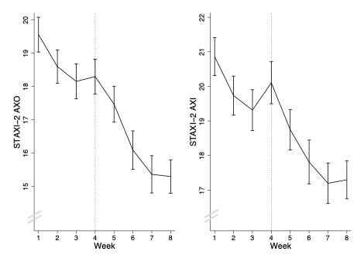

*Note.* STAXI = State-Trait Anger Expression Inventory.

**Supplementary Figure 2**

*Regions of significance for standardized frequency of anger expression (State-Trait Anger Expression Inventory Anger Expression-Out [STAXI-2 AXO]), aggression (Aggression Questionnaire [AQ]), trait anger (STAXI-2 TAS), and anger rumination (Anger Rumination Scale [ARS]) at primary endpoint (3-month follow-up [FU3]). Contrast 1 compare the mindful emotion awareness+cognitive reappraisal treatment (reference group) with the cognitive reappraisal and mindful emotion awareness treatment conditioned on baseline levels of the respective outcomes. Contrast 2 compares the cognitive reappraisal treatment with the emotion awareness treatment conditioned on baseline levels of the respective outcomes.*

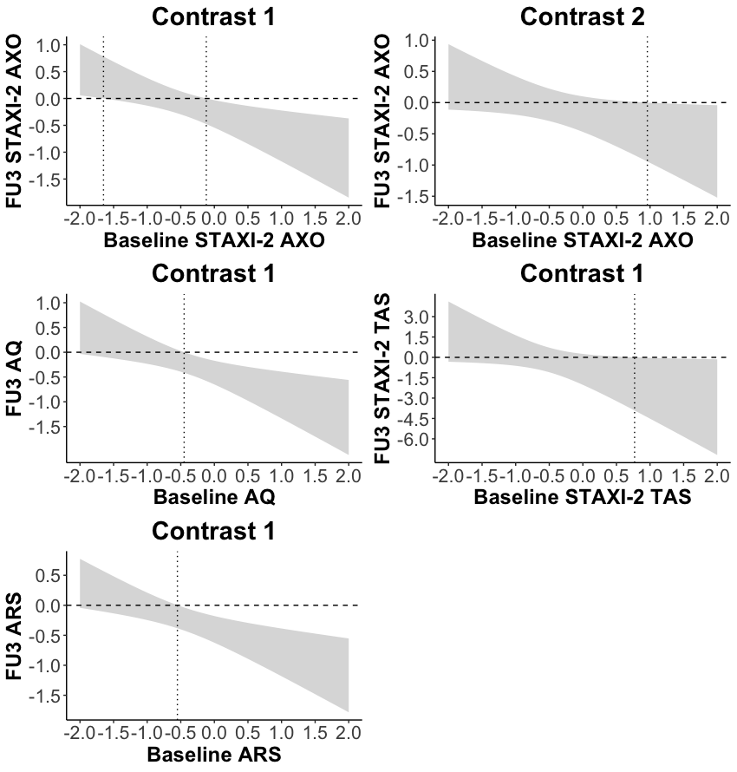

**References**

Barlow, D. H., Farchione, T. J., Sauer-Zavala, S., Latin, H. M., Ellard, K. K., Bullis, J. R., Bentley, K. H., Boettcher, H. T., & Cassiello-Robbins, C. (2018). *Unified Protocol for transdiagnostic treatment of emotional disorders* (2nd ed.). Oxford University Press. https://doi.org/10.1093/med-psych/9780190686017.001.0001

Bjureberg, J., Sahlin, H., Hedman-Lagerlöf, E., Gratz, K. L., Tull, M. T., Jokinen, J., Hellner, C., & Ljótsson, B. (2018). Extending research on Emotion Regulation Individual Therapy for Adolescents (ERITA) with nonsuicidal self-injury disorder: open pilot trial and mediation analysis of a novel online version. *BMC Psychiatry*, *18*(1), 326. https://doi.org/10.1186/s12888-018-1885-6

Bjureberg J, Sahlin H, Hellner C, Hedman-Lagerlöf E, Gratz KL, Bjärehed J, Jokinen J, Tull MT, Ljótsson B. Emotion regulation individual therapy for adolescents with nonsuicidal self-injury disorder: a feasibility study*. BMC Psychiatry. 2017;17*(1):411; https://doi.org/10.1186/s12888-017-1527-4

Cook, R. D. (1977). Detection of Influential Observation in Linear Regression. *Technometrics*, *19*(1), 15–18. https://doi.org/10.1080/00401706.1977.10489493

Deffenbacher, J. L., & McKay, M. (2000). *Overcoming situational and general anger: A protocol for the treatment of anger based on relaxation, cognitive restructuring, and coping skills training.* New Harbinger Publications.

Duncan, T. E., & Duncan, S. C. (2004). A Latent Growth Curve Modeling Approach to Pooled Interrupted Time Series Analyses. *Journal of Psychopathology and Behavioral Assessment*, *26*(4), 271–278. https://doi.org/10.1023/b:joba.0000045342.32739.2f

Eifert, G. H., Forsyth, J. P., & McKay, M. (2006). *ACT on life not on anger: The new Acceptance and Commitment Therapy guide to problem anger*. New Harbinger Publications.

Enders, C. K. (2010). *Applied missing data analysis*. Guilford press.

Hesser, H., Axelsson, S., Bäcke, V., Engstrand, J., Gustafsson, T., Holmgren, E., Jeppsson, U., Pollack, M., Nordén, K., Rosenqvist, D., & Andersson, G. (2017). Preventing intimate partner violence via the Internet: A randomized controlled trial of emotion-regulation and conflict-management training for individuals with aggression problems. *Clinical Psychology & Psychotherapy*, *24*(5), 1163–1177. https://doi.org/10.1002/cpp.2082

Linehan, M. (1993). *Cognitive-behavioral treatment of borderline personality disorder*. Guilford press.

McKay, M., Wood, J. C., & Brantley, J. (2007). *The Dialectical Behavior Therapy skills workbook: Practical DBT exercises for learning mindfulness, interpersonal effectiveness, emotion regulation, and distress tolerance*. New Harbinger Publications.

Öst, L.-G. (1987). Applied relaxation: Description of a coping technique and review of controlled studies. *Behaviour Research and Therapy*, *25*(5), 397–409. https://doi.org/10.1016/0005-7967(87)90017-9

Pustejovsky, J. E., Hedges, L. V., & Shadish, W. R. (2014). Design-comparable effect sizes in multiple baseline designs. *Journal of Educational and Behavioral Statistics*, *39*(5), 368–393. https://doi.org/10.3102/1076998614547577

Schafer, J. L., & Graham, J. W. (2002). Missing data: our view of the state of the art. *Psychological Methods*, *7*(2), 147. https://doi.org/10.1037/1082-989X.7.2.147