Supplementary Material
This text of this supplement contains eight sections:
- Stimulant Medication
- Behavior Management in Summer Classroom Setting
- Missing Data
- Specification of Multilevel Models
- Carryover Effects of OROS-MPH in the Crossover Design
- Calculation of Effect Sizes
- Many Research Designs Confound the Acute Effect of Medication on Test Scores from the Effect of Medication on Learning
- Sensitivity Analyses Probing Potential Explanations for Absence of Medication Effect on Learning

1. Stimulant Medication
Dose titration trial and selection of dose. The dose titration trial occurred in the first two weeks (i.e., 10 days) of camp, prior to the start of the current protocol. Each child received a randomized schedule of placebo (1 day), 18 mg (3 days), 27 mg (3 days), and 36 mg doses (3 days). Graphs of rule violations, negative verbalizations, seatwork productivity, and other criteria under each of these regimens were reviewed collectively by three Ph.D./M.D.-level clinicians, and the team identified for each child the maximum dose that conveyed clear improvement beyond the immediately lower dose. For example, if 27 mg produced clear improvement beyond 18 mg, but 36 mg did not produce clear improvements beyond 27 mg, then 27 mg was selected as that child’s dose. Side effects were also factored into dose selection.
11 children (of 173) used a different (i.e., non-Concerta) methylphenidate product because they were using it prior to the start of the study: 7 children used Focalin XR and 5 children used Metadate CD. For calculating mean dose or grouping children by dose, Focalin XR 5 mg was converted to 18 mg Concerta, Focalin XR 10 mg was converted to 36 mg Concerta, and Metadata CD 10 mg was converted to 18 mg Concerta.
Summer Classroom Setting

The analogue classroom was held in a classroom in the local elementary school in which the Summer Treatment Program is held each summer. Classrooms were staffed with a teacher and teacher’s aide. Class size ranged from 10 to 14 children (mean = 12.4), grouped by age. Classroom sessions were held twice per day, once in the morning and once in the afternoon. In the morning, children worked on independent seatwork. In the afternoon, teachers and aides taught the target academic curricula in the small group format. Each of these activities is described in more detail below.
2. Behavior Management in Summer Classroom Setting
Behavioral procedures in the classroom are described here (Pelham et al., 2017). Teachers and aides managed children’s behavior using simple response-cost and reward-based strategies typical of elementary-school classrooms. Classroom rules were as follows: (1) be respectful of others, (2) obey adults, (3) work quietly, (4) use materials appropriately, (5) remain in assigned seat or area, (6) raise hand to speak or ask for help, and (7) stay on task. While children were receiving age-appropriate academic instruction (afternoon classroom) or completing seatwork (morning classroom), teachers and aides also monitored the children’s behavior. Children lost points for each rule violation in a response-cost system. This response-cost system was in place during both the morning and afternoon classroom sessions.
One potential argument is that the intensity of behavior management in the analogue classroom in which social studies, science and vocabulary was taught, may have been more intensive than that of most general education classrooms and thus may have limited the potential for medication effects on learning. However, most teachers in elementary school settings report using multiple forms of behavior management for children with ADHD in general education classrooms and also typically use class-wide behavior management programs (Hart et al., 2017). For example, more than 90% of elementary-school teachers post the classroom rules and have procedures for class-wide tracking rule-following and violations; about 45-50% use a point or token system; and about 40% use a response-cost system (Hart et al., 2017). Also see https://www.classdojo.com/about/ and https://www.pbis.org/school/swpbis-for-beginners/pbis-faqs for information about class-wide behavior management programs used widely in elementary schools in the United States.
3. Missing Data
Dependent variables. No data were missing for test scores. On the pre-test and post-test days, 12% of values were missing for number of arithmetic problems correctly completed and 7% of values were missing for number of classroom rule violations. Missing values in arithmetic problems and classroom rule violations could arise if a child were absent during the classroom period (e.g., left early from camp). In this case, test scores were nonetheless present because the child was taken from a different activity during the daily schedule to complete the pre-test or post-test. The multilevel models included all children (N = 173) since the maximum likelihood estimator can accommodate missing values at one or more occasion.

4. Specification of Multilevel Models
Analyses were conducted in the R statistical software environment (R Core Team, 2022). Multilevel models were fit in the lme4 package (Bates, Machler, Bolker, & Walker, 2015). Statistical inference was conducted using the lmerTest package (Kuznetsova, Brockhoff, & Christensen, 2017). Data were structured in the long format, with multiple records per participant. For example, for test scores, each child contributed 4 rows to the dataset, reflecting scores at pre-test and post-test for Phase 1 and at pre-test and post-test for Phase 2. A separate lme4 model was fit to each of the four outcomes: test scores for subject-area content, test scores for vocabulary, number of arithmetic problems correctly completed per minute, number of classroom rule violations per hour. The models for test scores was specified with the following syntax:
lmer(y ~ (1 | idnum) +
order_medstatus + order_curriculum +
phase + curriculum + test + medstatus +
test*medstatus)
Each variable was encoded as follows:
- y: dependent measure (e.g., the number of correct responses on the vocabulary test)
- idnum: the child identifier
- order_medstatus: equaled 1 when child was randomized to take OROS-MPH in instructional Phase 1; equaled 0 when child was randomized to take placebo in instructional Phase 1
- order_curriculum: equaled 1 when child was randomized to complete Curriculum B in Phase 1; equaled 0 when randomized to complete Curriculum A in Phase 1
- phase: equaled 1 when occasion was in Phase 1; equaled 0 when occasion was in Phase 2
- curriculum: equaled 1 when occasion was testing content from Curriculum B; equaled 0 when occasion was testing Curriculum A
- test: equaled 1 when occasion was a post-test; equaled 0 when occasion was a pre-test
- medstatus: equaled 1 when occasion was within the child’s medicated Phase; equaled 0 when occasion was within the child’s unmedicated Phase
- test*medstatus: equaled test multiplied by medstatus, so was equal to 1 when occasion was a post-test within child’s medicated Phase and otherwise equaled 0
We explored additional fixed effects for cohort, classroom, and instructional small group. These effects were generally not statistically significant, and where they were, they had little impact on the estimates and standard errors of parameters of interest (i.e., main effect of medication, mean effect of time, and interaction of medication and time). Thus, we did not retain these fixed effects in the final specification.
The models for number of arithmetic problems correctly completed per minute and number of classroom rule violations per hour were just like those for the test scores, with two differences. First, these models included data from all the days of the instructional period (not just pre-test and post-test). Second, the test factor shown in the syntax above was replaced with a day factor indicating the day number within the instructional period (t = 1, 2, … 13).

5. Carryover Effects of OROS-MPH in the Crossover Design

Statistical tests for carryover effects in the crossover data. As shown in Table 3, randomization to order of OROS-MPH vs. placebo did not significantly predict test scores for subject-area content (p=.64) or for vocabulary (p=.98). When a phase (Phase 1 / Phase 2) by test (pre-test / post-test) by medication status (OROS-MPH / placebo) interaction was added to the \ model shown in Table 3, the interaction term was not statistically significant for either the subject-area content scores (F(1, 512) = 1.28, p = 0.26) or the vocabulary scores (F(1, 512) = 0.03, p = 0.86).

Analysis of only data from Phase 1. Analyzing only data from Phase 1, before the crossover, rules out the possibility of carryover effects. When we regress the change in test scores from pre-test to post-test in Phase 1 on an indicator of whether the participant was completing Curriculum A vs. B and an indicator of the participant’s current medication status (OROS-MPH), there is no significant effect of medication status for either subject-area content scores (d = 0.11, 95% CI = [0-0.13, 0.35], p = .38) or for vocabulary test scores (d = 0.08, 95% CI = [-0.28, 0.43], p = .68]

6. Calculation of Effect Sizes
Effect sizes for statistically significant factors were characterized using the estimated marginal means per the multilevel model. Marginal means were obtained via the emmeans package (Lenth, 2018). For a given factor (e.g., placebo vs. OROS-MPH), the marginal mean test score (e.g., for vocabulary) was calculated at each level of the factor. The difference between these marginal means can be interpreted on the raw metric, number of questions answered correctly, as a raw effect size. The difference in marginal means can also be converted into a standardized effect size (d) by dividing this value by the standard deviation of the scores. This standard deviation was calculated using the pre-test scores achieved when children were taking placebo (SD = 2.29 for subject-area content knowledge scores; SD = 3.16 for vocabulary scores; both values calculated based on 173 observations).
Worked example. There was a statistically significant main effect of medication status on vocabulary test scores (Table 3). The estimated marginal mean for vocabulary test scores under placebo was 11.276 questions correct under placebo and 11.880 questions correct under OROS-MPH. The difference in questions correct is calculated to be 0.604 (difference = 11.880 – 11.276). The standard deviation of the pre-test vocabulary test scores obtained by subjects under placebo equaled 3.157. Thus, the standardized effect of medication status on vocabulary test scores was calculated to be d = 0.19, as reported in the text of the manuscript (d = difference / SD = 0.604 / 3.157).
7. Many Research Designs Confound the Acute Effect of Medication on Test Scores from the Effect of Medication on Learning
As described in the Discussion, most research designs in the literature confound the acute effect of being medicated on the day of achievement testing (i.e., the effect on test scores) with the effect of being medicated on each day throughout the instructional period (i.e., the effect on learning). This study could separate acute effects on test scores from effects on learning due to (a) measuring academic achievement at both pre-test and post-test and (b) holding medication status fixed across both measurements. Thus, as a supplementary analysis, we considered the pattern of results we would have obtained counterfactually, had we not included both these design features, by excluding data that was included in the primary analyses (e.g., pretending we did not have access to pre-test measurements).
Figure 3 shows that in primary analyses, we found no effect of medication on learning. Figure S1 shows how these same findings would appear in research designs more common in the literature. First, had we omitted a pre-test measurement (Panels A1-A2), medication would have (incorrectly) appeared to improve learning. Second, had we failed to hold medication status fixed across pre-test and post-test (Panels B1-B2), medication would have (incorrectly) appeared to improve learning.
8. Sensitivity Analyses Probing Potential Explanations for Absence of Medication Effect on Learning
The Limitations sections notes three potential explanations for the absence of medication effects on learning. In that section, we discuss reasons to be skeptical of each explanation. Below, we report a sensitivity analysis that probed each possibility.
Medication dosage. One hypothesis is that medication failed to affect learning because the dose of OROS-MPH was insufficient. If so, we might expect a relation between the dosage of OROS-MPH and the magnitude of the medication effect on learning. We created a binary indicator of medication dosage: whether each child was on 18 mg (80% of sample) or 27/36 mg (20% of sample). We then refit the multilevel models for test scores while including this binary indicator in a three-way interaction with time (i.e., pre/post) and medication status (i.e., placebo/OROS-MPH). Results were similar for vocabulary and subject-area content scores. Terms for (a) the main effect of the dosage indicator, (b) the two-way interaction of the dosage indicator with medication status, and (c) the three-way interaction of the dosage indicator with medication status and time were all small in magnitude and not statistically significant (ns). Thus, the data did not support the hypothesis that medication dosage was related to the magnitude of the medication effect on either test scores or learning. Note that this is not a direct test of dosage effects because dosages were not randomly assigned, but rather were selected based on a titration trial.
Size of small group. Another hypothesis is that medication failed to affect learning because instruction was provided in small groups, rather than at the classroom level. If so, we might expect a relation between the size of the small group (range = 1 to 16 children) and the magnitude of the medication effect on learning. We evaluated the effect of the size of the small group using the same procedure described above: refit the multilevel models while including the size of the small group in a three-way interaction with time and medication status. Again, the terms of interest were small in magnitude and not statistically significant. Thus, the data did not support the hypothesis that the size of small group was related to the magnitude of the medication effect on either test scores or learning.
Behavior management. Another hypothesis is that medication failed to affect learning because of the presence of behavior management, which (presumably) reduced the rate of rule violations and thus potential disruptions of learning. If so, we might expect a relation between the rate of rule violations in the classroom and the magnitude of the medication effect on learning. We measured the mean rate of rule violations in each classroom during the two weeks before the start of the learning study protocol depicted in Figure 1 (i.e., during the dose titration period). We then evaluated the effect of this covariate using the same procedure described above: refit the multilevel models while including the classroom-wide rate of rule violations in a three-way interaction with time and medication status. Again, the terms of interest were small in magnitude and not statistically significant. Thus, the data did not support the hypothesis that the classroom-wide rate of rule violations (which would be reduced by the presence of behavior management) was related to the magnitude of the medication effect on either test scores or learning.

References
Bates, D., Machler, M., Bolker, B. M., & Walker, S. C. (2015). Fitting linear mixed-effects models using lme4. Journal of Statistical Software, 67, 1–48.
Clarke, P. J., Snowling, M. J., Truelove, E., & Hulme, C. (2010). Ameliorating children’s reading-comprehension difficulties: A randomized controlled trial. Psychological Science, 21, 1106–1116.
Connor, C. M., Dombek, J., Crowe, E. C., Spencer, M., Tighe, E. L., Coffinger, S., … Petscher, Y. (2017). Acquiring science and social studies knowledge in kindergarten through fourth grade: Conceptualization, design, implementation, and efficacy testing of content-area literacy instruction (CALI). Journal of Educational Psychology, 109, 301–320.
Hart, K. C., Fabiano, G. A., Evans, S. W., Manos, M. J., Hannah, J. N., & Vujnovic, R. K. (2017). Elementary and middle school teachers’ self-reported use of positive behavioral supports for children with ADHD: A national survey. Journal of Emotional and Behavioral Disorders, 25, 246–256.
Kuznetsova, A., Brockhoff, P. B., & Christensen, R. H. B. (2017). lmerTest package: Tests in linear mixed effects models. Journal of Statistical Software, 82. https://doi.org/10.18637/jss.v082.i13
Lenth, R. (2018). emmeans: Estimated Marginal Means, aka Least-Squares Means (Version 1.3.0) [R]. Retrieved from https://CRAN.R-project.org/package=emmeans
Marulis, L. M., & Neuman, S. B. (2010). The effects of vocabulary intervention on young children’s word learning: A meta-analysis. Review of Educational Research, 80, 300–335.
Pelham, W. E., Gnagy, E. M., Greiner, A. R., Fabiano, G. A., Daniel A. Waschbusch, & Coles, E. K. (2017). Summer treatment programs for Attention-Deficit/Hyperactivity Disorder. In J. R. Weisz & A. E. Kazdin (Eds.), Evidence-Based Psychotherapies for Children and Adolescents (3rd ed., pp. 215–234). New York, NY: The Guilford Press.
R Core Team. (2022). R: A language and environment for statistical computing. Vienna, Austria: R Foundating for Statistical Computing.

Table S1
Analysis of Variance and Contrasts from Multilevel Models for Arithmetic Problems Completed and Classroom Rule Violations

Dependent  Measure | Factor | Sum of squares | Mean  square  error | F-statistic | p-value | Contrast | Estimated  Marginal  Means [EMMs] | Difference  in EMMs  [95% CI]
Number of arithmetic problems correctly completed per minute | Randomization to order of OROS-MPH vs. placebo | 7.96 | 7.96 | F(1, 170.1) = 1.33 | .25 | OROS-MPH first - Placebo first | 6.2 - 5.6 | 0.60  [-0.42, 1.63]
 | Randomization to order of curricula | 27.67 | 27.67 | F(1, 170.0) = 4.63 | .03 | Curriculum B first - Curriculum A first | 5.3 - 6.4 | -1.13  [-2.15, -0.10]
 | Phase (1 vs. 2) | 318.12 | 318.12 | F(1, 7656.2) = 53.28 | <.001 | Phase 2 - Phase 1 | 6.1 - 5.7 | 0.41  [0.30, 0.52]
 | Curriculum (A vs. B) | 7.25 | 7.25 | F(1, 7656.0) = 1.21 | .27 | Curriculum B - Curriculum A | 5.8 - 5.9 | -0.06  [-0.17, 0.05]
 | Day (#1-13) | 676.61 | 56.38 | F(12, 7655.2) = 9.44 | <.001 | - | - | -
 | Medication (OROS-MPH vs. placebo) | 6014.42 | 6014.42 | F(1, 7656.2) = 1007.39 | <.001 | OROS-MPH - Placebo | 6.7 - 5.0 | 1.79  [1.68, 1.90]
 | Day-by-medication interaction | 106.86 | 8.90 | F(12, 7654.8) = 1.49 | .12 | - | - | -
Number of classroom rule violations per hour | Randomization to order of OROS-MPH vs. placebo | 3.15 | 3.15 | F(1, 169.8) = 0.29 | .59 | OROS-MPH first - Placebo first | 2.8 - 3.0 | -0.28  [-1.28, 0.72]
 | Randomization to order of curricula | 0.03 | 0.03 | F(1, 169.5) = 0.00 | .96 | Curriculum B first - Curriculum A first | 2.9 - 2.9 | -0.03  [-1.03, 0.98]
 | Phase (1 vs. 2) | 687.77 | 687.77 | F(1, 7018.8) = 64.44 | <.001 | Phase 2 - Phase 1 | 2.6 - 3.2 | -0.64  [-0.79, -0.48]
 | Curriculum (A vs. B) | 58.23 | 58.23 | F(1, 7017.5) = 5.46 | .02 | Curriculum B - Curriculum A | 2.8 - 3.0 | -0.18  [-0.33, -0.03]
 | Day (#1-13) | 620.38 | 51.70 | F(12, 7018.9) = 4.84 | <.001 | - | - | -
 | Medication (OROS-MPH vs. placebo) | 6518.39 | 6518.39 | F(1, 7017.8) = 610.72 | <.001 | OROS-MPH - Placebo | 1.9 - 3.9 | -2.02  [-2.18, -1.86]
 | Day-by-medication interaction | 247.58 | 20.63 | F(12, 7017.7) = 1.93 | .03 | - | - | -
Note. OROS-MPH = osmotic release oral system methylphenidate. “Curriculum A” refers to the combination of the social studies subject-area content and the first list of vocabulary words. “Curriculum B” refers to the combination of the science subject-area content and the second list of vocabulary words. Table reports Type III analysis of variance of the fitted multilevel models, as implemented in the lmerTest package (Kuznetsova et al., 2017). Asymptotic confidence interval for difference in estimated marginal means. See supplement for full description of model specification.
* p < .05, ** p < .01, *** p < .001
Table S2
Raw Means and Standard Deviations for Dependent Measures

Outcome | Randomized Group | Phase 1 |  |  | Phase 2
Outcome | Randomized Group | Pre-test | Post-test | Change from  pre-test to post-test | Pre-test | Post-test | Change from  pre-test to post-test
 |  | Mean (SD) | Mean (SD) | Mean | Mean (SD) | Mean (SD) | Mean
Test scores for subject-area content | Placebo first,  Curriculum A first | 4.2 (2.1) | 6.0 (2.1) | 1.9 | 5.9 (2.6) | 7.0 (2.4) | 1.2
 | OROS-MPH first,  Curriculum A first | 4.3 (1.8) | 6.9 (1.8) | 2.5 | 5.3 (2.5) | 7.5 (2.5) | 2.2
 | Placebo first,  Curriculum B first | 5.5 (2.4) | 6.8 (2.5) | 1.3 | 4.1 (2.3) | 6.5 (2.5) | 2.4
 | OROS-MPH first,  Curriculum B first | 5.2 (2.2) | 6.4 (2.3) | 1.2 | 3.7 (1.7) | 5.9 (2.0) | 2.2
Test scores for vocabulary | Placebo first,  Curriculum A first | 7.8 (3.0) | 14.2 (4.3) | 6.3 | 9.1 (3.4) | 15.2 (4.5) | 6.2
 | OROS-MPH first,  Curriculum A first | 8.7 (3.5) | 15.6 (4.0) | 6.9 | 8.6 (3.4) | 16.1 (3.6) | 7.4
 | Placebo first,  Curriculum B first | 8.5 (3.6) | 14.3 (4.7) | 5.8 | 8.3 (3.5) | 15.1 (4.1) | 6.9
 | OROS-MPH first,  Curriculum B first | 8.6 (3.7) | 14.4 (4.6) | 5.8 | 7.6 (2.6) | 13.4 (4.9) | 5.8
Number of arithmetic problems correctly completed per minute | Placebo first,  Curriculum A first | 3.5 (2.6) | 4.2 (4.0) | 0.1 | 5.6 (4.3) | 6.3 (4.7) | 0.7
 | OROS-MPH first,  Curriculum A first | 6.6 (3.5) | 5.6 (3.5) | -0.5 | 4.8 (4.4) | 6.1 (5.4) | 1.5
 | Placebo first,  Curriculum B first | 5.3 (3.2) | 6.1 (4.5) | 0.6 | 7.2 (3.9) | 8.1 (5.8) | 1.5
 | OROS-MPH first,  Curriculum B first | 7.5 (3.5) | 7.6 (4.6) | 0.1 | 5.3 (3.8) | 5.5 (4.4) | 0.0
Number of classroom rule violations per hour | Placebo first,  Curriculum A first | 4.2 (4.3) | 4.9 (7.2) | 0.7 | 1.7 (3.3) | 1.5 (2.0) | -0.1
 | OROS-MPH first,  Curriculum A first | 1.7 (2.8) | 1.5 (3.3) | -0.1 | 4.9 (7.1) | 3.5 (8.2) | -2.6
 | Placebo first,  Curriculum B first | 3.6 (6.3) | 4.0 (6.7) | 0.8 | 1.5 (3.4) | 1.2 (3.1) | -0.3
 | OROS-MPH first,  Curriculum B first | 2.1 (2.9) | 2.2 (3.2) | 0.2 | 4.2 (5.7) | 3.3 (4.1) | -1.2
Note. SD = standard deviation, OROS-MPH = osmotic release oral system methylphenidate. “Curriculum A” refers to the combination of the social studies subject-area content and the first list of vocabulary words. “Curriculum B” refers to the science subject-area content and the second list of vocabulary words. Based on available data.

Figure S1
Design Features Can Confound the Acute Effect of Being Medication on the Day of Achievement Testing with the Effect of Being Medicated Throughout the Instructional Period

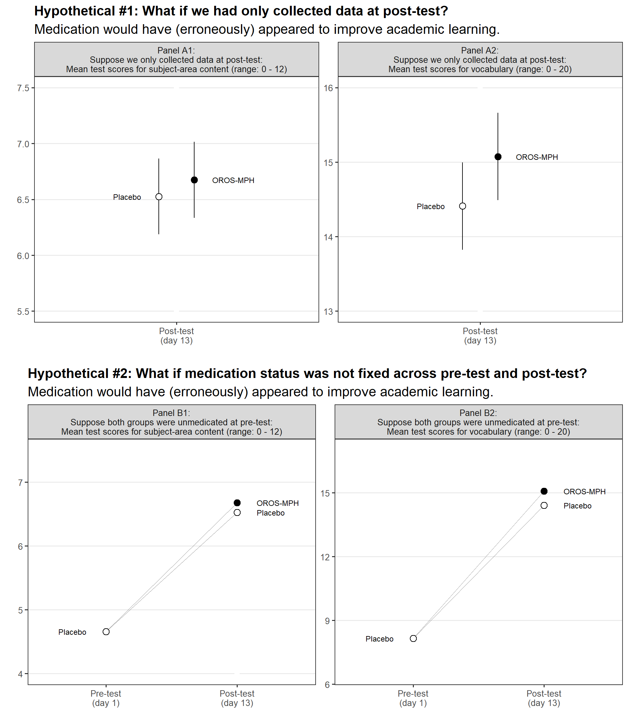

Note. Hypothetical #1 (upper two panels) shows how results would have differed had we only collected data at post-test. These panels are simply the marginal means depicted in Figure 2. When taking OROS-MPH (vs. placebo), children score higher at post-tests of both subject-area content and vocabulary, appearing to indicate an effect of medication on learning. However, in truth this difference reflects the persistence of an acute effect of medication on test scores, as can be seen in Figure 2 when viewing both the pre-test and post-test data simultaneously. Hypothetical #2 (lower two panels) shows how results would have differed had medication status not been fixed across pre-test and post-test. Since the groups would score the same under placebo at pre-test, the acute effect of medication on test scores at post-test would have appeared to indicate an effect of medication on learning. Note that this phenomenon would also apply if both groups were medicated (rather than unmedicated) at pre-test.

