Bayesian estimation
Estimation of Bayesian models is usually done using simulation-based methods, called Markov Chain Monte Carlo (MCMC) estimation. MCMC simulates values of parameters from the posterior distribution, given the model, the prior distributions, and the data. This is done in a series of steps in which each step depends on the results of the previous one. Given a long enough chain, this procedure should converge on the most likely parameter estimates. Usually more than one chain are run, in order to enable testing if the chains converge on similar distributions. In the present study two chains were used in all analyses.
The present study was not done using a fully Bayesian approach, which would have involved incorporating prior information in the estimation so that results represent a combination of prior knowledge and information in the data. Instead, a frequentist use of Bayesian estimation was used, and uninformative model priors were used to ensure that estimates were based on the data only. For instance, priors for variances were specified to follow an inverse Gamma distribution with alpha = -1 and Beta = 0, which means that the means and variances of the prior are infinite. This is a so-called improper prior, which is often used as an uninformative prior (Asparouhov & Muthén, 2010). Importantly, although this prior allows any positive variance estimate with equal probability, negative variance estimates cannot occur.
Model fit for Bayesian models can be tested using posterior predictive checking (Gelman et al., 2014). Posterior predictive checking is based on the idea that if future samples are simulated from the posterior distribution, these samples should be roughly similar to the observed data. The posterior predictive test value used in the current study was the probability that the discrepancy (i.e. chi-square test value) between the predicted and observed covariance matrices is smaller than the discrepancy between predicted and simulated covariance matrices for future samples (Asparouhov & Muthén, 2010). This implies that a small value of the posterior predictive p-value indicates bad model fit, while a value close to .50 (i.e. 50/50 probability for observed and generated data) indicates good fit.
Convergence of the Markov Chains needs to be carefully assessed. In this study we used the Gelman-Rubin convergence criterion, which compares the estimated between- and within-chain variances for each model parameter. The Potential Scale Reduction (PSR) factor is defined as the ratio of the pooled between and within chain variances and the within-chain variance. The PSR should approach 1.00 when convergence has been achieved. We used the criterion of PSR < 1.05 (Asparouhov & Muthén, 2010), and the Kolmogorov-Smirnoff test of between-chain parameter differences (Zyphur & Oswald, 2013). The latter should ideally not be statistically significant for any parameter. After initial convergence was established, the estimation was re-run with at least twice the number of chains to ensure that PSR values remained below the convergence criterion.

Figures of models testing assumptions
1) Measurement errors (Figure 2), 2) missing data (Figure 3), and 3) correlated trends (Figure 4).
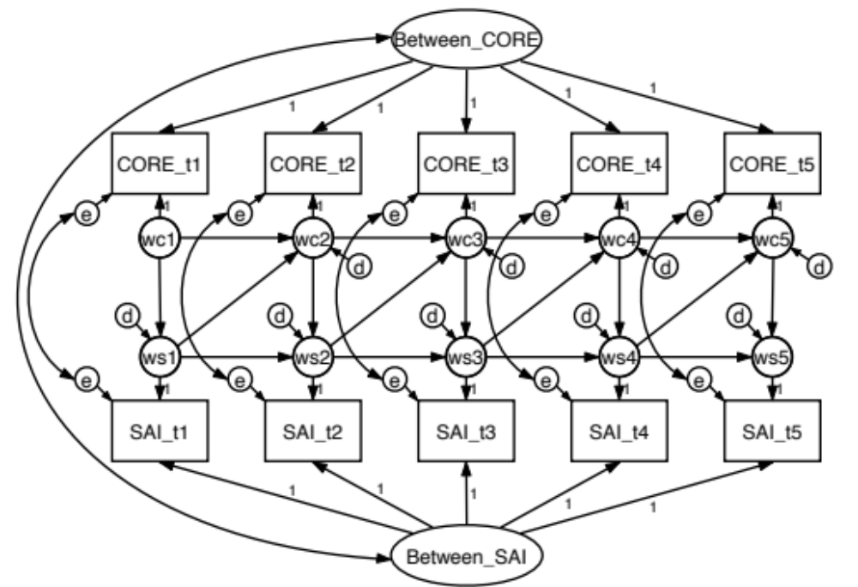
Note. Circles represent latent variables while rectangles represent observed variables. Variables wc1-xc5 and ws1-ws5 are latent within-person deviation variables (i.e. Level-1 variables), while Between_CORE and Between_SAI are the Level-2 random intercepts. The variables labeled ‘d’ represent so-called dynamic errors, or innovations, while the variables labeled ‘e’ represent measurement errors. The arced, double-headed arrow between the ‘e’ variables at the same occasion show the estimated correlation between measurement errors of SAI and CORE-OM.

Figure S1. Random Intercept Cross-Lagged Panel model of CORE-OM and SAI over the first five sessions of therapy, including the separation of measurement error.

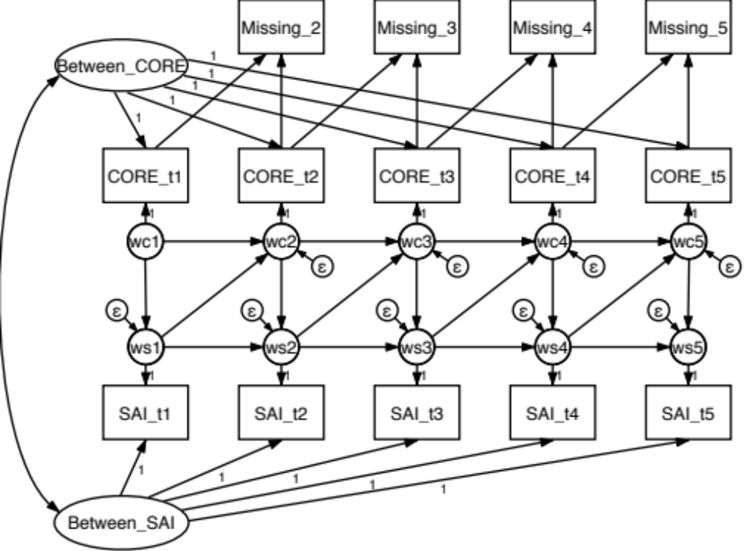
Note. Circles represent latent variables while rectangles represent observed variables. Variables wc1-xc5 and ws1-ws5 are latent within-person deviation variables (i.e. Level-1 variables), while Between_CORE and Between_SAI are the Level-2 random intercepts. The variables labeled ‘Missing_2’ – ‘Missing_5’ are missing data indicators, which are coded ‘0’ for non-missing, ‘1’ the first time data is missing, and as missing the second time data is missing (Enders, 2011). Paths from SAI_t1 – SAI_t5 to Missing_2 – Missing_5 were included but are not shown in the diagram to avoid cluttering.

Figure S2. Diggle-Kenward selection model for the Random Intercept Cross-Lagged Panel model of CORE-OM and SAI over the first five sessions of therapy.

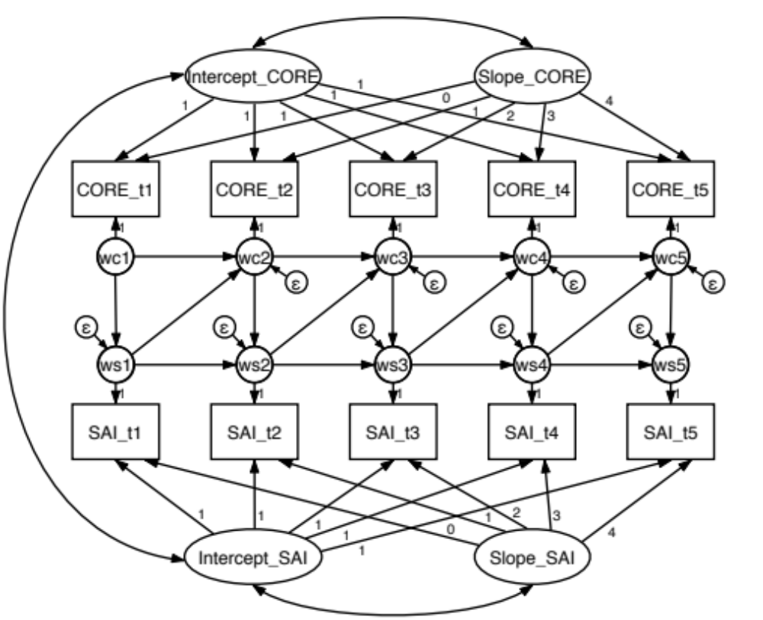
Note. Circles represent latent variables while rectangles represent observed variables. Variables wc1-xc5 and ws1-ws5 are latent within-person deviation variables (i.e. Level-1 variables), ‘Intercept_CORE’ and ‘Intercept_SAI’ are level-2 random intercepts representing varying initial status among patients, and ‘Slope_CORE’ and ‘Slope_SAI’ are random linear time-slopes representing variations in linear change over time.

Figure S3. Structured Residuals Model (Curran, Howard, Bainter, Lane, & McGinley, 2014) of CORE-OM and SAI over the first five sessions of therapy.

Table S1. Zero-order correlation matrix.
 | CORE_t1 | CORE_t2 | CORE_t3 | CORE_t4 | CORE_t5 | SAIP_t1 | SAIP_t2 | SAIP_t3 | SAIP_t4
CORE_t2 | 0.50*
CORE_t3 | 0.37* | 0.58*
CORE_t4 | 0.35* | 0.48* | 0.54*
CORE_t5 | 0.34* | 0.27 | 0.50* | 0.61*
SAIP_t1 | -0.11 | -0.15* | -0.15 | -0.15 | -0.18
SAIP_t2 | -0.04 | -0.22* | -0.21* | -0.19 | -0.29 | 0.49*
SAIP_t3 | -0.03 | -0.14 | -0.13 | -0.22 | -0.31 | 0.46* | 0.64*
SAIP_t4 | 0.12 | 0.13 | 0.09 | -0.28* | -0.26 | 0.46* | 0.59* | 0.81*
SAIP_t5 | 0.18 | 0.16 | -0.02 | -0.42* | -0.45* | 0.36* | 0.50* | 0.60* | 0.79*
Note. Estimates reported in the article are not reproducible from this table, since these are based on latent disaggregation of within- from between-patient sources of variance.

