Interpreting Teasing Through Texting: The Role of Emoji, Initialisms, Relationships, and Rejection Sensitivity in Ambiguous SMS

Supplemental Materials

Table of Contents
Supplemental Material A: Pilot Testing and Stimuli Design 3
Phase I: Focus Groups and Stimuli Development 4
Phase II: Online Piloting Study and Stimuli Refinement 6
Supplemental Material B: Study 1 and Study 2 Teasing Stimuli and Control Items 10

Supplemental Material A: Pilot Testing and Stimuli Design
Study 1 and Study 2 used text message stimuli to examine message features, social context, and rejection sensitivity in relation to the interpretation of teasing texts. The development of teasing text message stimuli and the selection of text message features was conducted across two phases (see Figure S1). These phases included three rounds of pilot testing (i.e., two stages of focus groups for stimuli development and an online pilot study for stimuli refinement). The University of Ottawa’s Health Sciences and Science Research Ethics Board approved all phases of the current research. Participants across phases were recruited from first year psychology and communication courses with an opt-out research participation component. Focus group participants received 2 grade points (out of 100) and participants in the online pilot study and main studies received 1 grade point, as per standard research procedures at the University of Ottawa. Participants were only permitted to take part in one part of the larger study (e.g., an individual could neither participate in a later phase of piloting if they took part in an initial focus group, nor in the main study if they took part in piloting).
Figure S1
Research Design Flow
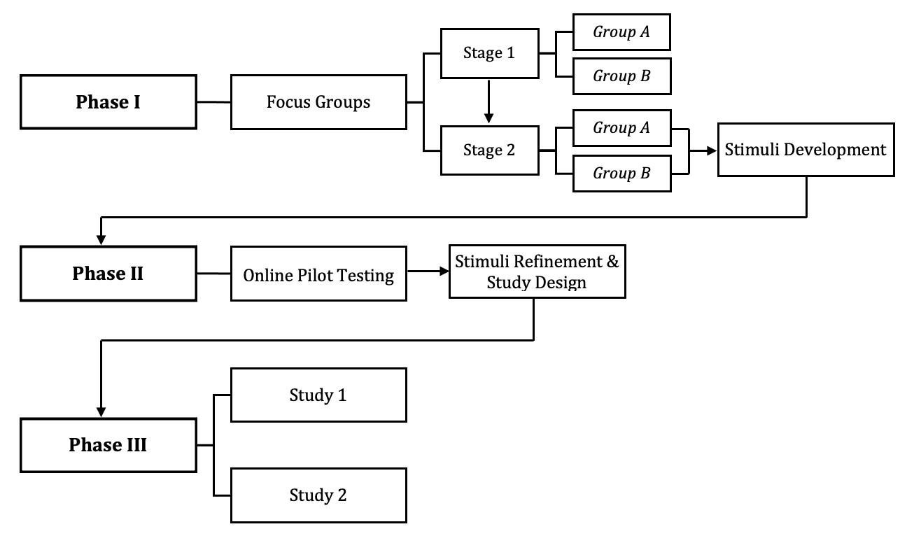

Phase I: Focus Groups and Stimuli Development
Stimuli development was facilitated by two stages of focus groups. Each focus group session was capped at 10 participants (see e.g., Krueger, 2002; Powell & Single, 1996) and were 90 minutes in length. Informed consent was collected at the outset, and an icebreaker activity was used to put participants at ease prior to the group discussion.
Initial piloting consisted of two open-ended focus groups. Eighteen undergraduate students (nine per group) between the ages of 18 to 32 (M = 19.89, SD = 3.14) took part in the initial focus groups (seven women and two men in each group). Group discussions explored teasing generally, teasing via computer-mediated communication, and the use of message features (emoji and initialisms). Examples of teasing text messages and interpretations were also generated during focus group sessions. Sample discussion starters from these initial focus groups included:
- When I bring up teasing, what types of behaviours or statements come to mind?
- Reflecting on your digital social interactions, what are examples of teasing that occur via text-based technological media (i.e., text-based messages rather than face-to-face)?
- Thinking about situations when you have either sent a teasing message or have been the recipient, how did you convey, or know, that the message was intended to be playful/friendly versus hurtful/hostile?
Informed by the first stage of focus groups, a series of initial stimuli teasing text messages and message features were created/selected and turned into a 40-item workbook. Workbook teasing statements were presented as text message bubbles. Each statement had two corresponding blank text bubbles to allow participants to fill in a negative/hurtful interpretation and a positive/playful interpretation (see Figure S2 for example). Participants were asked about the realism of the message (i.e., yes, maybe, no) in a follow-up question. Space was also provided for the generation of novel teasing statements. Participants were asked in the workbook about emoji and initialisms that are commonly used in teasing text messages.
The workbooks were presented to participants in a second round of two focus groups. Participants first worked independently to provide positive and negative interpretations of the teasing texts, feedback on the message features, and general feedback. Participants were 17 undergraduate students between the ages of 18 and 25 (M = 19.60, SD = 2.00). There were eight participants in the first focus group (seven women and one man) and nine participants in the second focus group (seven women and two men). Participants were encouraged to annotate the worksheets, modifying the wording of the presented text message statements to enhance the realism of the messages. Group discussion followed regarding the stimuli and message features. The individual and group feedback from the second round of focus groups was then used to create test stimuli and select message features which were piloted in a larger scale, online study.
Participants in all phases were asked if they owned a cell phone and to provide estimates of the average number of people with whom they text on a typical day, the average number of text messages they send and receive daily, and to indicate with whom they text (i.e., family, friends, romantic partner, classmates, acquaintances, others) ranked from most to least frequent.
Figure S2
Example Item from Focus Group Workbook
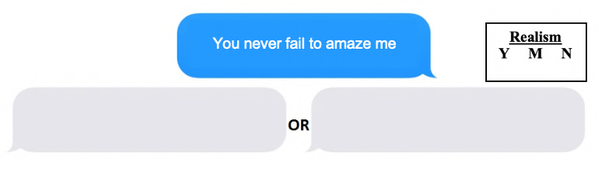

Phase II: Online Piloting Study and Stimuli Refinement
After the second round of focus groups, 45 teasing statements, with positive and negative interpretations for each, were finalized for online pilot testing. Seventy-six undergraduate students (49 female, 26 male, 1 undisclosed) between the ages of 17 and 27 (M = 19.60, SD = 1.83) took part in an online survey conducted using Qualtrics (Qualtrics, Provo, UT). Following informed consent, participants were asked a series of demographic questions and about their daily text message practices (as described in Phase I).
Participants were then administered the text message stimuli, displayed as screen captures, and were instructed to read each text message as if they had just received it. In pilot testing, no additional context was provided to ensure message ambiguity. Two opposing interpretations (one negative and one positive) were presented as endpoints on a 6-point Likert-type scale. Participants were asked, “Which thought is mostly likely to come to your mind?”, as a prompt to rate their degree of agreement (i.e., “definitely”, “moderately”, “slightly”) with one of the two interpretations. A similar prompt has been used in past research protocols examining ambiguous scenarios (e.g., Kingsbury & Coplan, 2016; Stopa & Clark, 2000). Ratings for each item were assigned to the participants’ responses and could range from 1 (definitely negative) to 6 (definitely positive). In line with past research (e.g., Kingsbury & Coplan, 2016), participants were asked to rate the realism of the message on a 5-point Likert-type scale ranging from 1 (very unlikely) to 5 (very likely). All messages were rated at a mean of 3 (likely) or above, so the realism measure was not used to discard any stimuli. Participants were also invited to provide feedback regarding the teasing statements or message features as an open-ended question.
Messages that elicited unipolar participant responses (i.e., primarily positive or primarily negative) were determined to be non-ambiguous. Messages that generated variance in responses (i.e., mixed positive/negative interpretations) were conceptualized as ambiguous. Messages that were more positively or negatively weighted (i.e., 61% or greater participant endorsement for either interpretation) were removed from the pool of items, yielding a total of 21 acceptable texts (means ranging from 2.96 to 3.87). The remaining items were examined for their relative positive or negative ratings and sorted into blocks (three for Study 1 and two for Study 2) to ensure a mix of item ambiguity. See Supplemental Material B for the list of items selected for inclusion.
Participants were presented with four emoji (iOS variations) selected from the focus groups and asked which emoji they believed would most likely be used to signal that a teasing text should be taken in a playful/joking manner. A chi-square analysis revealed a statistically significant difference between participants’ emoji endorsement, χ²(3) = 20.11, p < .001. The “face with tongue” emoji received the least support (n = 3, 3.9%). The “winking face” emoji was endorsed by approximately one quarter of participants (n = 20, 26.3%). A smaller difference was found between the “crying while laughing” emoji (n = 24, 31.6%) and the “winking face with tongue” emoji (n = 29, 38.2%). The “winking face with tongue” emoji, a synthesis of the “tongue” and “wink” emoji previously identified as indicators of humour and sarcasm (e.g., Sarkar et al., 2014), was chosen to be included as a Study 1 message feature.
Participants were asked the same regarding two initialisms (i.e., “lol” and “jk”). The lower-case variations were selected after consensus from focus group data determined that these were the most commonly used when teasing. A binomial test revealed a statistically significant difference (p = .015) between participants’ endorsement of the “lol” (n = 49, 64%) and “jk” (n = 27, 36%). The “lol” initialism was selected to be used as a message feature in Study 1.
The 18-item Rejection Sensitivity Questionnaire (RSQ, Downey & Feldman, 1996) was administered to participants. Measure psychometric properties are discussed in Study 1.
Supplemental Material A References
Downey, G., & Feldman, S. I. (1996). Implications of rejection sensitivity for intimate relationships. Journal of Personality and Social Psychology, 70(6), 1327–1343. https://doi.org/10.1037/0022-3514.70.6.1327
Kingsbury, M., & Coplan, R. J. (2016). RU mad @ me? Social anxiety and interpretation of ambiguous text messages. Computers in Human Behavior, 54, 368–379. https://doi.org/10.1016/j.chb.2015.08.032
Krueger, R. A. (2002). Designing and conducting focus group interviews. University of Minnesota. https://www.eiu.edu/ihec/Krueger-FocusGroupInterviews.pdf
Powell, R. A., & Single, H. M. (1996). Focus groups. International Journal for Quality in Health Care, 8(5), 499–504. https://doi.org/10.1093/intqhc/8.5.499
Sarkar, T., Shetty, N., & Humstoe, M. K. (2014). Emoticons & emotions: Contextual interpretation in text messages & consensus of meaning. The Learning Curve, 3, 24–33.
Stopa, L., & Clark, D. M. (2000). Social phobia and interpretation of social events. Behaviour Research and Therapy, 38(3), 273–283. https://doi.org/10.1016/S0005-7967(99)00043-1

Supplemental Material B: Study 1 and Study 2 Teasing Stimuli and Control Items
Pilot  Stimulus Item | Interpretation |  | Study  Inclusion
 | Negative | Positive | 1 | 2
You are certainly one of a kind | They think I’m weird. | They think I’m a special person. | Y | Y
You’re such a gym rat | They think I spend too much time at the gym. | They think I’m fit. | Y | Y
Thanks mom | They don’t want me telling them what to do. | They are thanking me for looking out for them. | Y | Y
Stop being so obsessed with me | They are suggesting they want me to leave them alone. | They like the attention I give them. | Y
Always the underachiever | They don’t think I try hard enough. | They are acknowledging my accomplishments. | - C | - C
There’s no way I’m posting that where you’re beside me | They think I look ugly in that photo. | They think I look really good in that photo. | Y | Y
Well you aren’t getting any younger | They think I need to take life more seriously. | They are happy that I’m having fun while I can. | Y | Y
You’re such a heartbreaker | They think I’m careless with other’s feelings. | They think I’m an attractive person. | Y | Y
You’re such a keener | They think I try too hard. | They think I’m a hard worker. | S | S
It’s not like you’re special or anything | They are implying that I think that I’m better than other people. | They really do think I’m special to them. | Y | Y
Now that was actually funny | They don’t think I’m usually funny. | They really think what I said was funny. | Y | Y
Well at least one of us has their priorities straight | They think I don’t have my priorities in order. | They think I have my life together. | Y | Y
You’re such a worrywart | They think I worry way too much. | They appreciate that I care. | - C
Glad to see you’re more than just a pretty face | Their first impression was that I was dumb. | They think I’m the whole package. | Y | Y
I was starting to worry you were dead | They’re upset because they think I’ve been ignoring them. | They’ve been worried about me. | Y | Y
You went on a date? | They didn’t think I could actually get a date. | They are excited for me that I went on a date. | Y | Y
Adulting does not seem to have made your priority list | They think I’m immature. | They think it’s great I’m having fun. | - C | - C
Stop trying to make me look bad | They think I’m intentionally trying to show them up. | They are complimenting what I’m doing. | Y | Y
My life would be so boring without you | They don’t enjoy the drama I bring to their life. | They enjoy the excitement I bring to their life. | + C | + C
Clearly your bae is important to you | They don’t think I make time for anyone else. | They think that I am a good boyfriend/girlfriend. | Y | Y
Wow, I almost didn’t recognize you | They are suggesting that I look awful. | They are complimenting how good I look. | + C
You never fail to amaze me | They think I’m constantly doing stupid things. | They are constantly impressed by me. | Y | Y
How dare you choose studying over me | They are upset that I have not prioritized time with them. | They are acknowledging that I’m a good student. | Y | Y
You’re so cool | They think what I’ve said is lame. | They think that I’m chill. | Y | Y
It’s like you actually know what you’re talking about | They are implying that I usually sound dumb. | They are implying that what I said sounds intelligent. | Y | Y
You definitely wear your heart on your sleeve | They think I’m too sensitive. | They think I’m a caring person. | Y | Y
I’d swear we were siblings if I didn’t know better | They are implying we have a dysfunctional relationship. | They are implying we have a close relationship. | + C | + C
I’d love to know how your mind works | They think my thoughts are peculiar. | They think my thoughts are complex. | Y | Y
Note. Y = included in study; +C/-C = included as positive (+) /negative (-) non-ambiguous control item; S = included as sample item

