Supplemental Material

Self-Esteem and Social Relationships: A Meta-Analytic Review of Longitudinal Studies With Continuous Time Modeling

Part 1: Supplemental Tables and Figures (pp. 2-20)
Part 2: Additional Information on Potential Study-Level Estimation Problems (p. 21)
Part 3: Reports Excluded Due to Insufficient Information on Effect Sizes (pp. 22-28)
Part 4: References (p. 29)
Part 1: Supplemental Tables and Figures

Table S1
Search in APA PsycInfo on September 13, 2024
Step | Search | Explanation | Number of records
1 | ((self-esteem or self-worth or self-concept* or self-liking or self-view* or self-respect or self-regard or self-acceptance or self-image*) and (parent* or mother* or father* or peer relation* or "relation* with peer*" or friend* or classmate* or coworker* or colleague* or boyfriend* or girlfriend* or partner* or spouse* or wife or wives or husband* or romantic relation* or relationship satisfaction or marital satisfaction or close relationship* or significant other* or relationship quality or relationship problem* or social relation* or social accept* or peer accept* or social reject* or peer reject* or social inclusion or social exclusion or social support* or support quality or support network* or connectedness or closeness or popularity or sibling* or grandparent*)).sh,tw. and (english or german or french).lg. and (longitudinal* or prospective* or cross-lag*).sh,tw. | Search Strategy 1: Search for terms related to self-esteem and social relationships in subject headings (i.e., index terms used in PsycInfo) and text words (i.e., title, abstract, key concepts, table of contents), restrict search to languages the authors are familiar with, and restrict search by including the terms longitudinal*, prospective*, and cross-lag*. | 2,270
2 | ((self-esteem or self-worth or self-concept* or self-liking or self-view* or self-respect or self-regard or self-acceptance or self-image*) and (parent* or mother* or father* or peer relation* or "relation* with peer*" or friend* or classmate* or coworker* or colleague* or boyfriend* or girlfriend* or partner* or spouse* or wife or wives or husband* or romantic relation* or relationship satisfaction or marital satisfaction or close relationship* or significant other* or relationship quality or relationship problem* or social relation* or social accept* or peer accept* or social reject* or peer reject* or social inclusion or social exclusion or social support* or support quality or support network* or connectedness or closeness or popularity or sibling* or grandparent*)).sh,tw. and (english or german or french).lg. and ("0450" and "1800").md. | Search Strategy 2: Search for terms related to self-esteem and social relationships in subject headings and text words, restrict search to languages the authors are familiar with, and restrict search by limitation options “Longitudinal Study” (i.e., “0450”.md.) and “Quantitative Study” (i.e., “1800”.md). | 1,322
3 | 1 or 2 | Set union of search results | 2,694
4 | limit 3 to up=20160901-20240913 | Limit search to records added since search for prior systematic review (Harris & Orth, 2020). | 820

Table S2
Drift Parameters of Self-Esteem (SE) and Relationship Quality (RQ), in Sensitivity Analysis With an Unrestricted Random-Intercept Model
Effect | Estimate | SD | 95% CI | p | τ² | I²
Auto-effects
SE SE | −4.16 | 0.28 | [−4.70, −3.61] | <.001 | 0.832 | 97.5
RQ RQ | −9.23 | 0.45 | [−10.13, −8.33] | <.001 | 0.806 | 97.9
Cross-effects
SE RQ | 4.12 | 0.38 | [3.36, 4.85] | <.001 | 0.145 | 90.6
RQ SE | 2.95 | 0.32 | [2.29, 3.56] | <.001 | 0.082 | 85.3
Note. This model was based on correlation matrices from samples with three or more waves (k = 56). Following the output of the CoTiMA package, results for drift parameters are reported with standard deviations (SDs), which can be interpreted as standard errors. The notation reflects that parameters are estimated as distributions, where the SD of the distribution serves as a direct measure of the uncertainty associated with each population estimate (Dormann et al., 2025). CI = credible interval; τ² = estimated between-study variance; I² = proportion of total variance attributable to between-study heterogeneity.
Table S3
Drift Parameters of Self-Esteem (SE) and Relationship Quality (RQ), in Sensitivity Analysis With a Fixed-Intercept Model
Effect | Estimate | SD | 95% CI | p | τ² | I²
Auto-effects
SE SE | −0.52 | 0.00 | [−0.53, −0.51] | <.001 | 0.063 | 99.2
RQ RQ | −0.65 | 0.00 | [−0.66, −0.64] | <.001 | 0.094 | 99.5
Cross-effects
SE RQ | 0.19 | 0.00 | [0.18, 0.19] | <.001 | 0.011 | 95.5
RQ SE | 0.15 | 0.00 | [0.14, 0.15] | <.001 | 0.008 | 93.7
Note. This model was based on correlation matrices from samples with three or more waves (k = 56). Following the output of the CoTiMA package, results for drift parameters are reported with standard deviations (SDs), which can be interpreted as standard errors. The notation reflects that parameters are estimated as distributions, where the SD of the distribution serves as a direct measure of the uncertainty associated with each population estimate (Dormann et al., 2025). CI = credible interval; τ² = estimated between-study variance; I² = proportion of total variance attributable to between-study heterogeneity.

Table S4
Intercorrelations Among Moderators
Variable | 1 | 2 | 3 | 4 | 5 | 6 | 7 | 8 | 9
1. Relationship partner: parentª | —
2. Relationship partner: peerª | −.43* | —
3. Relationship partner: romanticª | −.22* | −.24* | —
4. Relationship partner: generalª | −.26* | −.29* | −.15 | —
5. Relationship partner: mixed/otherª | −.25* | −.27* | −.14 | −.17 | —
6. Mean age of sample | −.32* | −.30* | .52* | .32* | .03 | —
7. Proportion of female participants | .01 | −.07 | .00 | .05 | .04 | −.07 | —
8. Cultural context: Westernª | .04 | −.01 | −.12 | −.07 | .14 | .06 | .07 | —
9. Relationship measure: self-reportª | −.04 | −.26* | .12 | .15 | .14 | .22* | .02 | .04 | —
ª 1 = yes, 0 = no.
* p < .05.

Table S5
Moderator Effects of Type of Relationship Partner on the Drift Parameters
Drift parameter | Moderator effect | SD | 95% CI | p
Peer
SE SE | 1.61 | 0.21 | [1.19, 2.01] | <.001
RQ RQ | 0.69 | 0.24 | [0.23, 1.13] | .004
SE RQ | −0.54 | 0.17 | [−0.86, −0.21] | .001
RQ SE | −0.86 | 0.16 | [−1.19, −0.55] | <.001
Romantic
SE SE | 3.99 | 0.26 | [3.49, 4.52] | <.001
RQ RQ | 4.34 | 0.30 | [3.76, 4.90] | <.001
SE RQ | −0.49 | 0.16 | [−0.81, −0.17] | .003
RQ SE | −0.74 | 0.16 | [−1.06, −0.46] | <.001
General
SE SE | −3.02 | 0.40 | [−3.81, −2.24] | <.001
RQ RQ | −4.69 | 0.36 | [−5.44, −3.95] | <.001
SE RQ | 6.09 | 0.39 | [5.30, 6.86] | <.001
RQ SE | 4.15 | 0.35 | [3.47, 4.81] | <.001
Mixed/other
SE SE | 2.26 | 0.25 | [1.75, 2.74] | <.001
RQ RQ | 0.76 | 0.31 | [0.18, 1.34] | .016
SE RQ | −0.68 | 0.19 | [−1.06, −0.28] | <.001
RQ SE | −0.80 | 0.19 | [−1.17, −0.45] | <.001
Note. Estimates are differences in drift parameters between the category of relationship partner (e.g., peer) and the reference category (i.e., parent). In continuous time modeling, standard deviations can be interpreted as standard errors since Bayesian methods estimate parameters directly for the population. CI = credible interval.
Table S6
Effects of Continuous Moderator Variables on the Drift Parameters
Drift parameter | Moderator effect | SD | 95% CI | p
Mean age of sample
SE SE | 0.40 | 0.03 | [0.33, 0.46] | <.001
RQ RQ | 0.87 | 0.06 | [0.75, 1.00] | <.001
SE RQ | −0.11 | 0.04 | [−0.19, −0.04] | .003
RQ SE | −0.14 | 0.03 | [−0.21, −0.08] | <.001
Proportion of female participants
SE SE | −0.22 | 0.07 | [−0.36, −0.09] | .001
RQ RQ | −0.98 | 0.09 | [−1.16, −0.79] | <.001
SE RQ | 0.35 | 0.05 | [0.24, 0.46] | <.001
RQ SE | 0.14 | 0.05 | [0.03, 0.23] | .006
Mean age of sample (studies on parent relationships)
SE SE | −0.61 | 0.24 | [−1.09, −0.15] | .012
RQ RQ | −0.21 | 0.21 | [−0.62, 0.20] | .316
SE RQ | 0.96 | 0.19 | [0.57, 1.32] | <.001
RQ SE | 1.06 | 0.21 | [0.65, 1.45] | <.001
Mean age of sample (studies on peer relationships)
SE SE | 0.18 | 0.05 | [0.08, 0.28] | <.001
RQ RQ | −0.55 | 0.08 | [−0.70, −0.39] | <.001
SE RQ | −0.23 | 0.06 | [−0.35, −0.10] | <.001
RQ SE | −0.36 | 0.06 | [−0.47, −0.25] | <.001
Note. In continuous time modeling, standard deviations can be interpreted as standard errors since Bayesian methods estimate parameters directly for the population. CI = credible interval.
Table S7
Moderator Effects of Cultural Context on the Drift Parameters
Drift parameter | Moderator effect | SD | 95% CI | p
SE SE | −0.41 | 0.09 | [−0.57, −0.23] | <.001
RQ RQ | −1.77 | 0.22 | [−2.21, −1.34] | <.001
SE RQ | 0.37 | 0.15 | [0.07, 0.65] | .012
RQ SE | 0.13 | 0.12 | [−0.10, 0.38] | .270
Note. Estimates are differences in drift parameters between Western and non-Western samples. Western is the reference category. In continuous time modeling, standard deviations can be interpreted as standard errors since Bayesian methods estimate parameters directly for the population. CI = credible interval.
Table S8
Moderator Effects of Type of Relationship Measure on the Drift Parameters
Drift parameter | Moderator effect | SD | 95% CI | p
SE SE | 1.51 | 0.50 | [0.56, 2.50] | .003
RQ RQ | 5.68 | 0.62 | [4.53, 6.87] | <.001
SE RQ | −5.99 | 0.54 | [−7.03, −4.94] | <.001
RQ SE | −4.51 | 0.49 | [−5.43, −3.54] | <.001
Note. Estimates are differences in drift parameters between self-report and other measures. Self-report is the reference category. In continuous time modeling, standard deviations can be interpreted as standard errors since Bayesian methods estimate parameters directly for the population. CI = credible interval.
Table S9
Drift Parameters of Self-Esteem (SE) and Relationship Quality (RQ), in Sensitivity Analysis Using One Randomly Selected Relationship-Quality Measure per Sample (k = 80)
Effect | Estimate | SD | 95% CI | p | τ² | I²
Auto-effects
SE SE | −3.75 | 0.32 | [−4.37, −3.13] | <.001 | 0.058 | 98.9
RQ RQ | −8.93 | 0.51 | [−9.95, −7.94] | <.001 | 0.084 | 99.2
Cross-effects
SE RQ | 3.44 | 0.47 | [2.56, 4.38] | <.001 | 0.012 | 94.7
RQ SE | 2.28 | 0.40 | [1.54, 3.05] | <.001 | 0.018 | 96.5
Note. Parameter estimates were controlled for stable between-person variance via latent trait variables. The correlation between the latent trait variables was r = .45 (p < .001). Following the output of the CoTiMA package, results for drift parameters are reported with standard deviations (SDs), which can be interpreted as standard errors. The notation reflects that parameters are estimated as distributions, where the SD of the distribution serves as a direct measure of the uncertainty associated with each population estimate (Dormann et al., 2025). CI = credible interval; τ² = estimated between-study variance; I² = proportion of total variance attributable to between-study heterogeneity.

Figure S1
Flow Diagram of the Search and Selection Procedures
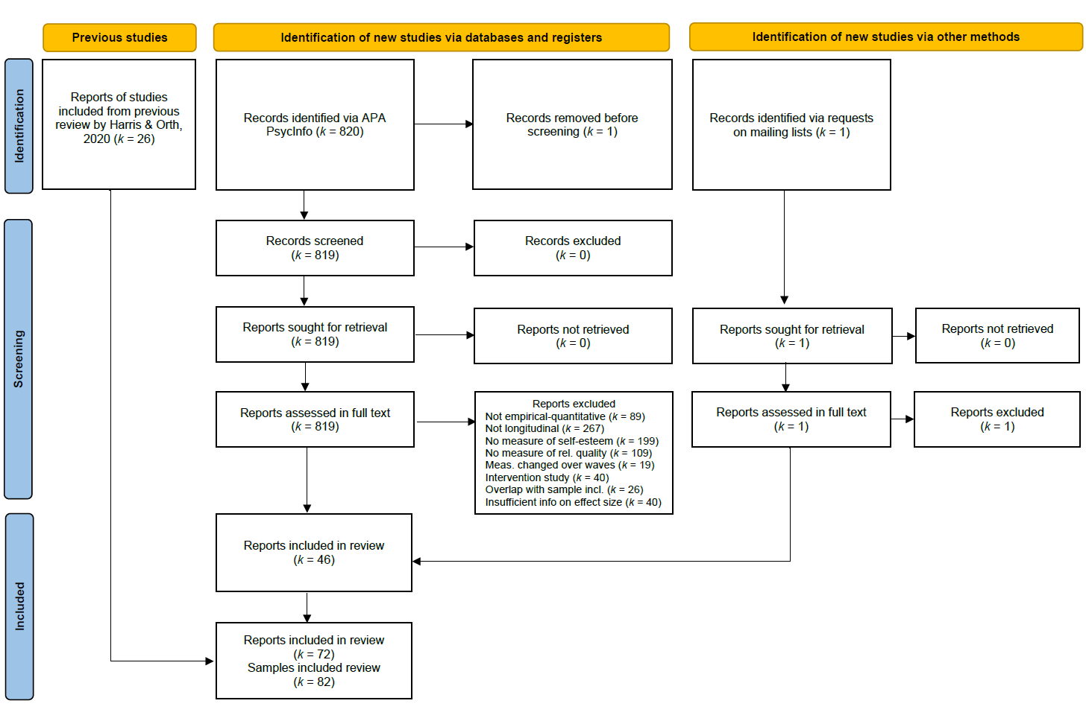
Note. The diagram has been adapted from Page et al. (2021).

Figure S2
Distribution of Number of Waves Across Samples

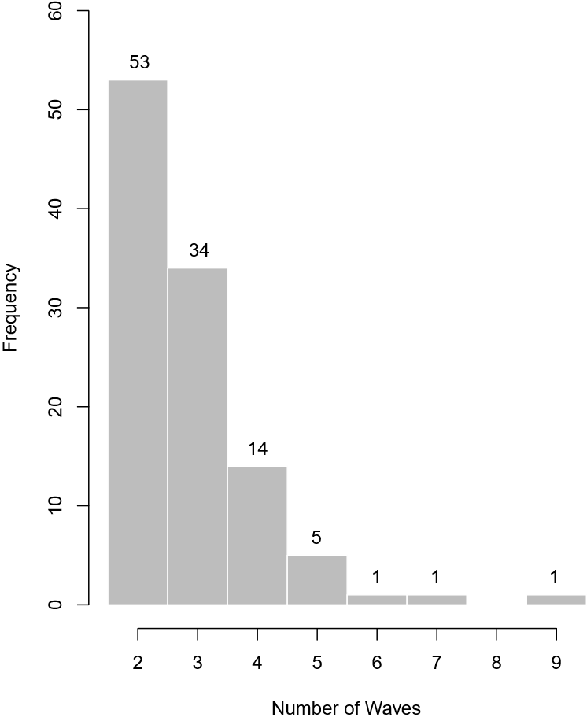

Note. Frequencies indicate the number of samples with a given number of waves.

Figure S3
Distribution of the Length of the First Time Interval Across Samples

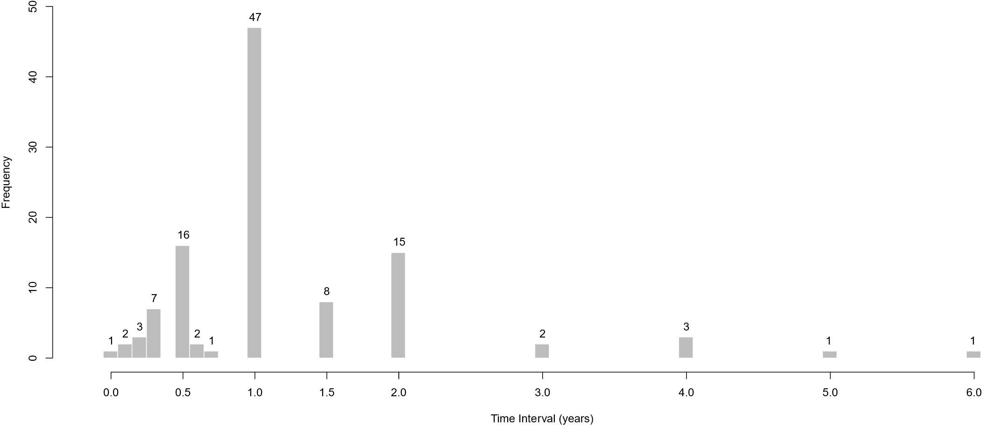

Note. Frequencies indicate the number of samples with a given time interval.

Figure S4
Autoregressive and Cross-Lagged Effects of Self-Esteem and Relationship Quality, in Sensitivity Analysis Without Study With Relatively Large Drift Parameters

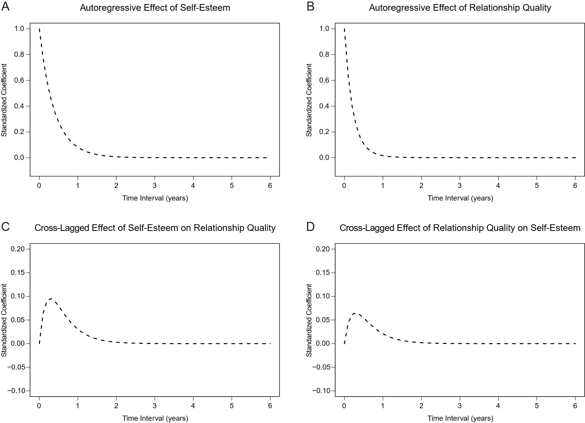

Note. The figure shows how autoregressive effects (Panels A and B) and cross-lagged effects (Panels C and D) of self-esteem and relationship quality change as a function of time interval. The cross-lagged effects peaked at approximately 0.2 years, with β = .10 (effect of self-esteem on relationship quality) and β = .07 (effect of relationship quality on self-esteem).
Figure S5
Autoregressive and Cross-Lagged Effects of Self-Esteem and Relationship Quality, in Sensitivity Analysis With Different Time Scale (Unit = 0.5 Years)

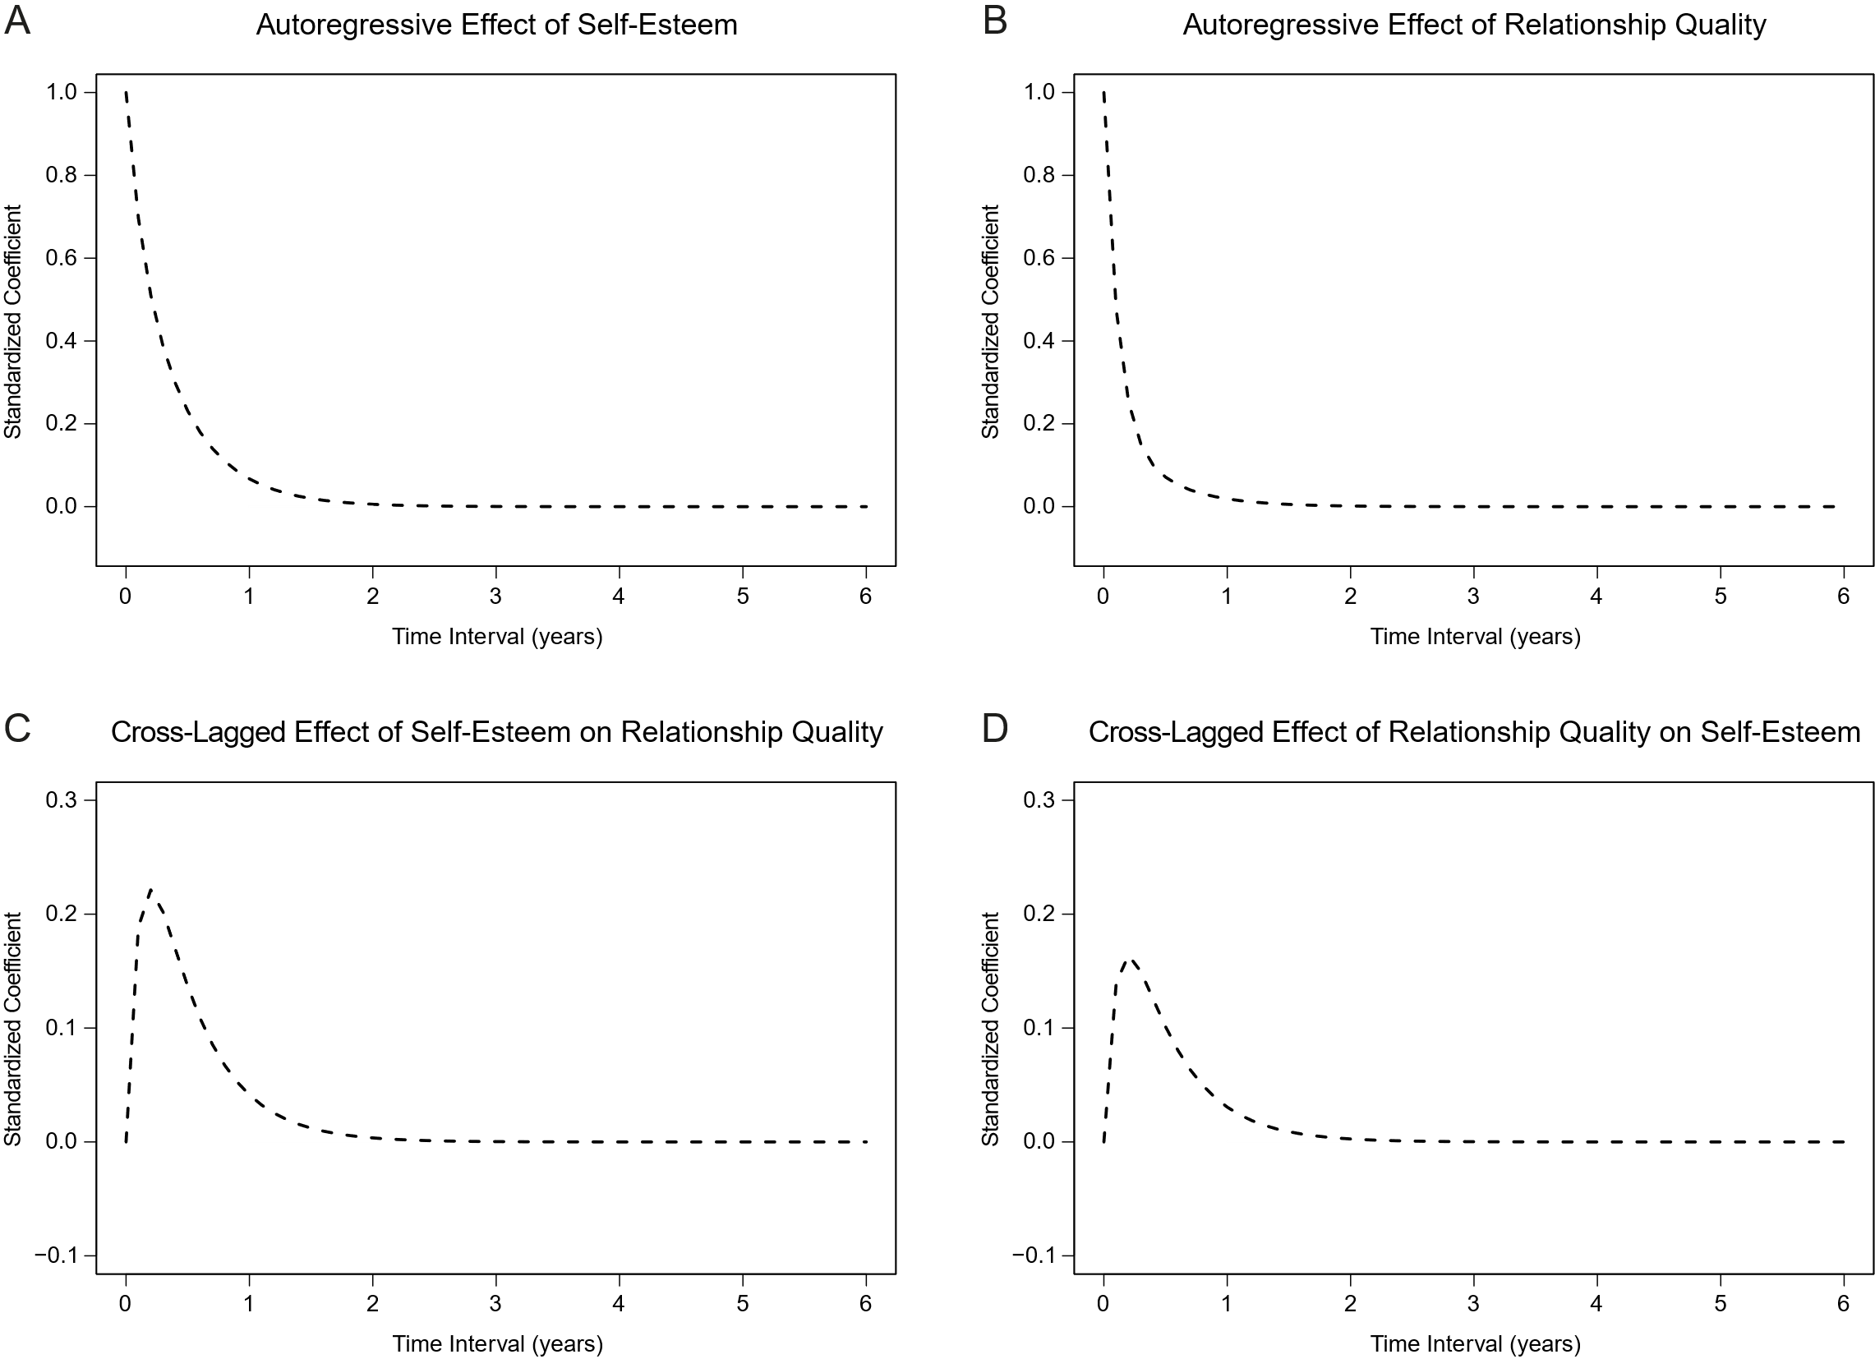

Note. The figure shows how autoregressive effects (Panels A and B) and cross-lagged effects (Panels C and D) of self-esteem and relationship quality change as a function of time interval. The cross-lagged effects peaked at approximately 0.2 years, with β = .22 (effect of self-esteem on relationship quality) and β = .16 (effect of relationship quality on self-esteem).
Figure S6
Autoregressive and Cross-Lagged Effects of Self-Esteem and Relationship Quality, in Sensitivity Analysis With an Unrestricted Random-Intercept Model

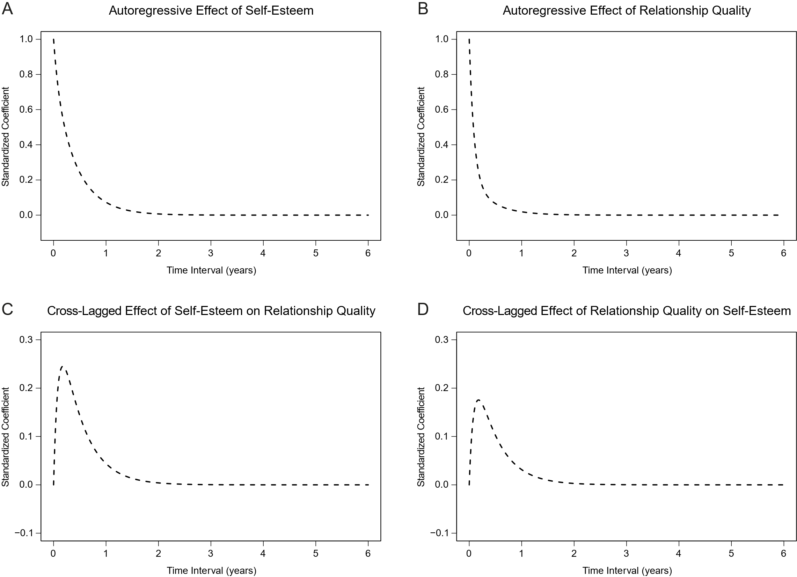

Note. The figure shows how autoregressive effects (Panels A and B) and cross-lagged effects (Panels C and D) of self-esteem and relationship quality change as a function of time interval. The cross-lagged effects peaked at approximately 0.1 years, with β = .24 (effect of self-esteem on relationship quality) and β = .17 (effect of relationship quality on self-esteem).
Figure S7
Autoregressive and Cross-Lagged Effects of Self-Esteem and Relationship Quality, in Sensitivity Analysis With a Fixed-Intercept Model

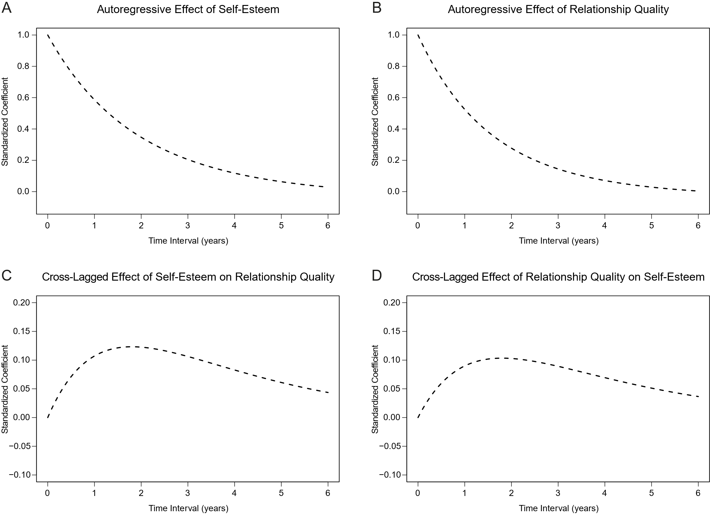

Note. The figure shows how autoregressive effects (Panels A and B) and cross-lagged effects (Panels C and D) of self-esteem and relationship quality change as a function of time interval. The cross-lagged effects peaked at approximately 1.7 years, with β = .12 (effect of self-esteem on relationship quality) and β = .10 (effect of relationship quality on self-esteem).
Figure S8
Funnel Graphs for Drift Parameters of Auto- and Cross-Effects of Self-Esteem and Relationship Quality

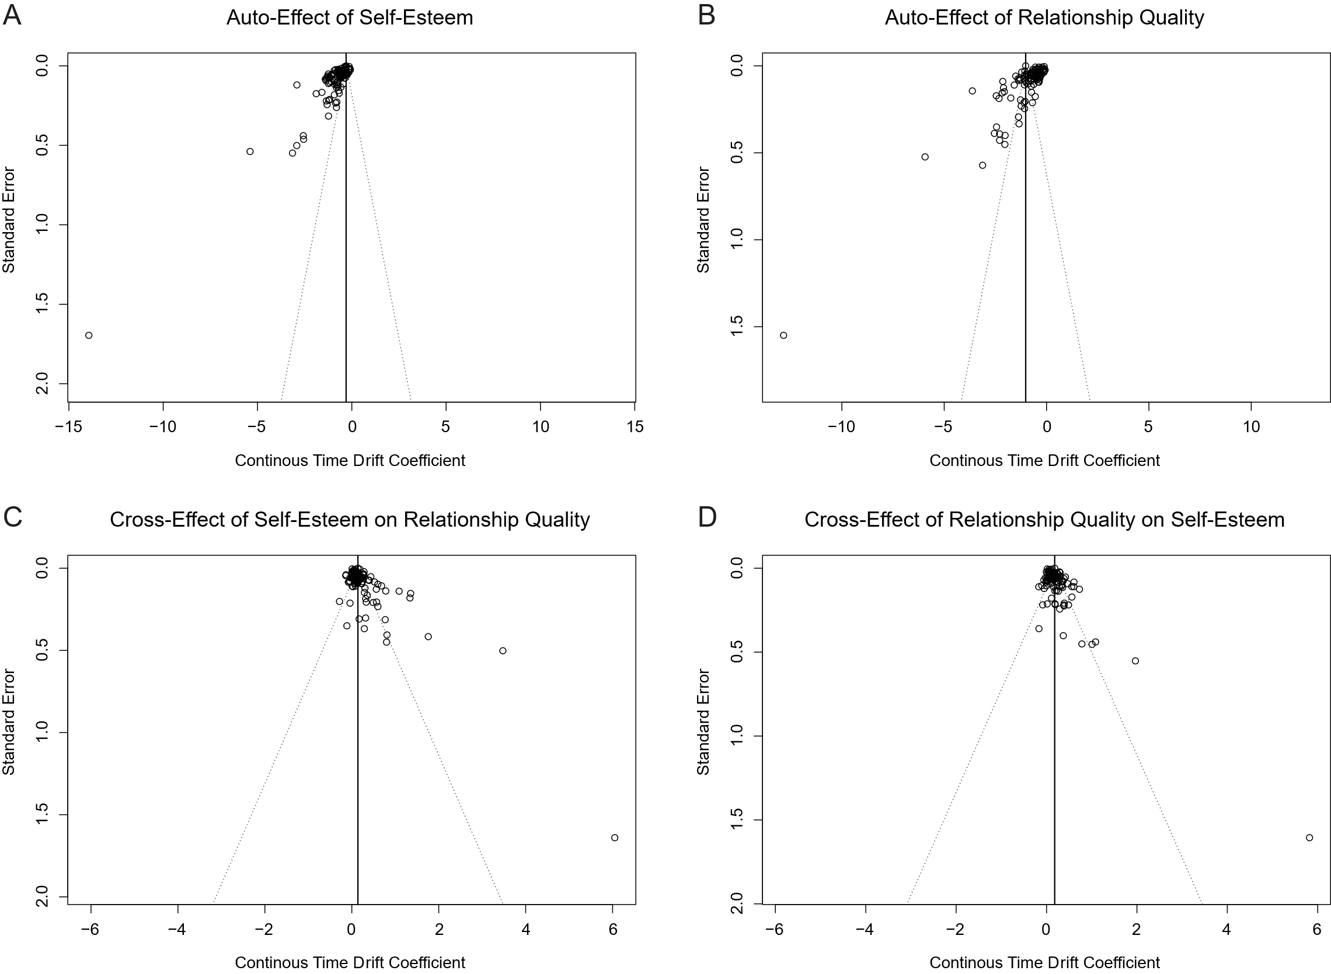

Note. The figure shows funnel graphs displaying the relation between standard error and effect size for the auto-effect of self-esteem (Panel A), auto-effect of relationship quality (Panel B), cross-effect of self-esteem on relationship quality (Panel C), and cross-effect of relationship quality on self-esteem (Panel D).
Figure S9
Autoregressive and Cross-Lagged Effects of Self-Esteem and Relationship Quality, in Sensitivity Analysis Using One Randomly Selected Relationship-Quality Measure per Sample

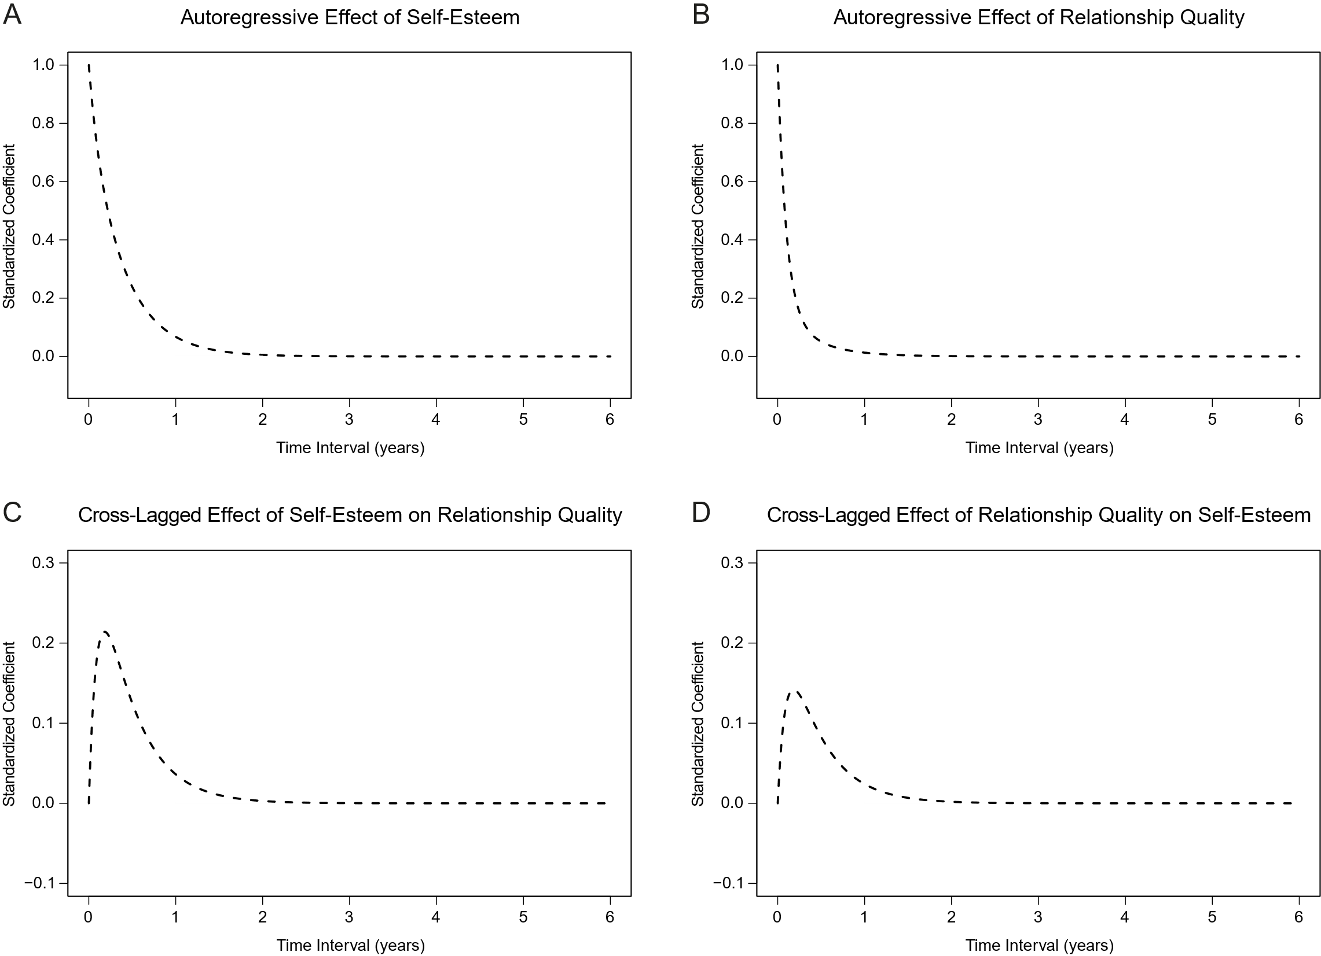

Note. The figure shows how autoregressive effects (Panels A and B) and cross-lagged effects (Panels C and D) of self-esteem and relationship quality change as a function of time interval. The cross-lagged effects peaked at approximately 0.1 years, with β = .21 (effect of self-esteem on relationship quality) and β = .14 (effect of relationship quality on self-esteem).
Part 2: Additional Information on Potential Study-Level Estimation Problems
In the analyses with the remaining 109 correlation matrices, the $estimationProblems element of the summary(CoTiMAInitFit) output indicated potential estimation problems for two studies. We reviewed both cases and decided to retain the studies. For Study 23, the function flagged the drift parameter V1toV2, likely because the lower bound of the credible interval for the drift effect from self-esteem to relationship quality was estimated to be zero. We examined the corresponding drift parameters and found no values that appeared implausible or inconsistent with the overall pattern of results; we therefore retained the study. For Study 101, the function indicated potential estimation problems because some standard errors were estimated to be zero. We examined the corresponding drift parameters and again found no values that appeared implausible or inconsistent with the overall pattern of results. We therefore retained this study as well.
Part 3: Reports Excluded Due to Insufficient Information on Effect Sizes
Albert Sznitman, G., Antonietti, J.-P., Van Petegem, S., Schwartz, S. J., Baudat, S., & Zimmermann, G. (2022). Trajectories of perceived parenting across an educational transition: Associations with psychosocial adjustment and identity development among Swiss adolescents. Developmental Psychology, 58(8), 1557–1573. https://doi.org/10.1037/dev0001367
Boutelle, K., Eisenberg, M. E., Gregory, M. L., & Neumark-Sztainer, D. (2009). The reciprocal relationship between parent–child connectedness and adolescent emotional functioning over 5 years. Journal of Psychosomatic Research, 66(4), 309–316. https://doi.org/10.1016/j.jpsychores.2008.10.019
Cahill, S., Hager, R., & Chandola, T. (2022). The validity of the residuals approach to measuring resilience to adverse childhood experiences. Child and Adolescent Psychiatry and Mental Health, 16, Article 18. https://doi.org/10.1186/s13034-022-00449-y
Chandler, A. B., & Lawrence, E. (2022). Covariations among attachment, attributions, self-esteem, and psychological aggression in early marriage. Journal of Family Psychology, 36(1), 46–56. https://doi.org/10.1037/fam0000842
Cho, R. M., & Choi, J. (2017). Social-psychological and educational outcomes associated with peer victimization among Korean adolescents. International Journal of Behavioral Development, 41(3), 329–340. https://doi.org/10.1177/0165025416631832
Conley, C. S., Shapiro, J. B., Huguenel, B. M., & Kirsch, A. C. (2020). Navigating the college years: Developmental trajectories and gender differences in psychological functioning, cognitive-affective strategies, and social well-being. Emerging Adulthood, 8(2), 103–117. https://doi.org/10.1177/2167696818791603
Doty, J. (2016). Intergenerational relationships across the life course: Links with adolescent wellbeing. Dissertation Abstracts International Section A: Humanities and Social Sciences, 77(3-A(E)).
Doughty, S. E. (2017). Sibling differentiation in activity interests: Longitudinal linkages to sibling relationship quality and self-worth. Dissertation Abstracts International: Section B: The Sciences and Engineering, 77(7-B(E)).
Fisher, A. N., Stinson, D. A., Wood, J. V., Holmes, J. G., & Cameron, J. J. (2021). Singlehood and attunement of self-esteem to friendships. Social Psychological and Personality Science, 12(7), 1326–1334. https://doi.org/10.1177/1948550620988460
Harris, P. R., Richards, A., & Bond, R. (2023). Individual differences in spontaneous self-affirmation and mental health: Relationships with self-esteem, dispositional optimism and coping. Self and Identity, 22(3), 351–378. https://doi.org/10.1080/15298868.2022.2099455
Hochgraf, A. K., Fosco, G. M., Lanza, S. T., & McHale, S. M. (2021). Developmental timing of parent–youth intimacy as a protective factor for adolescent adjustment problems. Journal of Family Psychology, 35(7), 916–926. https://doi.org/10.1037/fam0000864
Hochgraf, A. K., McHale, S. M., & Fosco, G. M. (2018). Parent responsiveness and gender moderate bidirectional links between self-esteem and weight concerns during adolescence. Journal of Family Psychology, 32(6), 828–834. https://doi.org/10.1037/fam0000434
Holopainen, L., Waltzer, K., Hoang, N., Lappalainen, K., Nuutinen, H., & Pesonen, H. (2023). The role of educational support in the development of subjective well‐being in Finnish general upper secondary education. Psychology in the Schools, 60(8), 2795–2808. https://doi.org/10.1002/pits.22885
Huang, Y.-H., Liu, H.-C., Sun, F.-J., Tsai, F.-J., Huang, K.-Y., Chen, T.-C., Huang, Y.-P., & Liu, S.-I. (2017). Relationship between predictors of incident deliberate self-harm and suicide attempts among adolescents. Journal of Adolescent Health, 60(5), 612–618. https://doi.org/10.1016/j.jadohealth.2016.12.005
Huey, M., Laursen, B., Kaniušonytė, G., Malinauskienė, O., & Žukauskienė, R. (2020). Self-esteem mediates longitudinal associations from adolescent perceptions of parenting to adjustment. Journal of Abnormal Child Psychology, 48(3), 331–341. https://doi.org/10.1007/s10802-019-00599-2
Iyer, P., Parmar, D., Ganson, K. T., Tabler, J., Soleimanpour, S., & Nagata, J. M. (2023). Investigating Asian American adolescents’ resiliency factors and young adult mental health outcomes at 14-year follow-up: A nationally representative prospective cohort study. Journal of Immigrant and Minority Health, 25(1), 75–85. https://doi.org/10.1007/s10903-022-01373-1
Johnson, M. K. (2013). Parental financial assistance and young adults' relationships with parents and well-being. Journal of Marriage and Family, 75(3), 713–733. https://doi.org/10.1111/jomf.12029
Katz-Wise, S. L., Sarda, V., Line, E. C., Marchwinski, B., Budge, S. L., Godwin, E. G., Moore, L. B. M., Ehrensaft, D., Rosal, M. C., & Thomson, K. A. (2024). Longitudinal family functioning and mental health in transgender and nonbinary youth and their families. Journal of Child and Family Studies, 33(4), 1321–1335. https://doi.org/10.1007/s10826-023-02738-2
Kvasková, L., Hlado, P., Juhaňák, L., & Macek, P. (2023). Self‐esteem and career adaptability: Moderating roles of parental and peer support. The Career Development Quarterly, 71(2), 84–96. https://doi.org/10.1002/cdq.12319
Lai, S., Su, C., Song, S., Yan, M., Tang, C., Zhang, Q., Yin, F., & Liu, Q. (2021). Depression and deliberate self-harm among rural adolescents of Sichuan Province in western China: A 2-year longitudinal study. Frontiers in Psychiatry, 12, Article 605785. https://doi.org/10.3389/fpsyt.2021.605785
Langheit, S., & Poulin, F. (2024). Links between best-friendship quality and well-being from early emerging adulthood to early established adulthood. Emerging Adulthood, 12(4), 539–552. https://doi.org/10.1177/21676968241248877
Larrieu, M., Fombouchet, Y., Billieux, J., & Decamps, G. (2023). How gaming motives affect the reciprocal relationships between video game use and quality of life: A prospective study using objective playtime indicators. Computers in Human Behavior, 147, Article 107824. https://doi.org/10.1016/j.chb.2023.107824
Lau, J. T. F., Wu, A. M. S., Gross, D. L., Cheng, K.-m., & Lau, M. M. C. (2017). Is Internet addiction transitory or persistent? Incidence and prospective predictors of remission of Internet addiction among Chinese secondary school students. Addictive Behaviors, 74, 55–62. https://doi.org/10.1016/j.addbeh.2017.05.034
Lemay, E. P., & Ashmore, R. D. (2006). The relationship of social approval contingency to trait self-esteem: Cause, consequence, or moderator? Journal of Research in Personality, 40(2), 121–139. https://doi.org/10.1016/j.jrp.2004.09.012
Li, J. (2017). Effects of online social networking use on inter-personal and psychological well-being among students in China: A longitudinal study. Dissertation Abstracts International: Section B: The Sciences and Engineering, 78(5-B(E)).
Luijten, C. C., van de Bongardt, D., & Nieboer, A. P. (2023). Adolescents' friendship quality and over‐time development of well‐being: The explanatory role of self‐esteem. Journal of Adolescence, 95(5), 1057–1069. https://doi.org/10.1002/jad.12175
Mancini, A. D., Westphal, M., & Griffin, P. (2021). Outside the eye of the storm: Can moderate hurricane exposure improve social, psychological, and attachment functioning? Personality and Social Psychology Bulletin, 47(12), 1722–1734. https://doi.org/10.1177/0146167221990488
Marshall, S. L., Parker, P. D., Ciarrochi, J., & Heaven, P. C. L. (2014). Is self-esteem a cause or consequence of social support? A 4-year longitudinal study. Child Development, 85(3), 1275–1291. https://doi.org/10.1111/cdev.12176
Nogueira Avelar e Silva, R., van de Bongardt, D., Baams, L., & Raat, H. (2018). Bidirectional associations between adolescents' sexual behaviors and psychological well-being. Journal of Adolescent Health, 62(1), 63–71. https://doi.org/10.1016/j.jadohealth.2017.08.008
Norrington, J. (2020). Mental health across the life course. Dissertation Abstracts International: Section B: The Sciences and Engineering, 81(10-B).
Reiter, S. F., Bjørk, M. H., Daltveit, A. K., Veiby, G., Kolstad, E., Engelsen, B. A., & Gilhus, N. E. (2016). Life satisfaction in women with epilepsy during and after pregnancy. Epilepsy & Behavior, 62, 251–257. https://doi.org/10.1016/j.yebeh.2016.06.025
Roosenschoon, B.-J., van Weeghel, J., Deen, M. L., van Esveld, E. W., Kamperman, A. M., & Mulder, C. L. (2021). Effects of illness management and recovery: A multicenter randomized controlled trial. Frontiers in Psychiatry, 12, Article 723435. https://doi.org/10.3389/fpsyt.2021.723435
Skoog, T., Holmqvist Gattario, K., & Lunde, C. (2019). Study protocol for PRISE: A longitudinal study of sexual harassment during the transition from childhood to adolescence. BMC Psychology, 7, Article 71. https://doi.org/10.1186/s40359-019-0345-5
Smokowski, P. R., Rose, R. A., Evans, C. B. R., Barbee, J., Cotter, K. L., & Bower, M. (2017). The impact of teen court on rural adolescents: Improved social relationships, psychological functioning, and school experiences. Journal of Primary Prevention, 38(4), 447–464. https://doi.org/10.1007/s10935-017-0470-y
Steinhoff, A., & Buchmann, M. (2018). Dynamic relations between perceived parental responsiveness, experiences of ambivalence, and self-esteem development in adolescence. In I. Albert, E. Abbey, & J. Valsiner (Eds.), Trans-generational family relations: Investigating ambivalences (pp. 121–140). Information Age Publishing.
Turner, H. A., Shattuck, A., Finkelhor, D., & Hamby, S. (2017). Effects of poly-victimization on adolescent social support, self-concept, and psychological distress. Journal of Interpersonal Violence, 32(5), 755–780. https://doi.org/10.1177/0886260515586376
Updegraff, K. A., Umaña-Taylor, A. J., Zeiders, K. H., Bravo, D. Y., & Jahromi, L. B. (2018). Familism values across the transition to adolescent motherhood: Links to family functioning and Mexican-origin adolescent mothers’ adjustment. Development and Psychopathology, 30(5), 1589–1609. https://doi.org/10.1017/S0954579418000986
Wang, S. B., Haynos, A. F., Wall, M. M., Chen, C., Eisenberg, M. E., & Neumark-Sztainer, D. (2019). Fifteen-year prevalence, trajectories, and predictors of body dissatisfaction from adolescence to middle adulthood. Clinical Psychological Science, 7(6), 1403–1415. https://doi.org/10.1177/2167702619859331
Wang, X., Huebner, E. S., & Tian, L. (2023). Longitudinal relations among perceived parental warmth, self‐esteem and social behaviours from middle childhood to early adolescence in China: Disentangling between‐ and within‐person associations. British Journal of Psychology, 114(4), 969–990. https://doi.org/10.1111/bjop.12672
Weber, E., Hopwood, C. J., Nissen, A. T., & Bleidorn, W. (2023). Disentangling self-concept clarity and self-esteem in young adults. Journal of Personality and Social Psychology, 125(6), 1420–1441. https://doi.org/10.1037/pspp0000460
Part 4: References
Dormann, C., Diener, O., & Homberg, M. (2025). CoTiMA user's guide: A package for R to perform continuous time meta-analysis. Johannes Gutenberg University Mainz. https://github.com/CoTiMA/CoTiMA/tree/Development/inst/guide
Page, M. J., McKenzie, J. E., Bossuyt, P. M., Boutron, I., Hoffmann, T. C., Mulrow, C. D., Shamseer, L., Tetzlaff, J. M., Akl, E. A., Brennan, S. E., Chou, R., Glanville, J., Grimshaw, J. M., Hrobjartsson, A., Lalu, M. M., Li, T., Loder, E. W., Mayo-Wilson, E., McDonald, S.,…Moher, D. (2021). The PRISMA 2020 statement: An updated guideline for reporting systematic reviews. BMJ, 372, n71. https://doi.org/10.1136/bmj.n71

