Supplemental Material 5 – Local Structural Equation Modeling
To visualize age trends, we combined parametric and nonparametric strategies by estimating nonlinear CFA (NLCFA) within a local structural equation modeling (LSEM) framework (Hildebrandt et al., 2009; Hildebrandt et al., 2016). LSEM models continuous change in factor structures across a moderator by fitting the same model repeatedly along a grid of focal moderator points. At each focal point, observations are reweighted using a Gaussian kernel centered on the current focal point of the moderator: cases close to the focal point receive weights near 1, and more distant cases receive weights approaching 0. Kernel width is determined by the variance of the moderator and a bandwidth parameter h, which controls the overlap of weighting distributions across neighboring grid points. The model is estimated with these weights, parameters of interest are extracted, and the procedure is repeated for all moderator grid points. Plotting the resulting parameter estimates across the grid yields a nonparametric depiction of how the factor structure varies with the moderator.
For the differentiation (g) analyses, we modified Model 2a to estimate separate parameters for the average linear g-factor loading and the average quadratic g² loading across subtests, based on NLCFA as described in the method section. This model was applied to each test at each focal value of age. The age grid spanned 0 to 18 years in 1-year steps (18 focal points). In the final figure, estimates of average linear g-factor and quadratic g² loadings between years (moderator points) within a test were connected using a LOESS-smoothing function. When a test’s observed age range was smaller than two years, we reported a single point estimate at the sample’s mean age. For all LSEM analyses we set the bandwidth to h = 2, following Hildebrandt et al. (2016). LOESS smoothing used an alpha parameter of 0.5. All models were estimated in Mplus 8 (Muthén & Muthén, 2015) and automated via MplusAutomation (Hallqusit & Wiley, 2018). Figure S2 displays the LSEM trends for g-factor loadings across age, and Figure S3 displays the corresponding g² loadings.

Figure S2. g-Loadings Across Age Based on Local Structural Equation Modeling Analyses and the Meta-Analytic Mean Effect for Age (De)differentiation
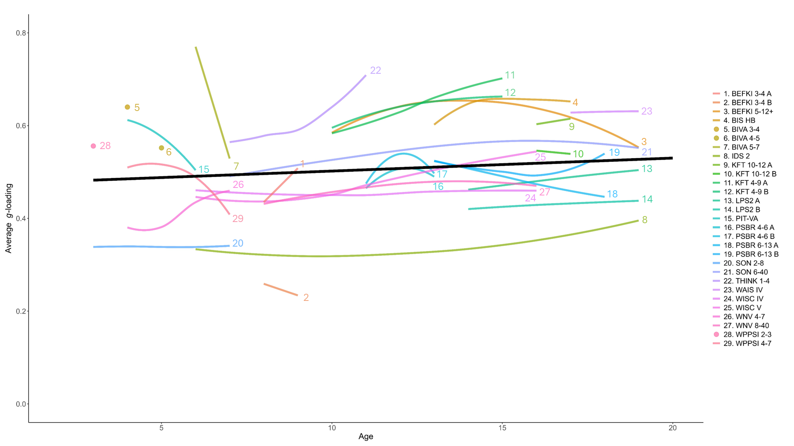
Note. The colored lines represent the smoothed trajectory of the average g-factor loading across age in each sample. The black solid line represents the meta-analytic mean effect for age (de)differentiation (non-significant).

Figure S3. g²-Loadings Across Age Based on Local Structural Equation Modeling Analyses and the Meta-Analytic Mean Effect for the Interaction Effect
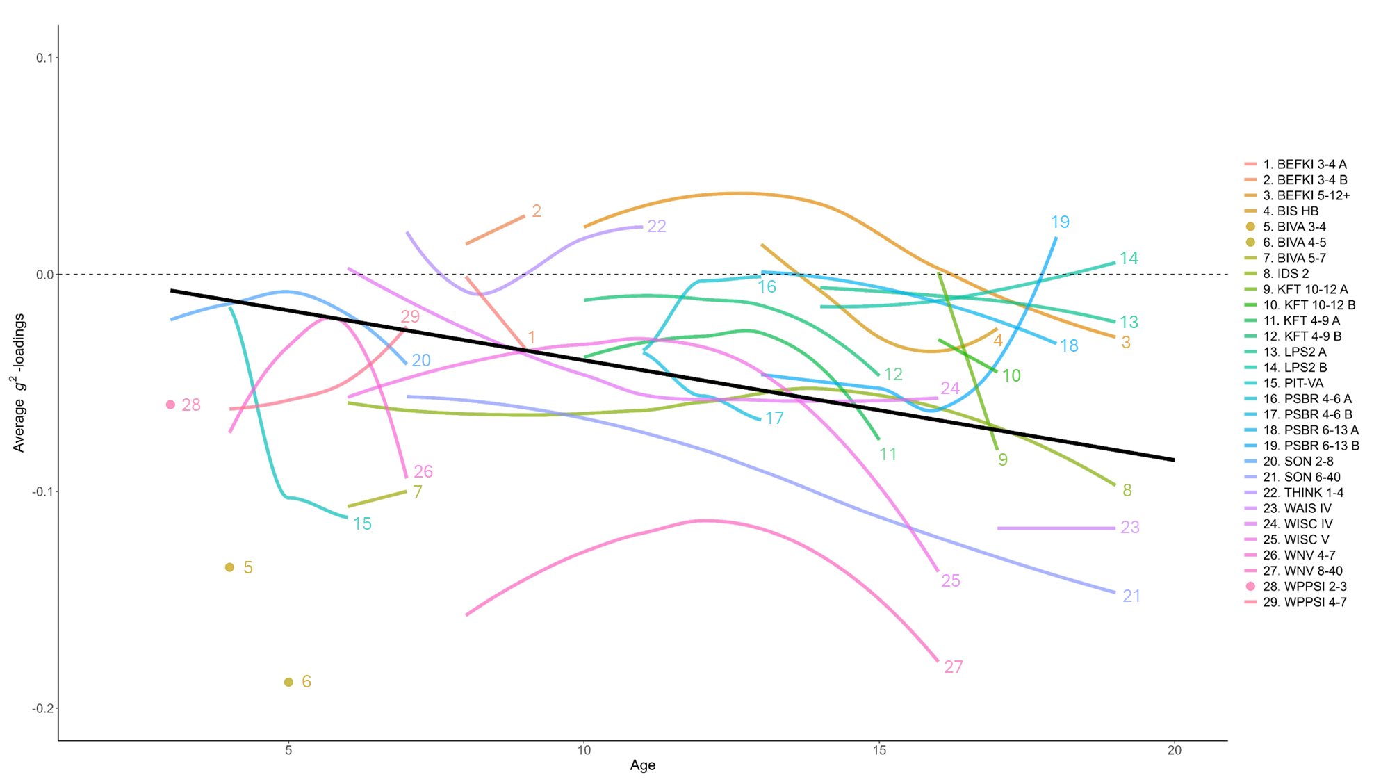
Note. The colored lines represent the smoothed trajectory of the average g²-factor loading across age in each sample black solid line represents the meta-analytic mean effect for the interaction effect (non-significant).

