Supplement
Table of Contents
S1. Overview of included studies 2
S2. Variance Decomposition Main Model 10
S3. Funnel Plot Main Model 11
S4. Sensitivity Analysis Main Model 12
S5. Leave-one-out analysis 13
S6. Variance Decomposition Main Model excluding Wang et al., 2018 20
S7. Funnel Plot Main Model excluding Wang et al., 2018 21
S8. Trim and Fill adjusted Model results 22
S9. Forest Plot of the main model with grouped at-risk samples 23
S10. Model Parameters for task moderator analyses 24
S11. Model Parameters for sample characteristics moderator analyses 26
S12. Model Parameters for clinical characteristics moderator analyses 27
S13. Moderator analyses for clinical characteristics in high reward trials 29
S14. Moderator analyses for clinical characteristics in high probability trials 30
S15. Moderator analyses for effort allocation from low to high reward/probability trials by cognitive functioning 31
S16. Moderator analyses for cognitive domains across all trials 33

S1. Overview of included studies
Table S1
Sample characteristics
 |  |  | Clinical Groups |  |  | Control groups
Source | Country | Risk of Bias | N | Age (SD) | Gender (%female) | N | Age (SD) | Gender (%female) | Task name | Effort Modality | Reward Type | Hedges g effect size
Schizophrenia Spectrum Disorder Samples
Barch et al., 2014 | USA | Moderate | 59 | 39.3 (8.12) | 42 | 39 | 37.4 (9.2) | 51 | Effort Expenditure for Rewards Task | Physical | Monetary | -0.195
Barch et al., 2023 | USA | Moderate | 50 | 34.73 (8.51) | 44 | 80 | 36.39 (9.19) | 59 | Deck Choice Task | Cognitive | Monetary | -0.256
Bergé et al., 2018 | Spain | Moderate | 43 | 35.13 (9.2) | 39 | 35 | 28.33 (7.2) | 60 | The reward and effort tasks | Physical | Monetary | -0.435
Cathomas et al., 2021 | Switzerland | Moderate | 42 | 34.69 (10.3) | 29 | 18 | 33 (9.49) | 50 | Effort Discounting Task | Physical | Monetary | 0.139
Chang et al., 2019 | China | Low | 45 | 24.9 (7) | 47 | 45 | 25 (6.7) | 60 | Effort Expenditure for Rewards Task | Physical | Monetary | -0.060
Chang et al., 2020 | China | High | 40 | 24.2 (6.6) | 60 | 44 | 25.1 (6.8) | 61 | Cognitive Effort-Discounting task | Cognitive | Monetary | -0.060
Culbreth et al., 2016 | USA | Moderate | 25 | 35 (10.3) | 58 | 25 | 36 (7) | 48 | Cognitive Effort-Discounting task | Cognitive | Monetary | -0.209
Culbreth et al., 2020 | USA | Low | 28 | 37.18 (12.25) | 29 | 30 | 35.2 (10.63) | 23 | Cognitive Effort-Discounting task | Cognitive | Monetary | -0.224
Culbreth et al., 2024 |  | Moderate |  |  |  |  |  |  |  |  |  | -
Schizophrenia | USA |  | 33 | 39.2 (11.2) | 44 | 70 | 34.9 (10.2) | 50 | Balloon Effort Task | Physical | Monetary | -0.297
Schizoaffective | USA |  | 28 | 36.1 (11.9) | 32 | 70 | 34.9 (10.2) | 50 | Balloon Effort Task | Physical | Monetary | -0.147
Culbreth et al., 2024 b | USA | Moderate | 30 | 41.8 (13.7) | 30 | 30 | 40.1 (11.6) | 40 | Apple Gathering task | Physical | Other | -0.585
Fervaha et al., 2013 | Canada | Moderate | 16 | 28 (4.6) | 63 | 16 | 27.5 (4.5) | 44 | Effort Expenditure for Rewards Task | Physical | Monetary | -0.359
Gold et al., 2013 | USA | Moderate | 44 | 41 (10.8) | 36 | 36 | 39.4 (11) | 39 | Balloon Effort Task | Physical | Monetary | -0.094
Ince Guliyev et al., 2022 | Turkey | Moderate | 31 | 25.45 (5.46) | 26 | 30 | 26 (2.44) | 27 | Effort Expenditure for Rewards Task | Physical | Monetary | -0.670
Hartmann et al., 2014 | Switzerland | Moderate | 31 | 30.42 (8.69) | 19 | 20 | 32.1 (6.79) | 25 | Effort Discounting Task | Physical | Monetary | -0.434
Huang et al., 2016 | China | Moderate | 23 | 34.48 (8.24) | 13 | 23 | 34.91 (6.69) | 35 | Effort Expenditure for Rewards Task | Physical | Monetary | -0.879
Isikli et al., 2024 | Turkey | Moderate | 41 | 40  (8.6) | 24 | 41 | 37.9  (6.5) | 27 | Effort Expenditure for Rewards Task | Physical | Monetary | -0.928
Liang et al., 2023 | Taiwan | High | 31 | 44.97 (-) | 32 | 31 | 37.81 (-) | 36 | Effort Expenditure for Rewards Task | Physical | Monetary | -0.484
 |  |  |  |  |  |  |  |  | Effort Expenditure for Rewards Task | Physical | Social | -0.289
Luther et al., 2023 | USA | Moderate | 30 | 37.43  (11.06) | 63 | 50 | 38.27  (10.79) | 74 | Effort Expenditure for Rewards Task | Physical | Monetary | -0.625
McCarthy et al., 2016 | USA | Moderate | 48 | 48.27 (7.51) | 38 | 27 | 44.22 (13.12) | 48 | Effort Expenditure for Rewards Task | Physical | Monetary | -1.047
Moran et al., 2023 | USA | Moderate | 33 | 33.92 (8.16) | 58 | 58 | 35.17 (8.76) | 50 | Balloon Effort Task | Physical | Monetary | -0.441
Neumann et al., 2021 | New Zealand | Moderate | 30 | 44 (11) | 20 | 30 | 32 (10) | 63 | Effort Expenditure for Rewards Task | Physical | Monetary | -0.508
Olsen 2015 | USA | Moderate | 28 | 46.08 (9.46) | 50 | 28 | 43.85 (13.9) | 63 | Effort-reward task | Cognitive | Other² | -0.200
Prettyman et al., 2021 | USA | Moderate | 21 | 36.6 (7.7) | 43 | 23 | 32.2 (10.3) | 43 | Effort Discounting Bigger Number Task | Cognitive | Monetary | -0.060
Pretus et al., 2021 | Spain | Moderate | 28 | 37.21 (8.62) | 36 | 20 | 31.35 (8.59) | 50 | Lottery game | Physical | Monetary | 0.096
Reddy et al., 2015 | USA | Low | 94 | 49.1 (11.7) | 31 | 40 | 47.2 (8.1) | 40 | Balloon Effort Task | Physical | Monetary | -0.361
 |  |  |  |  |  |  |  |  | Deck Choice Task | Cognitive | Monetary | -0.500
 |  |  |  |  |  |  |  |  | Perceptual Effort Task | Perceptual | Monetary | 0.177
 |  |  |  |  |  |  |  |  | Grip Effort Task | Physical | Monetary | -0.270
 |  |  |  |  |  |  |  |  | Effort Expenditure for Rewards Task | Physical | Monetary | -0.177
Reddy et al., 2018 | USA | Moderate | 33 | 46.2 (10.2) | 39 | 30 | 47.9 (7.8) | 47 | Deck Choice Task | Cognitive | Monetary | -0.288
Renz & Lincoln 2022 | Germany | Moderate | 28 | 38.6 (9.27) | 30 | 29 | 39.63 (14.02) | 40 | Balloon Effort Task | Physical | Monetary | -0.343
Saleh et al., 2023 | UK | Moderate | 40 | 46.35 (10.12) | 10 | 40 | 42.78 (12.72) | 3 | Apple Gathering task | Physical | Monetary | -0.268
Saperia et al., 2023 | Canada | Moderate | 51 | 32.9 (9.8) | 49 | 51 | 31.7 (11) | 51 | Effort Expenditure for Rewards Task | Physical | Monetary | -0.134
Shao et a., 2024 | China | Moderate | 41 | 22.31  (4.47) | 47 | 41 | 29.94  (4.31) | 49 | Mock Job Interview | Otherª | Social | -1.017
Strauss et al., 2016 | USA | Moderate | 27 | 40.3 (12.9) | 33 | 32 | 38.06 (11.15) | 34 | Balloon Effort Task | Physical | Monetary | -0.075
Treadway et al., 2015 | USA | Moderate | 12 | 38.5 (10.1) | 42 | 15 | 39.7 (8.2) | 60 | Effort Expenditure for Rewards Task | Physical | Monetary | -0.271
Vogel et al., 2015 | USA | Moderate | 50 | 40.76 (12.51) | 46 | 25 | 38.08 (14.97) | 48 | Effort Expenditure for Rewards Task | Physical | Monetary | -0.562
Wang et al., 2015 |  | Moderate
No negative symptoms | China |  | 18 | 33.22 (10.86) | 61 | 29 | 31.69 (8.82) | 31 | Effort-based pleasure experience task | Physical | Monetary | -0.605
Elevated negative symptoms |  |  | 22 | 35.73 (8.47) | 9 | 29 | 31.69 (8.82) | 31 | Effort-based pleasure experience task | Physical | Monetary | -0.869
Wang et al., 2022 | China | Moderate | 20 | 27.46 (7.99) | 55 | 30 | 26.87 (4.97) | 60 | Effort Expenditure for Rewards Task | Physical | Monetary | -0.674
Wang et al., 2024 | China | Moderate | 50 | 38.05  (9.53) | 70 | 56 | 38.8  (8.52) | 79 | Effort Based Pleasure Experience Task | Physical | Monetary | -0.427
Whitton et al., 2020 | USA | Moderate
Schizoaffective Disorder |  |  | 42 | 34.4  (11) | 45 | 52 | 37.8 (14.4) | 42 | Effort Expenditure for Rewards Task | Physical | Monetary | -0.214
Schizophrenia |  |  | 49 | 34.4  (11)^{i} | 45 ^{i} | 52 | 37.8 (14.4) | 42 | Effort Expenditure for Rewards Task | Physical | Monetary | -0.265
Wolf et al., 2014 | USA | Moderate | 41 | 41.7 (10.7) ^{i} | 46 ^{i} | 37 | 39.2 (12.1) | 51 | Progressive Ratio Task (number comparison) | Cognitive | Monetary | -0.211
Yang et al., 2021 | China | Moderate
Acute Schizophrenia |  |  | 30 | 25.48 (6.48) | 60 | 43 | 27.02 (5.83) | 60 | Effort Expenditure for Rewards Task | Physical | Monetary | -0.501
Stabilized Schizophrenia |  |  | 33 | 30.51 (8.66) | 76 | 43 | 27.02 (5.83) | 60 | Effort Expenditure for Rewards Task | Physical | Monetary | -0.276
Zhou et al., 2024 | China | Moderate | 61 | 29.10 (6.00) | 62.3 | 46 | 28.24 (6.81) | 58.47
 |  |  |  |  |  |  |  |  | Effort Expenditure for Rewards Task | Cognitive | Monetary | -1.097
 |  |  |  |  |  |  |  |  | Effort Expenditure for Rewards Task | Physical | Monetary | -0.512
Zou et al., 2020 | China | Moderate | 49 | 29.86 (7.46) | 45 | 57 | 32.35 (7.58) | 52 | Effort Expenditure for Rewards Task | Physical | Monetary | -0.954
Depression Samples
 |  |  | Clinical Groups |  |  | Control groups
Source | Country | Risk of Bias | N | Age (SD) | Gender (%female) | N | Age (SD) | Gender (%female) | Task name | Effort Modality | Reward Type | Hedges g effect size
Ang et al., 2023 | USA | Moderate | 26 | 25 (7.9) | 54 | 44 | 26.8 (5.9) | 71 | Cognitive Effort Motivation Task | Physical | Monetary | -0.805
Barch et al., 2023 | USA | Moderate
Acute Depression |  |  | 60 | 34.73 (8.44) | 62 | 80 | 36.39 (9.19) | 59 | Deck Choice Task | Cognitive | Monetary | -0.042
Remitted Depression |  |  | 51 | 36.14 (8.44) | 57 | 80 | 36.39 (9.19) | 59 | Deck Choice Task | Cognitive | Monetary | -0.095
Berwian et al., 2020 | Switzerland | Moderate | 74 | 34.1 (10.7) | 77 | 34 | 32.3 (10.02) | 65 | Balloon Effort Task | Physical | Other^{b} | -0.480
Cathomas et al., 2021 | Switzerland | Moderate | 44 | 34.69 (11.06) | 59 | 18 | 33 (9.49) | 50 | Effort Discounting Task | Physical | Monetary | 0.152
Cléry-Melin et al., 2011 | France | Moderate | 22 | 43.3 (2.9) | 77 | 26 | 44.8 (2.8) | 65 | The incentive force task | Physical | Monetary | 0.091
Culbreth et al., 2024 | USA | Moderate | 40 | 35.79 (9.4) | 48 | 70 | 34.9 (10.2) | 50 | Balloon Effort Task | Physical | Monetary | 0.062
Hershenberg et al., 2016 | USA | Moderate | 25 | 38.8 (12.8) | 44 | 43 | 40.2 (11.7) | 53 | Progressive Ratio Task (number comparison) | Physical | Monetary | -0.766
Klawohn et al., 2022 | USA | Moderate | 65 | 38.01 (11.83) | 80 | 44 | 34.88 (14.12) | 77 | Progressive Ratio Task | Physical | Monetary | -0.126
Mansur et al., 2019 | Canada | Moderate | 21 | 38.47 (12.85) | 57 | 20 | 41.50 (14.21) | 50 | Effort Expenditure for Rewards Task | Physical | Monetary
normal weight |  |  |  |  |  |  |  |  |  |  |  | -0.553
overweight |  |  |  |  |  |  |  |  |  |  |  | -1.012
Moran et al., 2023 | USA | Moderate | 61 | 33.92 (8.88) | 75 | 58 | 35.17 (8.76) | 50 | Balloon Effort Task | Physical | Monetary | -0.211
Saperia et al., 2023 | Canada | Moderate | 43 | 32.9 (11.2) | 54 | 51 | 31.7 (11) | 51 | Effort Expenditure for Rewards Task | Physical | Monetary | 0.144
Sherdell et al., 2012 | USA | Moderate | 31 | 44.42 (13.4) | 50 | 26 | 35.97 (12.18) | 47 | Effort-reward task | Physical | Other^{b} | 0.133
Tran et al., 2021 | Canada | Moderate | 44 | 37.07 (14.32) | 71 | 36 | 35.58 (14.85) | 75 | Effort Expenditure for Rewards Task | Physical | Monetary | 0.008
 |  |  |  |  |  |  |  |  | Modified N-back working memory task | Cognitive | Monetary | 0.044
Treadway et al., 2012 | USA | Moderate | 20 | 42.4 (10.1) | 70 | 15 | 39.7 (8.2) | 60 | Effort Expenditure for Rewards Task | Physical | Monetary | -0.800
Valton et al., 2025 | UK | Low
current |  |  | 41 | 30.24 (11.57) | 70 | 57 | 26.7 (8.14) | 68 | Apple Gathering task | Physical | Other | -0.212
remitted |  |  | 46 | 26.91 (7.06) | 63 | 57 | 26.7 (8.14) | 68 | Apple Gathering task | Physical | Other | -0.387
Vinckier et al., 2022 | France | Moderate | 20 | 45.7 (19.0) | 55 | 35 | 43.0 (16.3) | 51
 |  |  |  |  |  |  |  |  | Cognitive Effort Task | Cognitive | Monetary | -1.381
 |  |  |  |  |  |  |  |  | Hand Grip Task | Physical | Monetary | -0.915
Wang et al., 2022 | China | Moderate | 23 | 27.46 (9.19) | 65 | 30 | 26.87 (4.97) | 60 | Effort Expenditure for Rewards Task | Physical | Monetary | -0.288
Wang et al., 2024 | China | Moderate | 46 | 35.68  (9.33) | 87 | 56 | 38.8  (8.52) | 79 | Effort-based pleasure experience task | Physical | Monetary | -0.230
Yang et al., 2014 | China | Low
First episode |  |  | 46 | 27.48 (6.61) | 44 | 50 | 25.78 (7.61) | 43 | Effort Expenditure for Rewards Task | Physical | Monetary | -0.340
Remitted |  |  | 46 | 26 (5.49) | 49 | 50 | 25.78 (7.61) | 46 | Effort Expenditure for Rewards Task | Physical | Monetary | -0.071
Yang et al., 2021 | China | Moderate | 37 | 25.48 (7.56) | - | 43 | 27.02 (5.83) | - | Effort Expenditure for Rewards Task | Physical | Monetary | -0.112
Zou et al., 2020 | China | Moderate | 40 | 29.86 (8.21) | 44 | 57 | 32.35 (7.58) | 52 | Effort Expenditure for Rewards Task | Physical | Monetary | -0.676
Bipolar Disorder Samples
 |  |  | Clinical Groups |  |  | Control groups
Source | Country | Risk of Bias | N | Age (SD) | Gender (%female) | N | Age (SD) | Gender (%female) | Task name | Effort Modality | Reward Type | Hedges g effect size
Barch et al., 2023 | USA | Moderate | 58 | 37.56 (8.78) | 64 | 80 | 36.39 (9.19) | 59 | Deck Choice Task | Cognitive | Monetary | -0.211
Culbreth et al., 2024 | USA | Moderate | 39 | 37.7 (10.8) | 62 | 70 | 34.9 (10.2) | 50 | Balloon Effort Task | Physical | Monetary | -0.243
Hershenberg et al., 2016 | USA | Moderate | 28 | 36.4 (11.7) | 64 | 43 | 40.2 (11.7) | 36 | Progressive Ratio Task (number comparison) | Physical | Monetary | -0.874
Isıklı et al., 2024 | Turkey | Moderate | 34 | 41.1 (10.8) | 41 | 41 | 37.9  (6.5) | 27 | Effort Expenditure for Rewards Task | Physical | Monetary | -0.563
Johnson et al., 2024 | USA | Moderate | 49 | 37.77 (13.47) | 65.3 | 39 | 31.16 (13.38) | 64.9 | Effort Discounting Task | Physical | Monetary | -0.285
Moran et al., 2023 | USA | Moderate | 47 | 37.55 (8.28) | 66 | 58 | 35.17 (8.76) | 50 | Balloon Effort Task | Physical | Monetary | -0.138
Vinckier et al., 2022 | France | Moderate | 15 | 38.1 (12.9) | 47 | 35 | 43.0 (16.3) | 51
 |  |  |  |  |  |  |  |  | Cognitive Effort Stroop Task | Cognitive | Monetary | -1.112
 |  |  |  |  |  |  |  |  | Hand Grip Task | Physical | Monetary | -1.079
Wang et al., 2022 | China | Moderate | 17 | 30.06 (9.02) | 41.18 | 30 | 26.87 (4.97) | 60 | Effort Expenditure for Rewards Task | Physical | Monetary | -0.586
Yang et al., 2021 | China | Moderate
Bipolar depressed |  |  | 32 | 27.28 (7.87) | 22 | 47 | 27.02 (5.83) | 60 | Effort Expenditure for Rewards Task | Physical | Monetary | -0.108
Bipolar manic |  |  | 33 | 26.94 (6.31) | 33 | 47 | 27.02 (5.83) | 60 | Effort Expenditure for Rewards Task | Physical | Monetary | -0.156
Zou et al., 2020 | China | Moderate | 52 | 31.19 (6.37) | 50 | 57 | 32.35 (7.58) | 52 | Effort Expenditure for Rewards Task | Physical | Monetary | -0.126
At-Risk Samples
 |  |  | Clinical Groups |  |  | Control groups
Source | Country | Risk of Bias | N | Age (SD) | Gender (%female) | N | Age (SD) | Gender (%female) | Task name | Effort Modality | Reward Type | Hedges g effect size
Bi et al., 2021 | China | Moderate | 33 | 20.73 (2.20) | 70 | 30 | 20.23 (1.70) | 57
rewards for others |  |  |  |  |  |  |  |  | Effort Expenditure for Rewards Task | Physical | Monetary | 0.542
rewards for self |  |  |  |  |  |  |  |  | Effort Expenditure for Rewards Task | Physical | Monetary | 0.011
Bonnelle et al., 2015 | UK | Moderate | 25 | - | - | 25 | - | -
high reward-easy task |  |  |  |  |  |  |  |  | Apple Gathering task | Physical | Monetary | 0.033
high reward-hard task |  |  |  |  |  |  |  |  | Apple Gathering task | Physical | Monetary | -0.009
low reward-easy task |  |  |  |  |  |  |  |  | Apple Gathering task | Physical | Monetary | 0.014
low reward-hard task |  |  |  |  |  |  |  |  | Apple Gathering task | Physical | Monetary | -0.099
Bora et al., 2024 | Turkey | Moderate
UHR-BD |  |  | 32 | 20.9 (4.0) | 66 | 44 | 21.9 (4.4) | 66 | Effort Expenditure for Rewards Task | Physical | Monetary | -0.023
UHR-SZ |  |  | 44 | 20.0 (4.1) | 47 | 44 | 21.9 (4.4) | 66 | Effort Expenditure for Rewards Task | Physical | Monetary | -0.115
Chu et al., 2023 | China | Moderate
amotivation |  |  | 20 | 21.50 (2.54) | - | 40 | 21.03 (3.15) | - | Effort Expenditure for Rewards Task | Physical | Monetary | -0.108
schizotypy |  |  | 40 | 20.83 (2.81) | - | 40 | 21.03 (3.15) | - | Effort Expenditure for Rewards Task | Physical | Monetary | 0.005
Ermel et al., 2019 | USA | Moderate | 63 | - | - | 63 | - | - | Balloon Effort Task | Physical | Monetary | 0.292
Horne et al., 2024 | USA | Moderate | 85 | 31.7 (4.41) | 33 | 79 | 34.2 (7.90) | 62 | Cognitive Effort Task | Physical | Monetary | 0.081
Lafond-Brina et al., 2023 | France | Moderate | 23 | 20.74 (2.22) | 70 | 24 | 21.95 (1.73) | 58 | Deck Choice Task | Cognitive | Monetary | -0.606
McCarthy et al., 2015 | USA | High
positive schizotypy |  |  | 30 | 18.77 (.97) | 76.7 | 40 | 20.35 (2.47) | 72.5 | Effort Expenditure for Rewards Task | Physical | Monetary | -0.146
social anhedonia |  |  | 30 | 20.40 (3.35) | 70 | 40 | 20.35 (2.47) | 72.5 | Effort Expenditure for Rewards Task | Physical | Monetary | 0.390
Rzepa et al., 2017 | UK | Moderate | 16 | 16.63 (1.21) | 75 | 17 | 16.24 (1.6) | 65 | Progressive Ratio Task | Physical | Other | 0.242
Slaney et al., 2023 | UK | Moderate | 32 | 22.8 (8.6) | 47 | 34 | 24.0 (5.1) | 79
 |  |  |  |  |  |  |  |  | Effort Expenditure for Rewards Task | Physical | Monetary | -0.517
 |  |  |  |  |  |  |  |  | Joystick-Operated Runway Task | Physical | Other | -0.206
Strauss et al., 2023 | USA | Moderate | 44 | 20.43 (2.50) | 72.7 | 32 | 20.65 (1.89) | 64.5 | Effort Expenditure for Rewards Task | Physical | Monetary | -0.378
Terenzi et al., 2019 | France | Moderate
high vs. low psychotic experiences |  |  | 19 | 23.47 (2.91) | 74 | 20 | 23.75 (2.71) | 45 | Concurrent Schedule Task | Physical | Other | -0.066
medium vs. low psychotic experiences |  |  | 21 | 23.09 (3.3) | 76 | 20 | 23.75 (2.71) | 45 | Concurrent Schedule Task | Physical | Other | 0.087
Terenzi et al., 2024 | France | Moderate | 19 | 22.53 (2.01) | 89 | 20 | 22.70 (1.78) | 80 | Effort Discounting Task | Physical | Other | 0.090
Valton et al., 2025 | UK | Low | 36 | 26.06 (8.19) | 64 | 57 | 26.7 (8.14) | 68 | Apple Gathering task | Physical | Other | 0.163
Wang et al., 2018 | China | Moderate | 28 | 20.92  (2.43) | 43 | 26 | 21.41  (1.79) | 50 | Effort-based pleasure experience task | Physical | Monetary | -4.654
Yang et al., 2014 | China | Low | 43 | 18.33 (1.07) | 58 | 56 | 18.18 (0.88) | 59 | Effort Expenditure for Rewards Task | Physical | Monetary | -0.147
Note. ªperforming a job-interview; ^{b} Humorous video clips/cartoons (Olsen, 2015; Sherdell et al., 2012) or bonus points (Berwian et al., 2020).

S2. Variance Decomposition Main Model

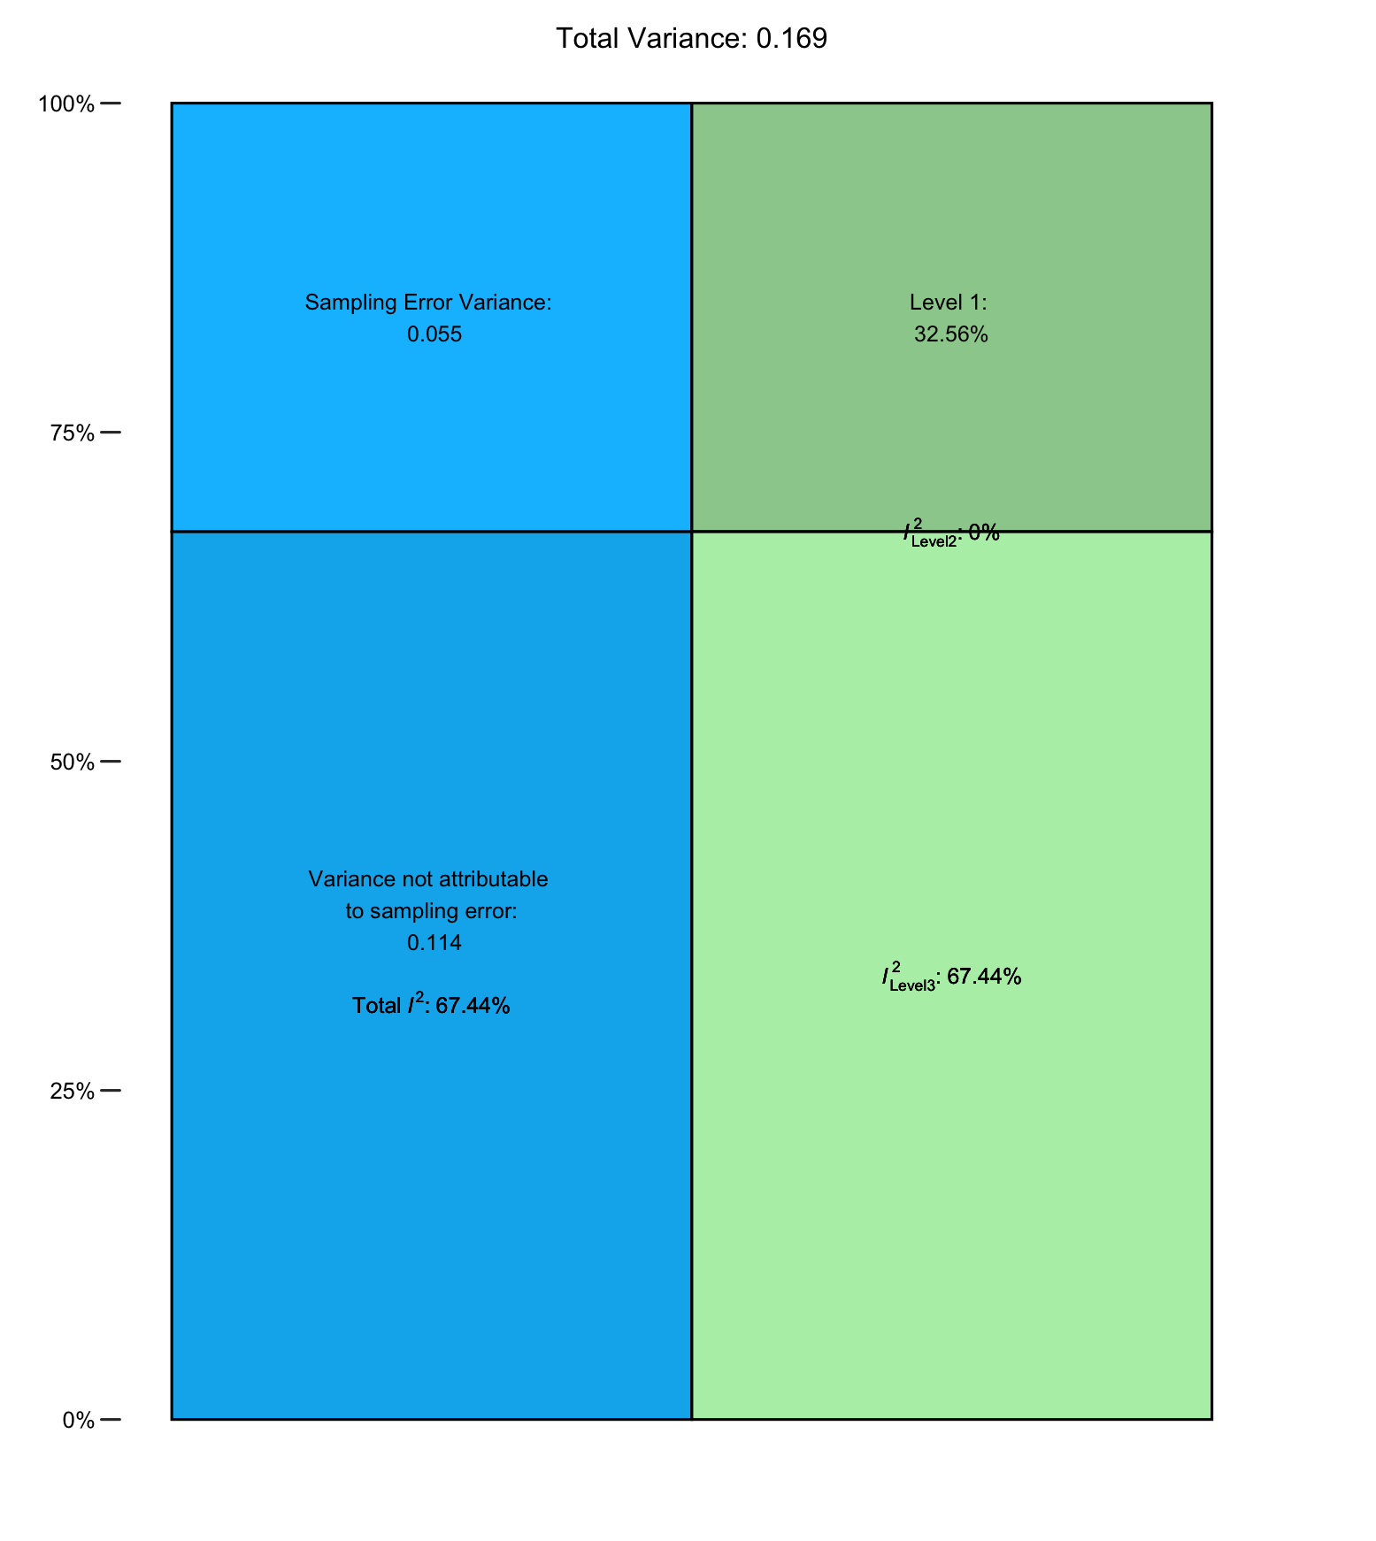

S3. Funnel Plot Main Model

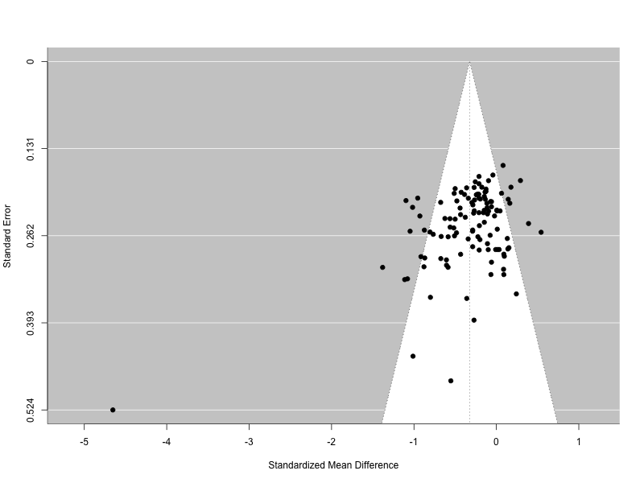

S4. Sensitivity Analysis Main Model

S5. Leave-one-out analysis
Study | estimate | se | tval | pval | ci.lb | ci.ub | Q | Qp | tau2 | I2 | H2
Zou et al., 2020.1 | -0.2978 | 0.0349 | -8.5359 | 0 | -0.3669 | -0.2287 | 288.0177 | 0 | 0.0786 | 58.782 | 2.4261
Zou et al., 2020.2 | -0.3014 | 0.0355 | -8.4911 | 0 | -0.3718 | -0.2311 | 295.3891 | 0 | 0.0834 | 60.2359 | 2.5148
Zou et al., 2020.3 | -0.3073 | 0.0358 | -8.5908 | 0 | -0.3781 | -0.2364 | 298.2939 | 0 | 0.0854 | 60.7491 | 2.5477
Zhou et al., 2024 (physical effort) | -0.3032 | 0.0357 | -8.4914 | 0 | -0.374 | -0.2325 | 297.5398 | 0 | 0.085 | 60.645 | 2.541
Zhou et al., 2024 (cognitive effort) | -0.2959 | 0.0345 | -8.5861 | 0 | -0.3641 | -0.2276 | 283.4776 | 0 | 0.0753 | 57.7673 | 2.3678
Yang et al., 2021 (stablilized SSD) | -0.3057 | 0.0358 | -8.5454 | 0 | -0.3766 | -0.2348 | 298.9348 | 0 | 0.0856 | 60.8999 | 2.5575
Yang et al., 2021 (actute SSD) | -0.3036 | 0.0357 | -8.5066 | 0 | -0.3743 | -0.2329 | 298.0544 | 0 | 0.085 | 60.7326 | 2.5466
Yang et al., 2021 (Bipoplar manic) | -0.3068 | 0.0357 | -8.5822 | 0 | -0.3776 | -0.236 | 298.6408 | 0 | 0.0854 | 60.8374 | 2.5535
Yang et al., 2021 (Bipolar depressed) | -0.3072 | 0.0357 | -8.6001 | 0 | -0.378 | -0.2364 | 298.3737 | 0 | 0.0852 | 60.7833 | 2.5499
Yang et al., 2021 | -0.3072 | 0.0357 | -8.5981 | 0 | -0.378 | -0.2364 | 298.354 | 0 | 0.0852 | 60.7778 | 2.5496
Yang et al., 2014 (Remitted) | -0.3076 | 0.0357 | -8.6155 | 0 | -0.3784 | -0.2369 | 297.9506 | 0 | 0.085 | 60.6959 | 2.5443
Yang et al., 2014 (First Episode) | -0.3051 | 0.0358 | -8.5226 | 0 | -0.376 | -0.2342 | 298.8454 | 0 | 0.0857 | 60.8754 | 2.5559
Yang et al., 2014 | -0.307 | 0.0358 | -8.5832 | 0 | -0.3779 | -0.2361 | 298.5049 | 0 | 0.0855 | 60.799 | 2.551
Wolf et al., 2014 | -0.3063 | 0.0358 | -8.564 | 0 | -0.3772 | -0.2354 | 298.8444 | 0 | 0.0855 | 60.8794 | 2.5562
Whitton et al., 2020 (Schizophrenia) | -0.3058 | 0.0358 | -8.5432 | 0 | -0.3768 | -0.2349 | 298.9305 | 0 | 0.0857 | 60.8887 | 2.5568
Whitton et al., 2020 (Schizoaffective | -0.3064 | 0.0358 | -8.5575 | 0 | -0.3773 | -0.2354 | 298.8278 | 0 | 0.0857 | 60.8586 | 2.5548
Wang et al., 2024.1 | -0.3042 | 0.0358 | -8.5019 | 0 | -0.375 | -0.2333 | 298.3645 | 0 | 0.0855 | 60.7874 | 2.5502
Wang et al., 2024.2 | -0.3062 | 0.0358 | -8.5522 | 0 | -0.3772 | -0.2353 | 298.8733 | 0 | 0.0857 | 60.8678 | 2.5554
Wang et al., 2022.1 | -0.3025 | 0.0355 | -8.5144 | 0 | -0.3728 | -0.2321 | 297.1475 | 0 | 0.0839 | 60.5079 | 2.5322
Wang et al., 2022.2 | -0.3033 | 0.0356 | -8.5228 | 0 | -0.3738 | -0.2328 | 297.945 | 0 | 0.0844 | 60.6684 | 2.5425
Wang et al., 2022.3 | -0.3055 | 0.0357 | -8.5553 | 0 | -0.3763 | -0.2348 | 298.934 | 0 | 0.0853 | 60.8925 | 2.5571
Wang et al., 2018 | -0.2869 | 0.0317 | -9.0573 | 0 | -0.3496 | -0.2241 | 229.1502 | 0 | 0.0559 | 50.5914 | 2.0239
Wang et al., 2015 (no negative sympto | -0.3031 | 0.0356 | -8.5207 | 0 | -0.3736 | -0.2326 | 297.8004 | 0 | 0.0843 | 60.6398 | 2.5406
Wang et al., 2015 (elevated negative | -0.3008 | 0.0353 | -8.5169 | 0 | -0.3707 | -0.2308 | 294.929 | 0 | 0.0823 | 60.0342 | 2.5021
Vogel et al., 2015 | -0.3031 | 0.0356 | -8.5054 | 0 | -0.3736 | -0.2325 | 297.6406 | 0 | 0.0846 | 60.6434 | 2.5409
Vinckier et al., 2022 (Hand Grip Task | -0.2996 | 0.0351 | -8.5354 | 0 | -0.3691 | -0.23 | 292.9255 | 0 | 0.0807 | 59.594 | 2.4749
Vinckier et al., 2022 (Hand Grip Task | -0.3003 | 0.0352 | -8.5199 | 0 | -0.3701 | -0.2305 | 294.2141 | 0 | 0.0817 | 59.8807 | 2.4926
Vinckier et al., 2022 (Cognitive Effo | -0.2964 | 0.0345 | -8.596 | 0 | -0.3647 | -0.2281 | 286.2211 | 0 | 0.0759 | 58.1027 | 2.3868
Vinckier et al., 2022 (Cognitive Effo | -0.2993 | 0.0351 | -8.539 | 0 | -0.3688 | -0.2299 | 292.4524 | 0 | 0.0803 | 59.4926 | 2.4687
Valton et al., 2025 (remitted) | -0.3046 | 0.0358 | -8.5105 | 0 | -0.3755 | -0.2337 | 298.6422 | 0 | 0.0856 | 60.8369 | 2.5534
Valton et al., 2025 (current) | -0.3064 | 0.0358 | -8.5594 | 0 | -0.3773 | -0.2355 | 298.8272 | 0 | 0.0857 | 60.864 | 2.5552
Valton et al., 2025 | -0.3096 | 0.0354 | -8.742 | 0 | -0.3797 | -0.2394 | 294.5939 | 0 | 0.0827 | 60.034 | 2.5021
Treadway et al., 2015 | -0.3055 | 0.0356 | -8.5796 | 0 | -0.376 | -0.235 | 298.9346 | 0 | 0.0848 | 60.8295 | 2.5529
Treadway et al., 2012 | -0.3021 | 0.0354 | -8.5262 | 0 | -0.3723 | -0.2319 | 296.7676 | 0 | 0.0834 | 60.4015 | 2.5253
Tran et al., 2021 (EEfRT) | -0.3082 | 0.0356 | -8.6504 | 0 | -0.3788 | -0.2376 | 297.2893 | 0 | 0.0844 | 60.5649 | 2.5358
Tran et al., 2021 (Cognitive Effort T | -0.3085 | 0.0356 | -8.6685 | 0 | -0.379 | -0.238 | 296.843 | 0 | 0.0841 | 60.4751 | 2.53
Terenzi et al., 2024 | -0.3079 | 0.0355 | -8.6619 | 0 | -0.3783 | -0.2375 | 297.601 | 0 | 0.0842 | 60.5983 | 2.538
Terenzi et al., 2019 (medium vs. low | -0.3079 | 0.0355 | -8.6627 | 0 | -0.3784 | -0.2375 | 297.5556 | 0 | 0.0841 | 60.5911 | 2.5375
Terenzi et al., 2019 (high vs. low ps | -0.3069 | 0.0356 | -8.6151 | 0 | -0.3775 | -0.2363 | 298.4915 | 0 | 0.0848 | 60.7814 | 2.5498
Strauss et al., 2021 | -0.3048 | 0.0358 | -8.5241 | 0 | -0.3756 | -0.2339 | 298.757 | 0 | 0.0855 | 60.8694 | 2.5555
Strauss et al., 2016 | -0.3072 | 0.0357 | -8.6125 | 0 | -0.3779 | -0.2366 | 298.3239 | 0 | 0.085 | 60.7692 | 2.549
Slaney et al., 2023 (JORT) | -0.3063 | 0.0357 | -8.5691 | 0 | -0.3771 | -0.2355 | 298.8477 | 0 | 0.0854 | 60.8817 | 2.5563
Slaney et al., 2023 (EEfRT) | -0.3035 | 0.0357 | -8.5096 | 0 | -0.3741 | -0.2328 | 298.0279 | 0 | 0.0848 | 60.7213 | 2.5459
Sherdell et al., 2012 | -0.3087 | 0.0355 | -8.6959 | 0 | -0.379 | -0.2384 | 296.5269 | 0 | 0.0836 | 60.3895 | 2.5246
Shao et al., 2024 | -0.2974 | 0.0348 | -8.5494 | 0 | -0.3663 | -0.2284 | 287.5134 | 0 | 0.0778 | 58.5872 | 2.4147
Saperia et al., 2023 | -0.3071 | 0.0358 | -8.5885 | 0 | -0.3779 | -0.2363 | 298.4415 | 0 | 0.0854 | 60.7897 | 2.5503
Saperia et al. 2023 | -0.3095 | 0.0354 | -8.7336 | 0 | -0.3797 | -0.2393 | 294.7307 | 0 | 0.0829 | 60.07 | 2.5044
Saleh et al., 2023 | -0.3058 | 0.0358 | -8.5466 | 0 | -0.3767 | -0.2349 | 298.9326 | 0 | 0.0856 | 60.8981 | 2.5574
Rzepa et al., 2017 | -0.3084 | 0.0354 | -8.7028 | 0 | -0.3787 | -0.2382 | 296.7023 | 0 | 0.0834 | 60.4109 | 2.5259
Renz & Lincoln 2022 | -0.3051 | 0.0357 | -8.541 | 0 | -0.3759 | -0.2343 | 298.878 | 0 | 0.0854 | 60.886 | 2.5566
Reddy et al., 2018 | -0.3056 | 0.0357 | -8.5491 | 0 | -0.3764 | -0.2347 | 298.9338 | 0 | 0.0855 | 60.9003 | 2.5576
Reddy et al., 2015 (Perceptual Effort | -0.31 | 0.0353 | -8.7704 | 0 | -0.38 | -0.24 | 293.0444 | 0 | 0.0821 | 59.7837 | 2.4866
Reddy et al., 2015 (Grip Effort Task) | -0.3058 | 0.0358 | -8.5368 | 0 | -0.3768 | -0.2349 | 298.9326 | 0 | 0.0859 | 60.8675 | 2.5554
Reddy et al., 2015 (EEfRT) | -0.3068 | 0.0358 | -8.5695 | 0 | -0.3777 | -0.2359 | 298.6375 | 0 | 0.0856 | 60.8089 | 2.5516
Reddy et al., 2015 (Deck Choice Task) | -0.3033 | 0.0357 | -8.4899 | 0 | -0.3741 | -0.2325 | 297.5772 | 0 | 0.0851 | 60.6504 | 2.5413
Reddy et al., 2015 (Balloon Task) | -0.3049 | 0.0358 | -8.5125 | 0 | -0.3758 | -0.2339 | 298.7463 | 0 | 0.0858 | 60.8432 | 2.5538
Pretus et al., 2021 | -0.3082 | 0.0355 | -8.6711 | 0 | -0.3786 | -0.2378 | 297.2854 | 0 | 0.084 | 60.5404 | 2.5342
Prettyman et al., 2021 | -0.3071 | 0.0356 | -8.6171 | 0 | -0.3777 | -0.2365 | 298.4033 | 0 | 0.0848 | 60.7713 | 2.5492
Olsen 2015 | -0.3062 | 0.0357 | -8.5745 | 0 | -0.377 | -0.2355 | 298.8471 | 0 | 0.0853 | 60.8774 | 2.5561
Neumann et al., 2021 | -0.3036 | 0.0357 | -8.5146 | 0 | -0.3743 | -0.233 | 298.1651 | 0 | 0.0849 | 60.7429 | 2.5473
Moran et al., 2023.1 | -0.3041 | 0.0357 | -8.5084 | 0 | -0.3749 | -0.2333 | 298.3919 | 0 | 0.0853 | 60.8006 | 2.5511
Moran et al., 2023.2 | -0.3065 | 0.0358 | -8.5556 | 0 | -0.3774 | -0.2355 | 298.7944 | 0 | 0.0858 | 60.8298 | 2.553
Moran et al., 2023.3 | -0.3071 | 0.0358 | -8.5863 | 0 | -0.378 | -0.2363 | 298.4104 | 0 | 0.0854 | 60.7754 | 2.5494
McCarthy et al., 2016 | -0.2981 | 0.0349 | -8.5434 | 0 | -0.3672 | -0.229 | 289.8167 | 0 | 0.0788 | 58.959 | 2.4366
McCarthy et al., 2015 (social anhedon | -0.3107 | 0.035 | -8.8645 | 0 | -0.3801 | -0.2412 | 291.3365 | 0 | 0.08 | 59.2948 | 2.4567
McCarthy et al., 2015 (positive schiz | -0.3068 | 0.0357 | -8.5872 | 0 | -0.3776 | -0.236 | 298.6311 | 0 | 0.0853 | 60.8365 | 2.5534
Mansur et al., 2019 (overweight) | -0.3019 | 0.0353 | -8.5403 | 0 | -0.3719 | -0.2318 | 296.196 | 0 | 0.0829 | 60.293 | 2.5185
Mansur et al., 2019 (normal weight) | -0.3042 | 0.0355 | -8.5653 | 0 | -0.3746 | -0.2339 | 298.6099 | 0 | 0.0844 | 60.7177 | 2.5457
Luther et al., 2023 | -0.3023 | 0.0356 | -8.498 | 0 | -0.3728 | -0.2318 | 296.7759 | 0 | 0.0841 | 60.4787 | 2.5303
Liang et al., 2023 (Social reward) | -0.3055 | 0.0357 | -8.5493 | 0 | -0.3764 | -0.2347 | 298.9335 | 0 | 0.0855 | 60.8999 | 2.5575
Liang et al., 2023 (Monetary reward) | -0.3038 | 0.0357 | -8.5157 | 0 | -0.3745 | -0.2331 | 298.2973 | 0 | 0.085 | 60.7722 | 2.5492
Lafond-Brina et al., 2023 | -0.303 | 0.0356 | -8.5181 | 0 | -0.3735 | -0.2326 | 297.725 | 0 | 0.0843 | 60.6288 | 2.5399
Klawohn et al., 2022 | -0.3073 | 0.0358 | -8.591 | 0 | -0.3781 | -0.2364 | 298.3164 | 0 | 0.0854 | 60.7567 | 2.5482
Johnson et al., 2024 | -0.3056 | 0.0358 | -8.5395 | 0 | -0.3765 | -0.2347 | 298.9341 | 0 | 0.0857 | 60.8953 | 2.5572
Isikli et al., 2024.1 | -0.2988 | 0.0351 | -8.5231 | 0 | -0.3683 | -0.2294 | 291.067 | 0 | 0.0801 | 59.2992 | 2.457
Isikli et al., 2024.2 | -0.3029 | 0.0356 | -8.5009 | 0 | -0.3735 | -0.2323 | 297.4796 | 0 | 0.0846 | 60.6191 | 2.5393
Ince Guliyev et al., 2022 | -0.3021 | 0.0355 | -8.5052 | 0 | -0.3725 | -0.2318 | 296.7152 | 0 | 0.0838 | 60.4415 | 2.5279
Huang et al., 2016 | -0.3009 | 0.0353 | -8.5191 | 0 | -0.3709 | -0.2309 | 295.1467 | 0 | 0.0824 | 60.074 | 2.5046
Horne et al., 2024 | -0.3096 | 0.0355 | -8.7201 | 0 | -0.3799 | -0.2392 | 293.5237 | 0 | 0.0831 | 59.9453 | 2.4966
Hershenberg et al., 2016.1 | -0.2999 | 0.0352 | -8.5137 | 0 | -0.3697 | -0.2301 | 293.3966 | 0 | 0.0815 | 59.7488 | 2.4844
Hershenberg et al., 2016.2 | -0.3012 | 0.0354 | -8.5058 | 0 | -0.3713 | -0.231 | 295.3981 | 0 | 0.0829 | 60.1673 | 2.5105
Hartmann et al., 2014 | -0.3044 | 0.0357 | -8.5327 | 0 | -0.375 | -0.2337 | 298.6474 | 0 | 0.0851 | 60.8276 | 2.5528
Gold et al., 2013 | -0.3073 | 0.0357 | -8.6053 | 0 | -0.3781 | -0.2366 | 298.2546 | 0 | 0.0851 | 60.7588 | 2.5483
Fervaha et al., 2013 | -0.305 | 0.0356 | -8.5607 | 0 | -0.3756 | -0.2344 | 298.8841 | 0 | 0.0849 | 60.8374 | 2.5535
Ermel et al., 2019 | -0.311 | 0.035 | -8.8795 | 0 | -0.3804 | -0.2416 | 288.62 | 0 | 0.0795 | 58.9969 | 2.4388
Culbreth et al., 2024 b | -0.3029 | 0.0356 | -8.5086 | 0 | -0.3735 | -0.2324 | 297.578 | 0 | 0.0844 | 60.6209 | 2.5394
Culbreth et al., 2024 (Schizophrenia) | -0.3055 | 0.0358 | -8.5353 | 0 | -0.3764 | -0.2346 | 298.9275 | 0 | 0.0857 | 60.8926 | 2.5571
Culbreth et al., 2024 (Schizoaffectiv | -0.3069 | 0.0357 | -8.585 | 0 | -0.3777 | -0.2361 | 298.5853 | 0 | 0.0854 | 60.8253 | 2.5527
Culbreth et al., 2024.1 | -0.3061 | 0.0358 | -8.5479 | 0 | -0.377 | -0.2351 | 298.9029 | 0 | 0.0858 | 60.875 | 2.5559
Culbreth et al., 2024.2 | -0.3089 | 0.0356 | -8.6875 | 0 | -0.3794 | -0.2385 | 295.9362 | 0 | 0.0838 | 60.3126 | 2.5197
Culbreth et al., 2020 | -0.3061 | 0.0357 | -8.5671 | 0 | -0.3768 | -0.2353 | 298.8918 | 0 | 0.0854 | 60.8882 | 2.5568
Culbreth et al., 2016 | -0.3061 | 0.0357 | -8.5747 | 0 | -0.3768 | -0.2354 | 298.8735 | 0 | 0.0853 | 60.8773 | 2.5561
Cléry-Melin et al., 2011 | -0.3082 | 0.0355 | -8.6698 | 0 | -0.3786 | -0.2377 | 297.2995 | 0 | 0.0841 | 60.5444 | 2.5345
Chu et al., 2023 (schizotypy) | -0.3082 | 0.0356 | -8.6492 | 0 | -0.3788 | -0.2376 | 297.3075 | 0 | 0.0845 | 60.5689 | 2.5361
Chu et al., 2023 (amotivation) | -0.3069 | 0.0357 | -8.6018 | 0 | -0.3776 | -0.2362 | 298.545 | 0 | 0.0851 | 60.8117 | 2.5518
Chang et al., 2020 | -0.3077 | 0.0357 | -8.6202 | 0 | -0.3784 | -0.237 | 297.916 | 0 | 0.0849 | 60.6905 | 2.5439
Chang et al., 2019 | -0.3077 | 0.0357 | -8.6206 | 0 | -0.3785 | -0.237 | 297.8411 | 0 | 0.0849 | 60.6747 | 2.5429
Cathomas et al., 2021.1 | -0.3086 | 0.0355 | -8.6923 | 0 | -0.3789 | -0.2382 | 296.7201 | 0 | 0.0837 | 60.4244 | 2.5268
Cathomas et al., 2021.2 | -0.3087 | 0.0355 | -8.6985 | 0 | -0.379 | -0.2384 | 296.554 | 0 | 0.0835 | 60.3898 | 2.5246
Bora et al, 2024 (UHR-SZ) | -0.3072 | 0.0357 | -8.5966 | 0 | -0.378 | -0.2364 | 298.3387 | 0 | 0.0853 | 60.7726 | 2.5492
Bora et al, 2024 (UHR-BD) | -0.3079 | 0.0357 | -8.6352 | 0 | -0.3785 | -0.2372 | 297.7051 | 0 | 0.0847 | 60.6474 | 2.5411
Bonelle et al., 2015 (low reward-hard | -0.3069 | 0.0357 | -8.6051 | 0 | -0.3776 | -0.2363 | 298.5283 | 0 | 0.085 | 60.805 | 2.5513
Bonelle et al., 2015 (low reward-easy | -0.3077 | 0.0356 | -8.6427 | 0 | -0.3783 | -0.2372 | 297.8548 | 0 | 0.0845 | 60.6637 | 2.5422
Bonelle et al., 2015 (high reward-har | -0.3076 | 0.0356 | -8.6345 | 0 | -0.3781 | -0.237 | 298.0191 | 0 | 0.0846 | 60.6982 | 2.5444
Bonelle et al., 2015 (high reward-eas | -0.3079 | 0.0356 | -8.6499 | 0 | -0.3784 | -0.2373 | 297.7067 | 0 | 0.0844 | 60.6325 | 2.5402
Bi et al., 2021 (rewards for self) | -0.308 | 0.0356 | -8.6464 | 0 | -0.3785 | -0.2374 | 297.6059 | 0 | 0.0845 | 60.6218 | 2.5395
Bi et al., 2021 (rewards for others) | -0.3113 | 0.0348 | -8.9543 | 0 | -0.3802 | -0.2424 | 288.6302 | 0 | 0.0779 | 58.6723 | 2.4197
Berwian et al., 2020 | -0.3036 | 0.0357 | -8.4991 | 0 | -0.3744 | -0.2329 | 298.0103 | 0 | 0.0852 | 60.7297 | 2.5465
Bergé et al., 2018 | -0.3042 | 0.0357 | -8.5128 | 0 | -0.375 | -0.2334 | 298.4741 | 0 | 0.0853 | 60.8158 | 2.552
Barch et al., 2023 (remitted MDD) | -0.3077 | 0.0358 | -8.6048 | 0 | -0.3785 | -0.2368 | 297.8691 | 0 | 0.0852 | 60.658 | 2.5418
Barch et al., 2023 (current MDD) | -0.3082 | 0.0357 | -8.6335 | 0 | -0.379 | -0.2375 | 296.9817 | 0 | 0.0848 | 60.4973 | 2.5315
Barch et al., 2023.1 | -0.306 | 0.0358 | -8.5389 | 0 | -0.377 | -0.235 | 298.9188 | 0 | 0.0859 | 60.8486 | 2.5542
Barch et al., 2023.2 | -0.3065 | 0.0358 | -8.5533 | 0 | -0.3775 | -0.2355 | 298.7772 | 0 | 0.0859 | 60.8031 | 2.5512
Barch et al., 2014 | -0.3065 | 0.0358 | -8.5657 | 0 | -0.3774 | -0.2356 | 298.7669 | 0 | 0.0856 | 60.8531 | 2.5545
Ang et al., 2022 | -0.3007 | 0.0353 | -8.5074 | 0 | -0.3707 | -0.2307 | 294.7026 | 0 | 0.0824 | 60.0239 | 2.5015

S6. Variance Decomposition Main Model excluding Wang et al., 2018
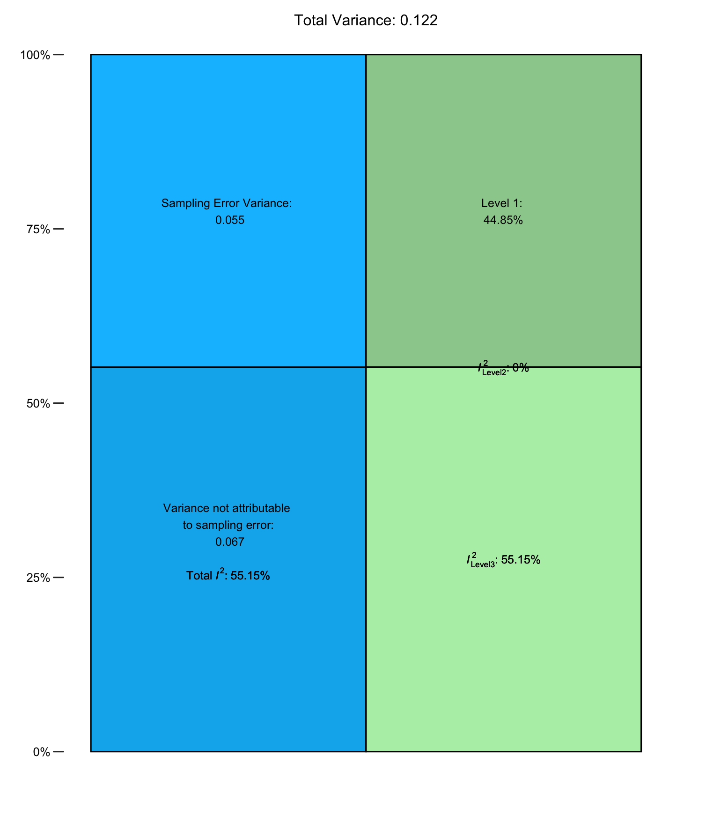

S7. Funnel Plot Main Model excluding Wang et al., 2018
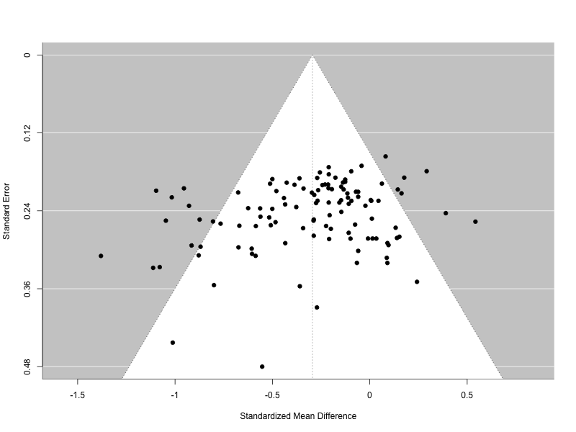

S8. Trim and Fill adjusted Model results
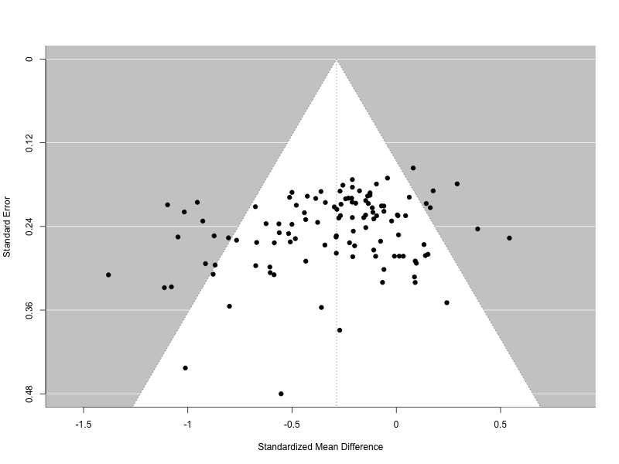

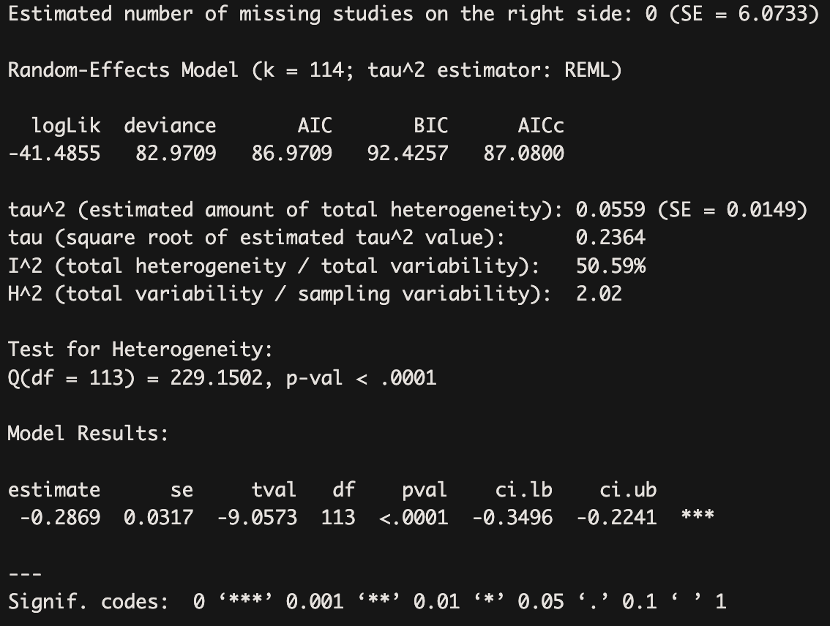

S9. Forest Plot of the main model with grouped at-risk samples
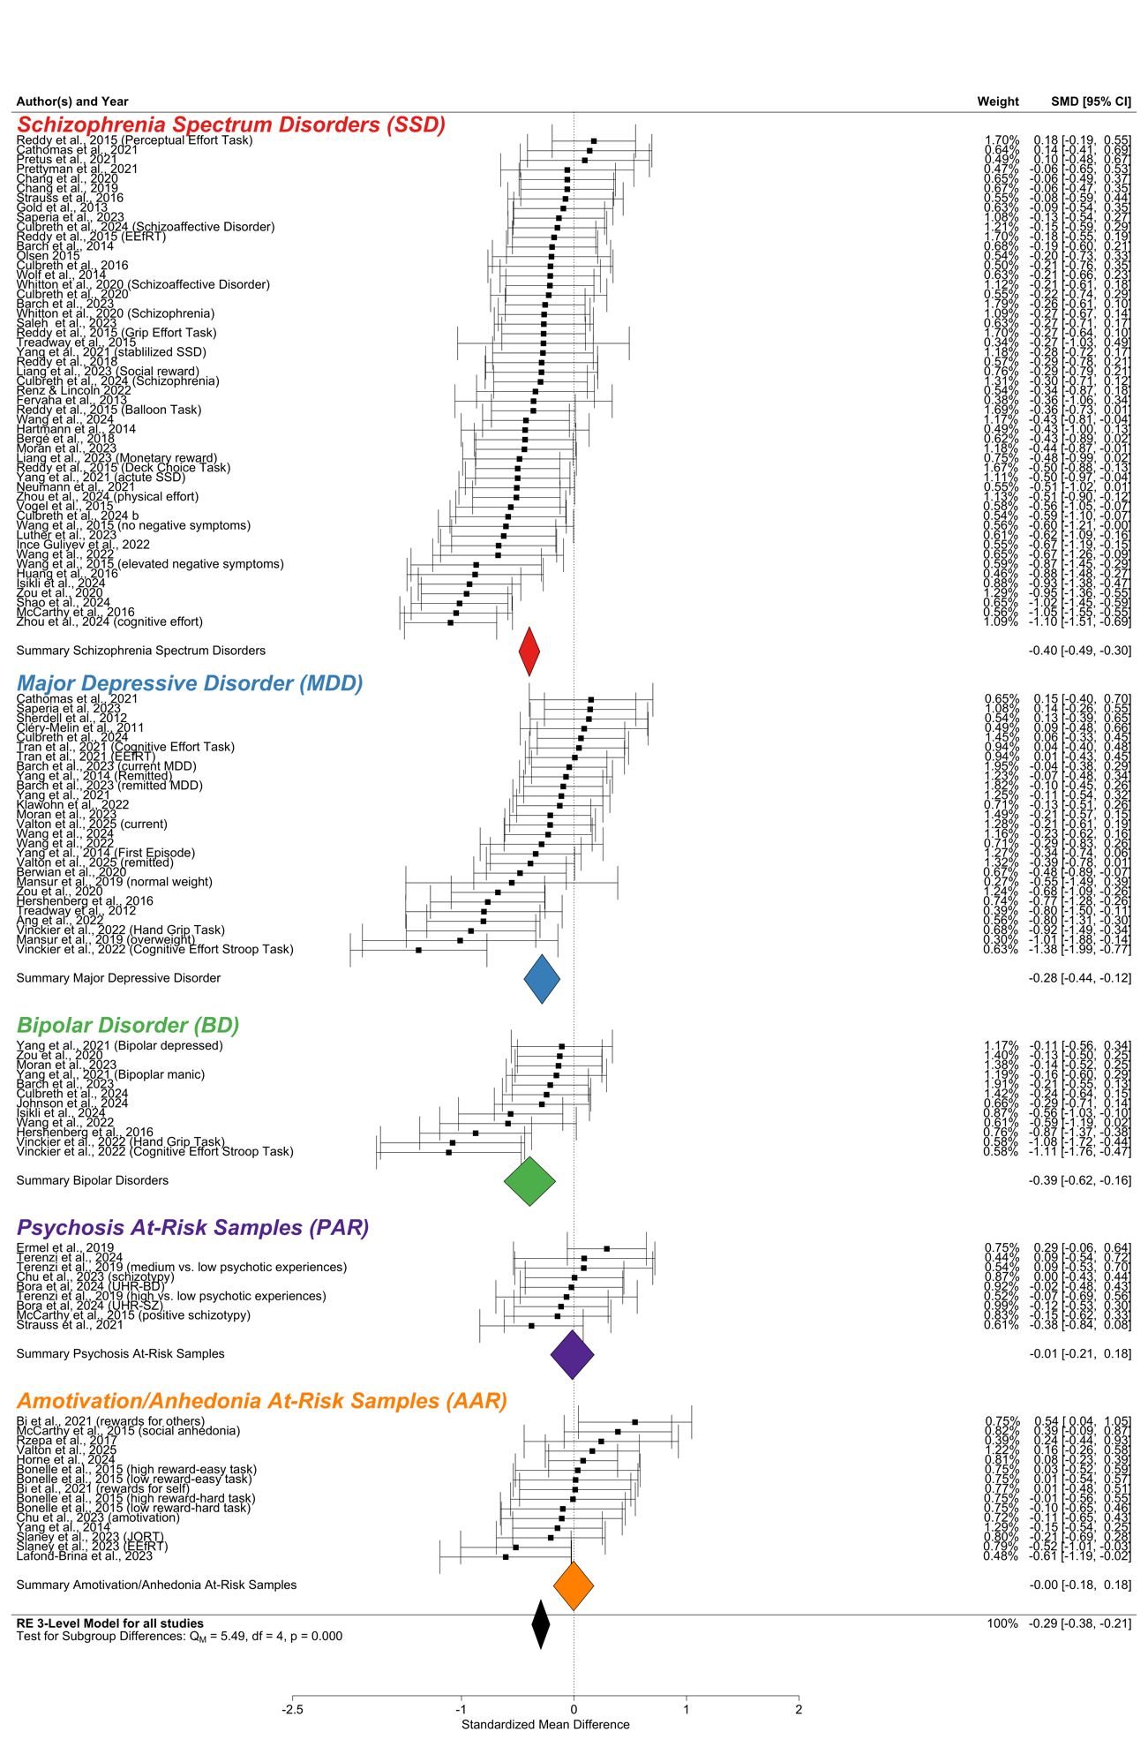

S10. Model Parameters for task moderator analyses
Sample_Type | Moderator | Estimate | CI_lower | CI_upper | P_value | k | SE
AR | task_type | -0.09 | -0.34 | 0.15 | 0.44 | 24 | 0.12
AR | effort_modality | 0.62 | -0.03 | 1.27 | 0.06 | 24 | 0.31
AR | reward_type | -0.09 | -0.38 | 0.20 | 0.53 | 24 | 0.14
AR | effort_measure | -0.06 | -0.38 | 0.27 | 0.71 | 22 | 0.16
AR | task_con | -0.05 | -0.19 | 0.10 | 0.50 | 24 | 0.07
AR | probability_number | -0.07 | -0.19 | 0.05 | 0.22 | 24 | 0.06
AR | task_payoff | -0.17 | -0.66 | 0.33 | 0.46 | 11 | 0.22
AR | task_payoff_told | -0.18 | -0.69 | 0.33 | 0.44 | 10 | 0.22
AR | task_diff_cali | 0.06 | -0.25 | 0.36 | 0.70 | 24 | 0.15
BD | task_type | 0.49 | 0.10 | 0.87 | 0.02 | 12 | 0.17
BD | effort_modality | 0.08 | -0.51 | 0.67 | 0.77 | 12 | 0.27
BD | reward_type | NA | NA | NA | NA | 12 | NA
BD | effort_measure | 0.64 | 0.03 | 1.24 | 0.04 | 10 | 0.26
BD | task_con | -0.09 | -0.26 | 0.07 | 0.24 | 12 | 0.07
BD | probability_number | 0.11 | -0.15 | 0.38 | 0.36 | 12 | 0.12
BD | task_payoff | 0.11 | -0.54 | 0.76 | 0.71 | 10 | 0.28
BD | task_payoff_told | 0.23 | -0.61 | 1.06 | 0.53 | 8 | 0.34
BD | task_diff_cali | -0.19 | -0.70 | 0.33 | 0.44 | 12 | 0.23
MDD | task_type | 0.34 | -0.04 | 0.71 | 0.08 | 27 | 0.18
MDD | effort_modality | 0.16 | -0.20 | 0.52 | 0.37 | 27 | 0.18
MDD | reward_type | -0.05 | -0.52 | 0.42 | 0.82 | 27 | 0.23
MDD | effort_measure | 0.16 | -0.34 | 0.66 | 0.51 | 21 | 0.24
MDD | task_con | -0.07 | -0.17 | 0.03 | 0.15 | 27 | 0.05
MDD | probability_number | 0.02 | -0.15 | 0.20 | 0.77 | 27 | 0.08
MDD | task_payoff | 0.40 | 0.00 | 0.80 | 0.05 | 23 | 0.19
MDD | task_payoff_told | 0.74 | 0.31 | 1.17 | 0.00 | 19 | 0.20
MDD | task_diff_cali | 0.11 | -0.23 | 0.44 | 0.51 | 27 | 0.16
SSD | task_type | -0.09 | -0.33 | 0.14 | 0.43 | 51 | 0.12
SSD | effort_modality | -0.02 | -0.22 | 0.17 | 0.82 | 49 | 0.10
SSD | reward_type | 0.09 | -0.20 | 0.38 | 0.55 | 51 | 0.14
SSD | effort_measure | -0.22 | -0.61 | 0.18 | 0.27 | 45 | 0.19
SSD | task_con | 0.02 | -0.05 | 0.09 | 0.62 | 51 | 0.04
SSD | probability_number | -0.12 | -0.21 | -0.04 | 0.01 | 51 | 0.04
SSD | task_payoff | 0.09 | -0.12 | 0.31 | 0.39 | 41 | 0.11
SSD | task_payoff_told | 0.14 | -0.09 | 0.38 | 0.23 | 37 | 0.12
SSD | task_diff_cali | -0.01 | -0.21 | 0.18 | 0.88 | 51 | 0.10
clinical | task_type | 0.06 | -0.13 | 0.25 | 0.53 | 90 | 0.10
clinical | effort_modality | 0.07 | -0.11 | 0.25 | 0.43 | 88 | 0.09
clinical | reward_type | 0.01 | -0.23 | 0.26 | 0.93 | 90 | 0.12
clinical | effort_measure | -0.03 | -0.33 | 0.26 | 0.82 | 76 | 0.15
clinical | task_con | -0.03 | -0.09 | 0.03 | 0.33 | 90 | 0.03
clinical | probability_number | -0.06 | -0.15 | 0.02 | 0.15 | 90 | 0.04
clinical | task_payoff | 0.14 | -0.07 | 0.35 | 0.18 | 74 | 0.10
clinical | task_payoff_told | 0.22 | 0.00 | 0.43 | 0.05 | 64 | 0.11
clinical | task_diff_cali | -0.01 | -0.18 | 0.17 | 0.95 | 90 | 0.09
overall | task_type | -0.05 | -0.22 | 0.12 | 0.59 | 114 | 0.09
overall | effort_modality | 0.14 | -0.03 | 0.32 | 0.11 | 112 | 0.09
overall | reward_type | -0.08 | -0.29 | 0.14 | 0.48 | 114 | 0.11
overall | effort_measure | -0.10 | -0.36 | 0.16 | 0.44 | 98 | 0.13
overall | task_con | -0.04 | -0.10 | 0.02 | 0.18 | 114 | 0.03
overall | probability_number | -0.07 | -0.15 | 0.01 | 0.07 | 114 | 0.04
overall | task_payoff | 0.01 | -0.18 | 0.21 | 0.90 | 85 | 0.10
overall | task_payoff_told | 0.04 | -0.16 | 0.24 | 0.71 | 74 | 0.10
overall | task_diff_cali | -0.02 | -0.18 | 0.14 | 0.82 | 114 | 0.08

S11. Model Parameters for sample characteristics moderator analyses
Sample_Type | Moderator | Estimate | CI_lower | CI_upper | P_value | k | SE
AR | med_z | -0.62 | -27.40 | 26.16 | 0.82 | 2 | 2.11
AR | age_clin_z | 0.09 | -0.21 | 0.39 | 0.53 | 19 | 0.14
AR | female_pct_clin_z | 0.04 | -0.15 | 0.23 | 0.66 | 17 | 0.09
AR | edu_clin_z | 0.09 | -0.10 | 0.28 | 0.32 | 9 | 0.08
AR | min_clin_z | 0.17 | -0.47 | 0.81 | 0.38 | 4 | 0.15
BP | med_z | 0.11 | -0.80 | 1.02 | 0.66 | 4 | 0.21
BP | age_clin_z | -0.21 | -0.67 | 0.25 | 0.33 | 12 | 0.21
BP | female_pct_clin_z | 0.02 | -0.31 | 0.35 | 0.90 | 12 | 0.15
BP | edu_clin_z | -0.04 | -0.33 | 0.25 | 0.77 | 12 | 0.13
BP | min_clin_z | -0.77 | -1.97 | 0.43 | 0.13 | 5 | 0.38
MDD | study_setting_bin | -0.07 | -0.72 | 0.58 | 0.78 | 6 | 0.23
MDD | med_z | 0.17 | -3.28 | 3.63 | 0.64 | 3 | 0.27
MDD | age_clin_z | -0.03 | -0.27 | 0.21 | 0.81 | 25 | 0.12
MDD | female_pct_clin_z | 0.04 | -0.17 | 0.24 | 0.72 | 25 | 0.10
MDD | edu_clin_z | -0.01 | -0.16 | 0.15 | 0.92 | 21 | 0.07
MDD | min_clin_z | -0.23 | -0.46 | 0.00 | 0.05 | 9 | 0.10
SSD | study_setting_bin | 0.28 | -0.43 | 0.99 | 0.42 | 17 | 0.33
SSD | med_z | -0.02 | -0.14 | 0.10 | 0.74 | 26 | 0.06
SSD | age_clin_z | 0.07 | -0.05 | 0.18 | 0.24 | 49 | 0.06
SSD | female_pct_clin_z | 0.02 | -0.09 | 0.13 | 0.73 | 49 | 0.05
SSD | edu_clin_z | 0.07 | -0.11 | 0.24 | 0.43 | 40 | 0.09
SSD | min_clin_z | -0.10 | -0.21 | 0.01 | 0.07 | 22 | 0.05
clinical | study_setting_bin | -0.48 | -1.26 | 0.30 | 0.22 | 36 | 0.38
clinical | med_z | -0.05 | -0.15 | 0.05 | 0.32 | 33 | 0.05
clinical | age_clin_z | 0.02 | -0.09 | 0.12 | 0.74 | 86 | 0.05
clinical | female_pct_clin_z | 0.04 | -0.03 | 0.12 | 0.22 | 86 | 0.04
clinical | edu_clin_z | 0.05 | -0.04 | 0.14 | 0.30 | 73 | 0.04
clinical | min_clin_z | -0.13 | -0.22 | -0.04 | 0.00 | 36 | 0.04
overall | study_setting_bin | -0.01 | -0.41 | 0.39 | 0.96 | 59 | 0.20
overall | med_z | -0.06 | -0.15 | 0.04 | 0.22 | 35 | 0.05
overall | age_clin_z | -0.07 | -0.15 | 0.01 | 0.10 | 105 | 0.04
overall | female_pct_clin_z | 0.07 | 0.00 | 0.13 | 0.05 | 103 | 0.03
overall | edu_clin_z | 0.05 | -0.03 | 0.14 | 0.23 | 82 | 0.04
overall | min_clin_z | -0.11 | -0.20 | -0.02 | 0.02 | 40 | 0.05

S12. Model Parameters for clinical characteristics moderator analyses
Sample_Type | Moderator | Estimate | CI_lower | CI_upper | P_value | k | SE
AR | depr_clin_z | -0.06 | -0.27 | 0.16 | 0.59 | 16 | 0.10
AR | mania_clin_z | 0.52 | -21.78 | 22.81 | 0.82 | 2 | 1.75
AR | possy_clin_z | 0.11 | -0.22 | 0.44 | 0.45 | 8 | 0.14
AR | negsy_clin_z | 0.03 | -0.24 | 0.29 | 0.80 | 8 | 0.11
AR | cog_clin_z | 0.09 | -0.14 | 0.33 | 0.34 | 6 | 0.08
AR | anh_clin_z | 0.03 | -0.17 | 0.24 | 0.71 | 10 | 0.09
AR | amot_clin_z | -0.06 | -0.25 | 0.12 | 0.47 | 9 | 0.08
AR | expr_clin_z | 0.08 | -2.79 | 2.95 | 0.78 | 3 | 0.23
AR | plea_clin_z | 0.06 | -0.22 | 0.34 | 0.63 | 12 | 0.12
BD | depr_clin_z | -0.21 | -0.42 | 0.00 | 0.05 | 12 | 0.10
BD | mania_clin_z | 0.06 | -0.12 | 0.24 | 0.45 | 8 | 0.07
BD | possy_clin_z | -0.57 | -7.27 | 6.13 | 0.48 | 3 | 0.53
BD | negsy_clin_z | -0.01 | -0.76 | 0.74 | 0.98 | 5 | 0.24
BD | cog_clin_z | 3.59 | -45.46 | 52.65 | 0.52 | 3 | 3.86
BD | anh_clin_z | 0.53 | 0.02 | 1.03 | 0.05 | 5 | 0.16
BD | amot_clin_z | -0.33 | -0.87 | 0.21 | 0.16 | 6 | 0.19
BD | expr_clin_z | -0.14 | -18.41 | 18.13 | 0.94 | 3 | 1.44
BD | plea_clin_z | 0.00 | -0.27 | 0.27 | 0.99 | 3 | 0.14
MDD | depr_clin_z | -0.07 | -0.21 | 0.07 | 0.32 | 25 | 0.07
MDD | mania_clin_z | 0.10 | -0.50 | 0.70 | 0.64 | 5 | 0.19
MDD | possy_clin_z | -0.55 | -2.06 | 0.96 | 0.48 | 5 | 0.77
MDD | negsy_clin_z | 0.07 | -0.21 | 0.35 | 0.55 | 7 | 0.11
MDD | cog_clin_z | -0.07 | -0.22 | 0.09 | 0.33 | 8 | 0.06
MDD | anh_clin_z | 0.03 | -0.23 | 0.30 | 0.78 | 12 | 0.12
MDD | amot_clin_z | 0.03 | -0.31 | 0.37 | 0.85 | 10 | 0.15
MDD | expr_clin_z | 0.14 | -1.86 | 2.14 | 0.53 | 3 | 0.16
MDD | plea_clin_z | -0.09 | -0.28 | 0.10 | 0.29 | 9 | 0.08
SSD | depr_clin_z | 0.01 | -0.25 | 0.27 | 0.91 | 23 | 0.13
SSD | mania_clin_z | 0.13 | -0.53 | 0.78 | 0.49 | 4 | 0.15
SSD | possy_clin_z | -0.12 | -0.22 | -0.02 | 0.02 | 37 | 0.05
SSD | negsy_clin_z | -0.08 | -0.18 | 0.01 | 0.09 | 45 | 0.05
SSD | cog_clin_z | -0.04 | -1.03 | 0.95 | 0.93 | 17 | 0.47
SSD | anh_clin_z | -0.06 | -0.40 | 0.28 | 0.70 | 10 | 0.15
SSD | amot_clin_z | 0.06 | -0.07 | 0.19 | 0.35 | 32 | 0.06
SSD | expr_clin_z | 0.02 | -0.14 | 0.17 | 0.82 | 26 | 0.08
SSD | plea_clin_z | -0.16 | -0.32 | -0.01 | 0.04 | 13 | 0.07
Clinical | depr_clin_z | 0.00 | -0.10 | 0.10 | 0.98 | 60 | 0.05
Clinical | mania_clin_z | 0.02 | -0.10 | 0.13 | 0.76 | 17 | 0.05
Clinical | possy_clin_z | -0.15 | -0.25 | -0.04 | 0.01 | 45 | 0.05
Clinical | negsy_clin_z | -0.09 | -0.18 | 0.00 | 0.06 | 57 | 0.05
Clinical | cog_clin_z | 0.02 | -0.14 | 0.17 | 0.80 | 28 | 0.08
Clinical | anh_clin_z | 0.02 | -0.16 | 0.20 | 0.84 | 27 | 0.09
Clinical | amot_clin_z | 0.01 | -0.12 | 0.13 | 0.90 | 48 | 0.06
Clinical | expr_clin_z | -0.03 | -0.16 | 0.11 | 0.68 | 32 | 0.06
Clinical | plea_clin_z | -0.11 | -0.25 | 0.03 | 0.13 | 25 | 0.07
Overall | depr_clin_z | -0.02 | -0.11 | 0.07 | 0.66 | 76 | 0.04
Overall | mania_clin_z | 0.00 | -0.11 | 0.11 | 1.00 | 19 | 0.05
Overall | possy_clin_z | -0.14 | -0.24 | -0.04 | 0.01 | 53 | 0.05
Overall | negsy_clin_z | -0.10 | -0.18 | -0.01 | 0.03 | 65 | 0.04
Overall | cog_clin_z | 0.05 | -0.11 | 0.21 | 0.52 | 34 | 0.08
Overall | anh_clin_z | 0.00 | -0.15 | 0.14 | 0.95 | 37 | 0.07
Overall | amot_clin_z | -0.01 | -0.12 | 0.10 | 0.85 | 57 | 0.06
Overall | expr_clin_z | -0.03 | -0.15 | 0.09 | 0.62 | 35 | 0.06
Overall | plea_clin_z | -0.02 | -0.16 | 0.12 | 0.78 | 37 | 0.07

S13. Moderator analyses for clinical characteristics in high reward trials

S14. Moderator analyses for clinical characteristics in high probability trials

S15. Moderator analyses for effort allocation from low to high reward/probability trials by cognitive functioning

Effort allocation from low to high reward

SSD (k =16) | b | SE | t | p | 95%CI
intercept | -0.24 | 0.16 | -1.47 | 0.17 | -0.60 | 0.12
rewConRH | -0.13 | 0.14 | -0.93 | 0.37 | -0.45 | 0.18
cog_clin | 0.00 | 0.01 | 0.18 | 0.86 | -0.02 | 0.02
rewConRH:cog_clin | -0.02 | 0.01 | -2.54 | 0.03 | -0.04 | -0.00

MDD (k = 10) | b | SE | t | p | 95%CI
intercept | 0.17 | 0.20 | 0.87 | 0.42 | -0.31 | 0.65
rewConRH | -0.19 | 0.17 | -1.12 | 0.30 | -0.60 | 0.22
cog_clin | -0.03 | 0.01 | -2.40 | 0.05 | -0.06 | 0.00
rewConRH:cog_clin | 0.02 | 0.01 | 1.61 | 0.16 | -0.01 | 0.04

Effort allocation from low to high probability

SSD (k = 12) | b | SE | t | p | 95%CI
intercept | 0.00 | 0.26 | 0.01 | 0.99 | -0.60 | 0.61
probConP100 | -0.48 | 0.17 | -2.77 | 0.02 | -0.89 | -0.08
cog_clin | 0.01 | 0.01 | 0.97 | 0.36 | -0.02 | 0.04
probConP100:cog_clin | -0.03 | 0.01 | -2.43 | 0.04 | -0.05 | -0.00

MDD (k = 4) | b | SE | t | p | 95%CI
intercept | 0.24 | 0.17 | 1.40 | 0.39 | -1.92 | 2.39
probConP100 | -0.25 | 0.24 | -1.03 | 0.49 | -3.29 | 2.80
cog_clin | 0.42 | 0.71 | 0.59 | 0.66 | -8.64 | 9.48
probConP100:cog_clin | -1.25 | 1.01 | -1.25 | 0.43 | -14.06 | 11.55

S16. Moderator analyses for cognitive domains across all trials

