Supplement Table 1

Database Search Results

Step | Search field | Search syntax | PsycINFO | PsycArticles | Pro-Quest | Web of Science | Academic Search Complete | PubMed | Sociology Collection | Eric
1 | Title | self-esteem OR self-worth OR self-liking OR self-view* OR self-concept OR self-respect OR self-acceptance OR self-regard OR self-opinion OR self-perception OR self-image* | 24,530  582 | 1,051  36 | 13,368  155 | 19,956  1287 | 12,290  803 | 8,251  1024 | 10,114  321 | 5,669  118
2 | Abstract | self-esteem OR self-worth OR self-liking OR self-view* OR self-concept OR self-respect OR self-acceptance OR self-regard OR self-opinion OR self-perception OR self-image* | 73,070  2273 | 3,776  141 | 38,157  872 | 56,470  4730 | 47,832  3018 | 38,149  4741 | 35,742  1233 | 22,464  466
3 |  | 1 OR 2 | 79,770  2299 | 3,824  141 | 42,716  882 | 63,832  4953 | 49,410  3082 | 38,149  4741 | 37,423  1249 | 23,175’  469
4 | Title | Internaliz* racism OR internaliz* racial oppression OR internaliz* racial stereotypes OR stereotype internalization OR internaliz* racialism OR model minority myth OR nigrescence OR Appropriated racial oppression OR self-hatred OR internaliz* inferiority | 202  29 | 26  6 | 88  14 | 216  18 | 128  20 | 98  33 | 159  22 | 57  4
5 | Abstract | Internaliz* racism OR internaliz* racial oppression OR internaliz* racial stereotypes OR stereotype internalization OR internaliz* racialism OR model minority myth OR nigrescence OR Appropriated racial oppression OR self-hatred OR internaliz* inferiority | 1,295  158 | 99  23 | 1,055  143 | 719  106 | 431  57 | 262  64 | 940  81 | 262  22
6 |  | 4 OR 5 | 1,326  162 | 99  24 | 1,069  144 | 825  114 | 473  62 | 282  64 | 974  84 | 282  24
7 |  | 3 AND 6 | 198  22 | 21  5 | 142  13 | 86  10 | 31  5 | 29  7 | 89  6 | 21  3
Note. Top row represents search results from January 1965- December 2021, whereas the bottom row represents search results from January 2022 – August 15, 2024

Database Search Terms

PsycINFO

Time limit shown below:
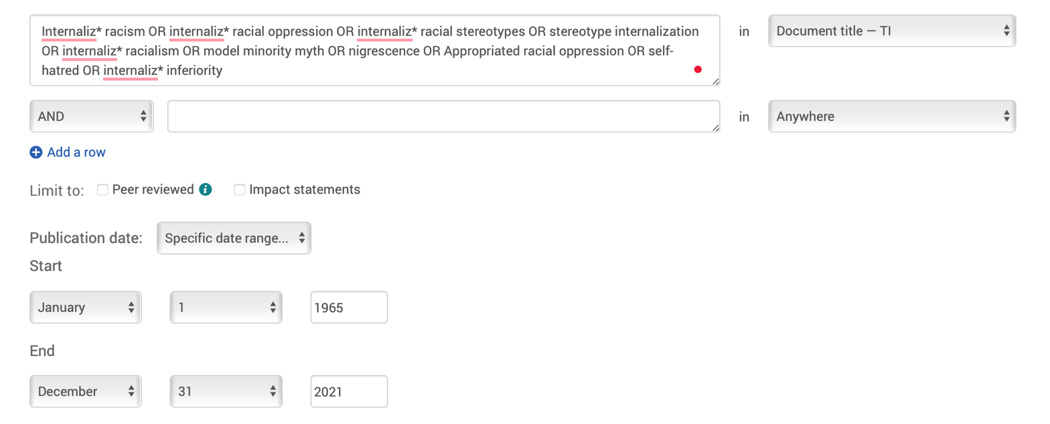

Search strings
ti(self-esteem OR self-worth OR self-liking OR self-view* OR self-concept OR self-respect OR self-acceptance OR self-regard OR self-opinion OR self-perception OR self-image* )

ab(self-esteem OR self-worth OR self-liking OR self-view* OR self-concept OR self-respect OR self-acceptance OR self-regard OR self-opinion OR self-perception OR self-image* )

ti(Internaliz* racism OR internaliz* racial oppression OR internaliz* racial stereotypes OR stereotype internalization OR internaliz* racialism OR model minority myth OR nigrescence OR Appropriated racial oppression OR self-hatred OR internaliz* inferiority)

ab(Internaliz* racism OR internaliz* racial oppression OR internaliz* racial stereotypes OR stereotype internalization OR internaliz* racialism OR model minority myth OR nigrescence OR Appropriated racial oppression OR self-hatred OR internaliz* inferiority)

PsycArticles

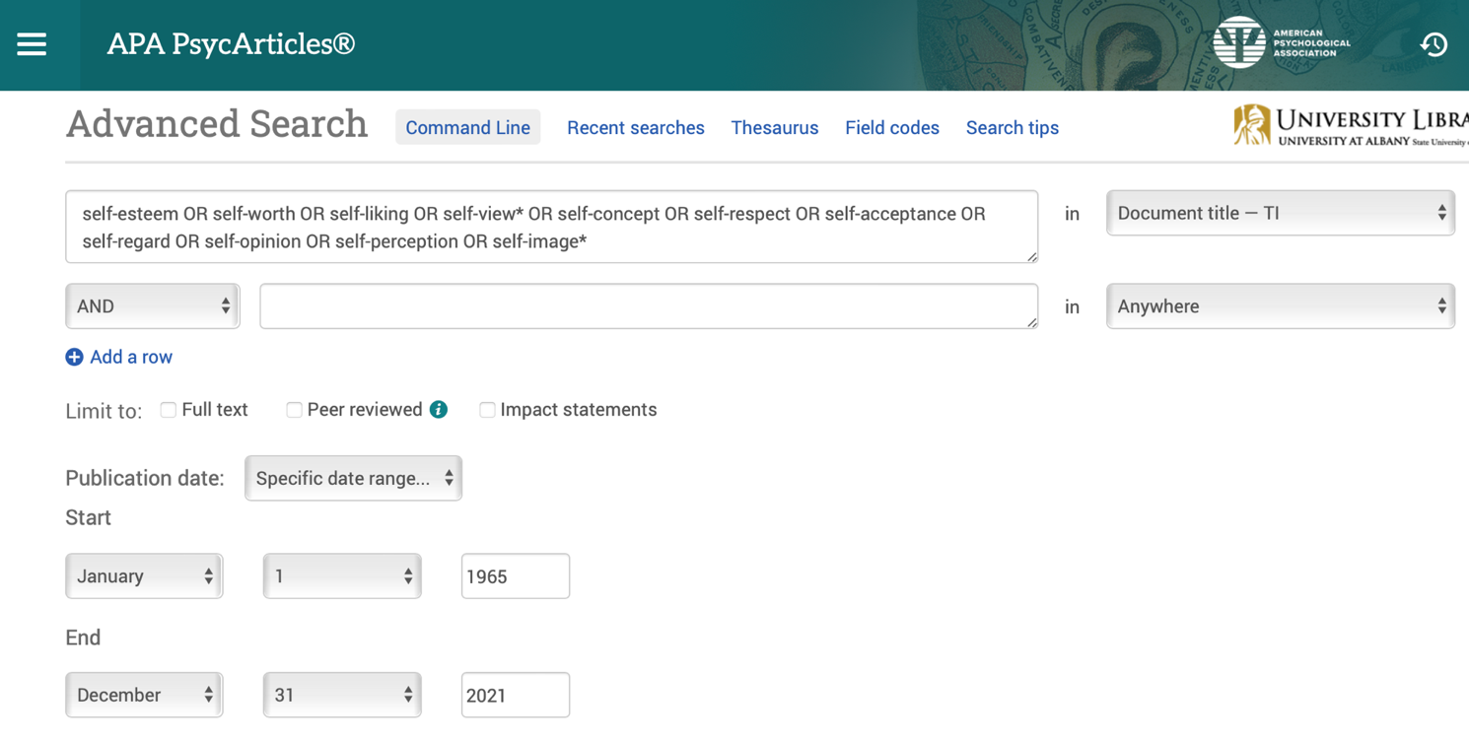

Search strings:

ti(self-esteem OR self-worth OR self-liking OR self-view* OR self-concept OR self-respect OR self-acceptance OR self-regard OR self-opinion OR self-perception OR self-image*)

ab(self-esteem OR self-worth OR self-liking OR self-view* OR self-concept OR self-respect OR self-acceptance OR self-regard OR self-opinion OR self-perception OR self-image*)

ti(Internaliz* racism OR internaliz* racial oppression OR internaliz* racial stereotypes OR stereotype internalization OR internaliz* racialism OR model minority myth OR nigrescence OR Appropriated racial oppression OR self-hatred OR internaliz* inferiority)

ab(Internaliz* racism OR internaliz* racial oppression OR internaliz* racial stereotypes OR stereotype internalization OR internaliz* racialism OR model minority myth OR nigrescence OR Appropriated racial oppression OR self-hatred OR internaliz* inferiority)

ProQuest


Search strings:
ti(self-esteem OR self-worth OR self-liking OR self-view* OR self-concept OR self-respect OR self-acceptance OR self-regard OR self-opinion OR self-perception OR self-image*)

ab(self-esteem OR self-worth OR self-liking OR self-view* OR self-concept OR self-respect OR self-acceptance OR self-regard OR self-opinion OR self-perception OR self-image*)

ti(Internaliz* racism OR internaliz* racial oppression OR internaliz* racial stereotypes OR stereotype internalization OR internaliz* racialism OR model minority myth OR nigrescence OR Appropriated racial oppression OR self-hatred OR internaliz* inferiority)

ab(Internaliz* racism OR internaliz* racial oppression OR internaliz* racial stereotypes OR stereotype internalization OR internaliz* racialism OR model minority myth OR nigrescence OR Appropriated racial oppression OR self-hatred OR internaliz* inferiority)

ERIC

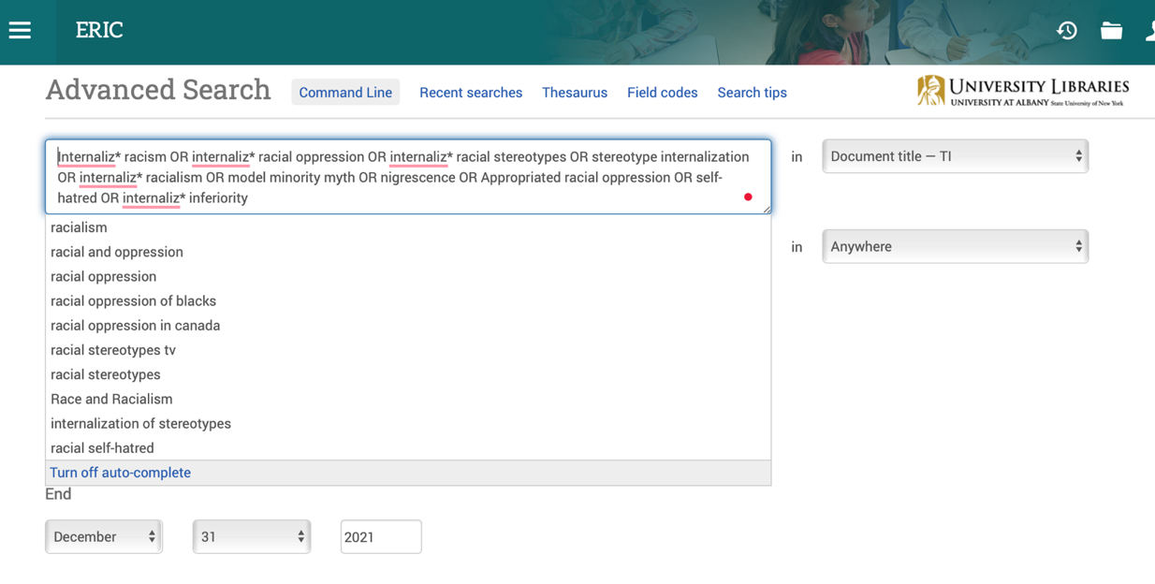
ti(self-esteem OR self-worth OR self-liking OR self-view* OR self-concept OR self-respect OR self-acceptance OR self-regard OR self-opinion OR self-perception OR self-image*)

ab(self-esteem OR self-worth OR self-liking OR self-view* OR self-concept OR self-respect OR self-acceptance OR self-regard OR self-opinion OR self-perception OR self-image*)

ti(Internaliz* racism OR internaliz* racial oppression OR internaliz* racial stereotypes OR stereotype internalization OR internaliz* racialism OR model minority myth OR nigrescence OR Appropriated racial oppression OR self-hatred OR internaliz* inferiority)

ab(Internaliz* racism OR internaliz* racial oppression OR internaliz* racial stereotypes OR stereotype internalization OR internaliz* racialism OR model minority myth OR nigrescence OR Appropriated racial oppression OR self-hatred OR internaliz* inferiority)

Sociology Collection

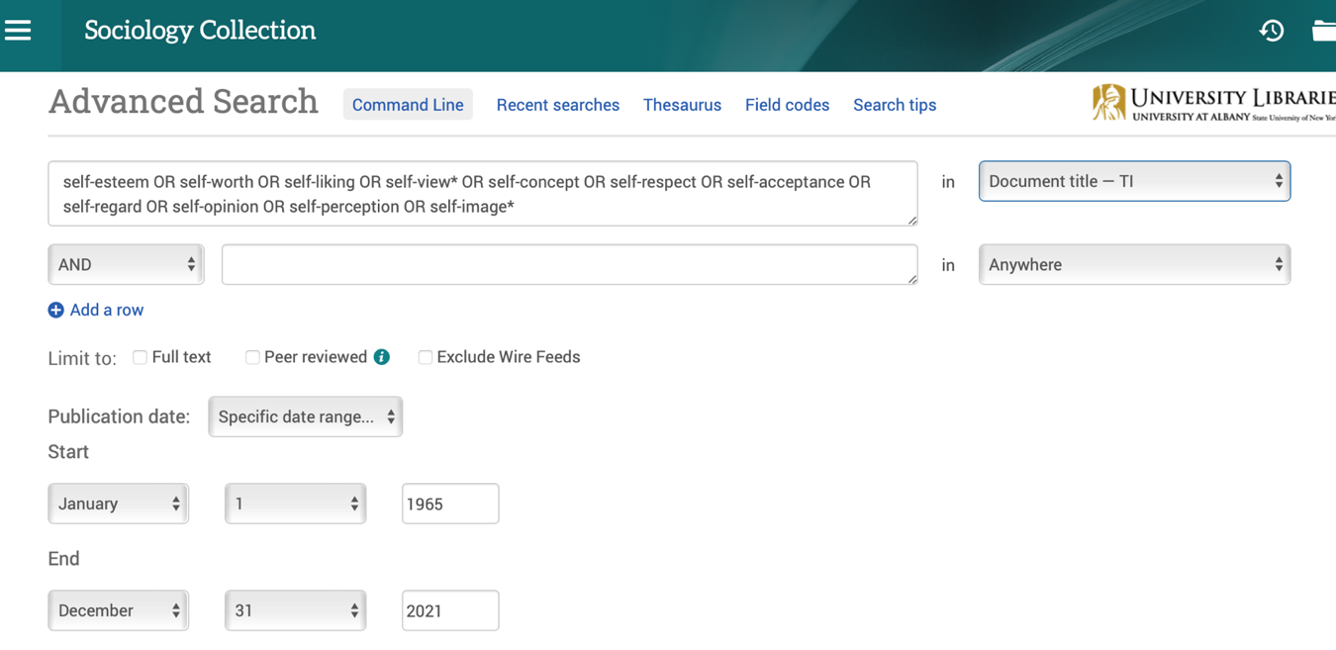
ti(self-esteem OR self-worth OR self-liking OR self-view* OR self-concept OR self-respect OR self-acceptance OR self-regard OR self-opinion OR self-perception OR self-image*)

ab(self-esteem OR self-worth OR self-liking OR self-view* OR self-concept OR self-respect OR self-acceptance OR self-regard OR self-opinion OR self-perception OR self-image*)

ti(Internaliz* racism OR internaliz* racial oppression OR internaliz* racial stereotypes OR stereotype internalization OR internaliz* racialism OR model minority myth OR nigrescence OR Appropriated racial oppression OR self-hatred OR internaliz* inferiority)

ab(Internaliz* racism OR internaliz* racial oppression OR internaliz* racial stereotypes OR stereotype internalization OR internaliz* racialism OR model minority myth OR nigrescence OR Appropriated racial oppression OR self-hatred OR internaliz* inferiority)

Web of Science

self-esteem OR self-worth OR self-liking OR self-view* OR self-concept OR self-respect OR self-acceptance OR self-regard OR self-opinion OR self-perception OR self-image* (Title)

self-esteem OR self-worth OR self-liking OR self-view* OR self-concept OR self-respect OR self-acceptance OR self-regard OR self-opinion OR self-perception OR self-image* (Abstract)

Internaliz* racism OR internaliz* racial oppression OR internaliz* racial stereotypes OR stereotype internalization OR internaliz* racialism OR model minority myth OR nigrescence OR Appropriated racial oppression OR self-hatred OR internaliz* inferiority (Title)

Internaliz* racism OR internaliz* racial oppression OR internaliz* racial stereotypes OR stereotype internalization OR internaliz* racialism OR model minority myth OR nigrescence OR Appropriated racial oppression OR self-hatred OR internaliz* inferiority (Abstract)

Academic Search Complete

TI self-esteem OR self-worth OR self-liking OR self-view* OR self-concept OR self-respect OR self-acceptance OR self-regard OR self-opinion OR self-perception OR self-image*

AB self-esteem OR self-worth OR self-liking OR self-view* OR self-concept OR self-respect OR self-acceptance OR self-regard OR self-opinion OR self-perception OR self-image*

TI Internaliz* racism OR internaliz* racial oppression OR internaliz* racial stereotypes OR stereotype internalization OR internaliz* racialism OR model minority myth OR nigrescence OR Appropriated racial oppression OR self-hatred OR internaliz* inferiority

AB Internaliz* racism OR internaliz* racial oppression OR internaliz* racial stereotypes OR stereotype internalization OR internaliz* racialism OR model minority myth OR nigrescence OR Appropriated racial oppression OR self-hatred OR internaliz* inferiority

PubMed

self-esteem[Title] OR self-worth[Title] OR self-liking[Title] OR self-view*[Title] OR self-concept[Title] OR self-respect[Title] OR self-acceptance[Title] OR self-regard[Title] OR self-opinion[Title] OR self-perception[Title] OR self-image*[Title]

self-esteem[Title/Abstract] OR self-worth[Title/Abstract] OR self-liking[Title/Abstract] OR self-view*[Title/Abstract] OR self-concept[Title/Abstract] OR self-respect[Title/Abstract] OR self-acceptance[Title/Abstract] OR self-regard[Title/Abstract] OR self-opinion[Title/Abstract] OR self-perception[Title/Abstract] OR self-image*[Title/Abstract]

Internaliz* racism[Title] OR internaliz* racial oppression[Title] OR internaliz* racial stereotypes[Title] OR stereotype internalization[Title] OR internaliz* racialism[Title] OR model minority myth[Title] OR nigrescence[Title] OR Appropriated racial oppression[Title] OR self-hatred[Title] OR internaliz* inferiority[Title]

Internaliz* racism[Title/Abstract] OR internaliz* racial oppression[Title/Abstract] OR internaliz* racial stereotypes[Title/Abstract] OR stereotype internalization[Title/Abstract] OR internaliz* racialism[Title/Abstract] OR model minority myth[Title/Abstract] OR nigrescence[Title/Abstract] OR Appropriated racial oppression[Title/Abstract] OR self-hatred[Title/Abstract] OR internaliz* inferiority[Title/Abstract]

Supplement Table 2
Initial List of Internalized Racism Instruments
Instrument
Appropriated Racial Oppression Scale (Campón & Carter, 2015): Full
Attitude Toward Asian Scale: Own-group (Ho & Jackson, 2001)
Attitude Toward Asian Scale: Self (Gupta et al., 2011)
Black-White Implicit association test (Nosek et al., 2007)
Collective Self-esteem Scale (Modified; Luhtanen & Crocker, 1992)
Colonial Mentality Implicit Association Test (David, 2010)
Colonial Mentality Scale (David & Okazaki, 2006)
Full Scale
Colonial debt subscale
Cultural shame subscale
Internalized cultural and ethnic inferiority subscale
Physical characteristics subscale
Within group discrimination subscale
Colonial Mentality Scale-Ghana (Utsey et al., 2015)
Colonial debt subscale
Internalized cultural and ethnic inferiority subscale
Physical characteristics subscale
Within group discrimination subscale
Cross Racial Identity Scale (Vandiver et al., 2002)
Self-hatred
Miseducation
Cross Ethnic-Racial Identity Scale-Adult: Pre-encounter: Self-hatred subscale (Worrell et al., 2017)
Gendered Racial-Ethnic Socialization Scale for Black Women: Internalized Gendered Racial Oppression subscale (Brown et al., 2017)
Internalization of Asian American Stereotypes Scale (Shen et al., 2011)
Full scale
Difficulties with English language communication
Emotional Reservation
Expected academic success
Pursuit of prestigious careers
Internalization of the Model Minority Myth Measure (Yoo et al., 2010)
M-Achievement subscale
M-Mobility subscale
Internalization of Racist Academic Stereotypes (Ellis et al., 2015)
Internalized Racism in Asian Americans Scale (Choi et al., 2017)
Full Scale
Appearance bias subscale
Self-negativity subscale
Weakness stereotypes subscale
Internalized Racial Oppression Scale (Bailey et al., 2011)
Full scale
Alteration of physical appearance subscale
Biased representation of history subscale
Devaluation of an African worldview subscale
Hair change
Internalization of negative stereotypes subscale
Internalized Racism Scale (Drazdowski et al., 2016)
Mochihua Tepehuani Scale (Hipolito-Delgado, 2010)
Modern Jezebel Scale (Townsend et al., 2010)
Nadanolitization Scale (Taylor & Grundy, 1996)
Racist subscale: Full
Mental/genetic deficiencies subscale
Natural ability of Blacks subscale
Sexual prowess subscale
Negative stereotype endorsement: Own-group
Negative stereotype endorsement & Positive stereotype rejection
Own-group
Self
Positive stereotype rejection: Own-group
Racial and Stereotyping Scale (Chambers, et al., 2004)
Racial Identity attitude scale: Pre-Encounter subscale (Parham & Helms, 1986)
Short form
Long form
Stereotypic Roles for Black Women Scale (Thomas et al., 2004)
Mammy
Jezebel
Sapphire
Superwoman
Subjective Stigmatization Scale (Brega & Coleman, 1999)
Racelessness Scale: Stereotypical Beliefs subscale (Modified; Arroyo & Zigler, 1995)

Listserv request for data
Listservs: APA Division 45, (2) APA Division 38, and (3) Society for Social and Personality Psychology Discussion Board
Dear Colleagues,

I hope this message finds you well. My name is [redacted], and I, along with my research team, are currently conducting a meta-analysis on the relationship between internalized racism and self-esteem. To ensure a comprehensive and inclusive analysis, I am reaching out to solicit unpublished data, manuscripts, preprints, and theses that explore this critical topic.

We are particularly interested in broad measurements and conceptualizations of internalized racism, including but not limited to:
- Racial self-hatred
- Internalization of the model minority myth
- Endorsement of colonial mentality ideologies
- Own-group stereotype endorsement

In terms of self-esteem, we are accepting various measures, including global self-esteem, self-worth, self-respect, and related constructs.

If you have conducted research in this area and have data or manuscripts that have not yet been published, we would greatly appreciate your contribution. Your work will be crucial in enhancing our understanding of how internalized racism impacts self-esteem across different contexts and populations.

Please send your contributions or any questions you might have to me at [redacted].

We assure you that all data will be treated confidentially and used solely for the purposes of this meta-analysis. Contributors will be appropriately acknowledged in the final publication.

Thank you for considering this request. Your support is invaluable in advancing research on internalized racism and its effects on self-esteem.

Best regards

Listserv | Email Responses | Studies Meeting Inclusion Criteria
APA Division 45 | 1 | 0
APA Division 38 | 1 | 0
Society for Social and Personality Psychology Discussion Board | 0

Contacting authors for missing data
Dear Author
I hope this email finds you well. My name is [Redacted], and I am conducting a meta-analysis on the relationship between internalized racism and self-esteem among ethnoracial minorities.
Your paper [Paper title and year] meets our inclusion criteria and will therefore be part of our meta-analysis.
To ensure the robustness and comprehensiveness of our meta-analysis, we are seeking additional data that was not included in the published paper. Specifically, we are interested in obtaining the following missing data from your study:
- [Example: Average age of participants]
We thank you in advance as your contribution would greatly enhance our understanding of how internalized racism impacts self-esteem.
If you have any concerns or require further information about our project, please do not hesitate to contact me.
Thank you very much for considering this request. I look forward to the possibility of including your research in our meta-analysis.
Best regards

Discrimination Measures
Discrimination was measured in only 11 studies. Among these, Gonzalez (2016) used an author-constructed, non-validated measure of within-group discrimination or “common ethnic and racial hassles” experienced by Oaxaqueño/a adolescents and young adults from their Mexican peers. Three studies—David and Okazaki (2006) in both subsamples, and Jones and colleagues (2007)—used the Schedule of Racist Events (SRE; Landrine & Klonoff, 1996), which is a valid and reliable measure of the frequency of African Americans’ experiences with racism and their stress appraisals for such experiences. Four studies—James (2021), Hughes and colleagues (2015), Cénat and colleagues (2024), and Ferrera (2011)—used the Everyday Discrimination Scale (EDS; Williams et al., 1997). The EDS is valid and reliable scale that measures the perceived source of racial discrimination and the frequency of daily lifetime discrimination. Velez and colleagues (2015) employed the validated “recent” subscale of the General Ethnic Discrimination Scale (GEDS-Recent; Landrine et al., 2006), which assesses the frequency of perceived racist discrimination within the past year. Last, Hernandez (2014) used the “daily racial hassles” subscale of the Racism and Life Experience Scales (RaLES; Harrell, 1997), a validated measure that evaluates racism experienced collectively, individually, and vicariously, categorized into three types of events, life event/episodic stress, daily hassles, and chronic/contextual stress.

Social Support Measures
Only two studies—Cénat and colleagues (2024) and Hughes and colleagues (2015)—measured social support. Cénat and colleagues (2024) used the Multidimensional Scale of Perceived Social Support (Zimet et al., 1988), which assesses support from family, friends, and significant others. In contrast, Hughes and colleagues (2015) employed a single-item measure, asking participants how often their family made them feel loved, listened to their problems, or expressed concern for their well-being.

Self-esteem Instruments
A large majority of the studies (n = 46; 85.19%) measured self-esteem using the RSE (Rosenberg, 1965), including one that employed a modified version. The remaining 8 studies (14.81%) used other measures of self-esteem, including: (a) The Piers-Harris Children’s Self-Concept Scale (Piers & Harris, 1969), a valid and reliable measure to assess global self-esteem among children. This measure was used by Buckley and Carter (2005); (b) short form of the Self-Description Questionnaire (SDQ; Marsh & O’Neil, 1984), a validated tool measuring self-esteem across multiple domains, including academic and relational areas, which was used by Cénat and colleagues (2024); (c) The “global positive self-concept” subscale of the Noncognitive Questionnaire (Sedlacek, 2004; Tracey & Sedlacek, 1984, 1987), which was used by Elion (2007). This validated measure assesses self-concept, particularly related to academic achievements; (d) the Coopersmith Self-Esteem Inventory (Coopersmith, 1967), a validated measure of self-esteem across personal, family, academic, and social domains. This measure was used by Fontaine (2013); (e) the “global self-worth” subscale of the Harter Self-Perception Profile for College Students (Neeman & Harter, 1986). This validated measure, used by Huckleberry (2002), captures general feelings about the self or global self-worth; (f) the “self-regard” subscale of the Personal Orientation Inventory (Shostrom, 1964). Employed by Parham (1982), this validated measure captures the degree to which individuals feel positive about themselves based on their worth and strengths; (g) the Unconditional Self-Regard Scale (Betz et al., 1995). This unpublished, non-validated measure assesses people’s enduring global sense of self-esteem. It was used by Speight and colleagues (1996); and (h) the Tennessee Self-Concept Scale (Roid & Fitts, 1988), which was used by Wilson and Constantine (1999), is a valid and reliable self-report inventory that represents a global assessment of self-concept.
Internalized Racism Instruments
Positive Internalized Racism. Of the seven instruments capturing positive internalized racism, most (n = 5) focused on Asian Americans, primarily addressing the internalization of the model minority myth, and the remaining two targeted Black Americans’ internalization of beliefs related to strength and resilience—one focusing on Black American men (n = 1) and the other on Black American women (n = 1).
The “academic conscientiousness” subscale of the Brief Internalization of Asian American Stereotypes Scale (Shen et al., 2008) captures positive stereotypes associated with academic success, assessing how individuals internalize expectations of high achievement and diligence commonly attributed to Asian Americans. Similarly, the Internalization of the Model Minority Myth Measure includes two subscales: the “achievement” subscale (Yoo et al., 2010, 2015), which assesses beliefs about internalized stereotypes related to work ethic and success, and the “innate intelligence” subscale, an adaptation of the original measure (Witkow et al., 2024), which examines internalized beliefs regarding cognitive abilities as inherent to Asian Americans. Last, the Internalization of the Model Minority Stereotype Scale (Chen, 1995; Chu, 2001) comprises three subscales: (a) social influence and expectations subscale, (b) belief subscale, and (c) congruence subscale. Collectively, these subscales assess perceived societal and familial pressures to excel in academic domains, particularly in math and science, as well as expectations for high academic performance. They also capture the internalization of traits such as resilience and intelligence and reflect the impact of parental expectations on educational choices and the self-imposed pressures individuals may experience to meet or exceed these expectations. Among Black Americans, the two measures of positive internalized racism included the Tough Black Man Scale (James, 2024b) and the superwoman subscale of the Stereotypic Roles for Black Women Scale (Thomas et al., 2004).
Negative Internalized Racism. Instruments capturing negative internalized racism varied in their focus, reflecting a range of experiences related to the internalization of negative stereotypes and beliefs about oneself and one’s ethnoracial group. For instance, some instruments assess feelings of inferiority, capturing the extent to which individuals perceive their ethnoracial group as biologically inferior to White Europeans (e.g., the Nadanalization Scale; Taylor & Grundy, 1996) or believe that their ethnoracial culture is inferior to that of White Europeans (e.g., the “internalized cultural and ethnic inferiority” subscale of the Colonial Mentality Scale; David & Okazaki, 2006). Other examples include the preference for and valuation of White European beauty standards over those of one’s ethnoracial group (e.g., the “beauty” subscale of the Appropriated Racial Oppression Scale; Campón & Carter, 2015). Additionally, some instruments focus on self-hatred and self-rejection, exploring the disdain individuals may feel toward their ethnoracial identity (e.g., the “minority identity shame” subscale of the Internalized Oppression Scale for Biracial Individuals; Chong, 2012). Several measures also examined the endorsement of negative stereotypes about one’s ethnoracial group, highlighting the adoption of harmful perceptions (e.g., the “endorsement of negative stereotypes” subscale of the Internalized Racism Scale for Asian Americans; Liao, 2017). Finally, some instruments explore positive views of colonialism, including the acceptance or internalization of colonial narratives such as believing in the “positive” contributions of European colonization (e.g., the Colonial Debt subscale of the Colonial Mentality Scale; David & Okazaki, 2006).

Forms of Internalized Racism
Self-Hatred. Self-hatred is characterized by deep discomfort, dissatisfaction, and hostility toward one’s ethnoracial identity. It can manifest as self-loathing or rejection of one’s own ethnoracial identity. Self-hatred is captured in several instruments, including the “self-hatred” subscale of the Cross Scale of Social Attitudes (Worrell & Vandiver, 2013) and the Cross Racial Identity Scale (CRIS; Vandiver et al., 2002). Across both instruments, the self-hatred subscale captures the intensity of self-directed racial hostility, including the degree to which individuals experience discomfort because or hatred towards their ethnoracial identity. Other measures, such as the “private” subscale of the Collective Self-Esteem Scale (Luhtanen & Crocker, 1992) and the “self-hatred” subscale of the American Indian Adolescent Self-Concept Scale (Aragon et al., 1990)—both of which were not validated measures of internalized racism—more closely captured negative affect towards one’s ethnoracial identity.
Cultural and Ethnoracial Group Inferiority. This form included various themes reflecting the denigration of one’s racial or ethnic group, often through the adoption of negative beliefs that portray one’s group as inferior or less worthy compared to White Europeans. This was evident in measures such as the “devaluation of own group” subscale of the Appropriated Racial Oppression Scale (AROS; Campón & Carter, 2015) and the Modern Jezebel Scale (Townsend et al., 2010). Another related theme is the preference for White European physical features, expressed through a positive bias towards attributes like fair skin, straight hair, and facial features associated with European descent. This was captured in instruments such as the “American standard of beauty” subscale of the AROS (Campón & Carter, 2015) and the “physical characteristics” subscale of the CMS (David & Okazaki, 2006). The belief in innate racial differences, defined by the acceptance of false ideas that racial or ethnic groups have immutable traits, is fully represented in the Nadanolitization Scale (Taylor & Grundy, 1996). Cultural shame, which reflects feelings of embarrassment or inadequacy about one’s cultural heritage, is captured by the “cultural shame and embarrassment” subscale of the CMS (David & Okazaki, 2006).
Internalized Negative Stereotypes and Narratives. This form is characterized by individuals endorsing negative societal stereotypes and narratives about their ethnoracial group. Example instruments include the “endorsement of negative stereotypes” subscale of the Internalized Racism Scale for Asian Americans (Liao, 2017), measures the degree to which Asian Americans internalize negative stereotypes about their group, and the “miseducation” subscale of the Cross Scale of Social Attitudes (Worrell & Vandiver, 2013), that captures the internalization of misinformation and negative beliefs about one’s own ethnoracial group.
Internalized Positive Stereotypes and Narratives. This form is characterized by individuals endorsing positive societal stereotypes and narratives about their ethnoracial group. This included the Tough Black Man scale (James, 2024b) and the “superwoman” subscale of the Stereotypic Roles for Black Women (Thomas et al., 2004).
Model Minority Expectations. This form of internalized racism reflects the pressure to conform to “model minority” stereotypes and expectations, particularly those associated with Asian Americans. It is captured in three scales and their respective subscales, all portraying Asian Americans as academically successful, emotionally restrained, and/or driven toward prestigious careers. The measures include the Internalization of Asian American Stereotypes Scale–Brief (Shen et al., 2008), Internalization of the Model Minority Stereotype Scale (Chen, 1995; Chu, 2001) and Internalization of the Model Minority Myth Measure (Witkow et al., 2024).
Colonial Mentality. The “colonial debt subscale” of the Colonial Mentality Scale (CMS; David & Okazaki, 2006) and the Colonial Mentality Scale, Ghana (CMS-Ghana; Utsey et al., 2015) were the only two instruments capturing this specific form of internalized racism. this instrument captures the belief that African (in the case of the Ghanaian measure) or Filipino (in the original measure) populations should feel grateful and indebted to colonial powers for “civilizing” or developing their culture.
Ignoring or Denying Racism. This form of internalized racism, newly identified in our analysis, reflects the tendency to downplay, deny, or minimize the existence of racial discrimination. Thus, it includes the internalization of beliefs that dismiss systemic inequalities and racial injustices. The instruments include the “patterns of thinking” subscale of the AROS (Campón & Carter, 2015), which assesses the extent to which individuals hold dismissive attitudes toward racism, often minimizing its impact on themselves or their communities, and the “denial or minimization of racism” subscale of the Internalized Racism Scale for Asian Americans (Liao, 2017), which evaluates the degree to which individuals downplay or deny the significance of racial discrimination. Both instruments highlight a form of internalized racism where individuals reject the importance or impact of racism in their lives, often aligning with societal narratives that undermine or ignore systemic inequalities.
Mixed Forms. Some instruments assess multiple forms of internalized racism simultaneously, rather than aligning with one primary form. In most cases, this occurs when researchers aggregated scores from several subscales within a single instrument, each reflecting different dimensions of internalized racism. For example, Vandiver and colleagues (2001) combined the “miseducation” and “self-hatred"” subscales of the CRIS (Vandiver et al., 2002). Similarly, Ferrera (2011) averaged scores across all subscales of the CMS (David, 2010).
Other. This category includes two instruments that we could not be confidently classified into a specific form of internalized racism due to incomplete access to items or because they assess internalized racism in unique ways. The first, the “internalization” subscale of the Beliefs and Impressions Inventory (Mendoza, unpublished), focuses on the self-ascription of negative stereotypes. However, these stereotypes do not fit the typical definition of “internalized negative stereotypes and narratives,” as they are not explicitly group-based but reflect whether individuals perceive group-level stereotypes as applying to them personally. We initially considered categorizing this instrument under “self-hatred” due to its focus on negative stereotypes. However, because we were unable to access the full list of items for review, we placed felt more comfortable place it into this category. Similarly, the Colonial Mentality Implicit Association Test (David, 2010) was categorized separately. As the only implicit measure in our analysis, it differs from the self-report instruments used in the other studies. Given its implicit nature, we opted not to classify it under “internalized negative stereotypes and narratives” to preserve conceptual consistency.

Sensitivity Analyses: PET–PEESE Analyses
In the PET model (effect size regressed on the standard error), the slope for the standard error was not statistically significant (b = 0.86, SE = 1.93, p = .663), providing no evidence of small‐study effects. The PET intercept, which estimates the adjusted effect size in the absence of bias, was negative but only marginally significant (b = –0.29, SE = 0.15, p = .083). In the PEESE model (effect size regressed on the squared standard error), the slope was again non‐significant (b = 0.15, SE = 6.89, p = .983), and the intercept indicated a statistically significant negative association (b = –0.22, SE = 0.05, p < .001). Taken together, the PET–PEESE results suggest little evidence of small‐study bias and support the robustness of the observed negative association between internalized racism and self-esteem.

Supplementary Table 2
Participant, Sampling, Measurement, and Moderator Information for Studies Meeting the Inclusion Criteria After Full-Text Screening

Study | Region | Design | Sampling procedure | Peer-reviewed | N | Mean age | %Female | Ethnoracial Group | Self-esteem | Internalized Racism | Risk of Bias | Discrimination | Social Support
Allwood (2012) | USA | Cross-sectional | Convenience | No | 137 | 33.92 | 62 | 2.2% Afro-Caribbean, 84.7% Black American, 6.6% Black African, 2.9% Latino American, 3.6% Bi/Multiracial | RSE | Cross Racial Identity Scale: Miseducation and Self-hatred subscales | 1
Aragon (2006) | USA | Cross-sectional | Convenience | No | 80 | 15.13 | 44.9 | 1.3% Afro-Caribbean, 10.3% Latino American, 82% American Indian and Alaskan Native, 2.8% Other race | American Indian Adolescent Self Concept Scale: Self-Esteem subscale | Author-Constructed: Self-Hatred subscale of the American Indian Adolescent Self-Concept Scale (Aragon et al., 1990) | 1
Bailey (2008) | USA | Cross-sectional | Convenience | No | 370 | 23 | 90 | 9% Afro-Caribbean, 84% Black American, 2% Bi/Multiracial, 5% Other race | RSE | Internalized Racial Oppression Scale | 3
Bhayani-Larsen (2020) | USA | Cross-sectional | Convenience | No | 131 | * | 100 | 100% South Asian (Indian, Pakistani) | RSE | Internalized Racial Oppression Scale | 2
Bianchi, F. T. (1997) | Brazil | Cross-sectional | Convenience | No | 203 | 19.5 | 0 | 100% Afro-Brazilian | RSE | Racial Identity Attitude Scale (Long Form): Pre-encounter subscale | 0
T. N. Brown et al. (2002) | USA | Cross-sectional | Probability | Yes | 2107 | 43.21 | 62 | 100% Black American | Modified RSE | Accept Negative Own-group Racial Stereotypes. Reject Positive Own-group Racial Stereotypes. | 1
Buckley & Carter (2005) | USA | Cross-sectional | Convenience | Yes | 200 | 16 | 100 | 100% Black American | Piers-Harris Children’s Self-Concept Scale (Piers & Harris, 1969) | Racial Identity Attitude Scale (Long Form): Pre-encounter subscale | 1
Cénat et al. (2024) | Canada | Cross-sectional | Convenience | Yes | 860 | 25 | 76.6 | 100% Black Canadian | Short form of the Self-Description Questionnaire (Marsh & O’Neil, 1984) | Stereotype Endorsement | 0 | Everyday Discrimination Scale (D. Williams et al., 1997) | Multidimensional Scale of Perceived Social Support (Zimet et al., 1988)
Chu (2001) | USA | Cross-sectional | Convenience + Snowball | No | 179 | 20.46 | 67.6 | 100% Asian American | RSE | Internalization of the Model Minority Stereotype Scale | 3
Chong (2012) | Canada | Cross-sectional | Convenience | No | 356 | 23 | 76 | 100% Asian-White Biracial Americans | RSE | Internalized Oppression Scale for Biracial Individuals | 2
Clement (2015) | USA | Cross-sectional | Convenience + Snowball | No | 154 | 32.56 | 60.3 | 100% Filipino American | RSE | Colonial Mentality Scale | 2
Colbert (1991) | USA | Cross-sectional | Convenience | No | 120 | * | 50 | 100% Black American | RSE | Developmental Inventory of Black Consciousness, Preconsciousness subscale | 3
Collins & Lightsey (2001) | USA | Cross-sectional | Convenience | Yes | 38 | 29.4 | 100 | 100% Black American | RSE | Racial Identity Attitude Scale (Form B): Pre-encounter subscale | 1
W. E. Cross et al. (2012) | USA | Cross-sectional | Convenience | No | 138 | 23.65 | * | 100% Black American | RSE | Cross Racial Identity Scale: Miseducation and Self-hatred subscales | 1
David (2008) | USA | Cross-sectional | Convenience | Yes | 248 | 28.4 | 48.8 | 100% Filipino American | RSE | Colonial Mentality Scale | 1
David (2010) | USA | Cross-sectional | Convenience | Yes | 102 | 22.82 | 56.86 | 100% Filipino American | RSE | Colonial Mentality Implicit Association Test. Colonial Mentality Scale. | 3
David & Okazaki (2006): Subsample 1 | USA | Cross-sectional | Convenience | Yes | 311 | 28.12 | 68.5 | 100% Filipino American | RSE | Colonial Mentality Scale. | 3 | Schedule of Racist Events (Landrine & Klonoff, 1996)
David & Okazaki (2006): Subsample 2 | USA | Cross-sectional | Convenience | Yes | 292 | 29.63 | 63.5 | 100% Filipino American | RSE | Colonial Mentality Scale. | 3 | Schedule of Racist Events (Landrine & Klonoff, 1996)
De Leon (2001) | USA | Cross-sectional | Probability | No | 107 | 29.19 | 66.4 | 100% Latino American | RSE | Beliefs and Impressions Inventory. | 4
Elion (2007) | USA | Cross-sectional | Convenience | No | 253 | 22.75 | 48.6 | 95.7% Black American, 2.7% Black African, 4.3% Bi/Multiracial | The Global Positive Self-Concept subscale of the Noncognitive Questionnaire (Sedlacek, 2004; Tracey & Sedlacek, 1984, 1987) | Cross Racial Identity Scale: Miseducation and Self-hatred subscales | 3
Elion et al. (2012) | USA | Cross-sectional | Convenience | Yes | 219 | 21.59 | 47.95 | 88.1% Black American, 1.8% Black African, 8.9% Bi/Multiracial, 1.4% Other race | RSE | Cross Racial Identity Scale: Miseducation and Self-hatred subscales | 1
Ferrera (2011) | USA | Cross-sectional | Probability | No | 30 | 20.16 | 56 | 100% Filipino American | RSE | Colonial Mentality Scale. | 3 | Everyday Discrimination Scale (D. Williams et al., 1997)
Flowers et al. (2012) | USA | Cross-sectional | Convenience | Yes | 85 | 20.44 | 100 | 100% Black American | RSE | Cross Racial Identity Scale: Miseducation and Self-hatred subscales | 3
Fontaine (2013) | USA | Cross-sectional | Convenience | No | 100 | 26.08 | 0 | 36% Afro-Caribbean, 58% Black American, 6% Other race | Coopersmith Self-Esteem Inventory (Coopersmith, 1967) | Racial Identity Attitude Scale (Long Form): Pre-encounter subscale | 0
Gonzalez (2016): High school Students | USA | Cross-sectional | Convenience | No | 77 | 21.27 | 58.2 | 100% Latino American | RSE | Cross Scale of Social Attitudes: Miseducation and Self-hatred subscales | 0 | Author-constructed
Gonzalez (2016): Young Adults | USA | Cross-sectional | Convenience | No | 55 | 16.52 | 68.8 | 100% Latino American | RSE | Cross Scale of Social Attitudes: Miseducation and Self-hatred subscales | 0 | Author-constructed
Goodstein & Ponterotto (1997): Black Americans | USA | Cross-sectional | Convenience | Yes | 126 | 23.51 | 73.02 | 100% Black American | RSE | Racial Identity Attitude Scale (Form B): Pre-encounter subscale | 1
Gougis (2014) | USA | Cross-sectional | Convenience | No | 202 | 35.16 | 100 | 82% Black American, 18% Other race | RSE | Cross Scale of Social Attitudes: Self-hatred subscale | 0 | Schedule of Racist Events (Landrine & Klonoff, 1996)
Grant (2021) | USA | Cross-sectional | Convenience | No | 89 | 36.51 | 57.3 | 100% Black American | RSE | Cross Racial Identity Scale: Miseducation and Self-hatred subscales | 0
Hernandez (2014) | USA | Cross-sectional | Convenience | No | 205 | 20.69 | 78.5 | 100% Latino American | RSE | Cross Scale of Social Attitudes: Miseducation and Self-hatred subscales | 0 | Racism and Life Experience Scale (Harrell, 1997)
Hoskins (2013) | USA | Cross-sectional | Convenience | No | 114 | 21.02 | 77.19 | 100% Black American | RSE | The Nadanalization Scale | 0
Huckleberry (2002) | USA | Cross-sectional | Convenience | No | 97 | 21 | 61.8 | 100% Black American | Global Self-Worth subscale of the Harter Self-Perception Profile for College Students (Neeman & Harter, 1986) | Racial Identity Attitude Scale (Long Form): Pre-encounter subscale | 1
Hughes et al. (2015) | USA | Cross-sectional | Multi-stage Probability | Yes | 3570 | 42.33 | 44.03 | 100% Black American | RSE | Accept Negative and Reject Positive Own-group Racial Stereotypes | 0 | Everyday Discrimination Scale (D. Williams et al., 1997) | Single item: how often respondents’ families made them feel loved, listened to their problems, or expressed concern for their well-being.
Hunt (2023) | USA | Cross-sectional | Convenience | No | 211 | 24.4 | 69.2 | 100% Bi/Multiracial | RSE | Internalized racial oppression scale for biracial individuals | 2
James (2017) | USA | Cross-sectional | Multi-stage Probability | Yes | 3570 | 42.33 | 44.03 | 100% Black American | RSE | Accept Negative and Reject Positive Own-group Racial Stereotypes | 3 | Everyday Discrimination Scale (D. Williams et al., 1997)
James (2021) | USA | Cross-sectional | Convenience | Yes | 780 | 37.68 | 57.6 | 100% Black American | RSE | Cross Racial Identity Scale: Self-hatred subscale | 0 | Everyday Discrimination Scale (D. Williams et al., 1997)
James (2024) | USA | Cross-sectional | Convenience | Yes | 329 | 37.2 | 0 | 100% Black American | RSE | Cross Racial Identity Scale: Self-hatred subscale | 2 | Everyday Discrimination Scale (D. Williams et al., 1997)
H. L. Jones et al. (2007) | USA | Cross-sectional | Convenience | Yes | 268 | 22.71 | 100 | 55% Afro-Caribbean, 45% Black American | RSE | Cross Racial Identity Scale: Miseducation and Self-hatred subscales | 1 | Schedule of Racist Events (Landrine & Klonoff, 1996)
Liao (2016) | USA | Cross-sectional | Convenience | No | 325 | 24.7 | 64.3 | 100% Asian American | RSE | Internalized Racism Scale for Asian Americans | 2
Lopez (2005) | USA | Cross-sectional | Convenience | No | 164 | 24 | 64.02 | 100% Bi/Multiracial | RSE | Racial Identity Attitude Scale (Long Form): Pre-encounter subscale | 2
Parham (1982) | USA | Cross-sectional | Convenience | No | 166 | * | 60.8 | 100% Black American | Self-Regard subscale of the Personal Orientation Inventory (Shostrom, 1964) | Racial Identity Attitude Scale (Form B): Pre-encounter subscale | 1
Phelps et al. (2001) | USA | Cross-sectional | Convenience | Yes | 160 | 23.14 | 91 | 11.8% Afro-Caribbean, 69% Black American, 16% Black African | RSE | Racial Identity Attitude Scale (Long Form): Pre-encounter subscale | 2
Pyant & Yanico (1991): Student Sample | USA | Cross-sectional | Convenience | Yes | 160 | 23.14 | 91 | 100% Black American | RSE | Racial Identity Attitude Scale, Form B: Pre-encounter subscale | 1
Pyant & Yanico (1991): Non-student Sample | USA | Cross-sectional | Convenience | Yes | 65 | 30.5 | 100 | 100% Black American | RSE | Racial Identity Attitude Scale, Form B: Pre-encounter subscale | 1
Rivera & Paredez (2014): Hispanic sample | USA | Cross-sectional | Convenience | Yes | 62 | 24.46 | 81 | 100% Latino American | RSE | Positive stereotype rejection and negative stereotype acceptance | 4
Rivera & Paredez (2014): White sample | USA | Cross-sectional | Convenience | Yes | 46 | 26.11 | 83 | 100% White American | RSE | Positive stereotype rejection and negative stereotype acceptance | 4
Roberson & Pieterse (2021) | USA | Cross-sectional | Convenience | Yes | 140 | 26.11 | 83 | 45.7% Black American, 16.4% Latino American, 1.4% American Indian and Alaskan Native, 18.6% Asian Americans, 1.5% Bi/Multiracial | RSE | Appropriated Racial Oppression Scale | 0
Shen (2008) | USA | Cross-sectional | Convenience | No | 315 | 21.2 | 69.8 | 100% Asian American | RSE | Internalization of Asian American Stereotypes Scale, brief | 3
Speight et al. (1996) | USA | Cross-sectional | Convenience | Yes | 232 | 19 | 65.3 | 100% Black American | Unconditional Self-Regard Scale (Betz et al., 1991) | Racial Identity Attitude Scale (Form B): Pre-encounter subscale | 3
Stamp (2023) | USA | Cross-sectional | Convenience | No | 74 | 33.57 | 0 | 100% Black American | RSE | The Nadanolitization Scale | 2
Szymanski & Gupta (2009) | USA | Cross-sectional | Convenience | Yes | 106 | 31.17 | 60 | 100% Black American | RSE | Cross Racial Identity Scale: Self-hatred subscale | 1
A. J. Thomas et al. (2004) | USA | Cross-sectional | Convenience | Yes | 186 | 27.9 | 100 | 100% Black American | RSE | Racial Identity Attitude Scale (Form B): Pre-encounter subscale. Stereotypic Roles for Black Women Scale. | 1
Tilghman (2015) | USA | Cross-sectional | Convenience | No | 214 | 27.05 | 75 | 100% Black American | RSE | Cross Racial Identity Scale: Miseducation and Self-hatred subscales | 1
Tolentino (2019) | USA | Cross-sectional | Convenience | No | 384 | 37 | 70.51 | 77.3% Asian Americans, 16.4% Bi/Multiracial, 6.3% Other race | Self-Acceptance subscale of the Psychological Well-Being Scale (Ryff & Keyes, 1995) | Colonial Mentality Scale | 0
Utsey et al. (2015) | Ghana | Cross-sectional | Convenience | Yes | 175 | 22.59 | 52.4 | 100% Black African | RSE | Colonial Mentality Scale, Ghana | 3
Vandiver et al. (2002) | USA | Cross-sectional | Convenience | Yes | 336 | 20.68 | 63.09 | 100% Black American | RSE | Cross Racial Identity Scale: Miseducation and Self-hatred subscales | 3
Vandiver et al. (2001) | USA | Cross-sectional | Convenience | Yes | 119 | 21.26 | 65.55 | 100% Black American | RSE | Cross Racial Identity Scale: Miseducation and Self-hatred subscales | 3
Velez et al. (2015) | USA | Cross-sectional | Convenience | Yes | 173 | 31.1 | 43 | 100% Latino American | RSE | Collective Self Esteem Scale | 2 | Recent subscale of the General Ethnic Discrimination Scale (Landrine et al., 2006),
Walker (2015) | USA | Cross-sectional | Convenience | Yes | 110 | 18.98 | 64.5 | 79.1% Black American, 19.1% Asian Americans, 1.8% Bi/Multiracial | RSE | Cross Racial Identity Scale: Miseducation and Self-hatred subscales | 0
Watt (2006) | USA | Cross-sectional | Convenience | Yes | 111 | * | 100 | 1.8% Afro-Caribbean, 94.6% Black American, 0.09% Black African, 2.7% Bi/Multiracial | RSE | Racial Identity Attitude Scale (Long Form): Pre-encounter subscale | 1
Wilson & Constantine (1999) | USA | Cross-sectional | Convenience | Yes | 94 | 20 | 66 | 100% Black American | Tennessee Self-Concept Scale (Roid & Fitts, 1988) | Racial Identity Attitude Scale (Form B): Pre-encounter subscale | 1
Witkow et al. (2024) | USA | Cross-sectional | Convenience | Yes | 241 | 21.6 | 61.8 | 100% Asian American | RSE | Internalization of the Model Minority Myth Measure: Innate intelligence; Internalization of the Model Minority Myth Measure: Achievement subscale | 1
Xie et al. (2021) | USA | Cross-sectional | Convenience | Yes | 145 | 14.3 | 65 | 100% Asian American | RSE | Internalization of the Model Minority Myth Measure: Achievement subscale (adapted) | 4
Note. * Missing data. Blank spaces for Discrimination and Social Support columns means that they were not measured in the corresponding study. RSE = Rosenberg Self-esteem Scale (Rosenberg, 1965). See Table 5a and 5b for more detail on internalized racism instruments.

Supplementary Table 3

Results of Moderation Analyses of the Robust Variance Estimation Adjusting for Within-Cluster Dependencies Removing –0.80 reported by Elion (2007)
 |  | Estimate | SE | p value | 95%CI LL | 95%CI UL
Intercept |  | 0.048 | 0.11 | .660 | –0.168 | 0.260
Publication year |  | –0.002 | 0.00 | .599 | –0.008 | 0.005
Race
 | Black American | Reference
 | Asian American | 0.040 | 0.07 | .544 | –0.090 | 0.169
 | Other | –0.027 | 0.07 | .678 | –0.155 | 0.102
Mean age |  | –0.009 | 0.00 | .021 | –0.016 | –0.001
Peer–reviewed (0 = No, 1 = Yes) |  | –0.047 | 0.05 | .351 | –0.146 | 0.053
%Female |  | –0.001 | 0.00 | .005 | –0.003 | –0.001
Evaluative focus of internalized racism
 | Group–focused | Reference
 | Self–focused | –0.056 | 0.03 | .037 | –0.109 | –0.003
 | Mixed–focused | –0.046 | 0.03 | .106 | –0.101 | 0.010
Forms of internalized racism
 | Internalized negative stereotypes and narratives | Reference
 | Self–hatred | –0.175 | 0.03 | < .001 | –0.239 | –0.109
 | Cultural and ethnoracial group inferiority | –0.045 | 0.03 | .179 | –0.111 | 0.021
 | Other | 0.016 | 0.02 | .464 | –0.028 | 0.060
 | Note. The meta-analysis was run using Fisher’s Z transformed effect sizes. The results displayed are back-transformed to Pearson’s correlation scale for convenient interpretation.

Supplementary Figure 1
Forest Plot Depicting Fisher Z-Transformed Correlation Coefficients Between Internalized Racism and Self-Esteem
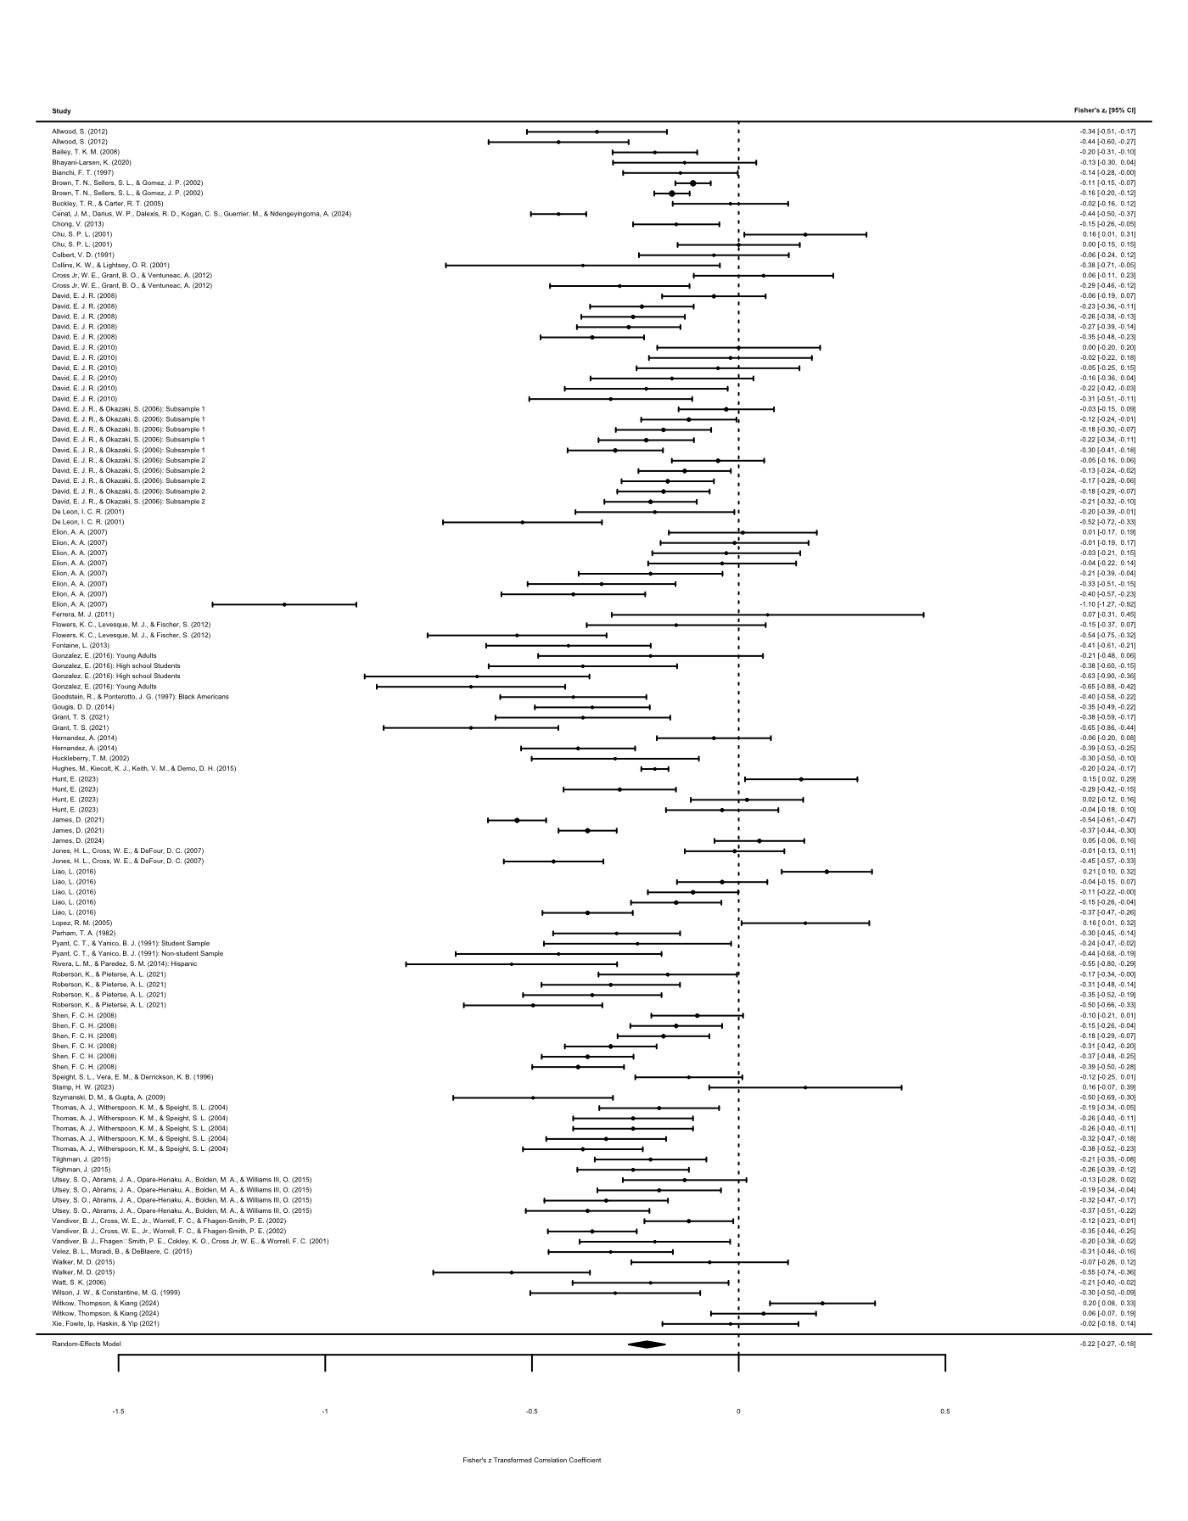

Note. Each correlation coefficient is represented by a square, the size of which corresponds to the study’s weight in the meta-analysis. The horizontal line through each square represents the 95% confidence interval (CI) for the correlation coefficient. The overall effect size is depicted as a diamond at the bottom, with its width representing the 95% CI.

