Online Supplements

Crossmodal Semantics in Memory:
Scoping Review and Meta-Analyses of Multisensory Effects in Short-Term and Episodic Memory Systems

Salvador Soto-Faraco^{1,2} and Charles Spence³

- Center for Brain and Cognition, Universitat Pompeu Fabra, Carrer Ramón Trias i Fargas 25-27, 08005 Barcelona, Spain
- Institució Catalana de Recerca i Estudis Avançats (ICREA), Passeig de Lluis Companys 23, 08010 Barcelona, Spain
- Department of Experimental Psychology, Oxford University, New Radcliffe House, Oxford OX2 6GG, Oxford, England

Online Suppplement 1.
Search queries used in article search

Scopus search query
Date of search: 20/11/2023
#1 (TITLE ( crossmodal OR cross-modal OR multisensory OR multimodal OR bimodal OR audiovisual OR "audio-visual" OR ( auditory AND visual ) ) AND TITLE ( memory OR mnemonic OR memories ) )
#2 (AUTHKEY ( crossmodal OR cross-modal OR multisensory OR multimodal OR bimodal OR audiovisual OR "audio-visual" OR ( auditory AND visual ) ) AND AUTHKEY (memory OR mnemonic OR memories ) )
#3 = #1 OR #2
#4 = #3 AND PUBYEAR > 1989 AND PUBYEAR < 2024 AND ( LIMIT-TO ( SUBJAREA,"NEUR" ) OR LIMIT-TO ( SUBJAREA,"PSYC" ) OR LIMIT-TO ( SUBJAREA,"MULT" ) ) AND ( LIMIT-TO ( LANGUAGE,"English" ) ) AND ( LIMIT-TO ( DOCTYPE,"ar" ) OR EXCLUDE ( DOCTYPE,"re") )
#5 = TITLE (rat* OR monkey OR priming)
#6 = #4 AND NOT #5
Result: 482 articles.

Web of Science core collection search query
Date of search: 20/11/2023
Timespan of search set to | Timespan: 1990-01-01 to 2023-12-31 (Publication Date)
#1 TI=((crossmodal OR cross-modal OR multisensory OR bimodal OR multimodal OR audiovisual OR audio-visual OR (auditory AND visual)) AND (memory OR mnemonic OR memories))
#2 AK=((crossmodal OR cross-modal OR multisensory OR bimodal OR multimodal OR audiovisual OR audio-visual OR (auditory AND visual)) AND (memory OR mnemonic OR memories))
#3 = #1 OR #2
(((#3) NOT TI=(rat* OR monkey OR priming)) AND (DT==("ARTICLE") AND LA==("ENGLISH"))) AND ((SJ==("NEUROSCIENCES NEUROLOGY" OR "PSYCHOLOGY" OR "BEHAVIORAL SCIENCES")) NOT (DT==("REVIEW")))
Result: 562 articles
Link to search query: https://www.webofscience.com/wos/alldb/summary/e5e4421a-9de5-4d74-b240-7e251e6749a0-b6027f95/relevance/1
Online Suppplement 2. Article selection criteria

Screening #1: Exclusion criteria

Art: Is not a primary research article. If the article does not report the results of an empirical study or studies. For example, review articles, commentaries and purely simulation studies are excluded based on this criterion.
Hum: Is not with humans. Studies are excluded if they do not report data from human participants. That is, studies exclusively based on non-human animals such as mice, rats or monkeys, or reporting IA algorithms or theoretical models without reporting empirical data from a study with humans, are excluded.
AV: Is not audio-visual. Studies are excluded if they include only unisensory memory encoding conditions, or do not include crossmodal conditions that are audio-visual. For instance, studies are excluded if only unisensory auditory and unisensory visual stimuli are presented separately in the memory encoding phase, or if the only crossmodal condition included is haptic-visual.
Sem: Is not semantic. Studies are excluded if none of the stimuli used in the memory protocol carry meaningful semantic information. For instance, a study would be excluded if it exclusively uses meaningless letters, and/or geometrical figures, and/or meaningless shapes as stimuli. Crossmodal correspondence studies are excluded, since they are based on crossmodal relationships of a low-level sensory nature (see text for more details on the distinction between semantic relationships and crossmodal correspondences).
Object: Is not with object images and/or sounds. We exclude papers reporting studies that do not include, at least in one of their conditions, either images of objects or characteristic sounds of objects. We specifically exclude studies that are exclusively conducted with linguistic materials like written and spoken words, or sentences (see main text for a justification of this choice). Studies regarding narrative, historical or autobiographical memory are excluded unless they include memory tests for specific object images or sounds.
Mem: Is not memory. We exclude papers whose protocol does not include a retrospective memory task with encoding (explicit or implicit), retention, and test phases. Priming, or retrieval by free association without any previous encoding (as in, for example, sound induced visual imagery), or prospective memory protocols are excluded. Memory tasks used as secondary or distractor tasks in the context of research on other processes (e.g., attention), are also excluded.

Screening #2: Inclusion criteria

2.1. Crossmodal congruence condition: The study includes at least one condition involving the presentation of semantically congruent crossmodal events for memory encoding (that is, the unisensory components of the crossmodal event are semantically congruent object categories), and a measurement (behavioural and/or physiological variable) for the retrieval of information of the whole multisensory object or one of its unisensory components is taken.
2.2. Control condition: The measurement from the semantically congruent crossmodal condition/s (in #2.1.) is compared to a measurment of one or more of the following conditions: (a) a semantically meaningful object stimulus presented in a single sensory modality; (b) a semantically incongruent crossmodal combination, or; (c) a crossmodal combination where one modality contains an semantically meaningful object and the other a meaningless event.

Online Suppplement 3.
Tables

Table S3.1. Summary of short-term memory and working memory studies

Study | N | Encoding conditions & proportions | Formats | Test mod. | Memory task | Retention interval |  | Behavioral outcome/s |  | Neural corr.
 |  |  |  |  |  |  | Cong. | Incong. | Non-sem. facilitation
Murray et al. 2004 | 11 | AVc=25%; V=75% | Picture /Sound | V | Old/New continuous | 17-32s | AVc > V |  |  | EEG
Murray et al. 2005 | 10 | AVc=25%; V=75% | Picture /Sound | V | Old/New continuous | 12-100s | AVc > V |  |  | fMRI
Lehmann et al. 2005 Exp1 (AV) | 16 | AVm=25%; V=75% | Picture /Tone | V | Old/New continuous | 8-42s |  |  | AVm < V
Exp1 (SV) |  | VSm=25%; V=75% | Picture /Skin vibration | V | Old/New continuous | 8-42s |  |  | SVm ~ V
Lehmann et al. 2005 Exp2 | 11 | AVc=12.5%; AVi=12.5%; V=75% | Picture /Sound | V | Old/New continuous | 8-42s | AVc > V | AVi ~ V
 |  |  |  |  |  |  | AVc > AVi
Thelen¹ et al. 2012 | 22 | AVm=25%; V=75% | Picture /Noise | V | Old/New continuous | 8-42s |  |  | AVm < V | EEG
Thelen^{1,2} et al. 2014 Exp1 | 12 | AVm=25%; V=75% | Picture /Noise | V | Old/New continuous | 8-42s |  |  | AVm ~ V | EEG
Thelen^{1,2} et al. 2014 Exp2 | 15 | AVc=12.5%; AVm=12.5%; A=75% | Sound /Picture /Scramble | A | Old/New continuous |  | n/r |  | AVm ~ A | EEG
Moran et al. 2013 Exp1 | 11 | AVc=25%; A=75% | Sound /Picture | A | Old/New continuous | ~32s | AVc > A
Moran et al. 2013 Exp2³ | 18 | AVc=25%; A=75% |  | A |  |  | AVc > A
Moran et al. 2013 Exp2³ | 18 | AVi=25%; A=75% |  | A |  |  |  | AVi~ A
Thelen et al. 2015 (visual) | 26 | AVc=16.6%; AVi=16.6%; AVm=16.6%; V=50% | Picture / Sound / Tone | V | Old/New continuous | 7-26s | AVc > V | AVi < V | AVm < V
(auditory) |  | AVc=16.6%; AVi=16.6%; AVm=16.6%; A=50% | Sound / Picture / Scramble | A | Old/New continuous | 7-26s | AVc > A | AVi < A | AVm ~ A
Matusz et al. 2015 | 18 | AVc=12.5%; AVm=12.5%; A=75% | Sound/ Picture/ Scramble | A | Old/New continuous | 10-39s | AVc > A |  | AVm ~ A | EEG
 |  |  |  |  |  |  | AVc > VAm
Radecke et al. 2022 (NH group) | 12 | AVc=12.5%; AVm=12.5%; A=75% | Sound/ Picture/ Scramble | A | Old/New continuous | 10-39s | AVc > A |  | AVm < A | EEG
 |  |  |  |  |  |  | AVc > VAm
(CI group) | 12 |  |  |  |  |  | AVc > A |  | AVm < A | EEG
 |  |  |  |  |  |  | AVc > VAm
Goolkasian & Foos 2005 | 53 | AV=33%; A=33%; V=33% | Picture / Spoken word; Written word | as encod | Verbal recall (3-6 item lists) | Immediate after study | AVc > V | ----
Delogu⁴ et al. 2009 | 40 | AVc=100%; A=100%; V=100% | Picture /Sound | as encod | Verbal recall (3-6 items list) | Immediate after study | AVc > A
 |  |  |  |  |  |  | AVc > V
Pecher & Zeelenmberg⁵ 2022 Exp. 1 | 51 | AVc=25%; AVi=25%; V=50% | Picture /Sound | V | Old/New continuous | 7-30s | AVc ~ V | AVi ~ V
Pecher & Zeelenberg⁵ 2022 Exp. 3 | 56 |  |  |  |  |  | AVc ~ V | AVi ~ V
Pecher & Zeelenberg⁵ 2022 Exp. 2 | 49 | AVc=25%; AVi=25%; A=50% | Sound/Picture | A | Old/New continuous | 7-30s | AVc ~ A | AVi ~ A
Pecher & Zeelenberg⁵ 2022 Exp. 4 | 56 |  |  |  |  |  | AVc < A | AVi ~ A
Almadori et al. 2021 Exp1 | 30 | AVc=50%; AVi=50% | Picture / Sound | V | Recall location | 2s | AVc > AVi
Almadori et al. 2021 Exp2 | 25 | AVc=50%; AVi=50% | Picture / Sound | V | Recall location | 2s | AVc > AVi
Xie et al.⁶ 2017 | 38 | AVc=100%; A=100%; V=100% | Picture / Sound | V or A | Match to sample | 2s | AVc > V |  |  | EEG
 |  |  |  |  |  |  | AVc > A
Xie et al.⁶ 2019 | 32 | AVc=100%; AVi=100%; A=100%; V=100% | Picture / Sound | V or A | Match to sample | 4s | AVc > V |  |  | fMRI
 |  |  |  |  |  |  | AVc > A
 |  |  |  |  |  |  | AVc > AVi
Xie et al.⁶ 2021a | 40 | AVc=100%; A=100%; V=100% | Picture / Sound | V or A | Match to sample | 2s | AVc > V |  |  | EEG
 |  |  |  |  |  |  | AVc > A
Xie et al.⁶ 2021b | 128 | AVc=100%; AVi=100%; A=100%; V=100% | Picture /Sound | V or A | Match to sample | 1s | AVc > V |  |  | fMRI
 |  |  |  |  |  |  | AVc > A
 |  |  |  |  |  |  | AVc > AVi
Yu et al.⁶ 2021 (selective att.) | 34 | AVc=100%; AVi=100% | Picture /Sound | V | Match to sample | 2s | AVc ~ AVi
 |  |  | Sound /Picture | A |  |  | AVc ~ AVi
(divided att.) |  |  | Picture / | V |  |  | AVc>AVi
 |  |  | Sound | A |  |  | AVc>AVi
Yu et al.⁶ 2022 (selective att.) | 34 | AVc=100%; AVi=100%; A=100%; V=100% | Picture /Sound | V | Match to sample | 2s | AVc ~ AVi
 |  |  |  |  |  |  | AVc>V
 |  |  | Sound /Picture | A |  |  | AVc>AVi
 |  |  |  |  |  |  | AVc>A
Note. Table summarising studies of crossmodal semantic effects on memory for Short Term Memory and Working Memory protocols, included in this review. The studies are identified with the first author name and the publication date, and listed in the order in which they are discussed in the main text. N refers to the sample size for the comparison reported. Encoding modalities and proportions refers to the stimulus modalities of the events presented during study (or initial exposure) A=auditory only, V=visual only, AV=audiovisual, AS=audio-somatosensory; AVm=Audiovisual where the distractor modality is meaningless (Noise, Visual scramble; Vibration). The proportions shown refer to the proportion of this modality combination within encoding/study blocks. When test and study items are mixed within a block (as in the continuous recognition task), the total proportion of each modality across all trials is shown. If a modality is blocked, the proportion for that modality is 100%. Format refers to the type of stimulus within the modality/ies used, with bold indicating the format/s to be tested at retrieval. Test mod. (test modality) refers to the modality used for the memory test (if recognition or localization). Memory task refers to the main task used to evaluate memory performance (other distracting tasks not reported). Retention interval is the interval between the end of the study/exposure and the beginning of the memory test (in continuous recognition tasks the intervening time between first and second presentation of the items is reported). Outcome refers to the outcome of the main statistical comparison/s of interest, > means more accurate than; < means less accurate than; ~ means not different from. Cong. = Congruence test, it refers to any tests checking facilitation from crossmodal congruence at encoding. Incong. = Incongruence test, refers to tests of worsening in performance after crossmodal incongruence at encoding. Non-sem. facilitation refers to tests for better performance after encoding with a meaningless, crossmodal stimulus. Neural corr. Indicates wether the study measured neural correlates, and which method was used. Colour coding: Green for significant outcomes (facilitation for congruence; interference for incongruence; facilitation for non-semantic pairings), and red for inconclusive or negative evidence. 1. Note that Thelen et al. 2012, and Thelen et al 2014 did not include a semantically congruent condition, but their results concerning crossmodal meaningless conditions are discussed in the main text and they have therefore been included in Table. 2. Thelen et al.’s (2014) main findings were concerned with individual variability. Here we report the main group outcome, for comparison with the rest of the studies which only reported group-level results. In Thelen et al.’s 2014 Exp 2, the proportions of conditions are not reported and we used values based on similar experiments from this group. 3. Audiovisual congruent and audiovisual incongruent were tested on different groups of participants, always combined with a proportion of 25% - 75% with auditory only events. 4. Dependent measure was memory span: in this case, > and < mean, respectively, more items than, and less items than. 5. Only relevant modality combinations shown. Values estimated from plots and averaged across experiments, but outcomes are statistically supported for each individual experiment. 6. Accuracy was at ceiling, and the outcomes are based on RT effects: in this case >, <, and ~ mean, respectively, faster than, slower than, and not significantly different from.

Table S2. Summary of episodic memory studies

Study | N | Encoding conditions & proportions | Formats | Test mod. | Memory task | Retention interval |  | Behavioral outcome/s |  | Neural corr.
 |  |  |  |  |  |  | Cong. | Incong. | Other
Thompson & Paivio 1994  Exp 1 | 165 | AVc=100%; AA=100%; VV=100% | Pictures / Sounds | Written | Free recall (36 items) | Immediate after study | AVc > AA |  | AA > VV
 |  |  |  |  |  |  | AVc > VV
 |  |  |  |  |  |  | AVc~(AA+VV)
Exp 2 | 76 | AVc=100%; A=100%;  V=100% | Pictures / Sounds | Written | Free recall (36 items) | Immediate after study | AVc > A |  | A ~ V
 |  |  |  |  |  |  | AVc > V
 |  |  |  |  |  |  | AVc ~ (A + V)
Nyberg et al. 2000 Exp 1 | 12 | AVc=100%; V=100% | Written words / Sounds | V | Old / new (>20 words) | Immediate after study | AVc < V |  |  | PET
Exp 2 | 6 | AVc=100%; V=100% | Written words / Sounds |  | Old / new (>20 words) | Immediate after study | Avc ~ V |  |  | PET
Wheeler et al. 2000* | 18 | AVc=50%; VVc=50%; | Written words + Sounds / Pictures | Written words | Recall modality associated to written label. | 1 day | (No memory performance behavioural measure reported) |  |  | fMRI
Cohen et al. 2009 Exp 2 | 12+12 | AVc=100%; A=100% | Sounds/ Pictures | A | Old / New (64 items) | Immediate after study | AVc ~ A
 | 12+12 | A=100%;  V=100% | Pictures/ Sounds | A; V (as enc.) |  |  |  |  | V > A
Naghavi et al. 2011 | 30 | AVc=50%;  AVi=50% | Pictures / Sounds | AV | Old/New |  | AVc > AVi |  |  | fMRI
Heikkilä et al. 2015 | 42 | AVc=33%; AVi=33%; AVm=33% | Pictures / Sounds / White noise | V | Old / New (lists of 51 items) | Immediate after study | AVc ~ AVm | AVi ~ AVm
 |  | VVc=33%; VVi=33%; VVm=33% | Pictures / Written words / X’s | V |  |  | AVc ~ AVm | AVi ~ AVm
 |  | AVc=33%; AVi=33%; AVm=33% | Written word / Spoken word / White noise | V |  |  | AVc > AVm | AVi ~ AVm
 |  | AVc=33%; AVi=33%; AVm=33% | Sounds / Pictures / Visual noise | A |  |  | AVc > AVm | AVi ~ AVm
 |  | AVc=33%; AVi=33%; AVm=33% | Spoken word / Written word / X’s | A |  |  | AVc > AVm | AVi ~ AVm
Heikkilä et al. 2016 (Children 8, 10, 12 y.o.) | 114 | AVc=33%; AVi=33%; AVm=33% | Pictures / Sounds / White noise | V | Old / New (lists of 51 items) | Immediate after study | AVc > AVm | AVi ~ AVm
 |  | VVc=33%; VVi=33%; VVm=33% | Pictures / Written words / X’s | V |  |  |  |  | VVc ~ VVm / VVi ~ VVm
 |  | AVc=33%; AVi=33%; AVm=33% | Written word / Spoken word / White noise | V |  |  | AVc ~ AVm | AVi ~ AVm
 |  | AVc=33%; AVi=33%; AVm=33% | Sounds / Pictures / Visual noise | A |  |  | AVc > AVm | AVi ~ AVm
 |  | AVc=33%; AVi=33%; AVm=33% | Spoken word / Written word / X’s | A |  |  | AVc ~ AVm | AVi ~ AVm
 |  | AVc=33%; AVi=33%; AVm=33% | Spoken word / Pictures / Visual noise | A |  |  | AVc > AVm | AVi > AVm
Heikkilä et al. 2017a (Exp 1) | 43 | AVc=33%; AVi=33%; AVm=33% | Spoken word / Pictures / Visual noise | A | Old / New (lists of 51 items) | Immediate after study | AVc > AVm | AVi > AVm
 |  | VVc=33%; VVi=33%; VVm=33% | Written words / Pictures / Visual noise | V |  |  |  |  | VVc > VVm
 |  |  |  |  |  |  |  |  | VVi ~ VVm
(Exp 2) | 42 | VVc=33%; VVi=33%; VVm=33% | Pictures / Written words / X’s | V | Old / New (lists of 51 items) | Immediate after study |  |  | VVc ~ VVm
 |  |  |  |  |  |  |  |  | VVi ~ VVm
 |  | VVc=33%; VVi=33%; VVm=33% | Pictures / Pictures / Visual noise | V |  |  |  |  | VVc > VVm
 |  |  |  |  |  |  |  |  | VVi ~ VVm
Heikkilä et al. 2017b | 43 | AVc=100%; V=100% | Written word / Spoken word | V | Old / New (lists of 51 items) | Immediate after study | AVc ~ V
 |  | AVc=100%; A=100% | Sounds / Pictures / | A |  |  | AVc > A
 |  | AVc=100%; A=100% | Sounds / Written words | A |  |  | AVc > A
 |  | AVc=100%; A=100% | Spoken word / Pictures | A |  |  | AVc > A
 |  | AVc=100%; A=100% | Spoken word / Written word | A |  |  | AVc ~ A
Heikkilä et al. 2018 (young adults) | 42 | AVc=100%; A=100% | Sounds / Pictures / | A | Old / New (lists of 51 items) | Immediate after study | AVc > A
 |  | AVc=100%; A=100% | Sounds / Written words | A |  |  | AVc > A
 |  | AVc=100%; A=100% | Spoken word / Pictures | A |  |  | AVc > A
 |  | AVc=100%; A=100% | Spoken word / Written word | A |  |  | AVc ~ A
(older adults) | 42 | AVc=100%; A=100% | Sounds / Pictures / | A |  |  | AVc > A
 |  | AVc=100%; A=100% | Sounds / Written words | A |  |  | AVc > A
 |  | AVc=100%; A=100% | Spoken word / Pictures | A |  |  | AVc > A
 |  | AVc=100%; A=100% | Spoken word / Written word | A |  |  | AVc > A
Meyerhoff & Huff 2016 (Exp 1) | 48 | AVc=33%;  A=33%;  V=33% | Movie clips / Silent clips; Movie soundtracks | V; A: AV (as enc.) | Old / New (lists of 900 movie clips) | 1 to 7 days | AVc > A |  | V > A
 |  |  |  |  |  |  | AVc > V
(Exp2) | 24 | AVc=33%; AVi=33%;  V=33% |  |  |  | 1 day | AVc > AVi
 |  |  |  |  |  |  | AVc > V | AVi > V
(Exp3a) | 24 | AVc=50%;  V=50% |  |  |  | 1 day | AVc > V
Meyerhoff et al. 2023 (Exp1a) | 24 | AVc=50%;  V=50% | Movie clips / Silent movie clip | AV / V | Old / New (lists of 900 movie clips) | 1 day | AVc > V
(Exp4) | 24 |  |  | AV / V |  |  | AVc > V
(Exp2) | 24 | AVc=50%; A=50% | Movie clips / Movie clip soundtracks | AV / A | Old / New (lists of 900 movie clips) | 1 day | AVc > A
Kassim et al. 2018 | 40 | AV=100%;  A=100%; V=100% | Pictures / Spoken words | AV; A (as enc) | Old / New | 8-14 s or 112-118 s | AV > A
 | 41 |  |  | AV; V (as enc) |  |  | AV > V
Marian et al. 2021 | 43 | AVc=33%; AVi=33%; AVm=33% | Picture / Spoken word | V | Old/New | Inmediate after study | AVc ~ AVi
 |  |  |  |  |  |  | AVc > AVm | AVi > AVm
 |  |  |  |  | Location |  | AVc ~ AVi
 |  |  |  |  |  |  | AVc ~ AVm | AVi ~ Avm
 |  |  | Picture / Sound | V | Old/New |  | AVc > AVi
 |  |  |  |  |  |  | AVc > AVm | AVi > Avm
 |  |  |  |  | Location |  | AVc > AVi
 |  |  |  |  |  |  | AVc > AVm | AVi ~ AVm
Glicksohn et al. 2023 Exp1 | 69 | AVc=87.5%; AVi=12.5% | Picture / Sound | V | Old/New | ~15 m after study | AVc < AVi
 |  |  |  |  | Location |  | AVc < AVi
Duarte et al. 2023 Exp1 (AUC) | 66 | AVc; AVi; AVm | Picture / Sound | V | Old/New | Immediate after study | AVc > AVi | AVi ~ AVm
 |  |  |  |  |  |  | AVc ~ AVm
Exp2 (AUC) | 66 |  |  |  |  |  | AVc > AVi | AVi ~ AVm
 |  |  |  |  |  |  | AVc > AVm
Exp 3 | 66 |  |  |  | Recall if image was associated with cong./ incong./ meaningless sound |  | AVc > AVi | AVi ~ AVm
 |  |  |  |  |  |  | AVc > AVm

Note. Table summarising the studies of crossmodal semantic effects on memory for episodic memory protocols, included in this review. The studies are identified with the first author name and the publication date, and listed in the order in which they are discussed in their rspective sections. N refers to the sample size of the study for the comparison/s reported. . Encoding modalities and proportions refers to the stimulus modalities of the events presented during study (or initial exposure) A=auditory only, V=visual only, AV=audiovisual, AS=audio-somatosensory; AVm=Audiovisual where the distractor modality is meaningless (Noise, Visual scramble; Vibration). The proportions shown refer to the proportion of this modality combination within encoding/study blocks. When test and study items are mixed within a block (as in the continuous recognition task), the total proportion of each modality across all trials is shown. If a modality is blocked, the proportion for that modality is 100%. Format refers to the type of stimulus within the modality/ies used. Test mod. (test modality) refers to the modality used for the memory test (if recognition or localization). Memory task refers to the main task used to evaluate memory performance (other distracting tasks not reported). Retention interval is the interval between the end of the study/exposure and the beginning of the memory test. Outcome: outcome of the main statistical comparison/s of interest, > means more accurate than; < means less accurate than, ~ means not different from, (A+V) refers to the probabilistic summation model. Cong. = Congruence test, it refers to any tests checking facilitation from crossmodal congruence at encoding. Incong. = Incongruence test refers to tests of worsening in performance after crossmodal incongruence at encoding. Other includes the outcomes of tests other than congruence or incongruence, such as those comparing two unisensory conditions. Neural corr. Indicates wether the study measured neural correlates, and which method was used. Colour coding: Green for significant outcomes (facilitation for congruence; interference for incongruence), and red for inconclusive or negative evidence.

Online Suppplement 4.
Funnel plots
A.  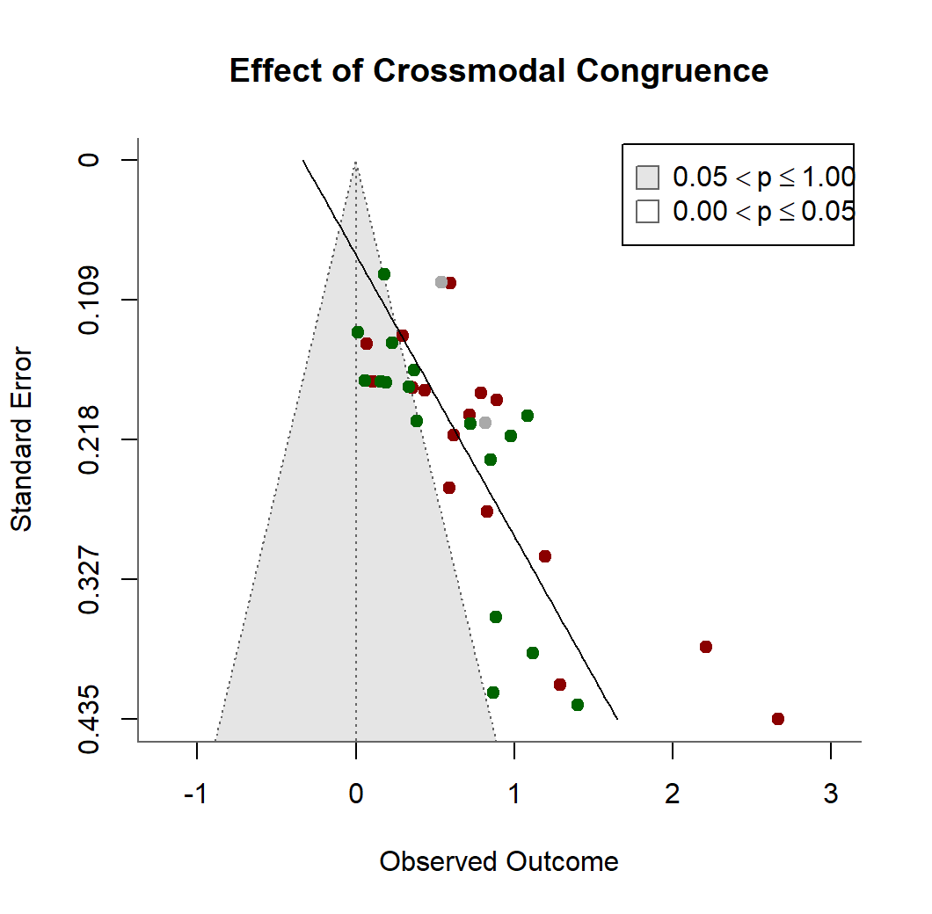 | B.  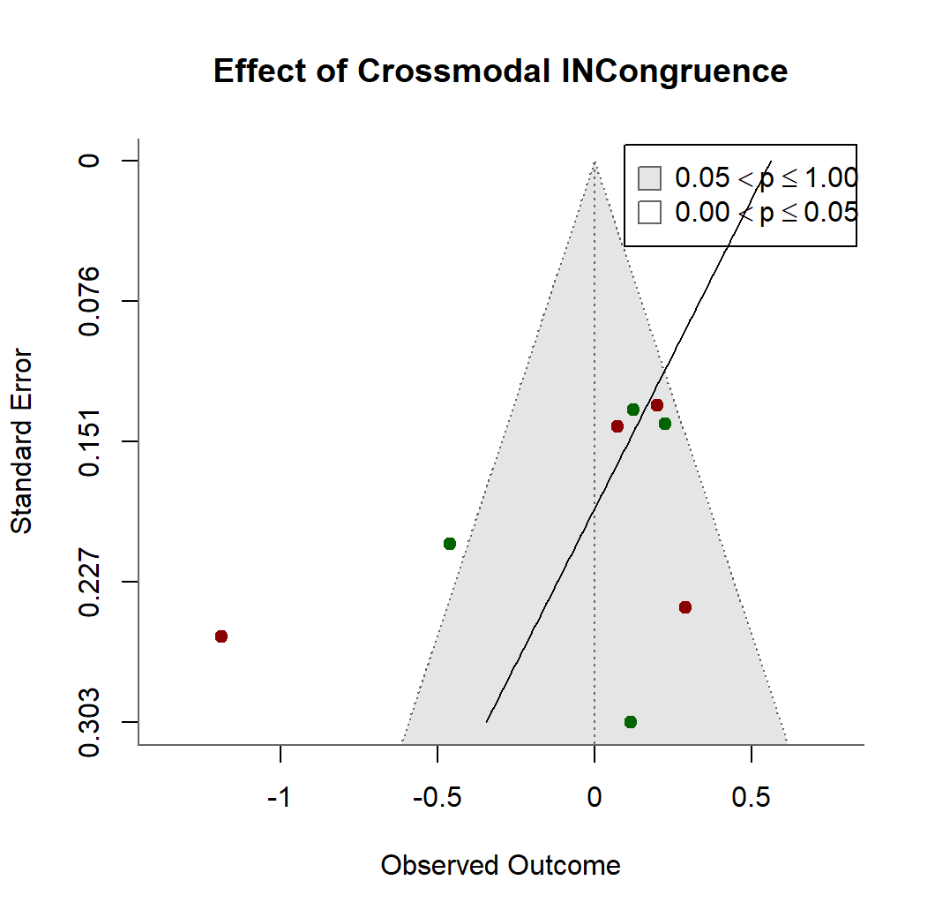
C.  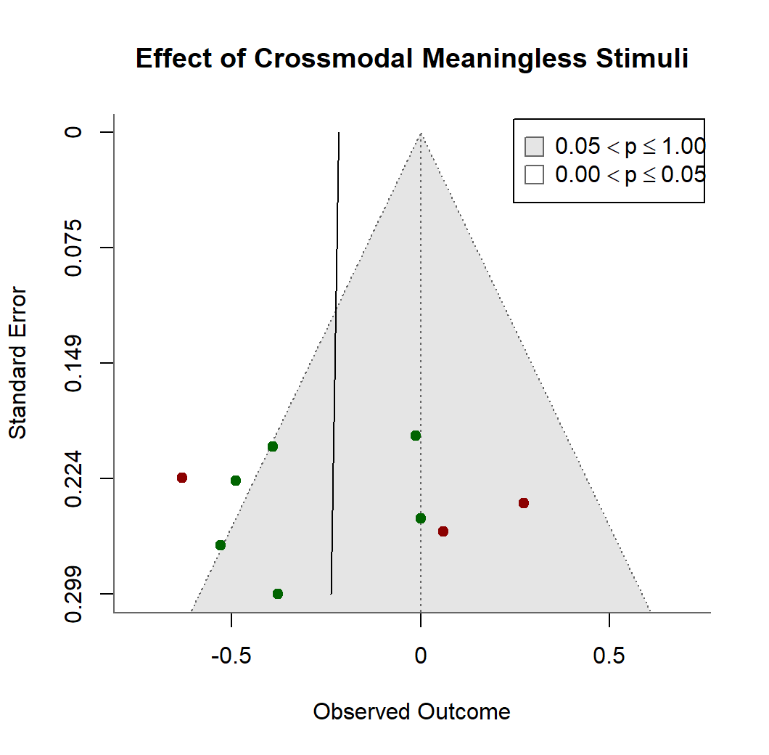 | Figure S4.1. Funnel plots corresponding to the metanalyses on short-term and working memory studies. In all plots, effect sizes are represented in the x-axis (expressed in Hedge’s gz), test modality has been colour coded (red=auditory, green=visual, gray=mixed), and the solid black line represents the regression used for the Egger’s test (see main text). For convenience, the two-sided null hypothesis contour (p>.05) is shown as a gray-shaded funnel. A. Outcomes for crossmodal semantic congruence contrasts. B. Outcomes for crossmodal semantic incongruence contrasts. C. Outcomes for crossmodal semantic meaningless stimuli contrasts.

A.  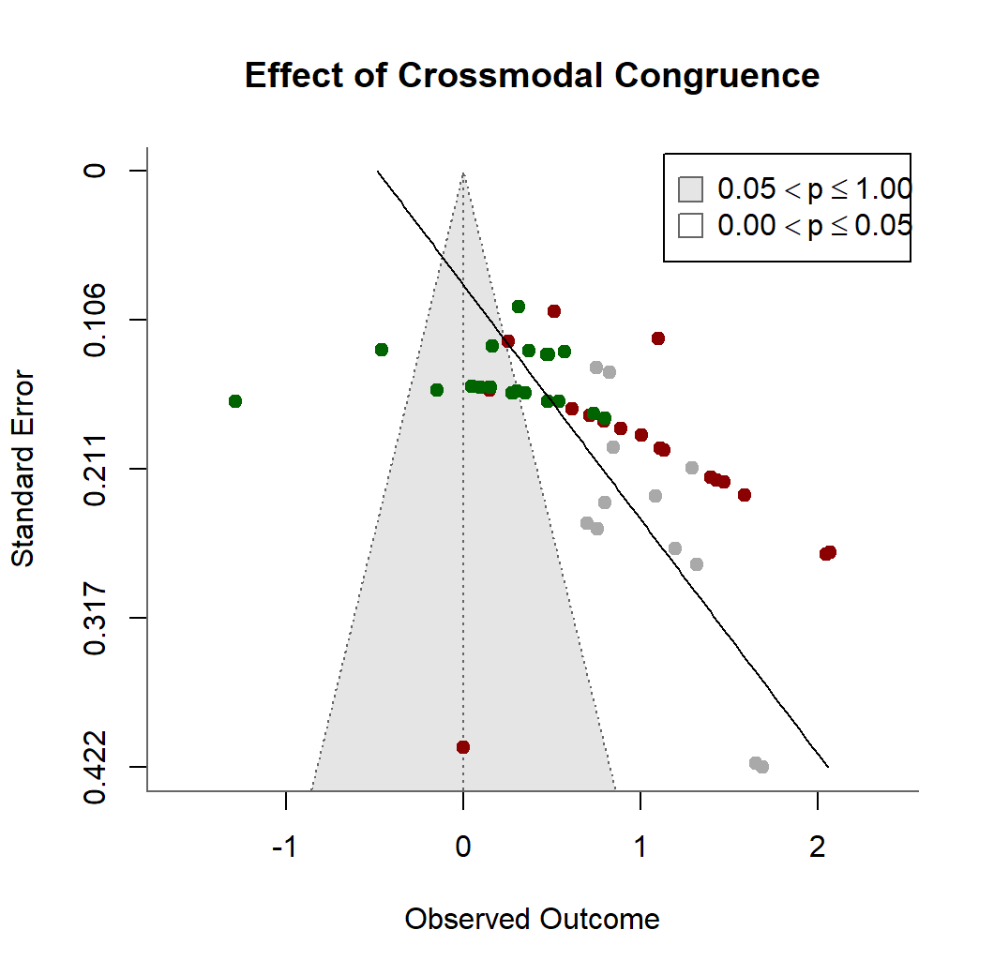 | B.  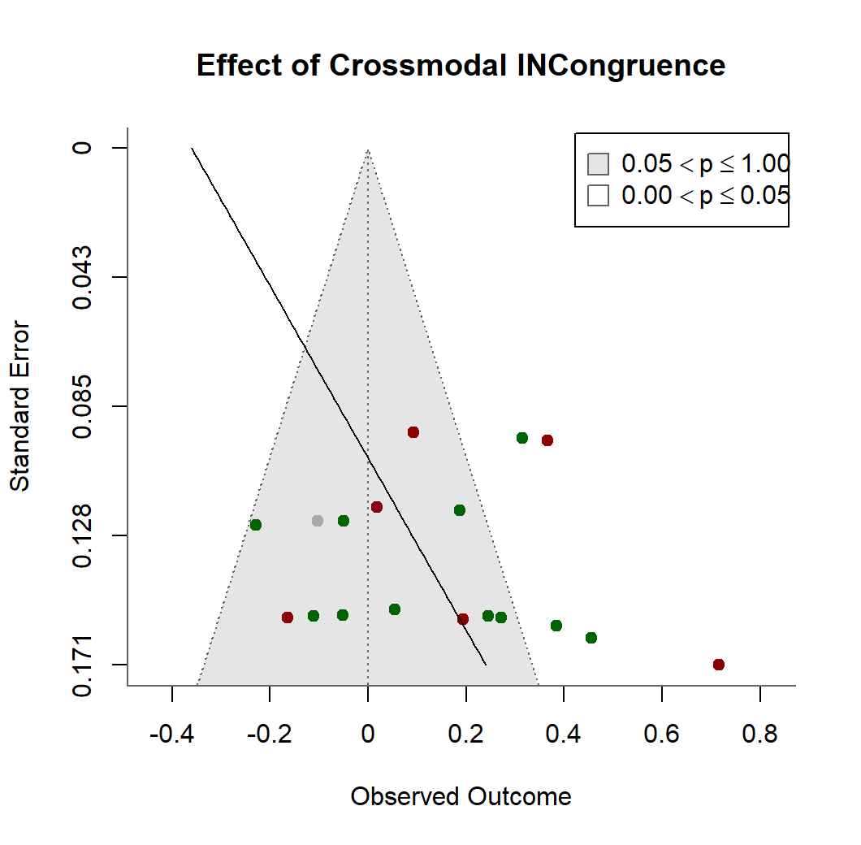
Figure S4.2. Funnel plots corresponding to the metanalyses on episodic memory studies. In all plots, effect sizes are represented in the x-axis (expressed in Hedge’s gz), test modality has been colour coded (red=auditory, green=visual, gray=mixed), and the solid black line represents the regression used for the Egger’s test (see main text). For convenience, the two-sided null hypothesis contour (p>.05) is shown as a gray-shaded funnel. A. Outcomes for crossmodal semantic congruence contrasts. B. Outcomes for crossmodal semantic incongruence contrasts.

