Supplemental Materials
Supplemental appendices:
- Supplemental Material A. PRISMA 2020 Reporting Checklist
- Supplemental Material B. Additional Descriptive Frequencies of Study Characteristics
- Supplemental Material C. Controlling for Cohort Confounds
- Supplemental Material D. Additional Robustness Checks
- Supplemental Material E. Additional Exploratory Analyses of Age Differences
- Supplemental Material F. Additional Moderator Analyses

Supplemental figures:
- Figure S1. Evidence Gap Map by STEM Domain and Age Category
- Figure S2. Comparisons Possible with the Present Meta-Analytic Approach
- Figure S3. Distribution of STEM and Verbal Stereotypes (Standardized Means)
- Figure S4. Moderation by Age, Gender, and Stereotype Domain (Standardized Means)
- Figure S5. Exploratory Analysis of Quadratic Age Effects (Stereotype Scores)
- Figure S6. Asymmetric Development of In-Group Bias (Stereotype Scores)
- Figure S7. Moderation by Age, Gender, and Stereotype Domain (Qualitative Responses)
- Figure S8. Moderation by STEM Domain, Race, and Measure Characteristics (STEM Stereotype Scores)
- Figure S9. Moderation by Additional Exploratory Moderators (Stereotype Scores)
- Figure S10. Moderation by Age, Gender, and Stereotype Domain (Sample Standard Deviations)

Supplemental tables:
- Table S1. Descriptive Frequencies for STEM Ability Stereotypes
- Table S2. Descriptive Frequencies for Verbal Ability Stereotypes
- Table S3. Meta-Analytic Summaries of Qualitative Response Categories
- Table S4. Conditional Means for Confirmatory Moderators
- Table S5. Predicted 10-Year Age Differences by Participant Gender
- Table S6. Mean STEM Stereotypes by Selective Reporting Adjustment (Stereotype Scores)
- Table S7. Age Effects Controlled for Data Collection Year or Birth Cohort (Stereotype Scores)
- Table S8. Confirmatory Moderator Results (Standardized Means)
- Table S9. Confirmatory Moderator Results by Inclusion of Outliers (Stereotype Scores)
- Table S10. Confirmatory Moderator Results by Inclusion of Older Studies (Stereotype Scores)
- Table S11. Confirmatory Moderator Results by Assumed Correlation (Stereotype Scores)
- Table S12. Within-Study Versus Between-Study Effects of Age (Stereotype Scores)
- Table S13. Confirmatory Moderator Results by Participant Gender (Stereotype Scores)
- Table S14. Confirmatory Moderator Results for Computer Science, Engineering, and Physics Stereotypes (Stereotype Scores)
- Table S15. Moderator Results for Qualitative Response Categories
- Table S16. Exploratory Moderator Results for STEM Stereotypes (Stereotype Scores)
- Table S17. Moderator Results for Sample Standard Deviations

Supplemental Material A: PRISMA 2020 Reporting Checklist [🔙]
Section and Topic | Item # | Checklist item | Location where item is reported
TITLE
Title | 1 | Identify the report as a systematic review. | 3
ABSTRACT
Abstract | 2 | See the PRISMA 2020 for Abstracts checklist. | 1
INTRODUCTION
Rationale | 3 | Describe the rationale for the review in the context of existing knowledge. | 3–6
Objectives | 4 | Provide an explicit statement of the objective(s) or question(s) the review addresses. | 3–6
METHODS
Eligibility criteria | 5 | Specify the inclusion and exclusion criteria for the review and how studies were grouped for the syntheses. | 21–23
Information sources | 6 | Specify all databases, registers, websites, organisations, reference lists and other sources searched or consulted to identify studies. Specify the date when each source was last searched or consulted. | 23–25
Search strategy | 7 | Present the full search strategies for all databases, registers and websites, including any filters and limits used. | Preregistration
Selection process | 8 | Specify the methods used to decide whether a study met the inclusion criteria of the review, including how many reviewers screened each record and each report retrieved, whether they worked independently, and if applicable, details of automation tools used in the process. | 26–27
Data collection process | 9 | Specify the methods used to collect data from reports, including how many reviewers collected data from each report, whether they worked independently, any processes for obtaining or confirming data from study investigators, and if applicable, details of automation tools used in the process. | 28
Data items | 10a | List and define all outcomes for which data were sought. Specify whether all results that were compatible with each outcome domain in each study were sought (e.g. for all measures, time points, analyses), and if not, the methods used to decide which results to collect. | 28
Data items | 10b | List and define all other variables for which data were sought (e.g., participant and intervention characteristics, funding sources). Describe any assumptions made about any missing or unclear information. | 28
Study risk of bias assessment | 11 | Specify the methods used to assess risk of bias in the included studies, including details of the tool(s) used, how many reviewers assessed each study and whether they worked independently, and if applicable, details of automation tools used in the process. | N/A
Effect measures | 12 | Specify for each outcome the effect measure(s) (e.g., risk ratio, mean difference) used in the synthesis or presentation of results. | 29–30
Synthesis methods | 13a | Describe the processes used to decide which studies were eligible for each synthesis (e.g., tabulating the study intervention characteristics and comparing against the planned groups for each synthesis (item #5)). | 27–29
Synthesis methods | 13b | Describe any methods required to prepare the data for presentation or synthesis, such as handling of missing summary statistics, or data conversions. | 28, 32
Synthesis methods | 13c | Describe any methods used to tabulate or visually display results of individual studies and syntheses. | 34–44
Synthesis methods | 13d | Describe any methods used to synthesize results and provide a rationale for the choice(s). If meta-analysis was performed, describe the model(s), method(s) to identify the presence and extent of statistical heterogeneity, and software package(s) used. | 30–31
Synthesis methods | 13e | Describe any methods used to explore possible causes of heterogeneity among study results (e.g., subgroup analysis, meta-regression). | 31–32
Synthesis methods | 13f | Describe any sensitivity analyses conducted to assess robustness of the synthesized results. | 33
Reporting bias assessment | 14 | Describe any methods used to assess risk of bias due to missing results in a synthesis (arising from reporting biases). | 33
Certainty assessment | 15 | Describe any methods used to assess certainty (or confidence) in the body of evidence for an outcome. | 33
RESULTS
Study selection | 16a | Describe the results of the search and selection process, from the number of records identified in the search to the number of studies included in the review, ideally using a flow diagram. | 25–26
Study selection | 16b | Cite studies that might appear to meet the inclusion criteria, but which were excluded, and explain why they were excluded. | Supp. data
Study characteristics | 17 | Cite each included study and present its characteristics. | Supp. data
Risk of bias in studies | 18 | Present assessments of risk of bias for each included study. | N/A
Results of individual studies | 19 | For all outcomes, present, for each study: (a) summary statistics for each group (where appropriate) and (b) an effect estimate and its precision (e.g. confidence/credible interval), ideally using structured tables or plots. | Supp. data
Results of syntheses | 20a | For each synthesis, briefly summarise the characteristics and risk of bias among contributing studies. | 34–35
Results of syntheses | 20b | Present results of all statistical syntheses conducted. If meta-analysis was done, present for each the summary estimate and its precision (e.g., confidence/credible interval) and measures of statistical heterogeneity. If comparing groups, describe the direction of the effect. | 35–44
Results of syntheses | 20c | Present results of all investigations of possible causes of heterogeneity among study results. | 36–42
Results of syntheses | 20d | Present results of all sensitivity analyses conducted to assess the robustness of the synthesized results. | 43–44
Reporting biases | 21 | Present assessments of risk of bias due to missing results (arising from reporting biases) for each synthesis assessed. | 43
Certainty of evidence | 22 | Present assessments of certainty (or confidence) in the body of evidence for each outcome assessed. | N/A
DISCUSSION
Discussion | 23a | Provide a general interpretation of the results in the context of other evidence. | 56–71
Discussion | 23b | Discuss any limitations of the evidence included in the review. | 71–73
Discussion | 23c | Discuss any limitations of the review processes used. | 71–73
Discussion | 23d | Discuss implications of the results for practice, policy, and future research. | 73–76
OTHER INFORMATION
Registration and protocol | 24a | Provide registration information for the review, including register name and registration number, or state that the review was not registered. | Author note
Registration and protocol | 24b | Indicate where the review protocol can be accessed, or state that a protocol was not prepared. | Author note
Registration and protocol | 24c | Describe and explain any amendments to information provided at registration or in the protocol. | Preregistration
Support | 25 | Describe sources of financial or non-financial support for the review, and the role of the funders or sponsors in the review. | Author note
Competing interests | 26 | Declare any competing interests of review authors. | Author note
Availability of data, code and other materials | 27 | Report which of the following are publicly available and where they can be found: template data collection forms; data extracted from included studies; data used for all analyses; analytic code; any other materials used in the review. | Author note
From: Page, M. J., McKenzie, J. E., Bossuyt, P. M., Boutron, I., Hoffmann, T. C., Mulrow, C. D., …, Moher, D. (2020) The PRISMA 2020 statement: An updated guideline for reporting systematic reviews. BMJ, 372, 71.

Supplemental Material B: Additional Descriptive Frequencies of Study Characteristics [🔙]
This section further describes study characteristics by reporting the available evidence for each STEM domain by age category and the frequencies for studies of verbal stereotypes, extending the previous description of study characteristics for STEM stereotypes (Table S1).

Figure S1. Evidence Gap Map by STEM Domain and Age Category
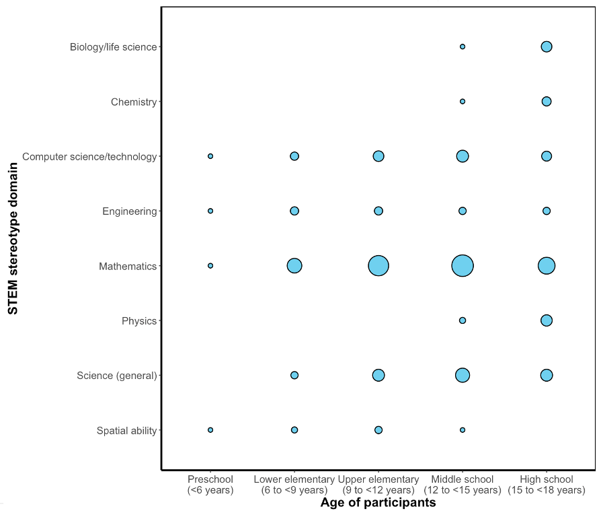
Note. A circle’s area is proportional to the number of applicable studies for each intersection of an age category and STEM domain.
STEM domain by age category. Figure S1 shows the available evidence at each intersection of STEM domain and age category, given the central importance of those characteristics to the analyses. Each circle’s size is proportional to the number of applicable studies. Fortunately, computing and engineering were represented across the age spectrum, supporting the value of age-related analyses for those male-dominated STEM fields, even though they were less studied overall.
One notable evidence gap, however, is the lack of studies on specific science fields (biology, chemistry, physics) among young children. All samples for specific science fields had an average age above 13 years (but note we statistically controlled for this age confound in moderator analyses, including for STEM domain differences). This evidence gap is sensible from the perspective of primary researchers, given that very young children might not know what “physics” or “biology” means. However, this evidence gap also leaves theoretically important questions unanswered (e.g., When do children’s stereotypes distinguish between science fields?).
Study characteristics for verbal stereotypes. Study characteristics for verbal stereotypes were typically similar to those for STEM stereotypes (Table S2). For instance, the average age was 12.06 (SD = 2.76) for verbal stereotypes versus 12.39 (SD = 2.99) for STEM stereotypes. The most common verbal subdomains were native language skills (39%; e.g., “good at German” in German samples), reading (38%), and writing (25%). Less common were stereotypes about foreign language skills (9%), spelling (7%), and general verbal ability (1%).

Supplemental Material C: Controlling for Cohort Confounds [🔙]
This section reports sensitivity analyses that controlled for data collection year and birth cohort to address potential concerns about cohort confounds. The key two empirical conclusions support a developmental interpretational of the age differences reported in the main text:
- Estimated age effects were robust to sampling and cohort confounds.
- Cohort and year effects were small in magnitude and not significant.
Potential Concern About Cohort Confounds
The literature we synthesized has overwhelmingly used cross-sectional designs, which raise concern about cohort confounds. Consider if a cross-sectional study found a difference between 6- versus 10-year-olds in 2010. The age difference might reflect development change (i.e., maturational processes). But the 10-year-olds were also born and raised earlier in historical time, presenting a cohort confound. Sociocultural change in children’s rearing might instead account for the results (for discussion, see Robinson et al., 2005).
To approach this issue, we leveraged that the reviewed studies were conducted across time, forming a cross-sectional sequence (Schaie & Caskie, 2005, p. 23). Consider if another study measured 6- and 10-year-olds in 2014. Comparing 6-year-olds in 2010 (Study 1) versus 10-year-olds in 2014 (Study 2) is a quasi-longitudinal comparison (i.e., an independent-samples same-cohort design; Salthouse, 2019). Computing effect sizes based on means (rather than mean differences) allowed for estimating these quasi-longitudinal comparisons (see Figure S2).

Figure S2. Comparisons Possible with the Present Meta-Analytic Approach
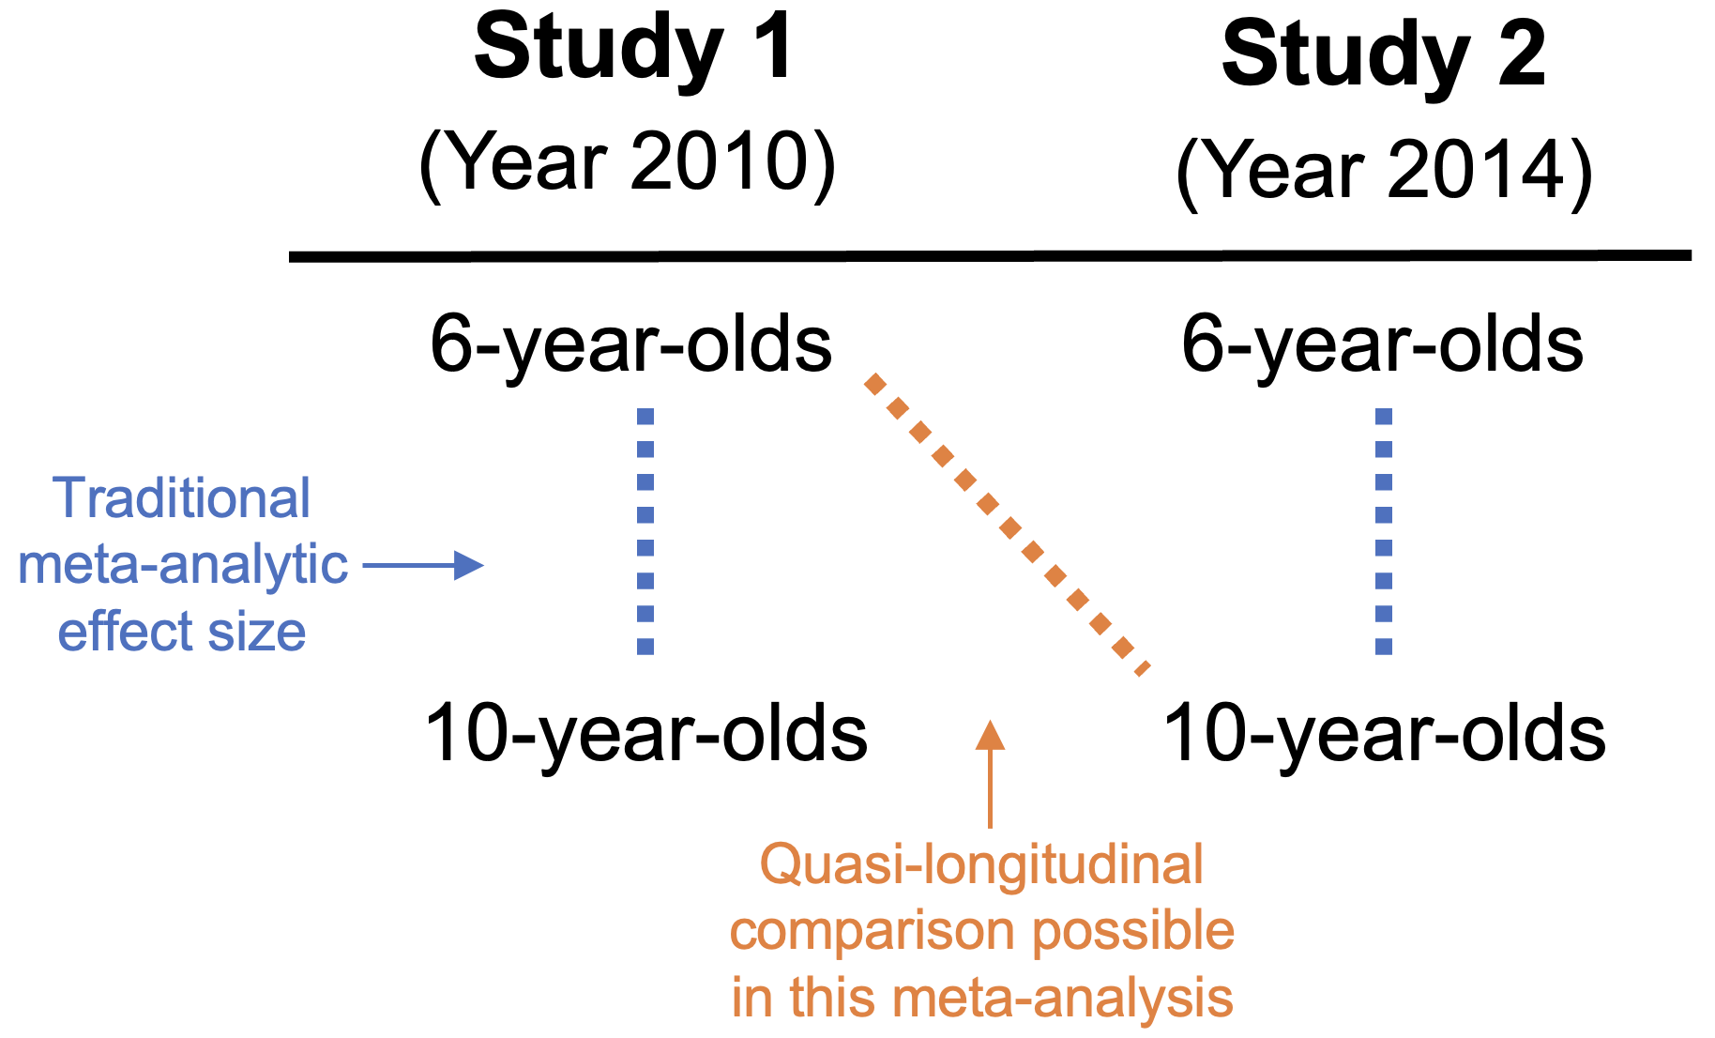
Note. Study 1 sampled 6-year-olds and 10-year-olds in 2010, whereas Study 2 did so in 2014. Traditional meta-analyses would extract only two within-study effect sizes, whereas our approach would extract four means as effect sizes, allowing for quasi-longitudinal comparisons.
We generally expected that developmental change in childhood (typical time scale of years) would be far more rapid than sociocultural change across birth cohorts (typical time scale of decades), minimizing these concerns (Miller et al., 2018, p. 1952). In contrast, cohort confounds are generally more concerning in life-span research that examines slower change across decades (e.g., adults in their 20s vs. 60s; Mirowsky & Kim, 2007, pp. 499–500), such as in aging research on cognitive decline (Nilsson et al., 2009; Salthouse, 2009).
We therefore expected that cohort confounds would have little influence on our interpretations. Nevertheless, we used neutral language like “age differences” in the results section and empirically examined this issue (as a preview, these concerns were indeed minimal).
Analytic Approach to Address Cohort Confounds
To empirically examine cohort confounds, we conducted sensitivity analyses that controlled for data collection year or birth cohort. Controlling for data collection year addresses sampling confounds (e.g., if older vs. earlier studies differentially focused on younger vs. older children). Doing so estimates cross-sectional comparisons (e.g., 6-year-olds in 2010 vs. 10-year-olds in 2010). Controlling for birth cohort addresses cohort confounds (e.g., 6-year-olds in 2010 vs. 10-year-olds in 2014). Doing so estimates quasi-longitudinal comparisons. These sensitivity analyses included interaction terms with participant gender to allow the year or cohort effect to vary by gender. Birth cohort was the data collection year minus mean age.
Conclusion 1: Estimated Age Effects Were Robust to Cohort Confounds
Estimated age effects were robust to controlling for data collection year or birth cohort (Table S7). For instance, for girls’ STEM stereotypes, the main text reported an age-related increase of b = 0.19 per 10 years. This estimated age effect was b = 0.20 when controlled for data collection year and b = 0.23 when controlled for birth cohort. Other estimated age effects were also robust (i.e., compare Table S5 vs. Table S7). This convergence is the meta-analytic equivalent to finding consistent age effects in cross-sectional and longitudinal comparisons.
Conclusion 2: Cohort and Year Effects Were Small in Magnitude and Not Significant
All estimated year or cohort effects were also small in magnitude and not significantly different from 0. These year or cohort effects were also significantly smaller than the age effects that were significant (see the rows in Table S7 for “Difference”). For instance, the estimated cohort effect for girls’ STEM stereotypes was an increase of 0.03 per 10 years (p = .096), which was far smaller than the corresponding age effect (b = 0.23). The 95% confidence interval was also narrow enough (-0.01 to 0.07) to reject moderately sized cohort effects.
Considering Other Alternative Explanations to the Estimated Age Effects
Disentangling age effects from both year and cohort effects simultaneously is challenging because the three dimensions are intertwined. For instance, even longitudinal comparisons have an age by time of measurement confound, even though birth cohort is controlled (Robinson et al., 2005). Nevertheless, the small magnitude of year and cohort effects (Conclusion 2) indicates this issue is not a major concern for this meta-analysis, simplifying interpretation.
Another concern is that sampling and selection bias might distort developmental interpretations in cross-sectional designs (Robinson et al., 2005, p. 6). For instance, in psychiatric research, early deaths due to a prognostic factor (e.g., susceptibility to disease) can distort that prognostic factor’s relationship with age in cross-sectional comparisons (i.e., survivorship bias; Kraemer et al., 2000). In the present context, however, ability stereotypes likely do not have a major, systematic influence on nonrandom entrances or exits out of the sampling frame (e.g., drop out of pre-college schooling), minimizing this concern. Any idiosyncratic differences in sampling frames would be averaged across the many studies in this meta-analysis, making them unable to explain the large, systematic age differences.
The Findings Support an Interpretation of Developmental Change
This section’s findings support a simple overall conclusion: Year or cohort effects cannot account for the large age differences found in the main confirmatory models. We therefore attribute the large magnitude of age differences to developmental change. These conclusions still have limits, of course. The findings help understand developmental change in group means, while saying nothing about stability in stereotyping or individual differences in developmental trajectories. Individuals may show different trajectories than the overall group means (e.g., Crouter et al., 2007), a phenomenon that only longitudinal studies can examine. Nevertheless, the results justify using language like “developmental change” to describe the age-related findings about aggregate means from the confirmatory models.

References
Crouter, A. C., Whiteman, S. D., McHale, S. M., & Osgood, D. W. (2007). Development of gender attitude traditionality across middle childhood and adolescence. Child Development, 78(3), 911–926. https://doi.org/10.1111/j.1467-8624.2007.01040.x
Kraemer, H. C., Yesavage, J. A., Taylor, J. L., & Kupfer, D. (2000). How can we learn about developmental processes from cross-sectional studies, or can we? American Journal of Psychiatry, 157(2), 163–171. https://doi.org/10.1176/appi.ajp.157.2.163
Miller, D. I., Nolla, K. M., Eagly, A. H., & Uttal, D. H. (2018). The development of children’s gender-science stereotypes: A meta-analysis of five decades of U.S. Draw-A-Scientist studies. Child Development, 89, 1943–1955. https://doi.org/10.1111/cdev.13039
Mirowsky, J., & Kim, J. (2007). Graphing age trajectories: Vector graphs, synthetic and virtual cohort projections, and virtual cohort projections, and cross-sectional profiles of depression. Sociological Methods & Research, 35(4), 497–541. https://doi.org/10.1177/0049124106296015
Nilsson, L.-G., Sternäng, O., Rönnlund, M., & Nyberg, L. (2009). Challenging the notion of an early-onset of cognitive decline. Neurobiology of Aging, 30(4), 521–524. https://doi.org/10.1016/j.neurobiolaging.2008.11.013
Robinson, K., Schmidt, T., & Teti, D. M. (2005). Issues in the use of longitudinal and cross-sectional designs. In D. Teti (Ed.), Handbook of research methods in developmental science (pp. 3–20). Blackwell. https://doi.org/10.1002/9780470756676.ch1
Salthouse, T. A. (2009). When does age-related cognitive decline begin? Neurobiology of Aging, 30(4), 507–514. https://doi.org/10.1016/j.neurobiolaging.2008.09.023
Schaie, K. W., & Caskie, I. L. (2005). Methodological issues in aging research. In D. M. Teti (Ed.), Handbook of Research Methods in Developmental Science (pp. 19–39). Blackwell. https://doi.org/10.1002/9780470756676.ch2

Supplemental Material D: Additional Robustness Checks [🔙]
We conducted several robustness checks of our confirmatory moderator analyses, by using standardized means rather than stereotype scores (Table S8), including versus excluding outliers (Table S9), restricting analyses to data from the year 2000 or later (Table S10), using different values for the assumed correlation between dependent effects (Table S11), using group‑mean centering to disentangle within-study versus between-study age effects (Table S12), and repeating analyses separately by participant gender (Table S13).
Standardized Means Yielded Similar Moderator Conclusions
Results were generally robust when repeating analyses for standardized means (as context, Figure S3 depicts the heterogeneity in standardized means). Compared to stereotype scores, standardized means showed similar qualitative conclusions about the statistical significance of moderators for overall age effects, overall gender effects, Age × Gender interactions, STEM domain differences, measurement characteristics, and overall STEM-verbal magnitude differences (Table S8). Figure S4 depicts the Age × Gender interactions for standardized means (analogous to Figure 4 in the main text).
One slight sensitivity concerned participant race: When analyzing standardized means, Black-White differences in STEM stereotypes were significant in a simple model without controlling for other confirmatory moderators, but the p value was 0.053 in the multivariable model. Notwithstanding this slight sensitivity, we interpret this overall Black-White difference as generally robust (e.g., it was significant when analyzing stereotype scores in a simple or multivariable model; see Table 2 in the main text).
We also preregistered examining a log transformation of stereotype scores that could vary from -∞ to +∞ (see the preregistration for details), but this transformation yielded nearly identical results relative to raw stereotype scores. For conciseness, we therefore focus on standardized means as the more stringent robustness check.

Figure S3. Distribution of STEM and Verbal Stereotypes (Standardized Means)
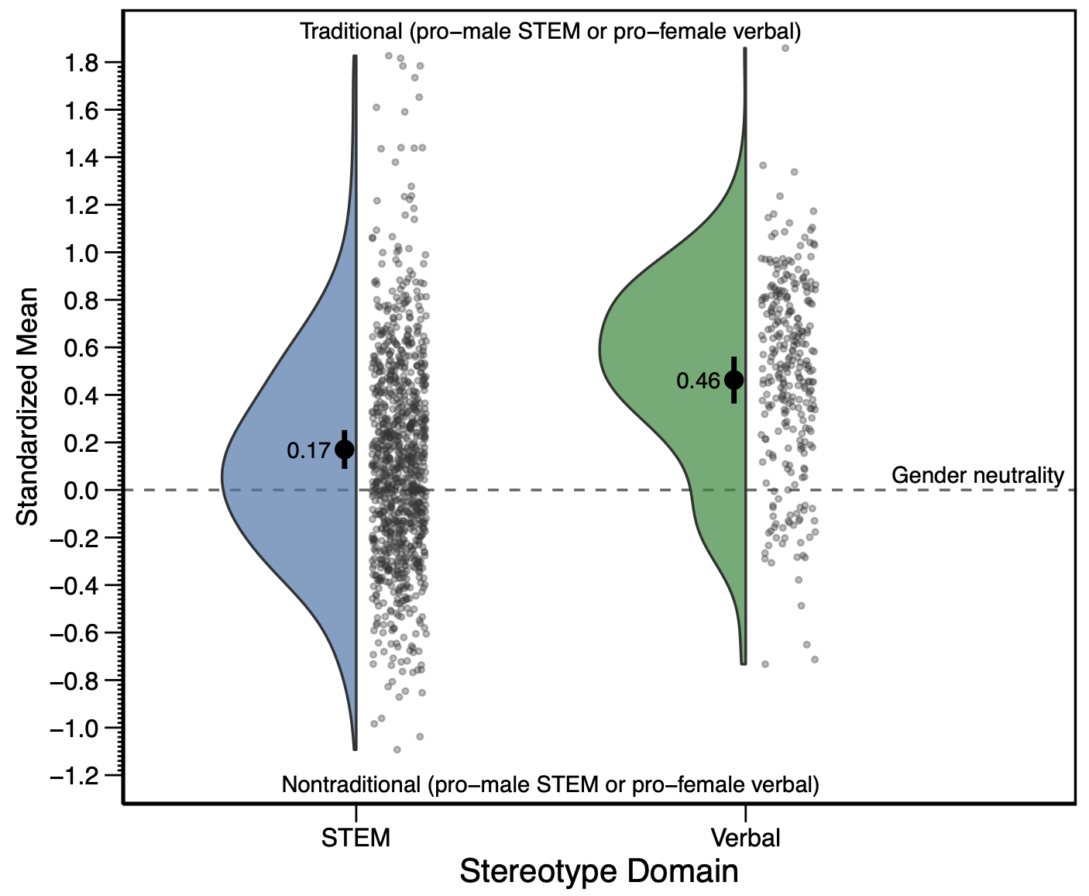
Note. The blue and green shapes on the left-hand sides show the effect size distributions, and the dots on the right-hand sides plot the effect sizes. The black dots inside the blue and green shapes indicate the weighted mean effect size (error bars denote 95% confidence intervals). Figure 3 in the main text shows the analogous graph for the confirmatory metric of stereotype scores.

Figure S4. Moderation by Age, Gender, and Stereotype Domain (Standardized Means)
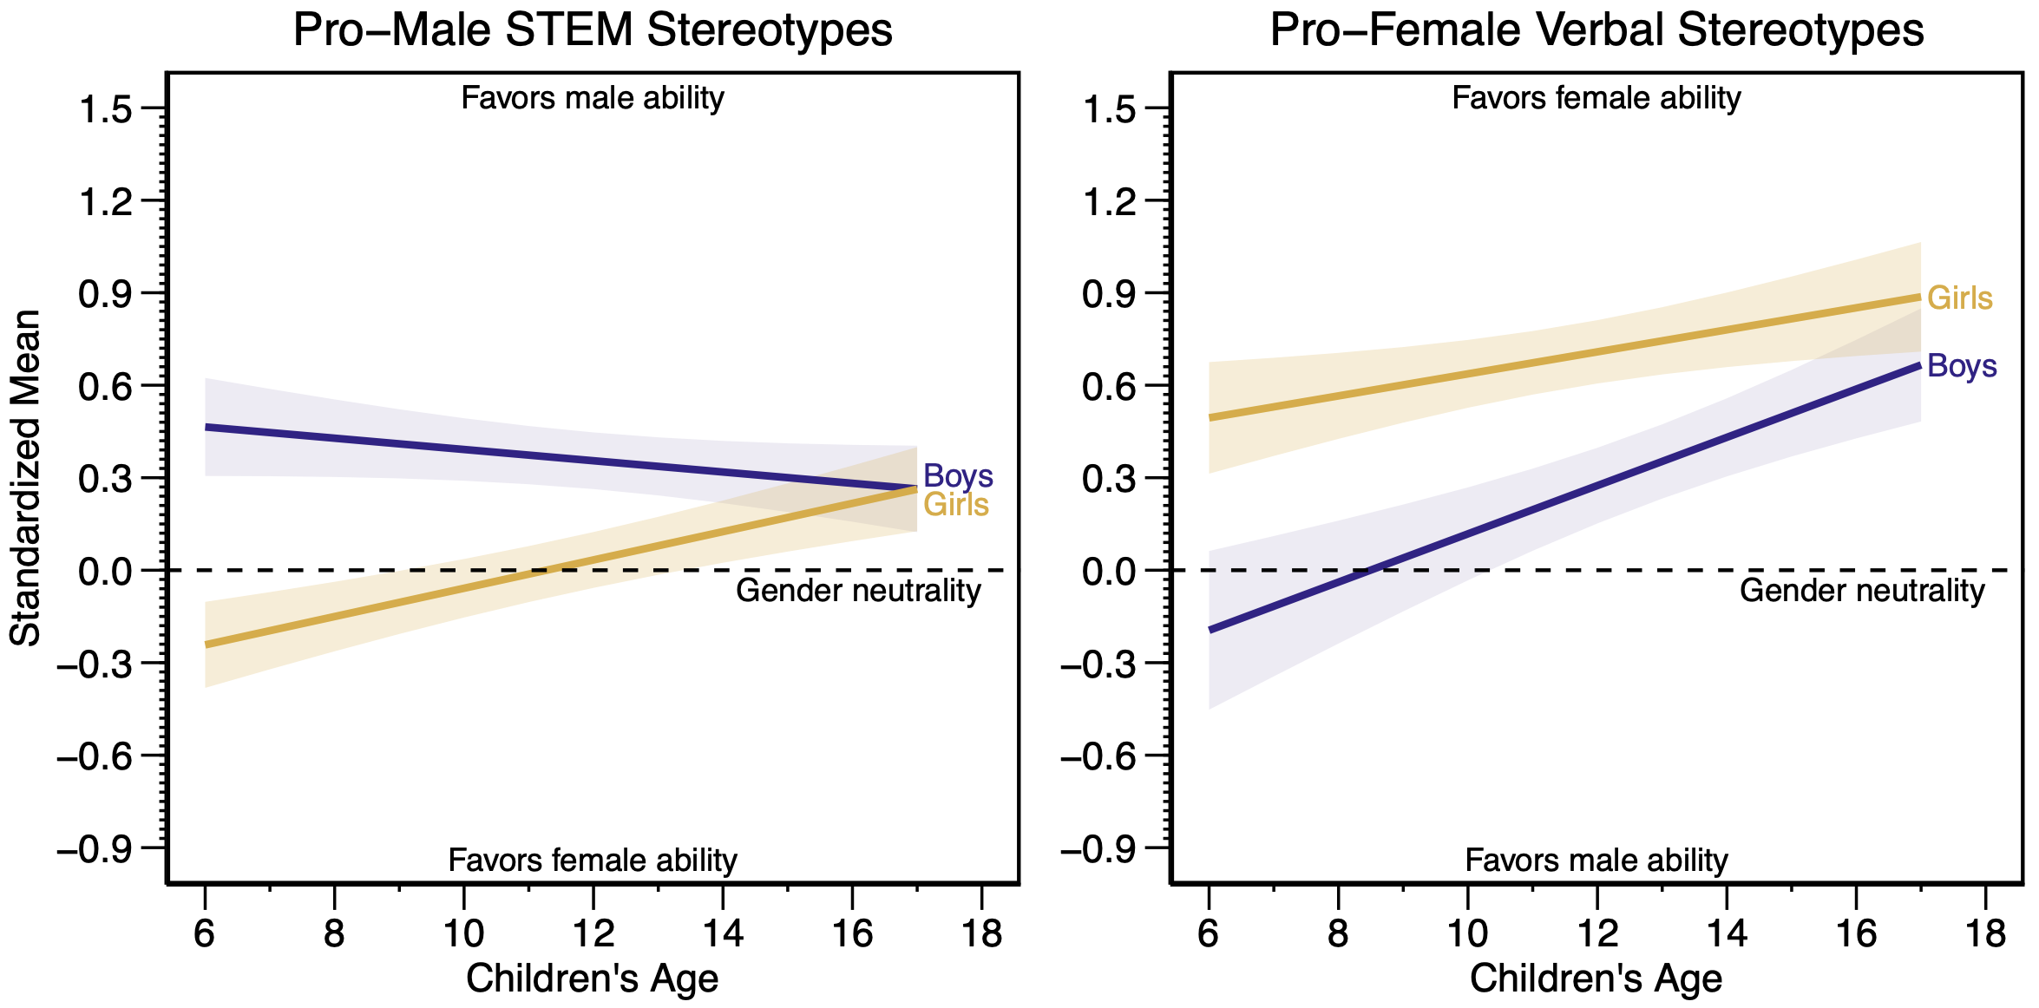
Note. These meta-analytic trends of standardized means came from mixed-effects models that included age, gender, and their interaction as predictors, while also controlling for methods covariates and other confirmatory moderators. The shaded areas represent 95% confidence intervals. Figure 4 in the main text shows the analogous graph for the confirmatory metric of stereotype scores.
Other Sensitivity Analyses Also Showed Robust Findings
Other analyses further showed empirical robustness. Results were robust to excluding outliers (Table S9), which we defined as having studentized deleted residuals exceeding 2.5 standard errors based on using the rstudent() function in the metafor R package. Results were also robust to excluding older studies from before the year 2000 (Table S10) and changing the assumed correlation between dependent effects (Table S11).
Stereotypes also varied in consistent ways for younger versus older children within the same study (i.e., within-study age effects) and for studies with younger versus older average ages (i.e., between-study age effects), as shown in Table S12. Within-study comparisons are especially valuable because they control for between-study features such as geographic location and scale type, supporting the robustness of results.
Repeating Analyses by Participant Gender Showed Some Sensitive Findings
Repeating analyses separately by participant gender further demonstrated the robustness of findings about within-STEM differences (Table S13). That is, both boy and girl participants had stronger stereotypes for male-dominated STEM fields (computer science, engineering, physics), as compared to general mathematics or general science.
Other moderators showed some sensitivity when repeating analyses by gender, however (Table S13). This sensitivity makes sense given our predictions (e.g., predicted Age × Gender interactions) and other possible substantive interactions with gender. For instance, age effects were different across gender (e.g., different directions for STEM stereotypes), but this difference reinforces earlier conclusions about Age × Gender interactions. Verbal stereotypes also had a larger magnitude than STEM stereotypes only for girls not boys, but this difference aligns with in-group bias effects already noted. That is, due to in-group bias, girls should have especially strong pro-female verbal stereotypes and weak pro-male STEM stereotypes, strengthening the STEM-verbal magnitude comparison. In contrast, the analogous effect of in-group bias for boys would mitigate the magnitude comparison. Hence, the difference in STEM-verbal magnitudes across participant gender aligns with our preregistered hypotheses about in-group bias.
Two other potentially substantive differences related to participant race and stereotype target age. First, differences in Black versus White participants’ STEM stereotypes were significant for girls (b = -0.08, SE = 0.02, t(4.01) = -5.18, p = .007) but not boys (b = -0.03, SE = 0.02, t(5.43) = -1.08, p = .327). Second, differences in STEM stereotypes for adult versus child targets were significant for girls (b = 0.13, SE = 0.04, t(4.24) = 3.35, p = .026) but not boys (b = 0.07, SE = 0.07, t(3.50) = 0.98, p = .392). However, we hesitate to infer much from these differences given that follow-up interaction tests (e.g., for Race × Gender) were not significant.
Two other sensitivities concerned disaggregated age effects for boys and girls. First, the increase in girls’ verbal stereotypes with age was significant for standardized means (b = 0.36, SE = 0.13, t(12.70) = 2.84, p = .014) but not for stereotype scores (Table S5). Second, the decline in boys’ STEM stereotypes with age was significant when analyzing their stereotype scores separately (b = -0.12, SE = 0.05, t(12.84) = -2.50, p = .027) but not when analyzing boys’ and girls’ effect sizes in the same statistical model with an Age × Gender interaction (b = -0.10, SE = 0.05, t(14.26) = -2.06, p = .058; Table S5). Importantly, however, our main age-related hypotheses focused on overall age effects and Age × Gender interactions, which were robust.
Overall Conclusion About Robustness
The conclusions regarding confirmatory moderators overall showed remarkable robustness to effect size metrics, outliers, exclusion of older studies, correlation assumptions, age modeling specifications, and differences for boys versus girls. Only a few results differed in qualitative conclusions across these many robustness checks (i.e., for participant race, stereotype target age, and disaggregated age effects for boys and girls).

Supplemental Material E: Additional Exploratory Analyses of Age Differences [🔙]
This section extends understanding of age differences through exploratory analyses of (a) nonlinear age effects and (b) a direct measure of in-group bias (focusing on stereotype scores). We also further comment on findings regarding gender-neutral responding.

Boys’ STEM Stereotypes Showed Nonlinear Age Effects
As noted in the main text, the preregistered analyses examined linear age effects. However, other theoretical perspectives and past evidence also suggest potential nonlinear change in gender stereotypes (e.g., Crouter et al., 2007), especially given the broad age range that our meta-analysis covered (e.g., including adolescence). We explored these nonlinearities by first testing for the quadratic effect of age; if significant, we further explored (e.g., testing for linear age effects before and after an informative age cut-off). These analyses controlled for methods covariates and confirmatory moderators, including linear Age × Gender interaction terms. These analyses found evidence for nonlinear age effects for boys’ STEM stereotypes.

Figure S5. Exploratory Analysis of Quadratic Age Effects (Stereotype Scores)
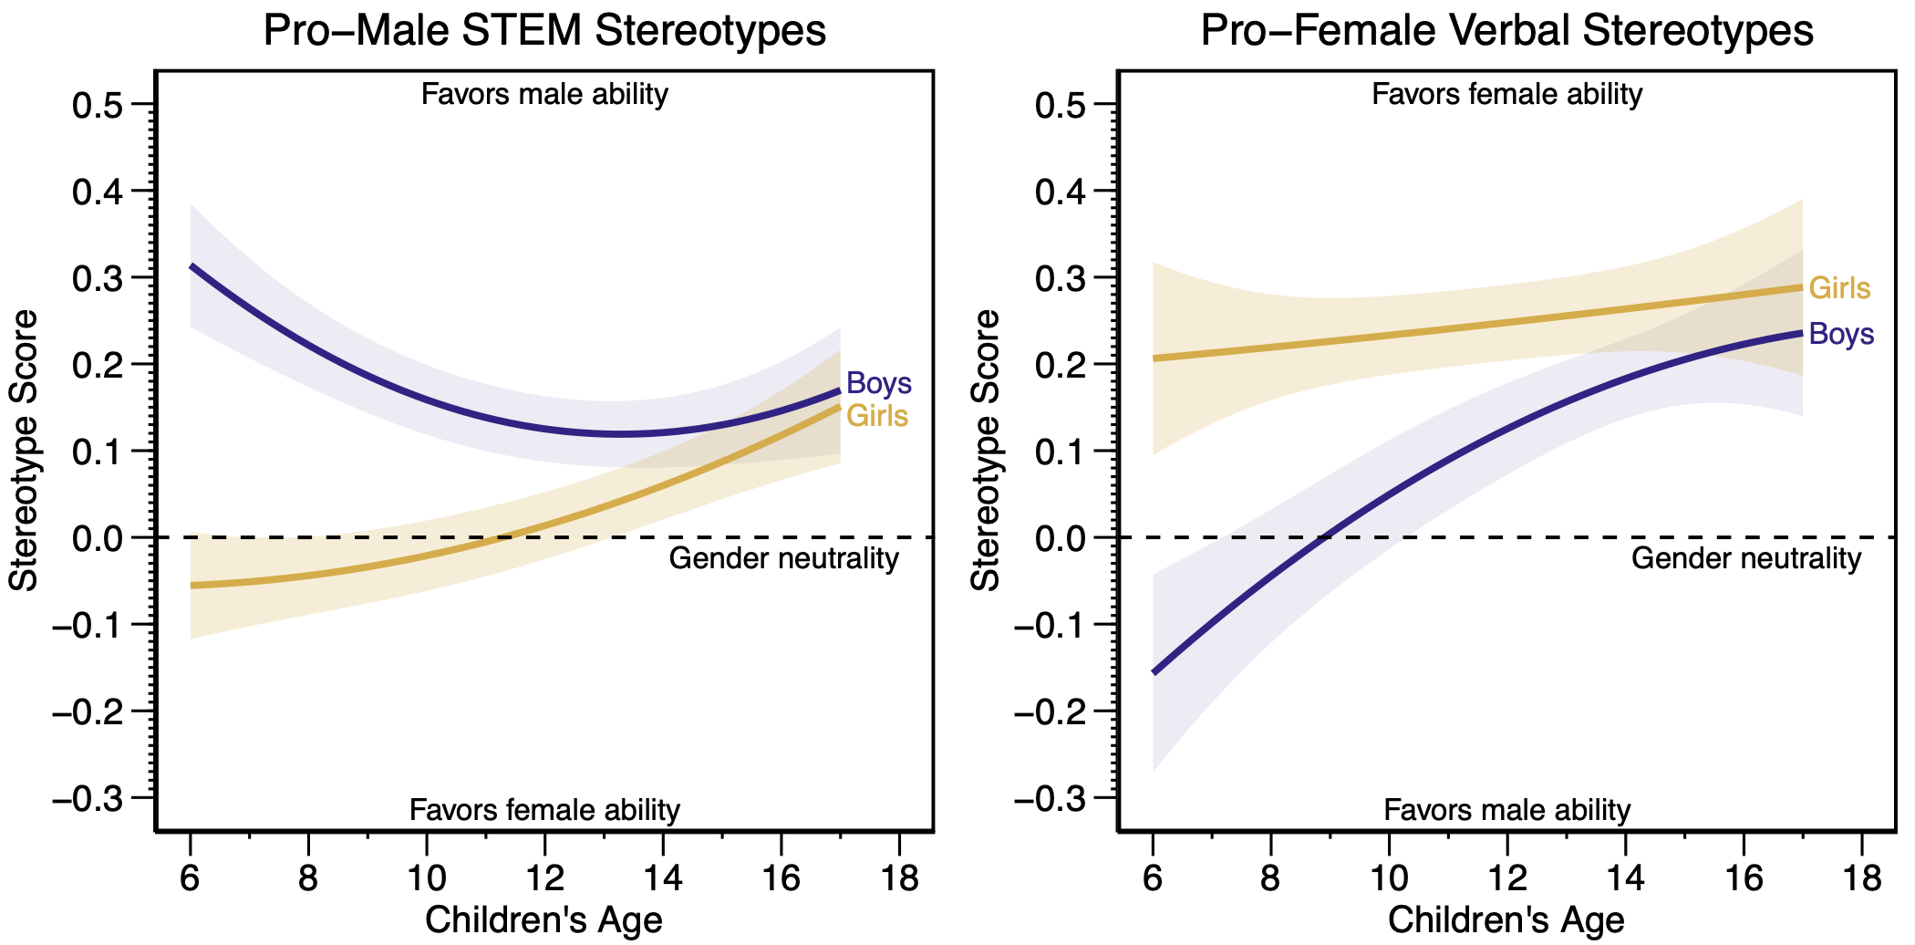
Note. These trends came from mixed-effects models that included methods covariates, confirmatory moderators, in addition to linear and quadratic age effects (with interactions for participant gender). The shaded areas represent 95% confidence intervals.
Figure S5 shows the quadratic models for STEM and verbal stereotypes. Figure 5 in the main text shows categorical models with dummy codes for age-gender groups, which have the advantage of making fewer parametric assumptions (e.g., does not assume smooth continuous change). But the two figures reinforce the same basic conclusions about nonlinear age effects.
Boys’ STEM stereotypes. Age differences in boys’ STEM stereotypes showed a significant quadratic effect (b = 0.37, SE = 0.08, t(13.87) = 4.46, p < .001). Boys’ stereotypes shifted from weakening with age to strengthening with age at age 13.3 (based on the quadratic model shown in Figure S5). In follow-up analyses, the linear age effect was significantly negative before age 13 (b = -0.28, SE = 0.05, t(13.46) = -5.97, p < .001) but significantly positive after age 13 (b = 0.28, SE = 0.09, t(8.04) = 3.06, p = .015). This quadratic effect was also found for boys’ computer science, engineering, and physics stereotypes (b = 0.29, SE = 0.11, t(5.49) = 2.52, p = .049), as well as math stereotypes (b = 0.44, SE = 0.13, t(9.71) = 3.48, p = .006).
Girls’ STEM stereotypes. In contrast, the quadratic effect of age was not significant for girls’ STEM stereotypes (b = 0.15, SE = 0.08, t(14.32) = 1.91, p = .076). Rather, girls’ STEM stereotypes increasingly favored male ability both before age 13 (b = 0.13, SE = 0.05, t(13.50) = 2.80, p = .015) and after 13 (b = 0.43, SE = 0.11, t(8.50) = 4.09, p = .003). If anything, girls’ increases with age accelerated after 13; but again, the p value was .076 for the quadratic effect.
Verbal stereotypes. The quadratic effect of age was not significant for boys’ verbal stereotypes (b = -0.23, SE = 0.13, t(9.29) = -1.78, p = .107) or girls’ verbal stereotypes (b = 0.01, SE = 0.13, t(9.56) = 0.08, p = .935). If anything, the age slopes were strongest for boys during ages 6–11 (see Figure 5 or S5); but again, the p value was .107 for the quadratic effect.

Boys’ In-Group Bias Rapidly Declined During Ages 6–13
Rationale. We sought to better understand the unexpected age findings (especially for boys’ STEM stereotypes) by computing a direct measure of in-group bias. We wondered if the asymmetric results for STEM versus verbal stereotypes might result from asymmetric in-group biases across participant gender. Many studies have found stronger in-group bias for girls than boys, which could arise from multiple factors (e.g., social status differences, positive maternal attachment, male aggression; for a review, see Powlishta, 2004, pp. 117–120). For instance, girls like girls more than boys like boys (e.g., Dunham et al., 2016; Verkuyten & Thijs, 2001), an empirical pattern also found among adult participants (e.g., Rudman & Goodwin, 2004).
Girls also tend to assign positive traits to girls more often than boys assign positive traits to boys (e.g., Powlishta et al., 1994; Susskind & Hodges, 2007). These “trait assignment” studies often aim to capture general tendencies in assigning positive traits by averaging across ratings of male-typed traits (e.g., confident) and female-typed traits (e.g., affectionate). As detailed next, we similarly averaged across male-typed and female-typed traits (STEM and verbal ability, respectively) to examine differences in in-group bias across participant gender.
Of greatest relevance to age differences, in-group bias in explicitly “liking” one’s own gender declined faster for boys than girls in a study of N = 441 children aged 4–17 (Dunham et al., 2016, Figure 2). That is, at ages 5–6, boys and girls had equally strong in-group bias. But this bias eroded with age for boys, whereas girls’ bias was stable. As detailed next, we found a similar empirical pattern using a “trait assignment” approach.
Defining in-group bias. We defined in-group bias as assigning more overall ability to one’s own gender more than other genders (collapsing across STEM and verbal domains). To motivate this definition, consider a boy who says “boys are good at math.” Without further information, this response is ambiguous: It could reflect in-group bias (e.g., “Boys rule, girls drool!”) or learned cultural stereotypes. Looking to that boy’s verbal stereotypes can help resolve that ambiguity, however. If that boy also said that “boys are good at reading,” he is likely expressing in-group bias (i.e., by saying that boys are generally better). But if that boy said that “girls are good at reading,” he is likely expressing learned cultural stereotypes (i.e., by saying that boys and girls have their respective strengths, not that boys are generally better).
Hence, the “trait assignment” definition of boys’ in-group bias would be their pro-male STEM stereotypes minus their pro-female verbal stereotypes. If a boy had a STEM score of +0.2 (favors male ability) and a verbal score of +0.2 (favors female ability), his in-group score would be 0 (reflecting cultural stereotypes, not in-group bias). But if his STEM score was +0.2 and verbal score was -0.2 (both favor male ability), his in-group score would be +0.4. The reverse definition applies to girls’ in-group bias (i.e., computed as girls’ pro-female verbal stereotypes minus their pro-male STEM stereotypes).

Figure S6. Asymmetric Development of In-Group Bias (Stereotype Scores)
Note. The trend for boys (blue line) is their pro-male STEM stereotypes (left-hand side of Figure 5) minus their pro-female verbal stereotypes (right-hand side of Figure 5). The trend for girls is the reverse (i.e., girls’ pro-female verbal stereotypes minus their pro-male STEM stereotypes).
Age differences in in-group bias. Figure S6 shows three main conclusions. First, boys and girls displayed equally strong in-group bias at ages 6–8. Second, boys’ in-group bias greatly declined until age 13, showing slight female positivity in adolescence. Third, girls’ in-group bias remained stable during ages 6–13 (with only slightly declining during late adolescence). These findings largely replicate Dunham et al.’s (2016) earlier findings (see their Figure 2), which showed similarity at ages 6–8, a substantial age decline for boys, and stability for girls.
Interpreting the results. The stability in girls’ in-group bias may seem surprising given the shift in girls’ STEM stereotypes, which switched from pro-female to pro-male beliefs at ages 10–12 (see Figure 5 in the main text). Looking to their verbal stereotypes resolves this apparent conflict, however. As girls learn negative stereotypes about their gender’s STEM abilities, they also increasingly endorse positive stereotypes about their gender’s verbal abilities (see Figure 5). This offset maintains in-group bias while girls learn cultural stereotypes with age.
The decline in boys’ in-group bias (and asymmetric stability in girls’ in-group bias) helps to explain some of the unexpected age differences noted earlier. That is, the decline in boys’ STEM stereotypes during ages 6–13 might result from a more general tendency in boys towards increased female positivity in that developmental period. This pro-female shift could override cultural learning of pro-male STEM messages during that period (leading to age-related declines), while strengthening the age-related increases in boys’ pro-female verbal stereotypes.
Theoretical implications. This examination helps place the findings in a broader developmental context. As noted earlier, other literatures in gender development have found greater in-group bias for girls than boys (Powlishta, 2004), a pattern we also found for ability stereotypes. The close alignment with Dunham et al.’s (2016) age differences also suggests the asymmetric findings for STEM versus verbal stereotypes might reflect broader changes in children’s in-group bias. The discussion section in the main text further unpacks this point.
Hence, though these in-group bias scores are somewhat tautological (e.g., Figure S6 simply restates the findings in Figure 5), this examination helps to bring certain empirical patterns into focus that might be overlooked otherwise. And importantly, these patterns potentially implicate broader domain-general mechanisms, given the alignment with other gender development literatures beyond ability stereotypes.

Gender-Neutral Responding Informs Understanding of Stereotype Flexibility
A key aspect to several cognitive theories of gender development is the construct of stereotype flexibility, often defined as the belief that a stereotyped attribute can apply to both genders (Ruble et al., 2006, p. 865). This construct maps to our exploratory analyses of gender-neutral responding (see Figure S7). These analyses showed both a consistency with prior findings and a surprise. The consistency was that gender-neutral responding significantly decreased with age for verbal stereotypes, which closely aligns with prior meta-analytic research on other descriptive gender stereotypes (e.g., “Who usually is…?”; Signorella et al., 1993, p. 165). The surprise was that gender-neutral responding showed a slight nonsignificant increase with age for STEM stereotypes. Seeking to explain this asymmetric development of stereotype flexibility could also be generative to future theory building and integration (we are unsure of the reason and do not speculate here). Table S15 presents further detail about moderator analyses of these qualitative response frequencies.

Figure S7. Moderation by Age, Gender, and Stereotype Domain (Qualitative Responses)
Note. These percentages were based on combining across models of the log odds for (a) pro-male versus gender-neutral responses and (b) pro-female versus gender-neutral responses (Begg & Gray, 1984; Eagly et al., 2020). See Table S3 for sample sizes for these analyses.

References
Begg, C. B., & Gray, R. (1984). Calculation of polychotomous logistic regression parameters using individualized regressions. Biometrika, 71, 11–18. http://dx.doi.org/10.2307/2336391
Crouter, A. C., Whiteman, S. D., McHale, S. M., & Osgood, D. W. (2007). Development of gender attitude traditionality across middle childhood and adolescence. Child Development, 78(3), 911–926. https://doi.org/10.1111/j.1467-8624.2007.01040.x
Dunham, Y., Baron, A. S., & Banaji, M. R. (2016). The development of implicit gender attitudes. Developmental Science, 19(5), 781–789. https://doi.org/10.1111/desc.12321
Eagly, A. H., Nater, C., Miller, D. I., Kaufmann, M., & Sczesny, S. (2020). Gender stereotypes have changed: A cross-temporal meta-analysis of U.S. public opinion polls from 1946 to 2018. American Psychologist, 75(3), 301–315. https://doi.org/10.1037/amp0000494
Powlishta, K. K. (2004). Gender as a social category: Intergroup processes and gender-role development. In M. Bennett & F. Sani (Eds.), The development of social self (pp. 103–133). New York, NY: Psychology Press. https://doi.org/10.4324/9780203391099
Powlishta, K. K., Serbin, L. A., Doyle, A. B., & White, D. R. (1994). Gender, ethnic, and body type biases: The generality of prejudice in childhood. Developmental Psychology, 30(4), 526–536. https://doi.org/10.1037/0012-1649.30.4.526
Ruble, D. N., Martin, C. L., & Berenbaum, S. A. (2006). Gender development. In N. Eisenberg, W. Damon, & R. M. Lerner (Eds.), Handbook of child psychology: Social, emotional, and personality development (pp. 858–932). John Wiley & Sons, Inc.
Rudman, L. A., & Goodwin, S. A. (2004). Gender differences in automatic in-group bias: Why do women like women more than men like men? Journal of Personality and Social Psychology, 87(4), 494–509. https://doi.org/10.1037/0022-3514.87.4.494
Serbin, L. A., Powlishta, K. K., & Gulko, J. (1993). The development of sex typing in middle childhood. Monographs of the Society for Research in Child Development, 58(2), i–95. https://doi.org/10.2307/1166118
Signorella, M. L., Bigler, R. S., & Liben, L. S. (1993). Developmental differences in children’s gender schemata about others: A meta-analytic review. Developmental Review, 13(2), 147–183. https://doi.org/10.1006/drev.1993.1007
Susskind, J. E., & Hodges, C. (2007). Decoupling children’s gender-based in-group positivity from out-group negativity. Sex Roles, 56, 707–716. https://doi.org/10.1007/s11199-007-9235-z
Verkuyten, M., & Thijs, J. (2001). Ethnic and gender bias among Dutch and Turkish children in late childhood: The role of social context. Infant and Child Development, 10(4), 203–217. https://doi.org/10.1002/icd.279
Zosuls, K. M., Miller, C. F., Ruble, D. N., Martin, C. L., & Fabes, R. A. (2011). Gender development research in sex roles: Historical trends and future directions. Sex Roles, 64, 826–842. https://doi.org/10.1007/s11199-010-9902-3

Supplemental Material F: Additional Moderator Analyses [🔙]
This section focuses on results for additional exploratory moderators (focusing on stereotype scores) and the exploratory metric of sample standard deviations. Results should be interpreted more cautiously than for confirmatory moderators given concerns about statistical power and the exploratory nature of these analyses.
Before presenting the exploratory analyses, Figure S8 graphically displays results for confirmatory moderators that are described in more detail in the main text (see also Table S4 for conditional means for confirmatory moderators).

Figure S8. Moderation by STEM Domain, Race, and Measure Characteristics (STEM Stereotype Scores)
Note. Data points represent conditional means from models controlling for methods covariates and confirmatory moderators. Error bars denote 95% confidence intervals. C.S. = computer science.
Cultural Characteristics
As shown in Table S16, results were not statistically significant for three cultural characteristics: (a) women’s national representation among female STEM majors, (b) women’s national representation among employed researchers, and (c) data collection year for U.S. samples. We originally preregistered those characteristics as confirmatory moderators, but concerns about low statistical power prompted us to categorize them as exploratory (see Appendix E of the preregistration for preregistered power analysis plans). The lack of statistical significance for those characteristics was therefore not surprising.
Nation-Specific Comparisons
We also compared U.S. samples to all nations that had at least five studies (Australia, France, Germany, Italy, United Kingdom). Samples from Germany (b = 0.28) and the United Kingdom (b = 0.18) had stronger pro-male STEM stereotypes than U.S. samples (b = 0.02), even after controlling for methods covariates and confirmatory moderators (see also Figure S9). Other nation-specific comparisons were not significant.
Participant Race/Ethnicity (Exploratory Comparisons)
We explored racial/ethnic differences in STEM stereotypes beyond the confirmatory contrast of Black versus White U.S. children. These analyses indicated the imprecise estimates for other racial/ethnic groups (e.g., Asian children); see the wide confidence intervals in Figure S9, reflecting the smaller sample sizes for these other racial/ethnic groups (Table S1). None of these other groups significantly differed from Black children, and none significantly differed from White children (i.e., we conducted two sets of exploratory analyses varying the reference category). As another exploratory test, we found that the confirmatory Black-White contrast was not significant for verbal stereotypes (b = 0.03, SE = 0.01, t(3.15) = 2.16, p = .115), though it was for STEM stereotypes (our confirmatory hypothesis was specific to STEM stereotypes).

Figure S9. Moderation by Additional Exploratory Moderators (Stereotype Scores)
Note. Data points are conditional means from meta-regression models controlling for methods covariates and confirmatory moderators (but controlling for one group of exploratory moderators at a time). Error bars denote 95% confidence intervals.
Item Wording
We investigated whether item wording predicted effect sizes by comparing the three most common wording categories (Table S1), which we labeled: (a) better (e.g., “Are girls or boys better at math?”), (b) ability (e.g., “Do girls or boys have stronger natural aptitudes for math?”), and (c) school (e.g., “Do girls or boys get better math grades?”). For clean comparisons, we compared measures that solely fell into one category, excluding other categories less commonly studied or measures that crossed multiple categories. Table S16 shows that the ability category had more male-biased STEM stereotypes than the school category across two different model specifications (see also Figure S9), whereas the contrasts with the better category were sensitive to the modeling specification. We caution in interpreting these results as our investigation was highly exploratory (e.g., requiring redefining our item wording categories several times); alternative coding schemes and analytic decisions could yield different results.
Perception of Others’ Stereotypes
As shown in Table S16, we did not find significant differences between measures of children’s self-endorsement of STEM stereotypes (e.g., “Do you think that boys or girls are better at mathematics?”) versus their perception of others’ stereotypes (e.g., “Do teachers think that boys or girls are better at mathematics?”). Both types of stereotypes were similar in magnitude and significantly differed from 0 (Figure S9).
This null finding is especially interesting in the context other scholars’ prior hypotheses. For instance, Master (2021) reasoned that perceptions of others’ stereotypes should show stronger STEM stereotypes because “children can be aware of stereotypes without personally endorsing them” (p. 207). But if anything, the stereotype mean was descriptively higher for self-endorsements than perceptions of others’ stereotypes (Figure S9), counter to that hypothesis.
Verbal Domain
No significant differences were found across the verbal domains for native language ability only, reading ability only, writing ability only, reading and writing aggregated, and other verbal ability. Stereotypes for each of these domains favored female verbal ability (Figure S9).
Sample Standard Deviations
We also examined an exploratory metric for a log transformation of sample standard deviations (see preregistration for details). For both STEM and verbal stereotypes, standard deviations were slightly but significantly larger for boys than girls (see left-hand side of Table S17). These standard deviations also significantly declined with age for STEM stereotypes, especially for girls (Figure S10). The main effect for age meant that children reached greater consensus of STEM stereotypes with age, in addition to boys’ and girls’ means converging with age (Figure 5). The standard deviation for verbal stereotypes also tended to decline with age, though this age effect was not significant (Table S17).

Figure S10. Moderation by Age, Gender, and Stereotype Domain (Sample Standard Deviations)
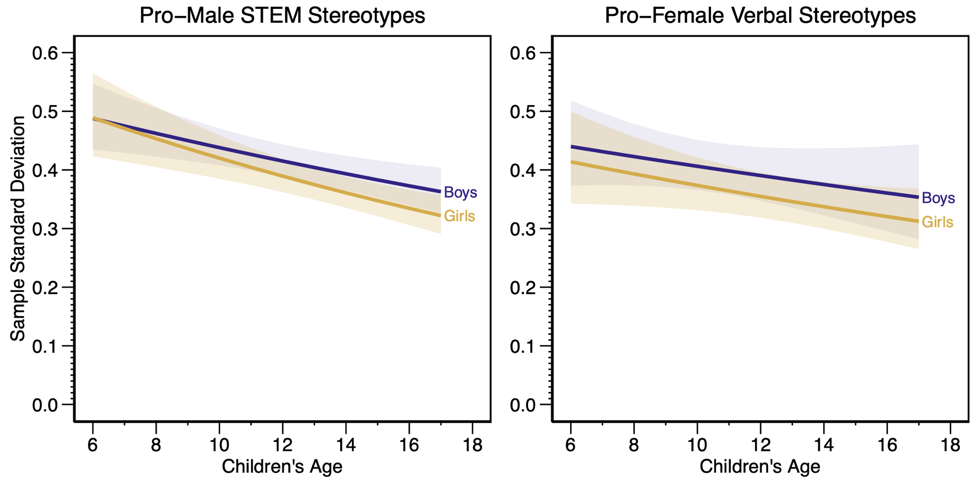
Note. These meta-analytic trends of sample standard deviations came from mixed-effects models that included age, gender, and their interaction as predictors, while also controlling for methods covariates and other confirmatory moderators. The regression models predicted log standard deviations, and this graph back transformed the predictions to a standard scale. The shaded areas represent 95% confidence intervals.

Supplemental Tables

Table S1 [🔙]
Descriptive Frequencies for STEM Ability Stereotypes
Characteristic | m | k | Mean | % Missing
Number of studies and effect sizes | 95 | 1053 | – | –
Measurement characteristics
STEM ability stereotype domain
Biology/life science | 8 | 18 | 2% | 0%
Chemistry | 6 | 11 | 1% | 0%
Computer science/technology | 17 | 146 | 14% | 0%
Engineering | 8 | 71 | 7% | 0%
Mathematics | 69 | 573 | 55% | 0%
Physics | 10 | 22 | 2% | 0%
Science (general) | 26 | 175 | 17% | 0%
Spatial ability | 5 | 25 | 2% | 0%
Directness of stereotype measure
Direct/overt measure | 90 | 1003 | 95% | 0%
Indirect/covert measure | 10 | 50 | 5% | 0%
Age of stereotype target
Adult target | 8 | 55 | 5% | 0%
Child target | 91 | 998 | 95% | 0%
Exceptionality of stereotype target
Average targets | 92 | 1027 | 98% | 0%
Exceptional targets | 8 | 26 | 2% | 0%
Item wording category
Better (e.g., who is better in math?)1 | 61 | 568 | 54% | 0%
School (e.g., who is the better student?) | 31 | 185 | 18% | 0%
Ability (e.g., math ability is better in...) | 28 | 164 | 16% | 0%
Can be (e.g., who can be a scientist?) | 4 | 55 | 5% | 0%
Does well (e.g., who does well in science?) | 18 | 142 | 13% | 0%
Type of rating scale
Direct comparisons | 74 | 755 | 72% | 0%
Separate ratings | 26 | 298 | 28% | 0%
Other measurement characteristics
Perception of others' stereotypes | 17 | 131 | 12% | 0%
Reliability (internal consistency) | – | – | 0.72 | 96%
Number of stereotype items for the effect size
1 item | 80 | 967 | 92% | 0%
2 items | 3 | 20 | 2% | 0%
3 items | 9 | 31 | 3% | 0%
4 items | 1 | 2 | 0.2% | 0%
8 items | 1 | 8 | 1% | 0%
20 items | 3 | 25 | 2% | 0%
Number of response options per item
2 options | 5 | 14 | 1% | 0%
3 options | 46 | 383 | 36% | 0%
5 options | 25 | 333 | 32% | 0%
7 options | 8 | 39 | 4% | 0%
9 options | 11 | 71 | 7% | 0%
11 options | 2 | 64 | 6% | 0%
13 options | 4 | 24 | 2% | 0%
Continuous | 8 | 125 | 12% | 0%
Child demographics
Age of participants | – | – | 12.39 | 0%
Preschool (<6 years) | 4 | 8 | 1% | 0%
Lower elementary (6 to <9 years) | 18 | 135 | 13% | 0%
Upper elementary (9 to <12 years) | 36 | 300 | 28% | 0%
Middle school (12 to <15 years) | 40 | 364 | 35% | 0%
High school (15 to <18 years) | 31 | 246 | 23% | 0%
Gender composition for the effect size
Boys | 78 | 480 | 46% | 0%
Girls | 82 | 484 | 46% | 0%
Aggregated | 31 | 89 | 8% | 0%
Race/ethnicity (U.S. samples only)
% American Indian/Alaskan Native | – | – | 1% | 4%
% Asian | – | – | 4% | 4%
% Black | – | – | 26% | 4%
% Hispanic/Latinx | – | – | 11% | 4%
% Native Hawaiian/Pacific Islander | – | – | 1% | 4%
% White | – | – | 51% | 4%
% Multiracial | – | – | 6% | 4%
Number of child participants | – | – | 579 | 0%
10 to 99 | 34 | 261 | 25% | 0%
100 to 299 | 43 | 444 | 42% | 0%
300 to 999 | 31 | 236 | 22% | 0%
1000+ | 12 | 112 | 11% | 0%
Number of schools | – | – | 24 | 38%
1 | 25 | 114 | 18% | 38%
2 to 9 | 26 | 383 | 59% | 38%
10 to 49 | 18 | 116 | 18% | 38%
50+ | 2 | 36 | 6% | 38%
Socioeconomic status (authors' description)
Low | 5 | 14 | 6% | 76%
Middle | 6 | 27 | 11% | 76%
High | 5 | 31 | 12% | 76%
Mixed SES | 17 | 181 | 72% | 76%
Contextual features
Year of testing (or publication year minus 4) | – | – | 2008 | 0%
1970s | 1 | 2 | 0.2% | 0%
1980s | 5 | 23 | 2% | 0%
1990s | 12 | 97 | 9% | 0%
2000s | 33 | 419 | 40% | 0%
2010s | 44 | 512 | 49% | 0%
Urbanicity
Urban | 31 | 326 | 79% | 61%
Suburban | 15 | 136 | 33% | 61%
Rural | 22 | 251 | 61% | 61%
Geographic region (U.S. samples only)
Midwest | 13 | 96 | 19% | 11%
Northeast | 9 | 144 | 29% | 11%
South | 13 | 352 | 71% | 11%
West | 8 | 92 | 18% | 11%
Country
Argentina | 1 | 4 | 0.4% | 0%
Australia | 5 | 19 | 2% | 0%
Austria | 1 | 2 | 0.2% | 0%
Bulgaria | 1 | 4 | 0.4% | 0%
Cameroon | 1 | 8 | 1% | 0%
Canada | 3 | 11 | 1% | 0%
Croatia | 2 | 5 | 0.5% | 0%
Dominican Republic | 1 | 2 | 0.2% | 0%
Ethiopia | 1 | 3 | 0.3% | 0%
France | 6 | 52 | 5% | 0%
Germany | 6 | 63 | 6% | 0%
Greece | 1 | 2 | 0.2% | 0%
India | 2 | 8 | 1% | 0%
Israel | 3 | 43 | 4% | 0%
Italy | 6 | 61 | 6% | 0%
Japan | 4 | 15 | 1% | 0%
Latvia | 1 | 2 | 0.2% | 0%
Netherlands | 2 | 13 | 1% | 0%
Romania | 1 | 4 | 0.4% | 0%
Russia | 1 | 1 | 0.1% | 0%
Singapore | 1 | 5 | 0.5% | 0%
Slovenia | 1 | 2 | 0.2% | 0%
Spain | 2 | 22 | 2% | 0%
Sweden | 4 | 49 | 5% | 0%
Switzerland | 1 | 5 | 0.5% | 0%
Taiwan | 3 | 8 | 1% | 0%
Thailand | 2 | 32 | 3% | 0%
Turkey | 1 | 1 | 0.1% | 0%
United Kingdom | 5 | 44 | 4% | 0%
United States | 40 | 559 | 53% | 0%
Zimbabwe | 1 | 4 | 0.4% | 0%
% Women Among STEM Graduates | – | – | 31% | 0%
0% to <10% | 4 | 15 | 1% | 0%
10% to <20% | 4 | 17 | 2% | 0%
20% to <30% | 36 | 375 | 36% | 0%
30% to <40% | 56 | 622 | 59% | 0%
40% to <50% | 4 | 24 | 2% | 0%
50+% | 0 | 0 | 0% | 0%
% Women Among Employed Researchers | – | – | 29% | 3%
0% to <10% | 5 | 20 | 2% | 3%
10% to <20% | 7 | 25 | 2% | 3%
20% to <30% | 58 | 764 | 75% | 3%
30% to <40% | 19 | 161 | 16% | 3%
40% to <50% | 5 | 19 | 2% | 3%
50+% | 2 | 32 | 3% | 3%
School composition (assume co-ed if missing)
Co-educational | 94 | 1050 | 100% | 0%
Single-sex | 5 | 67 | 6% | 0%
School type (assume public if missing)
Private | 12 | 107 | 10% | 0%
Public | 92 | 1041 | 99% | 0%
Publication type
Book chapter | 1 | 4 | 0.4% | 0%
Conference presentation/paper | 9 | 190 | 18% | 0%
Journal article | 63 | 717 | 68% | 0%
Report | 1 | 2 | 0.2% | 0%
Thesis/dissertation | 19 | 130 | 12% | 0%
Unpublished manuscript | 2 | 10 | 1% | 0%
Note. Means are based on effect sizes with non-missing moderator data. Some percentages sum to more than 100% for characteristics that are not mutually exclusive (e.g., a single effect size may represent data from both public and private schools). m = number of studies, k = number of effect sizes, Missing (%) = percentage of effect sizes with missing values for that characteristic.

Table S2 [🔙]
Descriptive Frequencies for Verbal Ability Stereotypes
Characteristic | m | k | Mean | % Missing
Number of studies and effect sizes | 46 | 310 | – | –
Measurement characteristics
Verbal ability stereotype domain
Foreign language | 9 | 28 | 9% | 0%
General verbal | 1 | 2 | 1% | 0%
Native language | 21 | 121 | 39% | 0%
Reading | 17 | 118 | 38% | 0%
Spelling | 4 | 21 | 7% | 0%
Writing | 8 | 76 | 25% | 0%
Directness of stereotype measure
Direct/overt measure | 42 | 280 | 90% | 0%
Indirect/covert measure | 8 | 30 | 10% | 0%
Age of stereotype target
Adult target | 5 | 17 | 5% | 0%
Child target | 43 | 293 | 95% | 0%
Exceptionality of stereotype target
Average targets | 43 | 292 | 94% | 0%
Exceptional targets | 6 | 18 | 6% | 0%
Item wording category
Better (e.g., who is better in math?) | 29 | 166 | 54% | 0%
School (e.g., who is the better student?) | 12 | 38 | 12% | 0%
Ability (e.g., math ability is better in...) | 14 | 58 | 19% | 0%
Occupational (e.g., who can be a scientist?) | 0 | 0 | 0% | 0%
Does well (e.g., who does well in science?) | 9 | 82 | 26% | 0%
Type of rating scale
Direct comparisons | 34 | 165 | 53% | 0%
Separate ratings | 16 | 145 | 47% | 0%
Other measurement characteristics
Perception of others' stereotypes | 4 | 26 | 8% | 0%
Reliability (internal consistency) | – | – | 0.74 | 92%
Number of stereotype items for the effect size
1 item | 37 | 259 | 84% | 0%
2 items | 3 | 14 | 5% | 0%
3 items | 3 | 13 | 4% | 0%
4 items | 1 | 2 | 1% | 0%
8 items | 1 | 4 | 1% | 0%
9 items | 1 | 6 | 2% | 0%
20 items | 2 | 12 | 4% | 0%
Number of response options per item
2 options | 6 | 15 | 5% | 0%
3 options | 17 | 70 | 23% | 0%
5 options | 12 | 75 | 24% | 0%
7 options | 7 | 24 | 8% | 0%
9 options | 5 | 29 | 9% | 0%
13 options | 2 | 13 | 4% | 0%
Continuous | 6 | 84 | 27% | 0%
Child demographics
Age of participants | – | – | 12.06 | 0%
Preschool (<6 years) | 1 | 2 | 1% | 0%
Lower elementary (6 to <9 years) | 10 | 40 | 13% | 0%
Upper elementary (9 to <12 years) | 19 | 106 | 34% | 0%
Middle school (12 to <15 years) | 17 | 113 | 36% | 0%
High school (15 to <18 years) | 13 | 49 | 16% | 0%
Gender composition for the effect size
Boys | 35 | 133 | 43% | 0%
Girls | 38 | 135 | 44% | 0%
Aggregated | 18 | 42 | 14% | 0%
Race/ethnicity (U.S. samples only)
% American Indian/Alaskan Native | – | – | 1% | 4%
% Asian | – | – | 3% | 4%
% Black | – | – | 39% | 4%
% Hispanic/Latinx | – | – | 8% | 4%
% Native Hawaiian/Pacific Islander | – | – | 1% | 4%
% White | – | – | 44% | 4%
% Multiracial | – | – | 3% | 4%
Number of child participants | – | – | 474 | 0%
10 to 99 | 15 | 98 | 32% | 0%
100 to 299 | 24 | 140 | 45% | 0%
300 to 999 | 14 | 49 | 16% | 0%
1000+ | 5 | 23 | 7% | 0%
Number of schools | – | – | 18 | 36%
1 | 11 | 36 | 18% | 36%
2 to 9 | 11 | 104 | 52% | 36%
10 to 49 | 10 | 55 | 28% | 36%
50+ | 2 | 4 | 2% | 36%
Socioeconomic status (authors' description)
Low | 4 | 15 | 20% | 75%
Middle | 3 | 9 | 12% | 75%
High | 1 | 4 | 5% | 75%
Mixed SES | 9 | 48 | 63% | 75%
Contextual features
Year of testing (or publication year minus 4) | – | – | 2006 | 0%
1980s | 3 | 16 | 5% | 0%
1990s | 6 | 19 | 6% | 0%
2000s | 20 | 182 | 59% | 0%
2010s | 17 | 93 | 30% | 0%
Urbanicity
Urban | 15 | 94 | 85% | 65%
Suburban | 4 | 25 | 23% | 65%
Rural | 9 | 49 | 45% | 65%
Geographic region (U.S. samples only)
Midwest | 6 | 27 | 14% | 5%
Northeast | 3 | 24 | 13% | 5%
South | 8 | 151 | 80% | 5%
West | 5 | 34 | 18% | 5%
Country
Australia | 1 | 2 | 1% | 0%
Canada | 1 | 2 | 1% | 0%
Chile | 1 | 6 | 2% | 0%
China | 1 | 12 | 4% | 0%
Dominican Republic | 1 | 1 | 0.3% | 0%
France | 2 | 8 | 3% | 0%
Germany | 4 | 20 | 6% | 0%
India | 1 | 3 | 1% | 0%
Italy | 4 | 17 | 5% | 0%
Japan | 2 | 6 | 2% | 0%
Russia | 1 | 1 | 0.3% | 0%
Sweden | 2 | 4 | 1% | 0%
Switzerland | 1 | 5 | 2% | 0%
Taiwan | 2 | 6 | 2% | 0%
Thailand | 1 | 4 | 1% | 0%
United Kingdom | 4 | 16 | 5% | 0%
United States | 22 | 197 | 64% | 0%
% Women Among STEM Graduates | – | – | 29% | 4%
0% to <10% | 2 | 6 | 2% | 4%
10% to <20% | 2 | 8 | 3% | 4%
20% to <30% | 21 | 159 | 53% | 4%
30% to <40% | 21 | 118 | 40% | 4%
40% to <50% | 2 | 7 | 2% | 4%
50+% | 0 | 0 | 0% | 4%
% Women Among Employed Researchers | – | – | 27% | 5%
0% to <10% | 2 | 6 | 2% | 5%
10% to <20% | 4 | 10 | 3% | 5%
20% to <30% | 28 | 229 | 78% | 5%
30% to <40% | 12 | 44 | 15% | 5%
40% to <50% | 0 | 0 | 0% | 5%
50+% | 1 | 4 | 1% | 5%
School composition (assume co-ed if missing)
Co-educational | 45 | 308 | 99% | 0%
Single-sex | 4 | 22 | 7% | 0%
School type (assume public if missing)
Private | 4 | 33 | 11% | 0%
Public | 44 | 305 | 98% | 0%
Publication type
Conference presentation/paper | 1 | 2 | 1% | 0%
Journal article | 33 | 275 | 89% | 0%
Report | 1 | 1 | 0.3% | 0%
Thesis/dissertation | 9 | 26 | 8% | 0%
Unpublished manuscript | 2 | 6 | 2% | 0%
Note. Means are based on effect sizes with non-missing moderator data. Some percentages sum to more than 100% for characteristics that are not mutually exclusive (e.g., a single effect size may represent data from both public and private schools). m = number of studies, k = number of effect sizes, Missing (%) = percentage of effect sizes with missing values for that characteristic.

Table S3 [🔙]
Meta-Analytic Summaries of Qualitative Response Categories
Model | m | k | Pro-male | Pro-female | Neutral
STEM stereotypes | 57 | 729 | 30% | 19% | 52%
Boys | 46 | 335 | 39% | 15% | 47%
Girls | 49 | 341 | 26% | 23% | 52%
Verbal stereotypes | 26 | 226 | 12% | 52% | 36%
Boys | 20 | 102 | 21% | 47% | 32%
Girls | 21 | 103 | 8% | 61% | 32%
Note. These percentages were based on random-effects models that separately modeled the log odds of (a) pro-male versus gender-neutral responses and (b) pro-female versus gender-neutral responses. We used the meta-analytic log odds from these models to determine the meta-analytic percentages in this table (Begg & Gray, 1984; Eagly et al., 2020). Many of the underlying effect sizes for this analysis came from 3-point stereotype scales, but we also included other scales (e.g., 5-point scales) if frequencies or percentages were reported for the three qualitative response categories in this table. m = number of studies, k = number of effect sizes.

Table S4 [🔙]
Conditional Means for Confirmatory Moderators
Moderator | m | k | Stereotype scores |  |  |  |  | Standardized means
Moderator | m | k | b | SE | df | p |  | b | SE | df | p
STEM stereotypes
Overall mean | 95 | 1053 | 0.10 | 0.02 | 90.21 | <.001 |  | 0.20 | 0.04 | 85.82 | <.001
Participant gender
Boys | 78 | 480 | 0.16 | 0.02 | 88.33 | <.001 |  | 0.35 | 0.05 | 84.47 | <.001
Girls | 82 | 484 | 0.04 | 0.02 | 89.21 | .054 |  | 0.05 | 0.05 | 84.91 | .276
Participant race (U.S. only)
Black children | 10 | 85 | -0.01 | 0.02 | 16.23 | .512 |  | -0.08 | 0.05 | 12.10 | .133
White children | 16 | 109 | 0.04 | 0.02 | 25.66 | .049 |  | 0.06 | 0.04 | 21.62 | .162
STEM domain
General math | 69 | 573 | 0.06 | 0.02 | 84.71 | .002 |  | 0.11 | 0.04 | 81.73 | .012
General science | 26 | 175 | 0.09 | 0.02 | 54.26 | <.001 |  | 0.20 | 0.05 | 55.25 | <.001
Male-dominatedª | 27 | 237 | 0.25 | 0.03 | 32.42 | <.001 |  | 0.51 | 0.07 | 30.53 | <.001
Directness of measure
Indirect/covert | 10 | 50 | 0.07 | 0.05 | 8.53 | .222 |  | 0.14 | 0.12 | 8.32 | .289
Direct/overt | 90 | 1003 | 0.10 | 0.02 | 90.78 | <.001 |  | 0.20 | 0.04 | 86.13 | <.001
Age of target
Adult | 8 | 55 | 0.21 | 0.05 | 4.93 | .009 |  | 0.48 | 0.12 | 4.92 | .012
Child | 91 | 998 | 0.09 | 0.02 | 89.39 | <.001 |  | 0.18 | 0.04 | 85.42 | <.001
Exceptionality of target
Exceptional | 8 | 26 | 0.08 | 0.09 | 5.93 | .392 |  | 0.17 | 0.10 | 6.73 | .118
Average | 92 | 1027 | 0.10 | 0.02 | 89.78 | <.001 |  | 0.20 | 0.04 | 85.47 | <.001
Verbal stereotypes
Overall mean | 46 | 310 | 0.18 | 0.02 | 41.44 | <.001 |  | 0.50 | 0.05 | 37.09 | <.001
Participant gender
Boys | 35 | 133 | 0.11 | 0.02 | 39.62 | <.001 |  | 0.28 | 0.06 | 35.88 | <.001
Girls | 38 | 135 | 0.25 | 0.02 | 40.53 | <.001 |  | 0.71 | 0.05 | 36.34 | <.001
Note. m = number of studies, k = number of effect sizes, b = conditional means from mixed-effects meta-regression models that simultaneously controlled for methods covariates and confirmatory moderators, SE = RVE-adjusted standard error of the conditional mean, df = degrees of freedom, p = p value for the conditional mean being significantly different from 0.
ª Male-dominated STEM fields were computer science, engineering, and physics.

Table S5 [🔙]
Predicted 10-Year Age Differences by Participant Gender
Moderator | Stereotype scores |  |  |  |  | Standardized means
Moderator | b | SE | df | p |  | b | SE | df | p
STEM stereotypes
Boys | -0.10 | 0.05 | 14.26 | .058 |  | -0.18 | 0.11 | 14.15 | .104
Girls | 0.19 | 0.04 | 14.44 | <.001 |  | 0.46 | 0.09 | 13.73 | <.001
Verbal stereotypes
Boys | 0.34 | 0.06 | 10.89 | <.001 |  | 0.78 | 0.16 | 13.10 | <.001
Girls | 0.08 | 0.06 | 10.97 | .219 |  | 0.36 | 0.13 | 12.70 | .014
Note. Age was entered as decades (e.g., 1.7 for 17 years of age) for scaling presentation purposes. The models reported in this table controlled for all confirmatory moderators and methods covariates simultaneously.

Table S6 [🔙]
Mean STEM Stereotypes by Selective Reporting Adjustment (Stereotype Scores)
Adjustment model | All effect sizes |  |  | Aggregated effect sizes
Adjustment model | Simple adjustment | Add  moderators |  | Simple adjustment | Add moderators
Unadjusted
None | 0.09 | 0.10 |  | 0.08 | 0.08
Small-study effects
PET | 0.06 | 0.08 |  | 0.04 | 0.03
PEESE | 0.08 | 0.10 |  | 0.06 | 0.06
Publication status
Unpublished | 0.07 | 0.07 |  | 0.05 | 0.06
Selection models
Unadjusted | 0.07 | 0.07 |  | 0.08 | 0.08
p = .025 | 0.13 | 0.11 |  | 0.12 | 0.09
p = .025, .05 | 0.13 | 0.10 |  | 0.12 | 0.09
p = .025, 0.5 | 0.13 | 0.09 |  | 0.10 | 0.07
p = .025, .05, 0.5 | 0.13 | 0.09 |  | 0.10 | 0.07
p = .005, .025 | 0.14 | 0.11 |  | 0.14 | 0.10
p = .005, .025, .05 | 0.15 | 0.10 |  | 0.14 | 0.09
p = .005, .025, 0.5 | 0.14 | 0.10 |  | 0.12 | 0.07
p = .005, .025, .05, 0.5 | 0.15 | 0.10 |  | 0.12 | 0.07
p = .025, 0.975 | 0.12 | 0.08 |  | 0.10 | 0.08
p = .025, .05, 0.95, 0.975 | 0.13 | 0.08 |  | 0.10 | 0.08
p = .025, 0.5, 0.975 | 0.13 | 0.07 |  | 0.09 | 0.07
p = .025, .05, 0.5, 0.95, 0.975 | 0.13 | 0.07 |  | 0.09 | 0.07
p = .005, .025, 0.975, 0.995 | 0.13 | 0.06 |  | 0.12 | 0.07
p = .005, .025, .05, 0.95, 0.975, 0.995 | 0.13 | 0.07 |  | 0.11 | 0.07
p = .005, .025, 0.5, 0.975, 0.995 | 0.13 | 0.06 |  | 0.10 | 0.06
p = .005, .025, .05, 0.5, 0.95, 0.975, 0.995 | 0.13 | 0.06 |  | 0.10 | 0.06
p = .005, .025, .05, .1, .2, .3, .4, .5,  .6, .7, .8, .9, .95, .975, .995 | 0.15 | 0.05 |  | 0.11 | 0.05
Note. The “add moderators” column controlled for differences in confirmatory moderators in addition to methods covariates. These moderators were grand mean-centered so that the intercept can be interpreted as an overall mean estimate. Publication status was dummy coded (1 = published; 0 = unpublished), meaning that the regression intercept can be interpreted as the estimate for unpublished literature. The p value cut points for the selection models correspond to one-tailed tests. A cut point of p = .025 denotes finding directionally consistent, significant results with a two-tailed test; p = .50 specifies the boundary for directional differences (e.g., pro-male vs. pro-female stereotypes).

Table S7 [🔙]
Age Effects Controlled for Data Collection Year or Birth Cohort (Stereotype Scores)
 | Control for collection year |  |  |  |  | Control for birth cohort
 | b | SE | df | p |  | b | SE | df | p
Effects for girl participants
STEM stereotypes
Age | 0.20 | 0.04 | 14.64 | <.001 |  | 0.23 | 0.05 | 23.99 | <.001
Year | 0.03 | 0.02 | 27.33 | .096 |  | – | – | – | –
Cohort | – | – | – | – |  | 0.03 | 0.02 | 27.33 | .096
Difference |  |  |  | .001 |  |  |  |  | <.001
Verbal stereotypes
Age | 0.08 | 0.06 | 10.79 | .199 |  | 0.08 | 0.07 | 12.97 | .261
Year | 0.00 | 0.03 | 14.82 | .909 |  | – | – | – | –
Cohort | – | – | – | – |  | 0.00 | 0.03 | 14.82 | .909
Difference |  |  |  | .192 |  |  |  |  | .199
Effects for boy participants
STEM stereotypes
Age | -0.11 | 0.05 | 14.46 | .044 |  | -0.10 | 0.05 | 23.48 | .074
Year | 0.01 | 0.02 | 27.45 | .759 |  | – | – | – | –
Cohort | – | – | – | – |  | 0.01 | 0.02 | 27.45 | .759
Difference |  |  |  | .039 |  |  |  |  | .044
Verbal stereotypes
Age | 0.34 | 0.07 | 10.67 | <.001 |  | 0.36 | 0.07 | 12.59 | <.001
Year | 0.03 | 0.02 | 15.84 | .256 |  | – | – | – | –
Cohort | – | – | – | – |  | 0.03 | 0.02 | 15.84 | .256
Difference |  |  |  | .001 |  |  |  |  | <.001
Note. All age, year, and cohort predictors were entered as decades (e.g., 1.7 for 17 years of age) for scaling presentation purposes. The models reported in this table controlled for all confirmatory moderators and methods covariates simultaneously. Age = participants’ mean chronological age, Year = year of data collection, Cohort = participants’ mean birth year (i.e., Year minus Age), Difference = Wald test p value for whether the Age coefficient significantly differed from the entered Year or Cohort coefficient.

Table S8 [🔙]
Confirmatory Moderator Results (Standardized Means)
Moderator | Simple |  |  |  |  | Multivariable
Moderator | b | SE | df | p |  | b | SE | df | p
STEM stereotypes
Age (in decadesª) | 0.13 | 0.08 | 13.40 | .132 |  | 0.14 | 0.09 | 11.31 | .141
Proportion male | 0.29 | 0.04 | 29.72 | <.001 |  | 0.30 | 0.03 | 29.49 | <.001
Age × Male^{b} | -0.64 | 0.09 | 20.96 | <.001 |  | -0.64 | 0.09 | 20.71 | <.001
Proportion Black (U.S. only) | -0.15 | 0.05 | 5.43 | .032 |  | -0.13 | 0.06 | 6.56 | .053
Male-dominated vs. math^{c} | 0.40 | 0.06 | 6.07 | .001 |  | 0.40 | 0.06 | 5.58 | .001
Male-dominated vs. science^{c} | 0.32 | 0.06 | 5.61 | .003 |  | 0.31 | 0.06 | 5.20 | .003
Indirect measure | -0.13 | 0.11 | 5.60 | .276 |  | -0.07 | 0.11 | 5.07 | .577
Adult target | 0.29 | 0.12 | 3.46 | .084 |  | 0.30 | 0.12 | 2.96 | .086
Exceptional target | -0.04 | 0.18 | 5.33 | .810 |  | -0.03 | 0.09 | 5.31 | .783
Verbal stereotypes
Age (in decadesª) | 0.59 | 0.14 | 13.06 | .001 |  | 0.57 | 0.13 | 10.85 | .001
Proportion female | 0.44 | 0.05 | 14.41 | <.001 |  | 0.43 | 0.04 | 14.57 | <.001
Age × Female^{b} | -0.43 | 0.12 | 15.67 | .003 |  | -0.43 | 0.12 | 15.67 | .003
Cross-domain comparison^{d}
Verbal vs. STEM | 0.48 | 0.08 | 10.45 | <.001 |  | 0.48 | 0.08 | 10.47 | <.001
Note. The simple models (left-hand side) tested each confirmatory moderator one-by-one in separate models, but controlling for four methods covariates: (a) 2 or 3 discrete response options, (b) forced-choice scale with no gender-neutral option, (c) continuous scale, and (d) separate ratings (vs. comparative scale). The multivariable models (right-hand side) controlled for all confirmatory moderators and methods covariates simultaneously. Table 2 in the main text provides the analogous table for the confirmatory stereotype score metric.
ª Age was entered as decades (e.g., 1.7 for 17 years of age) for scaling presentation purposes. Hence, the regression coefficient is the predicted difference per 10 years of age.
^{b} Age and gender were grand mean centered so that the age and gender effect in the multivariable models can be interpreted as overall average effects.
^{c} “Male-dominated” refers to computer science, engineering, and physics, which have the most extreme gender imbalance compared to other STEM fields.
^{d} We analyzed STEM and verbal ability stereotypes in separate statistical models, except when testing the bottom hypothesis about overall magnitude difference; in that one case, we included the stereotype domain as a dummy code (1 = verbal; 0 = STEM).

Table S9 [🔙]
Confirmatory Moderator Results by Inclusion of Outliers (Stereotype Scores)
Moderator | Exclude outliers |  |  |  |  | Include outliers
Moderator | b | SE | df | p |  | b | SE | df | p
STEM stereotypes
Age (in decadesª) | 0.03 | 0.04 | 11.97 | .501 |  | 0.05 | 0.04 | 11.21 | .277
Proportion male | 0.12 | 0.01 | 27.99 | <.001 |  | 0.12 | 0.01 | 28.28 | <.001
Age × Male^{b} | -0.27 | 0.03 | 22.91 | <.001 |  | -0.29 | 0.03 | 23.41 | <.001
Proportion Black (U.S. only) | -0.05 | 0.02 | 4.50 | .022 |  | -0.05 | 0.02 | 4.34 | .025
Male-dominated vs. math^{c} | 0.17 | 0.02 | 6.68 | <.001 |  | 0.19 | 0.03 | 7.05 | <.001
Male-dominated vs. science^{c} | 0.14 | 0.02 | 6.22 | .001 |  | 0.16 | 0.03 | 6.52 | .001
Indirect measure | -0.03 | 0.04 | 5.88 | .563 |  | -0.03 | 0.05 | 5.60 | .523
Adult target | 0.09 | 0.04 | 2.66 | .137 |  | 0.12 | 0.05 | 3.21 | .079
Exceptional target | -0.02 | 0.09 | 4.88 | .822 |  | -0.02 | 0.09 | 4.87 | .856
Verbal stereotypes
Age (in decadesª) | 0.19 | 0.06 | 8.68 | .009 |  | 0.21 | 0.06 | 8.41 | .007
Proportion female | 0.13 | 0.01 | 11.94 | <.001 |  | 0.14 | 0.01 | 11.96 | <.001
Age × Female^{b} | -0.28 | 0.03 | 16.40 | <.001 |  | -0.27 | 0.03 | 17.49 | <.001
Cross-domain comparison^{d}
Verbal vs. STEM | 0.16 | 0.02 | 10.71 | <.001 |  | 0.16 | 0.02 | 10.89 | <.001
Note. The left-hand side excluded outliers that had studentized deleted residuals larger than 2.5 standard errors based on simple random-effects models, whereas the right-hand side included outliers. The right-hand side is identical to the right-hand side in Table 2 and is repeated here for comparison. All results in this table were based on multivariable models that included methods covariates and confirmatory moderators.
ª Age was entered as decades (e.g., 1.7 for 17 years of age) for scaling presentation purposes. Hence, the regression coefficient is the predicted difference per 10 years of age.
^{b} Age and gender were grand mean centered so that the age and gender effect in the multivariable models can be interpreted as overall average effects.
^{c} “Male-dominated” refers to computer science, engineering, and physics, which have the most extreme gender imbalance compared to other STEM fields.
^{d} We analyzed STEM and verbal ability stereotypes in separate statistical models, except when testing the bottom hypothesis about overall magnitude difference; in that one case, we included the stereotype domain as a dummy code (1 = verbal; 0 = STEM).

Table S10 [🔙]
Confirmatory Moderator Results by Inclusion of Older Studies (Stereotype Scores)
Moderator | Year 2000 or later |  |  |  |  | All years (1977–2020)
Moderator | b | SE | df | p |  | b | SE | df | p
STEM stereotypes
Age (in decadesª) | 0.02 | 0.04 | 8.50 | .584 |  | 0.05 | 0.04 | 11.21 | .277
Proportion male | 0.11 | 0.01 | 24.26 | <.001 |  | 0.12 | 0.01 | 28.28 | <.001
Age × Male^{b} | -0.30 | 0.03 | 20.15 | <.001 |  | -0.29 | 0.03 | 23.41 | <.001
Proportion Black (U.S. only) | -0.05 | 0.02 | 3.91 | .030 |  | -0.05 | 0.02 | 4.34 | .025
Male-dominated vs. math^{c} | 0.18 | 0.03 | 5.09 | .001 |  | 0.19 | 0.03 | 7.05 | <.001
Male-dominated vs. science^{c} | 0.15 | 0.03 | 4.83 | .003 |  | 0.16 | 0.03 | 6.52 | .001
Indirect measure | -0.03 | 0.05 | 5.26 | .520 |  | -0.03 | 0.05 | 5.60 | .523
Adult target | 0.13 | 0.06 | 2.05 | .156 |  | 0.12 | 0.05 | 3.21 | .079
Exceptional target | -0.04 | 0.08 | 4.13 | .639 |  | -0.02 | 0.09 | 4.87 | .856
Verbal stereotypes
Age (in decadesª) | 0.18 | 0.07 | 6.11 | .037 |  | 0.21 | 0.06 | 8.41 | .007
Proportion female | 0.13 | 0.02 | 11.19 | <.001 |  | 0.14 | 0.01 | 11.96 | <.001
Age × Female^{b} | -0.26 | 0.04 | 16.20 | <.001 |  | -0.27 | 0.03 | 17.49 | <.001
Cross-domain comparison^{d}
Verbal vs. STEM | 0.17 | 0.02 | 8.76 | <.001 |  | 0.16 | 0.02 | 10.89 | <.001
Note. The left-hand side excluded samples with data collection years before the year 2000. The right-hand side is identical to the right-hand side in Table 2 and is repeated here for comparison. All results in this table were based on multivariable models that included methods covariates and confirmatory moderators.
ª Age was entered as decades (e.g., 1.7 for 17 years of age) for scaling presentation purposes. Hence, the regression coefficient is the predicted difference per 10 years of age.
^{b} Age and gender were grand mean centered so that the age and gender effect in the multivariable models can be interpreted as overall average effects.
^{c} “Male-dominated” refers to computer science, engineering, and physics, which have the most extreme gender imbalance compared to other STEM fields.
^{d} We analyzed STEM and verbal ability stereotypes in separate statistical models, except when testing the bottom hypothesis about overall magnitude difference; in that one case, we included the stereotype domain as a dummy code (1 = verbal; 0 = STEM).

Table S11 [🔙]
Confirmatory Moderator Results by Assumed Correlation (Stereotype Scores)
Moderator | r = 0.2 |  |  |  |  | r = 0.8
Moderator | b | SE | df | p |  | b | SE | df | p
STEM stereotypes
Age (in decadesª) | 0.04 | 0.04 | 10.72 | .326 |  | 0.05 | 0.04 | 11.65 | .242
Proportion male | 0.12 | 0.01 | 26.93 | <.001 |  | 0.12 | 0.01 | 29.20 | <.001
Age × Male^{b} | -0.29 | 0.03 | 22.42 | <.001 |  | -0.30 | 0.03 | 24.17 | <.001
Proportion Black (U.S. only) | -0.05 | 0.02 | 4.38 | .023 |  | -0.05 | 0.02 | 4.30 | .025
Male-dominated vs. math^{c} | 0.19 | 0.03 | 7.14 | <.001 |  | 0.19 | 0.03 | 7.01 | <.001
Male-dominated vs. science^{c} | 0.16 | 0.03 | 6.59 | .001 |  | 0.16 | 0.03 | 6.49 | .001
Indirect measure | -0.03 | 0.05 | 5.53 | .519 |  | -0.03 | 0.05 | 5.69 | .527
Adult target | 0.12 | 0.05 | 3.16 | .081 |  | 0.13 | 0.05 | 3.33 | .073
Exceptional target | -0.01 | 0.08 | 4.87 | .879 |  | -0.02 | 0.09 | 4.90 | .846
Verbal stereotypes
Age (in decadesª) | 0.22 | 0.06 | 7.40 | .010 |  | 0.21 | 0.06 | 9.41 | .005
Proportion female | 0.14 | 0.01 | 10.46 | <.001 |  | 0.14 | 0.01 | 12.95 | <.001
Age × Female^{b} | -0.27 | 0.03 | 17.25 | <.001 |  | -0.27 | 0.04 | 17.57 | <.001
Cross-domain comparison^{d}
Verbal vs. STEM | 0.16 | 0.02 | 10.94 | <.001 |  | 0.16 | 0.02 | 10.90 | <.001
Note. The left-hand side assumed a correlation of r = .2 for correlated effects from the same sample and the right-hand side assumed r = .8. All results in this table were based on multivariable models that included methods covariates and confirmatory moderators.
ª Age was entered as decades (e.g., 1.7 for 17 years of age) for scaling presentation purposes. Hence, the regression coefficient is the predicted difference per 10 years of age.
^{b} Age and gender were grand mean centered so that the age and gender effect in the multivariable models can be interpreted as overall average effects.
^{c} “Male-dominated” refers to computer science, engineering, and physics, which have the most extreme gender imbalance compared to other STEM fields.
^{d} We analyzed STEM and verbal ability stereotypes in separate statistical models, except when testing the bottom hypothesis about overall magnitude difference; in that one case, we included the stereotype domain as a dummy code (1 = verbal; 0 = STEM).

Table S12 [🔙]
Within-Study Versus Between-Study Effects of Age (Stereotype Scores)
 | Within-study effect |  |  |  |  | Between-study effect
 | b | SE | df | p |  | b | SE | df | p
Main effect of age and interaction with gender
STEM stereotypes
Age | 0.04 | 0.05 | 7.89 | .385 |  | 0.07 | 0.06 | 41.28 | .309
Age × Male | -0.34 | 0.05 | 7.60 | <.001 |  | -0.28 | 0.04 | 20.21 | <.001
Verbal stereotypes
Age | 0.21 | 0.08 | 4.62 | .043 |  | 0.21 | 0.07 | 19.70 | .008
Age × Female | -0.22 | 0.06 | 3.94 | .028 |  | -0.28 | 0.04 | 15.23 | <.001
Effect of age separately by gender
STEM stereotypes
Boys | -0.13 | 0.06 | 7.69 | .065 |  | -0.07 | 0.07 | 42.19 | .272
Girls | 0.21 | 0.05 | 7.74 | .003 |  | 0.20 | 0.07 | 42.03 | .004
Verbal stereotypes
Boys | 0.32 | 0.09 | 4.28 | .019 |  | 0.35 | 0.07 | 20.64 | <.001
Girls | 0.10 | 0.08 | 4.19 | .251 |  | 0.07 | 0.08 | 19.72 | .377
Note. Age was entered as decades (e.g., 1.7 for 17 years of age) for scaling presentation purposes. The models reported in this table controlled for all confirmatory moderators and methods covariates simultaneously.

Table S13 [🔙]
Confirmatory Moderator Results by Participant Gender (Stereotype Scores)
Moderator | Boys |  |  |  |  | Girls
Moderator | b | SE | df | p |  | b | SE | df | p
STEM stereotypes
Age (in decadesª) | -0.12 | 0.05 | 12.84 | .027 |  | 0.21 | 0.04 | 12.58 | <.001
Proportion Black (U.S. only) | -0.03 | 0.02 | 5.43 | .327 |  | -0.08 | 0.02 | 4.01 | .007
Male-dominated vs. math^{b} | 0.18 | 0.03 | 6.82 | <.001 |  | 0.21 | 0.04 | 6.83 | .002
Male-dominated vs. science^{b} | 0.15 | 0.03 | 6.19 | .002 |  | 0.18 | 0.04 | 6.21 | .002
Indirect measure | 0.00 | 0.05 | 6.96 | .992 |  | -0.04 | 0.06 | 6.66 | .552
Adult target | 0.07 | 0.07 | 3.50 | .392 |  | 0.13 | 0.04 | 4.24 | .026
Exceptional target | 0.09 | 0.11 | 4.35 | .446 |  | -0.03 | 0.12 | 5.19 | .792
Verbal stereotypes
Age (in decadesª) | 0.29 | 0.07 | 7.31 | .005 |  | 0.07 | 0.06 | 7.40 | .338
Cross-domain comparison^{c}
Verbal vs. STEM | 0.01 | 0.03 | 8.92 | .755 |  | 0.31 | 0.03 | 8.97 | <.001
Note. All results in this table were based on multivariable models that included methods covariates and confirmatory moderators.
ª Age was entered as decades (e.g., 1.7 for 17 years of age) for scaling presentation purposes. Hence, the regression coefficient is the predicted difference per 10 years of age.
^{b} “Male-dominated” refers to computer science, engineering, and physics, which have the most extreme gender imbalance compared to other STEM fields.
^{c} We analyzed STEM and verbal ability stereotypes in separate statistical models, except when testing the bottom hypothesis about overall magnitude difference; in that one case, we included the stereotype domain as a dummy code (1 = verbal; 0 = STEM).

Table S14 [🔙]
Confirmatory Moderator Results for Computer Science, Engineering, and Physics Stereotypes (Stereotype Scores)
Moderator | Computer science, engineering, and physics |  |  |  |  | Mathematics
Moderator | b | SE | df | p |  | b | SE | df | p
Age (in decadesª) | 0.06 | 0.08 | 3.07 | .515 |  | 0.07 | 0.07 | 14.70 | .304
Proportion male | 0.12 | 0.02 | 6.53 | .002 |  | 0.11 | 0.01 | 22.79 | <.001
Age × Male^{b} | -0.26 | 0.06 | 6.89 | .004 |  | -0.31 | 0.04 | 17.06 | <.001
Proportion Black (U.S. only) | -0.01 | 0.05 | 1.14 | .872 |  | -0.07 | 0.01 | 2.68 | .011
Indirect measure | -0.19 | 0.07 | 1.18 | .198 |  | 0.00 | 0.05 | 5.36 | .931
Adult target | 0.15 | 0.24 | 1.07 | .640 |  | 0.11 | 0.05 | 2.17 | .143
Exceptional target | -0.14 | 0.05 | 17.97 | .012 |  | -0.02 | 0.09 | 3.83 | .804
Note. All models were multivariable models that controlled for all confirmatory moderators and methods covariates simultaneously. The models separately analyzed computer science, engineering, and physics stereotypes (left-hand side) versus mathematics stereotypes (right-hand side). Table 2 in the main text provides analogous results collapsed across STEM fields.
ª Age was entered as decades (e.g., 1.7 for 17 years of age) for scaling presentation purposes. Hence, the regression coefficient is the predicted difference per 10 years of age.
^{b} Age and gender were grand mean centered so that the age and gender effect in the multivariable models can be interpreted as overall average effects.

Table S15 [🔙]
Moderator Results for Qualitative Response Categories
Moderator | Traditional vs. nontraditional |  |  |  |  | Same vs. different
Moderator | b | SE | df | p |  | b | SE | df | p
STEM stereotypes
Age (in decadesª) | 0.42 | 0.19 | 9.06 | .059 |  | 0.35 | 0.29 | 7.28 | .267
Proportion male | 0.86 | 0.10 | 17.97 | <.001 |  | -0.14 | 0.06 | 17.99 | .030
Age × Male^{b} | -1.66 | 0.29 | 13.21 | <.001 |  | 0.03 | 0.16 | 12.23 | .852
Proportion Black (U.S. only) | -0.18 | 0.14 | 4.24 | .253 |  | -0.44 | 0.11 | 4.07 | .016
Male-dominated vs. math^{c} | 1.21 | 0.13 | 5.70 | <.001 |  | -0.49 | 0.09 | 5.36 | .002
Male-dominated vs. science^{c} | 0.94 | 0.14 | 5.37 | .001 |  | -0.61 | 0.08 | 4.95 | .001
Indirect measure | -0.30 | 0.43 | 5.72 | .518 |  | -2.39 | 0.62 | 4.45 | .015
Adult target | 0.49 | 0.17 | 2.25 | .089 |  | 0.61 | 0.19 | 1.76 | .097
Exceptional target | 0.08 | 0.45 | 3.77 | .863 |  | 0.37 | 0.26 | 3.01 | .251
Verbal stereotypes
Age (in decadesª) | 1.23 | 0.34 | 8.82 | .006 |  | -0.79 | 0.23 | 5.66 | .016
Proportion female | 1.12 | 0.18 | 8.21 | <.001 |  | -0.01 | 0.07 | 8.46 | .932
Age × Female^{b} | -0.93 | 0.47 | 10.04 | .074 |  | 0.35 | 0.25 | 7.80 | .196
Cross-domain comparison^{d}
Verbal vs. STEM | 1.48 | 0.27 | 6.99 | .001 |  | -0.27 | 0.08 | 7.13 | .013
Note. Regression coefficients are the predicted change in log odds for one type of qualitative response versus another. Traditional responses refer to pro-male STEM stereotypes or pro-female verbal stereotypes, nontraditional responses refer to pro-female STEM stereotypes or pro-male verbal stereotypes, same responses refer to gender-neutral stereotypes, and different responses refer to pro-male or pro-female stereotypes. All results in this table were based on multivariable models that included methods covariates and confirmatory moderators.
ª Age was entered as decades (e.g., 1.7 for 17 years of age) for scaling presentation purposes. Hence, the regression coefficient is the predicted difference per 10 years of age.
^{b} Age and gender were grand mean centered so that the age and gender effect in the multivariable models can be interpreted as overall average effects.
^{c} “Male-dominated” refers to computer science, engineering, and physics, which have the most extreme gender imbalance compared to other STEM fields.
^{d} We analyzed STEM and verbal ability stereotypes in separate statistical models, except when testing the bottom hypothesis about overall magnitude difference; in that one case, we included the stereotype domain as a dummy code (1 = verbal; 0 = STEM).

Table S16 [🔙]
Exploratory Moderator Results for STEM Stereotypes (Stereotype Scores)
 | Simple |  |  |  |  | Multivariable
 | b | SE | df | p |  | b | SE | df | p
Cultural characteristics
Female STEM majors | -0.14 | 0.11 | 2.32 | .308 |  | -0.17 | 0.10 | 1.85 | .248
Female researchers | 0.26 | 0.11 | 3.59 | .087 |  | 0.19 | 0.09 | 2.34 | .146
Year (U.S. only) | 0.04 | 0.02 | 13.83 | .072 |  | 0.01 | 0.02 | 12.41 | .464
Nation-specific comparisons
Australia vs. U.S. | -0.02 | 0.07 | 1.87 | .830 |  | -0.03 | 0.07 | 1.53 | .755
France vs. U.S. | 0.07 | 0.04 | 7.19 | .148 |  | 0.04 | 0.06 | 6.99 | .461
Germany vs. U.S. | 0.20 | 0.07 | 4.82 | .034 |  | 0.26 | 0.07 | 3.12 | .029
Italy vs. U.S. | 0.03 | 0.03 | 6.58 | .411 |  | 0.08 | 0.05 | 6.46 | .178
U.K. vs. U.S. | 0.14 | 0.05 | 5.06 | .033 |  | 0.16 | 0.06 | 4.97 | .042
Otherª vs. U.S. | 0.13 | 0.06 | 11.67 | .055 |  | 0.15 | 0.07 | 5.89 | .097
Item wording
Ability vs. better | 0.04 | 0.02 | 17.14 | .094 |  | 0.02 | 0.02 | 14.51 | .475
Ability vs. school | 0.07 | 0.02 | 12.36 | .007 |  | 0.07 | 0.02 | 10.15 | .003
Better vs. school | 0.04 | 0.02 | 12.76 | .128 |  | 0.06 | 0.02 | 10.32 | .022
Perceive others' stereotypes
Perceive vs. endorse | -0.02 | 0.01 | 8.01 | .161 |  | -0.02 | 0.01 | 7.63 | .110
STEM domain (vs. math)
Biology | -0.28 | 0.10 | 6.07 | .032 |  | -0.29 | 0.10 | 5.82 | .032
Chemistry | -0.08 | 0.09 | 3.78 | .433 |  | -0.10 | 0.09 | 3.68 | .308
Computer science | 0.11 | 0.02 | 6.59 | <.001 |  | 0.11 | 0.02 | 6.08 | <.001
Engineering | 0.21 | 0.02 | 4.61 | <.001 |  | 0.21 | 0.03 | 4.42 | .001
Physics | 0.27 | 0.06 | 7.42 | .003 |  | 0.26 | 0.06 | 6.88 | .004
Science | 0.02 | 0.01 | 6.51 | .043 |  | 0.02 | 0.01 | 6.41 | .034
Spatial ability | 0.03 | 0.04 | 2.66 | .521 |  | 0.03 | 0.03 | 2.22 | .447
Note. The simple models (left-hand side) tested each exploratory moderator in separate models, but controlling for methods covariates. The multivariable models (right-hand side) controlled for all confirmatory moderators and methods covariates simultaneously (but separately for each exploratory moderator).

ª The "Other" in this contrast are the 25 nations that each had less than 5 studies with STEM stereotype effect sizes (see Table S1).

Table S17 [🔙]
Moderator Results for Sample Standard Deviations
Moderator | Log standard deviations |  |  |  |  | Stereotype scores
Moderator | b | SE | df | p |  | b | SE | df | p
STEM stereotypes
Age (in decadesª) | -0.32 | 0.08 | 12.16 | .002 |  | 0.05 | 0.04 | 11.21 | .277
Proportion male | 0.07 | 0.03 | 29.34 | .018 |  | 0.12 | 0.01 | 28.28 | <.001
Age × Male^{b} | 0.11 | 0.05 | 21.33 | .034 |  | -0.29 | 0.03 | 23.41 | <.001
Proportion Black (U.S. only) | 0.23 | 0.05 | 4.90 | .004 |  | -0.05 | 0.02 | 4.34 | .025
Male-dominated vs. math^{c} | 0.07 | 0.03 | 6.18 | .041 |  | 0.19 | 0.03 | 7.05 | <.001
Male-dominated vs. science^{c} | 0.13 | 0.02 | 5.71 | .002 |  | 0.16 | 0.03 | 6.52 | .001
Indirect measure | -0.11 | 0.39 | 5.60 | .790 |  | -0.03 | 0.05 | 5.60 | .523
Adult target | -0.07 | 0.10 | 3.34 | .566 |  | 0.12 | 0.05 | 3.21 | .079
Exceptional target | 0.25 | 0.11 | 5.75 | .061 |  | -0.02 | 0.09 | 4.87 | .856
Verbal stereotypes
Age (in decadesª) | -0.23 | 0.12 | 8.36 | .089 |  | 0.21 | 0.06 | 8.41 | .007
Proportion female | -0.10 | 0.04 | 12.58 | .025 |  | 0.14 | 0.01 | 11.96 | <.001
Age × Female^{b} | -0.06 | 0.11 | 16.55 | .597 |  | -0.27 | 0.03 | 17.49 | <.001
Cross-domain comparison^{d}
Verbal vs. STEM | 0.00 | 0.02 | 10.21 | .844 |  | 0.16 | 0.02 | 10.89 | <.001
Note. The right-hand side is identical to the right-hand side in Table 2 and is repeated here for comparison. All results in this table were based on multivariable models that included methods covariates and confirmatory moderators.
ª Age was entered as decades (e.g., 1.7 for 17 years of age) for scaling presentation purposes. Hence, the regression coefficient is the predicted difference per 10 years of age.
^{b} Age and gender were grand mean centered so that the age and gender effect in the multivariable models can be interpreted as overall average effects.
^{c} “Male-dominated” refers to computer science, engineering, and physics, which have the most extreme gender imbalance compared to other STEM fields.
^{d} We analyzed STEM and verbal ability stereotypes in separate statistical models, except when testing the bottom hypothesis about overall magnitude difference; in that one case, we included the stereotype domain as a dummy code (1 = verbal; 0 = STEM).

We favor this interpretation over other ways to state these findings. For instance, another interpretation is that girls’ in-group bias is domain-specific (i.e., girls maintain their in-group bias in verbal domains, while their in-group bias diminishes in STEM domains). This alternate framing ignores how children’s expression of gender stereotypes can reflect both affective and cultural elements (Zosuls et al., 2011, pp. 288–289). Consistent with other cognitive theorists, we define in-group bias as a general positivity towards one’s gender (e.g., “Boys rule!”) across both traditionally male-typed and female-typed domains (Powlishta et al., 1994). With age, this bias evolves and combines with the cultural learning of societal norms to shape children’s expression of stereotypes (Serbin et al., 1993).
Several effect sizes (k = 53) corresponded to where the primary study authors averaged across reading and writing ability without reporting results separately by domain.

