Supplemental Material

Development of Narcissism Across the Life Span:
A Meta-Analytic Review of Longitudinal Studies

Table S1
Search in APA PsycInfo on July 2, 2021
Step | Search | Explanation | Number of records
1 | narcissis*.sh,tw,tm.  and "0450".md. | Search Strategy 1: Search for term “narcissis*” in subject headings (i.e., index terms used in PsycInfo), text words (i.e., title, abstract, key concepts, table of contents), and tests and measures, and restrict search by limitation option “Longitudinal Study” (i.e., “0450”.md.) | 230
2 | narcissis*.sh,tw,tm. | Search Strategy 2: Search for term “narcissis*” in subject headings, text words, and tests and measures | 16,656
3 | (longitudinal* or multi-wave* or stabilit* or prospective* or follow-up*).sh,tw. or "psychological development".sh. | Search Strategy 2: Search for terms used to operationalize “longitudinal” in subject headings (all terms) and text words (all terms except “psychological development”) | 340,928
4 | 2 and 3 | Search Strategy 2: Intersecting set of search results in Steps 2 and 3 | 661
5 | 1 or 4 | Search Strategies 1 and 2: Set union of search results | 743

Table S2
Intercorrelations Among Moderators
Variable | 1 | 2 | 3
1. Proportion of female | —
2. Mean year of birth | −.01 | —
3. Clinical sampleª | −.22 | −.24 | —
Note. The number of samples is k = 51.
ª 1 = yes, 0 = no.
* p < .05.

Table S3
Estimates of Mean-Level Change (d_{year}) in Narcissism (Clinical Samples)
 |  |  | Weighted mean |  |  | Variances
Factor | k | N | effect size | 95% CI | Q | σ₁² | σ₂²
Agentic | 16 | 861 | −0.060 | [−0.241, 0.120] | 63.5* | .043 | .007
Antagonistic | 4 | 533 | −0.181 | [−0.374, 0.012] | 13.3* | .010 | .018
Neurotic | 2 | 20 | −0.251 | [−0.429, 0.074] | 2.2 | .000 | .009
Note. Computations were made with multilevel random-effects models. d_{year} = standardized mean change d per year; k = number of effect sizes; N = number of unique participants, on which effect sizes are based; CI = confidence interval; Q = statistic used in heterogeneity test; σ₁² = variance component corresponding to the level of the grouping variable (i.e., between samples); σ₂² = variance component corresponding to the level nested within the grouping variable (i.e., within samples).
* p < .05.

Table S4
Estimates of Mean-Level Change (d_{year}) in Narcissism (Replication with Reduced Set of Measures)
 |  |  | Weighted mean |  |  | Variances
Factor | k | N | effect size | 95% CI | Q | σ₁² | σ₂²
All samples
Agentic | 59 | 16,896 | −0.011 | [−0.043, 0.021] | 716.3* | .000 | .012
Antagonistic | 27 | 4,798 | −0.037 | [−0.092, 0.018] | 316.8* | .006 | .004
Neurotic | 3 | 2,075 | −0.050* | [−0.098, −0.003] | 2.6 | .000 | .000
Nonclinical samples
Agentic | 57 | 16,836 | −0.003 | [−0.032, 0.026] | 689.6* | .000 | .009
Antagonistic | 24 | 4,325 | −0.004 | [−0.029, 0.022] | 283.4* | .000 | .003
Neurotic | 2 | 2,055 | −0.038 | [−0.089, 0.012] | 0.3 | .000 | .000
Note. Computations were made with multilevel random-effects models. d_{year} = standardized mean change d per year; k = number of effect sizes; N = number of unique participants, on which effect sizes are based; CI = confidence interval; Q = statistic used in heterogeneity test; σ₁² = variance component corresponding to the level of the grouping variable (i.e., between samples); σ₂² = variance component corresponding to the level nested within the grouping variable (i.e., within samples).
* p < .05.

Table S5
Age Effects on Rank-Order Stability of Narcissism (Controlled for Time Lag)
 | Model 1 |  |  |  | Model 2 |  |  |  | Model 3
Moderator | B | SE | p |  | B | SE | p |  | B | SE | p
Agentic (k = 179)
Linear age | .0468 | .0335 | .163 |  | .0832 | .0492 | .091 |  | .0818 | .0490 | .095
Quadratic age | — | — | — |  | −.0194 | .0192 | .312 |  | −.0827 | .0448 | .065
Cubic age | — | — | — |  | — | — | — |  | .0153 | .0098 | .119
Time lag | −.0075 | .0037 | .044 |  | −.0073 | .0037 | .052 |  | −.0080 | .0038 | .033
Antagonistic (k = 60)
Linear age | .0220 | .0345 | .524 |  | .0369 | .0551 | .504 |  | .0202 | .0626 | .747
Quadratic age | — | — | — |  | −.0069 | .0193 | .721 |  | .0290 | .0650 | .656
Cubic age | — | — | — |  | — | — | — |  | −.0071 | .0123 | .565
Time lag | −.0068 | .0034 | .045 |  | −.0067 | .0035 | .056 |  | −.0065 | .0035 | .061
Neurotic (k = 42)
Linear age | .0172 | .0192 | .371 |  | .0145 | .0303 | .632 |  | −.0044 | .0338 | .896
Quadratic age | — | — | — |  | .0011 | .0105 | .919 |  | .0440 | .0358 | .219
Cubic age | — | — | — |  | — | — | — |  | −.0084 | .0067 | .210
Time lag | −.0041 | .0018 | .025 |  | −.0041 | .0019 | .027 |  | −.0039 | .0018 | .033
Note. Computations were made with multilevel mixed-effects models. Regression coefficients are unstandardized. For the analyses, age was centered at 23.13 years and, to avoid numerically small estimates, rescaled by the factor 10⁻¹. Dash indicates that predictor was not included in the model. k = number of effect sizes.

Table S6
Estimates of Rank-Order Stability of Narcissism (Replication with Reduced Set of Measures)
 |  |  | Weighted mean |  |  | Variances
Factor | k | N | effect size | 95% CI | Q | σ₁² | σ₂²
Not controlled for time lag
Agentic | 105 | 16,483 | .691* | [.650, .728] | 2286.6* | .008 | .076
Antagonistic | 55 | 4,927 | .669* | [.556, .757] | 972.3* | .067 | .054
Neurotic | 2 | 2,055 | .778* | [.693, .841] | 11.7* | .008 | .008
Controlled for time lag
Agentic | 105 | 16,483 | .679* | [.634, .720] | 2024.1* | .011 | .071
Antagonistic | 55 | 4,927 | .661* | [.555, .747] | 715.4* | .060 | .048
Neurotic | 2 | 2,055 | .778* | [.693, .841] | 11.7* | .008 | .008
Note. Computations were made with multilevel random-effects models (not controlled for time lag) and multilevel mixed-effects models (controlled for time lag). Time lag was centered at 11.42 years for the analyses. k = number of effect sizes; N = number of unique participants, on which effect sizes are based; CI = confidence interval; Q = statistic used to test residual heterogeneity; σ₁² = variance component corresponding to the level of the grouping variable (i.e., between samples); σ₂² = variance component corresponding to the level nested within the grouping variable (i.e., within samples).
* p < .05.

Figure S1
Flow Diagram of the Search and Selection Procedures

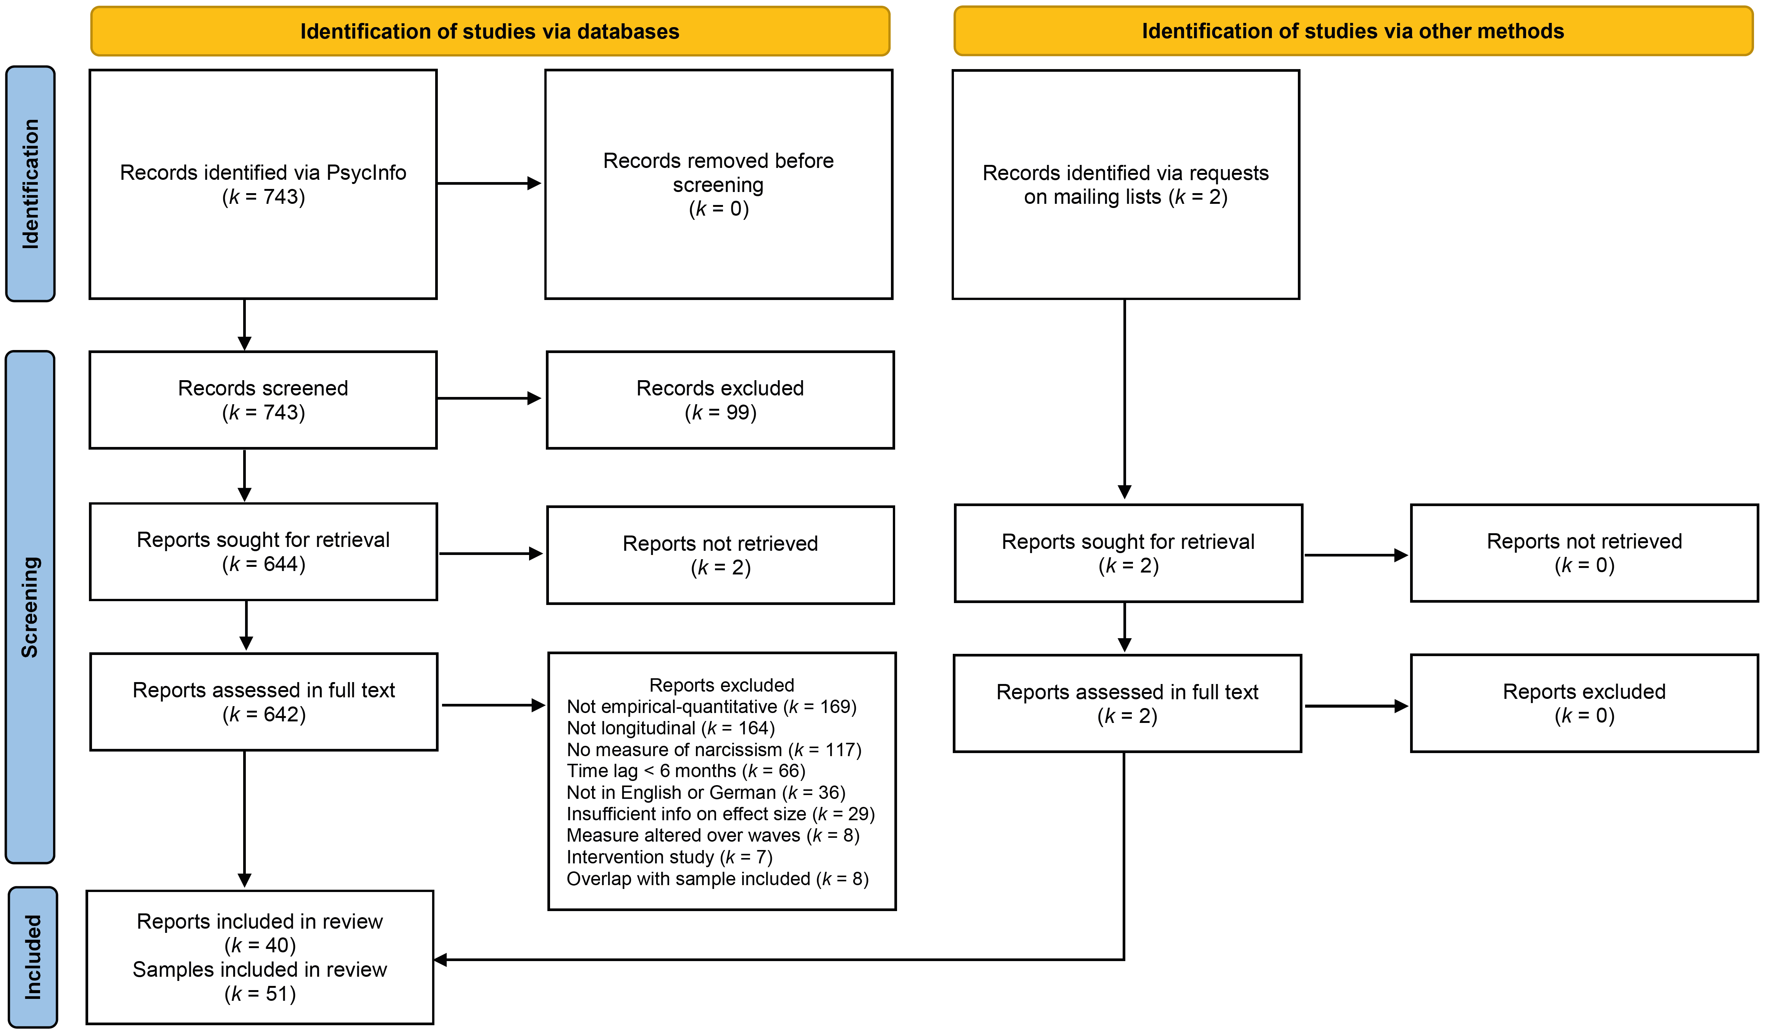

Note. The diagram has been adapted from Page et al. (2021).

References
Page, M. J., McKenzie, J. E., Bossuyt, P. M., Boutron, I., Hoffmann, T. C., Mulrow, C. D., Shamseer, L., Tetzlaff, J. M., Akl, E. A., Brennan, S. E., Chou, R., Glanville, J., Grimshaw, J. M., Hrobjartsson, A., Lalu, M. M., Li, T., Loder, E. W., Mayo-Wilson, E., McDonald, S., McGuinness, L. A., Stewart, L. A., Thomas, J., Tricco, A. C., Welch, V. A., Whiting, P., & Moher, D. (2021). The PRISMA 2020 statement: An updated guideline for reporting systematic reviews. BMJ, 372, n71. https://doi.org/10.1136/bmj.n71

