Supplemental Materials

Sex Drive: Theoretical Conceptualization and Meta-Analytic Review of Gender Differences

Introduction
These supplemental materials contain additional figures and tables to complement the analyses reported in the main article. Table S1 summarizes the terms for the electronic literature search. Table S2 gives an overview of the psychometric inventories from which we drew individual items to included them in the meta-analysis. Tables S3 to S5 summarize results for meta-moderation analyses for the indicators of latent sex drive. Table S6 gives references for all psychometric inventories from which we drew questionnaire items. Figure 1 shows the distribution of effect sizes for the sex drive manifestations and indicators of latent sex drive, as well as for the bias indicators. Figure S2 depicts results of the leave-one-out analyses for outlier detection. Figures S3 and S4 show funnel plots for the indicators of latent sex drive and bias indicators, respectively. Figure S5 shows how the distributions of men’s and women’s sex drive overlap under assumptions of normality.

A Formalized Definition of Sex Drive
In line with recent calls to incorporate more formal modelling into psychology (Guest & Martin, 2020), we now present a mathematical definition of our conceptualization of sex drive. The illustrative data in Figure 1 in the main article were generated according to these equations. We describe the fluctuation of state sex drive in an individual over time $X$ as a simple auto-regressive process (AR(1) process; Mills, 1991), assuming that state sex drive at a given point in time $X_{t}$ depends by some factor $β$ on state sex drive at the previous point in time $X_{t-1}$:
$$X_{t}=c + βX_{t-1}+ϵ_{t}$$ | (1)
where $ϵ_{t}$ is Gaussian white noise with zero mean and constant variance $σ_{ϵ}^{2}$ and c is a constant.
The relationship between state sex drive $X$ and the probability $p$ that a particular sexual event s occurs at a given point in time t, may be described by some function $Φ$:
$$p(s_{t}) = Φ(X_{t})$$ | (2)
While the exact nature of the relationship between state sex drive and the probability of sexual events, that is, $Φ$, is beyond the scope of the current work, we may engage in some speculation. For instance, it appears reasonable to assume that the relationship follows a monotonic function, such that higher sex drive implies a higher probability of sexual events. It may also be reasonable to assume that the relationship is not identical for the events of sexual cognition, affect, and behavior. For example, sexual cognition may be more likely than sexual behavior at any given point in time. There are many potential functions that satisfy these requirements. A natural contender could for example be the logistic function multiplied with some constant b:
$$Φ(z) = b\left(\frac{1}{1+ e^{-z}}\right)$$ | (3)
where b is different for each type of sexual event, that is, sexual cognition, affect, and behavior. We wish to emphasize again that this is speculative, and that finding the true relationship is beyond the scope of this work. For full transparency: Our choice of function was in part guided by aesthetic considerations for generating the data in Figure 1. The same is true for our choice of parametrizations when generating the data. We assumed that $σ_{ϵ}^{2}= 0.64$, $β = 0.9$, $c = 0$, $b_{SexCog }= 0.8$, $b_{SexAff}= 0.5$, and $b_{SexBeh}= 0.2$. We note that some obvious shortcomings of this model come immediately to mind. The fact that b effectively caps the probability of sexual events, such that for example the probability of sexual behavior never exceeds 20%, is unrealistic. It is also unrealistic that the probabilities for each type of sexual event always move in tandem, that is, that the lines never cross. Furthermore, we have omitted “hard” situational constraints on sexual behavior from the model (i.e., in most situations, behavioral acts to attain sexual gratification are not an option). However, addressing these limitations would severely complicate the model, and a more complicated model would not serve our purpose of illustration. For the moment, we view the model as oversimplified, yet useful.

References
Guest, O., & Martin, A. E. (2020). How computational modeling can force theory building in psychological science. PsyArXiv. https://psyarxiv.com/rybh9/
Mills, T. C. (1991). Time series techniques for economists. Cambridge University Press.

Table S1
Search Terms for Literature Search
Domain | Terms | a | b | c | d | e | f | g
Cognition
 | Terms 1 | sex* | for sex | erotic
 | Terms 2 | thought* | cogniti* | reverie* | fantas* | daydream* | think* | ruminat*
 | Terms 3 | disorder | disfunction
Affect
 | Terms 1 | sex* | for sex | erotic
 | Terms 2 | desire* | urge* | impuls* | crav* | drive* | motiv*
 | Terms 3 | disorder | disfunction
Behavior
 | Terms 1 | masturbate*
 | Terms 2
 | Terms 3 | disorder | disfunction
Note. Search terms for each domain were composed as "One of term 1 AND one of term 2 NOT one of term 3".

Table S2
Overview of Psychometric Inventories
Indicator | Inventories
Cognition Frequency | Sociosexual Orientation Inventory Revised, Sociosexual Orientation Inventory, Sexual Desire Inventory, Derogatis Sexual Functioning Inventory, Sexual Compulsivity Scale, Sexuality Scale, Imaginal Process Inventory, Multidimensional Sociosexual Orientation Inventory, Multidimensional Sexuality Questionnaire, Hurlbert Index of Sexual Desire, Sexual Behavior Inventory, Sex Knowledge and Attitudes Test Adolescents, Changes in Sexual Functioning Inventory, Trait Sex Drive Scale
Affect Frequency | Sex Drive Questionnaire, Sexual Desire Inventory, International Index of Erectile Function / Female Sexual Functioning Index, Sociosexual Orientation Inventory Revised, Israeli Sexual Behaviour Inventory , Hurlbert Index of Sexual Desire, Changes in Sexual Functioning Inventory, Trait Sex Drive Scale
Behavior Frequency | Sex Drive Questionnaire, Derogatis Sexual Functioning Inventory, Sexual Behavior Inventory, Sex Knowledge and Attitudes Test Adolescents, Trait Sex Drive Scale
Affect Intensity | Sexual Desire Inventory, International Index of Erectile Function / Female Sexual Functioning Index, Multidimensional Sexuality Questionnaire, Hurlbert Index of Sexual Desire
Self-Rated Sex Drive | Hurlbert Index of Sexual Desire
Sexual Intercourse Frequency | Sociosexual Orientation Inventory, Derogatis Sexual Functioning Inventory, Israeli Sexual Behaviour Inventory , Sex Knowledge and Attitudes Test Adolescents
Total One-Night Stands | Sociosexual Orientation Inventory Revised, Sociosexual Orientation Inventory, Multidimensional Sociosexual Orientation Inventory
Total Sex Partners | Multidimensional Sociosexual Orientation Inventory, Sociosexual Orientation Inventory, Sexuality Scale
Total Sex Partners in Last Year | Sociosexual Orientation Inventory Revised, Sociosexual Orientation Inventory, Multidimensional Sociosexual Orientation Inventory
Note. See the supplementary online materials for a complete list of the inventories with references.

Table S3

List of Included Inventories with References

Inventory | Abbreviation | Reference
Changes in Sexual Functioning Inventory | CSFQ | Clayton, A. H., McGarvey, E. L., & Clavet, G. J. (1997). The Changes in Sexual Functioning Questionnaire (CSFQ): Development, reliability, and validity. Psychopharmacology Bulletin, 33(4), 731–745.
Derogatis Sexual Functioning Inventory | DSFI | Derogatis, L. R., & Melisaratos, N. (1979). The DSFI: A multidimensional measure of sexual functioning. Journal of Sex & Marital Therapy, 5(3), 244–281. https://doi.org/10.1080/00926237908403732
Hurlbert Index of Sexual Desire | HISD | Apt, C. V., & Hurlbert, D. F. (1992). Motherhood and female sexuality beyond one year postpartum: A study of military wives. Journal of Sex Education and Therapy, 18(2), 104–114. https://doi.org/10.1080/01614576.1992.11074044
Imaginal Process Inventory | ISI | Giambra, L. M. (1980). A factor analysis of the items of the Imaginal Processes Inventory. Journal of Clinical Psychology, 36(2), 383–409. https://doi.org/10.1002/jclp.6120360203
International Index of Erectile Function / Female Sexual Functioning Index | IIEF/FSFI | Rosen, R., Brown, C., Heiman, J., Meston, C., Shabsigh, R., Ferguson, D., & D’Agostino, R. (2000). The Female Sexual Function Index (FSFI): A multidimensional self-report instrument for the assessment of female sexual function. Journal of Sex & Marital Therapy, 26(2), 191–208. https://doi.org/10.1080/009262300278597  Rosen, R., Riley, A., Wagner, G., Osterloh, I. H., Kirkpatrick, J., & Mishra, A. (1997). The international index of erectile function (IIEF): A multidimensional scale for assessment of erectile dysfunction. Urology, 49(6), 822–830. https://doi.org/10.1016/S0090-4295(97)00238-0
Israeli Sexual Behaviour Inventory | ISBI | Kravetz, S. (1999). The Israeli Sexual Behavior Inventory (ISBI): Scale construction and preliminary validation. Sexuality and Disability, 17(2), 115–128. https://doi.org/10.1023/A:1021420300693
Multidimensional Sexuality Questionnaire | MSQ | Snell, W. E., Fisher, T. D., & Walters, A. S. (1993). The Multidimensional Sexuality Questionnaire: An objective self-report measure of psychological tendencies associated with human sexuality. Annals of Sex Research, 6, 27–55. https://doi.org/10.1007/BF00849744
Multidimensional Sociosexual Orientation Inventory | M-SOI | Jackson, J. J., & Kirkpatrick, L. A. (2007). The structure and measurement of human mating strategies: Toward a multidimensional model of sociosexuality. Evolution and Human Behavior, 28(6), 382–391. https://doi.org/10.1016/j.evolhumbehav.2007.04.005
Sex Drive Questionnaire | SDQ | Ostovich, J. M., & Sabini, J. (2004). How are sociosexuality, sex drive, and lifetime number of sexual partners related? Personality and Social Psychology Bulletin, 30(10), 1255–1266. https://doi.org/10.1177/0146167204264754
Sex Knowledge and Attitudes Test Adolescents | SKAT-A | Lief, H. I., Fullard, W., & Devlin, S. J. (1990). A new measure of adolescent sexuality: SKAT-A. Journal of Sex Education and Therapy, 16(2), 79–91. https://doi.org/10.1080/01614576.1990.11074980
Sexual Behavior Inventory | SBI | Díaz-Loving, R., & Rodríguez, G. G. (2008). Sociosexual orientation and sexual behavior in Mexican adults. Social and Personality Psychology Compass, 2(3), 1199–1217. https://doi.org/10.1111/j.1751-9004.2008.00111.x
Sexual Compulsivity Scale | SCS | Kalichman, S. C., & Rompa, D. (1995). Sexual sensation seeking and sexual compulsivity scales: Reliability, validity, and predicting HIV risk behavior. Journal of Personality Assessment, 65(3), 586–601. https://doi.org/10.1207/s15327752jpa6503_16
Sexual Desire Inventory | SDI | Spector, I. P., Carey, M. P., & Steinberg, L. (1996). The Sexual Desire Inventory: Development, factor structure, and evidence of reliability. Journal of Sex & Marital Therapy, 22(3), 175–190. https://doi.org/10.1080/00926239608414655
Sexuality Scale | SS | Snell, W. E., & Papini, D. R. (1989). The Sexuality Scale: An instrument to measure sexual‐esteem, sexual‐depression, and sexual‐preoccupation. Journal of Sex Research, 26(2), 256–263. https://doi.org/10.1080/00224498909551510
Sociosexual Orientation Inventory | SOI | Simpson, J. A., & Gangestad, S. W. (1991). Individual differences in sociosexuality: Evidence for convergent and discriminant validity. Journal of Personality and Social Psychology, 60(6), 870–883. https://doi.org/10.1037//0022-3514.60.6.870
Sociosexual Orientation Inventory Revised | SOI-R | Penke, L., & Asendorpf, J. B. (2008). Beyond global sociosexual orientations: A more differentiated look at sociosexuality and its effects on courtship and romantic relationships. Journal of Personality and Social Psychology, 95(5), 1113–1135. https://doi.org/10.1037/0022-3514.95.5.1113
Note. The inventories listed here are not analyzed in full in the present meta-analysis. Rather, we retrieved one or more items that matched our conceptualization of sex drive from these inventories and meta-analysed gender differences on the level of individual items.
Table S4
Tests for Moderation (Indicators of Latent Sex Drive)
Moderator |  | Cognition Frequency (uncontrolled) |  |  |  |  |  | Affect Intensity |  |  |  |  |  | Self-Rated Sex Drive
Moderator |  | AHZ | df | p | I² | τ |  | AHZ | df | p | I² | τ |  | AHZ | df | p | I² | τ
Outcome-level Moderators
Aggregation Span |  | 4.05 | 7.26 | .083 | 79.81 | 0.12 |  | 7.07 | 11.37 | .022 | 81.97 | 0.20
Item Content |  | 21.00 | 49.54 | < .001 | 85.78 | 0.19 |  | 15.76 | 23.05 | < .001 | 88.92 | 0.15
Item Context |  |  |  |  |  |  |  | 21.41 | 14.16 | < .001 | 81.58 | 0.11
Type of Response Scale |  | 9.63 | 6.44 | .019 | 89.93 | 0.23
Scale Range |  | 12.90 | 55.53 | < .001 | 90.00 | 0.23 |  | 1.42 | 28.19 | .243 | 90.30 | 0.16 |  | 0.64 | 2.75 | N/A | 86.70 | 0.16
Item Wording |  | 12.60 | 5.56 | .007 | 87.66 | 0.20 |  | 0.04 | 2.26 | N/A | 90.82 | 0.15
Publication-level Moderators
Aim to Find Gender Differences in Sex Drive |  | 14.71 | 11.62 | .003 | 89.28 | 0.22 |  | 0.53 | 17.25 | .478 | 89.68 | 0.19
Focus on Anonymity |  | 1.62 | 135.29 | .205 | 89.97 | 0.23 |  | 0.38 | 38.01 | .544 | 89.64 | 0.16
Focus on Gender Differences in Sex Drive |  | 6.85 | 25.63 | .015 | 87.62 | 0.21 |  | 0.07 | 29.19 | .795 | 89.49 | 0.16
Focus on Gender Differences |  | 2.39 | 108.91 | .125 | 88.86 | 0.22 |  | 0.02 | 23.01 | .890 | 89.71 | 0.15
Gender of First Author |  | 1.10 | 112.97 | .297 | 89.72 | 0.23 |  | 1.23 | 16.39 | .283 | 90.57 | 0.16
Mean Author Gender |  | 4.20 | 67.90 | .044 | 89.80 | 0.23 |  | 1.47 | 15.68 | .244 | 90.68 | 0.17 |  | 2.53 | 3.25 | N/A | 79.86 | 0.14
Publication Status |  | 2.68 | 36.44 | .110 | 89.11 | 0.22 |  | 0.08 | 3.45 | N/A | 90.60 | 0.16
Sexuality Journal |  | 9.87 | 76.50 | .002 | 89.65 | 0.23 |  | 0.32 | 36.19 | .577 | 90.61 | 0.18
Sample-level Moderators
Mean Age |  | 0.88 | 33.02 | .356 | 89.79 | 0.23 |  | 2.70 | 6.36 | .148 | 89.94 | 0.16 |  | 0.00 | 2.47 | N/A | 87.67 | 0.20
Percent White |  | 0.18 | 11.91 | .683 | 89.40 | 0.22 |  | 0.77 | 9.06 | .402 | 89.25 | 0.27 |  | 0.86 | 2.02 | N/A | 78.16 | 0.25
Country-Level Gender Development |  | 3.60 | 40.58 | .065 | 88.88 | 0.22 |  | 3.17 | 7.05 | .118 | 88.73 | 0.21 |  | 0.45 | 2.30 | N/A | 79.23 | 0.21
Country-Level Gender Inequality |  | 0.52 | 18.89 | .479 | 88.58 | 0.22 |  | 0.22 | 35.90 | .644 | 89.13 | 0.22 |  | 1.54 | 2.05 | N/A | 75.75 | 0.21
Percent Heterosexual |  | 1.71 | 10.29 | .220 | 90.65 | 0.21 |  | 2.54 | 4.78 | .175 | 92.55 | 0.18 |  | 0.12 | 1.18 | N/A | 71.25 | 0.15
Average Partnership Duration in Weeks |  | 1.19 | 7.58 | .308 | 75.39 | 0.18 |  | 0.01 | 1.66 | N/A | 84.36 | 0.27
Percent Parents |  | 0.18 | 5.17 | .685 | 89.56 | 0.28 |  | 0.73 | 3.05 | N/A | 89.99 | 0.37
Country-Level Sex Ratio |  | 0.48 | 21.38 | .494 | 88.72 | 0.22 |  | 0.01 | 8.64 | .937 | 89.42 | 0.22 |  | 0.09 | 1.54 | N/A | 79.59 | 0.24
Study Restricted to Sexually Active |  | 9.97 | 19.41 | .005 | 83.79 | 0.18 |  | 0.04 | 14.61 | .841 | 90.43 | 0.19
Percent Single |  | 12.92 | 31.11 | .001 | 88.86 | 0.22 |  | 0.00 | 7.74 | .974 | 90.13 | 0.23 |  | 7.47 | 1.00 | N/A | 51.57 | 0.14
Percent University Students |  | 0.72 | 11.58 | .414 | 85.20 | 0.22 |  | 0.66 | 4.44 | .459 | 92.16 | 0.26
Study-level Moderators
Anonymity Reassurance |  | 2.32 | 90.82 | .131 | 90.14 | 0.23 |  | 3.41 | 11.55 | .090 | 89.62 | 0.16
Participant Compensation |  | 1.68 | 51.20 | .182 | 89.87 | 0.25 |  | 0.90 | 2.85 | N/A | 91.36 | 0.38
Electronic Data Collection |  | 0.21 | 57.29 | .647 | 90.55 | 0.23 |  | 0.36 | 4.13 | .720 | 91.15 | 0.16
Group Assessment |  | 6.18 | 20.36 | .008 | 90.35 | 0.22 |  | 1.47 | 3.39 | N/A | 92.21 | 0.16
Personal Contact |  | 2.66 | 10.96 | .115 | 90.18 | 0.23 |  | 0.51 | 7.84 | .619 | 91.51 | 0.16
Sexuality Study |  | 6.57 | 41.89 | .014 | 86.18 | 0.19 |  | 0.41 | 5.63 | .547 | 92.22 | 0.23
Year of Study |  | 0.18 | 42.54 | .676 | 89.52 | 0.23 |  | 0.11 | 13.56 | .747 | 89.07 | 0.16 |  | 0.92 | 4.18 | .388 | 83.64 | 0.15
Note.Tests for moderation of the indicators of latent sex drive and cognition frequency (not controlled for item content). The tests indicate the significance of the slope for continuous moderator or differences between subgroups for categorical moderators. Some models could not be fitted because the number of available codings was insufficient. These are left blank. AHZ = Hotelling-T-approximated test statistic. df = small-sample-corrected degrees of freedom. p = p-value associated with the test statistic and df in the same row. I² = proportion of the variation in observed effects that is due to variation in true effects. τ = estimated standard deviation of the true effects. Note that if degrees of freedom fall below 4, significance tests are unreliable. p-values for unreliable tests are not reported (N/A).

Table S5
Regression Tables for Moderation Analyses (Indicators of Latent Sex Drive)

Moderator |  | Cognition Frequency (uncontrolled) |  |  |  |  |  |  |  | Affect Intensity |  |  |  |  |  |  |  | Self-Rated Sex Drive
Moderator |  | g | SE | k | m | t | df | p |  | g | SE | k | m | t | df | p |  | g | SE | k | m | t | df | p
Outcome-level Moderators
Aggregation Span
Intercept |  | 0.37 | 0.09 | 30 | 46 | 3.87 | 4.91 | .012 |  | 0.18 | 0.07 | 16 | 17 | 2.72 | 5.72 | .036
Slope |  | 0.01 | 0.00 |  |  | 2.01 | 7.26 | .083 |  | 0.01 | 0.00 |  |  | 2.66 | 11.37 | .022
Item Content
Extra pair partner |  | 0.82 | 0.02 | 106 | 168 | 36.77 | 98.63 | < .001
No target |  | 0.57 | 0.04 | 43 | 82 | 14.85 | 36.36 | < .001 |  | 0.45 | 0.03 | 39 | 88 | 13.34 | 29.95 | < .001
Unspecified partner |  | 0.58 | 0.05 | 24 | 32 | 11.74 | 19.20 | < .001 |  | 0.27 | 0.03 | 20 | 39 | 8.51 | 16.49 | < .001
Masturbation |  |  |  |  |  |  |  |  |  | 0.49 | 0.04 | 19 | 20 | 11.94 | 16.22 | < .001
Own partner |  |  |  |  |  |  |  |  |  | 0.27 | 0.04 | 13 | 19 | 6.81 | 10.01 | < .001
Item Context
First seeing an attractive person |  |  |  |  |  |  |  |  |  | 0.67 | 0.04 | 19 | 19 | 15.21 | 14.92 | < .001
Not specified |  |  |  |  |  |  |  |  |  | 0.43 | 0.03 | 47 | 81 | 12.80 | 31.17 | < .001
Romantic situation |  |  |  |  |  |  |  |  |  | 0.09 | 0.04 | 20 | 20 | 2.51 | 15.43 | .024
While having sexual thoughts |  |  |  |  |  |  |  |  |  | 0.23 | 0.04 | 20 | 20 | 6.25 | 15.43 | < .001
While spending time with an attractive person |  |  |  |  |  |  |  |  |  | 0.50 | 0.04 | 20 | 20 | 13.46 | 15.43 | < .001
Type of Response Scale
No |  | 0.74 | 0.02 | 157 | 268 | 36.61 | 149.22 | < .001
Yes |  | 0.43 | 0.10 | 8 | 14 | 4.23 | 6.03 | .005
Scale Range
Intercept |  | 0.46 | 0.08 | 155 | 265 | 5.52 | 41.91 | < .001 |  | 0.52 | 0.12 | 49 | 165 | 4.36 | 20.88 | < .001 |  | 1.05 | 0.45 | 7 | 7 | 2.34 | 2.60 | N/A
Slope |  | 0.04 | 0.01 |  |  | 3.59 | 55.53 | < .001 |  | -0.02 | 0.02 |  |  | -1.19 | 28.19 | .243 |  | -0.07 | 0.08 |  |  | -0.80 | 2.75 | N/A
Item Wording
Daydreams |  | 0.39 | 0.12 | 6 | 10 | 3.11 | 4.00 | .036
Fantasies |  | 0.81 | 0.02 | 120 | 189 | 35.24 | 111.37 | < .001
Other |  | 0.37 | 0.24 | 4 | 5 | 1.55 | 1.98 | N/A |  | 0.39 | 0.09 | 4 | 5 | 4.44 | 2.14 | N/A
Thoughts |  | 0.57 | 0.03 | 46 | 74 | 20.89 | 39.17 | < .001
Desire |  |  |  |  |  |  |  |  |  | 0.40 | 0.03 | 48 | 156 | 15.27 | 40.42 | < .001
Publication-level Moderators
Aim to Find Gender Differences in Sex Drive
No |  | 0.76 | 0.02 | 127 | 215 | 33.40 | 120.96 | < .001 |  | 0.39 | 0.03 | 35 | 124 | 12.06 | 31.34 | < .001
Yes |  | 0.50 | 0.06 | 11 | 28 | 8.09 | 9.75 | < .001 |  | 0.43 | 0.04 | 11 | 33 | 9.93 | 9.63 | < .001
Focus on Anonymity
No |  | 0.76 | 0.03 | 74 | 136 | 26.37 | 70.99 | < .001 |  | 0.42 | 0.04 | 26 | 80 | 11.13 | 22.31 | < .001
Yes |  | 0.71 | 0.03 | 70 | 118 | 21.27 | 65.60 | < .001 |  | 0.39 | 0.04 | 20 | 77 | 10.84 | 17.36 | < .001
Focus on Gender Differences in Sex Drive
No |  | 0.76 | 0.02 | 118 | 201 | 32.50 | 111.74 | < .001 |  | 0.41 | 0.04 | 31 | 110 | 11.36 | 26.63 | < .001
Yes |  | 0.60 | 0.06 | 20 | 42 | 10.72 | 18.24 | < .001 |  | 0.40 | 0.04 | 15 | 47 | 10.84 | 13.14 | < .001
Focus on Gender Differences
No |  | 0.78 | 0.04 | 55 | 93 | 21.07 | 51.79 | < .001 |  | 0.40 | 0.06 | 15 | 45 | 7.31 | 12.36 | < .001
Yes |  | 0.71 | 0.03 | 83 | 150 | 25.92 | 78.77 | < .001 |  | 0.41 | 0.03 | 31 | 112 | 13.77 | 26.90 | < .001
Gender of First Author
Female |  | 0.71 | 0.03 | 57 | 102 | 22.08 | 54.00 | < .001 |  | 0.41 | 0.03 | 39 | 122 | 12.53 | 33.86 | < .001
Male |  | 0.75 | 0.03 | 100 | 173 | 27.91 | 95.14 | < .001 |  | 0.36 | 0.03 | 11 | 44 | 11.51 | 9.13 | < .001
Mean Author Gender
Intercept |  | 0.66 | 0.04 | 157 | 275 | 18.33 | 51.38 | < .001 |  | 0.43 | 0.04 | 50 | 166 | 11.00 | 25.32 | < .001 |  | 0.82 | 0.16 | 7 | 7 | 5.18 | 2.21 | N/A
Slope |  | 0.11 | 0.06 |  |  | 2.05 | 67.90 | .044 |  | -0.09 | 0.07 |  |  | -1.21 | 15.68 | .244 |  | -0.27 | 0.17 |  |  | -1.59 | 3.25 | N/A
Publication Status
Published |  | 0.75 | 0.02 | 133 | 222 | 33.24 | 126.95 | < .001 |  | 0.40 | 0.03 | 45 | 151 | 15.32 | 39.56 | < .001
Unpublished |  | 0.66 | 0.05 | 28 | 60 | 14.57 | 25.58 | < .001 |  | 0.37 | 0.12 | 5 | 15 | 2.94 | 2.95 | N/A
Sexuality Journal
No |  | 0.77 | 0.02 | 117 | 196 | 30.82 | 111.54 | < .001 |  | 0.38 | 0.03 | 32 | 84 | 11.02 | 27.55 | < .001
Yes |  | 0.64 | 0.03 | 44 | 86 | 20.63 | 41.50 | < .001 |  | 0.41 | 0.04 | 18 | 82 | 10.25 | 16.19 | < .001
Sample-level Moderators
Mean Age
Intercept |  | 0.83 | 0.09 | 137 | 234 | 9.22 | 48.29 | < .001 |  | 0.24 | 0.10 | 48 | 164 | 2.35 | 10.10 | .041 |  | 0.64 | 0.50 | 6 | 6 | 1.30 | 1.80 | N/A
Slope |  | -0.00 | 0.00 |  |  | -0.94 | 33.02 | .356 |  | 0.01 | 0.00 |  |  | 1.64 | 6.36 | .148 |  | -0.00 | 0.02 |  |  | -0.03 | 2.47 | N/A
Percent White
Intercept |  | 0.84 | 0.13 | 47 | 79 | 6.43 | 9.92 | < .001 |  | 0.29 | 0.11 | 27 | 98 | 2.56 | 6.26 | .041 |  | 0.51 | 0.18 | 6 | 6 | 2.77 | 1.76 | N/A
Slope |  | -0.00 | 0.00 |  |  | -0.42 | 11.91 | .683 |  | 0.00 | 0.00 |  |  | 0.88 | 9.06 | .402 |  | 0.00 | 0.00 |  |  | 0.92 | 2.02 | N/A
Country-Level Gender Development
Intercept |  | -2.39 | 1.66 | 143 | 253 | -1.44 | 39.93 | .157 |  | 3.52 | 1.76 | 48 | 159 | 2.00 | 7.01 | .085 |  | 36.92 | 53.99 | 6 | 6 | 0.68 | 2.31 | N/A
Slope |  | 3.19 | 1.68 |  |  | 1.90 | 40.58 | .065 |  | -3.16 | 1.78 |  |  | -1.78 | 7.05 | .118 |  | -36.52 | 54.52 |  |  | -0.67 | 2.30 | N/A
Country-Level Gender Inequality
Intercept |  | 0.70 | 0.07 | 146 | 256 | 10.48 | 32.25 | < .001 |  | 0.43 | 0.08 | 48 | 159 | 5.05 | 27.57 | < .001 |  | 1.04 | 0.25 | 6 | 6 | 4.15 | 1.24 | N/A
Slope |  | 0.25 | 0.35 |  |  | 0.72 | 18.89 | .479 |  | -0.19 | 0.41 |  |  | -0.47 | 35.90 | .644 |  | -1.60 | 1.29 |  |  | -1.24 | 2.05 | N/A
Percent Heterosexual
Intercept |  | 0.48 | 0.17 | 81 | 150 | 2.86 | 9.18 | .018 |  | 0.19 | 0.13 | 35 | 129 | 1.44 | 4.21 | .219 |  | 0.83 | 0.27 | 4 | 4 | 3.09 | 1.00 | N/A
Slope |  | 0.00 | 0.00 |  |  | 1.31 | 10.29 | .220 |  | 0.00 | 0.00 |  |  | 1.59 | 4.78 | .175 |  | -0.00 | 0.00 |  |  | -0.35 | 1.18 | N/A
Average Partnership Duration in Weeks
Intercept |  | 0.76 | 0.06 | 31 | 46 | 12.50 | 19.13 | < .001 |  | 0.35 | 0.06 | 23 | 57 | 6.09 | 18.30 | < .001
Slope |  | -0.00 | 0.00 |  |  | -1.09 | 7.58 | .308 |  | 0.00 | 0.00 |  |  | 0.08 | 1.66 | N/A
Percent Parents
Intercept |  | 0.80 | 0.12 | 21 | 37 | 6.49 | 13.45 | < .001 |  | 0.30 | 0.26 | 7 | 34 | 1.17 | 3.14 | N/A
Slope |  | -0.00 | 0.00 |  |  | -0.43 | 5.17 | .685 |  | 0.00 | 0.00 |  |  | 0.85 | 3.05 | N/A
Country-Level Sex Ratio
Intercept |  | 0.10 | 0.92 | 146 | 256 | 0.11 | 21.06 | .915 |  | 0.55 | 1.89 | 48 | 159 | 0.29 | 8.52 | .779 |  | 2.36 | 5.66 | 6 | 6 | 0.42 | 1.49 | N/A
Slope |  | 0.01 | 0.01 |  |  | 0.70 | 21.38 | .494 |  | -0.00 | 0.02 |  |  | -0.08 | 8.64 | .937 |  | -0.02 | 0.06 |  |  | -0.29 | 1.54 | N/A
Study Restricted to Sexually Active
No |  | 0.78 | 0.02 | 97 | 172 | 32.40 | 89.47 | < .001 |  | 0.40 | 0.04 | 29 | 94 | 11.41 | 25.83 | < .001
Yes |  | 0.59 | 0.06 | 16 | 29 | 10.23 | 14.16 | < .001 |  | 0.39 | 0.06 | 10 | 36 | 6.59 | 8.25 | < .001
Percent Single
Intercept |  | 0.61 | 0.04 | 88 | 158 | 17.24 | 40.77 | < .001 |  | 0.36 | 0.04 | 39 | 130 | 9.43 | 27.16 | < .001 |  | 0.83 | 0.13 | 3 | 3 | 6.16 | 1.00 | N/A
Slope |  | 0.00 | 0.00 |  |  | 3.59 | 31.11 | .001 |  | 0.00 | 0.00 |  |  | 0.03 | 7.74 | .974 |  | -0.01 | 0.00 |  |  | -2.73 | 1.00 | N/A
Percent University Students
Intercept |  | 0.70 | 0.10 | 80 | 132 | 7.05 | 8.84 | < .001 |  | 0.30 | 0.09 | 20 | 75 | 3.49 | 2.87 | N/A
Slope |  | 0.00 | 0.00 |  |  | 0.85 | 11.58 | .414 |  | 0.00 | 0.00 |  |  | 0.81 | 4.44 | .459
Study-level Moderators
Anonymity Reassurance
No |  | 0.76 | 0.03 | 92 | 164 | 28.82 | 88.65 | < .001 |  | 0.42 | 0.03 | 36 | 116 | 12.73 | 31.20 | < .001
Yes |  | 0.69 | 0.04 | 49 | 86 | 17.20 | 45.39 | < .001 |  | 0.35 | 0.03 | 9 | 35 | 13.47 | 7.19 | < .001
Participant Compensation
Coursecredit |  | 0.80 | 0.05 | 29 | 53 | 15.68 | 27.46 | < .001 |  | 0.43 | 0.04 | 4 | 14 | 11.20 | 2.91 | N/A
Material |  | 0.66 | 0.05 | 35 | 64 | 13.13 | 32.95 | < .001 |  | 0.35 | 0.05 | 18 | 58 | 7.20 | 16.83 | < .001
Mixed |  | 0.77 | 0.04 | 18 | 29 | 19.79 | 16.61 | < .001 |  | 0.30 | 0.06 | 7 | 29 | 5.51 | 5.93 | .002
None |  | 0.79 | 0.06 | 18 | 35 | 12.92 | 16.36 | < .001 |  | 0.46 | 0.13 | 2 | 18 | 3.44 | 1.00 | N/A
Electronic Data Collection
No |  | 0.71 | 0.05 | 36 | 53 | 14.06 | 33.40 | < .001 |  | 0.43 | 0.05 | 10 | 39 | 8.37 | 8.24 | < .001
Yes |  | 0.73 | 0.03 | 96 | 181 | 29.21 | 91.98 | < .001 |  | 0.39 | 0.03 | 33 | 103 | 12.86 | 28.82 | < .001
Mixed |  |  |  |  |  |  |  |  |  | 0.49 | 0.14 | 3 | 15 | 3.61 | 1.69 | N/A
Group Assessment
Mixed |  | 0.52 | 0.06 | 10 | 13 | 8.78 | 8.66 | < .001 |  | 0.35 | 0.03 | 4 | 26 | 11.70 | 2.65 | N/A
No |  | 0.74 | 0.02 | 103 | 180 | 30.09 | 97.61 | < .001 |  | 0.40 | 0.03 | 36 | 112 | 12.85 | 31.30 | < .001
Yes |  | 0.79 | 0.07 | 19 | 30 | 11.39 | 17.45 | < .001
Personal Contact
Mixed |  | 0.62 | 0.05 | 5 | 8 | 13.17 | 3.84 | N/A |  | 0.39 | 0.04 | 4 | 26 | 8.97 | 2.69 | N/A
No |  | 0.73 | 0.03 | 84 | 151 | 27.45 | 80.36 | < .001 |  | 0.43 | 0.04 | 24 | 83 | 11.96 | 21.29 | < .001
Yes |  | 0.75 | 0.04 | 57 | 97 | 19.63 | 53.81 | < .001 |  | 0.37 | 0.04 | 18 | 53 | 8.42 | 15.09 | < .001
Sexuality Study
No |  | 0.80 | 0.04 | 25 | 42 | 18.31 | 21.98 | < .001 |  | 0.35 | 0.10 | 5 | 25 | 3.52 | 3.94 | N/A
Yes |  | 0.65 | 0.03 | 44 | 87 | 18.69 | 40.93 | < .001 |  | 0.42 | 0.04 | 25 | 68 | 10.69 | 22.82 | < .001
Year of Study
Intercept |  | -4.29 | 11.95 | 152 | 266 | -0.36 | 42.48 | .722 |  | 5.29 | 14.82 | 49 | 160 | 0.36 | 13.53 | .727 |  | -39.65 | 41.85 | 7 | 7 | -0.95 | 4.18 | .395
Slope |  | 0.00 | 0.01 |  |  | 0.42 | 42.54 | .676 |  | -0.00 | 0.01 |  |  | -0.33 | 13.56 | .747 |  | 0.02 | 0.02 |  |  | 0.96 | 4.18 | .388
Note. Meta-regression tables for moderation of the indicators of latent sex drive and cognition frequency (not controlled for item content). For categorical moderators, point estimates for subgroups and corresponding significance tests are presented. For continuous moderators, values are presented for the intercept and slope. Some models could not be fitted because the number of available codings was insufficient. These are left blank. g = Hedges' g effect size (positive favors males). SE = Standard Error for Hedges' g effect size. k = number of studies per subgroup. m = number of effect sizes per subgroup. t-value from t-test testing the parameter against zero. df = small-sample-corrected degrees of freedom. p = p-value associated with the t-value and df in the same row. Note that if degrees of freedom fall below 4, significance tests are unreliable. p-values for unreliable tests are not reported (N/A).

Table S6
Moderator Overview for Secondary Indicators

Moderator |  | Total |  |  | Affect Intensity |  |  |  | Self-Rated Sex Drive
Moderator |  | m | Compl. |  | m | Compl. | Distribution |  | m | Compl. | Distribution
Outcome-level Moderators
Item Content |  | 524 | 61% |  | 166 | 100% | masturbation (m = 20), no target (m = 88), own partner (m = 19), unspecified partner (m = 39) |  | 0 | 0% | NA (m = 7)
Item Context |  | 605 | 71% |  | 166 | 100% | being attracted to someone wrong to pursue (m = 3), during sex (m = 1), first seeing an attractive person (m = 19), not specified (m = 81), prior to sex (m = 1), romantic situation (m = 20), seeing an attractive person (m = 1), while having sexual thoughts (m = 20), while spending time with an attractive person (m = 20) |  | 0 | 0% | NA (m = 7)
Type of Response Scale |  | 856 | 100% |  | 166 | 100% | no (m = 166) |  | 7 | 100% | no (m = 7)
Scale Range |  | 691 | 81% |  | 165 | 99% | Q = [4.00, 7.00, 8.00, 8.00, 9.00], M = 7.19, SD = 1.50 |  | 7 | 100% | Q = [4.00, 5.00, 6.00, 7.00, 8.00], M = 6.00, SD = 1.63
Item Wording |  | 605 | 71% |  | 166 | 100% | appetite (m = 2), desire (m = 156), libido (m = 1), motivation (m = 2), other (m = 5) |  | 0 | 0% | NA (m = 7)
Aggregation Span |  | 185 | 22% |  | 17 | 10% | Q = [1.00, 1.00, 28.00, 28.00, 28.00], M = 15.65, SD = 13.58 |  | 0 | 0% | Q = [NA, NA, NA, NA, NA], M = NaN, SD = NA
Publication-level Moderators
Aim to Find Gender Differences in Sex Drive |  | 745 | 87% |  | 157 | 95% | no (m = 124), yes (m = 33), NA (m = 9) |  | 6 | 86% | no (m = 1), yes (m = 5), NA (m = 1)
Focus on Gender Differences in Sex Drive |  | 746 | 87% |  | 157 | 95% | no (m = 110), yes (m = 47), NA (m = 9) |  | 7 | 100% | no (m = 1), yes (m = 6)
Focus on Gender Differences |  | 746 | 87% |  | 157 | 95% | no (m = 45), yes (m = 112), NA (m = 9) |  | 7 | 100% | yes (m = 7)
Gender of First Author |  | 843 | 98% |  | 166 | 100% | female (m = 122), male (m = 44) |  | 7 | 100% | female (m = 4), male (m = 3)
Publication Status |  | 856 | 100% |  | 166 | 100% | published (m = 151), unpublished (m = 15) |  | 7 | 100% | published (m = 6), unpublished (m = 1)
Sexuality Journal |  | 856 | 100% |  | 166 | 100% | No (m = 84), Yes (m = 82) |  | 7 | 100% | No (m = 5), Yes (m = 2)
Focus on Anonymity |  | 776 | 91% |  | 157 | 95% | no (m = 80), yes (m = 77), NA (m = 9) |  | 7 | 100% | no (m = 4), yes (m = 3)
Mean Author Gender |  | 843 | 98% |  | 166 | 100% | Q = [0.00, 0.00, 0.25, 0.50, 1.00], M = 0.35, SD = 0.32 |  | 7 | 100% | Q = [0.00, 0.38, 0.50, 1.00, 1.00], M = 0.61, SD = 0.40
Sample-level Moderators
Mean Age |  | 735 | 86% |  | 165 | 99% | Q = [18.04, 24.21, 27.57, 31.70, 74.59], M = 28.51, SD = 7.22 |  | 6 | 86% | Q = [18.60, 24.44, 32.02, 35.90, 39.56], M = 30.22, SD = 8.29
Percent White |  | 302 | 35% |  | 98 | 59% | Q = [0.00, 65.83, 84.75, 91.00, 98.00], M = 74.00, SD = 24.18 |  | 6 | 86% | Q = [42.00, 63.90, 73.30, 88.25, 98.00], M = 73.43, SD = 20.47
Country-Level Gender Inequality |  | 790 | 92% |  | 159 | 96% | Q = [0.08, 0.12, 0.22, 0.25, 0.31], M = 0.18, SD = 0.07 |  | 6 | 86% | Q = [0.11, 0.16, 0.25, 0.26, 0.26], M = 0.21, SD = 0.07
Country-Level Gender Development |  | 790 | 92% |  | 159 | 96% | Q = [0.96, 0.99, 0.99, 1.00, 1.03], M = 0.99, SD = 0.01 |  | 6 | 86% | Q = [0.99, 0.99, 0.99, 0.99, 1.00], M = 0.99, SD = 0.00
Percent Heterosexual |  | 487 | 57% |  | 129 | 78% | Q = [0.00, 76.30, 90.00, 100.00, 100.00], M = 84.04, SD = 18.53 |  | 4 | 57% | Q = [0.00, 72.20, 98.14, 100.00, 100.00], M = 74.07, SD = 49.41
Percent Single |  | 517 | 60% |  | 130 | 78% | Q = [0.00, 0.00, 0.00, 35.10, 95.00], M = 16.28, SD = 22.42 |  | 3 | 43% | Q = [0.00, 0.00, 0.00, 14.50, 29.00], M = 9.67, SD = 16.74
Percent University Students |  | 398 | 46% |  | 75 | 45% | Q = [0.00, 54.80, 91.53, 100.00, 100.00], M = 75.17, SD = 30.67 |  | 2 | 29% | Q = [100.00, 100.00, 100.00, 100.00, 100.00], M = 100.00, SD = 0.00
Average Partnership Duration in Weeks |  | 179 | 21% |  | 57 | 34% | Q = [1.80, 14.00, 53.40, 109.20, 554.40], M = 74.15, SD = 87.93 |  | 2 | 29% | Q = [109.20, 121.50, 133.80, 146.10, 158.40], M = 133.80, SD = 34.79
Percent Parents |  | 134 | 16% |  | 34 | 20% | Q = [17.30, 30.75, 64.00, 100.00, 100.00], M = 64.32, SD = 32.15 |  | 1 | 14% | Q = [64.00, 64.00, 64.00, 64.00, 64.00], M = 64.00, SD = NA
Study Restricted to Sexually Active |  | 629 | 73% |  | 130 | 78% | no (m = 94), yes (m = 36), NA (m = 36) |  | 6 | 86% | no (m = 6), NA (m = 1)
Country-Level Sex Ratio |  | 790 | 92% |  | 159 | 96% | Q = [93.92, 100.88, 101.03, 101.23, 104.69], M = 100.90, SD = 2.19 |  | 6 | 86% | Q = [95.65, 100.10, 100.88, 100.99, 101.03], M = 99.88, SD = 2.12
Study-level Moderators
Anonymity Reassurance |  | 761 | 89% |  | 151 | 91% | no (m = 116), yes (m = 35), NA (m = 15) |  | 7 | 100% | no (m = 7)
Participant Compensation |  | 545 | 64% |  | 119 | 72% | coursecredit (m = 14), material (m = 58), mixed (m = 29), none (m = 18), NA (m = 47) |  | 5 | 71% | coursecredit (m = 1), material (m = 2), none (m = 2), NA (m = 2)
Sexuality Study |  | 428 | 50% |  | 93 | 56% | no (m = 25), yes (m = 68), NA (m = 73) |  | 2 | 29% | no (m = 1), yes (m = 1), NA (m = 5)
Year of Study |  | 813 | 95% |  | 160 | 96% | Q = [1998.00, 2008.00, 2011.00, 2013.00, 2016.00], M = 2010.56, SD = 3.10 |  | 7 | 100% | Q = [2004.00, 2004.50, 2011.00, 2011.50, 2014.00], M = 2008.71, SD = 4.23
Face-to-Face Interview |  | 807 | 94% |  | 163 | 98% | no (m = 161), yes (m = 2), NA (m = 3) |  | 7 | 100% | no (m = 7)
Electronic Data Collection |  | 745 | 87% |  | 157 | 95% | mixed (m = 15), no (m = 39), yes (m = 103), NA (m = 9) |  | 5 | 71% | no (m = 1), yes (m = 4), NA (m = 2)
Group Assessment |  | 695 | 81% |  | 141 | 85% | mixed (m = 26), no (m = 112), yes (m = 3), NA (m = 25) |  | 4 | 57% | no (m = 4), NA (m = 3)
Personal Contact |  | 788 | 92% |  | 162 | 98% | mixed (m = 26), no (m = 83), yes (m = 53), NA (m = 4) |  | 5 | 71% | no (m = 3), yes (m = 2), NA (m = 2)
Note. m: Absolute number of effect sizes for which the corresponding characteristic could be coded. Compl.: Percentage of effect sizes for which the corresponding characteristic could be coded. Distribution: Information about the distribution of the coded characteristics. For categorical characteristics, the number of effect sizes per subgroup is reported. For continuous characteristics, Q are quartiles (minimum, 25% quartile, median, 75% quartile, maximum), M is the mean, and SD is the standard deviation. Note that summaries for continous moderators are computed on the effect size level for this table. In the results section, some of this information was presented on the level of individual participants (i.e. as summaries weighted by sample size). Some values may therefore differ.

Table S7
Interrater Reliability
Moderator | Reliability | Statistic | No. of Categories | Type of Moderator | NA Match | NA Missmatch
Gender of First Author | 0.86 | Cohen's κ | 3
Focus on Gender Differences | 0.79 | Cohen's κ | 3
Focus on Gender Differences in Sex Drive | 0.79 | Cohen's κ | 3
Aim to Find Gender Differences in Sex Drive | 0.57 | Cohen's κ | 3
Face-to-Face Interview | 0.93 | Cohen's κ | 3
Personal Contact | 1.00 | Cohen's κ | 3
Group Assessment | 0.93 | Cohen's κ | 3
Electronic Data Collection | 1.00 | Cohen's κ | 3
Focus on Anonymity | 1.00 | Cohen's κ | 3
Anonymity Reassurance | 1.00 | Cohen's κ | 3
Participant Compensation | 0.94 | Cohen's κ | 4
Sexuality Study | 0.79 | Cohen's κ | 3
Study Restricted to Sexually Active | 0.71 | Cohen's κ | 3
Journal (open) | 1.00 | Percent Agreement |  | Unknown no. of categories
Nation (open) | 0.90 | Percent Agreement |  | Unknown no. of categories
Mean Author Gender | 0.94 | Pearson Correlation |  | Numeric moderator | 0 | 0
Percent University Students | 0.71 | Pearson Correlation |  | Numeric moderator | 4 | 9
Percent Single | 0.94 | Pearson Correlation |  | Numeric moderator | 1 | 10
Average Partnership Duration in Weeks | 1.00 | Pearson Correlation |  | Numeric moderator | 1 | 17
Percent Parents |  | Pearson Correlation |  | Numeric moderator | 4 | 16
Percent White | 1.00 | Pearson Correlation |  | Numeric moderator | 0 | 14
Percent Heterosexual | 1.00 | Pearson Correlation |  | Numeric moderator | 0 | 7
Mean Age | 1.00 | Pearson Correlation |  | Numeric moderator | 4 | 11
Year the Study was Published | 0.99 | Pearson Correlation |  | Numeric moderator | 0 | 0
Year the Study was Conducted | 1.00 | Pearson Correlation |  | Numeric moderator | 2 | 16
Year the Study was Submitted | 1.00 | Pearson Correlation |  | Numeric moderator | 1 | 11
Note. Interrater reliability for study and publication level moderators. The results in this table were derived from 21 studies that were coded by two coders. Some moderators reported in the main manuscript were derived from other raw codings and hence do not appear in this table. The codings 'Publication Status' and 'Sexuality Journal' were derived from 'Journal (open)'. The codings 'Country-Level Gender Inequality', Country-Level Gender Development', and 'Country-Level Sex Ratio' were derived from 'Nation'. The coding 'Year' was derived from 'Year the study was conducted', 'Year the study was published', and 'Year the study was submitted'. We report different reliability indicators for different moderators. For categorical codings, we report Cohen's κ along with the number of possible categories. For categorical codings with an unknown number of categories, we report percent agreement. For numerical codings, we report Pearson's correlation coefficient along with the number of cases were coders agreed that the information was missing (NA Match) and the number of cases where only one coder found information (NA Missmatch). For categorical codings, 'information missing' was treated as a normal category.

Figure S1
Distribution of Effect Sizes
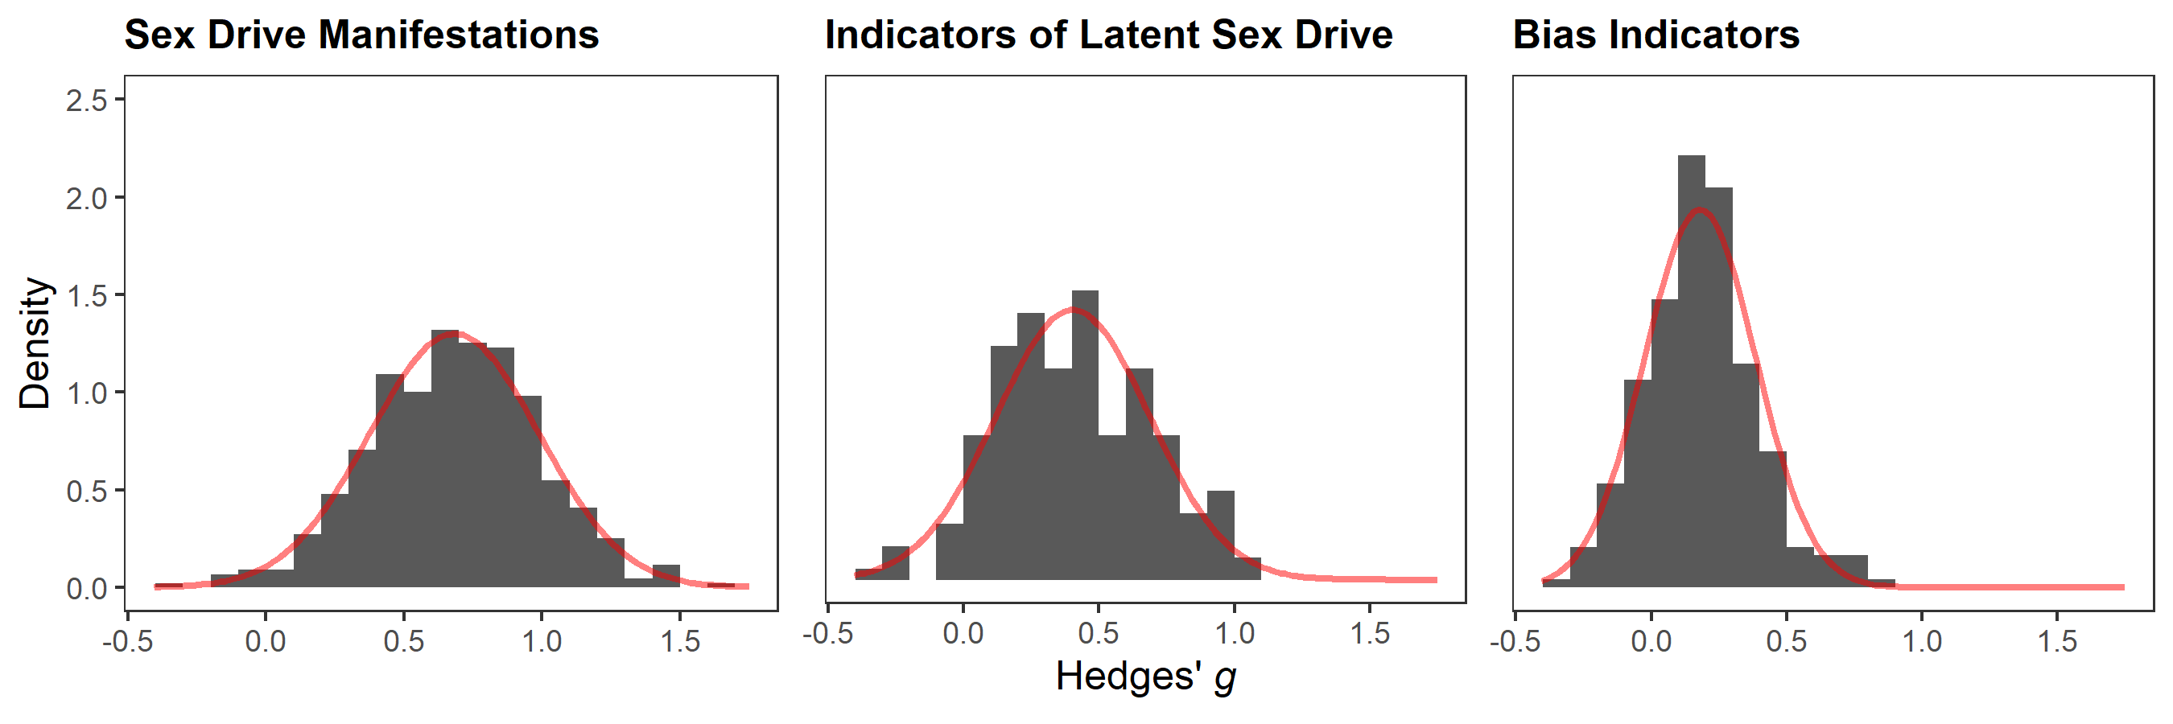
Note. The red curve denotes the fitted normal density curve for the unweighted effect sizes.

Figure S2
Results for Leave-One-Out Analyses
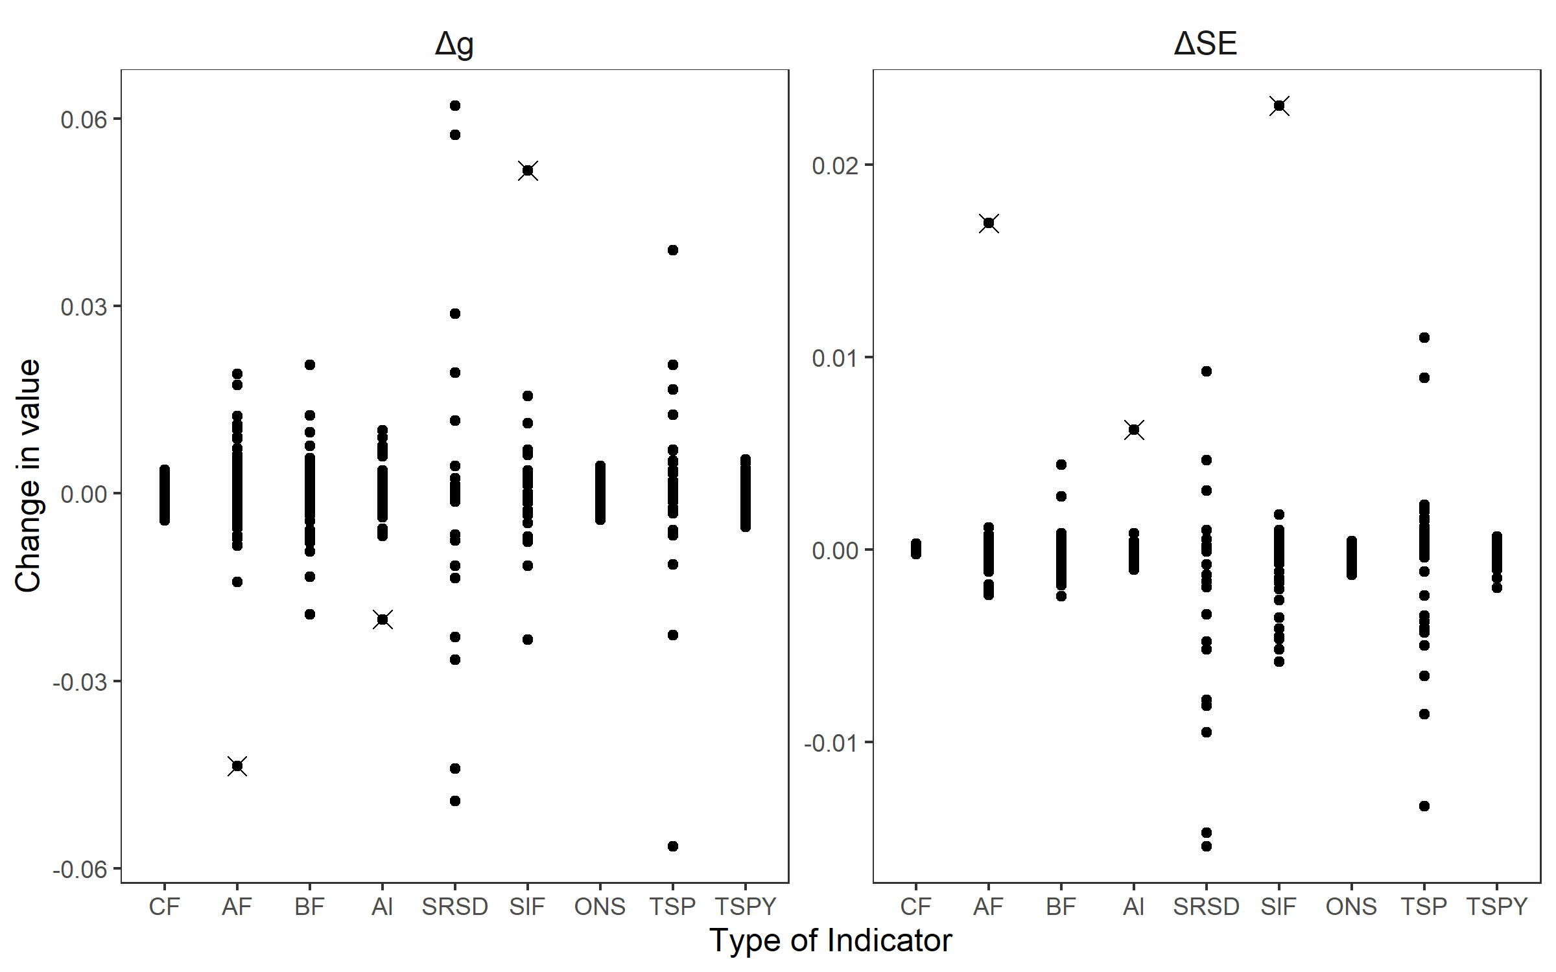
Note. This figure illustrates results from a leave-one-out analysis to detect outliers for the sex drive manifestations and latent sex drive indicators and the bias indicators. The left pane depicts changes in Hedges’ g summary effects when effect sizes are removed iteratively. The right pane depicts changes in the standard error of Hedges’ g. CF = Cognition Frequency; AF = Affect Frequency; BF = Behavior Frequency; AI = Affect Intensity; SRSD = Self-Rated Sex Drive; TSP = Total Sexual Partners; TSPY = Total Sexual Partners in Last Year; ONS = Total One-night Stands; SIF = Sexual Intercourse Frequency. Crossed out effect sizes were removed from all subsequent analyses.

Figure S3
Funnel Plots for Indicators of Latent Sex Drive
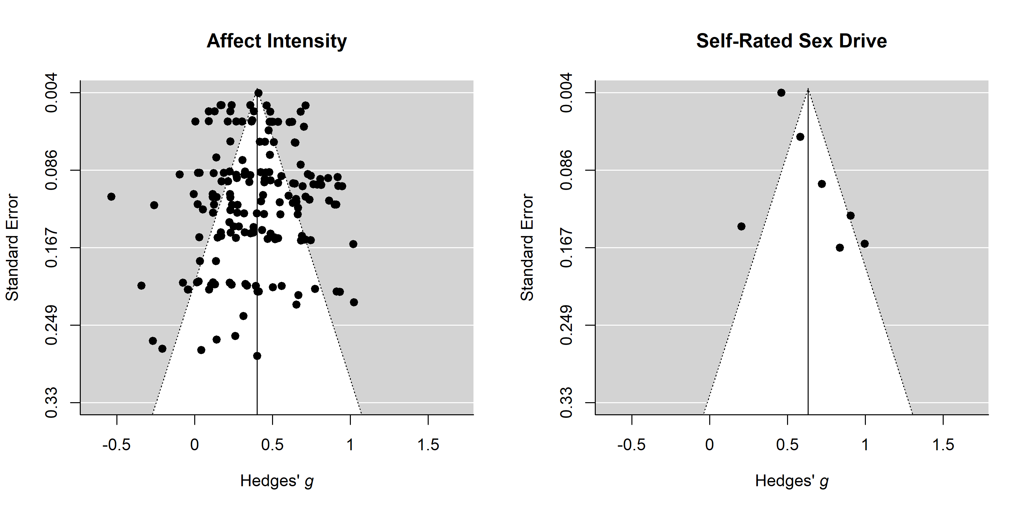
Note. The solid vertical lines represent the within-subgroup summary effects. The dotted lines denote the area in which 95% of effect sizes are expected to fall in the absence of heterogeneity. x-axis: Hedges’ g effect sizes, positive values indicate larger values in men. y-axis: Standard error of effect sizes. Leave-one-out analyses identified one outlier in the left plot at g < -0.5 and Standard Error < 0.167. This effect was removed for all other analyses. Summary effects displayed in the figure were computed after removing the outlier.

Figure S4
Funnel Plots for Bias Indicators
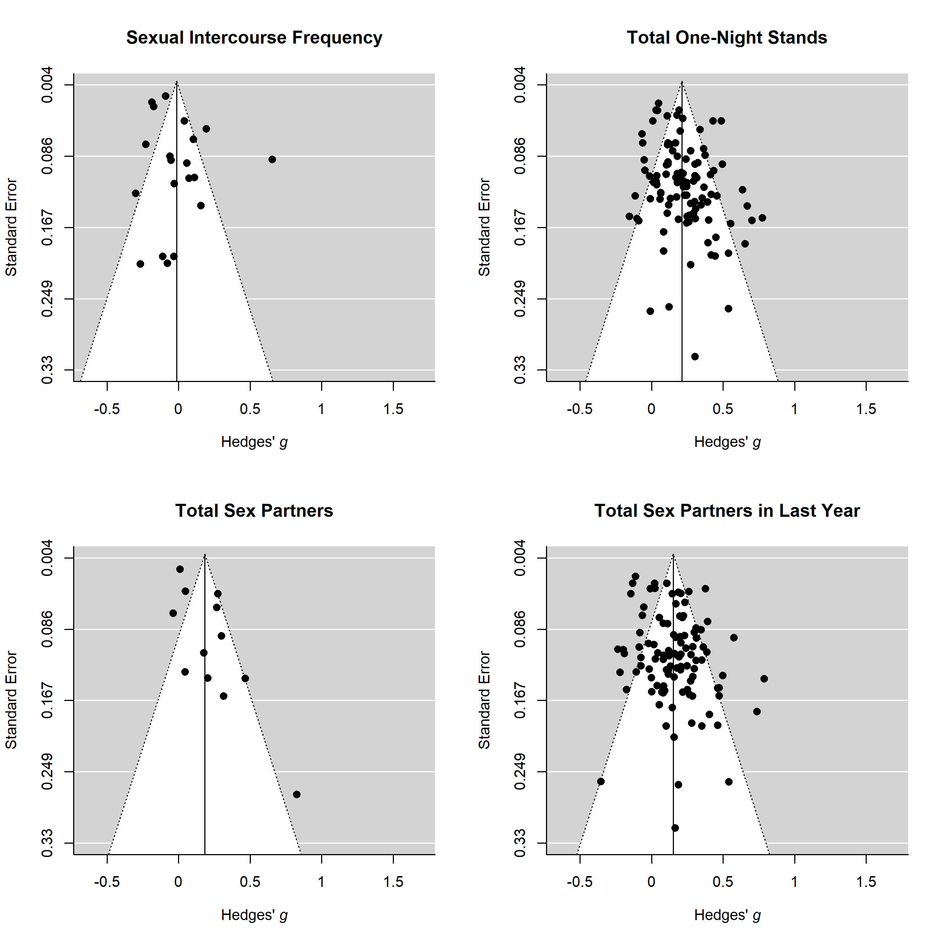
Note. The solid vertical lines represent the within-subgroup summary effects. The dotted lines denote the area in which 95% of effect sizes are expected to fall in the absence of heterogeneity. x-axis: Hedges’ g effect sizes, positive values indicate larger values in men. y-axis: Standard error of effect sizes. Leave-one-out analyses identified one outlier in the upper left plot at g > 0.5 and Standard Error > 0.249. This effect was removed for all other analyses. Summary effects displayed in the figure were computed after removing the outlier.

Figure S5
Distribution Overlap for Adjusted and Unadjusted Gender Difference in Sex Drive
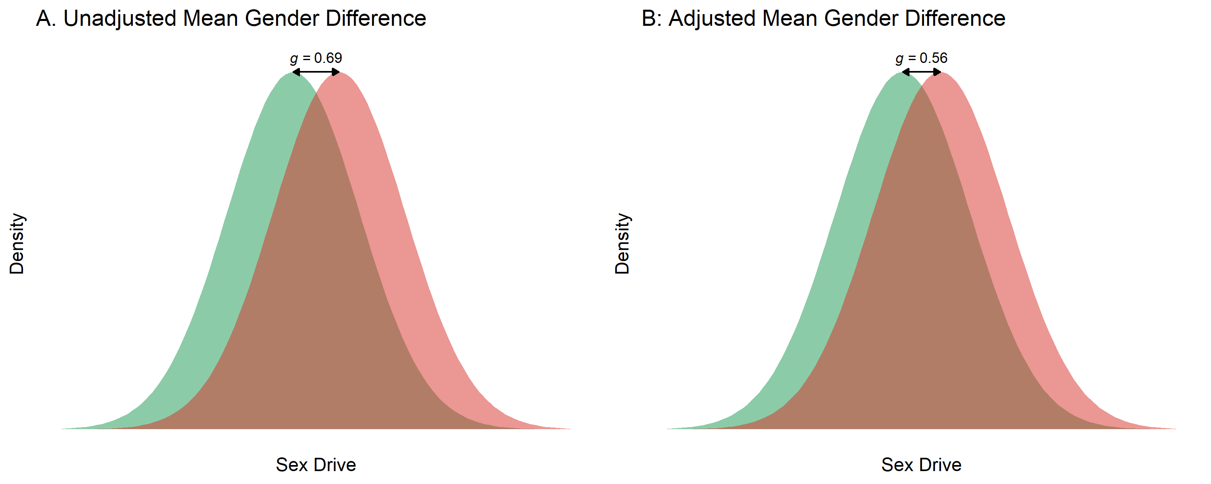
Note. This figure displays the overlap of the density distributions for female (green) and male sex drive (red) under normality assumptions. The gender difference displayed in the left panel (A) is g = 0.69, which is the unadjusted global summary effect for sex drive manifestation indicators (i.e., averaged across cognition, affect, and behavior frequency). The gender difference displayed in the right panel (B) is g = 0.56, which is the global summary effect for sex drive manifestation indicators (g = 0.69) adjusted for response bias tendencies, that is, the global summary effect for bias indicators (indicating potentially biased responding; g = 0.13).

