Coding Western vs. non-Western
We present here two tables of countries coded as Western (Table 1) and non-Western (Table 2) as well as number of effects per country.
Table 1. Countries and number of effects coded as Western
 | Australia | Belgium | Bulgaria | Canada (Fr) | France | Germany | Greece | Hongkong | Hungary | International | Israel (Jew) | Italy | Latvia
Identity | 22 | 6 | 1 | 5 | 2 | 18 | 1 | 3 | 4 | 4 | 10 | 16 | 1
Morality | 1 | 0 | 0 | 0 | 0 | 5 | 1 | 1 | 1 | 0 | 2 | 13 | 0
Injustice | 14 | 4 | 0 | 5 | 1 | 17 | 1 | 5 | 1 | 4 | 12 | 18 | 1
Efficacy | 18 | 0 | 0 | 4 | 0 | 13 | 0 | 6 | 3 | 2 | 7 | 17 | 1
 | Netherlands | New Zealand | Norway | Poland | Romania | Russia | Slovakia | Spain | Sweden | Turkey | Ukraine | United Kingdom | USA
Identity | 25 | 3 | 1 | 8 | 3 | 0 | 1 | 6 | 2 | 5 | 2 | 17 | 69
Morality | 12 | 5 | 0 | 3 | 0 | 0 | 0 | 4 | 0 | 0 | 0 | 4 | 25
Injustice | 25 | 2 | 1 | 5 | 1 | 0 | 1 | 8 | 1 | 3 | 2 | 30 | 62
Efficacy | 23 | 2 | 1 | 6 | 1 | 1 | 0 | 7 | 2 | 4 | 2 | 16 | 52

Table 2. Countries and number of effects coded as non-Western
 | Brazil | China | Egypt | Ethiopia | India | Indonesia | Iran | Israel (Arab) | Jordan | Korea South | Mexico | Philippines | South Africa | Taiwan
Identity | 1 | 7 | 2 | 1 | 1 | 4 | 2 | 4 | 2 | 0 | 2 | 2 | 1 | 0
Morality | 0 | 1 | 0 | 0 | 0 | 1 | 2 | 0 | 0 | 0 | 0 | 0 | 0 | 0
Injustice | 1 | 12 | 2 | 0 | 2 | 2 | 3 | 5 | 2 | 1 | 0 | 1 | 3 | 1
Efficacy | 1 | 11 | 2 | 0 | 2 | 1 | 3 | 4 | 2 | 0 | 0 | 0 | 1 | 1

P-curve Analysis
A p-curve analysis suggested little concern for biased publishing. Power estimates were 99%. P-curve plots illustrated in Figures 1a (Identity), 1b (Morality), 1c (Injustice), 1d (Efficacy) showed evidence for right skewness but not flatness. These analyses are based on the 403 samples.
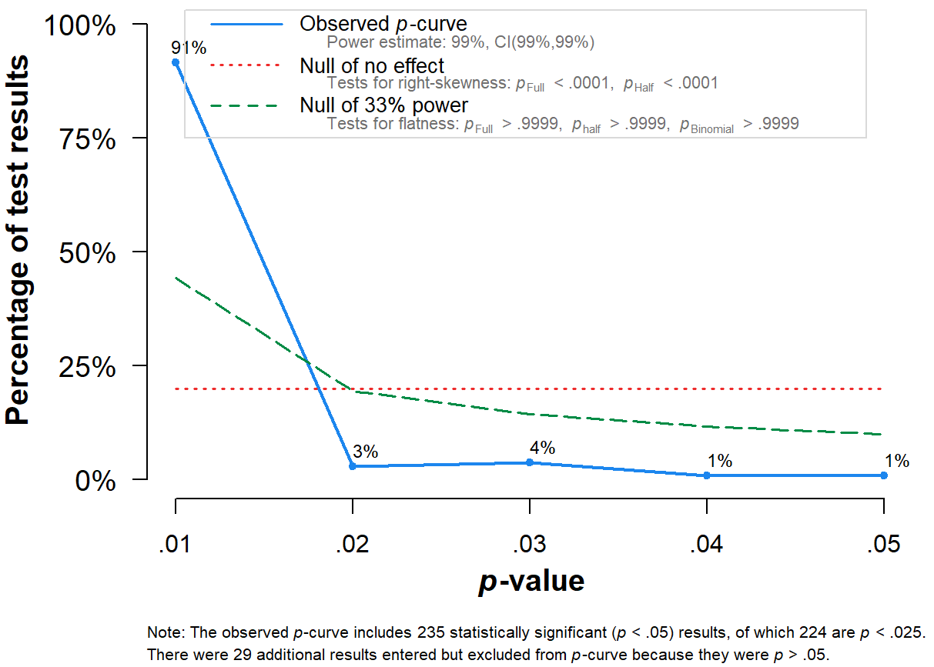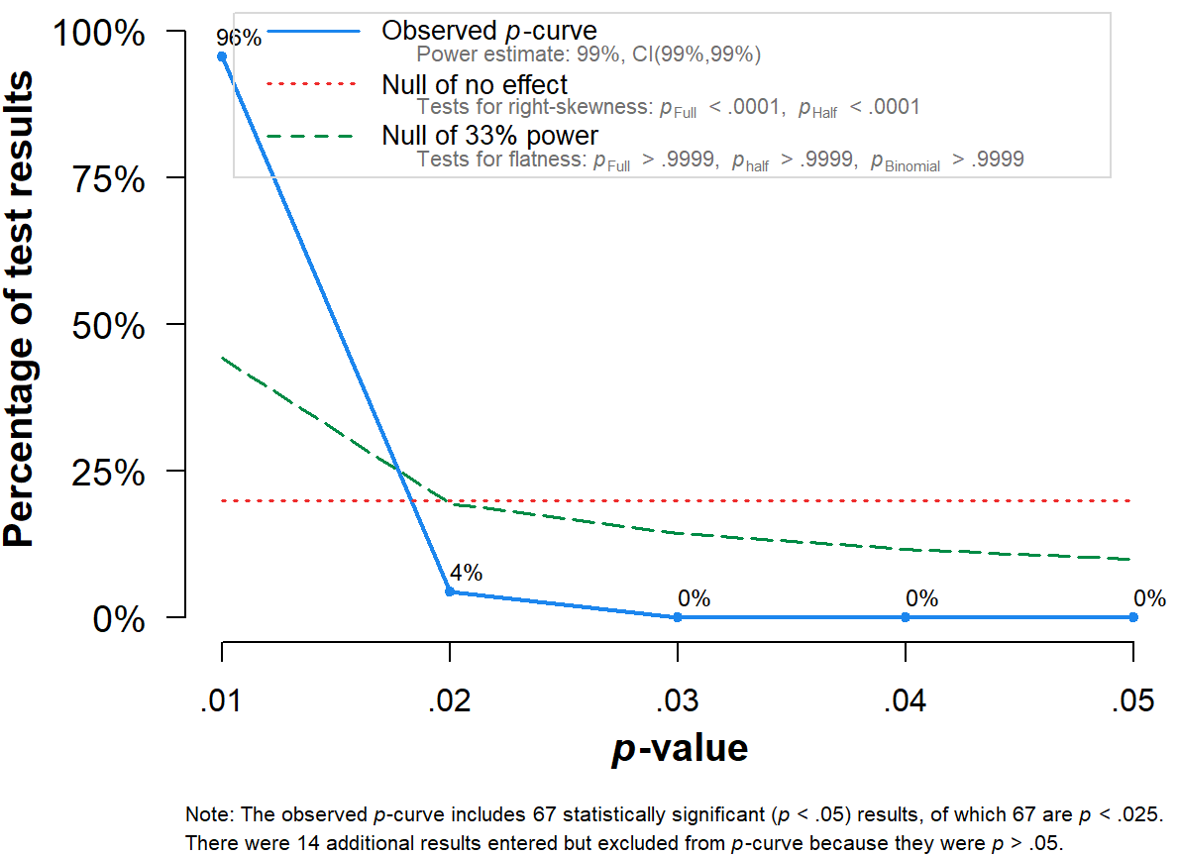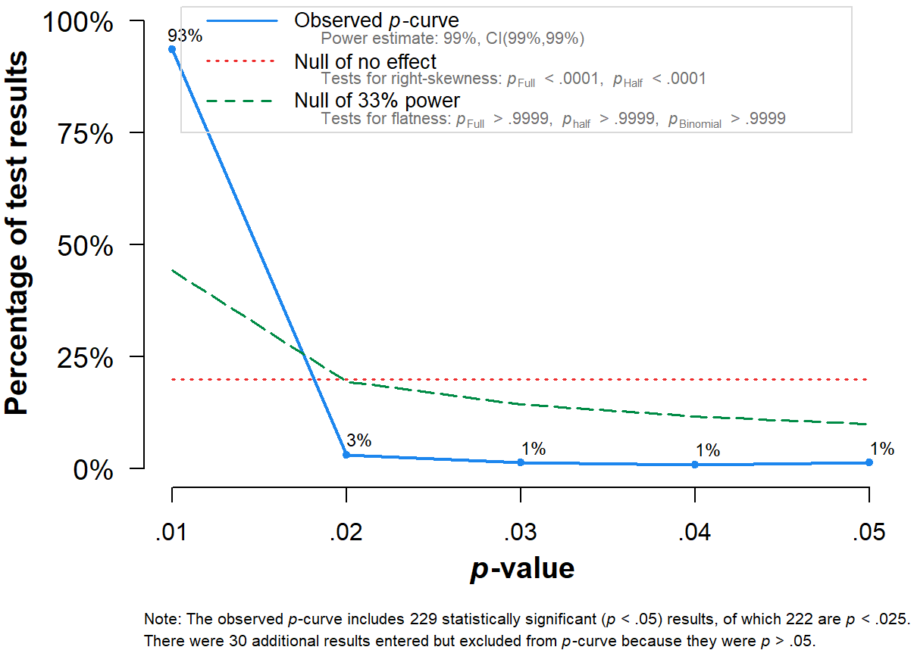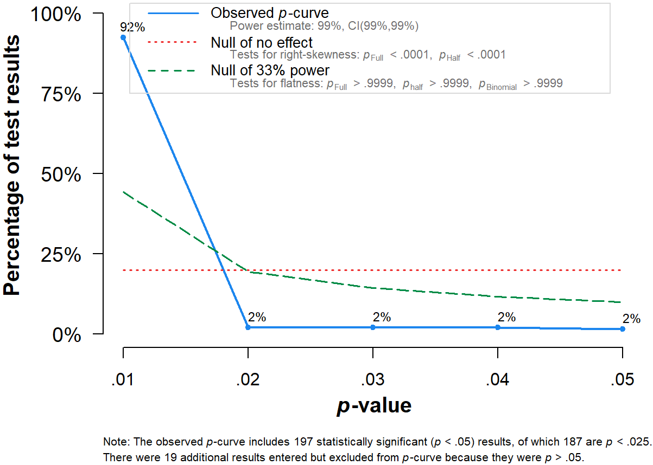
1c
1d
1b
1a
Moderators Non-Substantive and Explorative Variables
We present here the explorative moderator variables. In a nutshell and summarized in Table 1, we found little influence of age, gender and causality on the effects of the four motivations on CA. Furthermore, type of collective action (i.e., behavioral or non-behavioral measures of collective action) replicated previous findings that effect sizes are smaller but still sizeable for behavioral measures. More exploratory, most motivations for collective action were constrained by the violent nature of collective action, but mainly unconstrained by the online or offline nature of collective action. A detailed write-up follows below. Tau-squared + standard error (in brackets) are presented in Table 1. Additional error variance measures are displayed in the OSF repository.
Non-substantive and Explorative Moderator Variables
Age. On average participants were 30.10 years old for the identity meta-analysis, 34.08 years old for the morality meta-analysis, 30.88 years old for the injustice meta-analysis, and 30.81 years old for the efficacy meta-analysis. We did not observe indications that age moderated the results between identity and collective action, Q_{M} = 0.004, df = 1, p = .953 (Q_{E} = 3662.569, df = 254, p < .0001), injustice and collective action, Q_{M} = 0.749, df = 1, p = .387 (Q_{E} = 2647.787, df = 251, p < .0001), or efficacy and collective action, Q_{M} = 0.17, df = 1, p = .68 (Q_{E} = 2714.228, df = 208, p < .0001). We did, however, observe a small effect of age on the correlation between morality and collective action, Q_{M} = 4.479, df = 1, p = .034 (Q_{E} = 915.374, df = 75, p < .0001), suggesting that older people had a weaker link between morality and collective action. Aside from this, we found little evidence that age influenced other moderation findings in this meta-analysis.
Gender composition. Most studies featured a mixed gender composition in the sample, or included female-only samples because of the specific group or context (e.g., discrimination of women). We observed no moderation effects of gender on the relationship between identity and collective action, Q_{M} = 1.000, df = 2, p = .607 (Q_{E} = 3689.383, df = 257, p < .0001), morality and collective action, Q_{M} = 2.04, df = 2, p = .361 (Q_{E} = 965.294, df = 77, p < .0001), injustice and collective action, Q_{M} = 2.938, df = 2, p = .23 (Q_{E} = 2783.643, df = 252, p < .0001), or efficacy and collective action, Q_{M} = 0.754, df = 2, p = .686 (Q_{E} = 2767.724, df = 210, p < .0001). As such, we found no evidence that gender composition influenced other moderation findings in this meta-analysis.
Type of method. Most studies were survey studies, thus relying on correlational data. We observed no moderation effects of type of method on the relationship between identity and collective action, Q_{M} = 1.471, df = 1, p = .225 (Q_{E} = 3545.501, df = 246, p < .0001), injustice and collective action, Q_{M} = 1.986, df = 1, p = .16 (Q_{E} = 2103.961, df = 230, p < .0001), or efficacy and collective action, Q_{M} = 0.285, df = 1, p = .60 (Q_{E} = 2614.145, df = 188, p < .0001). We did observe moderation of type of method on the relationship between morality and collective action, Q_{M} = 4.975, df = 1, p = .026 (Q_{E} = 739.821, df = 76, p < .0001), in that experiments had a stronger correlation between morality and collective action, k = 24, r = .42, 95% CI: .35 to .49, than in survey studies, k = 54, r = .32, 95% CI: .27 to .37. Aside from this, we found little evidence that type of method influenced other moderation findings in this meta-analysis.
Causality. We identified studies that allowed for causal interpretation of the effect size, versus studies that did not allow for this interpretation. We found no moderation effects between identity and collective action, Q_{M} = 0.007, df = 1, p = .93 (Q_{E} = 3783.244, df = 262, p < .0001), morality and collective action, Q_{M} = 1.504, df = 1, p = .22 (Q_{E} = 942.151, df = 79, p < .0001), injustice and collective action, Q_{M} = 1.72, df = 1, p = .19 (Q_{E} = 2835.306, df = 257, p < .0001), or efficacy and collective action, Q_{M} = 0.158, df = 1, p = .69 (Q_{E} = 2878.05, df = 214, p < .0001). As such, we found little evidence that causality influenced other moderation findings in this meta-analysis.
Type of collective action. The current literature often operationalized collective action through a focus on proxies of actual behavior, such as intentions or attitudinal support. Behavior is often measured through self-reported past behavior, or actual behavior (e.g., signing a petition). When comparing behavioral and non-behavioral measures, we found moderation for identity, Q_{M} = 20.333, df = 1, p < .001 (Q_{E} = 3670.86, df = 280, p < .0001), injustice, Q_{M} = 26.828, df = 1, p < .001 (Q_{E} = 2303.296, df = 273, p < .0001), and efficacy, Q_{M} = 26.644, df = 1, p < .001 (Q_{E} = 2828.731, df = 229, p < .0001), but not morality, Q_{M} = 0.014, df = 1, p = .91 (Q_{E} = 985.316, df = 81, p < .0001). Replicating Van Zomeren and colleagues (2008), actual behavior (Identity: k = 72, r = .30, 95% CI: .25 to .35, Injustice: k = 49, r = .25, 95% CI: .19 to .30, Efficacy: k = 48, r = .24, 95% CI: .18 to .30) produced smaller effects than self-reported behavior (Identity: k = 210, r = .43, 95% CI: .40 to .45, Injustice: k = 226, r = .39, 95% CI: .37 to .41, Efficacy: k = 183, r = .40, 95% CI: .38 to .43). Although we do not know why we did not observe this effect for morality (actual behavior: k = 10, r = .36, 95% CI: .24 to .46, non-behavioral: k = 73, r = .36, 95% CI: .32 to .40), it might be explained by the lower number of observations in this meta-analysis, particularly for behavioral measures. All in all, we conclude that non-behavioral measures of CA produce, at least in three out of four meta-analyses, stronger effects than behavioral measures. Importantly, however, the effects of the motivations on behavioral measures of CA still produce sizeable effects that are clearly distinguishable from zero (Van Zomeren et al., 2008). This implies that behavioral proxies may therefore inflate effect sizes somewhat, but do not invalidate them.
Violent action. Exploratively, we compared collective action measures including violent actions with measures that did not include violence. We observed moderation effects for identity, Q_{M} = 9.27, df = 1, p = .002 (Q_{E} = 4066.411, df = 279, p < .0001), morality, Q_{M} = 8.215, df = 1, p = .004 (Q_{E} = 1068.173, df = 88, p < .0001), and injustice, Q_{M} = 4.068, df = 1, p = .044 (Q_{E} = 3116.682, df = 275, p < .0001), but not for efficacy, Q_{M} = 1.715, df = 1, p = .19 (Q_{E} = 3186.876, df = 229, p < .0001). For identity, morality, and injustice effect sizes were constrained by violent action (Identity: k = 21, r = .26, 95% CI: .16 to .35, Morality: k = 11, r = .19, 95% CI: .07 to .31, Injustice: k = 25, r = .29, 95% CI: .22 to .36), compared to non-violent action (Identity: k = 260, r = .41, 95% CI: .38 to .43, Morality: k = 79, r = .37, 95% CI: .33 to .41, Injustice: k = 252, r = .37, 95% CI: .35 to .39). We did not observe this effect for efficacy (non-violent: k = 210, r = .37, 95% CI: .34 to .40 vs. violent: k = 21, r = .31, 95% CI: .22 to .40). Thus, the violent nature of collective action may constrain the effects of injustice, identity and morality somewhat.
Online action. Exploratively, we also compared measures including online actions with measures that included offline actions. We observed no moderation effects for morality, Q_{M} = 1.205, df = 1, p = .27 (Q_{E} = 1021.324, df = 80, p < .0001, injustice, Q_{M} = 0.186, df = 1, p = .67 (Q_{E} = 3027.576, df = 267, p < .0001, or efficacy, Q_{M} = 1.059, df = 1, p = .30 (Q_{E} = 3011.403, df = 225, p < .0001). We did observe a marginal moderation effect for identity, Q_{M} = 3.81, df = 1, p = .051 (Q_{E} = 3887.273, df = 274, p < .0001, in that identification showed a stronger correlation with online actions, k = 44, r = .45, 95% CI: .39 to .50, than with offline actions, k = 232, r = .39, 95% CI: .36 to .41. Thus, across the board these findings suggest that we can extend the application of the four motivations for collective action from offline to online action and movements.

.
Table 6. Non-Substantive and Exploratory Moderator - Correlations for Motivations for Collective Action (Identity, Morality, Injustice, Efficacy)
Test Reason | Moderators | Motivations for Collective Action
 |  | Identity | Morality | Injustice | Efficacy
Participant | Age | Q_{M} = 0.01, df = 1, p = .953; Τ² = .053 (.0053) | Q_{M} = 4.48, df = 1, p = .034; Τ² = .037 (.0071) | Q_{M} = 0.75, df = 1, p = .387; Τ² = .036 (.0038) | Q_{M} = 0.17, df = 1, p = .68; Τ² = .048 (.0054)
Participant | Slope | b = 0.001 [-0.003, 0.003] | b = -0.005 [-0.01, 0.001] | b = -0.001 [-0.004, 0.001] | b = -0.001 [-0.004, 0.003]
Participant | Gender | Q_{M} = 1, df = 2, p = .607; Τ² = .052 (.0052) | Q_{M} = 2.04, df = 2, p = .361; Τ² = .039 (.0072) | Q_{M} = 2.94, df = 2, p = .23; Τ² = .036 (.0037) | Q_{M} = 0.75, df = 2, p = .686; Τ² = .049 (.0054)
Participant | Female | k = 24, r = .37 [.28, .45] | k = 11, r = .43 [.32, .53] | k = 20, r = .43 [.35, .50] | k = 10, r = .42 [.29, .54]
Participant | Male | k = 3, r = .48 [.24, .66] | k = 1, r = .22 [-.20, .57] | k = 5, r = .40 [.24, .54] | k = 3, r = .37 [.12, .58]
Participant | Mix | k = 236, r = .40 [.37, .42] | k = 69, r = .36 [.31, .40] | k = 235, r = .36 [.34, .38] | k = 203, r = .37 [.34, .39]
Study Method | Type Method | Q_{M} = 1.47, df = 1, p = .225; Τ² = .052 (.0052) | Q_{M} = 4.98, df = 1, p = .026; Τ² = .036 (.007) | Q_{M} = 1.99, df = 1, p = .159; Τ² = .035 (.0039) | Q_{M} = 0.29, df = 1, p = .593; Τ² = .05 (.0058)
Study Method | Experiment | k = 50, r = .37 [.30, .42] | k = 24, r = .42 [.35, .49] | k = 49, r = .39 [.34, .44] | k = 39, r = .39 [.32, .45]
Study Method | Survey | k = 198, r = .41 [.38, .43] | k = 54, r = .32 [.27, .37] | k = 183, r = .35 [.33, .38] | k = 151, r = .37 [.33, .40]
Study Method | Causality | Q_{M} = 0.01, df = 1, p = .932; Τ² = .052 (.0051) | Q_{M} = 1.5, df = 1, p = .22; Τ² = .039 (.0072) | Q_{M} = 1.72, df = 1, p = .19; Τ² = .035 (.0037) | Q_{M} = 0.16, df = 1, p = .691; Τ² = .049 (.0054)
Study Method | No | k = 258, r = .40 [.37, .42] | k = 73, r = .35 [.31, .40] | k = 250, r = .37 [.35, .39] | k = 209, r = .37 [.34, .40]
Study Method | Yes | k = 6, r = .39 [.21, .54] | k = 8, r = .44 [.31, .55] | k = 9, r = .29 [.15, .41] | k = 7, r = .40 [.24, .54]
Collective Action | Type CA | Q_{M} = 20.33, df = 1, p < 0.001; Τ² = .048 (.0046) | Q_{M} = 0.01, df = 1, p = .906; Τ² = .04 (.0073) | Q_{M} = 26.83, df = 1, p <.001; Τ² = .033 (.0033) | Q_{M} = 25.64, df = 1, p <.001; Τ² = .043 (.0046)
Collective Action | Behavior | k = 72, r = .30 [.25, .35] | k = 10, r = .35 [.24, .46] | k = 49, r = .25 [.19, .30] | k = 48, r = .24 [.18, .30]
Collective Action | Intention | k = 210, r = .43 [.40, .45] | k = 73, r = .36 [.32, .4] | k = 226, r = .39 [.37, .41] | k = 183, r = .40 [.37, .43]
Collective Action | Type CA | Q_{M} = 3.81, df = 1, p = .051; Τ² = .05 (.0048) | Q_{M} = 1.2, df = 1, p = .272; Τ² = .04 (.0073) | Q_{M} = 0.19, df = 1, p = .666; Τ² = .036 (.0036) | Q_{M} = 1.06, df = 1, p = .303; Τ² = .048 (.0051)
Collective Action | Offline | k = 232, r = .39 [.36, .41] | k = 66, r = .35 [.30, .39] | k = 213, r = .37 [.34, .39] | k = 180, r = .36 [.33, .39]
Collective Action | Online/Mix | k = 44, r = .45 [.39, .50] | k = 16, r = .40 [.31, .49] | k = 56, r = .35 [.31, .40] | k = 47, r = .40 [.34, .45]
Collective Action | Type CA | Q_{M} = 9.27, df = 1, p = .002; Τ² = .053 (.005) | Q_{M} = 8.21, df = 1, p = .004; Τ² = .039 (.0068) | Q_{M} = 4.07, df = 1, p = .044; Τ² = .037 (.0037) | Q_{M} = 1.71, df = 1, p = .19; Τ² = .051 (.0054)
Collective Action | Non-Violent | k = 260, r = .41 [.38, .43] | k = 79, r = .37 [.33, .41] | k = 252, r = .37 [.35, .39] | k = 210, r = .37 [.34, .40]
Collective Action | Violent/Both | k = 21, r = .26 [.16, .35] | k = 11, r = .19 [.07, .31] | k = 25, r = .29 [.22, .36] | k = 21, r = .31 [.22, .40]
File Drawer | Published | Q_{M} = 13.33, df = 1, p = 0; Τ² = .049 (.0048) | Q_{M} = 1.79, df = 1, p = .181; Τ² = .039 (.0072) | Q_{M} = 8.17, df = 1, p = .004; Τ² = .034 (.0036) | Q_{M} = 3.16, df = 1, p = .076; Τ² = .048 (.0053)
File Drawer | No | k = 41, r = .50 [.44, .55] | k = 24, r = .40 [.33, .47] | k = 29, r = .45 [.39, .51] | k = 35, r = .43 [.36, .49]
File Drawer | Yes | k = 223, r = .38 [.35, .40] | k = 57, r = .34 [.29, .39] | k = 230, r = .36 [.33, .38] | k = 181, r = .36 [.33, .39]
Note. Number of Effects (k), correlations (r) and 95%-CIs [in brackets] are presented. The first row of each moderator shows the overall moderation effect. Error variance is displayed online. The following rows show effects per moderator subgroup. Non-significant effects are marked dark grey.

Simple Models and Comparison to Full Models
Evaluating the Dual Chamber Model Directly
We report in detail how we built up models step-by-step, testing whether assumptions for simpler models held when complexity (i.e. mediators or a new predictor) was added to the model. We also include Figures that visualize these steps.
Fitting the original SIMCA. Figures 1a and 1b show support for the original SIMCA, in which identity predicts collective action directly, and indirectly through injustice and efficacy. When predicting collective action, identification explained around 18% of variance in collective action through its strong direct effect, b = .42 (95% CI: .39 to .46). This effect was reduced to b = .14 (95% CI: .09 to .19), when adding injustice and efficacy as mediators. As predicted by the SIMCA, we observed indirect effects from identity through injustice on collective action, b = .119 (95% CI: .140 to .163), as well as from identity through efficacy on collective action, b = .072 (95% CI: .085 to .099), suggesting that both variables explained parts of the effect from identity to collective action. As such, these findings directly replicate and support the original SIMCA.
Fitting the extended SIMCA. Figure 1f shows support for the extended SIMCA, which adds morality to the original SIMCA (i.e. morality is added as a predictor of the original SIMCA, such that it predicts these three motivations for collective action). We observed all hypothesized direct and indirect effects, with direct paths ranging from b = .15 (95% CI: .11 to .19; identity to injustice) to b = .40 (95% CI: .36 to .44; morality to efficacy). Indirect paths were also significant ranging from b = .010 (95% CI: .006 to .015; morality identity injustice collective action) to b = .106 (95% CI: .081 to .134; morality efficacy collective action). These findings directly replicate and support the extended SIMCA.
When comparing the original and extended SIMCA, we conclude that adding morality seemed to maintain good model fit while adding predictive power by explaining variance in three motivations of collective action. Indeed, compared to the independence model, χ² (10, N = 30186) = 2691.89, p < .001), model fit even improved somewhat when fitting the extended SIMCA, χ² (2, N = 30186) = 97.39, p < .001 , with other fit indices indicating adequate fit (with the absolute fit measures RMSEA = 0.040, 95% CI: .033 to .047, and SRMR = .059 being smaller than the recommended .08; the CFI = .96 was above the .9 rule of thumb but the TLI = .82 was slightly below, probably due to the TLI adjusting for the number of parameters fitted). Explained variance in collective action remained around 27%, but the extended model was uniquely able to explain variance within identity (9%), efficacy (28%), and injustice (21%).
Testing the dual chamber model. Figure 2b shows support for the dual chamber model, which conceptualizes morality and identity as different chambers of the protester’s beating heart, both of which predict the injustice and efficacy motivations for collective action. The simple model again proved adequate, with both identity, b = .27 (95% CI: .20 to .33), and morality, b = .31 (95% CI: .27 to .37) having direct effects on collective action (see Figure 2a). Figure 2b shows that, in line with the dual chamber model, these effects were reduced when adding efficacy and injustice as mediators (somewhat more strongly so for morality to collective action, b = .18 (95% CI: .08 to .28), than identity to collective action: b = .24 (95% CI: .16 to .31)). In terms of indirect effects, we observed slightly stronger effects originating from morality (morality injustice collective action, b = .046 (95% CI: .011 to .082); morality efficacy collective action, b = .072 (95% CI: .042 to .103)), than originating from identity (identity injustice collective action, b = .020 (95% CI: .005 to .036); identity efficacy collective action, b = .048 (95% CI: .030 to .069)). Model fit was once again adequate, χ² (1, N = 30186) = 84.55, p < .001; RMSEA = 0.053, 95% CI: .044 to .062, SRMR = .048, TLI = .68, CFI = .97; explained variance remained the same for collective action (27%), for efficacy (28%) and injustice (21%). In sum, all three models fit the data (as they should), but the dual chamber model performed slightly better.

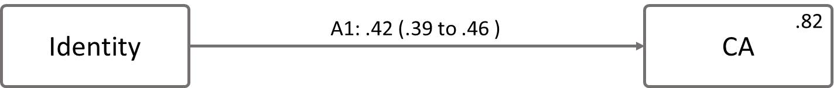
Figure 1a. Identity to Collective Action. Each path contains the unstandardized effect as well as the 95% CI.

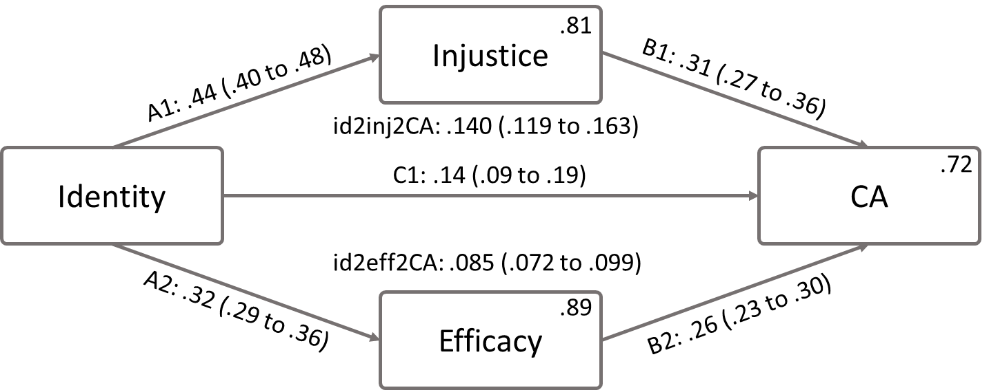
Figure 1b. The SIMCA. Each path contains the unstandardized effect as well as the 95% CI. Indirect effects and their confidence intervals are also presented in the figure (id2eff2CA = identity efficacy collective action).

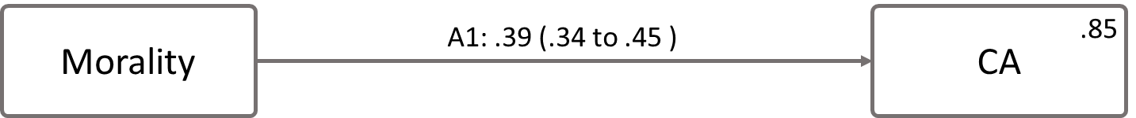
Figure 1c. Morality to Collective Action. Each path contains the unstandardized effect as well as the 95% CI.

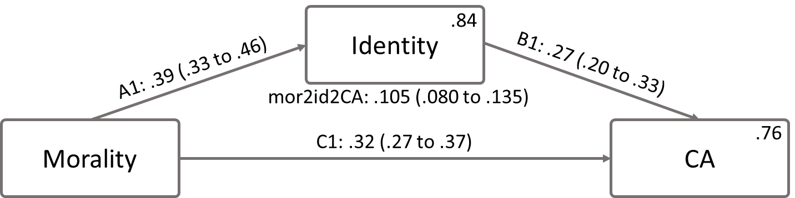
Figure 1d. Morality to Collective Action mediated by Identity. Each path contains the unstandardized effect as well as the 95% CI. Indirect effects and their confidence intervals are also presented in the figure (mor2id2CA = morality identity collective action).

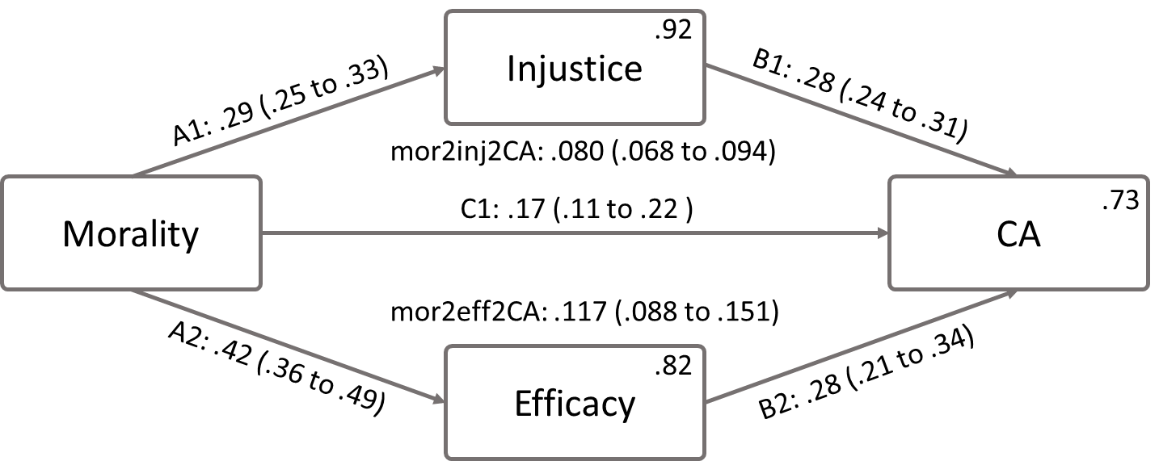
Figure 1e. Morality to Collective Action Mediated by Injustice and Efficacy. Each path contains the unstandardized effect as well as the 95% CI. Indirect effects and their confidence intervals are also presented in the figure (mor2eff2CA = morality efficacy collective action).

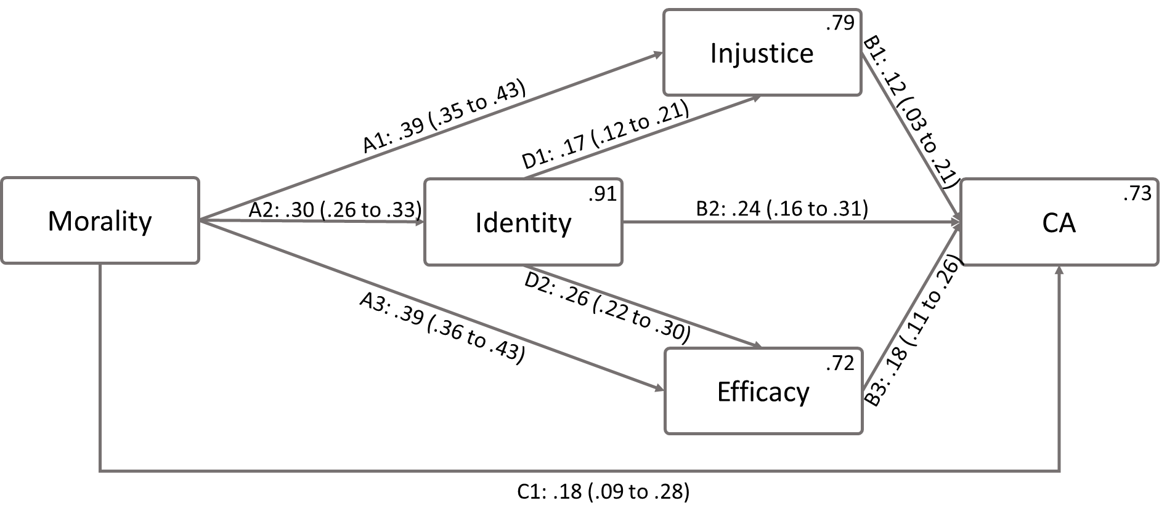
Figure 1f. The Extended SIMCA. Each path contains the unstandardized effect as well as the 95% CI. Indirect effects and their confidence intervals can be found in the OSF repository.

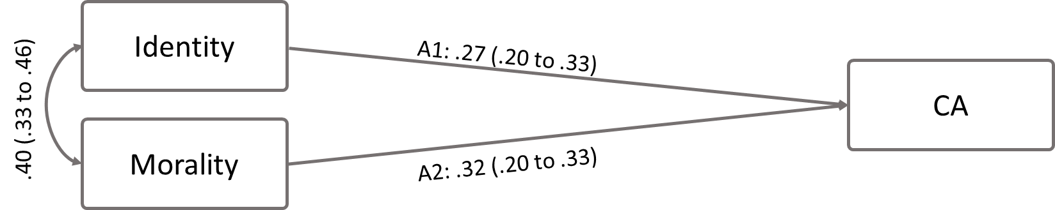
Figure 2a. The basic dual chamber model. Each path contains the unstandardized effect as well as the 95% CI.

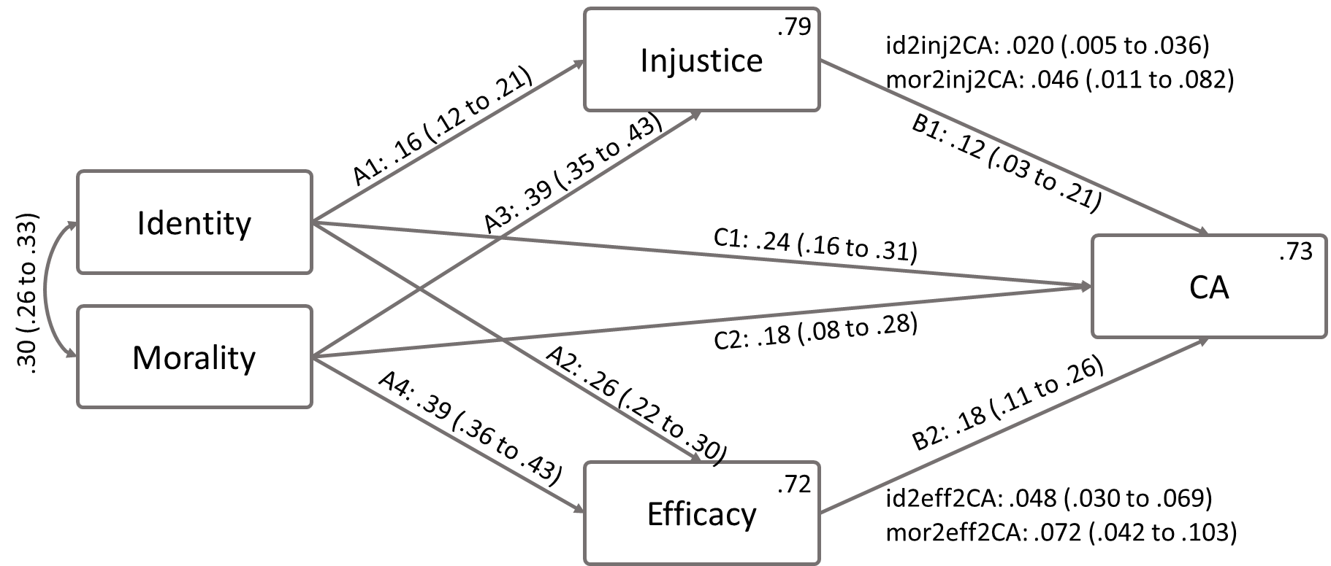
Figure 2b. The dual chamber model of why people protest (statistical model). Each path contains the unstandardized effect as well as the 95% CI. Indirect effects and their confidence intervals are also presented in the figure (mor2eff2CA = morality efficacy collective action).

Moderation Illustration
In the R-Markdown file under header “Moderator Illustration Function” we present a function to visualize moderation effects. Plots are similar to the following example (type of injustice; emotion = first facet; perception = second facet):
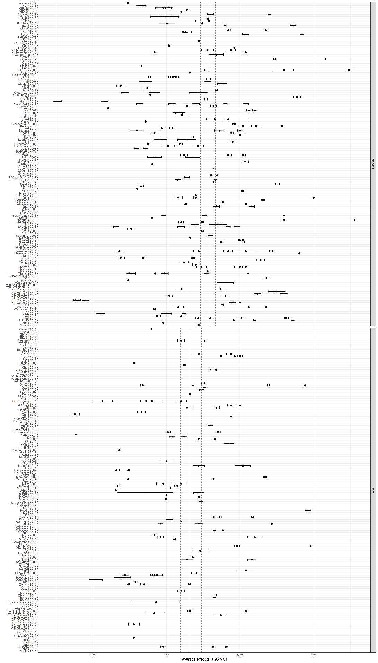

To test whether morality was a viable extension of the SIMCA, we also analyzed the direct effect from morality to collective action, b = .39 (95% CI: .34 to .45), which explained around 15% of variance in collective action (see Figure 1c). Adding identity as a mediator reduced the direct effect of morality on collective action to b = .32 (95% CI: .27 to .37), with an indirect effect from morality through identity on collective action of b = .105 (95% CI: .080 to .135; see Figure 1d). When assessing whether injustice and efficacy mediated the effect of morality on collective action (see Figure 1e), we found the direct effect to be reduced to b = .17 (95% CI: .11 to .22). Both indirect effects were pronounced, with the indirect effect from morality to efficacy to collective action, b = .117 (95% CI: .088 to .151) being somewhat stronger than the indirect effect from morality to injustice to collective action, b = .080 (95% CI: .068 to .094).
Note that this model does not include the direct effect of morality on collective action. We tested model fit on the hypothesized model which did not include a direct path. The illustration includes the direct paths to compare reductions of direct effects, when including mediators.

