Supplemental Materials
A Meta-Analysis of Longitudinal Associations between Substance Use and Interpersonal Attachment Security
by C. E. Fairbairn et al., 2018, Psychological Bulletin
http://dx.doi.org/10.1037/bul0000141

In this online supplement, we present the MPlus code used for meta-analytic regression analyses. We also present a table that is complementary to Table 3 presented within the main text. Although Table 3 in the main text presents average effect sizes for subcategories of identified moderators, the supplemental table reports our meta-analytic results in terms of meta-regression parameters. More specifically, Table S1 reports the results of effects coded meta-regression and thus displays how different specific moderators are from the average effect size for the overall class of moderators. This table also supplies confidence intervals for judging statistical significance and subdivides effects according to the type of effect size and the direction of effects. These supplemental materials also include funnel plots (Figures S1 and S2) that display the relationship between effect size estimates and the precision of the estimate and thus might be used to assess publication bias.

MPlus Code for Meta-Analytic Models

The following is the MPlus code used to fit meta-analytic models. The below represents code for an “empty” model used to estimate an overall average effect. EffN=Number of effect sizes per study; StdErr=the standard error of each effect size estimate; SampleNum=numeric variable indicating the sample that each effect size belongs to.

DATA: FILE IS "C:\Desktop\AttachDataFile.dat";

DEFINE:
w = (1/EffN) * (1/((StdErr)^2));
y=(w^.5)*(Correlation);
e=w^.5;

VARIABLE:
NAMES ARE
SampleNum
Correlation
StdErr
EffN;

MISSING ARE ALL (-9999);

USEVARIABLES ARE
e
y;

cluster = SampleNum;
ANALYSIS:
type = complex random;
MODEL:
u | y on e;
y@1;
[y@0];

[u*](m);

zU by u*(tau);
zU@1;
u@0;

Table S1. Effects Coding Of Categorical Moderators And Also Effects For Continuous Moderators As Subdivided By Correlation Type
 | Prospective Correlations |  | Cross-Sectional Correlations |  | Combined Cross-Sectional Prospective
Categorical Moderators | b | 95% CI | b | 95% CI | b | 95% CI
Drug Type
Alcohol | 0.015 | -0.010, 0.040 | 0.023 | -0.011, 0.057 | 0.012 | -0.015, 0.040
Marijuana | 0.000 | -0.023, 0.022 | -0.005 | -0.045, 0.034 | -0.003 | -0.031, 0.025
Nicotine | -0.026 | -0.044, -0.007 | -0.029 | -0.051, 0.008 | -0.027 | -0.047, -0.007
Mixed/Other | 0.011 | -0.020, 0.041 | 0.012 | -0.031, 0.054 | 0.019 | -0.016, 0.054
Use Pattern
Frequency | -0.004 | -0.034, 0.026 | -0.026 | -0.061, 0.009 | -0.011 | -0.044, 0.022
Quantity | 0.012 | -0.038, 0.061 | 0.006 | -0.044, 0.055 | 0.012 | -0.038, 0.062
Problems | -0.029 | -0.056, -0.002 | -0.019 | -0.060, 0.022 | -0.024 | -0.051, 0.003
Mixed/Other | 0.022 | -0.004, 0.047 | 0.039 | -0.001, 0.079 | 0.024 | -0.004, 0.051
Attachment Figure
Mother | 0.018 | -0.012, 0.048 | -0.014 | -0.042, 0.014 | 0.022 | -0.010, 0.054
Father | -0.013 | -0.054, 0.028 | 0.019 | -0.020, 0.058 | -0.008 | -0.051, 0.035
Family/Parents | -0.019 | -0.045, 0.008 | -0.04 | -0.078, -0.003 | -0.026 | -0.057, 0.005
Peer/Partner/Other | 0.014 | -0.034, 0.061 | 0.035 | -0.017, 0.087 | 0.012 | -0.041, 0.064
Attachment Measure
IPPA | -0.018 | -0.043, 0.007 | -0.057 | -0.113, -0.002 | -0.04 | -0.086, 0.005
AAS | 0.053 | 0.035, 0.070 | 0.062 | 0.020, 0.104 | 0.043 | 0.005, 0.082
AAI | -0.036 | -0.049, -0.023 | 0.033 | -0.084, 0.150 | 0.019 | -0.086, 0.124
Other | 0.001 | -0.028, 0.030 | -0.038 | -0.087, 0.011 | -0.022 | -0.069, 0.025
Attachment Subtype
Anxiety | 0.027 | 0.006, 0.048 | 0.060 | 0.032, 0.088 | 0.036 | 0.014, 0.058
Avoidance | -0.002 | -0.035, 0.032 | 0.000 | -0.040, 0.041 | -0.002 | -0.037, 0.034
General Insecurity | -0.025 | -0.055, 0.004 | -0.061 | -0.085, -0.036 | -0.035 | -0.063, -0.006
Geographic Region
North America | 0.002 | -0.029, 0.033 | -0.025 | -0.066, 0.016 | -0.002 | -0.039, 0.035
Europe | -0.015 | -0.045, 0.016 | 0.001 | -0.057, 0.058 | -0.014 | -0.052, 0.023
Australia/NZ | 0.015 | -0.028, 0.057 | 0.019 | -0.050, 0.089 | 0.016 | -0.036, 0.069
Continuous Moderators
Age | 0.008 | 0.003, 0.012 | 0.004 | -0.007, 0.016 | 0.009 | 0.004, 0.014
% Female | 0.043 | -0.107, 0.193 | 0.028 | -0.110, 0.166 | 0.046 | -0.118, 0.210
Publication Year | 0.004 | 0.001, 0.008 | 0.004 | 0.000, 0.007 | 0.005 | 0.001, 0.009
Racial Composition
%White | 0.025 | -0.089, 0.139 | -0.044 | -0.176, 0.089 | 0.015 | -0.117, 0.147
%Black | 0.029 | -0.111, 0.168 | 0.104 | -0.101, 0.309 | 0.049 | -0.109, 0.207
CI=confidence interval; τ =unexplained variance; SE=standard error. AAI=Adult Attachment Interview; AAS=Adult Attachment Scale; IPPA=Inventory of Parent and Peer Attachment.

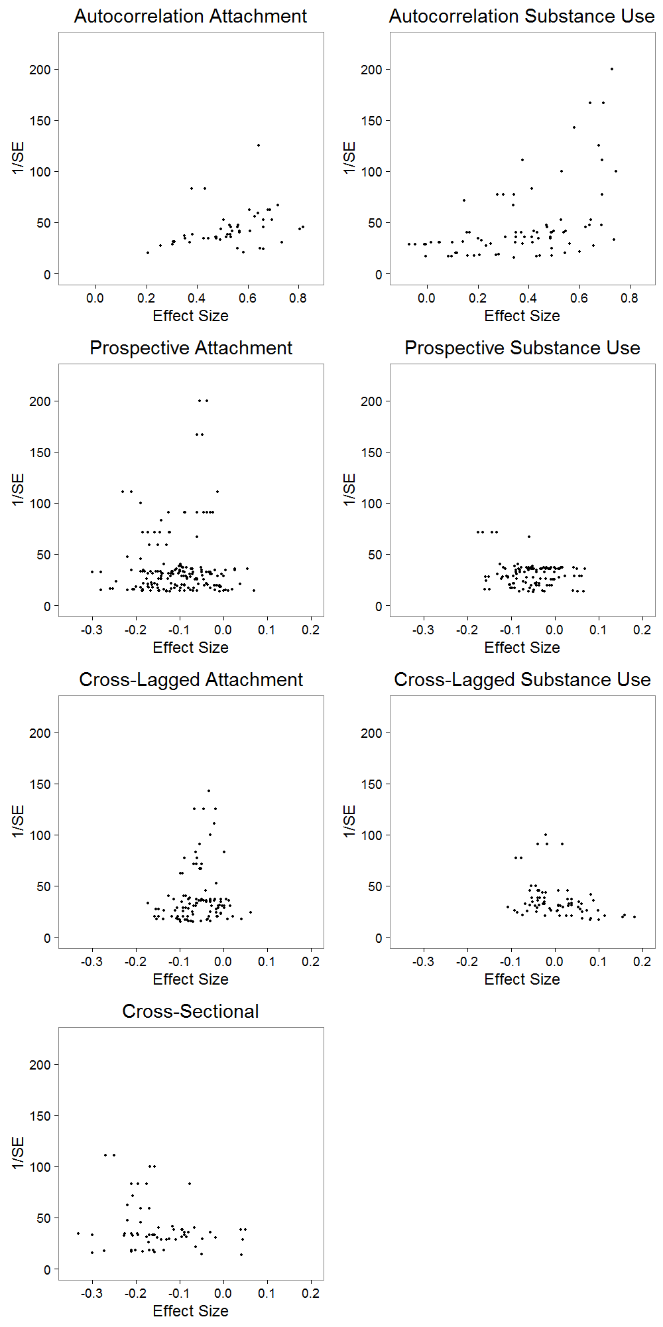
Figure S1. Funnel Plots Subdivided By Coefficient Type. Effect Sizes (Represented As R’s) Are Plotted Against The Inverse Of The Standard Error. A Negative Correlation Implies That Substance Use Increases As Attachment Security Decreases.
Prospective Attachment=the prospective correlation between attachment at time 1 and substance use at time 2; Prospective Substance Use=the prospective correlation between substance use at time 1 and attachment at time 2; Cross-Lagged Attachment=the cross-lagged association between attachment at time 1 and substance use at time 2 (controlled for substance use at time 1); Cross-Lagged Substance Use=the cross-lagged association between substance use at time 1 and attachment at time 2 (controlled for attachment at time 1)

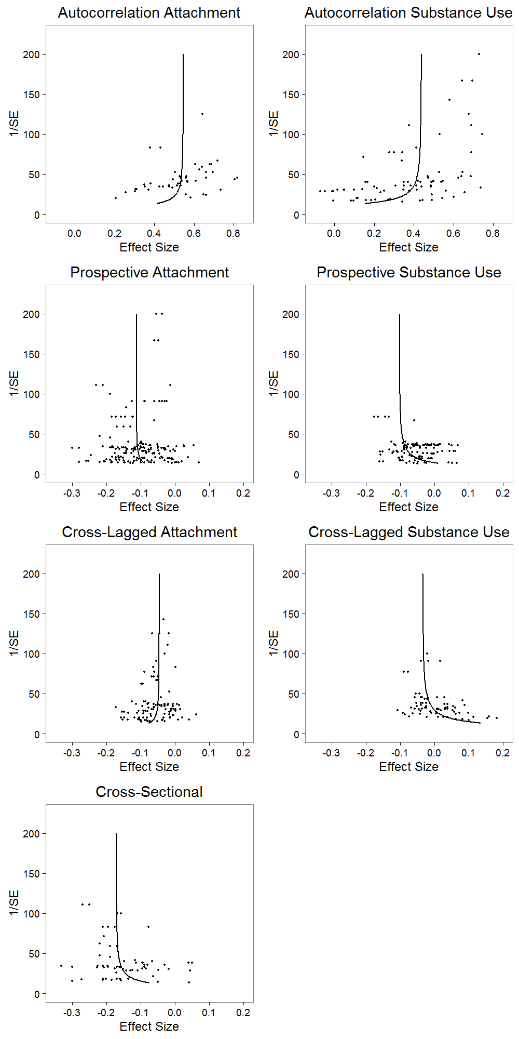
Figure S2. Funnel Plots (See Figure S1) With PEESE Regression Lines Superimposed

